Appendix

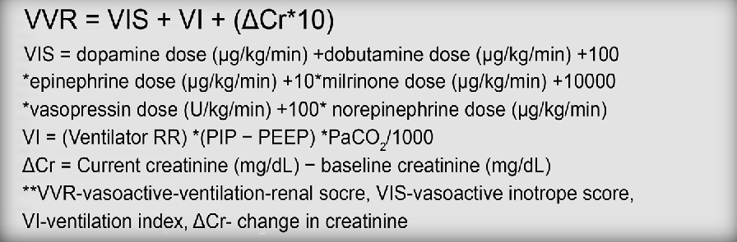
Figure 1: Calculation of VVR score.

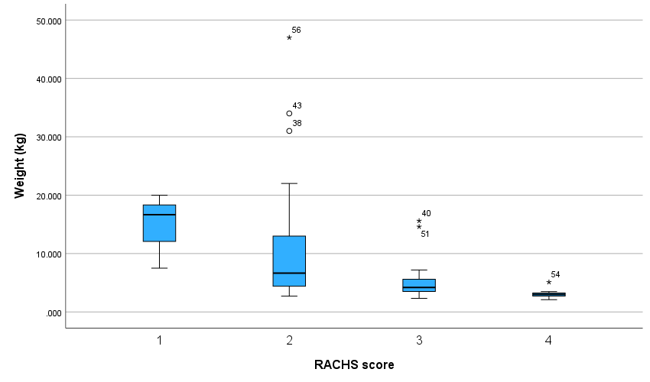
Figure 7: box plot of RACHS score with weight (kg)

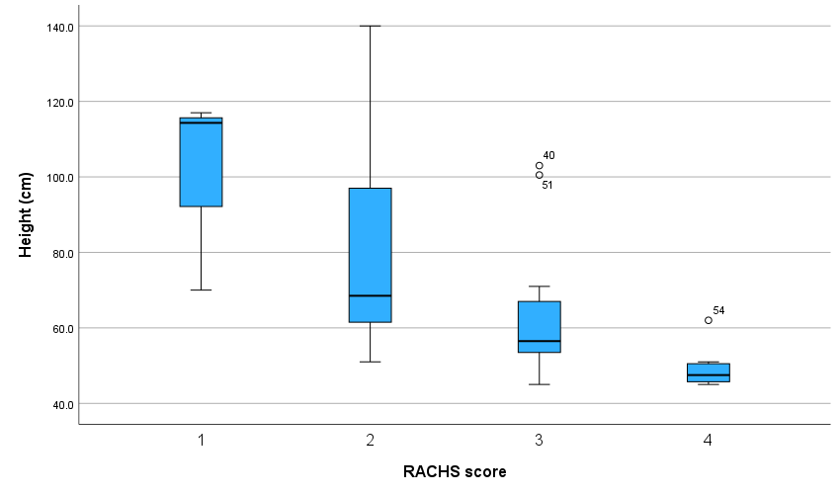
Figure 8: box plot of RACHS score with Height (cm)
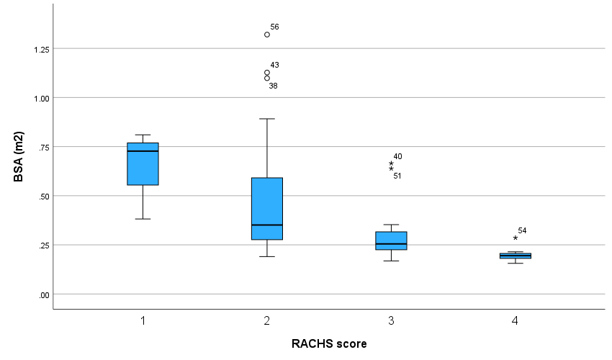
Figure 9: box plot of RACHS score with BSA (m2).

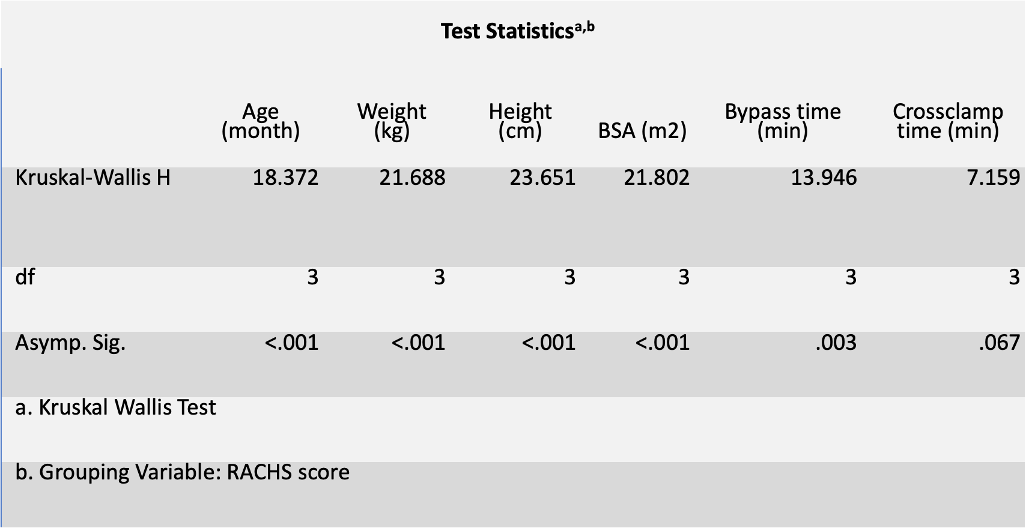
Table 9: Box plot p value for the RACHS score with other parameter.

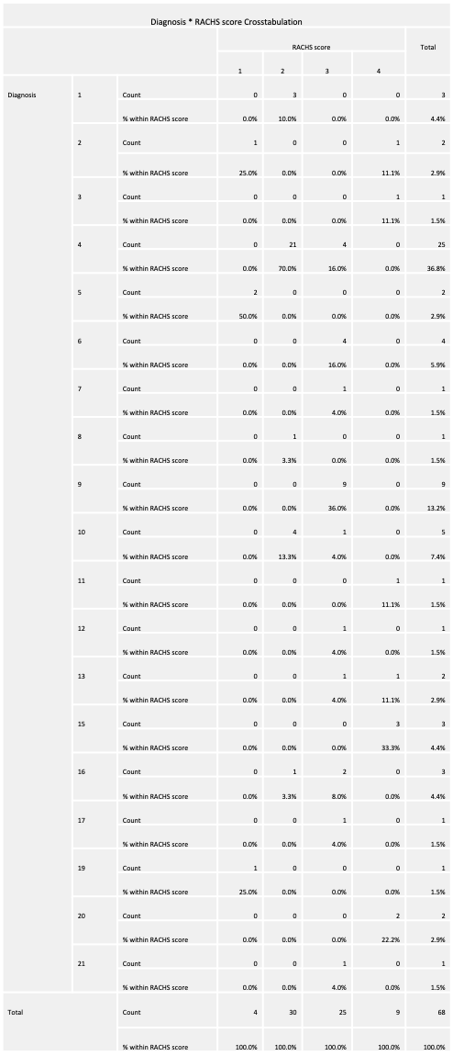
Table 10 association between RACHS and Diagnosis.

Diagnosis | Frequency | Percent | Cumulative Percent
4.VSD | 25 | 36.8 | 36.8
9.Complete AVSD | 9 | 13.2 | 50.0
10.TOF | 5 | 7.4 | 57.4
6.D-TGA with intact IVS | 4 | 5.9 | 63.2
1.Subaortic Membrane | 3 | 4.4 | 67.6
15.Interrupted AA | 3 | 4.4 | 72.1
16.Hypoplastic AA | 3 | 4.4 | 76.5
2.Coarctation of Aorta | 2 | 2.9 | 79.4
5.ASD | 2 | 2.9 | 82.4
13.DILV with L-TGA and hypoplastic AA | 2 | 2.9 | 85.3
20.Truncus Arteriosus | 2 | 2.9 | 88.2
3.D-TGA with single ventricle physiology | 1 | 1.5 | 89.7
7.PA aneurysm | 1 | 1.5 | 91.2
8.Partial AVSD | 1 | 1.5 | 92.6
11.D-TGA with DORV, VSD and COA | 1 | 1.5 | 94.1
12.Tricuspid Atresia with hypoplastic RV | 1 | 1.5 | 95.6
17.TA with D-TGA | 1 | 1.5 | 97.1
19.PAPVR | 1 | 1.5 | 98.5
21.D-TGA with VSD | 1 | 1.5 | 100.0
Total | 68 | 100.0
Table 11 List of diagnosis and present

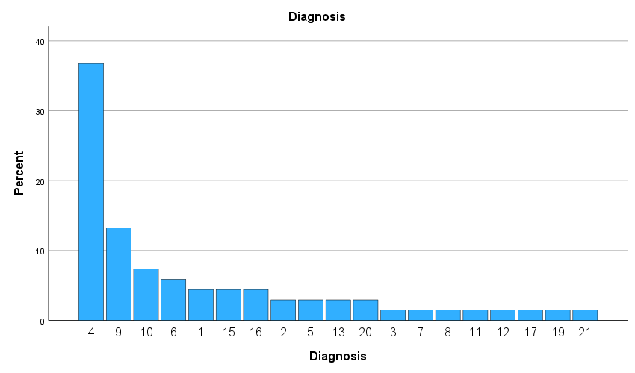
Figure 10 : List of diagnosis
. 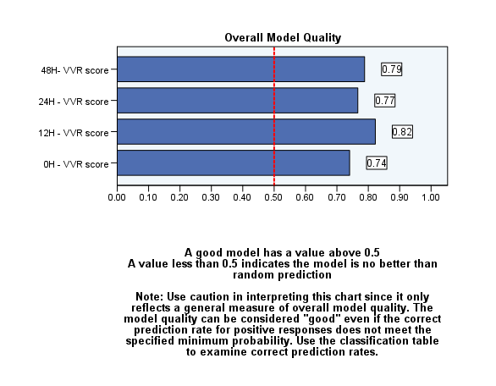
Figure 11: Model quality of VVR score with hospital LOS > 7 days.

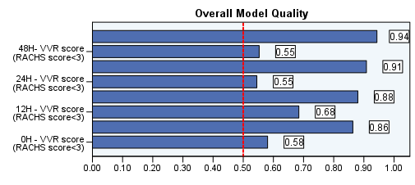
Figure 12: Model quality of VVR score and RACH score < 3 with hospital LOS > 7 days.

Table 13 ROC curve for Hospital LOS > 7 days with VVR score
Coordinates of the ROC Curve
Test Result Variable(s) | Positive if Greater Than or Equal Toª | Sensitivity | 1 - Specificity
0H - VVR score | -1.000 | 1.000 | 1.000
0H - VVR score | .400 | 1.000 | .941
0H - VVR score | .900 | 1.000 | .824
0H - VVR score | 1.300 | 1.000 | .765
0H - VVR score | 1.950 | 1.000 | .706
0H - VVR score | 3.400 | .980 | .706
0H - VVR score | 4.700 | .980 | .647
0H - VVR score | 8.700 | .980 | .588
0H - VVR score | 12.750 | .980 | .529
0H - VVR score | 13.200 | .980 | .471
0H - VVR score | 13.600 | .961 | .471
0H - VVR score | 13.850 | .941 | .471
0H - VVR score | 14.450 | .922 | .471
0H - VVR score | 15.750 | .922 | .412
0H - VVR score | 16.750 | .922 | .353
0H - VVR score | 17.300 | .922 | .294
0H - VVR score | 18.050 | .902 | .294
0H - VVR score | 18.950 | .882 | .294
0H - VVR score | 19.650 | .882 | .235
0H - VVR score | 20.200 | .863 | .235
0H - VVR score | 20.550 | .843 | .235
0H - VVR score | 20.900 | .824 | .176
0H - VVR score | 21.950 | .804 | .176
0H - VVR score | 22.900 | .784 | .176
0H - VVR score | 23.250 | .765 | .176
0H - VVR score | 23.450 | .745 | .176
0H - VVR score | 23.950 | .725 | .176
0H - VVR score | 24.500 | .706 | .176
0H - VVR score | 24.950 | .686 | .176
0H - VVR score | 25.400 | .667 | .176
0H - VVR score | 26.150 | .647 | .118
0H - VVR score | 26.850 | .627 | .118
0H - VVR score | 26.950 | .588 | .118
0H - VVR score | 27.650 | .569 | .118
0H - VVR score | 28.950 | .549 | .118
0H - VVR score | 29.800 | .529 | .118
0H - VVR score | 30.100 | .529 | .059
0H - VVR score | 30.800 | .510 | .059
0H - VVR score | 31.850 | .510 | .000
0H - VVR score | 32.800 | .490 | .000
0H - VVR score | 34.050 | .471 | .000
0H - VVR score | 35.450 | .451 | .000
0H - VVR score | 36.600 | .431 | .000
0H - VVR score | 37.350 | .412 | .000
0H - VVR score | 37.700 | .392 | .000
0H - VVR score | 38.200 | .373 | .000
0H - VVR score | 38.800 | .353 | .000
0H - VVR score | 39.100 | .333 | .000
0H - VVR score | 39.650 | .314 | .000
0H - VVR score | 40.200 | .294 | .000
0H - VVR score | 41.600 | .275 | .000
0H - VVR score | 43.450 | .255 | .000
0H - VVR score | 44.150 | .235 | .000
0H - VVR score | 45.450 | .216 | .000
0H - VVR score | 46.950 | .196 | .000
0H - VVR score | 48.750 | .176 | .000
0H - VVR score | 50.850 | .157 | .000
0H - VVR score | 54.900 | .137 | .000
0H - VVR score | 58.950 | .118 | .000
0H - VVR score | 59.950 | .098 | .000
0H - VVR score | 60.350 | .078 | .000
0H - VVR score | 64.150 | .059 | .000
0H - VVR score | 71.200 | .039 | .000
0H - VVR score | 78.850 | .020 | .000
0H - VVR score | 84.200 | .000 | .000
12H - VVR score | -1.000 | 1.000 | 1.000
12H - VVR score | 1.400 | 1.000 | .706
12H - VVR score | 2.900 | 1.000 | .647
12H - VVR score | 4.000 | .980 | .647
12H - VVR score | 5.200 | .961 | .647
12H - VVR score | 5.700 | .961 | .588
12H - VVR score | 6.500 | .941 | .471
12H - VVR score | 7.150 | .922 | .294
12H - VVR score | 7.650 | .922 | .235
12H - VVR score | 8.400 | .922 | .176
12H - VVR score | 9.400 | .902 | .176
12H - VVR score | 11.200 | .882 | .118
12H - VVR score | 12.700 | .882 | .059
12H - VVR score | 13.550 | .863 | .059
12H - VVR score | 14.150 | .843 | .059
12H - VVR score | 14.250 | .843 | .000
12H - VVR score | 14.900 | .824 | .000
12H - VVR score | 15.650 | .804 | .000
12H - VVR score | 15.850 | .784 | .000
12H - VVR score | 15.950 | .765 | .000
12H - VVR score | 16.100 | .745 | .000
12H - VVR score | 16.300 | .725 | .000
12H - VVR score | 17.250 | .686 | .000
12H - VVR score | 18.150 | .667 | .000
12H - VVR score | 18.400 | .647 | .000
12H - VVR score | 18.650 | .627 | .000
12H - VVR score | 19.400 | .608 | .000
12H - VVR score | 20.300 | .588 | .000
12H - VVR score | 20.700 | .569 | .000
12H - VVR score | 21.250 | .549 | .000
12H - VVR score | 21.650 | .529 | .000
12H - VVR score | 22.050 | .510 | .000
12H - VVR score | 22.450 | .490 | .000
12H - VVR score | 23.250 | .471 | .000
12H - VVR score | 24.100 | .451 | .000
12H - VVR score | 24.600 | .431 | .000
12H - VVR score | 25.850 | .412 | .000
12H - VVR score | 26.750 | .392 | .000
12H - VVR score | 26.850 | .353 | .000
12H - VVR score | 27.100 | .333 | .000
12H - VVR score | 28.100 | .314 | .000
12H - VVR score | 29.700 | .294 | .000
12H - VVR score | 30.750 | .275 | .000
12H - VVR score | 31.250 | .255 | .000
12H - VVR score | 31.800 | .235 | .000
12H - VVR score | 32.750 | .216 | .000
12H - VVR score | 33.450 | .157 | .000
12H - VVR score | 35.200 | .137 | .000
12H - VVR score | 36.950 | .118 | .000
12H - VVR score | 37.650 | .098 | .000
12H - VVR score | 44.850 | .078 | .000
12H - VVR score | 51.800 | .059 | .000
12H - VVR score | 54.850 | .039 | .000
12H - VVR score | 62.900 | .020 | .000
12H - VVR score | 69.300 | .000 | .000
24H - VVR score | -1.000 | 1.000 | 1.000
24H - VVR score | .050 | .902 | .647
24H - VVR score | 1.550 | .902 | .529
24H - VVR score | 3.300 | .902 | .353
24H - VVR score | 3.800 | .902 | .294
24H - VVR score | 4.050 | .902 | .235
24H - VVR score | 4.550 | .882 | .235
24H - VVR score | 5.250 | .824 | .176
24H - VVR score | 5.750 | .804 | .118
24H - VVR score | 6.500 | .765 | .059
24H - VVR score | 7.500 | .706 | .000
24H - VVR score | 8.500 | .686 | .000
24H - VVR score | 9.050 | .667 | .000
24H - VVR score | 9.600 | .647 | .000
24H - VVR score | 10.200 | .627 | .000
24H - VVR score | 11.150 | .608 | .000
24H - VVR score | 12.250 | .588 | .000
24H - VVR score | 13.500 | .569 | .000
24H - VVR score | 15.050 | .549 | .000
24H - VVR score | 15.750 | .529 | .000
24H - VVR score | 16.000 | .510 | .000
24H - VVR score | 16.200 | .490 | .000
24H - VVR score | 16.350 | .471 | .000
24H - VVR score | 16.550 | .451 | .000
24H - VVR score | 17.100 | .431 | .000
24H - VVR score | 17.850 | .412 | .000
24H - VVR score | 19.100 | .392 | .000
24H - VVR score | 20.550 | .373 | .000
24H - VVR score | 21.300 | .353 | .000
24H - VVR score | 21.600 | .333 | .000
24H - VVR score | 21.950 | .314 | .000
24H - VVR score | 22.850 | .294 | .000
24H - VVR score | 24.150 | .275 | .000
24H - VVR score | 26.000 | .255 | .000
24H - VVR score | 27.550 | .216 | .000
24H - VVR score | 27.950 | .196 | .000
24H - VVR score | 28.100 | .176 | .000
24H - VVR score | 28.250 | .157 | .000
24H - VVR score | 28.600 | .137 | .000
24H - VVR score | 29.900 | .118 | .000
24H - VVR score | 32.150 | .098 | .000
24H - VVR score | 33.500 | .078 | .000
24H - VVR score | 35.300 | .059 | .000
24H - VVR score | 45.500 | .039 | .000
24H - VVR score | 57.600 | .020 | .000
24H - VVR score | 62.200 | .000 | .000
48H- VVR score | -1.000 | 1.000 | 1.000
48H- VVR score | .050 | .863 | .118
48H- VVR score | .250 | .843 | .118
48H- VVR score | 1.200 | .843 | .059
48H- VVR score | 2.250 | .824 | .059
48H- VVR score | 2.550 | .804 | .059
48H- VVR score | 2.800 | .784 | .059
48H- VVR score | 3.050 | .667 | .059
48H- VVR score | 3.450 | .647 | .059
48H- VVR score | 4.000 | .627 | .059
48H- VVR score | 4.600 | .627 | .000
48H- VVR score | 5.400 | .588 | .000
48H- VVR score | 6.050 | .569 | .000
48H- VVR score | 6.650 | .549 | .000
48H- VVR score | 7.500 | .471 | .000
48H- VVR score | 8.100 | .431 | .000
48H- VVR score | 8.600 | .412 | .000
48H- VVR score | 10.100 | .392 | .000
48H- VVR score | 11.650 | .373 | .000
48H- VVR score | 12.450 | .353 | .000
48H- VVR score | 13.050 | .333 | .000
48H- VVR score | 15.000 | .314 | .000
48H- VVR score | 16.800 | .294 | .000
48H- VVR score | 17.050 | .275 | .000
48H- VVR score | 17.650 | .255 | .000
48H- VVR score | 18.650 | .235 | .000
48H- VVR score | 19.400 | .196 | .000
48H- VVR score | 20.000 | .176 | .000
48H- VVR score | 23.700 | .157 | .000
48H- VVR score | 27.300 | .137 | .000
48H- VVR score | 27.750 | .118 | .000
48H- VVR score | 29.800 | .098 | .000
48H- VVR score | 31.750 | .078 | .000
48H- VVR score | 31.950 | .059 | .000
48H- VVR score | 33.000 | .039 | .000
48H- VVR score | 35.700 | .020 | .000
48H- VVR score | 38.500 | .000 | .000
The test result variable(s): 0H - VVR score, 12H - VVR score , 24H - VVR score, 48H- VVR score has at least one tie between the positive actual state group and the negative actual state group.
a. The smallest cutoff value is the minimum observed test value minus 1, and the largest cutoff value is the maximum observed test value plus 1. All the other cutoff values are the averages of two consecutive ordered observed test values.

Table 14 ROC curve for Hospital LOS > 7 days with VVR score and RACHS ROC curve
Coordinates of the ROC Curve
Test Result Variable(s) | RACHS score | Positive if Greater Than or Equal Toª | Sensitivity | 1 - Specificity
0H - VVR score | < 3.00 | -1.000 | 1.000 | 1.000
0H - VVR score | < 3.00 | .400 | 1.000 | .929
0H - VVR score | < 3.00 | .900 | 1.000 | .786
0H - VVR score | < 3.00 | 1.300 | 1.000 | .714
0H - VVR score | < 3.00 | 1.950 | 1.000 | .643
0H - VVR score | < 3.00 | 3.400 | .950 | .643
0H - VVR score | < 3.00 | 4.700 | .950 | .571
0H - VVR score | < 3.00 | 8.950 | .950 | .500
0H - VVR score | < 3.00 | 13.200 | .950 | .429
0H - VVR score | < 3.00 | 13.600 | .900 | .429
0H - VVR score | < 3.00 | 14.400 | .850 | .429
0H - VVR score | < 3.00 | 16.000 | .850 | .357
0H - VVR score | < 3.00 | 17.300 | .850 | .286
0H - VVR score | < 3.00 | 18.050 | .800 | .286
0H - VVR score | < 3.00 | 18.950 | .750 | .286
0H - VVR score | < 3.00 | 19.650 | .750 | .214
0H - VVR score | < 3.00 | 20.250 | .700 | .214
0H - VVR score | < 3.00 | 20.900 | .650 | .214
0H - VVR score | < 3.00 | 21.950 | .600 | .214
0H - VVR score | < 3.00 | 23.100 | .550 | .214
0H - VVR score | < 3.00 | 23.950 | .500 | .214
0H - VVR score | < 3.00 | 24.950 | .450 | .214
0H - VVR score | < 3.00 | 26.200 | .450 | .143
0H - VVR score | < 3.00 | 26.950 | .400 | .143
0H - VVR score | < 3.00 | 28.500 | .350 | .143
0H - VVR score | < 3.00 | 30.700 | .350 | .071
0H - VVR score | < 3.00 | 31.850 | .350 | .000
0H - VVR score | < 3.00 | 33.550 | .300 | .000
0H - VVR score | < 3.00 | 35.950 | .250 | .000
0H - VVR score | < 3.00 | 37.450 | .200 | .000
0H - VVR score | < 3.00 | 38.200 | .150 | .000
0H - VVR score | < 3.00 | 40.750 | .100 | .000
0H - VVR score | < 3.00 | 46.550 | .050 | .000
0H - VVR score | < 3.00 | 51.200 | .000 | .000
0H - VVR score | >= 3.00 | 11.500 | 1.000 | 1.000
0H - VVR score | >= 3.00 | 13.200 | 1.000 | .667
0H - VVR score | >= 3.00 | 15.200 | .968 | .667
0H - VVR score | >= 3.00 | 18.500 | .968 | .333
0H - VVR score | >= 3.00 | 20.550 | .935 | .333
0H - VVR score | >= 3.00 | 21.850 | .935 | .000
0H - VVR score | >= 3.00 | 23.250 | .903 | .000
0H - VVR score | >= 3.00 | 24.000 | .871 | .000
0H - VVR score | >= 3.00 | 24.950 | .839 | .000
0H - VVR score | >= 3.00 | 25.400 | .806 | .000
0H - VVR score | >= 3.00 | 26.150 | .774 | .000
0H - VVR score | >= 3.00 | 26.850 | .742 | .000
0H - VVR score | >= 3.00 | 27.600 | .710 | .000
0H - VVR score | >= 3.00 | 28.950 | .677 | .000
0H - VVR score | >= 3.00 | 29.900 | .645 | .000
0H - VVR score | >= 3.00 | 31.750 | .613 | .000
0H - VVR score | >= 3.00 | 34.700 | .581 | .000
0H - VVR score | >= 3.00 | 36.850 | .548 | .000
0H - VVR score | >= 3.00 | 38.300 | .516 | .000
0H - VVR score | >= 3.00 | 39.100 | .484 | .000
0H - VVR score | >= 3.00 | 39.650 | .452 | .000
0H - VVR score | >= 3.00 | 40.200 | .419 | .000
0H - VVR score | >= 3.00 | 42.150 | .387 | .000
0H - VVR score | >= 3.00 | 44.150 | .355 | .000
0H - VVR score | >= 3.00 | 45.450 | .323 | .000
0H - VVR score | >= 3.00 | 46.950 | .290 | .000
0H - VVR score | >= 3.00 | 49.400 | .258 | .000
0H - VVR score | >= 3.00 | 54.900 | .226 | .000
0H - VVR score | >= 3.00 | 58.950 | .194 | .000
0H - VVR score | >= 3.00 | 59.950 | .161 | .000
0H - VVR score | >= 3.00 | 60.350 | .129 | .000
0H - VVR score | >= 3.00 | 64.150 | .097 | .000
0H - VVR score | >= 3.00 | 71.200 | .065 | .000
0H - VVR score | >= 3.00 | 78.850 | .032 | .000
0H - VVR score | >= 3.00 | 84.200 | .000 | .000
12H - VVR score | < 3.00 | -1.000 | 1.000 | 1.000
12H - VVR score | < 3.00 | 1.400 | 1.000 | .643
12H - VVR score | < 3.00 | 2.900 | 1.000 | .571
12H - VVR score | < 3.00 | 4.000 | .950 | .571
12H - VVR score | < 3.00 | 5.200 | .900 | .571
12H - VVR score | < 3.00 | 5.700 | .900 | .500
12H - VVR score | < 3.00 | 6.500 | .850 | .429
12H - VVR score | < 3.00 | 7.150 | .800 | .286
12H - VVR score | < 3.00 | 7.650 | .800 | .214
12H - VVR score | < 3.00 | 9.000 | .800 | .143
12H - VVR score | < 3.00 | 11.500 | .750 | .071
12H - VVR score | < 3.00 | 13.600 | .700 | .071
12H - VVR score | < 3.00 | 14.850 | .700 | .000
12H - VVR score | < 3.00 | 15.650 | .650 | .000
12H - VVR score | < 3.00 | 15.850 | .600 | .000
12H - VVR score | < 3.00 | 15.950 | .550 | .000
12H - VVR score | < 3.00 | 16.200 | .500 | .000
12H - VVR score | < 3.00 | 18.650 | .400 | .000
12H - VVR score | < 3.00 | 21.250 | .350 | .000
12H - VVR score | < 3.00 | 24.200 | .300 | .000
12H - VVR score | < 3.00 | 26.850 | .200 | .000
12H - VVR score | < 3.00 | 28.950 | .150 | .000
12H - VVR score | < 3.00 | 32.200 | .100 | .000
12H - VVR score | < 3.00 | 34.400 | .000 | .000
12H - VVR score | >= 3.00 | 5.000 | 1.000 | 1.000
12H - VVR score | >= 3.00 | 6.500 | 1.000 | .667
12H - VVR score | >= 3.00 | 7.900 | 1.000 | .333
12H - VVR score | >= 3.00 | 10.600 | .968 | .333
12H - VVR score | >= 3.00 | 13.250 | .968 | .000
12H - VVR score | >= 3.00 | 14.200 | .935 | .000
12H - VVR score | >= 3.00 | 15.250 | .903 | .000
12H - VVR score | >= 3.00 | 17.150 | .871 | .000
12H - VVR score | >= 3.00 | 18.150 | .839 | .000
12H - VVR score | >= 3.00 | 18.400 | .806 | .000
12H - VVR score | >= 3.00 | 18.650 | .774 | .000
12H - VVR score | >= 3.00 | 19.400 | .742 | .000
12H - VVR score | >= 3.00 | 20.300 | .710 | .000
12H - VVR score | >= 3.00 | 21.100 | .677 | .000
12H - VVR score | >= 3.00 | 22.050 | .645 | .000
12H - VVR score | >= 3.00 | 22.450 | .613 | .000
12H - VVR score | >= 3.00 | 23.250 | .581 | .000
12H - VVR score | >= 3.00 | 24.100 | .548 | .000
12H - VVR score | >= 3.00 | 24.600 | .516 | .000
12H - VVR score | >= 3.00 | 25.850 | .484 | .000
12H - VVR score | >= 3.00 | 27.000 | .452 | .000
12H - VVR score | >= 3.00 | 28.100 | .419 | .000
12H - VVR score | >= 3.00 | 29.700 | .387 | .000
12H - VVR score | >= 3.00 | 31.000 | .355 | .000
12H - VVR score | >= 3.00 | 31.800 | .323 | .000
12H - VVR score | >= 3.00 | 32.750 | .290 | .000
12H - VVR score | >= 3.00 | 33.450 | .258 | .000
12H - VVR score | >= 3.00 | 35.200 | .226 | .000
12H - VVR score | >= 3.00 | 36.950 | .194 | .000
12H - VVR score | >= 3.00 | 37.650 | .161 | .000
12H - VVR score | >= 3.00 | 44.850 | .129 | .000
12H - VVR score | >= 3.00 | 51.800 | .097 | .000
12H - VVR score | >= 3.00 | 54.850 | .065 | .000
12H - VVR score | >= 3.00 | 62.900 | .032 | .000
12H - VVR score | >= 3.00 | 69.300 | .000 | .000
24H - VVR score | < 3.00 | -1.000 | 1.000 | 1.000
24H - VVR score | < 3.00 | .050 | .750 | .571
24H - VVR score | < 3.00 | 1.550 | .750 | .429
24H - VVR score | < 3.00 | 4.000 | .750 | .286
24H - VVR score | < 3.00 | 5.250 | .650 | .214
24H - VVR score | < 3.00 | 5.750 | .600 | .143
24H - VVR score | < 3.00 | 6.500 | .550 | .071
24H - VVR score | < 3.00 | 7.500 | .500 | .000
24H - VVR score | < 3.00 | 8.500 | .450 | .000
24H - VVR score | < 3.00 | 10.750 | .400 | .000
24H - VVR score | < 3.00 | 13.500 | .350 | .000
24H - VVR score | < 3.00 | 15.200 | .300 | .000
24H - VVR score | < 3.00 | 16.100 | .250 | .000
24H - VVR score | < 3.00 | 16.500 | .200 | .000
24H - VVR score | < 3.00 | 18.350 | .150 | .000
24H - VVR score | < 3.00 | 23.600 | .100 | .000
24H - VVR score | < 3.00 | 27.700 | .050 | .000
24H - VVR score | < 3.00 | 29.200 | .000 | .000
24H - VVR score | >= 3.00 | 2.000 | 1.000 | 1.000
24H - VVR score | >= 3.00 | 3.300 | 1.000 | .667
24H - VVR score | >= 3.00 | 3.800 | 1.000 | .333
24H - VVR score | >= 3.00 | 4.050 | 1.000 | .000
24H - VVR score | >= 3.00 | 4.550 | .968 | .000
24H - VVR score | >= 3.00 | 5.500 | .935 | .000
24H - VVR score | >= 3.00 | 6.500 | .903 | .000
24H - VVR score | >= 3.00 | 8.050 | .839 | .000
24H - VVR score | >= 3.00 | 9.600 | .806 | .000
24H - VVR score | >= 3.00 | 10.200 | .774 | .000
24H - VVR score | >= 3.00 | 11.150 | .742 | .000
24H - VVR score | >= 3.00 | 13.800 | .710 | .000
24H - VVR score | >= 3.00 | 15.850 | .677 | .000
24H - VVR score | >= 3.00 | 16.250 | .645 | .000
24H - VVR score | >= 3.00 | 16.950 | .613 | .000
24H - VVR score | >= 3.00 | 17.850 | .581 | .000
24H - VVR score | >= 3.00 | 19.650 | .548 | .000
24H - VVR score | >= 3.00 | 21.300 | .516 | .000
24H - VVR score | >= 3.00 | 21.600 | .484 | .000
24H - VVR score | >= 3.00 | 21.950 | .452 | .000
24H - VVR score | >= 3.00 | 22.850 | .419 | .000
24H - VVR score | >= 3.00 | 24.150 | .387 | .000
24H - VVR score | >= 3.00 | 26.000 | .355 | .000
24H - VVR score | >= 3.00 | 27.550 | .323 | .000
24H - VVR score | >= 3.00 | 27.950 | .290 | .000
24H - VVR score | >= 3.00 | 28.150 | .258 | .000
24H - VVR score | >= 3.00 | 28.600 | .226 | .000
24H - VVR score | >= 3.00 | 29.900 | .194 | .000
24H - VVR score | >= 3.00 | 32.150 | .161 | .000
24H - VVR score | >= 3.00 | 33.500 | .129 | .000
24H - VVR score | >= 3.00 | 35.300 | .097 | .000
24H - VVR score | >= 3.00 | 45.500 | .065 | .000
24H - VVR score | >= 3.00 | 57.600 | .032 | .000
24H - VVR score | >= 3.00 | 62.200 | .000 | .000
48H- VVR score | < 3.00 | -1.000 | 1.000 | 1.000
48H- VVR score | < 3.00 | .200 | .650 | .143
48H- VVR score | < 3.00 | 1.200 | .650 | .071
48H- VVR score | < 3.00 | 2.250 | .600 | .071
48H- VVR score | < 3.00 | 2.550 | .550 | .071
48H- VVR score | < 3.00 | 2.800 | .500 | .071
48H- VVR score | < 3.00 | 3.600 | .300 | .071
48H- VVR score | < 3.00 | 5.250 | .300 | .000
48H- VVR score | < 3.00 | 6.650 | .250 | .000
48H- VVR score | < 3.00 | 7.500 | .150 | .000
48H- VVR score | < 3.00 | 9.600 | .100 | .000
48H- VVR score | < 3.00 | 19.400 | .050 | .000
48H- VVR score | < 3.00 | 28.600 | .000 | .000
48H- VVR score | >= 3.00 | -1.000 | 1.000 | 1.000
48H- VVR score | >= 3.00 | .050 | 1.000 | .000
48H- VVR score | >= 3.00 | 1.550 | .968 | .000
48H- VVR score | >= 3.00 | 3.050 | .903 | .000
48H- VVR score | >= 3.00 | 3.450 | .871 | .000
48H- VVR score | >= 3.00 | 4.400 | .839 | .000
48H- VVR score | >= 3.00 | 5.400 | .774 | .000
48H- VVR score | >= 3.00 | 6.400 | .742 | .000
48H- VVR score | >= 3.00 | 7.500 | .677 | .000
48H- VVR score | >= 3.00 | 8.100 | .645 | .000
48H- VVR score | >= 3.00 | 8.600 | .613 | .000
48H- VVR score | >= 3.00 | 10.550 | .581 | .000
48H- VVR score | >= 3.00 | 12.450 | .548 | .000
48H- VVR score | >= 3.00 | 13.050 | .516 | .000
48H- VVR score | >= 3.00 | 15.000 | .484 | .000
48H- VVR score | >= 3.00 | 16.800 | .452 | .000
48H- VVR score | >= 3.00 | 17.050 | .419 | .000
48H- VVR score | >= 3.00 | 17.650 | .387 | .000
48H- VVR score | >= 3.00 | 18.650 | .355 | .000
48H- VVR score | >= 3.00 | 19.400 | .290 | .000
48H- VVR score | >= 3.00 | 20.000 | .258 | .000
48H- VVR score | >= 3.00 | 23.700 | .226 | .000
48H- VVR score | >= 3.00 | 27.450 | .194 | .000
48H- VVR score | >= 3.00 | 29.800 | .161 | .000
48H- VVR score | >= 3.00 | 31.750 | .129 | .000
48H- VVR score | >= 3.00 | 31.950 | .097 | .000
48H- VVR score | >= 3.00 | 33.000 | .065 | .000
48H- VVR score | >= 3.00 | 35.700 | .032 | .000
48H- VVR score | >= 3.00 | 38.500 | .000 | .000
The test result variable(s): 12H - VVR score , 24H - VVR score, 48H- VVR score has at least one tie between the positive actual state group and the negative actual state group.
a. The smallest cutoff value is the minimum observed test value minus 1, and the largest cutoff value is the maximum observed test value plus 1. All the other cutoff values are the averages of two consecutive ordered observed test values.

Table 15 ROC curve for ICU LOS > 5 days with VVR score
Coordinates of the ROC Curve
Test Result Variable(s) | Positive if Greater Than or Equal Toª | Sensitivity | 1 - Specificity
0H - VVR score | -1.000 | 1.000 | 1.000
0H - VVR score | .400 | 1.000 | .969
0H - VVR score | .900 | 1.000 | .906
0H - VVR score | 1.300 | 1.000 | .875
0H - VVR score | 1.950 | 1.000 | .844
0H - VVR score | 3.400 | 1.000 | .813
0H - VVR score | 4.700 | 1.000 | .781
0H - VVR score | 8.700 | 1.000 | .750
0H - VVR score | 12.750 | 1.000 | .719
0H - VVR score | 13.200 | 1.000 | .688
0H - VVR score | 13.600 | 1.000 | .656
0H - VVR score | 13.850 | .972 | .656
0H - VVR score | 14.450 | .944 | .656
0H - VVR score | 15.750 | .944 | .625
0H - VVR score | 16.750 | .944 | .594
0H - VVR score | 17.300 | .944 | .563
0H - VVR score | 18.050 | .944 | .531
0H - VVR score | 18.950 | .944 | .500
0H - VVR score | 19.650 | .944 | .469
0H - VVR score | 20.200 | .917 | .469
0H - VVR score | 20.550 | .917 | .438
0H - VVR score | 20.900 | .917 | .375
0H - VVR score | 21.950 | .889 | .375
0H - VVR score | 22.900 | .889 | .344
0H - VVR score | 23.250 | .889 | .313
0H - VVR score | 23.450 | .861 | .313
0H - VVR score | 23.950 | .861 | .281
0H - VVR score | 24.500 | .833 | .281
0H - VVR score | 24.950 | .806 | .281
0H - VVR score | 25.400 | .806 | .250
0H - VVR score | 26.150 | .778 | .219
0H - VVR score | 26.850 | .750 | .219
0H - VVR score | 26.950 | .722 | .188
0H - VVR score | 27.650 | .694 | .188
0H - VVR score | 28.950 | .694 | .156
0H - VVR score | 29.800 | .667 | .156
0H - VVR score | 30.100 | .667 | .125
0H - VVR score | 30.800 | .639 | .125
0H - VVR score | 31.850 | .639 | .094
0H - VVR score | 32.800 | .639 | .063
0H - VVR score | 34.050 | .611 | .063
0H - VVR score | 35.450 | .611 | .031
0H - VVR score | 36.600 | .583 | .031
0H - VVR score | 37.350 | .556 | .031
0H - VVR score | 37.700 | .528 | .031
0H - VVR score | 38.200 | .500 | .031
0H - VVR score | 38.800 | .472 | .031
0H - VVR score | 39.100 | .444 | .031
0H - VVR score | 39.650 | .417 | .031
0H - VVR score | 40.200 | .389 | .031
0H - VVR score | 41.600 | .361 | .031
0H - VVR score | 43.450 | .333 | .031
0H - VVR score | 44.150 | .306 | .031
0H - VVR score | 45.450 | .278 | .031
0H - VVR score | 46.950 | .250 | .031
0H - VVR score | 48.750 | .250 | .000
0H - VVR score | 50.850 | .222 | .000
0H - VVR score | 54.900 | .194 | .000
0H - VVR score | 58.950 | .167 | .000
0H - VVR score | 59.950 | .139 | .000
0H - VVR score | 60.350 | .111 | .000
0H - VVR score | 64.150 | .083 | .000
0H - VVR score | 71.200 | .056 | .000
0H - VVR score | 78.850 | .028 | .000
0H - VVR score | 84.200 | .000 | .000
12H - VVR score | -1.000 | 1.000 | 1.000
12H - VVR score | 1.400 | 1.000 | .844
12H - VVR score | 2.900 | 1.000 | .813
12H - VVR score | 4.000 | 1.000 | .781
12H - VVR score | 5.200 | .972 | .781
12H - VVR score | 5.700 | .972 | .750
12H - VVR score | 6.500 | .972 | .656
12H - VVR score | 7.150 | .972 | .531
12H - VVR score | 7.650 | .972 | .500
12H - VVR score | 8.400 | .972 | .469
12H - VVR score | 9.400 | .944 | .469
12H - VVR score | 11.200 | .944 | .406
12H - VVR score | 12.700 | .944 | .375
12H - VVR score | 13.550 | .944 | .344
12H - VVR score | 14.150 | .944 | .313
12H - VVR score | 14.250 | .944 | .281
12H - VVR score | 14.900 | .944 | .250
12H - VVR score | 15.650 | .944 | .219
12H - VVR score | 15.850 | .944 | .188
12H - VVR score | 15.950 | .917 | .188
12H - VVR score | 16.100 | .889 | .188
12H - VVR score | 16.300 | .861 | .188
12H - VVR score | 17.250 | .806 | .188
12H - VVR score | 18.150 | .806 | .156
12H - VVR score | 18.400 | .778 | .156
12H - VVR score | 18.650 | .778 | .125
12H - VVR score | 19.400 | .750 | .125
12H - VVR score | 20.300 | .722 | .125
12H - VVR score | 20.700 | .694 | .125
12H - VVR score | 21.250 | .667 | .125
12H - VVR score | 21.650 | .639 | .125
12H - VVR score | 22.050 | .611 | .125
12H - VVR score | 22.450 | .583 | .125
12H - VVR score | 23.250 | .583 | .094
12H - VVR score | 24.100 | .556 | .094
12H - VVR score | 24.600 | .528 | .094
12H - VVR score | 25.850 | .500 | .094
12H - VVR score | 26.750 | .472 | .094
12H - VVR score | 26.850 | .444 | .063
12H - VVR score | 27.100 | .444 | .031
12H - VVR score | 28.100 | .417 | .031
12H - VVR score | 29.700 | .389 | .031
12H - VVR score | 30.750 | .361 | .031
12H - VVR score | 31.250 | .333 | .031
12H - VVR score | 31.800 | .306 | .031
12H - VVR score | 32.750 | .278 | .031
12H - VVR score | 33.450 | .222 | .000
12H - VVR score | 35.200 | .194 | .000
12H - VVR score | 36.950 | .167 | .000
12H - VVR score | 37.650 | .139 | .000
12H - VVR score | 44.850 | .111 | .000
12H - VVR score | 51.800 | .083 | .000
12H - VVR score | 54.850 | .056 | .000
12H - VVR score | 62.900 | .028 | .000
12H - VVR score | 69.300 | .000 | .000
24H - VVR score | -1.000 | 1.000 | 1.000
24H - VVR score | .050 | .972 | .688
24H - VVR score | 1.550 | .972 | .625
24H - VVR score | 3.300 | .972 | .531
24H - VVR score | 3.800 | .972 | .500
24H - VVR score | 4.050 | .972 | .469
24H - VVR score | 4.550 | .944 | .469
24H - VVR score | 5.250 | .944 | .344
24H - VVR score | 5.750 | .944 | .281
24H - VVR score | 6.500 | .889 | .250
24H - VVR score | 7.500 | .806 | .219
24H - VVR score | 8.500 | .778 | .219
24H - VVR score | 9.050 | .778 | .188
24H - VVR score | 9.600 | .750 | .188
24H - VVR score | 10.200 | .722 | .188
24H - VVR score | 11.150 | .722 | .156
24H - VVR score | 12.250 | .722 | .125
24H - VVR score | 13.500 | .694 | .125
24H - VVR score | 15.050 | .667 | .125
24H - VVR score | 15.750 | .667 | .094
24H - VVR score | 16.000 | .639 | .094
24H - VVR score | 16.200 | .639 | .063
24H - VVR score | 16.350 | .639 | .031
24H - VVR score | 16.550 | .611 | .031
24H - VVR score | 17.100 | .583 | .031
24H - VVR score | 17.850 | .556 | .031
24H - VVR score | 19.100 | .528 | .031
24H - VVR score | 20.550 | .500 | .031
24H - VVR score | 21.300 | .472 | .031
24H - VVR score | 21.600 | .444 | .031
24H - VVR score | 21.950 | .417 | .031
24H - VVR score | 22.850 | .389 | .031
24H - VVR score | 24.150 | .361 | .031
24H - VVR score | 26.000 | .333 | .031
24H - VVR score | 27.550 | .306 | .000
24H - VVR score | 27.950 | .278 | .000
24H - VVR score | 28.100 | .250 | .000
24H - VVR score | 28.250 | .222 | .000
24H - VVR score | 28.600 | .194 | .000
24H - VVR score | 29.900 | .167 | .000
24H - VVR score | 32.150 | .139 | .000
24H - VVR score | 33.500 | .111 | .000
24H - VVR score | 35.300 | .083 | .000
24H - VVR score | 45.500 | .056 | .000
24H - VVR score | 57.600 | .028 | .000
24H - VVR score | 62.200 | .000 | .000
48H- VVR score | -1.000 | 1.000 | 1.000
48H- VVR score | .050 | .944 | .375
48H- VVR score | .250 | .917 | .375
48H- VVR score | 1.200 | .917 | .344
48H- VVR score | 2.250 | .889 | .344
48H- VVR score | 2.550 | .889 | .313
48H- VVR score | 2.800 | .861 | .313
48H- VVR score | 3.050 | .806 | .188
48H- VVR score | 3.450 | .778 | .188
48H- VVR score | 4.000 | .750 | .188
48H- VVR score | 4.600 | .750 | .156
48H- VVR score | 5.400 | .722 | .125
48H- VVR score | 6.050 | .694 | .125
48H- VVR score | 6.650 | .667 | .125
48H- VVR score | 7.500 | .611 | .063
48H- VVR score | 8.100 | .556 | .063
48H- VVR score | 8.600 | .556 | .031
48H- VVR score | 10.100 | .528 | .031
48H- VVR score | 11.650 | .500 | .031
48H- VVR score | 12.450 | .500 | .000
48H- VVR score | 13.050 | .472 | .000
48H- VVR score | 15.000 | .444 | .000
48H- VVR score | 16.800 | .417 | .000
48H- VVR score | 17.050 | .389 | .000
48H- VVR score | 17.650 | .361 | .000
48H- VVR score | 18.650 | .333 | .000
48H- VVR score | 19.400 | .278 | .000
48H- VVR score | 20.000 | .250 | .000
48H- VVR score | 23.700 | .222 | .000
48H- VVR score | 27.300 | .194 | .000
48H- VVR score | 27.750 | .167 | .000
48H- VVR score | 29.800 | .139 | .000
48H- VVR score | 31.750 | .111 | .000
48H- VVR score | 31.950 | .083 | .000
48H- VVR score | 33.000 | .056 | .000
48H- VVR score | 35.700 | .028 | .000
48H- VVR score | 38.500 | .000 | .000
The test result variable(s): 0H - VVR score, 12H - VVR score , 24H - VVR score, 48H- VVR score has at least one tie between the positive actual state group and the negative actual state group.
a. The smallest cutoff value is the minimum observed test value minus 1, and the largest cutoff value is the maximum observed test value plus 1. All the other cutoff values are the averages of two consecutive ordered observed test values.

Table 16 ROC curve for ICU LOS > 5 days with VVR score and RACHS ROC curve
Coordinates of the ROC Curve
Test Result Variable(s) | RACHS score | Positive if Greater Than or Equal Toª | Sensitivity | 1 - Specificity
0H - VVR score | < 3.00 | -1.000 | 1.000 | 1.000
0H - VVR score | < 3.00 | .400 | 1.000 | .958
0H - VVR score | < 3.00 | .900 | 1.000 | .875
0H - VVR score | < 3.00 | 1.300 | 1.000 | .833
0H - VVR score | < 3.00 | 1.950 | 1.000 | .792
0H - VVR score | < 3.00 | 3.400 | 1.000 | .750
0H - VVR score | < 3.00 | 4.700 | 1.000 | .708
0H - VVR score | < 3.00 | 8.950 | 1.000 | .667
0H - VVR score | < 3.00 | 13.200 | 1.000 | .625
0H - VVR score | < 3.00 | 13.600 | 1.000 | .583
0H - VVR score | < 3.00 | 14.400 | .900 | .583
0H - VVR score | < 3.00 | 16.000 | .900 | .542
0H - VVR score | < 3.00 | 17.300 | .900 | .500
0H - VVR score | < 3.00 | 18.050 | .900 | .458
0H - VVR score | < 3.00 | 18.950 | .900 | .417
0H - VVR score | < 3.00 | 19.650 | .900 | .375
0H - VVR score | < 3.00 | 20.250 | .800 | .375
0H - VVR score | < 3.00 | 20.900 | .800 | .333
0H - VVR score | < 3.00 | 21.950 | .700 | .333
0H - VVR score | < 3.00 | 23.100 | .700 | .292
0H - VVR score | < 3.00 | 23.950 | .700 | .250
0H - VVR score | < 3.00 | 24.950 | .600 | .250
0H - VVR score | < 3.00 | 26.200 | .600 | .208
0H - VVR score | < 3.00 | 26.950 | .600 | .167
0H - VVR score | < 3.00 | 28.500 | .500 | .167
0H - VVR score | < 3.00 | 30.700 | .500 | .125
0H - VVR score | < 3.00 | 31.850 | .500 | .083
0H - VVR score | < 3.00 | 33.550 | .500 | .042
0H - VVR score | < 3.00 | 35.950 | .500 | .000
0H - VVR score | < 3.00 | 37.450 | .400 | .000
0H - VVR score | < 3.00 | 38.200 | .300 | .000
0H - VVR score | < 3.00 | 40.750 | .200 | .000
0H - VVR score | < 3.00 | 46.550 | .100 | .000
0H - VVR score | < 3.00 | 51.200 | .000 | .000
0H - VVR score | >= 3.00 | 11.500 | 1.000 | 1.000
0H - VVR score | >= 3.00 | 13.200 | 1.000 | .875
0H - VVR score | >= 3.00 | 15.200 | .962 | .875
0H - VVR score | >= 3.00 | 18.500 | .962 | .750
0H - VVR score | >= 3.00 | 20.550 | .962 | .625
0H - VVR score | >= 3.00 | 21.850 | .962 | .500
0H - VVR score | >= 3.00 | 23.250 | .962 | .375
0H - VVR score | >= 3.00 | 24.000 | .923 | .375
0H - VVR score | >= 3.00 | 24.950 | .885 | .375
0H - VVR score | >= 3.00 | 25.400 | .885 | .250
0H - VVR score | >= 3.00 | 26.150 | .846 | .250
0H - VVR score | >= 3.00 | 26.850 | .808 | .250
0H - VVR score | >= 3.00 | 27.600 | .769 | .250
0H - VVR score | >= 3.00 | 28.950 | .769 | .125
0H - VVR score | >= 3.00 | 29.900 | .731 | .125
0H - VVR score | >= 3.00 | 31.750 | .692 | .125
0H - VVR score | >= 3.00 | 34.700 | .654 | .125
0H - VVR score | >= 3.00 | 36.850 | .615 | .125
0H - VVR score | >= 3.00 | 38.300 | .577 | .125
0H - VVR score | >= 3.00 | 39.100 | .538 | .125
0H - VVR score | >= 3.00 | 39.650 | .500 | .125
0H - VVR score | >= 3.00 | 40.200 | .462 | .125
0H - VVR score | >= 3.00 | 42.150 | .423 | .125
0H - VVR score | >= 3.00 | 44.150 | .385 | .125
0H - VVR score | >= 3.00 | 45.450 | .346 | .125
0H - VVR score | >= 3.00 | 46.950 | .308 | .125
0H - VVR score | >= 3.00 | 49.400 | .308 | .000
0H - VVR score | >= 3.00 | 54.900 | .269 | .000
0H - VVR score | >= 3.00 | 58.950 | .231 | .000
0H - VVR score | >= 3.00 | 59.950 | .192 | .000
0H - VVR score | >= 3.00 | 60.350 | .154 | .000
0H - VVR score | >= 3.00 | 64.150 | .115 | .000
0H - VVR score | >= 3.00 | 71.200 | .077 | .000
0H - VVR score | >= 3.00 | 78.850 | .038 | .000
0H - VVR score | >= 3.00 | 84.200 | .000 | .000
12H - VVR score | < 3.00 | -1.000 | 1.000 | 1.000
12H - VVR score | < 3.00 | 1.400 | 1.000 | .792
12H - VVR score | < 3.00 | 2.900 | 1.000 | .750
12H - VVR score | < 3.00 | 4.000 | 1.000 | .708
12H - VVR score | < 3.00 | 5.200 | .900 | .708
12H - VVR score | < 3.00 | 5.700 | .900 | .667
12H - VVR score | < 3.00 | 6.500 | .900 | .583
12H - VVR score | < 3.00 | 7.150 | .900 | .458
12H - VVR score | < 3.00 | 7.650 | .900 | .417
12H - VVR score | < 3.00 | 9.000 | .900 | .375
12H - VVR score | < 3.00 | 11.500 | .900 | .292
12H - VVR score | < 3.00 | 13.600 | .900 | .250
12H - VVR score | < 3.00 | 14.850 | .900 | .208
12H - VVR score | < 3.00 | 15.650 | .900 | .167
12H - VVR score | < 3.00 | 15.850 | .900 | .125
12H - VVR score | < 3.00 | 15.950 | .800 | .125
12H - VVR score | < 3.00 | 16.200 | .700 | .125
12H - VVR score | < 3.00 | 18.650 | .500 | .125
12H - VVR score | < 3.00 | 21.250 | .400 | .125
12H - VVR score | < 3.00 | 24.200 | .300 | .125
12H - VVR score | < 3.00 | 26.850 | .200 | .083
12H - VVR score | < 3.00 | 28.950 | .200 | .042
12H - VVR score | < 3.00 | 32.200 | .100 | .042
12H - VVR score | < 3.00 | 34.400 | .000 | .000
12H - VVR score | >= 3.00 | 5.000 | 1.000 | 1.000
12H - VVR score | >= 3.00 | 6.500 | 1.000 | .875
12H - VVR score | >= 3.00 | 7.900 | 1.000 | .750
12H - VVR score | >= 3.00 | 10.600 | .962 | .750
12H - VVR score | >= 3.00 | 13.250 | .962 | .625
12H - VVR score | >= 3.00 | 14.200 | .962 | .500
12H - VVR score | >= 3.00 | 15.250 | .962 | .375
12H - VVR score | >= 3.00 | 17.150 | .923 | .375
12H - VVR score | >= 3.00 | 18.150 | .923 | .250
12H - VVR score | >= 3.00 | 18.400 | .885 | .250
12H - VVR score | >= 3.00 | 18.650 | .885 | .125
12H - VVR score | >= 3.00 | 19.400 | .846 | .125
12H - VVR score | >= 3.00 | 20.300 | .808 | .125
12H - VVR score | >= 3.00 | 21.100 | .769 | .125
12H - VVR score | >= 3.00 | 22.050 | .731 | .125
12H - VVR score | >= 3.00 | 22.450 | .692 | .125
12H - VVR score | >= 3.00 | 23.250 | .692 | .000
12H - VVR score | >= 3.00 | 24.100 | .654 | .000
12H - VVR score | >= 3.00 | 24.600 | .615 | .000
12H - VVR score | >= 3.00 | 25.850 | .577 | .000
12H - VVR score | >= 3.00 | 27.000 | .538 | .000
12H - VVR score | >= 3.00 | 28.100 | .500 | .000
12H - VVR score | >= 3.00 | 29.700 | .462 | .000
12H - VVR score | >= 3.00 | 31.000 | .423 | .000
12H - VVR score | >= 3.00 | 31.800 | .385 | .000
12H - VVR score | >= 3.00 | 32.750 | .346 | .000
12H - VVR score | >= 3.00 | 33.450 | .308 | .000
12H - VVR score | >= 3.00 | 35.200 | .269 | .000
12H - VVR score | >= 3.00 | 36.950 | .231 | .000
12H - VVR score | >= 3.00 | 37.650 | .192 | .000
12H - VVR score | >= 3.00 | 44.850 | .154 | .000
12H - VVR score | >= 3.00 | 51.800 | .115 | .000
12H - VVR score | >= 3.00 | 54.850 | .077 | .000
12H - VVR score | >= 3.00 | 62.900 | .038 | .000
12H - VVR score | >= 3.00 | 69.300 | .000 | .000
24H - VVR score | < 3.00 | -1.000 | 1.000 | 1.000
24H - VVR score | < 3.00 | .050 | .900 | .583
24H - VVR score | < 3.00 | 1.550 | .900 | .500
24H - VVR score | < 3.00 | 4.000 | .900 | .417
24H - VVR score | < 3.00 | 5.250 | .900 | .292
24H - VVR score | < 3.00 | 5.750 | .900 | .208
24H - VVR score | < 3.00 | 6.500 | .800 | .167
24H - VVR score | < 3.00 | 7.500 | .700 | .125
24H - VVR score | < 3.00 | 8.500 | .600 | .125
24H - VVR score | < 3.00 | 10.750 | .600 | .083
24H - VVR score | < 3.00 | 13.500 | .500 | .083
24H - VVR score | < 3.00 | 15.200 | .400 | .083
24H - VVR score | < 3.00 | 16.100 | .300 | .083
24H - VVR score | < 3.00 | 16.500 | .300 | .042
24H - VVR score | < 3.00 | 18.350 | .200 | .042
24H - VVR score | < 3.00 | 23.600 | .100 | .042
24H - VVR score | < 3.00 | 27.700 | .100 | .000
24H - VVR score | < 3.00 | 29.200 | .000 | .000
24H - VVR score | >= 3.00 | 2.000 | 1.000 | 1.000
24H - VVR score | >= 3.00 | 3.300 | 1.000 | .875
24H - VVR score | >= 3.00 | 3.800 | 1.000 | .750
24H - VVR score | >= 3.00 | 4.050 | 1.000 | .625
24H - VVR score | >= 3.00 | 4.550 | .962 | .625
24H - VVR score | >= 3.00 | 5.500 | .962 | .500
24H - VVR score | >= 3.00 | 6.500 | .923 | .500
24H - VVR score | >= 3.00 | 8.050 | .846 | .500
24H - VVR score | >= 3.00 | 9.600 | .808 | .500
24H - VVR score | >= 3.00 | 10.200 | .769 | .500
24H - VVR score | >= 3.00 | 11.150 | .769 | .375
24H - VVR score | >= 3.00 | 13.800 | .769 | .250
24H - VVR score | >= 3.00 | 15.850 | .769 | .125
24H - VVR score | >= 3.00 | 16.250 | .769 | .000
24H - VVR score | >= 3.00 | 16.950 | .731 | .000
24H - VVR score | >= 3.00 | 17.850 | .692 | .000
24H - VVR score | >= 3.00 | 19.650 | .654 | .000
24H - VVR score | >= 3.00 | 21.300 | .615 | .000
24H - VVR score | >= 3.00 | 21.600 | .577 | .000
24H - VVR score | >= 3.00 | 21.950 | .538 | .000
24H - VVR score | >= 3.00 | 22.850 | .500 | .000
24H - VVR score | >= 3.00 | 24.150 | .462 | .000
24H - VVR score | >= 3.00 | 26.000 | .423 | .000
24H - VVR score | >= 3.00 | 27.550 | .385 | .000
24H - VVR score | >= 3.00 | 27.950 | .346 | .000
24H - VVR score | >= 3.00 | 28.150 | .308 | .000
24H - VVR score | >= 3.00 | 28.600 | .269 | .000
24H - VVR score | >= 3.00 | 29.900 | .231 | .000
24H - VVR score | >= 3.00 | 32.150 | .192 | .000
24H - VVR score | >= 3.00 | 33.500 | .154 | .000
24H - VVR score | >= 3.00 | 35.300 | .115 | .000
24H - VVR score | >= 3.00 | 45.500 | .077 | .000
24H - VVR score | >= 3.00 | 57.600 | .038 | .000
24H - VVR score | >= 3.00 | 62.200 | .000 | .000
48H- VVR score | < 3.00 | -1.000 | 1.000 | 1.000
48H- VVR score | < 3.00 | .200 | .800 | .292
48H- VVR score | < 3.00 | 1.200 | .800 | .250
48H- VVR score | < 3.00 | 2.250 | .700 | .250
48H- VVR score | < 3.00 | 2.550 | .700 | .208
48H- VVR score | < 3.00 | 2.800 | .600 | .208
48H- VVR score | < 3.00 | 3.600 | .500 | .083
48H- VVR score | < 3.00 | 5.250 | .500 | .042
48H- VVR score | < 3.00 | 6.650 | .400 | .042
48H- VVR score | < 3.00 | 7.500 | .300 | .000
48H- VVR score | < 3.00 | 9.600 | .200 | .000
48H- VVR score | < 3.00 | 19.400 | .100 | .000
48H- VVR score | < 3.00 | 28.600 | .000 | .000
48H- VVR score | >= 3.00 | -1.000 | 1.000 | 1.000
48H- VVR score | >= 3.00 | .050 | 1.000 | .625
48H- VVR score | >= 3.00 | 1.550 | .962 | .625
48H- VVR score | >= 3.00 | 3.050 | .923 | .500
48H- VVR score | >= 3.00 | 3.450 | .885 | .500
48H- VVR score | >= 3.00 | 4.400 | .846 | .500
48H- VVR score | >= 3.00 | 5.400 | .808 | .375
48H- VVR score | >= 3.00 | 6.400 | .769 | .375
48H- VVR score | >= 3.00 | 7.500 | .731 | .250
48H- VVR score | >= 3.00 | 8.100 | .692 | .250
48H- VVR score | >= 3.00 | 8.600 | .692 | .125
48H- VVR score | >= 3.00 | 10.550 | .654 | .125
48H- VVR score | >= 3.00 | 12.450 | .654 | .000
48H- VVR score | >= 3.00 | 13.050 | .615 | .000
48H- VVR score | >= 3.00 | 15.000 | .577 | .000
48H- VVR score | >= 3.00 | 16.800 | .538 | .000
48H- VVR score | >= 3.00 | 17.050 | .500 | .000
48H- VVR score | >= 3.00 | 17.650 | .462 | .000
48H- VVR score | >= 3.00 | 18.650 | .423 | .000
48H- VVR score | >= 3.00 | 19.400 | .346 | .000
48H- VVR score | >= 3.00 | 20.000 | .308 | .000
48H- VVR score | >= 3.00 | 23.700 | .269 | .000
48H- VVR score | >= 3.00 | 27.450 | .231 | .000
48H- VVR score | >= 3.00 | 29.800 | .192 | .000
48H- VVR score | >= 3.00 | 31.750 | .154 | .000
48H- VVR score | >= 3.00 | 31.950 | .115 | .000
48H- VVR score | >= 3.00 | 33.000 | .077 | .000
48H- VVR score | >= 3.00 | 35.700 | .038 | .000
48H- VVR score | >= 3.00 | 38.500 | .000 | .000
The test result variable(s): 12H - VVR score , 24H - VVR score, 48H- VVR score has at least one tie between the positive actual state group and the negative actual state group.
a. The smallest cutoff value is the minimum observed test value minus 1, and the largest cutoff value is the maximum observed test value plus 1. All the other cutoff values are the averages of two consecutive ordered observed test values.

