Supporting Information
Rapid degradation of methyl p-hydroxybenzoate by dielectric barrier discharge synergized with persulfate: Performance, mechanism, pathway and toxicity assessment
Yu Duanª, Bingyan Dong*^{,a}, Zhendong Li^{b}, Peixiang Wang^{b}, Yanwen Tanª, Qin Zhangª
ªJiangxi University of Science and Technology, College of Emergency Management and Safety Engineering, Ganzhou, 341000, P.R. China
^{b}Jiangxi University of Science and Technology, School of Resources Environmental Engineering, Ganzhou, 341000, P.R. China

*Corresponding author. E-mail address:dongbingyan1@sina.com

Text.1 Reactor structural parameters
DBD reactor consists of inner and outer double-layer quartz media electrode and column tank, threaded rod (diameter 8mm, length 250mm) as the high voltage electrode, the inner layer of media (length 200mm, thickness 1mm, inner diameter 8mm) placed outside the threaded electrode, the outer layer of media (length 200mm, thickness 1mm, inner diameter 14mm) at the top of the open air holes (diameter 6mm). The tank (height 170mm, thickness 5mm, inner diameter 80mm) is made of Plexiglas. The amount of MeP solution added for the experiment was 500 mL. The lower right side was passed through the tank bolt (long 15 mm, diameter 4 mm) as a grounding electrode. Electrodes and media coaxial to the center of the tank, plasma generated by the air gap between the two media, through the gas through the bottom of the tank into the solution to produce a large number of bubbles, so that the active substance in the bubbles and the full contact with the solution.
Text.2 DFT calculation
The Fukui function is an important concept in conceptual density functional theory and has been widely used for the prediction of reactive sites. In general, the larger the Fukui function, the greater the corresponding reactivity. The Fukui function is defined as:
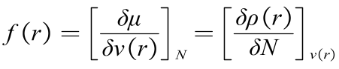
where N represents the number of electrons in the current system, and μ is the chemical potential of the system. ν(r) represents the potential of attraction of the nucleus to the electrons, determined by the geometry of the system.
Atoms that are covered to a greater extent by the Fukui function's equivalence surface, the more likely it is that the corresponding type of reaction will occur. The so-called Condensed Fukui Function (CFF) is a contraction of the Fukui function to atoms. In this way, each atom has an exact value, which facilitates comparison of the magnitude of the Fukui function at different sites at a quantitative level. Therefore, CFF can be calculated based on atomic charge (Hirshfeld).
Electrophilic reaction: 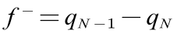
Nucleophilic reactions: 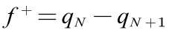
Free radical reactions: 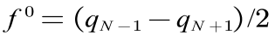

Text.3
Quantitative Structure Activity Relationships (QSARs) are mathematical models that are used to predict measures of toxicity from physical characteristics of the structure of chemicals (known as molecular descriptors). Acute toxicity levels (such as the concentration at which 50% of exposed fish die) are one example of toxicity measures, which may be predicted from QSARs. Simple QSAR models calculate the toxicity of chemicals using a simple linear function of molecular descriptors:
$$Toxicity=ax_{1}+bx_{2}+c$$
where $x_{1}$ and $x_{2}$ are the independent descriptor variables and a, b, and c are fitted parameters. The molecular weight and the octanol-water partition coefficient are examples of molecular descriptors.
In this research, the value for several toxicity endpoints were calculated based on QSARs using consensus method on Toxicity Estimation Software Tool (version 5.1.2.0). The toxicity endpoints and QSAR methodologies mentioned in this paper were described as follows.
(1) Oral rat LD₅₀ (amount of chemical in mg/kg body weight that is lethal to 50% of rats after oral ingestion)
(2) Developmental toxicity (binary indication of whether or not a chemical can interfere with normal development of humans or animals)

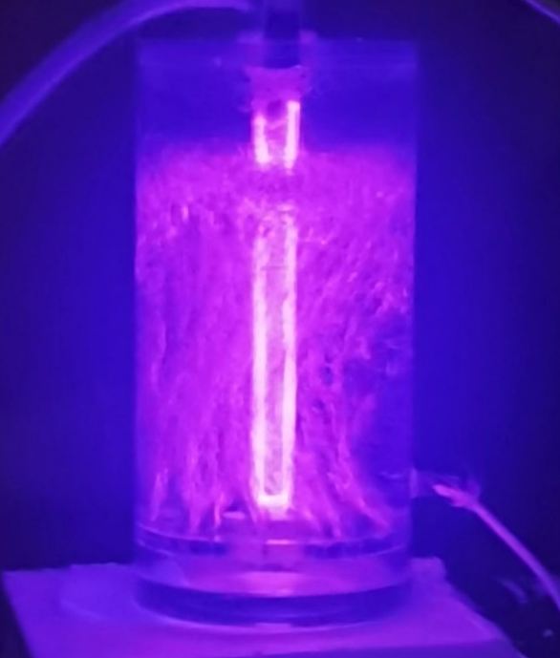
S1
Fig.S1 Photographs of the discharge process

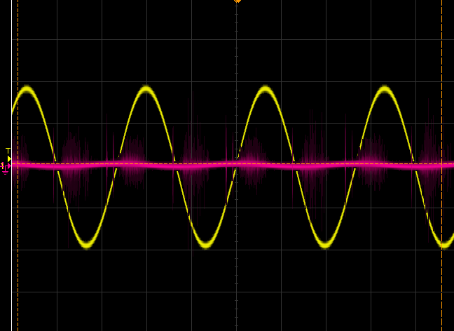
Fig. S2 Current-Voltage Waveform

Table S1 Energy efficiency, kinetic constants and synergy factors under different conditions
system | different conditions |  | degradation（%） | energy efficiency（g/kWh） | k  (min⁻¹) | R² | synergistic factor
PS |  |  | 5.55 | 0.03 | 0.0031 | 0.9938
DBD |  |  | 81.26 | 0.47 | 0.0885 | 0.9899
DBD+PS |  |  | 95.76 | 0.55 | 0.1685 | 0.9946 | 1.84
DBD+PS | PS additions | 1 mM | 81.26 | 0.47 | 0.0985 | 0.9992 | 1.08
DBD+PS | PS additions | 3 mM | 85.42 | 0.50 | 0.1226 | 0.9975 | 1.34
DBD+PS | PS additions | 5 mM | 89.73 | 0.52 | 0.1528 | 0.9973 | 1.67
DBD+PS | PS additions | 10 mM | 93.96 | 0.54 | 0.1685 | 0.9946 | 1.84
DBD+PS | PS additions | 15 mM | 98.10 | 0.57 | 0.2292 | 0.9954 | 2.50
DBD+PS | PS additions | 20 mM | 96.66 | 0.56 | 0.1889 | 0.9970 | 2.06
DBD+PS | MeP additions | 120 mg | 42.34 | 0.98 | 0.0278 | 0.9255 | 0.30
DBD+PS | MeP additions | 90 mg | 56.92 | 0.99 | 0.0434 | 0.9583 | 0.47
DBD+PS | MeP additions | 60 mg | 66.06 | 0.77 | 0.0564 | 0.9808 | 0.62
DBD+PS | MeP additions | 30 mg | 92.15 | 0.53 | 0.1536 | 0.9974 | 1.68
DBD+PS | MeP additions | 10 mg | 100 | 0.19 | 0.7651 | 0.8016 | 8.35
DBD+PS | pH | 3 | 92.97 | 0.54 | 0.1446 | 0.9988 | 1.58
DBD+PS | pH | 5 | 92.15 | 0.53 | 0.1373 | 0.9964 | 1.50
DBD+PS | pH | 7 | 85.42 | 0.50 | 0.1040 | 0.9941 | 1.14
DBD+PS | pH | 9 | 98.23 | 0.57 | 0.2129 | 0.9875 | 2.32

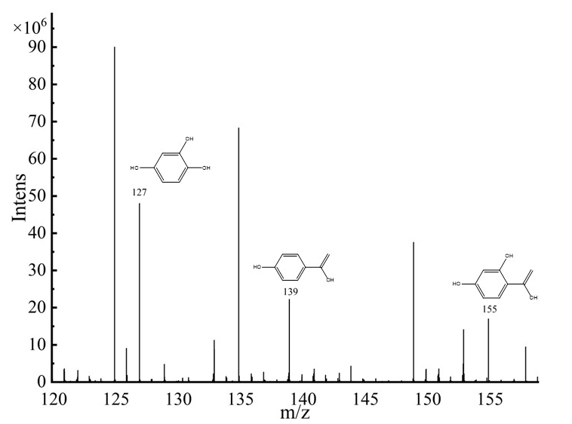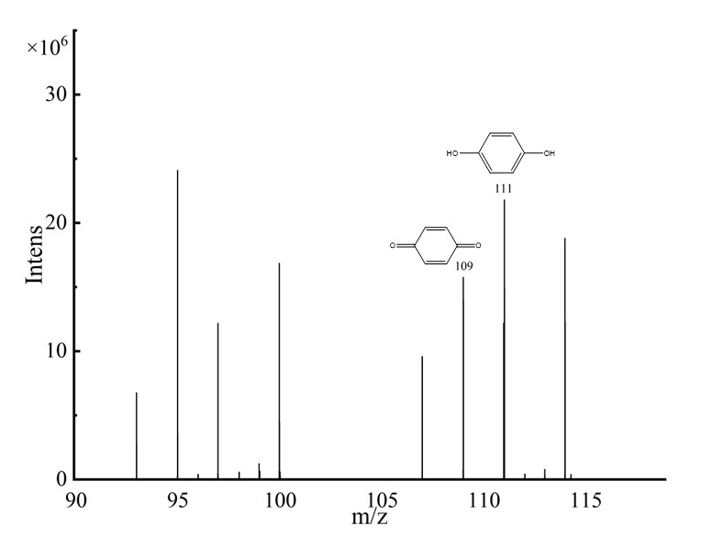
Fig.S3 LC-MS detection mass spectra

Table S2 The available intermediate compounds of MeP by LC-MS/MS analysis.
Name | Molecular formula | m/z | Chemical structure
MeP | C8H8O3 | 152 | 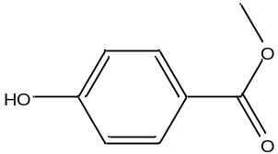
P1 | C7H6O3 | 138 | 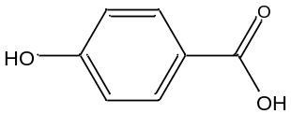
P2 | C6H6O2 | 110 | 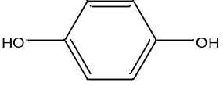
P3 | C7H604 | 154 | 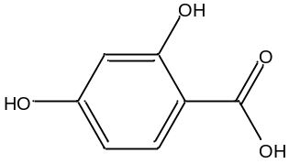
P4 | C7H6O4 | 154 | 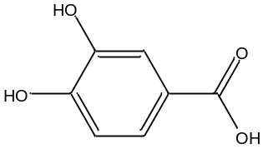
P5 | C6H4O2 | 108 | 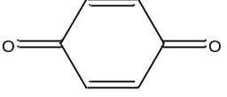
P6 | C6H6O | 94 | 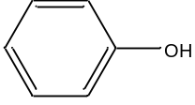
P7 | C6H6O2 | 110 | 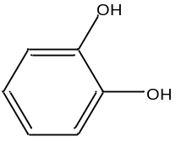
P8 | C6H6O2 | 110 | 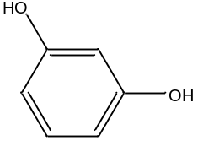
P9 | C6H6O3 | 126 | 