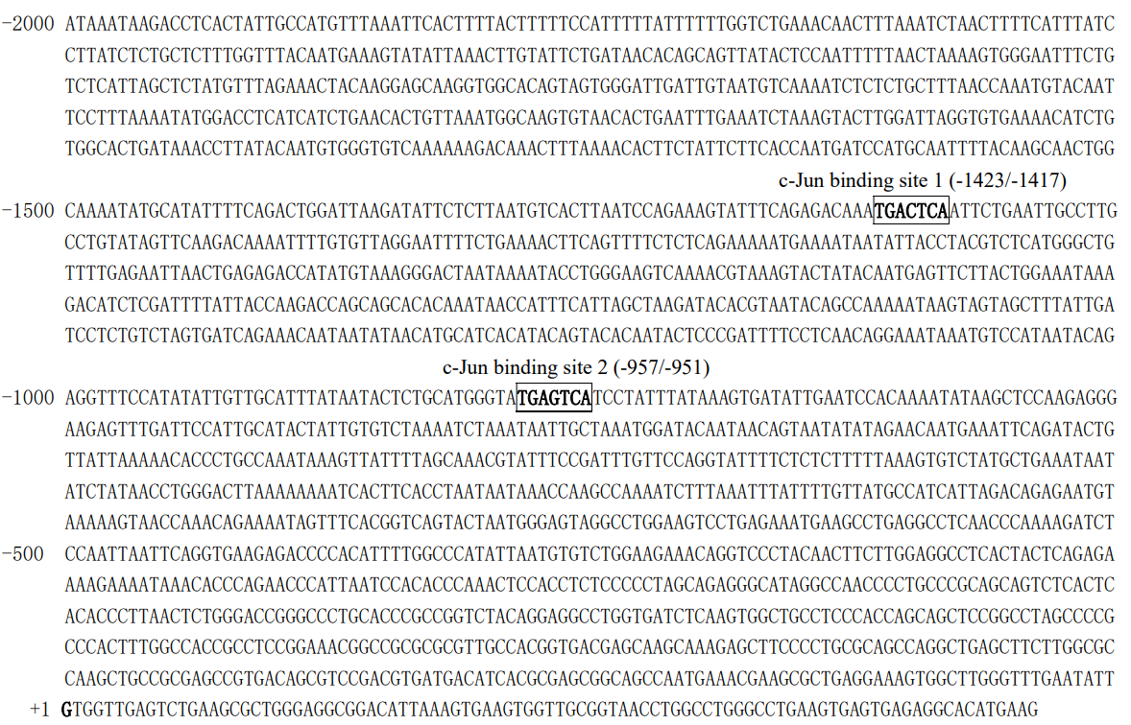
Supporting Information:
TSS
Figure S1. In-silico Analysis of the KIF18A Promoter Sequence Reveals Two Potential c-Jun Binding Motifs. The figure displays a sequence of -2000 bp to +100 bp relative to TSS (+1) within the KIF18A promoter region. Transcription factor (TF) binding motif analysis was performed using the Promo Alggen program with a matrix dissimilarity threshold set at 0. Two putative c-Jun binding motifs are denoted as site 1 and site 2 respectively. The transcription start site (TSS) is marked as +1.

Table S1. Systematically transcriptome analysis of all accessible protein kinases positively correlated with KIF18A in cervical cancer. (see appendix)

Table S2. In-silico analysis of binding motifs for potential transcription factors on KIF18A promoter.
