Secondary metabolites in host pears defense against two fruit borers and cytochrome P450-mediated counterdefense

Shi-Pan Zhang ^{1,2,3,†}, Bing Bai ^{1,2,3,†}, Gao-Man Chen ^{1,2,3}, Ya-Qi Wang ^{1,2,3}, Chao Hu ^{1,2,3}, Xu-fei Liu^{1,2,3}, Ping Gao ^{1,2,3}, Yu-Ting Li ^{1,2,3}, Nan-xia Fu⁴, Xue-Qing Yang^{1,2,3, *}

¹ College of Plant Protection, Shenyang Agricultural University, Shenyang 110866, Liaoning, China

² Key Laboratory of Economical and Applied Entomology of Liaoning Province, Shenyang 110866, Liaoning, China

³ Key Laboratory of Major Agricultural Invasion Biological Monitoring and Control, Shenyang 110866, Liaoning, China
⁴ Tea Research Institute, Chinese Academy of Agricultural Sciences, Hangzhou 310008, China

†These authors contributed equally to this work.
*Correspondence: sling233@hotmail.com, ORCID:0000-0002-3919-8013

2. Materials and Methods

2.1 Detection of plant secondary metabolites
The samples were ground to a powdered form using liquid nitrogen in a mortar and subsequently transferred to a 50 mL centrifuge tube. Then, 30 mL of 80% chromatographic grade methanol was added to the tube, and the mixture was subjected to ultrasonication at 25°C for 30 min (using an ultrasonic power of 40 kHz). The tube was then placed in a shaker at a speed of 200 rpm for an additional 30 min, followed by centrifugation at 8500 rpm for 20 min. The resulting supernatant was carefully transferred to a new tube, and the aforementioned steps were repeated once. The crude extract was then subjected to rotary evaporation at a temperature of 35°C to remove the methanol, leaving behind a nearly dry residue. This residue was subsequently adjusted to a final volume of 10 mL using 80% chromatographic grade methanol and filtered through a 0.22 μm membrane prior to analysis. The amount of chlorogenic acid, epicatechin, catechin, quercetin, rutinum, gallic acid, and isoquercitrin in pears was expressed as μg equivalents per g of fresh weight.
The samples underwent analysis using high performance liquid chromatography (HPLC) (Agilent 1260, USA). The detection parameters were as follows: a 10 μL injection volume was utilized, and a XDB-C18 liquid chromatographic column from Agilent (USA) was employed. The mobile phase consisted of a mixture of a 0.1% formic acid aqueous solution (A) and chromatographic grade methanol (B). The mobile phases eluted in a gradient manner at a flow rate of 0.1 mL/min and a temperature of 30 °C. The concentration gradient elution conditions were as follows: 40% B for 20 min, 50% B for 30 min, and 80% B for 40 min. Detection was performed at wavelengths of 280 nm, 320 nm, and 360 nm. Each experiment group was repeated 3 times.

Table S1 Primers used in this study
Primer name | Primer sequences (5’-3’) | Fragment length (bp)
CpEF-1α-F | GGTCCCCTCCAAGCCTCTGT | 157
CpEF-1α-R | CTCGGCAGCTTTGGTGACCT | 157
CpCYP6A2-F | ATTGTTGAGGCAGAGGATGA | 159
CpCYP6A2-R | CGATGAAGTCGGTGGTGTAG | 159
CpCYP6B2d-F | CAGATAAAATGCCAGGAGGA | 217
CpCYP6B2d-R | TGGGAACGATGATACCGAC | 217
CpCYP6A2a-F | CAGAAAGGGACTATGGTTGGA | 191
CpCYP6A2a-R | TGAGCGTCAGAGTGGAAGG | 191
CpCYP6AB135-F | AGATACGATTGCTTTGGTGAGA | 242
CpCYP6AB135-R | TCGCCGACGAGGACG | 242
CpCYP6AB133-F | CGGCAGAGGATGACGC | 212
CpCYP6AB133-R | TCTCGGAACGGGGATGT | 212
CpCYP6AB134-F | ACGCTTGCCTTGGTGAAA | 229
CpCYP6AB134-R | GCCATCAGCAACTCGTCC | 229
CpCYP6AB136-F | CGTTGAGTTTGGTGAGAAGTATC | 237
CpCYP6AB136-R | TCGCCGACGAGGACG | 237
CPOM03544-F | TGTCACAGAAATCGCAACG | 226
CPOM03544-R | CCGCCACAAGTCTCCATC | 226
CpCYP6AB138-F | ACTGATGTAACCATAGACGAAGGA | 164
CpCYP6AB138-R | CAGCCCCGCCAAAGAC | 164
CpCYP6AN38-F | ACCCGAAGGTGGAGCC | 222
CpCYP6AN38-R | CAGTGGTGAAGCGTGCC | 222
CPOM02806-F | CCGTTCCCAGTCATAATAAAGT | 248
CPOM02806-R | ACAGTCACAGGCGTACCGT | 248
CpCYP6B6-F | ACAGCCCAAGTGTTCGTATTC | 173
CpCYP6B6-R | GCCACGGCATCGTAGCA | 173
CpCYP6AB137-F | AGAAGTATCCCAACGAGAAAGTC | 194
CpCYP6AB137-R | CCACAAATCTCCGTCCAAG | 194
CPOM11145-F | GAATGGAAAGCCGTCGAA | 177
CPOM11145-R | GTCTCATAACCAGCAGCGTAA | 177
CpCYP6B77-F | AGAAGTTCACCCAATCTGCC | 201
CpCYP6B77-R | ATGCCTGTGCCGCTATG | 201
CpCYP6B4b-F | TTGGGAACATAGAAGTGTCATCA | 158
CpCYP6B4b-R | TCCGAACGGCAAGTAAGC | 158
CPOM07791-F | AAATACCAGAACCAAATAGAACCT | 211
CPOM07791-R | TAAAACATCGGCGAGTGC | 211
CPOM20563-F | TTTCGCTTTCGGTAGTGGT | 214
CPOM20563-R | AGGTTCTATTTGGTTCTGGTATTT | 214
CPOM20562-F | TCCGCCATAAGCCAGGTG | 187
CPOM20562-R | AACAAAACGATAATGTAGTTGAAGA | 187
CpCYP6AW1-F | GGAAGAAAATACTGGCTACAAAG | 242
CpCYP6AW1-R | AGGTCACTAAAACAAGCAAAATC | 242
CpCYP332A19-F | GACATAGTGATTGAGGAGGGC | 156
CpCYP332A19-R | CCGAAGGGCAGGAAGGT | 156
CpCYP6J1-F | GGACGGTGATGATAAAGGAGA | 193
CpCYP6J1-R | GAATTTGGTCGGTTCAGGAT | 193
CpCYP6J1b-F | ATGCCGTTTGGAGATGGA | 160
CpCYP6J1b-R | GGAAAGTAAGGATGTAGTGCTGAT | 160
CPOM21987-F | AGGGAATACCCACAGCATCG | 177
CPOM21987-R | TATCCAAATCTTTCACCATCAA | 177
CpCYP9e2a-F | CGTTACGATTGTTCCCACC | 188
CpCYP9e2a-R | CTCTTCCCCGATAAACCTCT | 188
CpCYP345A22-F | AAATACACCCTACCTGGAACAC | 249
CpCYP345A22-R | CAAAAGCGAAACCATAGCC | 249
CpCYP9A61-F | CTTGAAAGGTGACGAATGGA | 221
CpCYP9A61-R | CGAAGACGCAGGTGGC | 221
CpCYP6K1b-F | CTTCAACAACCCCAACGC | 169
CpCYP6K1b-R | CGCCTCCCAAAACACCT | 169
CpCYP9A120-F | AAAACCTGCATCAGCATCTTTACCA | 226
CpCYP9A120-R | GGACCAGCAGTTGAAGGAGT | 226
CpCYP9A121-F | TACGTCGAAGGTTTGATTTTGTGCT | 161
CpCYP9A121-R | AACGACGAAGCTACAACCGATTACA | 161
CpCYP9A122-F | TGTCACCAGCTGCCTAAAGAAACTC | 174
CpCYP9A122-R | GACTCGCAGAACAACGAAACAGAAT | 174
Gmβ-actin-F | CTTTCACCACCACCGCTG | 197
Gmβ-actin-R | CGCAAGATTCCATACCCA | 197
GmCYP6B74-F | CGGTCTCCAGATTTACTCATACG | 234
GmCYP6B74-R | GAACCTGTCTCCTCGCTCC | 234
GmCYP6AB112-F | TACCAGCACTCGGAAACCAT | 237
GmCYP6AB112-R | TCGCTTCCAAGGTGTGATCT | 237
GmCYP6AB113-F | TTTGGTTTCCTTACACGCCG | 152
GmCYP6AB113-R | TCATCCTCAGGGTCGAATCG | 152
GmCYP6AB114-F | AAATGGCACCAACCAGTTC | 234
GmCYP6AB114-R | ACCTCATGGCTCGCTACAC | 234
GmCYP6AB115-F | AAATGGCACCAACCAGTTC | 234
GmCYP6AB115-R | ACCTCATGGCTCGCTACAC | 234
GmCYP6AB116-F | GACTCCCCAACAATCAAACC | 205
GmCYP6AB116-R | CCAAACAAGCCATTATCTCAG | 205
GmCYP6AB117-F | ACCAGCCCCGCCATC | 151
GmCYP6AB117-R | ACTTCCCAGACCCTGAAGAG | 151
GmCYP6AN35-F | ACCAGCCCTCATCATCAGAG | 214
GmCYP6AN35-R | GCAGCTTCCAAGTATCACCG | 214
GmCYP6AE2-F | AATCCAGCAGCGAATAAACC | 239
GmCYP6AE2-R | CTTCATCAACTTTCCCTCGG | 239
GmCYP6B2-F | ATGCGTATCCAGGTGAGAAAG | 243
GmCYP6B2-R | GAGGTAAACATCGGCGAGAA | 243
GmCYP6B3-F | GTATCTCGTCCGTTGGTTCC | 249
GmCYP6B3-R | CCGACCTTTAGAGCAAACTTCA | 249
GmCYP6B4-F | TGATGTTTCCGTCGTGCTT | 231
GmCYP6B4-R | TGCGTGAGTCTACAGAAGGC | 231
GmCYP6J1-F | GTTGGTTGGCTACTACACGATG | 160
GmCYP6J1-R | TTTGGAAGAATGGGTGGG | 160
gm_13876-F | GGTTTCAACATCTGGAGCGTA | 250
gm_13876-R | TCTTGCTACTCTCTCTCGGTGA | 250
GmCYP6B6-F | TCAATACCTTCACCTCGCA | 188
GmCYP6B6-R | GCGTAAAGATTCCGACTGG | 188
GmCYP9A-F | TCTGGATAAGGTGGTTTCGG | 152
GmCYP9A-R | TCGGGATGTTGAGGCTTT | 152
GmCYP9E-F | AAACTCCACAATCTTCGCC | 246
GmCYP9E-R | ACGGTAAACAAATCCCTCG | 246
GmCYP332A-F | TTGTTTTGGAGCGTTGTCG | 227
GmCYP332A -R | GCTTCAGGATGGTGGGATAG | 227
gm_06953-F | TCCTTATTTCCTACCGATGTGA | 158
gm_06953-R | TGTTTCCGTGCTCTGTTTTC | 158
GmCYP6K1-F | CGATGGGTTGGCTGGAC | 191
GmCYP6K1-R | CGAGAATGGGACGATGTTG | 191
gm_13182-F | CCCTGGTGTCCGTGTTCT | 191
gm_13182-R | CTCGTATAAAGGATTCTGTGGC | 191
gm_15311-F | GGTTTGGCGAAGGATGC | 195
gm_15311-R | TCTGGATAATGAAAGAAGACGG | 195
GmCYP9E2a-F | TGATACATCTACTAATGGAGGCTAA | 175
GmCYP9E2a-R | GCGAGAAAGAAAAGGACGG | 175
gm_16205-F | TACCGCCTTGCCTTGG | 197
gm_16205-R | CATTCGTAATCGTTCTGTGCT | 197
GmCYP9E2e-F | AGAGTGGCGGGAAGTTTG | 233
GmCYP9E2e-R | TGGGAAGTATTGCGGGTC | 233
GmCYP6A14-F | CAATAGAGCGTAGGAACCCA | 235
GmCYP6A14-R | ACGGCATCGTAGCATAACTT | 235
GmCYP6B7-F | TGGACCAAGCGTGGAGTAA | 246
GmCYP6B7-R | AAGCGGGTGCAAGTTTCTA | 246
GmCYP6B5-F | TATGTATTTATGCCGTTTGGAG | 152
GmCYP6B5-R | GTTGGTTCAGGAGGAGGGT | 152
GmCYP6A17-F | GACGGATTTGCGTGACTGA | 238
GmCYP6A17-R | TCGTTGGAGGCATTGGAC | 238
gm_36654-F | GCGATGTTTCCTCTGATTGTG | 193
gm_36654-R | TTCCTAGTTTGCGGATTGG | 193
dsGmCYP6B74-F | GGATCCTAATACGACTCACTATAGGAGCCAAAACTGCTTACAAGATAC | 266
dsGmCYP6B74-R | GGATCCTAATACGACTCACTATAGGCGGATACCAATACACTGCTTC | 266
dsgm_13876-F | GGATCCTAATACGACTCACTATAGGTAGGACACGGTTCGCGATAA | 269
dsgm_13876-R | GGATCCTAATACGACTCACTATAGGGCGCTCAAAACGTCGACATA | 269
dsCpCYP6K1b-F | GGATCCTAATACGACTCACTATAGGTGAAAATCTGCTGTACCAGTCC | 204
dsCpCYP6K1b-R | GGATCCTAATACGACTCACTATAGGCCACCCGTGCTCCTTGA | 204
dsCpCYP6AW1-F | GGATCCTAATACGACTCACTATAGGGCACCTCACCTTGTAAACTCA | 242
dsCpCYP6AW1-R | GGATCCTAATACGACTCACTATAGGGCCACCTCCATCCTGCT | 242
dsCpGFP-F | GGATCCTAATACGACTCACTATAGGTTCAATGCTTTTCCCGTTAT | 254
dsCPGFP-R | GGATCCTAATACGACTCACTATAGGTGTTTGTCTGCCGTGATGTA | 254
dsGmGFP-F | GGATCCTAATACGACTCACTATAGGCAGTGCTTTAGCCGCTATCC | 246
dsGmGFP-R | GGATCCTAATACGACTCACTATAGGCGGGGTGTTCTGCTGATAAT | 246
Note：The underscore indicates the T7 promoter sequence.
Table S2 Weight gain and nutrition utilization index
Nutrient utilization index calculation formula
Relative growth rate: (D-C)/[(C+D)/2] ×100%
Relative consumption rate: (A-B)/[(C+D)/2] ×100%
Efficiency of the conversion of ingested food: (D-C)/(A-B) ×100%
Efficiency of the conversion of digested food: (D-C)/(A-B-E) ×100%
Note: A: feed quality before the test; B: feed quality after the test; C: larval weight before the test; D: larval weight after the test; E: larval fecal weight.
Table S3 Correlation between fruit infestation rate and fruit hardness of C. pomonella and G. molesta
Host plants | Species | Regression equations | F | R² | P
P.yrus ussuriensis | C. pomonella | Y = -1.075 x + 28.15 | 110.70 | 0.9651 | 0.0005
P.yrus ussuriensis | G. molesta | Y = -0.3580 x + 9.422 | 119.50 | 0.9676 | 0.0004
Pyrus bretschneideri | C. pomonella | Y = -5.787 x + 143.1 | 110.10 | 0.9650 | 0.0005
Pyrus bretschneideri | G. molesta | Y = -0.6249 x + 13.67 | 74.01 | 0.9487 | 0.0010

Figure legends
Figure S1 The fruit hardness of P. ussuriensis and P. bretschneideri. * represented the difference in the fruit hardness of P. ussuriensis and P. bretschneideri.
Figure S2 Survival rate of C. pomonella (A) and G. molesta (B) under different concentrations of rutin.
Figure S3 Survival rate of 100 μg/g quercetin by dsRNA injection of C. pomonella (A) and G. molesta (B). The data in the figure are represented as mean ± SD. Different letters above bars indicate significant difference P < 0.05.
Figure S4 Weight growth of 0 μg/g and 100 μg/g of quercetin for sensitive strains of C. pomonella (A) and G. molesta (B). The data in the figure are represented as mean ± SE. Independent sample t-test to calculate the significance of the difference between groups, *** P < 0.001；** P < 0.01；* P < 0.05.
Figure S5 Weight growth of 0 μg/g and 100 μg/g quercetin by dsGFP injection of C. pomonella (A) and G. molesta (B). dsGFP-1：Feeding 0 μg/g quercetin forage；dsGFP-2：Feeding 100 μg/g quercetin forage; The data in the figure are represented as mean ± SE. Independent sample t-test to calculate the significance of the difference between groups, *** P < 0.001；** P < 0.01；* P < 0.05.
Figure S6 Verification of the presence of your gene of interest in the recombinant bacmid DNA by PCR. Bacmid DNA were used as templates, and the predicted PCR product size in Bacmid transposed with pFastBac1 vector was size of individual P450 plus 2300bp.
Figure S7 Western blot detection using Anti-His antibody. Microsome was prepared from Sf9 cells that were co-transfected with recombinant baculovirus expressing CYP341B14 and CPR that fused with C-terminal His-tag. The observed molecular weights agreed with predictions from their sequences.
Figure S8 Liquid chromatogram of P450s of C. pomonella and G. molesta against quercetin and rutinum. Recombinant protein CYP6AW1 and CYP6K1b against quercetin (A-C and D-F), recombinant protein CYP6B74 and Gm_13876 against quercetin (G-I and J-L). Recombinant protein CYP6AW1 and CYP6K1b against rutinum (M-O and P-R), recombinant protein CYP6B74 and Gm_13876 against rutinum (S-U and V-X).

Figure S1
Figure S2
Figure S3
Figure S4
Figure S5
Figure S6
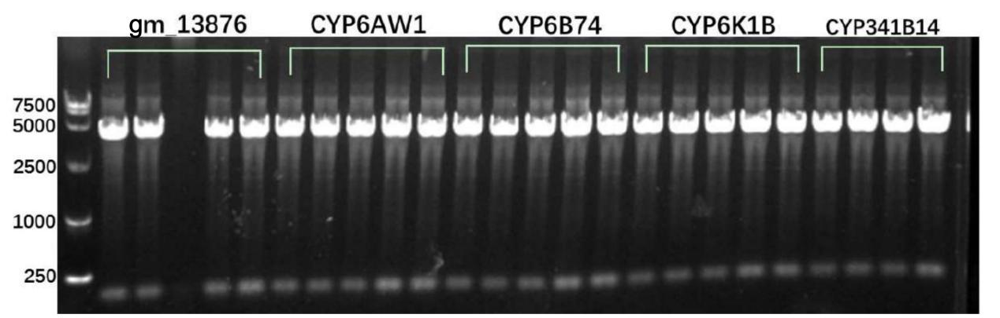

Figure S7
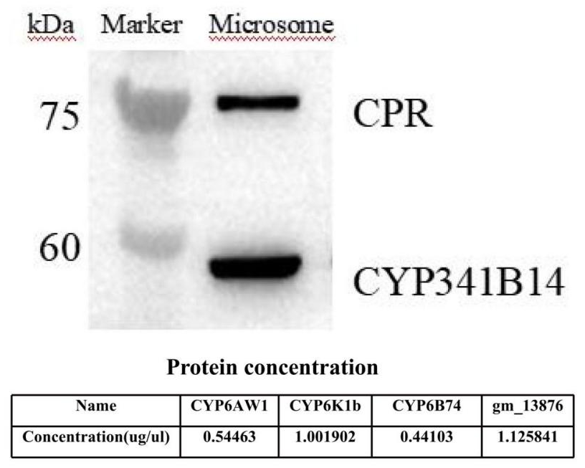
Figure S8
