Supplementary Informatiom

Supplementary Table S1. Estimates of net, gross, and within mean distance among monthly collection groups from SBCVIC and GISAID.
The number of base substitutions per site, representing the estimation of gross (upper right), within (diagonal), and net (lower left) averages between groups of sequences is shown. Analyses were conducted using the Tamura-Nei model. The rate of variation among the sites was modeled using a gamma distribution. Differences in composition bias among sequences were considered in evolutionary comparisons.
 | SB-Jun | SB-Jul | SB-Aug | SB-Sep | SB-Oct | GISAID-Jun | GISAID-Jul | GISAID-Aug | GISAID-Sep | GISAID-Oct
SB-Jun | 0.00053230 | 0.00071911 | 0.00078806 | 0.00083523 | 0.00088317 | 0.00049297 | 0.00056792 | 0.00073733 | 0.00082714 | 0.00095564
SB-Jul | 0.00014273 | 0.00062046 | 0.00057227 | 0.00059163 | 0.00065333 | 0.00071836 | 0.00067514 | 0.00065079 | 0.00063194 | 0.00089937
SB-Aug | 0.00028575 | 0.00002588 | 0.00047233 | 0.00047601 | 0.00054504 | 0.00080220 | 0.00071096 | 0.00060198 | 0.00053447 | 0.00086695
SB-Sep | 0.00033430 | 0.00004663 | 0.00000507 | 0.00046955 | 0.00054394 | 0.00085529 | 0.00075190 | 0.00061419 | 0.00052969 | 0.00088479
SB-Oct | 0.00031049 | 0.00003657 | 0.00000234 | 0.00000263 | 0.00061306 | 0.00089701 | 0.00079813 | 0.00067394 | 0.00059552 | 0.00093906
GISAID-Jun | 0.00001237 | 0.00019368 | 0.00035159 | 0.00040607 | 0.00037603 | 0.00042890 | 0.00052664 | 0.00072806 | 0.00083404 | 0.00094410
GISAID-Jul | 0.00001829 | 0.00008144 | 0.00019131 | 0.00023365 | 0.00020812 | 0.00002871 | 0.00056696 | 0.00068444 | 0.00074271 | 0.00091053
GISAID-Aug | 0.00014383 | 0.00001321 | 0.00003846 | 0.00005206 | 0.00004006 | 0.00018626 | 0.00007361 | 0.00065471 | 0.00062763 | 0.00089508
GISAID-Sep | 0.00028900 | 0.00004972 | 0.00002631 | 0.00002292 | 0.00001700 | 0.00034760 | 0.00018724 | 0.00002828 | 0.00054399 | 0.00088035
GISAID-Oct | 0.00016986 | 0.00006951 | 0.00011116 | 0.00013038 | 0.00011290 | 0.00021002 | 0.00010742 | 0.00004810 | 0.00008873 | 0.00103925

Supplementary Figure S1. Bayesian skyline plot analysis of Omicron variants in Japan based on data from the SBCVIC and GISAID.
Past population dynamics of Omicron variants of SARS-CoV-2, estimated from sequences in GISAID-(upper) and the SBCVIC (lower), were separately visualized using the Bayesian Skyline model. The shaded portion represents the 95% Bayesian credibility interval and the solid line represents the posterior median. The vertical lines and rectangles represent the study period.
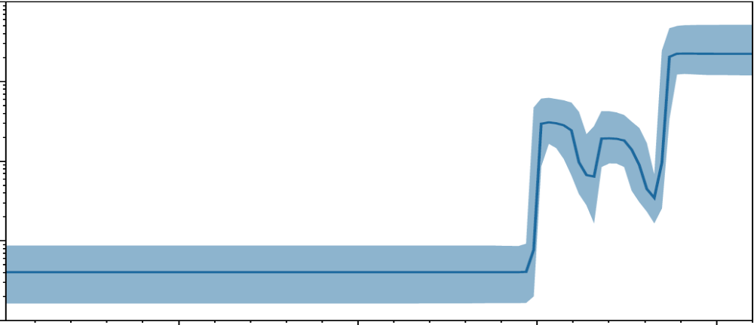
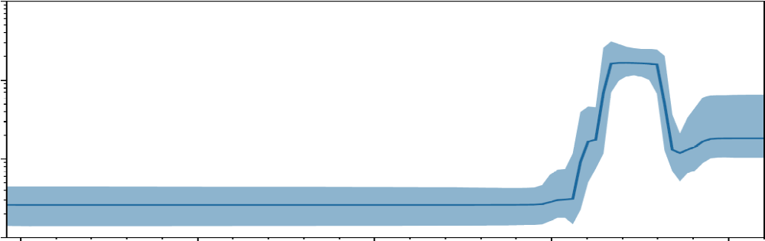
10
100
1000
10000
100000
100
1000
10000
Aug.’20
May.’21
Jan.’22
Sep.’22
Jan.’20
GISAID
SBCVIC
Relative Population Size
19000
19250
18750
18500
Days after Jan.1970
Date
Study period

Supplementary Figure S2. Distribution of size and proportion of SBCVIC cases within the network components.
A. The histogram displays the size distribution of network components comprising BA.2 (orange) and BA.5 (blue).
B. The histogram depicts the number of components based on each proportion of SBCVIC cases, considering only the components containing more than 5 cases.
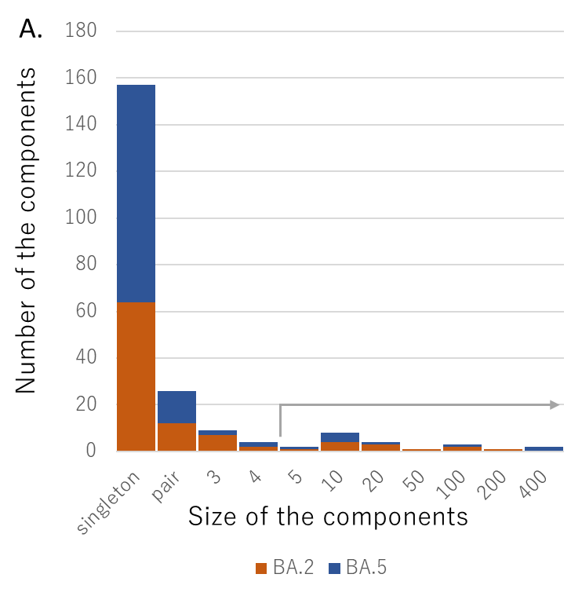

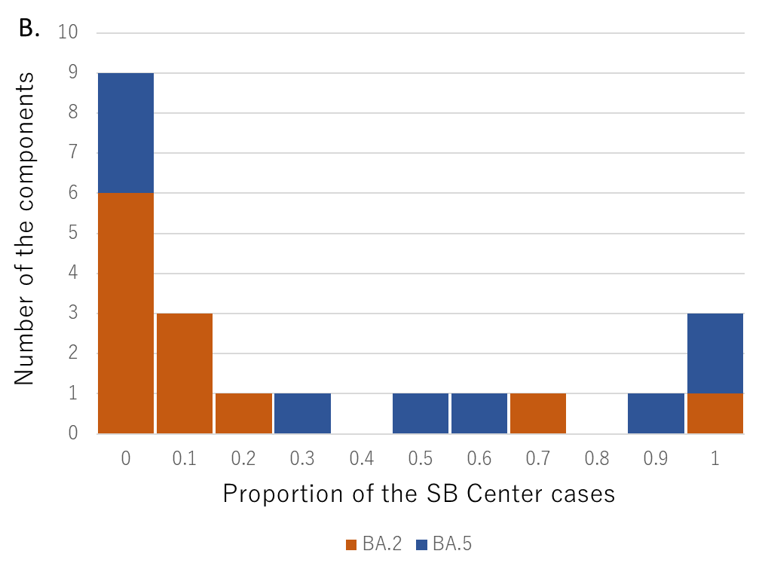

Supplementary Figure S3. Bayesian coalescent clade credibility tree representing Omicron variants collected during the study period in Japan.
The time-based phylogenetic tree was inferred using whole genome sequences of belonging SARS-CoV-2, specifically BA.2 and BA.5, from cases at the SBCVIC (blue) and GISAID (orange), collected from June to October 2022 in Japan. To determine the root location, Wuhan/Hu-1 was added to determine the origin of the virus. Symbols for each collection route we colored darker to indicate more recent months of sample collection. The posterior probability of a node is denoted by a green number only if it exceeded 0.95. Vertical lines, indicating 3-month intervals, was used to grid the tree. Corresponding Pango lineages for each clade are shown in parentheses on the right-hand side.

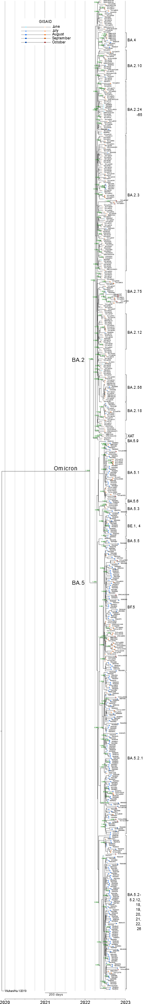
Supplementary Table S2. Collection date and accession number in INSDC of the viral sequence from SBCVIC.
Sample ID | Collection Date | Accession Number
050645923 | 2022-06-09
050688978 | 2022-06-14
050718210 | 2022-06-10
301132002 | 2022-06-16
353530537 | 2022-06-27
353782655 | 2022-06-01
354955940 | 2022-06-01
355045108 | 2022-06-08
355074268 | 2022-06-10
500266277 | 2022-06-30
750383728 | 2022-06-04
750384468 | 2022-06-02
750394890 | 2022-06-08
750395696 | 2022-06-30
750396956 | 2022-06-28
750399758 | 2022-06-23
750399765 | 2022-06-22
750399818 | 2022-06-22
750399843 | 2022-06-24
750400850 | 2022-06-22
750400954 | 2022-06-12
750400983 | 2022-06-12
750401105 | 2022-06-23
750401477 | 2022-06-20
750401483 | 2022-06-21
750401487 | 2022-06-22
750401761 | 2022-06-19
750401777 | 2022-06-16
750401920 | 2022-06-12
750404501 | 2022-06-17
750404814 | 2022-06-06
750405597 | 2022-06-02
750405603 | 2022-06-05
750406420 | 2022-06-14
750406436 | 2022-06-14
750406519 | 2022-06-05
750406537 | 2022-06-03
750406558 | 2022-06-09
750407474 | 2022-06-06
750408359 | 2022-06-06
750408408 | 2022-06-06
900006779 | 2022-06-13
900006780 | 2022-06-13
900006782 | 2022-06-13
900212451 | 2022-06-22
000085674 | 2022-07-28
000516804 | 2022-07-08
000529117 | 2022-07-05
000533342 | 2022-07-04
000533567 | 2022-07-15
000534892 | 2022-07-21
000535352 | 2022-07-26
000535421 | 2022-07-27
050583553 | 2022-07-21
050591114 | 2022-07-08
050592881 | 2022-07-25
050611099 | 2022-07-20
050622185 | 2022-07-22
050643044 | 2022-07-23
050663303 | 2022-07-22
050690225 | 2022-07-26
050715177 | 2022-07-07
050719115 | 2022-07-14
050726724 | 2022-07-21
050746613 | 2022-07-14
050747026 | 2022-07-20
050750082 | 2022-07-14
050754422 | 2022-07-22
050754935 | 2022-07-22
050755231 | 2022-07-20
050757590 | 2022-07-30
050758313 | 2022-07-29
050759241 | 2022-07-29
050794886 | 2022-07-16
050801037 | 2022-07-25
090121593 | 2022-07-28
100330093 | 2022-07-27
100414630 | 2022-07-26
100415756 | 2022-07-17
100415874 | 2022-07-20
100415906 | 2022-07-21
100415909 | 2022-07-30
100422217 | 2022-07-27
100423718 | 2022-07-29
100425136 | 2022-07-23
100428065 | 2022-07-26
301120121 | 2022-07-09
301124958 | 2022-07-19
301129169 | 2022-07-21
301139842 | 2022-07-12
301140837 | 2022-07-21
353402031 | 2022-07-29
353793783 | 2022-07-27
354967779 | 2022-07-04
355058648 | 2022-07-22
355058822 | 2022-07-26
355058852 | 2022-07-26
355059341 | 2022-07-29
355059554 | 2022-07-26
355085220 | 2022-07-15
355097075 | 2022-07-14
355100849 | 2022-07-20
355100866 | 2022-07-20
355139781 | 2022-07-23
355147234 | 2022-07-05
355147462 | 2022-07-26
355148015 | 2022-07-29
355148915 | 2022-07-20
355166972 | 2022-07-28
355168952 | 2022-07-28
355177973 | 2022-07-09
355178056 | 2022-07-09
355190819 | 2022-07-21
355192323 | 2022-07-27
355196473 | 2022-07-28
355196477 | 2022-07-28
355206269 | 2022-07-21
355215485 | 2022-07-23
355216358 | 2022-07-14
355216359 | 2022-07-14
355216368 | 2022-07-14
355216377 | 2022-07-14
355231547 | 2022-07-26
355233780 | 2022-07-28
355238318 | 2022-07-28
355239459 | 2022-07-28
355239753 | 2022-07-28
355243482 | 2022-07-29
500098694 | 2022-07-21
700011275 | 2022-07-20
700011382 | 2022-07-12
750000768 | 2022-07-24
750036684 | 2022-07-20
750229489 | 2022-07-26
750237665 | 2022-07-27
750241484 | 2022-07-26
750249899 | 2022-07-21
750260423 | 2022-07-12
750290763 | 2022-07-25
750290764 | 2022-07-25
750298570 | 2022-07-21
750298754 | 2022-07-21
750299645 | 2022-07-07
750301450 | 2022-07-22
750303713 | 2022-07-30
750304770 | 2022-07-28
750304773 | 2022-07-22
750309346 | 2022-07-26
750313808 | 2022-07-09
750323987 | 2022-07-23
750337911 | 2022-07-29
750340392 | 2022-07-21
750343761 | 2022-07-24
750351451 | 2022-07-30
750366958 | 2022-07-16
750370326 | 2022-07-15
750375225 | 2022-07-06
750379558 | 2022-07-20
750379760 | 2022-07-27
750381565 | 2022-07-26
750385432 | 2022-07-16
750390404 | 2022-07-24
750395331 | 2022-07-01
750395967 | 2022-07-01
750396175 | 2022-07-19
750396276 | 2022-07-21
750396865 | 2022-07-29
750396994 | 2022-07-05
750397550 | 2022-07-05
750397846 | 2022-07-10
750397853 | 2022-07-10
750397865 | 2022-07-10
750397881 | 2022-07-10
750398168 | 2022-07-07
750398222 | 2022-07-09
750399116 | 2022-07-07
750399370 | 2022-07-03
750399431 | 2022-07-05
750399534 | 2022-07-03
750400072 | 2022-07-01
750400335 | 2022-07-02
750403967 | 2022-07-26
750405128 | 2022-07-12
750407607 | 2022-07-27
750409278 | 2022-07-18
750409432 | 2022-07-18
750409502 | 2022-07-13
750409746 | 2022-07-14
750410252 | 2022-07-24
750410654 | 2022-07-16
750410758 | 2022-07-16
750410759 | 2022-07-16
750410810 | 2022-07-14
750410843 | 2022-07-16
750412765 | 2022-07-29
750412959 | 2022-07-19
750413280 | 2022-07-16
750413497 | 2022-07-16
750413785 | 2022-07-13
750413841 | 2022-07-16
750413845 | 2022-07-14
750414220 | 2022-07-16
750414237 | 2022-07-16
750414346 | 2022-07-24
750414596 | 2022-07-16
750414756 | 2022-07-12
750416123 | 2022-07-09
750416151 | 2022-07-09
750416154 | 2022-07-12
750416171 | 2022-07-13
750416197 | 2022-07-11
750416212 | 2022-07-10
750416251 | 2022-07-10
750416326 | 2022-07-12
750416401 | 2022-07-13
750416464 | 2022-07-12
750416925 | 2022-07-12
750416943 | 2022-07-12
750416965 | 2022-07-11
750416979 | 2022-07-12
750417632 | 2022-07-15
750418124 | 2022-07-23
750418936 | 2022-07-24
750418963 | 2022-07-24
750419804 | 2022-07-19
750419817 | 2022-07-20
750419855 | 2022-07-20
750419902 | 2022-07-24
750419967 | 2022-07-24
750419979 | 2022-07-21
750420044 | 2022-07-24
750420591 | 2022-07-19
750420601 | 2022-07-19
750420615 | 2022-07-19
750420905 | 2022-07-20
750421727 | 2022-07-21
750421779 | 2022-07-19
750422050 | 2022-07-30
750422789 | 2022-07-19
750422800 | 2022-07-31
750422832 | 2022-07-21
750422846 | 2022-07-20
750422849 | 2022-07-20
750422942 | 2022-07-22
750423800 | 2022-07-21
750423812 | 2022-07-19
750423851 | 2022-07-21
750423882 | 2022-07-21
750423930 | 2022-07-21
750423954 | 2022-07-22
750423987 | 2022-07-25
750424048 | 2022-07-25
750424859 | 2022-07-19
750424952 | 2022-07-24
750424963 | 2022-07-22
750425620 | 2022-07-20
750425648 | 2022-07-20
750425677 | 2022-07-20
750425737 | 2022-07-23
750425879 | 2022-07-21
750425883 | 2022-07-20
750425892 | 2022-07-24
750425932 | 2022-07-22
750425966 | 2022-07-21
750426064 | 2022-07-24
750427051 | 2022-07-14
750427325 | 2022-07-19
750427465 | 2022-07-20
750427765 | 2022-07-25
750428357 | 2022-07-25
750428798 | 2022-07-28
750428893 | 2022-07-24
750428894 | 2022-07-25
750428948 | 2022-07-24
750429017 | 2022-07-24
750429132 | 2022-07-24
750429414 | 2022-07-26
750429528 | 2022-07-26
750429536 | 2022-07-26
750429564 | 2022-07-25
750429841 | 2022-07-26
750429894 | 2022-07-26
750429922 | 2022-07-26
750430344 | 2022-07-27
750430372 | 2022-07-28
750430406 | 2022-07-28
750430458 | 2022-07-26
750430647 | 2022-07-30
750430659 | 2022-07-28
750430726 | 2022-07-26
750430756 | 2022-07-27
750430764 | 2022-07-26
750430787 | 2022-07-28
750431365 | 2022-07-22
750431404 | 2022-07-25
750432144 | 2022-07-25
750432148 | 2022-07-24
750432153 | 2022-07-26
750433031 | 2022-07-27
750433130 | 2022-07-31
750433138 | 2022-07-31
750433763 | 2022-07-28
750433980 | 2022-07-27
750434121 | 2022-07-31
750434298 | 2022-07-24
750434328 | 2022-07-24
750436803 | 2022-07-31
750436856 | 2022-07-31
750437699 | 2022-07-31
750437700 | 2022-07-31
750437706 | 2022-07-31
750437715 | 2022-07-31
750438194 | 2022-07-31
750439098 | 2022-07-30
750439135 | 2022-07-31
750440204 | 2022-07-30
750440248 | 2022-07-31
750440278 | 2022-07-30
750440282 | 2022-07-30
750440299 | 2022-07-30
750440300 | 2022-07-31
750440340 | 2022-07-31
750440570 | 2022-07-30
750440873 | 2022-07-31
900005604 | 2022-07-21
920020394 | 2022-07-23
920024113 | 2022-07-21
920024115 | 2022-07-24
000085681 | 2022-08-07
000535896 | 2022-08-01
000535964 | 2022-08-02
050464362 | 2022-08-23
050628681 | 2022-08-04
050659910 | 2022-08-22
050673594 | 2022-08-01
050705690 | 2022-08-15
050707054 | 2022-08-14
050707099 | 2022-08-14
050713453 | 2022-08-03
050714637 | 2022-08-06
050715302 | 2022-08-15
050716140 | 2022-08-03
050723430 | 2022-08-22
050736950 | 2022-08-06
050738661 | 2022-08-15
050746246 | 2022-08-09
050746306 | 2022-08-22
050747682 | 2022-08-03
050749847 | 2022-08-15
050760000 | 2022-08-10
050761682 | 2022-08-03
050762260 | 2022-08-05
050763102 | 2022-08-05
050763619 | 2022-08-03
050763787 | 2022-08-18
050764861 | 2022-08-05
050768808 | 2022-08-04
050769564 | 2022-08-04
050770442 | 2022-08-04
050772163 | 2022-08-08
050773057 | 2022-08-08
050773447 | 2022-08-08
050773831 | 2022-08-08
050776807 | 2022-08-08
050776970 | 2022-08-08
050778503 | 2022-08-10
050778662 | 2022-08-09
050779560 | 2022-08-09
050779975 | 2022-08-25
050781125 | 2022-08-26
050782574 | 2022-08-15
050785658 | 2022-08-15
050786417 | 2022-08-15
050793090 | 2022-08-19
050798599 | 2022-08-09
050802193 | 2022-08-20
050804187 | 2022-08-16
050805325 | 2022-08-26
050807121 | 2022-08-15
050807379 | 2022-08-15
050807558 | 2022-08-09
050811908 | 2022-08-22
050812930 | 2022-08-22
050814246 | 2022-08-22
050815148 | 2022-08-22
050816788 | 2022-08-23
050817809 | 2022-08-25
050819789 | 2022-08-26
050820422 | 2022-08-28
050908748 | 2022-08-23
090122734 | 2022-08-03
090123573 | 2022-08-06
090124182 | 2022-08-08
100399373 | 2022-08-28
100403795 | 2022-08-03
100403837 | 2022-08-01
100404773 | 2022-08-02
100405014 | 2022-08-10
100409493 | 2022-08-05
100410401 | 2022-08-03
100410417 | 2022-08-03
100410418 | 2022-08-03
100410652 | 2022-08-02
100410741 | 2022-08-02
100415299 | 2022-08-16
100419155 | 2022-08-24
100423789 | 2022-08-02
100425169 | 2022-08-02
100425243 | 2022-08-03
100426134 | 2022-08-08
100426217 | 2022-08-08
100426292 | 2022-08-23
100426447 | 2022-08-17
100426448 | 2022-08-17
100426528 | 2022-08-03
100426582 | 2022-08-05
100427518 | 2022-08-08
100428206 | 2022-08-02
100432734 | 2022-08-28
100432808 | 2022-08-05
100433813 | 2022-08-02
100433907 | 2022-08-04
100435893 | 2022-08-18
100435916 | 2022-08-16
100437628 | 2022-08-17
100439973 | 2022-08-19
100441106 | 2022-08-19
100444725 | 2022-08-31
100446696 | 2022-08-24
100448476 | 2022-08-23
212006647 | 2022-08-04
212006821 | 2022-08-23
212006836 | 2022-08-23
212007815 | 2022-08-08
212008680 | 2022-08-22
220806009 | 2022-08-06
301132732 | 2022-08-22
301132733 | 2022-08-22
301134835 | 2022-08-14
301137818 | 2022-08-20
301140147 | 2022-08-23
301140475 | 2022-08-09
301140698 | 2022-08-28
301141299 | 2022-08-19
301141940 | 2022-08-18
301142809 | 2022-08-10
301142810 | 2022-08-10
301142836 | 2022-08-14
301143228 | 2022-08-08
353403227 | 2022-08-05
353403233 | 2022-08-05
353403655 | 2022-08-05
353405259 | 2022-08-11
353406480 | 2022-08-15
353406664 | 2022-08-20
353408027 | 2022-08-22
353409073 | 2022-08-24
353755643 | 2022-08-06
353755648 | 2022-08-07
353796791 | 2022-08-12
353797304 | 2022-08-17
354998644 | 2022-08-26
355041831 | 2022-08-04
355041853 | 2022-08-12
355052896 | 2022-07-20
355059733 | 2022-08-01
355059795 | 2022-08-01
355059917 | 2022-08-15
355059944 | 2022-08-11
355060576 | 2022-08-08
355061312 | 2022-08-15
355061459 | 2022-08-15
355061899 | 2022-08-26
355062063 | 2022-08-22
355062430 | 2022-08-26
355103988 | 2022-08-09
355109984 | 2022-08-11
355130439 | 2022-08-06
355145866 | 2022-08-25
355149389 | 2022-08-24
355154165 | 2022-08-25
355160708 | 2022-08-04
355161896 | 2022-08-25
355163214 | 2022-08-25
355166574 | 2022-08-24
355167012 | 2022-08-25
355168977 | 2022-08-25
355179667 | 2022-08-21
355180532 | 2022-08-05
355197615 | 2022-08-05
355198302 | 2022-08-10
355201412 | 2022-08-11
355209074 | 2022-08-09
355231630 | 2022-08-26
355236492 | 2022-08-02
355241207 | 2022-08-10
355245779 | 2022-08-03
355251650 | 2022-08-25
355252046 | 2022-08-05
355253566 | 2022-08-02
355255023 | 2022-08-15
355260318 | 2022-08-04
355266353 | 2022-08-13
355266805 | 2022-08-10
355268242 | 2022-08-10
355270212 | 2022-08-10
355270810 | 2022-08-25
355271291 | 2022-08-09
355278531 | 2022-08-19
355280295 | 2022-08-12
355281324 | 2022-08-12
355281517 | 2022-08-12
355284307 | 2022-08-30
355285197 | 2022-08-26
355287853 | 2022-08-09
355287936 | 2022-08-09
355288303 | 2022-08-10
355288949 | 2022-08-15
355289020 | 2022-08-15
355289959 | 2022-08-19
355290130 | 2022-08-19
355290199 | 2022-08-19
355290542 | 2022-08-22
355297101 | 2022-08-08
355297115 | 2022-08-08
355301676 | 2022-08-27
355303929 | 2022-08-27
355304116 | 2022-08-27
355304176 | 2022-08-25
355304628 | 2022-08-26
355314769 | 2022-08-19
355316905 | 2022-08-20
355317453 | 2022-08-21
355318164 | 2022-08-26
355320354 | 2022-08-19
355324013 | 2022-08-22
355324078 | 2022-08-22
355326694 | 2022-08-24
355329849 | 2022-08-25
355329875 | 2022-08-25
355330406 | 2022-08-25
355339626 | 2022-08-19
355354018 | 2022-08-26
355354492 | 2022-08-26
355354520 | 2022-08-26
355355654 | 2022-08-26
355356234 | 2022-08-26
500098987 | 2022-08-07
500099161 | 2022-08-09
500099423 | 2022-08-14
500099445 | 2022-08-14
500099609 | 2022-08-25
500272928 | 2022-08-15
500273246 | 2022-08-20
700001272 | 2022-08-25
750025169 | 2022-08-02
750163499 | 2022-08-18
750232405 | 2022-08-04
750233118 | 2022-08-16
750233500 | 2022-08-09
750236184 | 2022-08-06
750280519 | 2022-08-18
750286176 | 2022-08-15
750288213 | 2022-08-02
750289463 | 2022-08-03
750289538 | 2022-08-04
750290089 | 2022-08-20
750291332 | 2022-08-09
750292841 | 2022-08-15
750295504 | 2022-08-09
750296627 | 2022-08-02
750297667 | 2022-08-06
750298727 | 2022-08-03
750299111 | 2022-08-11
750299199 | 2022-08-31
750315282 | 2022-08-09
750317687 | 2022-08-06
750317717 | 2022-08-03
750325726 | 2022-08-02
750329324 | 2022-08-29
750337707 | 2022-08-10
750337781 | 2022-08-12
750337816 | 2022-08-03
750337830 | 2022-08-04
750338384 | 2022-08-09
750338547 | 2022-08-03
750340356 | 2022-08-06
750350985 | 2022-08-18
750351564 | 2022-08-20
750359209 | 2022-08-18
750365711 | 2022-08-16
750377372 | 2022-08-02
750383225 | 2022-08-07
750384144 | 2022-08-05
750384481 | 2022-08-17
750387495 | 2022-08-06
750390220 | 2022-08-26
750393776 | 2022-08-12
750393829 | 2022-08-12
750393830 | 2022-08-12
750404066 | 2022-08-16
750405856 | 2022-08-18
750407958 | 2022-08-06
750408222 | 2022-08-03
750410792 | 2022-08-18
750412473 | 2022-08-04
750414046 | 2022-08-02
750418453 | 2022-08-18
750418892 | 2022-08-09
750419131 | 2022-08-02
750421202 | 2022-08-10
750422008 | 2022-08-02
750422210 | 2022-08-01
750422485 | 2022-08-01
750424504 | 2022-08-04
750424695 | 2022-08-16
750429301 | 2022-08-18
750429521 | 2022-08-15
750431071 | 2022-08-09
750431106 | 2022-08-28
750433549 | 2022-08-08
750434275 | 2022-08-17
750434495 | 2022-08-02
750434573 | 2022-08-01
750434747 | 2022-08-03
750434818 | 2022-08-06
750434840 | 2022-08-04
750434886 | 2022-08-01
750435019 | 2022-08-07
750435362 | 2022-08-14
750435485 | 2022-08-29
750435532 | 2022-08-08
750435748 | 2022-08-10
750435770 | 2022-08-10
750435892 | 2022-08-04
750435914 | 2022-08-06
750435958 | 2022-08-09
750436043 | 2022-08-07
750436056 | 2022-08-08
750436067 | 2022-08-07
750436111 | 2022-08-01
750436131 | 2022-08-01
750436134 | 2022-08-02
750436354 | 2022-08-06
750436362 | 2022-08-03
750436376 | 2022-08-03
750436708 | 2022-08-12
750436714 | 2022-08-01
750436732 | 2022-08-01
750436764 | 2022-08-02
750436892 | 2022-08-02
750436925 | 2022-08-02
750436963 | 2022-08-03
750437020 | 2022-08-01
750437068 | 2022-08-01
750437170 | 2022-08-17
750437368 | 2022-08-17
750437522 | 2022-08-03
750437608 | 2022-08-18
750437646 | 2022-08-08
750437761 | 2022-08-01
750437882 | 2022-08-05
750438002 | 2022-08-04
750438031 | 2022-08-04
750438037 | 2022-08-04
750438045 | 2022-08-03
750438212 | 2022-08-09
750438213 | 2022-08-12
750438282 | 2022-08-14
750438414 | 2022-08-03
750438439 | 2022-08-06
750438448 | 2022-08-03
750438484 | 2022-08-02
750438497 | 2022-08-01
750438520 | 2022-08-01
750438521 | 2022-08-01
750438570 | 2022-08-02
750438581 | 2022-08-02
750438591 | 2022-08-22
750438605 | 2022-08-01
750438638 | 2022-08-02
750438640 | 2022-08-01
750438657 | 2022-08-01
750438702 | 2022-08-01
750438732 | 2022-08-01
750438764 | 2022-08-01
750438777 | 2022-08-01
750438812 | 2022-08-01
750438925 | 2022-08-01
750439067 | 2022-08-02
750439079 | 2022-08-01
750439188 | 2022-08-01
750439201 | 2022-08-01
750439212 | 2022-08-01
750439225 | 2022-08-02
750439252 | 2022-08-01
750439643 | 2022-08-03
750440868 | 2022-08-03
750440923 | 2022-08-05
750441326 | 2022-08-15
750441495 | 2022-08-06
750441497 | 2022-08-08
750441532 | 2022-08-10
750441556 | 2022-08-08
750441623 | 2022-08-04
750441668 | 2022-08-08
750441683 | 2022-08-08
750441690 | 2022-08-04
750441694 | 2022-08-04
750441729 | 2022-08-06
750441790 | 2022-08-08
750441815 | 2022-08-09
750441876 | 2022-08-08
750442209 | 2022-08-10
750442230 | 2022-08-09
750442241 | 2022-08-12
750442274 | 2022-08-09
750442333 | 2022-08-12
750442361 | 2022-08-15
750442391 | 2022-08-14
750442394 | 2022-08-14
750442448 | 2022-08-12
750442460 | 2022-08-14
750442562 | 2022-08-09
750442585 | 2022-08-04
750442602 | 2022-08-04
750442686 | 2022-08-14
750442693 | 2022-08-06
750442755 | 2022-08-06
750442776 | 2022-08-06
750442789 | 2022-08-08
750442805 | 2022-08-09
750442845 | 2022-08-09
750442864 | 2022-08-10
750443010 | 2022-08-11
750443055 | 2022-08-21
750443186 | 2022-08-09
750443203 | 2022-08-09
750443216 | 2022-08-14
750443287 | 2022-08-12
750443291 | 2022-08-09
750443299 | 2022-08-09
750443315 | 2022-08-14
750443328 | 2022-08-30
750443353 | 2022-08-09
750443376 | 2022-08-09
750443413 | 2022-08-15
750443456 | 2022-08-14
750443466 | 2022-08-14
750443499 | 2022-08-06
750443604 | 2022-08-07
750443622 | 2022-08-07
750443625 | 2022-08-04
750443644 | 2022-08-04
750443652 | 2022-08-04
750443656 | 2022-08-06
750443765 | 2022-08-06
750443786 | 2022-08-07
750443801 | 2022-08-06
750443818 | 2022-08-08
750443855 | 2022-08-08
750443878 | 2022-08-08
750444230 | 2022-08-09
750444237 | 2022-08-08
750444251 | 2022-08-09
750444269 | 2022-08-09
750444288 | 2022-08-18
750444298 | 2022-08-09
750444299 | 2022-08-09
750444357 | 2022-08-09
750444364 | 2022-08-10
750444410 | 2022-08-10
750444412 | 2022-08-09
750444489 | 2022-08-09
750444503 | 2022-08-08
750444558 | 2022-08-07
750444569 | 2022-08-08
750444580 | 2022-08-08
750444587 | 2022-08-04
750444616 | 2022-08-07
750444632 | 2022-08-08
750444711 | 2022-08-07
750444785 | 2022-08-08
750444804 | 2022-08-08
750444842 | 2022-08-08
750444848 | 2022-08-09
750444866 | 2022-08-09
750444878 | 2022-08-08
750445211 | 2022-08-09
750445229 | 2022-08-09
750445246 | 2022-08-09
750445249 | 2022-08-12
750445263 | 2022-08-09
750445313 | 2022-08-09
750445354 | 2022-08-09
750445367 | 2022-08-09
750445462 | 2022-08-16
750445478 | 2022-08-16
750445522 | 2022-08-08
750445539 | 2022-08-08
750445540 | 2022-08-09
750445545 | 2022-08-09
750445698 | 2022-08-07
750445754 | 2022-08-07
750445903 | 2022-08-06
750445956 | 2022-08-06
750446189 | 2022-08-30
750446227 | 2022-08-09
750446256 | 2022-08-12
750446275 | 2022-08-12
750446422 | 2022-08-12
750447004 | 2022-08-24
750447059 | 2022-08-24
750447392 | 2022-08-21
750447395 | 2022-08-21
750447477 | 2022-08-21
750447568 | 2022-08-26
750447998 | 2022-08-22
750448023 | 2022-08-24
750448033 | 2022-08-24
750448041 | 2022-08-24
750448064 | 2022-08-22
750448202 | 2022-08-27
750448398 | 2022-08-24
750448410 | 2022-08-19
750448461 | 2022-08-22
750448475 | 2022-08-22
750448554 | 2022-08-26
750448894 | 2022-08-22
750448896 | 2022-08-22
750448903 | 2022-08-24
750448951 | 2022-08-24
750448991 | 2022-08-24
750449063 | 2022-08-22
750449084 | 2022-08-21
750449103 | 2022-08-18
750449137 | 2022-08-21
750449212 | 2022-08-22
750449280 | 2022-08-22
750449374 | 2022-08-19
750449411 | 2022-08-21
750449422 | 2022-08-22
750449461 | 2022-08-21
750449465 | 2022-08-20
750449470 | 2022-08-21
750449950 | 2022-08-22
750449973 | 2022-08-24
750450187 | 2022-08-21
750450203 | 2022-08-21
750450218 | 2022-08-20
750450261 | 2022-08-21
750450263 | 2022-08-21
750450270 | 2022-08-19
750450273 | 2022-08-19
750450279 | 2022-08-19
750450405 | 2022-08-24
750450407 | 2022-08-20
750450419 | 2022-08-21
750450431 | 2022-08-21
750450897 | 2022-08-24
750451007 | 2022-08-29
750451025 | 2022-08-22
750451039 | 2022-08-22
750451074 | 2022-08-24
750451198 | 2022-08-24
750451213 | 2022-08-22
750451216 | 2022-08-22
750451226 | 2022-08-22
750451268 | 2022-08-22
750451302 | 2022-08-22
750451359 | 2022-08-22
750451402 | 2022-08-22
750451441 | 2022-08-22
750451524 | 2022-08-21
750451613 | 2022-08-22
750451630 | 2022-08-22
750451645 | 2022-08-24
750451682 | 2022-08-22
750451755 | 2022-08-22
750451794 | 2022-08-16
750451799 | 2022-08-16
750451827 | 2022-08-16
750451828 | 2022-08-18
750451840 | 2022-08-16
750451848 | 2022-08-16
750451849 | 2022-08-15
750451890 | 2022-08-16
750451902 | 2022-08-16
750451954 | 2022-08-16
750451991 | 2022-08-16
750452033 | 2022-08-18
750452067 | 2022-08-18
750452146 | 2022-08-15
750452158 | 2022-08-15
750452167 | 2022-08-16
750452197 | 2022-08-16
750452272 | 2022-08-16
750452278 | 2022-08-16
750452304 | 2022-08-15
750452316 | 2022-08-16
750452321 | 2022-08-15
750452368 | 2022-08-18
750452396 | 2022-08-12
750452429 | 2022-08-14
750452461 | 2022-08-14
750452525 | 2022-08-15
750452544 | 2022-08-14
750452666 | 2022-08-18
750452713 | 2022-08-19
750452780 | 2022-08-19
750452992 | 2022-08-15
750453086 | 2022-08-16
750453091 | 2022-08-16
750453117 | 2022-08-16
750453127 | 2022-08-18
750453166 | 2022-08-18
750453205 | 2022-08-18
750453257 | 2022-08-18
750453267 | 2022-08-18
750453272 | 2022-08-18
750453280 | 2022-08-18
750453283 | 2022-08-18
750453294 | 2022-08-12
750453347 | 2022-08-15
750453352 | 2022-08-14
750453369 | 2022-08-15
750453371 | 2022-08-15
750453493 | 2022-08-14
750453653 | 2022-08-12
750453734 | 2022-08-15
750453745 | 2022-08-15
750453754 | 2022-08-15
750453797 | 2022-08-21
750453856 | 2022-08-19
750453878 | 2022-08-18
750453960 | 2022-08-18
750454040 | 2022-08-24
750454047 | 2022-08-19
750454053 | 2022-08-19
750454055 | 2022-08-19
750454102 | 2022-08-18
750454326 | 2022-08-14
750454356 | 2022-08-14
750454364 | 2022-08-15
750454367 | 2022-08-15
750454502 | 2022-08-14
750454532 | 2022-08-15
750454534 | 2022-08-14
750454729 | 2022-08-14
750454741 | 2022-08-14
750454760 | 2022-08-14
750454863 | 2022-08-23
750455090 | 2022-08-18
750455093 | 2022-08-18
750455126 | 2022-08-18
750455147 | 2022-08-18
750455151 | 2022-08-18
750455180 | 2022-08-19
750455183 | 2022-08-19
750455219 | 2022-08-18
750455232 | 2022-08-16
750455306 | 2022-08-13
750455392 | 2022-08-15
750455426 | 2022-08-14
750455439 | 2022-08-22
750455440 | 2022-08-15
750455447 | 2022-08-15
750455457 | 2022-08-14
750455460 | 2022-08-14
750455494 | 2022-08-14
750455594 | 2022-08-14
750455596 | 2022-08-15
750455645 | 2022-08-16
750455667 | 2022-08-14
750455691 | 2022-08-16
750455743 | 2022-08-16
750455745 | 2022-08-16
750455760 | 2022-08-16
750455888 | 2022-08-18
750455903 | 2022-08-18
750455991 | 2022-08-18
750456002 | 2022-08-18
750456032 | 2022-08-18
750456059 | 2022-08-18
750456249 | 2022-08-25
750456402 | 2022-08-18
750456433 | 2022-08-16
750456452 | 2022-08-18
750456464 | 2022-08-18
750456473 | 2022-08-18
750456479 | 2022-08-16
750456547 | 2022-08-12
750456565 | 2022-08-14
750456884 | 2022-08-14
750456960 | 2022-08-16
750457003 | 2022-08-18
750457041 | 2022-08-19
750457099 | 2022-08-14
750457128 | 2022-08-14
750457168 | 2022-08-15
750457288 | 2022-08-15
750457297 | 2022-08-16
750457318 | 2022-08-15
750457319 | 2022-08-15
750457351 | 2022-08-15
750457359 | 2022-08-14
750457464 | 2022-08-09
750457467 | 2022-08-10
750457552 | 2022-08-19
750457568 | 2022-08-14
750457716 | 2022-08-27
750457731 | 2022-08-12
750457789 | 2022-08-12
750458572 | 2022-08-10
750458581 | 2022-08-10
750458582 | 2022-08-10
750459262 | 2022-08-31
750459726 | 2022-08-10
750459785 | 2022-08-09
750459788 | 2022-08-10
750460077 | 2022-08-10
750461567 | 2022-08-26
750461570 | 2022-08-24
750461609 | 2022-08-24
750462541 | 2022-08-26
750462599 | 2022-08-26
750463069 | 2022-08-28
750463466 | 2022-08-24
750463511 | 2022-08-24
750463517 | 2022-08-24
750463534 | 2022-08-26
750463622 | 2022-08-26
750464038 | 2022-08-26
750464085 | 2022-08-26
750464105 | 2022-08-26
750464486 | 2022-08-24
750464742 | 2022-08-28
750464764 | 2022-08-24
750464805 | 2022-08-29
750465025 | 2022-08-24
750465045 | 2022-08-24
750465065 | 2022-08-24
750465473 | 2022-08-24
750465538 | 2022-08-28
750465580 | 2022-08-26
750466197 | 2022-10-02
750469831 | 2022-08-28
750469842 | 2022-08-28
750469850 | 2022-08-28
750470043 | 2022-08-26
750470061 | 2022-08-28
750470121 | 2022-08-28
750470630 | 2022-08-26
750470700 | 2022-08-28
750470829 | 2022-08-26
750470844 | 2022-08-26
750470870 | 2022-08-26
750470948 | 2022-08-28
750470994 | 2022-08-29
750471136 | 2022-08-26
750471195 | 2022-08-26
750471197 | 2022-08-26
750471205 | 2022-08-26
750471223 | 2022-08-26
750472285 | 2022-08-29
750472297 | 2022-08-30
750473775 | 2022-08-30
750473847 | 2022-08-29
750473890 | 2022-08-30
750473940 | 2022-08-30
750473948 | 2022-08-30
750473954 | 2022-08-30
750473986 | 2022-08-30
750474186 | 2022-08-30
750474310 | 2022-08-28
750474445 | 2022-08-30
750474460 | 2022-08-30
750474483 | 2022-08-30
750474630 | 2022-08-27
750474688 | 2022-08-27
750474851 | 2022-08-29
900107702 | 2022-08-10
900107890 | 2022-08-01
910006066 | 2022-08-05
910006070 | 2022-08-03
910006087 | 2022-08-08
920024266 | 2022-08-15
920024378 | 2022-08-30
920025801 | 2022-08-07
050599235 | 2022-09-02
050679461 | 2022-09-27
050732737 | 2022-09-08
050734799 | 2022-09-03
050823635 | 2022-09-06
050827243 | 2022-09-08
050829438 | 2022-09-06
050839268 | 2022-09-13
050850597 | 2022-09-22
050853255 | 2022-09-24
050911516 | 2022-09-21
050913804 | 2022-09-21
050914631 | 2022-09-26
050915276 | 2022-09-27
090127077 | 2022-09-06
100437930 | 2022-09-03
100443396 | 2022-09-28
100445524 | 2022-09-15
100446567 | 2022-09-06
100446616 | 2022-09-07
100455475 | 2022-09-27
100455684 | 2022-09-27
212009736 | 2022-09-15
212009844 | 2022-09-15
212009845 | 2022-09-15
220909009 | 2022-09-09
301132139 | 2022-09-04
301132741 | 2022-09-15
301140714 | 2022-09-04
355063071 | 2022-09-08
355063788 | 2022-09-14
355298635 | 2022-09-14
355315995 | 2022-09-02
355320829 | 2022-09-01
355332542 | 2022-09-07
355333857 | 2022-09-06
355360306 | 2022-09-04
355368710 | 2022-09-01
355368794 | 2022-09-15
355379506 | 2022-09-08
355380267 | 2022-09-13
355384074 | 2022-09-28
355389971 | 2022-09-15
355397248 | 2022-09-07
355397531 | 2022-09-07
355398386 | 2022-09-08
355404896 | 2022-09-08
355420041 | 2022-09-20
355428788 | 2022-09-16
355431837 | 2022-09-14
355456308 | 2022-09-17
355456309 | 2022-09-17
355456319 | 2022-09-17
750221812 | 2022-09-03
750235319 | 2022-09-11
750286115 | 2022-09-03
750380565 | 2022-09-08
750397012 | 2022-09-01
750435820 | 2022-09-01
750448197 | 2022-09-15
750462550 | 2022-09-01
750463290 | 2022-09-27
750463772 | 2022-09-17
750464847 | 2022-09-08
750464884 | 2022-09-03
750473444 | 2022-09-04
750473469 | 2022-09-02
750473505 | 2022-09-02
750473508 | 2022-09-02
750473631 | 2022-09-01
750473659 | 2022-09-01
750473984 | 2022-09-01
750474928 | 2022-09-01
750475019 | 2022-09-01
750475225 | 2022-09-06
750475290 | 2022-09-05
750475830 | 2022-09-02
750475933 | 2022-09-02
750476034 | 2022-09-02
750476062 | 2022-09-01
750476751 | 2022-09-03
750476776 | 2022-09-04
750476777 | 2022-09-03
750476795 | 2022-09-04
750476818 | 2022-09-04
750476825 | 2022-09-01
750476834 | 2022-09-01
750476910 | 2022-09-01
750483720 | 2022-09-10
900106669 | 2022-09-05
050792131 | 2022-10-24
050843745 | 2022-11-07
050871581 | 2022-10-25
050875819 | 2022-10-10
050885456 | 2022-10-22
050886182 | 2022-10-17
050886413 | 2022-11-07
050890251 | 2022-10-30
050892056 | 2022-11-07
050913308 | 2022-10-12
050916474 | 2022-10-18
050916480 | 2022-10-18
100442669 | 2022-11-05
100456772 | 2022-10-18
212013647 | 2022-10-21
212013670 | 2022-10-21
301143261 | 2022-10-08
301147233 | 2022-10-18
301147962 | 2022-10-01
301149388 | 2022-10-31
354967844 | 2022-10-12
355342057 | 2022-11-05
355342453 | 2022-11-05
355429884 | 2022-10-17
355449015 | 2022-10-29
355449818 | 2022-11-03
355455138 | 2022-10-20
355487695 | 2022-10-06
355503518 | 2022-10-21
355515166 | 2022-10-06
355521940 | 2022-10-13
355529955 | 2022-10-14
355533149 | 2022-10-21
355538461 | 2022-11-02
355568092 | 2022-10-28
355569759 | 2022-10-23
355573418 | 2022-10-26
355585416 | 2022-11-06
355587422 | 2022-10-30
355650329 | 2022-11-05
355650341 | 2022-11-05
355650369 | 2022-11-05
750227044 | 2022-10-25
750234915 | 2022-10-22
750246555 | 2022-10-15
750248501 | 2022-10-10
750284293 | 2022-11-01
750303885 | 2022-11-01
750385967 | 2022-10-19
750409762 | 2022-10-31
750417298 | 2022-10-13
750430212 | 2022-10-29
750436575 | 2022-10-25
750443079 | 2022-11-05
750461848 | 2022-10-26
750464851 | 2022-10-26
750465300 | 2022-10-04
750494694 | 2022-11-05
750495037 | 2022-10-30
750495994 | 2022-11-01
750496974 | 2022-11-05
750503345 | 2022-10-28
750503716 | 2022-10-30
750504981 | 2022-10-28
750506557 | 2022-10-25
750518251 | 2022-11-06
750520896 | 2022-11-04
900009462 | 2022-10-24
900105859 | 2022-10-11

