Appendix
A. Conceptual Diagram
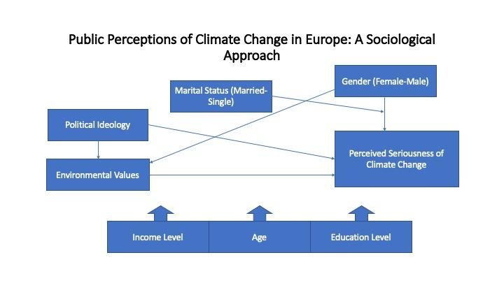

B. Tables
Table 1. Descriptive Summary Statistics
Variable | Distribution (%) | Mean [S.D.] | Skew / Kurtosis
Gender (% Male) | 43.93
Marital Status (% Married) | 52.11
Income |  | 3.86 [1.36] | -.319 / 2.376
Age |  | 49.94 [18.24] | -.017 / 2.058
Education |  | 19.47 [5.09] | 2.121 / 13.151
Political Ideology |  | 5.25 [2.31] | .175 / 2.698
Environmental Values
1. Least important | 0.09
2. | 0.25
3. | 0.81
4. | 2.19
5. | 15.24
6. | 21.99
7. Most important | 59.42
Perceived Seriousness of Climate Change  (Dependent Variable) |  | 7.24 [2.11] | -.585 / 2.999

N = 27,718
Source: Eurobarometer 83.4: Climate Change, Biodiversity, and Discrimination of Minority Group (European Commission, 2015)

Table 2. Ordinary Least Squares Regression Model of the Effects of Gender, Marital Status, Income, Age, Education, Political Ideology, and Environmental Values on Concern over Climate Change.

Independent Variables | Model 1 | Model 2 | Model 3 | Model 4 | Model 5
Gender (Male) | -0.241* | -0.250* | -0.244* | -0.193* | -0.200*
Marital Status (Married) |  | 0.146* | 0.153* | 0.157* | 0.151*
Income |  | -0.068* | -0.059* | -0.053* | -0.053*
Age |  | -0.003* | -0.003* | -0.005* | -0.005*
Education |  | 0.004 | 0.003 | -0.003 | -0.003
Political Ideology |  |  | -0.057* | -0.052* | -0.052*
Environmental Values |  |  |  | 0.429* | 0.428*
Married X Male |  |  |  |  | 0.012
Constant | 7.341* | 7.612* | 7.905* | 5.324* | 5.329*
Model fit
F | 63.44* | 25.91* | 34.72* | 130.2* | 113.93*
R² | 0.3% | 0.6% | 1% | 4% | 4%
N | 19,150 | 19,150 | 19,150 | 19,150 | 19.150

* p < .05

Values shown in each cell are unstandardized coefficients

Source: Eurobarometer 83.4: Climate Change, Biodiversity, and Discrimination of Minority Group (European Commission, 2015)

