Tri-reforming of methane over Ni/ZrO₂ catalyst derived from Zr-MOF
for the production of synthesis gas

Akansha Pandey and Prakash Biswas *
Department of Chemical Engineering, Indian Institute of Technology Roorkee, Roorkee-247667, Uttarakhand, India

*Corresponding author: Tel.: (+91)-1332-28-5820
Email: prakash.biswas@ch.iitr.ac.in; prakashbiswas@gmail.com
Supplementary Information (SI)

S1. N₂ adsorption-desorption of Zr-MOF
Table 1. Physio-chemical properties of the calcined Z-1000 MOF
Catalyst | BET surface area (m²/g) | Pore volume (cc/g) | Pore Diameter (nm)
Cal 400 | 415.086 | 0.276 | 2.657
Cal 500 | 20.576 | 0.032 | 6.299
Cal 600 | 10.910 | 0.031 | 11.273
Cal 700 | 3.555 | 0.011 | 12.756
Cal 800 | 3.469 | 0.011 | 13.697

(a)  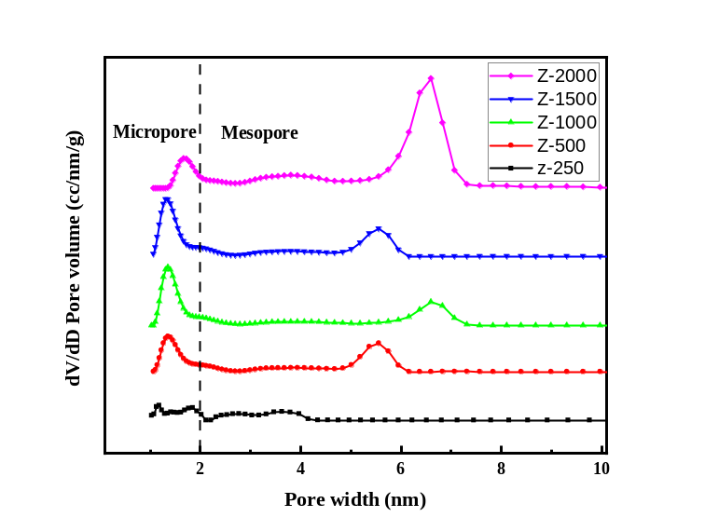 | (b)  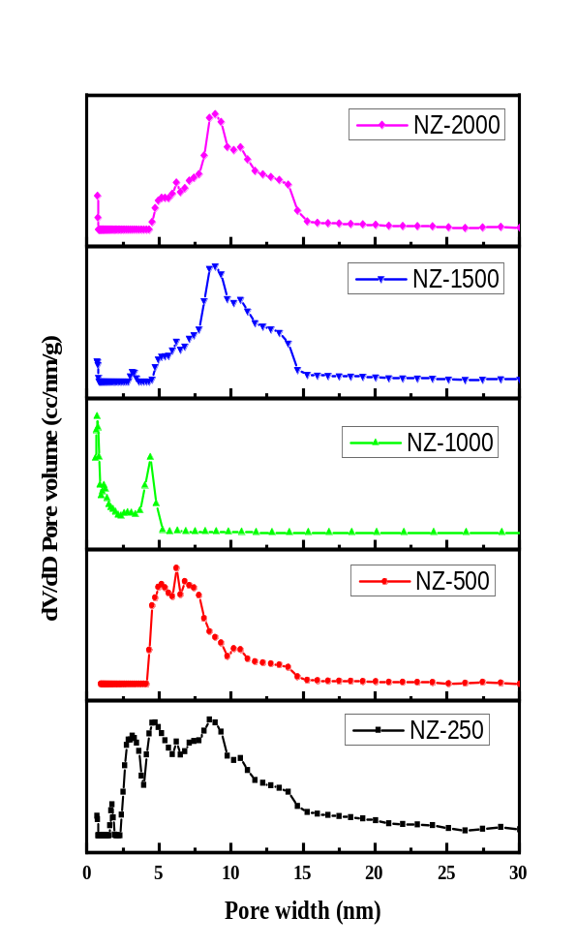

Fig. S1. Pore size distribution of (a) Zr-MOF, (b) Ni/ZrO₂ derived MOF catalysts
S2. FE-SEM Analysis
Fig. S2 depicts FE-SEM images of Zr-MOF, the reduced Ni/ZrO₂ derived MOF catalyst, and the spent NZ-1000 (ANZ-1000) catalyst after a 12-hour reaction.
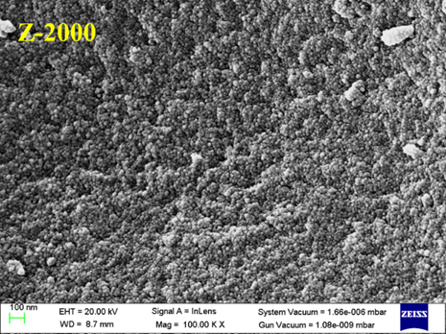 | 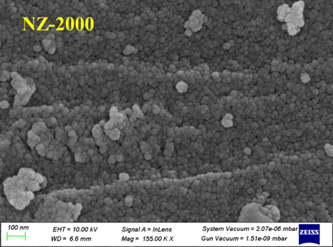
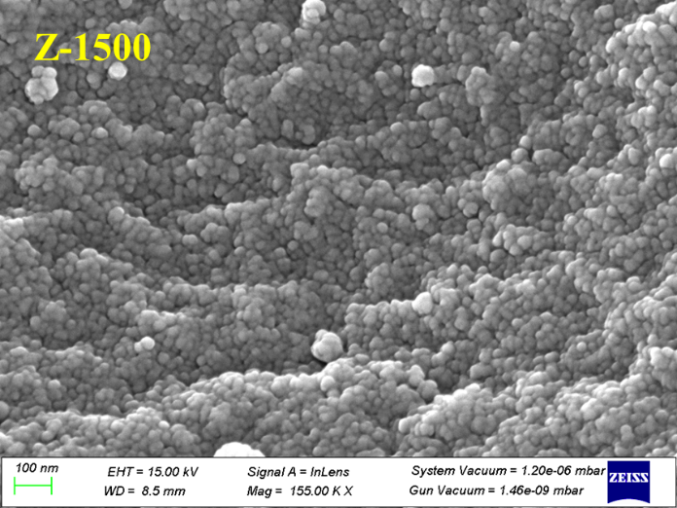 | 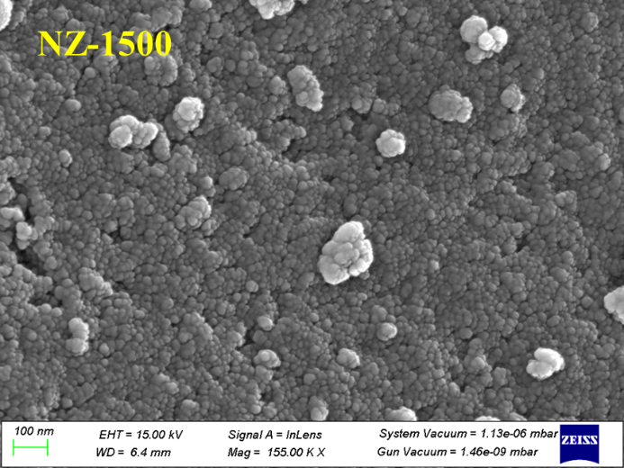
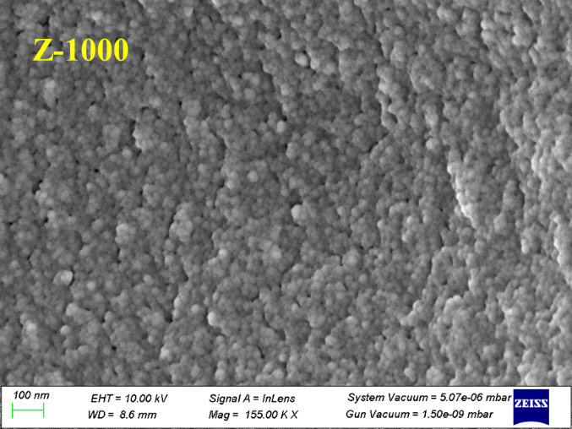 | 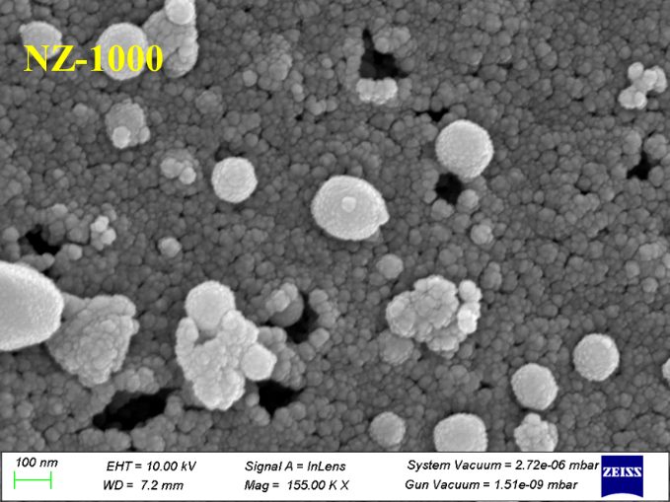
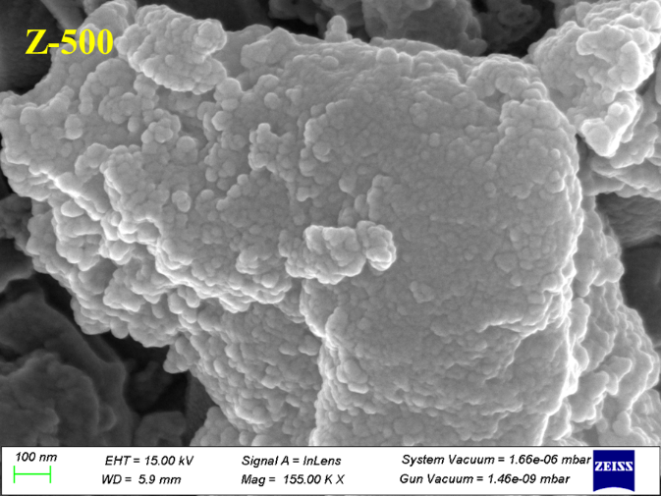 | 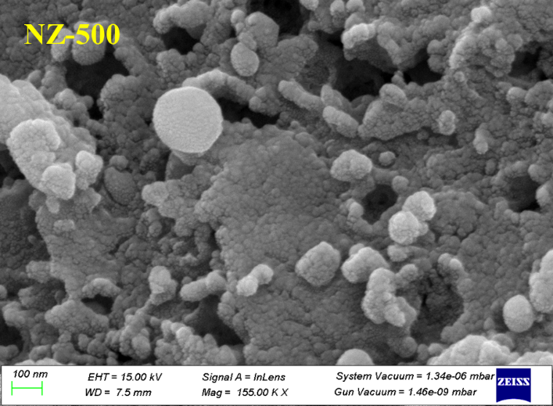
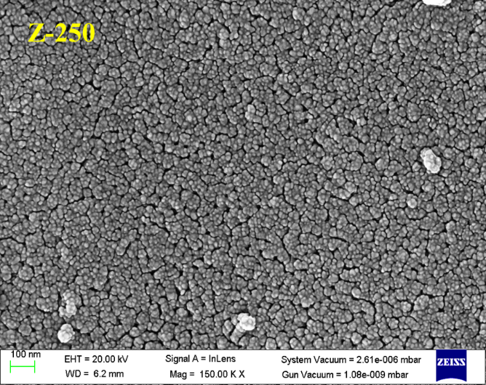 | 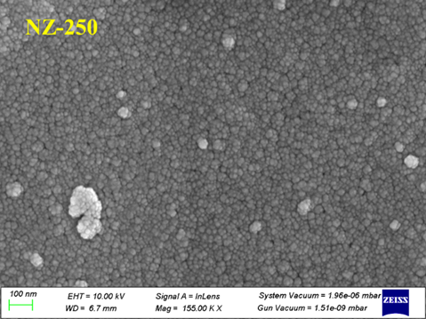
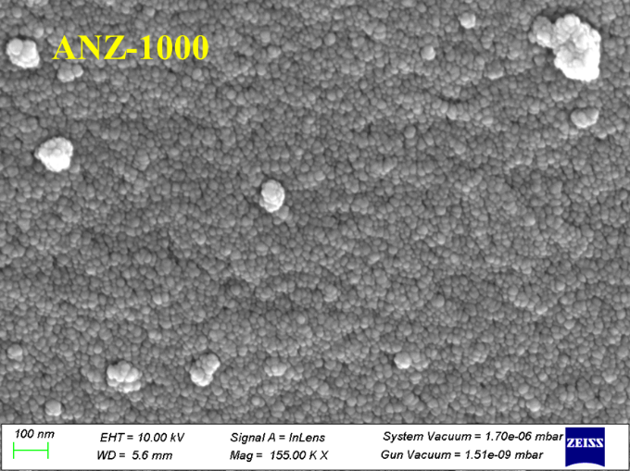 | 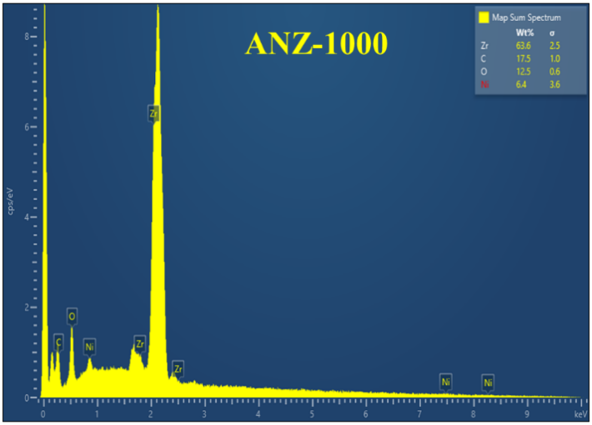
Fig. S2. Fe-SEM images of Zr-MOF, Ni/ZrO₂ derived MOF and spent NZ-1000 catalyst after 12.5 h reaction.
It was observed that Zr-MOF exhibited a dense morphology. However, for the reduced Ni/ZrO₂ derived MOF catalyst, clear morphological changes were noted. NZ-2000 and NZ-1500 displayed spherical-shaped particles closely aligned with each other. In contrast, NZ-1000 exhibited well-aligned spherical particles like those reported in the literature (Wen et al. 2017; Pandey et al. 2023). Furthermore, as the amount of zirconia precursor increased (NZ-500 and NZ-250) during the synthesis, it was observed that agglomerated clusters and compactness increased. BET and PSD analysis also demonstrated the changes in porosity. The FE-SEM results suggested that the morphology of the catalysts was significantly influenced by the molar ratio of the precursor and solvent, as well as by the addition of nickel followed by calcination. The spent catalyst (NZ-1000) characterization results indicated a compact cluster of particles. EDX of the ANZ-1000 catalyst showed a relative 17.5 wt.% carbon over the catalyst.

S3. HR-TEM Analysis
Fig. S3 (a) shows the ill-defined nano-sheets arranged randomly and SAED (selected area electron diffraction) in Fig.S3(b) illustrates the absence of crystallinity. However, Ni/ZrO₂ derived MOF (NZ-1000) nanoparticles were observed in Fig. S3(c) due to the presence of nickel metal and calcination of the catalyst breakdown the Zr-MOF structure into ZrO₂. The crystallinity of the catalyst was also observed by SEAD (Fig. S3(d)). The EDX mapping confirmed the even dispersion of Ni-metal on the catalyst (Fig. S3(e)). The particle size histogram is plotted in Fig. S3(f) and the calculated average Ni- particle size was ~ 32 nm, which is different from Ni-particle size calculated by XRD because in XRD Ni and Zr peaks appeared in the same 2θ position. TEM image of the spent catalyst (Fig. S3(g)) revealed the bigger size nanoparticles, and the increase of nickel particle size also enhanced the crystallinity that was observed by SAED (Fig. S3(h)). The agglomeration of the Ni-metal and carbon deposition was also observed by the EDX analysis (Fig. S3(i)) and the calculated average Ni- particle size was ~ 88 nm was calculated by histogram (Fig. S3(j)). The increase in nickel particle size was due to metal sintering (Kumar et al. 2019; Pham et al. 2021).

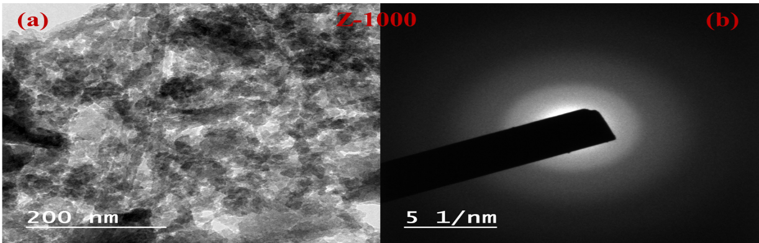
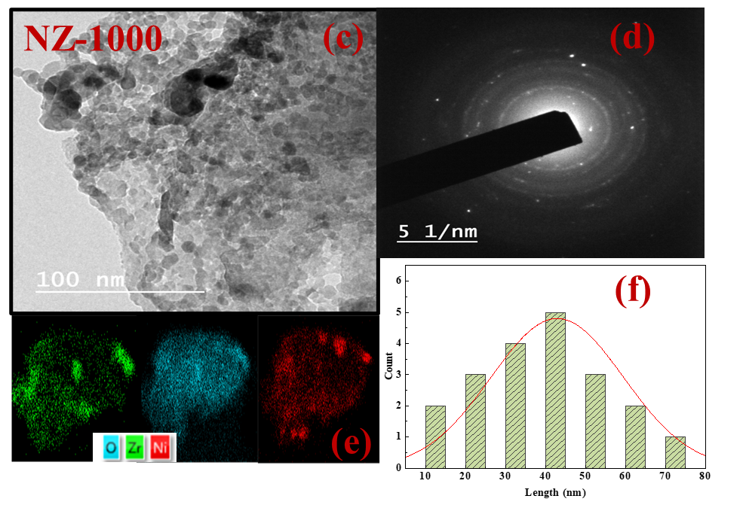
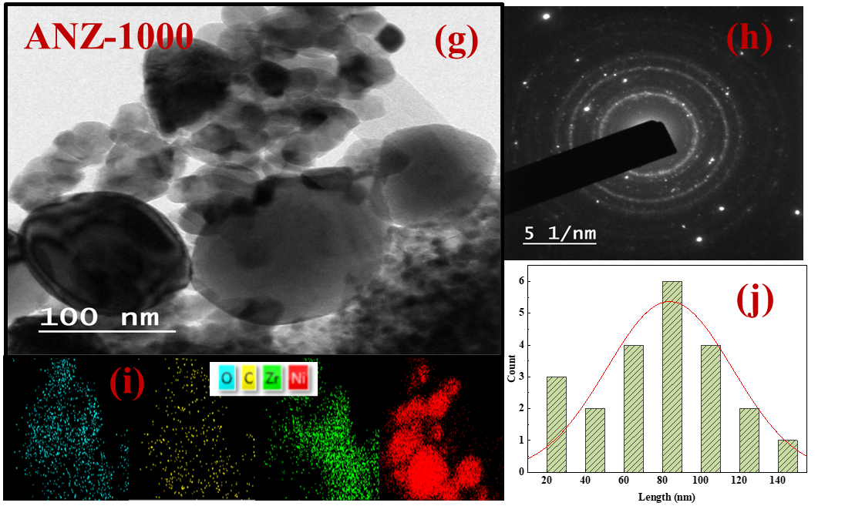
Fig. S3. HR-TEM images of Zr-MOF (Z-1000), Ni/ZrO₂ derived MOF (NZ-1000) and spent NZ-1000 catalyst after 12.5 h reaction.

References
Kumar R, Kumar K, Choudary N V., Pant KK (2019) Effect of support materials on the performance of Ni-based catalysts in tri-reforming of methane. Fuel Processing Technology 186:40–52. https://doi.org/10.1016/j.fuproc.2018.12.018
Pandey A, Biswas P, Pant KK, Dalai AK (2023) Tri-reforming of CH4 over a Thermally Stable and Carbon-Resistant Nanonickel Metal Catalyst Dispersed on Mesoporous-Zirconia. Ind Eng Chem Res. https://doi.org/10.1021/acs.iecr.3c03645
Pham XH, Ashik UPM, Hayashi JI, et al (2021) Review on the catalytic tri-reforming of methane - Part II: Catalyst development. Appl Catal A Gen 623. https://doi.org/10.1016/j.apcata.2021.118286
Wen J, Zhu T, Xie Z, et al (2017) A strategy to obtain a high-density and high-strength zirconia ceramic via ceramic injection molding by the modification of oleic acid. International Journal of Minerals, Metallurgy, and Materials 24:718–725. https://doi.org/10.1007/s12613-017-1455-9

