Multiple roles of the anillin gene in the Drosophila nervous system

Man Anh Huynh, Dang Thi Phuong Thao, Hideki Yoshida

Supplementary Figure 1. Expression patterns of Ani in the larval CNS. Ani is expressed throughout the CNS, especially in the optic lobe and at the thorax in the VNC, including in the putative midline glia. The proliferating cells were visualized with BrdU. Dpn and Dac are markers for type I and II NBs and lamina furrow and neurons, respectively. Scale bar, 100 µm.
Supplementary Figure 2. The expression patterns of Ani and Elav in the larval CNS. Ani is colocalized with Elav throughout the larval CNS. Scale bar, 100 µm.

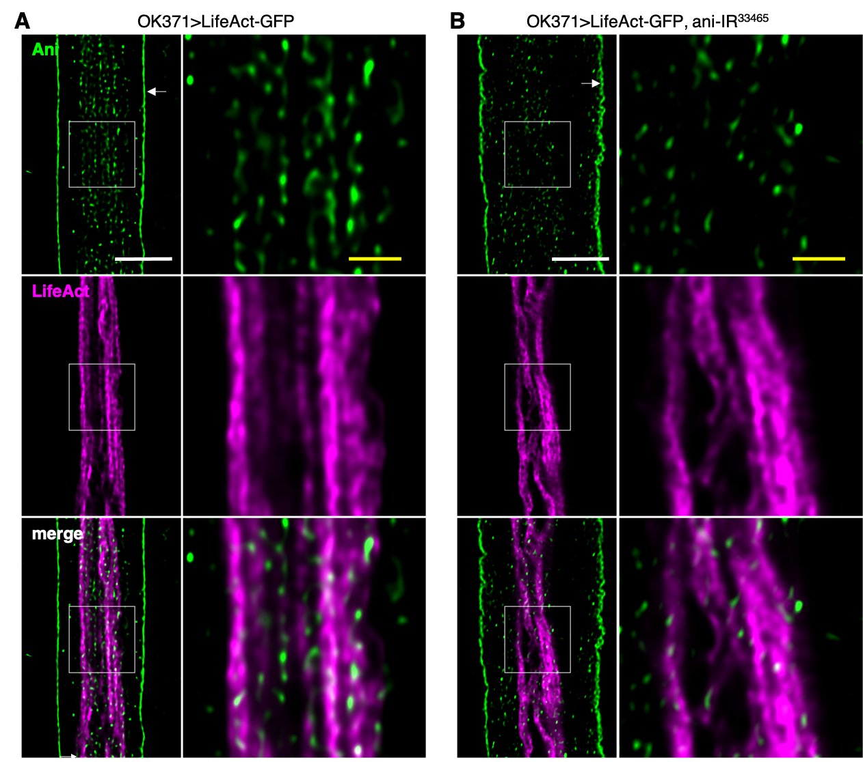

Supplementary Figure 3. Expression patterns of Ani in the axon of the motor neuron. Some Ani signals were colocalized with F-actin in the axon. The Ani expression level decreased and the alignment of F-actin was impaired in the ani knockdown larvae. Arrows indicate the layer of the predicted perineurial and subperineurial glia. The areas marked with white boxes are shown in the right panels as a high-magnification image. White scale bar, 10 µm. Yellow scale bar, 2.5 µm.

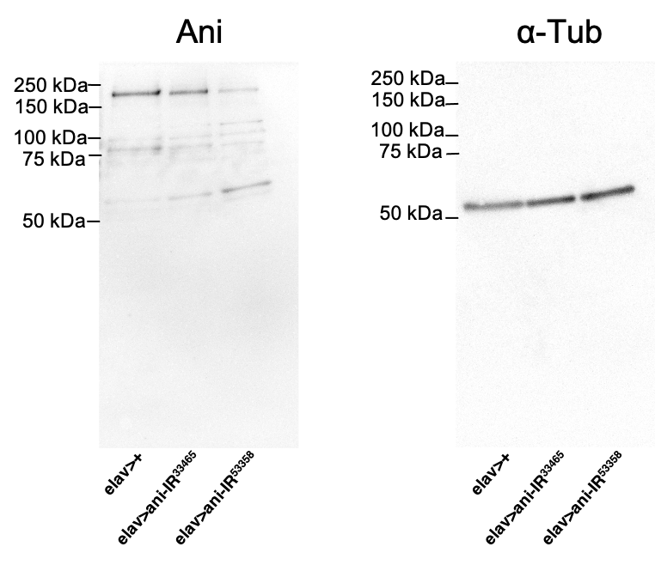
Supplementary Figure 4. Pan-neuron-specific ani knockdown decreased the expression level of Ani in the CNS. The protein was detected through Western blotting using anti-Ani IgG (Ani) or anti-α-Tub IgG (α-Tub). The arrow indicates bands of full-size Ani in each strain. The expression level of Ani decreased in ani knockdown flies. Positions of size markers are indicated.

Supplementary Figure 5. Expression patterns of elav-GAL4 (III) in the optic lobe of the larval CNS. Elav is colocalized with Ani and Dpn in the larval optic lobe. Dpn is a marker for type I and II NBs. Scale bar, 20 µm.

