Supplementary Figures
Table of contents
Fig. S1. Distribution heatmap of SNPs and InDels identified in the 166 autotetraploid potatoes.
Fig. S2. Neighbor-joining phylogenetic tree of the 166 autotetraploid potato accessions with bootstrap supporting values indicated.
Fig. S3. Phylogenetic tree of the 166 autotetraploid potato accessions.
Fig. S4. Determination of the best optimal K values in STRUCTURE analysis.
Fig. S5. Model-based clustering analysis of 166 autotetraploid potato accessions.
Fig. S6. Enrichment for InterPro protein functional domains in genes carrying starch group-specific variants that possibly affect protein functions.
Fig. S7. Ten permutation tests of computing FST.
Fig. S8. Validation of the population fixation approach by recovering previously mapped major-effect functional QTLs.
Fig. S9. Alien introgression in starch potato varieties from S. vernei.
Fig. S10. Genome-wide introgression signatures of 12 out of the 23 starch varieties.
Fig. S11. Genome-wide introgression signatures of the remaining 11 out of the 23 starch varieties.
Fig. S12. Distribution and correlation between the five investigated agronomic traits.
Fig. S13. GWAS for tuber flesh color, tuber skin color and resistance to common scab.
Fig. S14. Tajima’s D measured in European potatoes and starch industry potato varieties.
Fig. S15. Genome-wide distribution of NLR-encoding genes and signature of wild introgression.
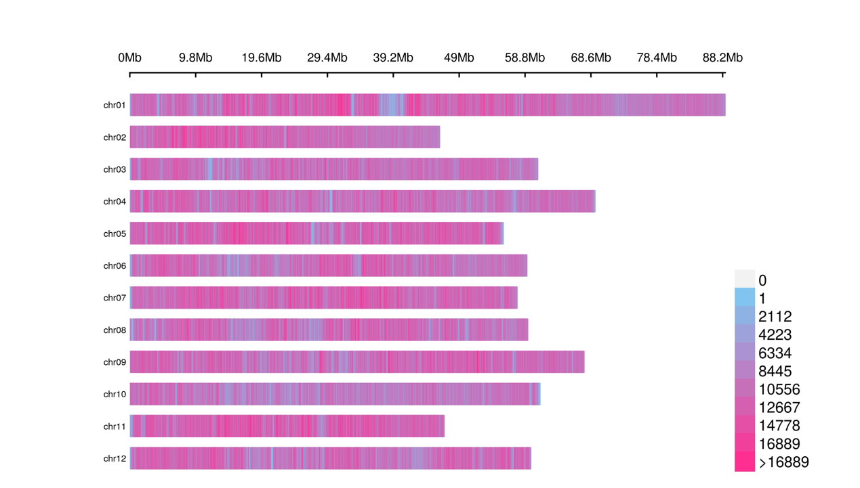
Fig. S1. Distribution heatmap of SNPs and InDels identified in the 166 autotetraploid potatoes. Number of SNPs and InDels were computed based on 100-kb non-overlapping genomic windows.
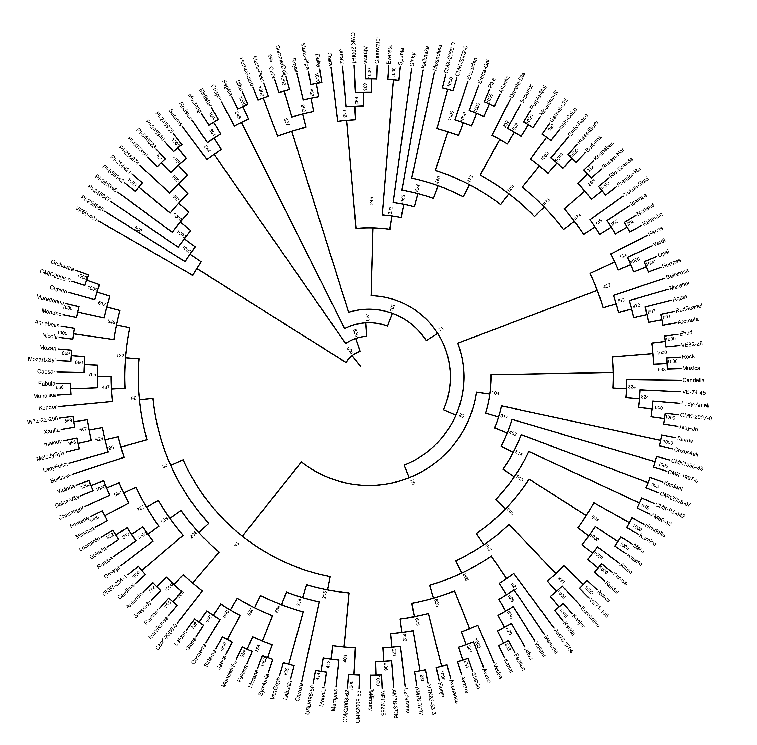
Fig. S2. Neighbor-joining phylogenetic tree of the 166 autotetraploid potato accessions with bootstrap supporting values indicated. A total of 1,000 bootstraps were performed.
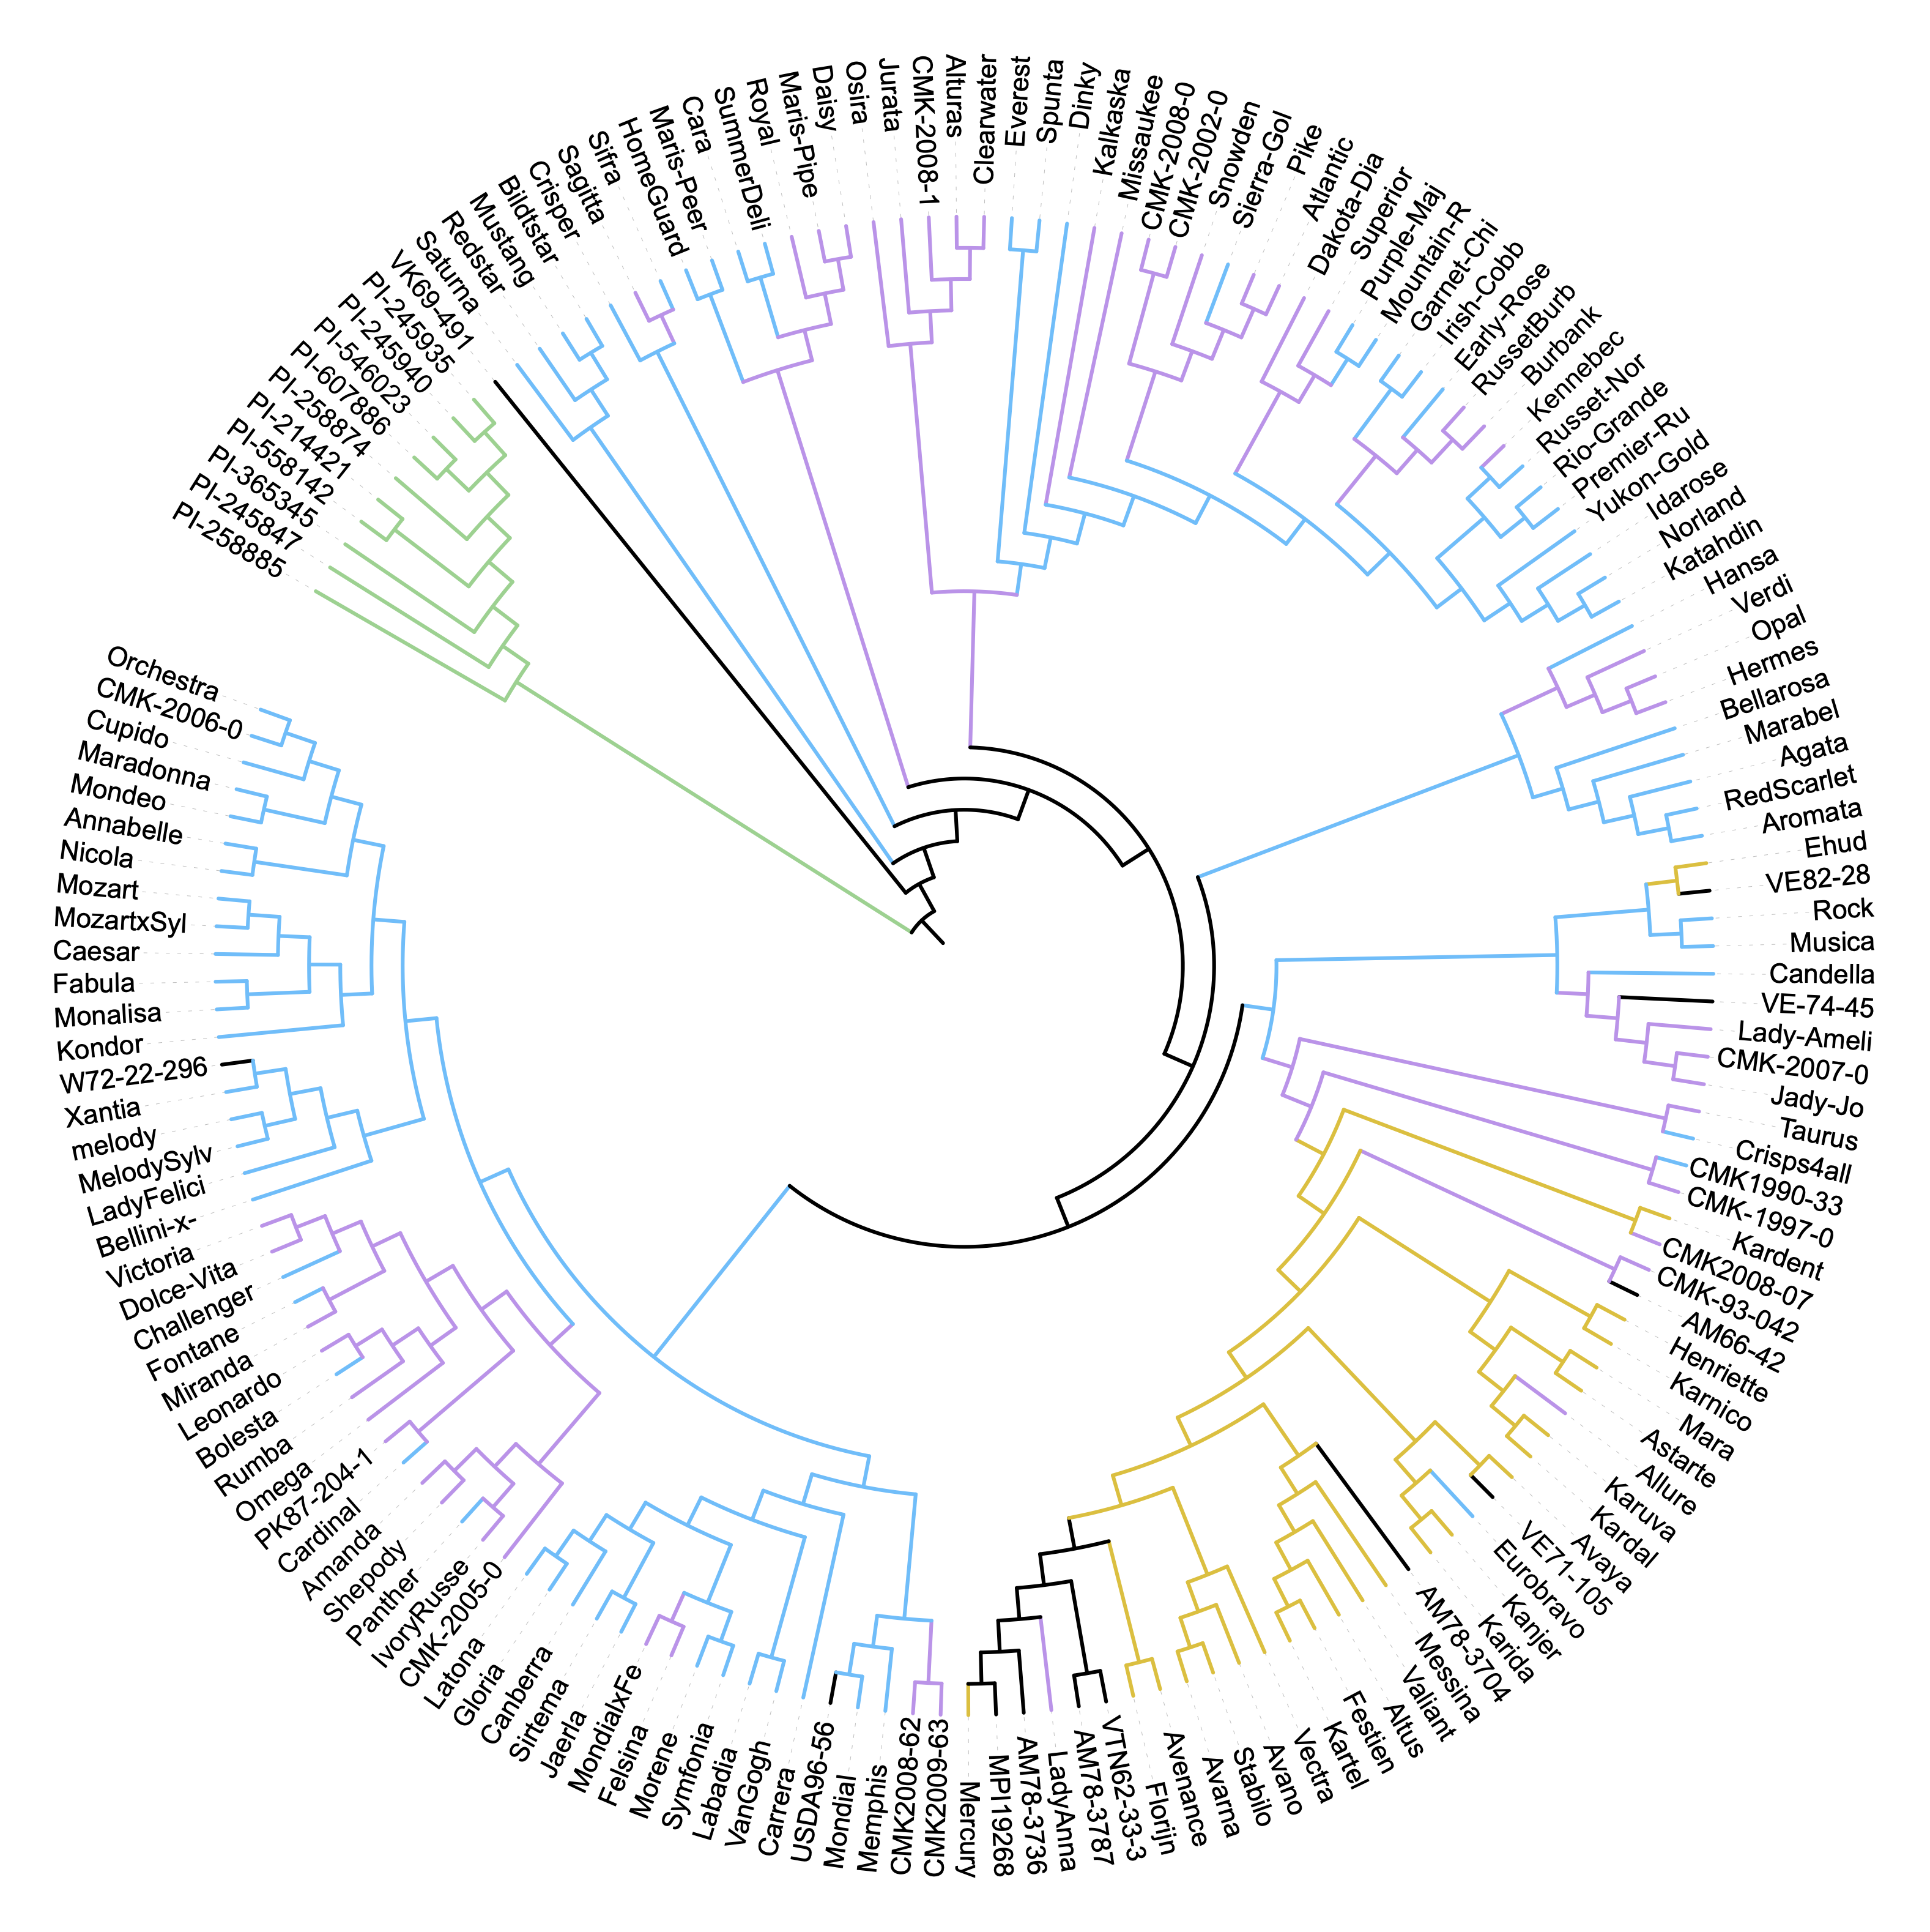
Fig. S3. Phylogenetic tree of the 166 autotetraploid potato accessions. Branches are colored based on market classes of these accessions. Blue, fresh consumption market; purple, processing crisps or French fries; yellow, starch industry; black, breeding materials; green, tetraploid landraces (outgroup).
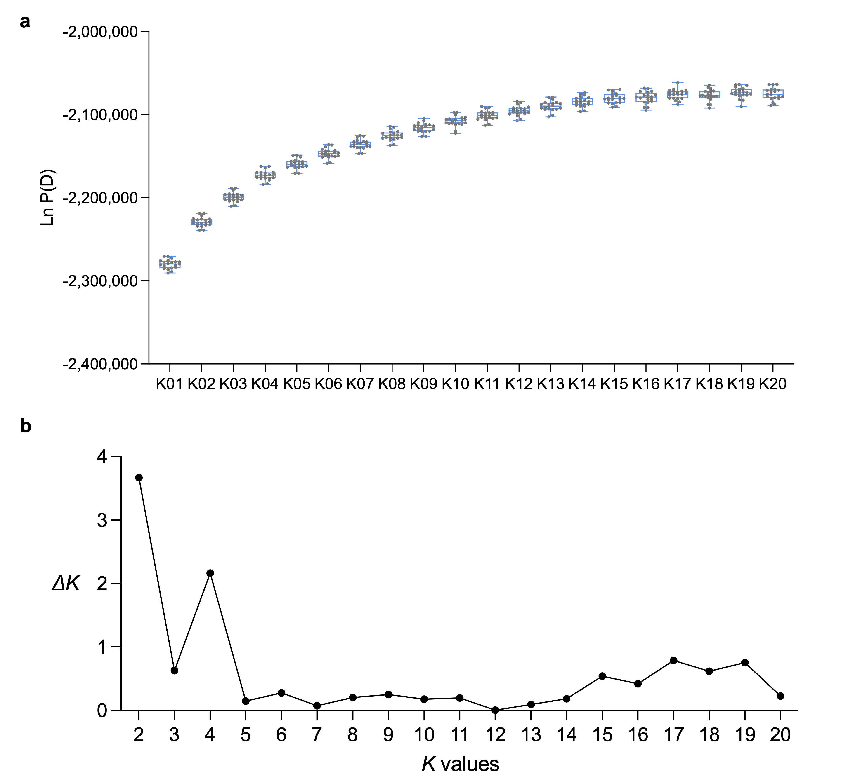
Fig. S4. Determination of the best optimal K values in STRUCTURE analysis. a, The posterior probability Ln P(D) when K is equal to 1–20. The upper and lower edges of boxes denote 75% and 25% quartiles and the central line indicates the median. Each box contains 20 replicates. The whiskers extend to the minimum and maximum of the data. b, ∆K values when K is ranged between 2 and 20.
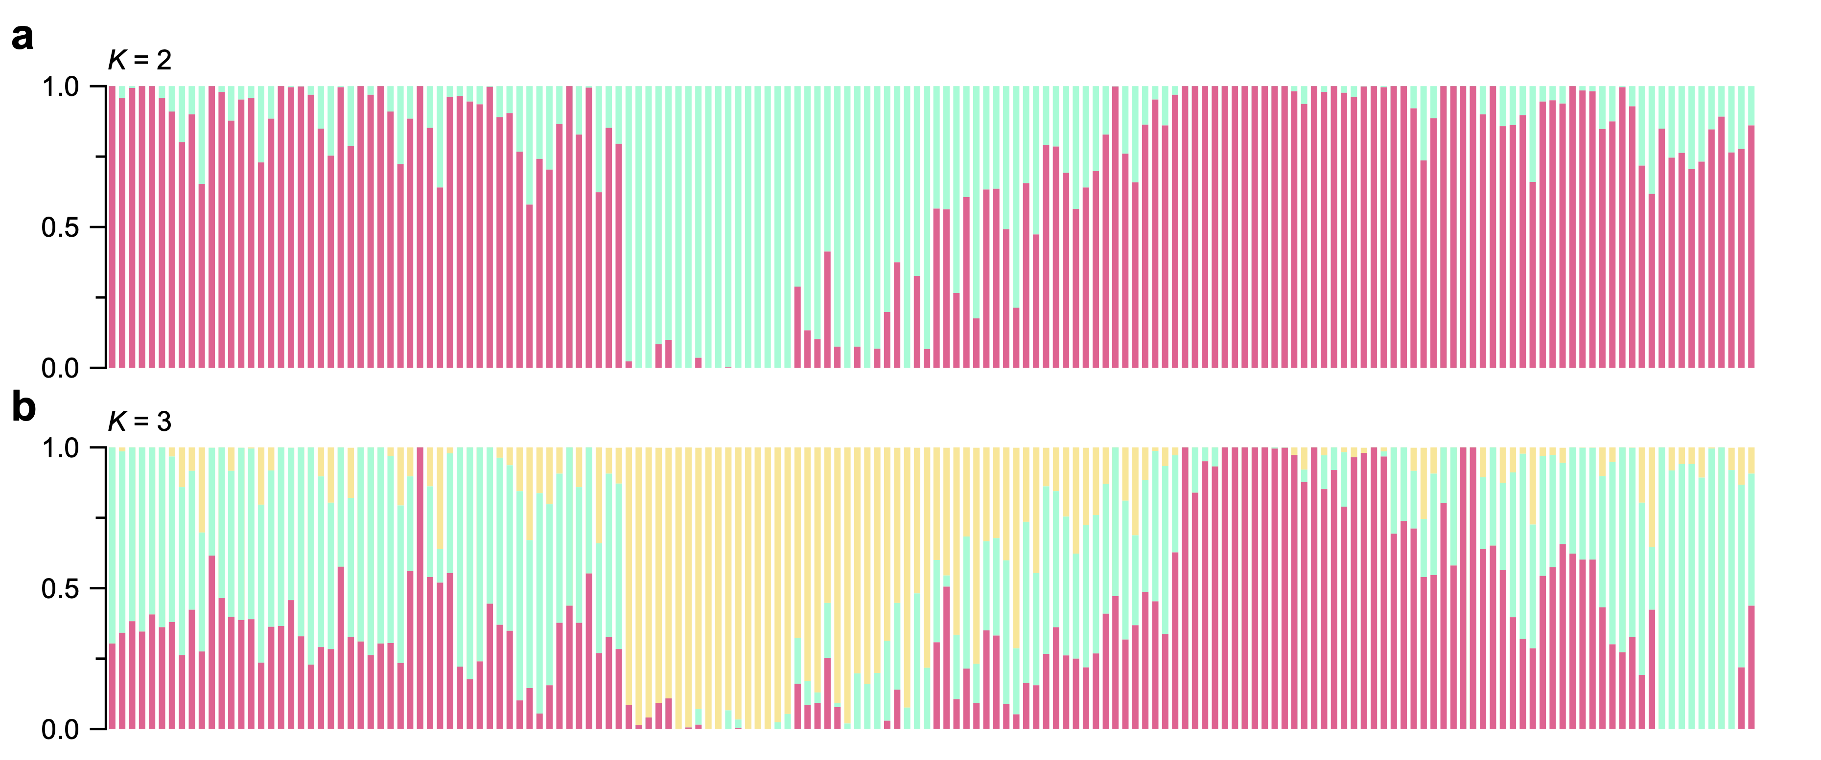
Fig. S5. Model-based clustering analysis of 166 autotetraploid potato accessions. The number of groups (K) was set to 2 (a) and 3 (b). The y axis quantifies group membership, and the x axis denotes the different accessions.
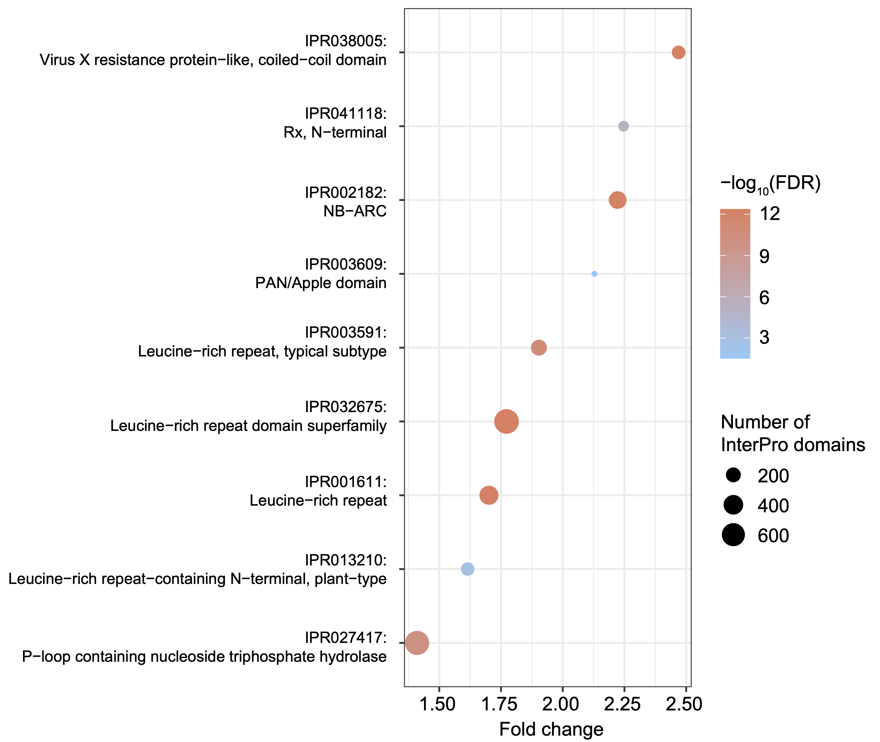
Fig. S6. Enrichment for InterPro protein functional domains in genes carrying starch group-specific variants that possibly affect protein functions. FDR, false discovery rate computed by two-tailed Fisher’s exact test. Fold change was calculated by dividing proportions of given InterPro domains in genes carrying starch group-specific variants and those in all genes in the potato genome.
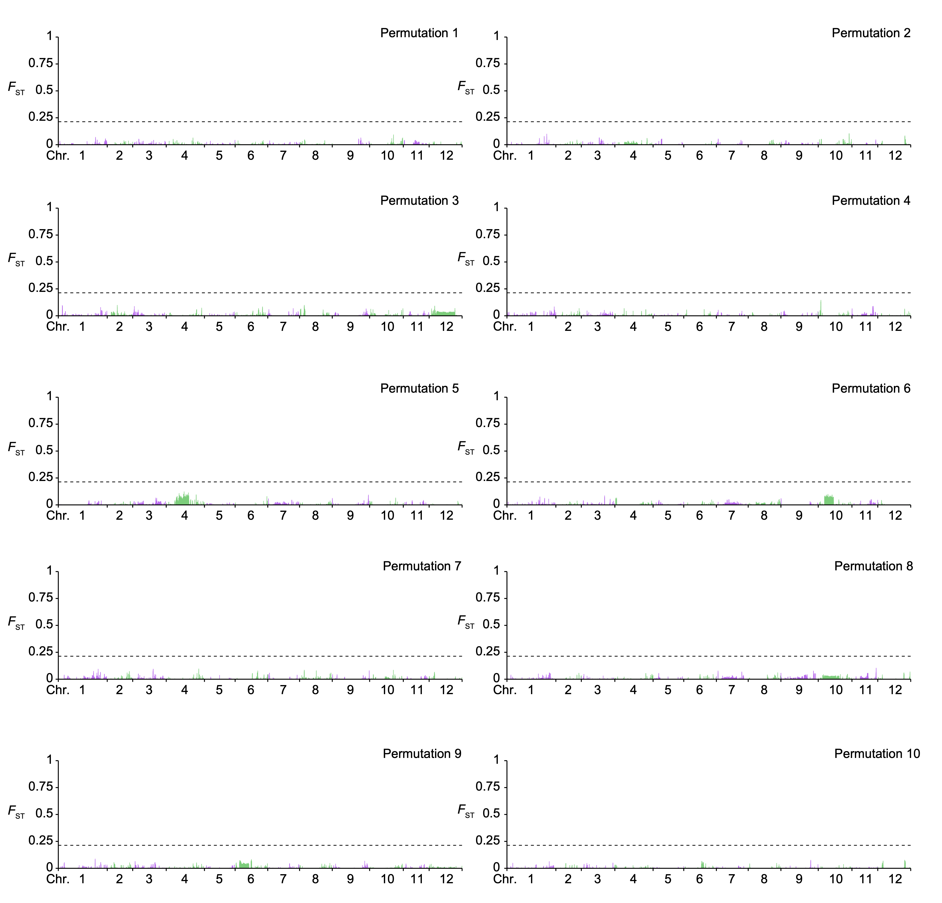
Fig. S7. Ten permutation tests of computing F_{ST}. F_{ST} in the ten permutation tests were computed by reshuffling the 125 potato accessions into two groups. The black dash line denotes the threshold (0.21).
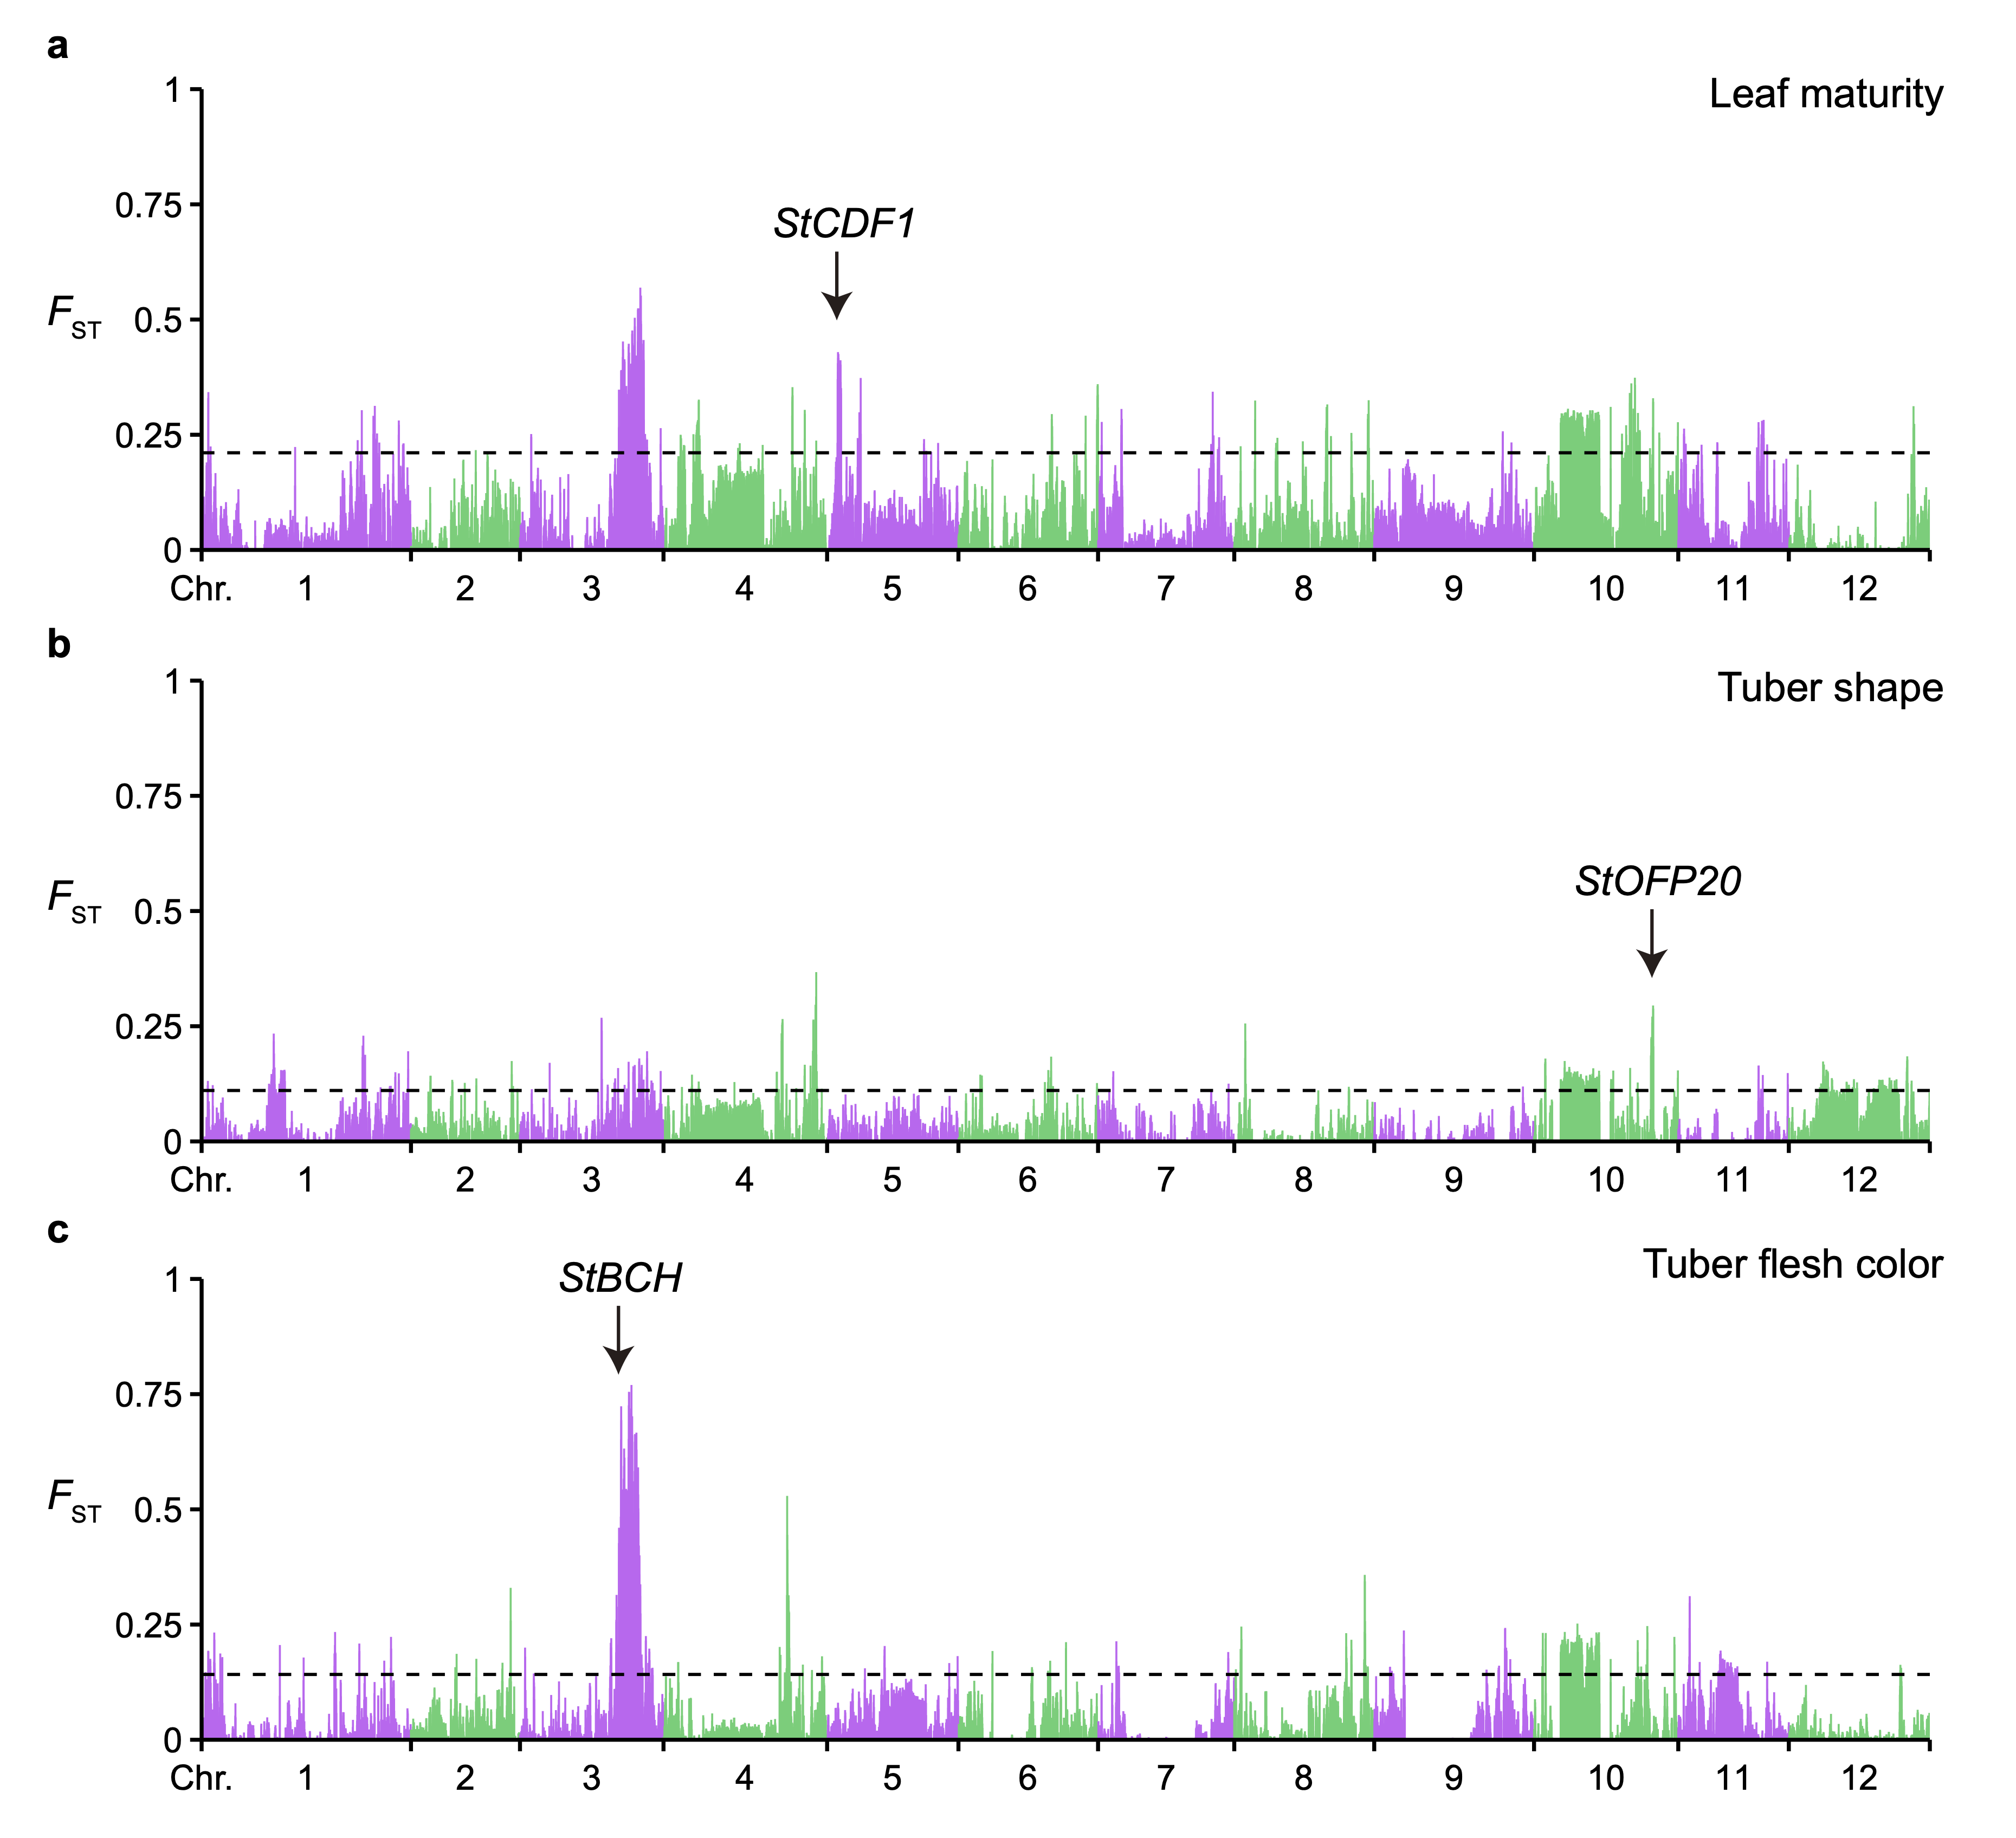
Fig. S8. Validation of the population fixation approach by recovering previously mapped major-effect functional QTLs. a, Identification of the StCDF1 locus between potato accessions showing the most early (21) and the most late (18) plant maturity. b, Identification of the StOFP20 locus between potato accessions with the lowest tuber shape index (round; 16) and the highest tuber shape index (long; 22). c, Identification of the StBCH locus between potato accessions with the darkest (27) and the lightest (18) tuber flesh color.
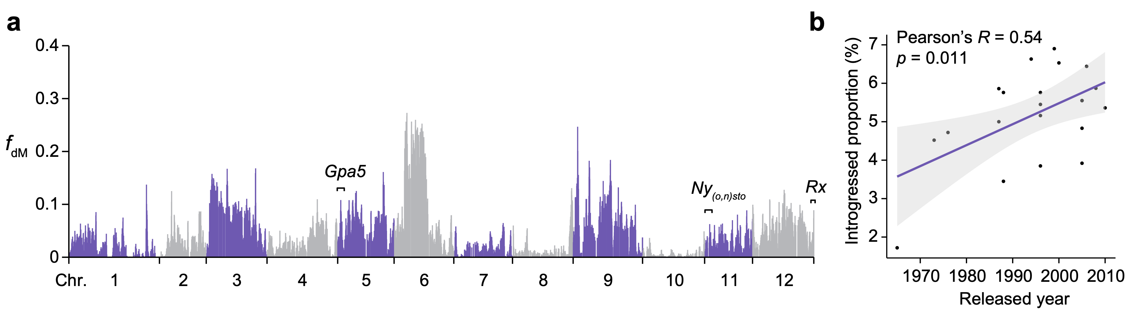
Fig. S9. Alien introgression in starch potato varieties from S. vernei. a, Overview of introgressions from S. vernei in the 23 starch varieties measured by f_{dM}. Previously reported resistance gene loci are also marked. b, Correlation between released years of starch varieties and proportions of introgressed genomic regions. Number of starch varieties with available data is 21. Correlation coefficient R and the p value were calculated by two-tailed Pearson’s correlation test. The grey shade indicates 95% confidence interval.
Fig. S10. Genome-wide introgression signatures of 12 out of the 23 starch varieties. Introgression patterns measured by f_{dM} for Altus, Astarte, Avano, Avarna, Avaya, Avenance, Ehud, Festien, Florijn, Henriette, Kanjer and Kardal are shown.
Fig. S11. Genome-wide introgression signatures of the remaining 11 out of the 23 starch varieties. Introgression patterns measured by f_{dM} for Kardent, Karida, Karnico, Kartel, Karuva, Mara, Mercury, Messina, Stabilo, Valiant and Vectra are shown.
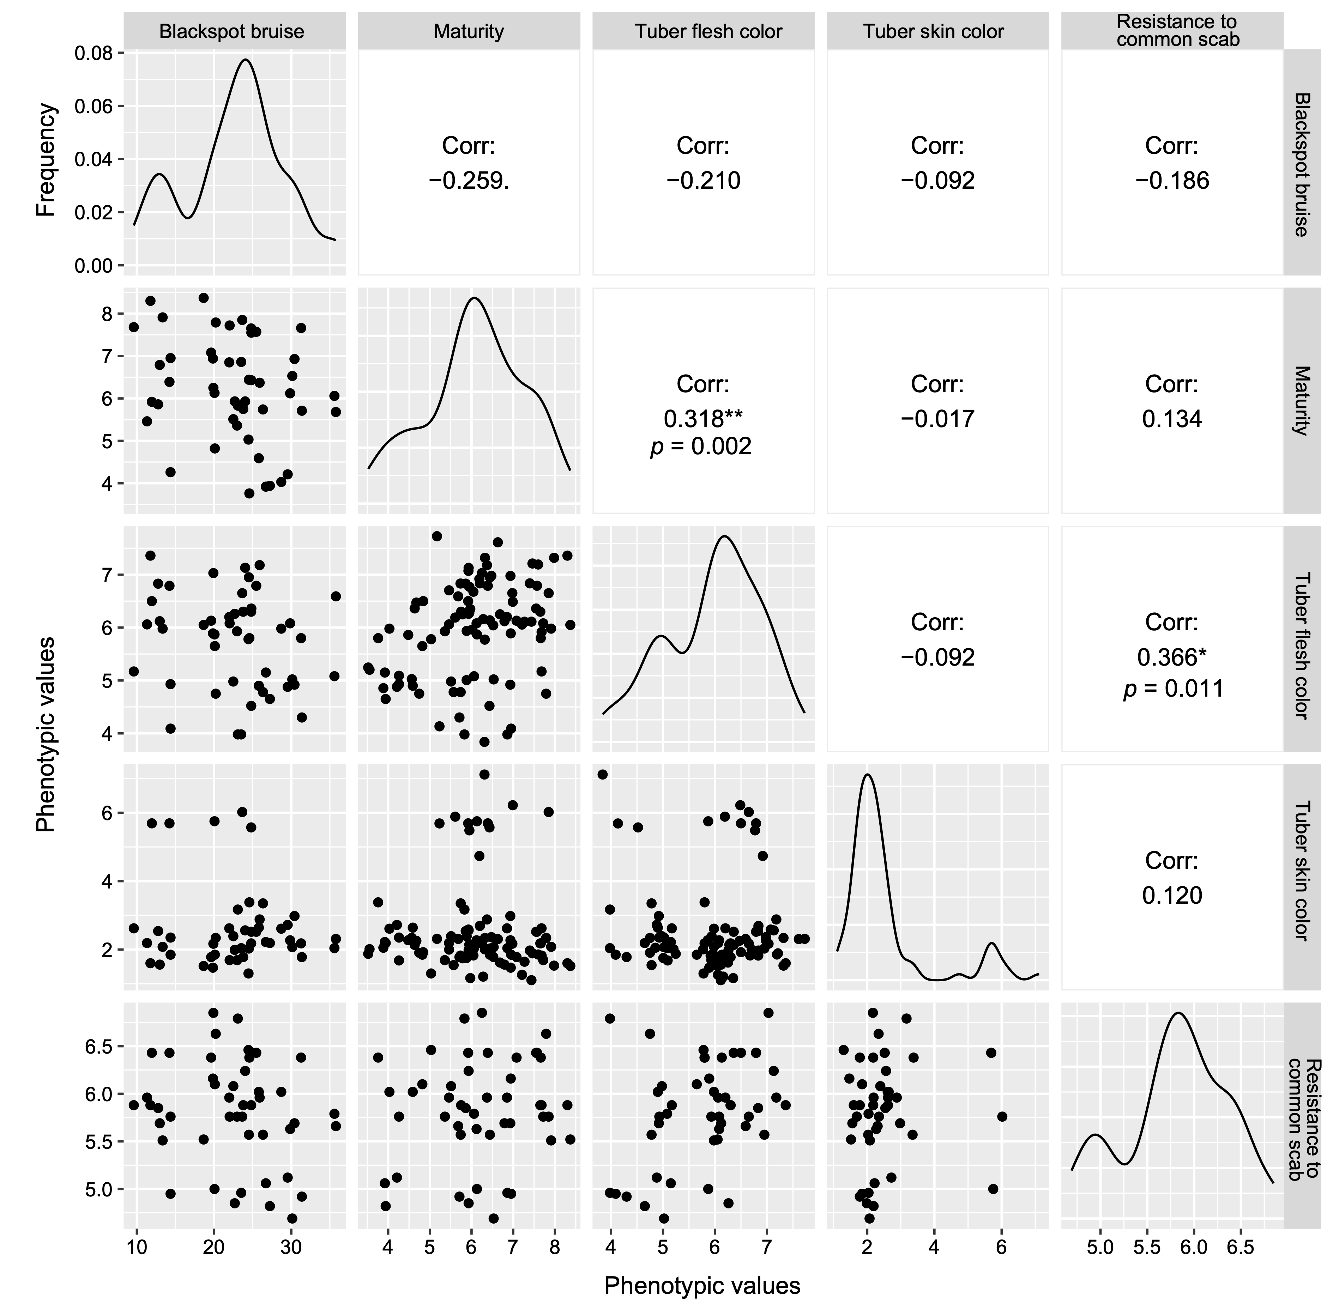
Fig. S12. Distribution and correlation between the five investigated agronomic traits. Pearson’s correlation coefficients (R) between each pair of traits are indicated. * p < 0.05 and ** p < 0.01 in two-tailed Pearson’s correlation tests.
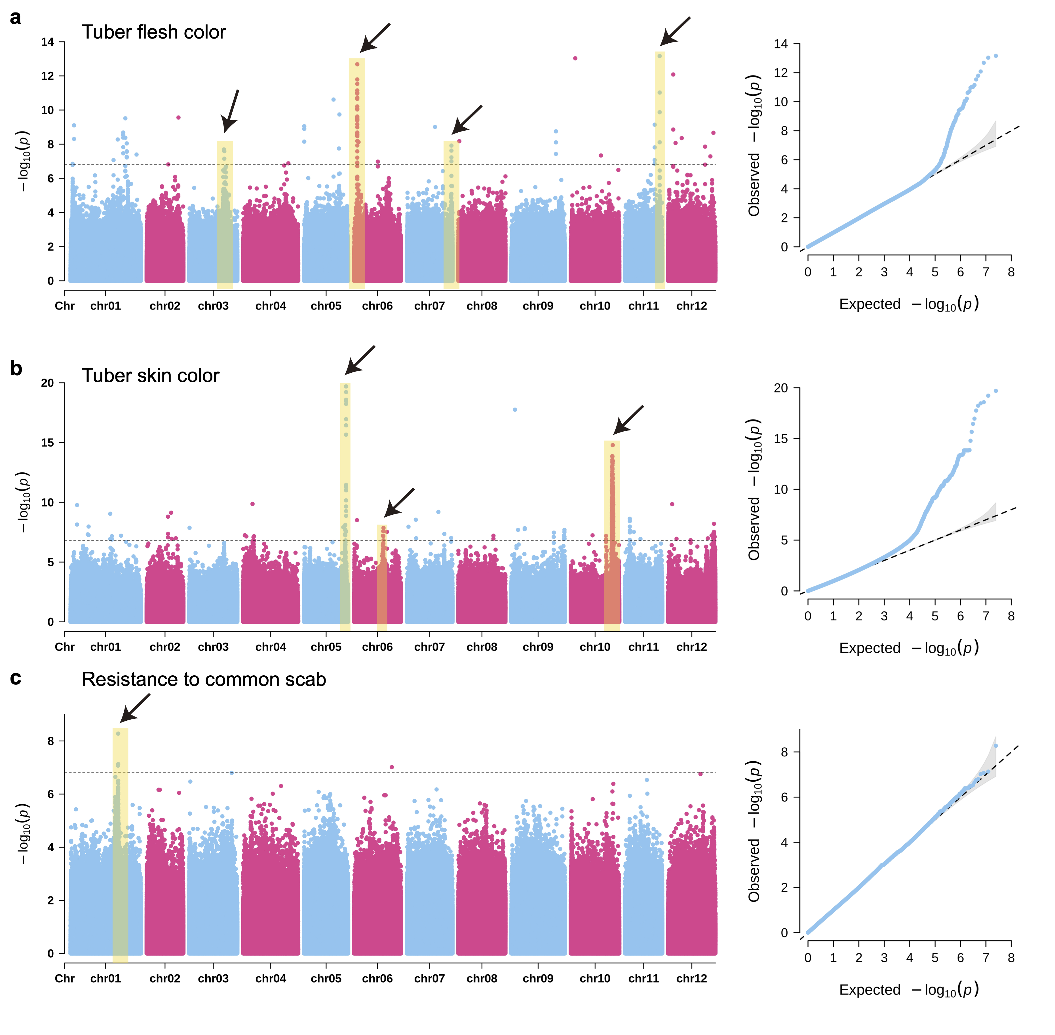
Fig. S13. GWAS for tuber flesh color, tuber skin color and resistance to common scab. Manhattan plots and quantile-quantile (QQ) plots of GWAS for tuber flesh color (a), tuber skin color (b) and resistance to common scab (c). Significantly associated signals are marked using black arrows and yellow rectangles. Grey shades in QQ plots represent 95% confidence interval. P values were calculated using the GWASpoly software under the additive model. The black dashed line indicates genome-wide significant threshold (1.5 × 10⁻⁷).
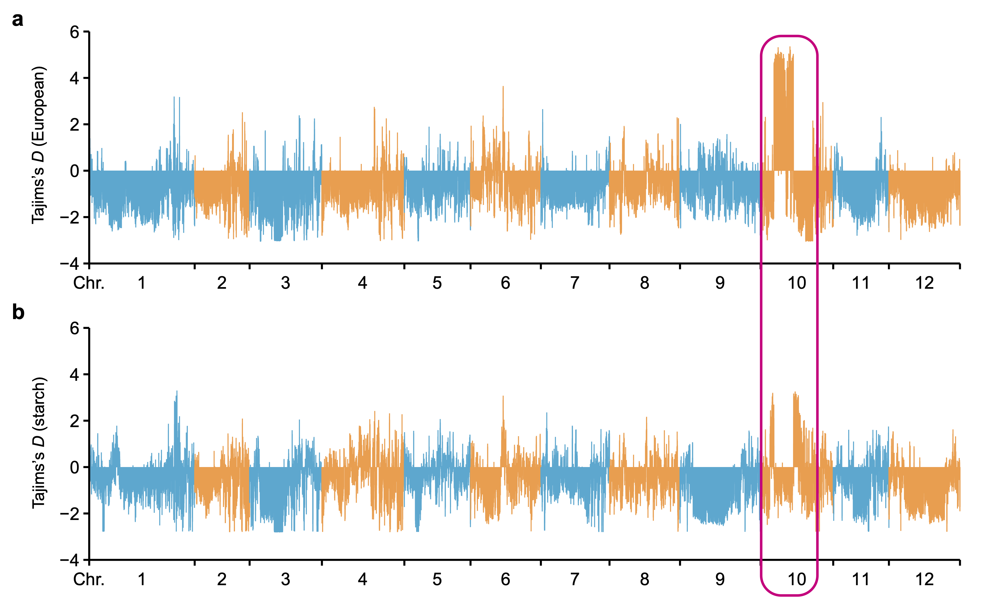
Fig. S14. Tajima’s D measured in European potatoes and starch industry potato varieties. a, Tajima’s D in the 95 European potato accessions. b, Tajima’s D in the 23 starch industry potato varieties. The pink circle marks the region on chromosome 10 that has possibly under strong positive selection in starch varieties. The pink rectangular marks the genomic region on chromosome 10 which may have undergone selection in starch potato varieties.
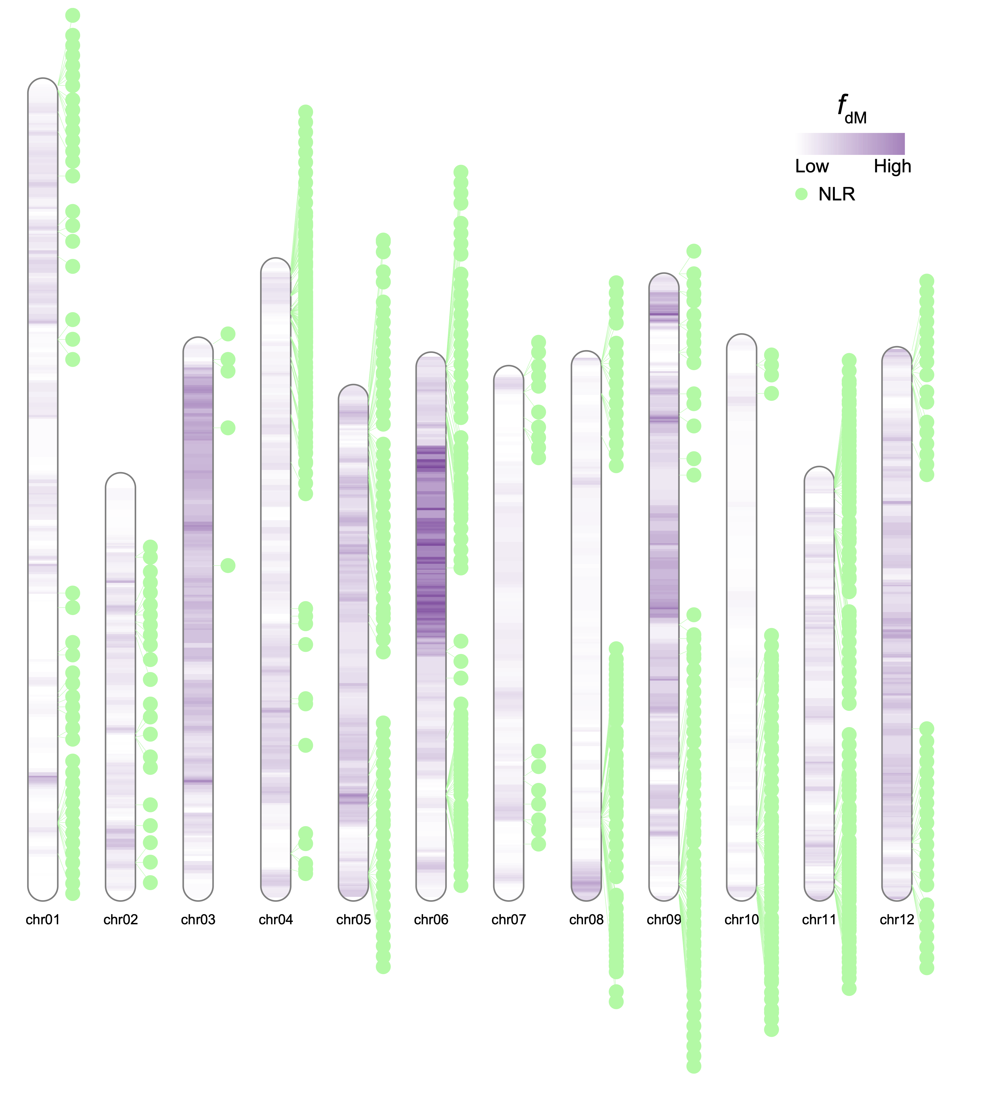
Fig. S15. Genome-wide distribution of NLR-encoding genes and signature of wild introgression. NLR-encoding genes are marked using green dots. Introgression proportion, estimated by f_{dM}, is shown in heat maps across the 12 potato chromosomes.

