SUPPLEMENTARY MATERIALS

Inhibitory Activity of Chemical Constituents from Vitellaria paradoxa Gaertn. (Sapotaceae) Against Pathogens associated with Respiratory Tract Infections
Olusesan Ojo ^{1,2*}, Edwin M. Mmutlane³ and Derek T. Ndinteh^{1*}
¹Centre for Natural Product Research (CNPR), Chemical Sciences Department, University of Johannesburg, Doornfontein, Johannesburg 2028, South Africa
²Department of Chemical Sciences, Lead City University, Toll Gate Area, Ibadan, Oyo State, Nigeria
³Research Centre for Synthesis and Catalysis, Department of Chemical Sciences, University of Johannesburg, Kingsway Campus, Auckland Park, P.O. Box 524, Johannesburg, South Africa

* Corresponding authors. ojoolusesan33@gmail.com (O. O.); dndinteh@uj.ac.za (D.T.N)

Figure 1.1: ¹H NMR spectrum of 11α-hydroxy-β-amyrin cinnamate (Compound 1)
Figure 1.2: ¹³C NMR spectrum of 11α-hydroxy-β-amyrin cinnamate (Compound 1)
Figure 1.3: DEPT spectrum of 11α-hydroxy-β-amyrin cinnamate (Compound 1)
Figure 1.4: ESI-MS spectrum of 11α-hydroxy-β-amyrin cinnamate (Compound 1)
Figure 1.5: ¹H NMR spectrum of α-amyrin cinnamate (Compound 2)
Figure 1.6: ¹³C NMR spectrum of α-amyrin cinnamate (Compound 2)
Figure 1.7: FTIR spectrum of α-amyrin cinnamate (Compound 2)
Figure 1.8: ESI-MS spectrum of α-amyrin cinnamate (Compound 2)
Figure 1.9: ¹H NMR spectrum of sitosterol cinnamate (Compound 3)
Figure 1.10: ¹³C NMR spectrum of sitosterol cinnamate (Compound 3)
Figure 1.11: HSQC spectrum of sitosterol cinnamate (Compound 3)
Figure 1.12: FTIR spectrum of sitosterol cinnamate (Compound 3)
Table S1. GC-MS profile of hexane extract of V. paradoxa stem-bark

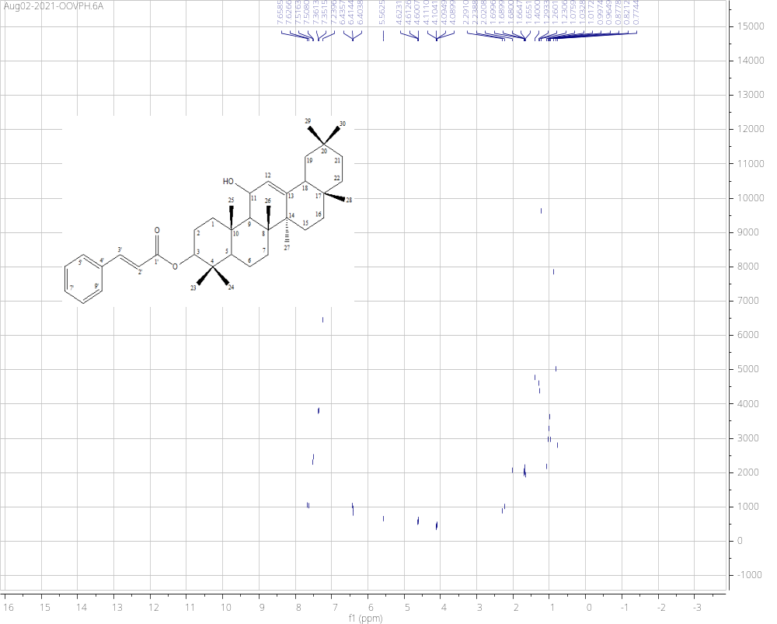
Figure 1.1: ¹H NMR spectrum of 11α-hydroxy-β-amyrin cinnamate (Compound 1)

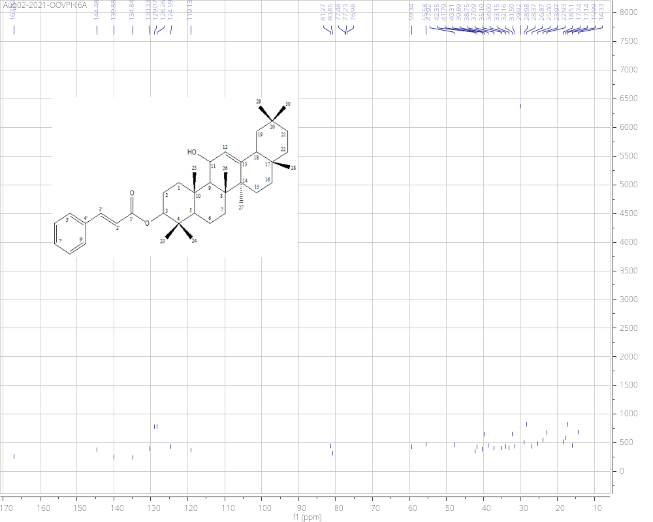
Figure 1.2: ¹³C NMR spectrum of 11α-hydroxy-β-amyrin cinnamate (Compound 1)

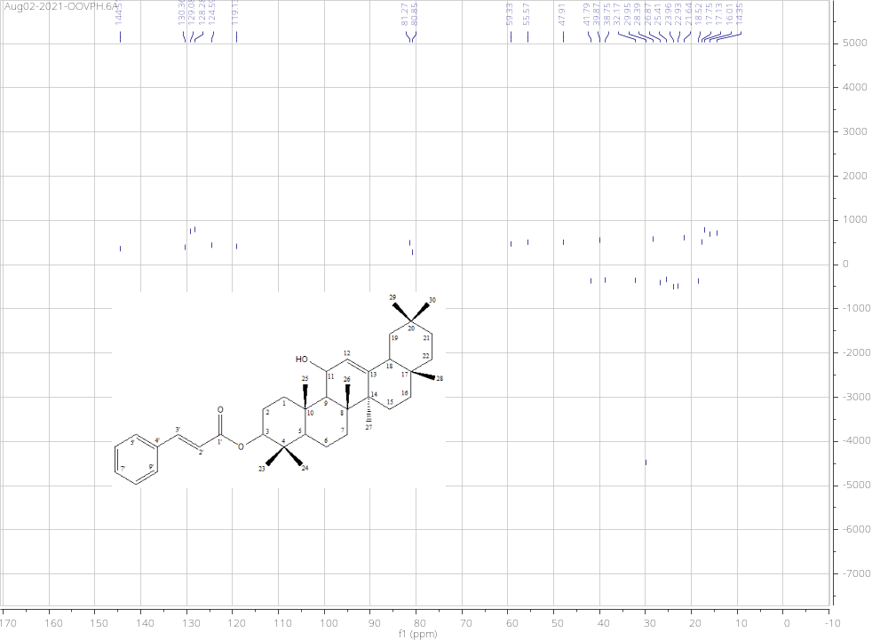
Figure 1.3: DEPT spectrum of 11α-hydroxy-β-amyrin cinnamate (Compound 1)

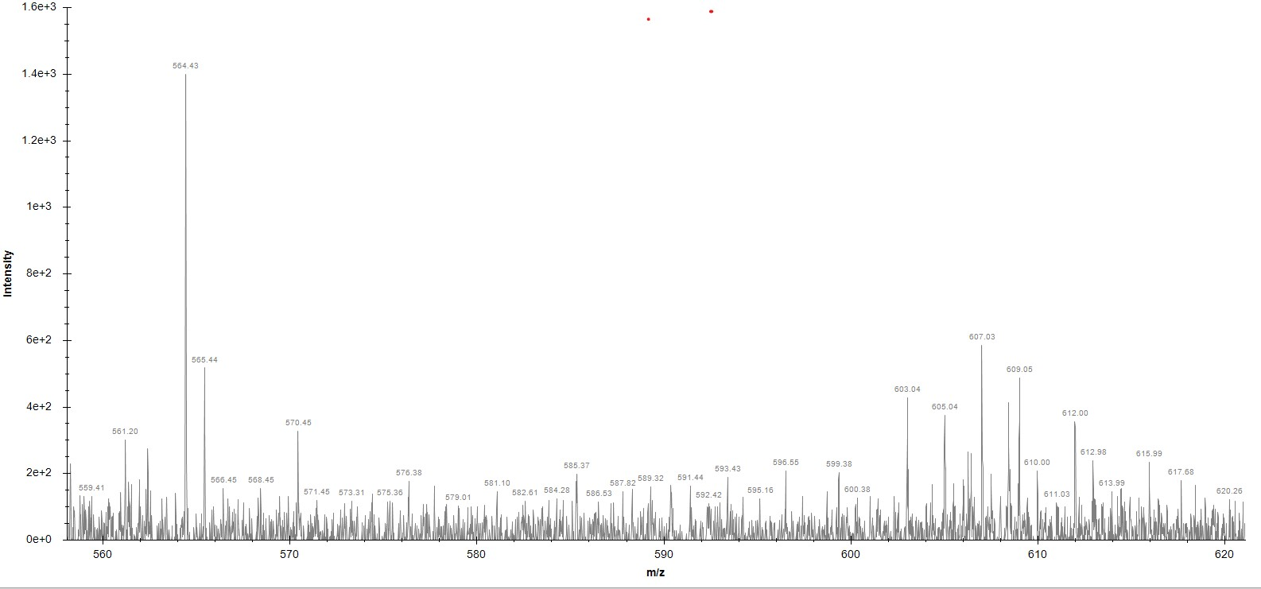

Figure 1.4: ESI-MS spectrum of 11α-hydroxy-β-amyrin cinnamate (Compound 1)

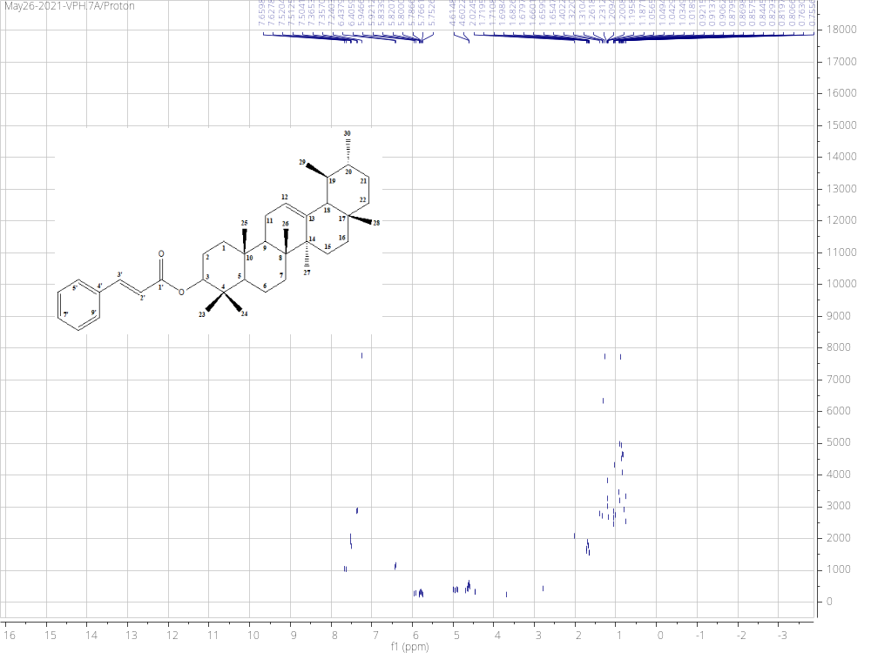
Figure 1.5: ¹H NMR spectrum of α-amyrin cinnamate (Compound 2)

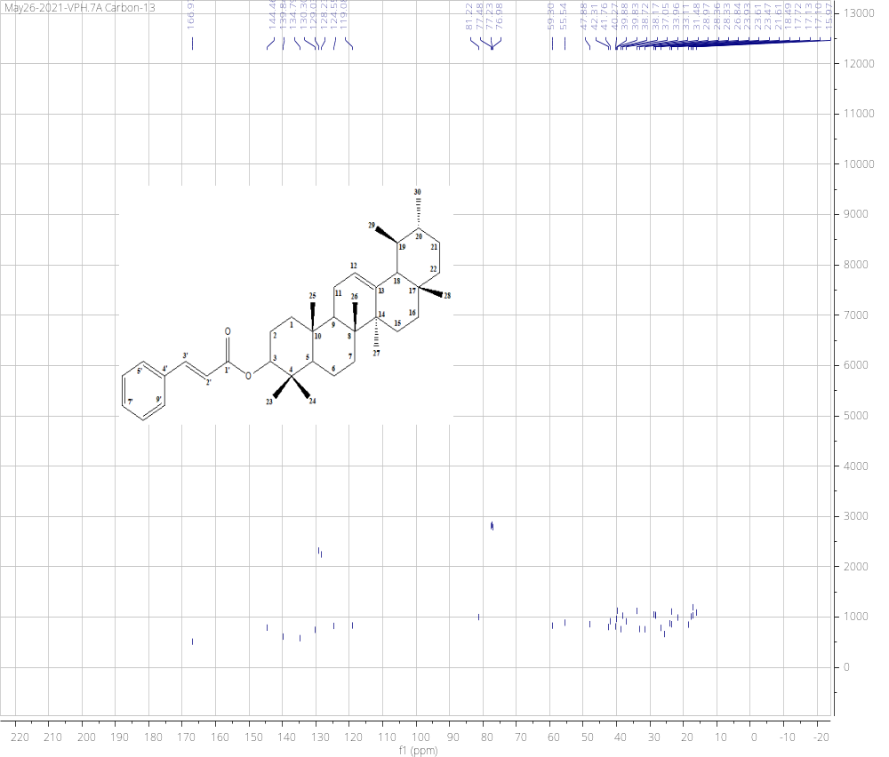
Figure 1.6: ¹³C NMR spectrum of α-amyrin cinnamate (Compound 2)

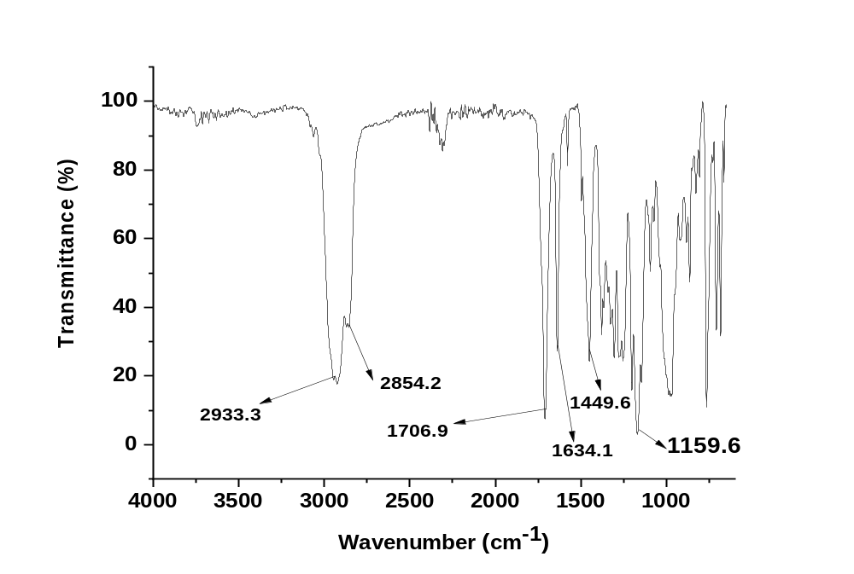
Figure 1.7: FTIR spectrum of α-amyrin cinnamate (Compound 2)

Figure 1.8: ESI-MS spectrum of α-amyrin cinnamate (Compound 2)

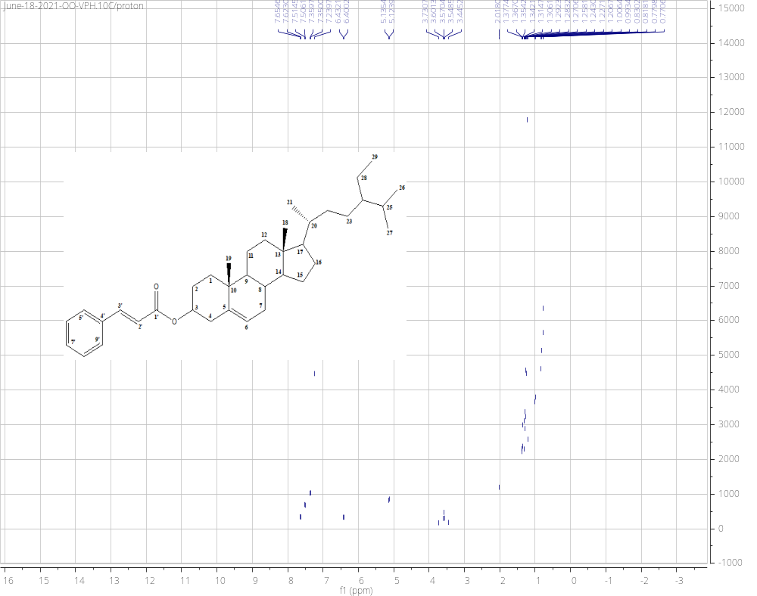
Figure 1.9: ¹H NMR spectrum of sitosterol cinnamate (Compound 3)

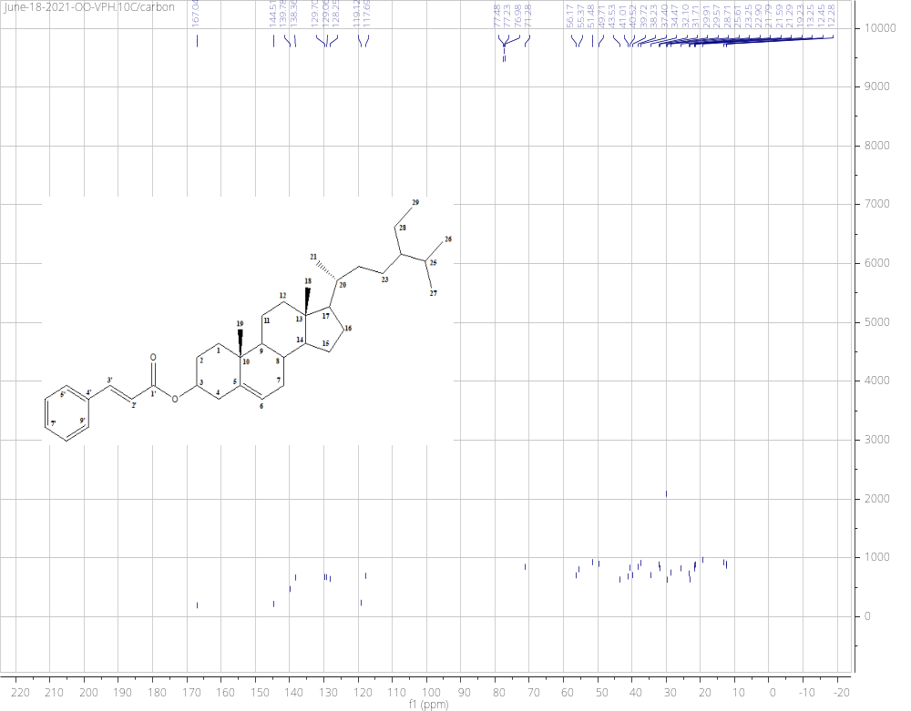
Figure 1.10: ¹³C NMR spectrum of sitosterol cinnamate (Compound 3)

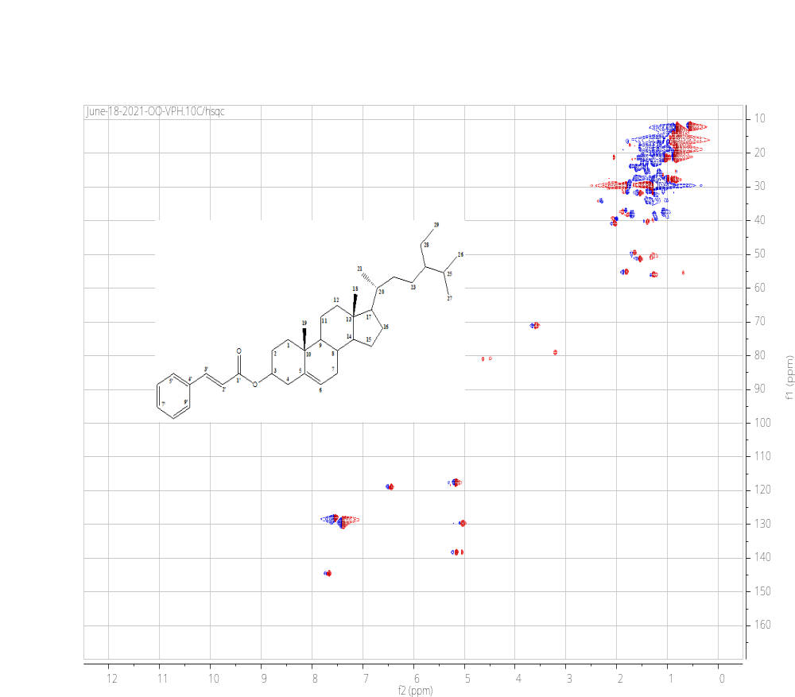
Figure 1.11: HSQC spectrum of sitosterol cinnamate (Compound 3)

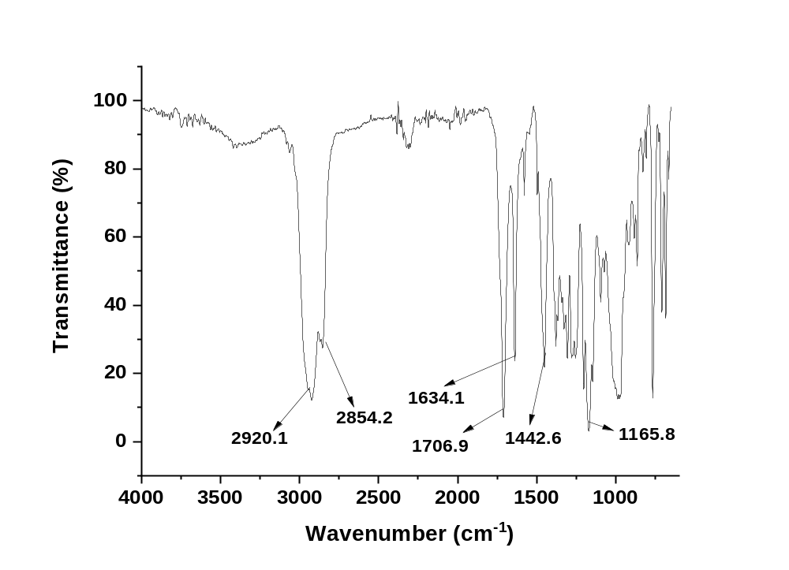
Figure 1.12: FTIR spectrum of sitosterol cinnamate (Compound 3)

Table S1. GC-MS profile of hexane extract of V. paradoxa stem-bark

S/N | Identified compounds | Peak number | Molecular weight | Molecular formula | Retention time (RT) | Peak area (%)
1 | Tetradecane | 1 | 198.4 | C₁₄H₃₀ | 11.714 | 7.61
2 | 2-Cyclohexen-1-one,4-(1-methylethyl) | 2 | 152.2 | C₁₀H₁₆O | 9.280 | 0.44
3 | 4-Oxononanal | 4 | 156.2 | C₉H₁₆O₂ | 10.016 | 1.69
4 | 2-Nonenal, (E)- | 5 | 140.2 | C₉H₁₆O | 10.202 | 0.91
5 | Oxalic acid,2-ethylhexyl undecyl ester | 6 | 356.5 | C₂₁H₄₀O₄ | 10.280 | 0.67
6 | 2-Methyltetracosane | 7 | 352.7 | C₂₅H₅₂ | 10.611 | 1.41
7 | 2,4-Decadienal, (E,E)- | 8 | 152.2 | C₁₀H₁₆O | 10.871 | 1.88
8 | 1-Undecene, 8-methyl- | 9 | 168.3 | C₁₂H₂₄ | 11.202 | 0.58
9 | 1-Iodoundecane | 10 | 282.2 | C₁₁H₂₃I | 11.312 | 0.50
10 | 2-Undecenal | 11 | 168.3 | C₁₁H₂₀O | 11.371 | 1.17
11 | Cis-4,5-Epoxy-(E) -2-decenal | 12 | 168.2 | C₁₀H₁₆O₂ | 11.549 | 0.35
12 | 1-Tetradecene | 13 | 196.4 | C₁₄H₂₈ | 11.622 | 1.35
13 | Nonanoic acid, 9-oxo-, methyl ester | 15 | 186.2 | C₁₀H₁₈O₃ | 12.082 | 0.24
14 | Dodecane,2,6,10-trimethyl- | 16 | 212.4 | C₁₅H₃₂ | 12.178 | 0.34
15 | Hexadecane | 17 | 226.4 | C₁₆H₃₄ | 13.590 | 11.23
16 | Tetradecane,3-methyl- | 18 | 212.4 | C₁₅H₃₂ | 12.393 | 0.28
17 | Cycloheptasiloxane, tetradecamethyl- | 19 | 519.07 | C₁₄H₄₂O₇Si₇ | 12.598 | 0.19
18 | Tetradecane,5-methyl- | 22 | 212.4 | C₁₅H₃₂ | 13.140 | 0.17
19 | Pentadecane,4-methyl- | 23 | 226.4 | C₁₆H₃₄ | 13.191 | 0.16
20 | Iron, tricarbonyl[N-(phenyl-2-pyridinylmethylene)benzenamine-N,N']- | 24 | 398.2 | C₂₁H₁₄FeN₂O₃ | 13.238 | 0.26
21 | Pentadecane,3-methyl- | 25 | 226.4 | C₁₆H₃₄ | 13.307 | 0.24
22 | 1-Hexadecene | 26 | 224.4 | C₁₆H₃₂ | 13.506 | 3.34
23 | 1-Heptadecanol | 28 | 256.5 | C₁₇H₃₆O | 13.715 | 0.18
24 | Cyclooctasiloxane,hexadecamethyl- | 30 | 593.2 | C₁₆H₄₈O₈Si₈ | 14.054 | 0.41
25 | Eicosane | 31 | 282.5 | C₂₀H₄₂ | 14.090 | 0.17
26 | Hexadecane,3-methyl- | 32 | 240.5 | C₁₇H₃₆ | 14.158 | 0.17
27 | 6-Dodecanone | 33 | 184.3 | C₁₂H₂₄O | 14.205 | 0.18
28 | Methyl tetradecanoate | 35 | 242.4 | C₁₅H₃₀O₂ | 14.606 | 0.30
29 | 1-Hexadecanol, 3,7,11,15-tetramethyl- | 36 | 298.5 | C₂₀H₄₂O | 14.950 | 0.30
30 | n-Pentadecanol | 37 | 228.4 | C₁₅H₃₂O | 15.140 | 4.43
31 | 1H-Purin-6-amine, [(2-fluorophenyl)methyl]- | 39 | 243.2 | C₁₂H₁₀FN₅ | 15.309 | 0.40
32 | Pentadecanoic acid, methyl ester | 40 | 256.4 | C₁₆H₃₂O₂ | 15.394 | 0.22
33 | Hexadecanoic acid, methyl ester | 42 | 270.5 | C₁₇H₃₄O₂ | 16.135 | 3.58
34 | Eicosamethylcyclodecasiloxane | 43 | 741.5 | C₂₀H₆₀O₁₀Si₁₀ | 16.426 | 0.28
35 | Dibutyl phthalate | 44 | 278.3 | C₁₆H₂₂O₄ | 16.485 | 0.27
36 | 1-Nonadecene | 45 | 266.5 | C₁₉H₃₈ | 16.606 | 4.81
37 | 9-Octadecenoic acid, methyl ester, ( E )- | 46 | 296.5 | C₁₉H₃₆O₂ | 17.367 | 4.69
38 | Tetracosamethylcyclododecasiloxane | 47 | 889.8 | C₂₄H₇₂O₁₂Si₁₂ | 17.440 | 0.32
39 | Octadecanoic acid, methyl ester | 48 | 298.5 | C₁₉H₃₈O₂ | 17.515 | 2.82
40 | 9-Octadecenoic acid, ethyl ester | 49 | 310.5 | C₂₀H₃₈O₂ | 17.788 | 0.27
41 | 1-Heptacosanol | 50 | 396.7 | C₂₇H₅₆O | 17.940 | 4.15
42 | Silicone oil | 51 | 236.5 | C₈H₂₄O₂Si₃ | 18.357 | 0.32
43 | Oxiraneoctanoic acid, 3-octyl-, methyl ester, cis- | 52 | 312.5 | C₁₉H₃₆O₃ | 18.520 | 0.27
44 | Glycidyl palmitate | 53 | 312.5 | C₁₉H₃₆O₃ | 18.620 | 2.89
45 | 9-Octadecenoic acid, 1,2,3-propanetriyl ester, (E,E,E)- | 54 | 1058.8 | C₆₃H₁₁₀O₁₂ | 18.982 | 0.67
46 | Glycidyl oleate | 57 | 338.5 | C₂₁H₃₈O₃ | 19.697 | 3.55
47 | Tetracosane | 58 | 338.7 | C₂₄H₅₀ | 19.755 | 0.35
48 | Docosanoic acid, methyl ester | 60 | 354.6 | C₂₃H₄₆O₂ | 19.936 | 0.25

