Supplemental Material of the Manuscript

“The deterministic behaviour of earthquake rupture beginning”
By V. Longobardi¹, S. Colombelli¹, and A. Zollo¹
¹Department of Physics E. Pancini, University of Naples Federico II.

Table S.1: source parameters of data used in the paper
Date | Mw | Lat(°) | Lon(°) | Depth (km) | N. of records
2003-09-26 | 8 | 41.781 | 144.074 | 42 | 41
2003-09-26 | 7.1 | 41.71 | 143.691 | 21 | 24
2008-05-08 | 7 | 36.227 | 141.607 | 51 | 130
2008-06-14 | 7.2 | 39.028 | 140.88 | 8 | 161
2008-06-14 | 4.6 | 39.09 | 140.905 | 13 | 45
2008-06-14 | 4.5 | 39.035 | 140.903 | 12 | 64
2008-06-14 | 4.3 | 39.023 | 140.888 | 10 | 60
2008-06-14 | 3.9 | 39.057 | 140.863 | 10 | 26
2008-06-14 | 3.7 | 39.035 | 140.893 | 12 | 32
2008-06-14 | 3.5 | 39.042 | 140.873 | 9 | 18
2008-06-14 | 4.8 | 38.995 | 140.89 | 10 | 88
2008-06-16 | 5.3 | 38.997 | 140.84 | 11 | 90
2008-06-17 | 3.2 | 39.065 | 140.962 | 10 | 16
2010-01-10 | 6.5 | 40.652 | -124.692 | 28.737 | 6
2010-02-04 | 5.8 | 40.4123 | -124.961 | 23.048 | 2
2010-06-15 | 5.7 | 32.763 | -115.936 | 9.114 | 3
2010-03-29 | 4.3 | 36.035 | 139.882 | 43 | 121
2010-05-01 | 4.9 | 37.558 | 139.19 | 9 | 115
2010-07-21 | 5.1 | 34.205 | 135.693 | 58 | 176
2010-10-24 | 4.4 | 36.058 | 139.852 | 45 | 138
2011-03-11 | 9 | 38.103 | 142.86 | 24 | 26
2011-03-12 | 6.7 | 36.985 | 138.597 | 8 | 283
2011-03-23 | 5.8 | 37.063 | 140.77 | 7 | 141
2011-04-11 | 5.9 | 36.965 | 140.633 | 11 | 201
2011-04-12 | 6.4 | 37.052 | 140.643 | 15 | 228
2011-04-13 | 5.7 | 36.915 | 140.707 | 5 | 133
2011-06-18 | 6 | 37.617 | 141.82 | 28 | 119
2011-07-05 | 5.5 | 33.99 | 135.233 | 7 | 124
2011-07-08 | 5.6 | 37.097 | 141.128 | 55 | 145
2011-07-25 | 6.3 | 37.708 | 141.627 | 46 | 145
2011-08-01 | 6.2 | 34.708 | 138.547 | 23 | 214
2011-08-12 | 6.1 | 36.968 | 141.16 | 52 | 165
2011-09-21 | 5.2 | 36.737 | 140.577 | 9 | 152
2011-10-20 | 4.4 | 37.043 | 140.643 | 9 | 104
2011-11-20 | 5.3 | 36.71 | 140.587 | 9 | 121
2012-02-13 | 5.6 | 41.1432 | -123.79 | 27.358 | 11
2012-05-20 | 6.1 | 44.8955 | 11.2635 | 9.5 | 42
2012-05-29 | 6 | 44.8417 | 11.0657 | 8.07 | 91
2012-05-29 | 5.5 | 44.8652 | 10.9795 | 4.35 | 83
2012-05-29 | 5.5 | 44.866 | 10.9763 | 7.2 | 37
2012-01-28 | 4.9 | 35.492 | 138.978 | 18 | 163
2012-01-28 | 5.4 | 35.488 | 138.977 | 18 | 231
2012-01-29 | 4.7 | 35.537 | 138.983 | 21 | 147
2012-02-19 | 5.2 | 36.75 | 140.588 | 7 | 112
2012-03-01 | 5.3 | 36.438 | 140.625 | 56 | 183
2012-03-10 | 5.4 | 36.717 | 140.612 | 7 | 143
2012-05-18 | 4.8 | 36.135 | 139.84 | 51 | 210
2012-05-20 | 6.5 | 39.537 | 143.62 | 7 | 18
2012-06-01 | 5.1 | 36.027 | 139.875 | 44 | 220
2012-10-25 | 5.6 | 38.3 | 141.9 | 50 | 32
2012-10-27 | 4.5 | 33.5 | 133.5 | 40 | 104
2013-02-06 | 7.9 | -10.864 | 165.142 | 23.8 | 10
2013-02-06 | 7 | -10.5087 | 165.817 | 9.9 | 2
2013-02-08 | 7 | -10.8933 | 166.145 | 22.4 | 8
2013-02-09 | 7 | 1.0345 | -77.462 | 144.2 | 50
2013-04-06 | 7 | -3.4714 | 138.474 | 69.4 | 11
2013-04-16 | 7.7 | 27.9704 | 62.136 | 63.1 | 5
2013-04-19 | 7.2 | 46.0722 | 150.924 | 109 | 7
2013-05-23 | 7.4 | -23.0783 | -177.213 | 177.7 | 8
2013-05-24 | 5.6 | 40.1918 | -121.06 | 7.968 | 6
2013-05-24 | 8.3 | 54.815 | 153.391 | 607 | 7
2013-07-07 | 7.3 | -4.0134 | 153.928 | 387.1 | 7
2013-07-15 | 7.3 | -61.0527 | -25.2274 | 19.9 | 6
2013-08-30 | 7 | 51.5001 | -175.214 | 30.2 | 25
2013-09-24 | 7.8 | 26.9109 | 65.5315 | 15.5 | 5
2013-09-25 | 7 | -15.9001 | -74.6012 | 38.2 | 27
2013-10-12 | 6.5 | 35.5277 | 23.3718 | 46.8687 | 4
2013-10-15 | 7.1 | 9.8331 | 124.123 | 23.2 | 14
2013-10-25 | 7.1 | 37.1457 | 144.754 | 14.7 | 14
2013-11-17 | 7.8 | -60.3783 | -46.5876 | 7.9 | 6
2014-01-02 | 6.2 | 38.1522 | 20.3912 | 15 | 38
2014-01-26 | 6.2 | 38.1522 | 20.3912 | 15 | 5
2014-02-01 | 6.5 | 14.6682 | -58.9272 | 14.8 | 9
2014-02-03 | 6 | 38.2637 | 20.3897 | 5 | 6
2014-03-10 | 6.8 | 40.8287 | -125.134 | 16.441 | 16
2014-04-01 | 8.1 | -19.6193 | -70.7877 | 17.1 | 23
2014-04-01 | 7 | -19.962 | -71.0177 | 10.8 | 1
2014-04-03 | 7.7 | -20.5887 | -70.4905 | 12 | 25
2014-04-11 | 7.1 | -6.6064 | 155.033 | 57.8 | 7
2014-04-12 | 7.6 | -11.2581 | 162.139 | 15.3 | 7
2014-04-13 | 7.4 | -11.4669 | 161.96 | 34.2 | 8
2014-04-18 | 7.3 | 17.3211 | -100.994 | 24.4 | 21
2014-04-19 | 7.5 | -6.708 | 154.992 | 39.8 | 4
2014-06-23 | 7.9 | 51.7028 | 178.643 | 102.1 | 17
2014-08-24 | 6 | 38.2152 | -122.312 | 11.12 | 276
2014-10-14 | 7.3 | 12.5893 | -88.072 | 63.9 | 19
2014-11-01 | 7.1 | -19.8023 | -177.833 | 435.3 | 11
2014-11-15 | 7 | 1.834 | 126.463 | 47.8 | 42
2014-11-22 | 5.6 | 45.8977 | 27.1505 | 32 | 11
2015-01-28 | 5.7 | 40.3178 | -124.607 | 16.881 | 6
2015-02-13 | 7.1 | 52.5097 | -32.0209 | 16.9 | 7
2015-02-27 | 7 | -7.358 | 122.491 | 559.1 | 64
2015-03-29 | 7.5 | -4.7758 | 152.578 | 41.3 | 8
2015-04-16 | 6.2 | 35.1952 | 26.8373 | 22.5896 | 4
2015-04-25 | 7.9 | 28.1302 | 84.7168 | 13.4 | 5
2015-05-05 | 7.5 | -5.5168 | 151.864 | 29.6 | 9
2015-05-07 | 7 | -7.3019 | 154.555 | 30.4 | 11
2015-05-12 | 7.2 | 27.8014 | 86.126 | 12.3 | 6
2015-05-22 | 7 | -11.1336 | 163.594 | 19.6 | 15
2015-05-30 | 7.9 | 27.8281 | 140.494 | 685.5 | 18
2015-07-27 | 7 | -2.7134 | 138.543 | 47.8 | 23
2015-09-16 | 8.3 | -31.5729 | -71.6744 | 22.44 | 41
2015-09-16 | 7 | -31.5622 | -71.4262 | 28.41 | 6
2015-10-20 | 7.1 | -14.8595 | 167.303 | 135 | 13
2015-10-26 | 7.5 | 36.5244 | 70.3676 | 231 | 25
2015-11-17 | 6.5 | 38.67 | 20.6 | 11 | 3
2015-11-24 | 7.6 | -10.5372 | -70.9437 | 606.21 | 27
2015-11-24 | 7.6 | -10.0598 | -71.0184 | 620.56 | 21
2015-12-07 | 7.2 | 38.2107 | 72.7797 | 22 | 41
2016-01-24 | 7.1 | 59.6204 | -153.339 | 125.6 | 55
2016-01-30 | 7.2 | 54.0057 | 158.513 | 163.22 | 6
2016-03-02 | 7.8 | -4.9521 | 94.3299 | 24 | 13
2016-04-15 | 7 | 32.7906 | 130.754 | 10 | 41
2016-04-16 | 7.8 | 0.3819 | -79.9218 | 20.59 | 18
2016-04-28 | 7 | -16.0429 | 167.379 | 24 | 14
2016-07-29 | 7.7 | 18.5439 | 145.541 | 207.62 | 3
2016-08-10 | 5 | 39.3293 | -122.802 | 14.45 | 27
2016-08-12 | 7.2 | -22.4778 | 173.111 | 16.44 | 12
2016-08-24 | 6 | 42.6983 | 13.2335 | 8.1 | 99
2016-10-26 | 5.5 | 42.8747 | 13.1243 | 8.1 | 87
2016-10-26 | 5.9 | 42.9087 | 13.1288 | 7.5 | 90
2016-10-30 | 6.6 | 42.8322 | 13.1107 | 9.2 | 84
2016-11-24 | 7 | 11.9597 | -88.8355 | 10.34 | 20
2016-12-08 | 7.8 | -10.676 | 161.33 | 41 | 9
2016-12-17 | 7.9 | -4.5049 | 153.522 | 94.54 | 6
2016-12-25 | 7.6 | -43.4053 | -73.9403 | 38 | 41
2016-12-28 | 5.6 | 38.3722 | -118.898 | 10.01 | 12
2016-12-28 | 5.7 | 38.3757 | -118.903 | 7.01 | 15
2016-12-28 | 5.5 | 38.3615 | -118.897 | 2.43 | 11
2017-01-10 | 7.3 | 4.4634 | 122.575 | 612.71 | 33
2017-01-18 | 5.5 | 42.531 | 13.2838 | 9.6 | 107
2017-01-22 | 7.9 | -6.2145 | 155.144 | 135 | 6
2017-07-02 | 6.6 | 36.9293 | 27.4139 | 7 | 30
2017-07-17 | 7.7 | 54.4715 | 168.815 | 10.99 | 18
2017-09-08 | 8.1 | 15.0356 | -93.9067 | 56.67 | 16
2017-09-19 | 7.1 | 18.5678 | -98.4808 | 51 | 28
2017-11-12 | 7.3 | 34.9052 | 45.9563 | 19 | 71
2017-11-19 | 7 | -21.3337 | 168.683 | 10 | 14
2018-01-10 | 7.5 | 17.4743 | -83.5193 | 10 | 74
2018-01-14 | 7.1 | -15.7589 | -74.7095 | 39 | 36
2018-01-23 | 7.9 | 56.0464 | -149.073 | 25 | 234
2018-02-16 | 7.2 | 16.3887 | -97.9789 | 25.98 | 26
2018-02-25 | 7.5 | -6.0529 | 142.77 | 24.43 | 14
2018-08-19 | 8.2 | -18.1125 | -178.154 | 600 | 11
2018-08-21 | 7.3 | 10.7791 | -62.907 | 146.18 | 42
2018-08-24 | 7.1 | -11.0424 | -70.8169 | 609.48 | 18
2018-08-29 | 7.1 | -22.0663 | 170.05 | 26.68 | 12
2018-09-06 | 7.9 | -18.4952 | 179.355 | 617.87 | 15
2018-09-28 | 7.5 | -0.1781 | 119.84 | 10 | 39
2018-10-10 | 7 | -5.7078 | 151.22 | 45.05 | 8
2018-10-30 | 5.7 | 37.58 | 20.5457 | 20.8612 | 3
2018-11-30 | 7 | 61.3464 | -149.955 | 46.7 | 146
2018-12-05 | 7.5 | -21.9568 | 169.418 | 10 | 11
2018-12-20 | 7.3 | 55.0999 | 164.699 | 16.56 | 8
2018-12-29 | 7 | 5.8983 | 126.921 | 60.21 | 27
2019-02-22 | 7.5 | -2.199 | -77.0231 | 132.36 | 9
2019-03-01 | 7 | -14.7016 | -70.135 | 267 | 20
2019-05-06 | 7.1 | -6.973 | 146.451 | 146 | 9
2019-05-14 | 7.5 | -4.081 | 152.569 | 10 | 4
2019-05-26 | 8 | -5.8132 | -75.2775 | 122.4 | 9
2019-06-23 | 5.5 | 40.2735 | -124.3 | 9.44 | 24
2019-06-24 | 7.3 | -6.4078 | 129.169 | 212 | 43
2019-07-04 | 6.4 | 35.6973 | -117.506 | 14.76 | 12
2019-07-06 | 6.8 | 35.7188 | -117.638 | 3.71 | 10
2019-07-06 | 5.5 | 35.9048 | -117.704 | 6.88 | 8
2019-07-14 | 7.3 | -0.529 | 128.093 | 10 | 29
2019-11-14 | 7.1 | 1.6199 | 126.414 | 33 | 24
2019-11-26 | 6.44 | 41.38 | 19.47 | 10 | 4
2020-01-17 | 4.3 | 37.5979 | 20.9084 | 19.5537 | 11
2020-01-22 | 4.4 | 39.0283 | 27.8642 | 13.1127 | 9
2020-01-25 | 4.28 | 39.036 | 27.8546 | 12.6161 | 9
2020-01-28 | 4.99 | 39.096 | 27.8563 | 12.3432 | 16
2020-01-28 | 7.7 | 19.418 | -78.7582 | 15.18 | 38
2020-01-30 | 4.29 | 35.1327 | 27.8882 | 2.9811 | 2
2020-02-01 | 4.69 | 39.1659 | 20.6065 | 15.8338 | 8
2020-02-02 | 4.61 | 39.0024 | 27.8881 | 14.9947 | 11
2020-02-02 | 4.43 | 39.0939 | 27.8981 | 6.542 | 8
2020-02-06 | 4.7 | 39.2022 | 21.4886 | 14.3913 | 13
2020-02-13 | 7 | 45.6313 | 148.929 | 144 | 11
2020-02-24 | 4.3 | 39.3608 | 16.241 | 9.1 | 17
2020-02-27 | 4.74 | 35.169 | 27.9748 | 14.5061 | 1
2020-03-09 | 5.7 | 40.3917 | -125.094 | 3.19 | 14
2020-03-22 | 4.6 | 45.8754 | 15.9717 | 9.766 | 6
2020-03-25 | 7.5 | 48.9688 | 157.691 | 55.39 | 8
2020-04-15 | 4.1 | 40.5397 | 21.8065 | 16.6236 | 1
2020-04-26 | 4.26 | 34.521 | 24.7092 | 27.1127 | 1
2020-04-30 | 4.53 | 36.9708 | 28.5566 | 11.5173 | 7
2020-05-15 | 6.4 | 38.2162 | -117.844 | 13.05 | 5
2020-06-04 | 5.5 | 35.6177 | -117.43 | 12.11 | 13
2020-06-23 | 7.4 | 15.8829 | -96.0101 | 20 | 17
2020-06-24 | 5.8 | 36.447 | -117.983 | 7.31 | 16
2020-07-17 | 7 | -7.8386 | 147.775 | 73 | 8
2020-07-22 | 7.8 | 55.0298 | -158.522 | 28 | 337
2020-10-03 | 7 | 37.91 | 26.84 | 10 | 44
2020-10-19 | 7.6 | 54.6093 | -159.652 | 31.08 | 344
2020-10-30 | 7 | 37.9175 | 26.7901 | 21 | 241
2021-01-21 | 7 | 5.0054 | 127.519 | 80 | 13
2021-02-10 | 7.7 | -23.0508 | 171.657 | 10 | 11
2021-02-13 | 7.1 | 37.7602 | 141.72 | 51.89 | 18
2021-03-04 | 7.4 | -29.6762 | -177.842 | 43 | 5
2021-03-12 | 5.6 | 39.84 | 22.01 | 7 | 3
2021-03-20 | 7 | 38.4754 | 141.633 | 43 | 17
2021-05-21 | 7.3 | 34.5884 | 98.2402 | 10 | 9
2021-06-05 | 5.5 | 33.2422 | -116.013 | 3.8 | 11
2021-07-08 | 6 | 38.5075 | -119.5 | 7.45 | 13
2021-07-29 | 8.2 | 55.3635 | -157.888 | 35 | 317
2021-08-14 | 7.2 | 18.4167 | -73.4804 | 10 | 47
2021-08-22 | 7.1 | -60.2897 | -24.8801 | 14 | 5
2021-09-08 | 7 | 16.9722 | -99.7429 | 20 | 9
2021-10-02 | 7.3 | -21.1265 | 174.896 | 527 | 13
2021-11-28 | 7.5 | -4.4528 | -76.8109 | 126 | 8
2021-12-14 | 7.3 | -7.6046 | 122.227 | 15.06 | 30
2021-12-20 | 6.2 | 40.3902 | -124.298 | 27.04 | 24
2021-12-29 | 7.3 | -7.5465 | 127.576 | 164.28 | 48
2022-03-16 | 7.3 | 37.7302 | 141.595 | 59.85 | 19
2022-03-31 | 7 | -22.5855 | 170.375 | 10 | 13
2022-05-26 | 7.2 | -14.8942 | -70.1969 | 252 | 26
2022-07-27 | 7 | 17.5524 | 120.796 | 46 | 17
2022-09-10 | 7.6 | -6.2949 | 146.503 | 116 | 15
2022-09-14 | 7 | -21.1909 | 170.267 | 137 | 13
2022-09-19 | 7.6 | 18.4967 | -102.982 | 25.485 | 18
2022-11-11 | 7.3 | -19.2868 | -172.149 | 37 | 8
2022-11-12 | 7 | -20.0924 | -178.343 | 586.942 | 15
2022-11-22 | 7 | -9.809 | 159.594 | 14 | 14
2023-01-08 | 7 | -14.9466 | 166.879 | 29 | 12
2023-01-09 | 7.6 | -7.0642 | 130.004 | 105.249 | 50
2023-01-18 | 7 | 2.7357 | 127.027 | 28.855 | 17
2023-02-06 | 7.8 | 37.2251 | 37.0209 | 10 | 17
2023-02-06 | 7.5 | 38.0235 | 37.203 | 10 | 18
2023-03-16 | 7 | -30.1743 | -176.198 | 10 | 7
2023-04-02 | 7 | -4.3258 | 143.159 | 70 | 15
2023-04-14 | 7 | -6.0255 | 112.033 | 594.028 | 14
2023-04-24 | 7.1 | -29.9918 | -177.811 | 29 | 7
2023-04-24 | 7.1 | -0.8026 | 98.524 | 34 | 8
2023-05-10 | 7.6 | -15.6278 | -174.492 | 210 | 7
2023-05-19 | 7.7 | -23.1903 | 170.734 | 32.986 | 14
2023-05-20 | 7.1 | -23.0483 | 170.511 | 25.807 | 12
2023-06-15 | 7.2 | -22.9936 | -177.107 | 179 | 10
2023-07-16 | 7.2 | 54.3919 | -160.761 | 25 | 311
2023-08-28 | 7.1 | -6.8051 | 116.527 | 500 | 18

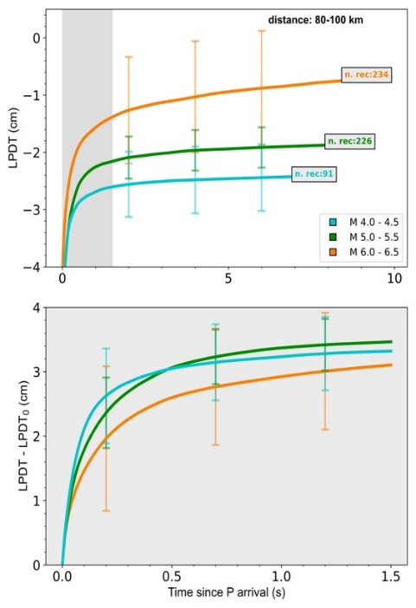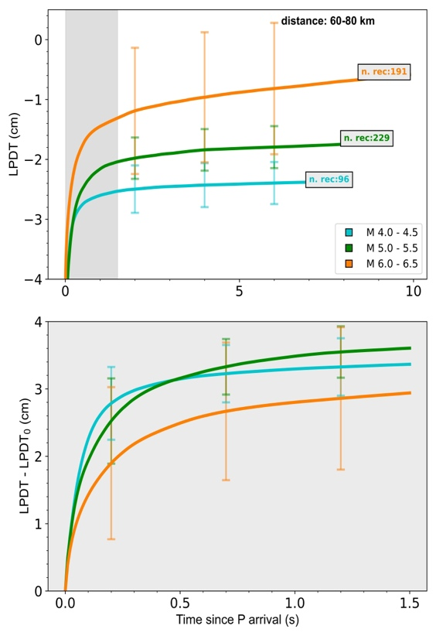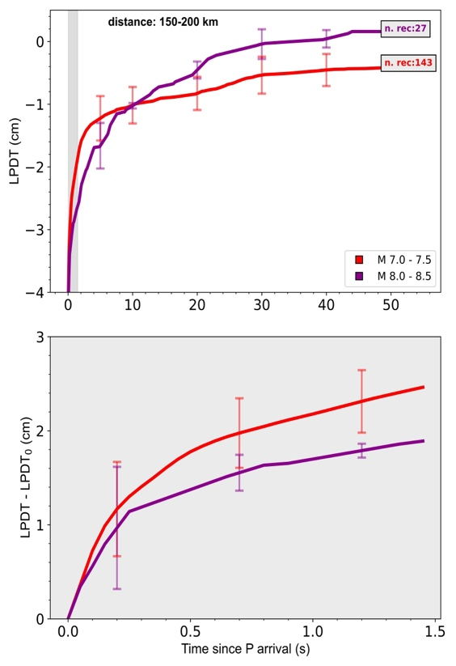

Figure S1: LPDT curves averaged in different distance and magnitude bins. Top panels show the entire duration of LPDT. Shadow areas highlight 1.5 of PTW. In box legends there is the total number of used records to obtain each averaged LPDT. Bottom panels show zoomed shadow area of upper panels. LPDT are referred to their first point to appreciate slope variation with magnitude.

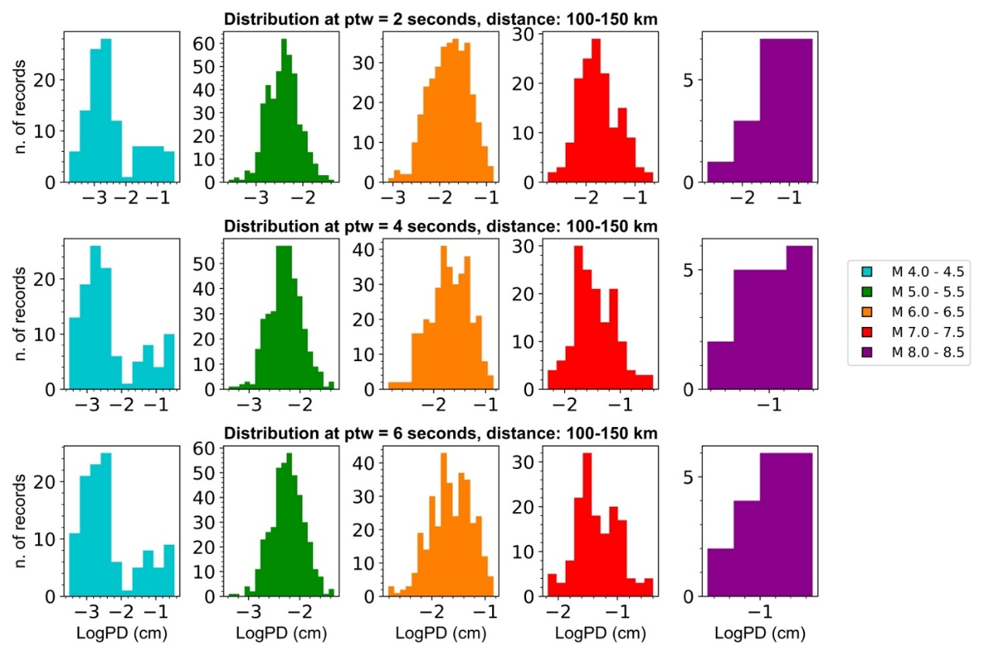

Figure S2: Distribution of Logarithm of P-peak displacement in different P-time windows (ptw). The figure shows the distribution of P-peak amplitude data in each magnitude bin, where the mean value and the standard deviation is computed. Histograms show a Gaussian-like shape, at least in the most populated bins. From top to bottom: ptw = 2 seconds; ptw = 4 seconds; ptw = 6 seconds. Distance range is 100 – 150 km, where there is the most completed data availability. Histograms are colored according to the magnitude bin.

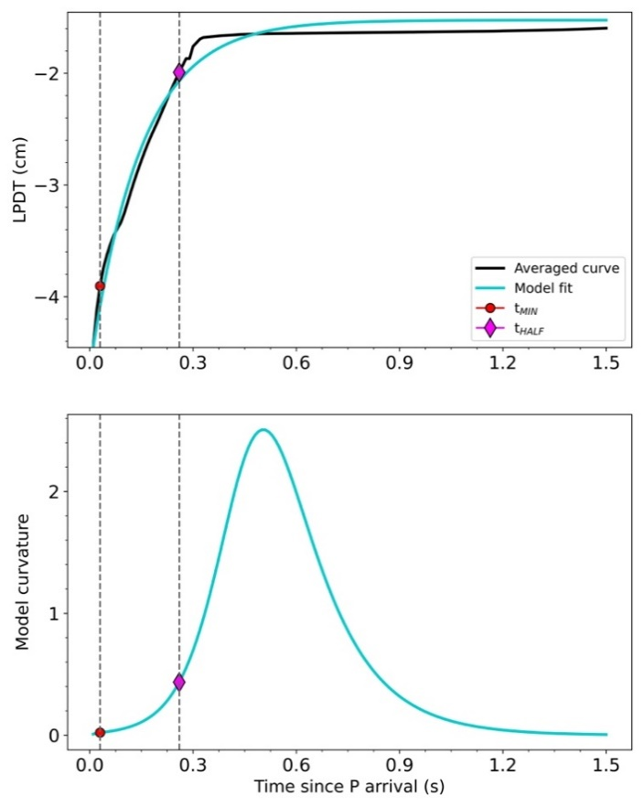

Figure S3: Curvature. Top panel: example of an averaged LPDT curve (black solid line) and model exponential fit (light blue line). Bottom panel: model curvature. Slope on averaged LPDT is evaluated between t_{MIN} = 0.05 s and t_{HALF} corresponding to the half of the time at which curvature has its maximum.

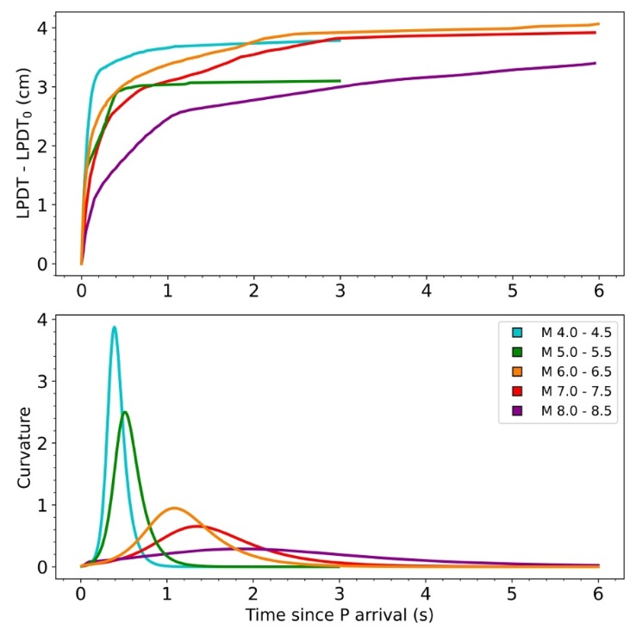
Figure S4: Example of LPDT curves. Top panel: Averaged LPDT curves (one per each bin of magnitude) referred to their first point to appreciate slope variation. Bottom panel: Model curvature of LPDT in top panel.
Text S1. Numerical simulations of the P-wave displacement pulse for variable magnitude earthquakes

Here we used the Sato & Hirasawa (1973) quasi-dynamic model of a circular rupture at constant stress-drop and uniform rupture velocity to simulate the P-wave displacement recorded at the strong motion network that recorded the Mw 6.5 Central Italy earthquake in 2016.
Three different magnitude (M 5,6 and 7) events have been simulated at the 50 stations located within 100 km of epicentral distance. We assumed a homogeneous velocity model (vp=5500 m/s and Vp/Vs=radq3) and the normal fault mechanism of the 2016 Mw 6,5 mainshock (strike: 330°, dip: 43°, rake: -91°). To show the effect of a variable rupture velocity with magnitude, we set Vr=0.9vs for Mw 5, Vr=0.7 Vs for Mw 6 and Vr=0.5 for Mw 7.

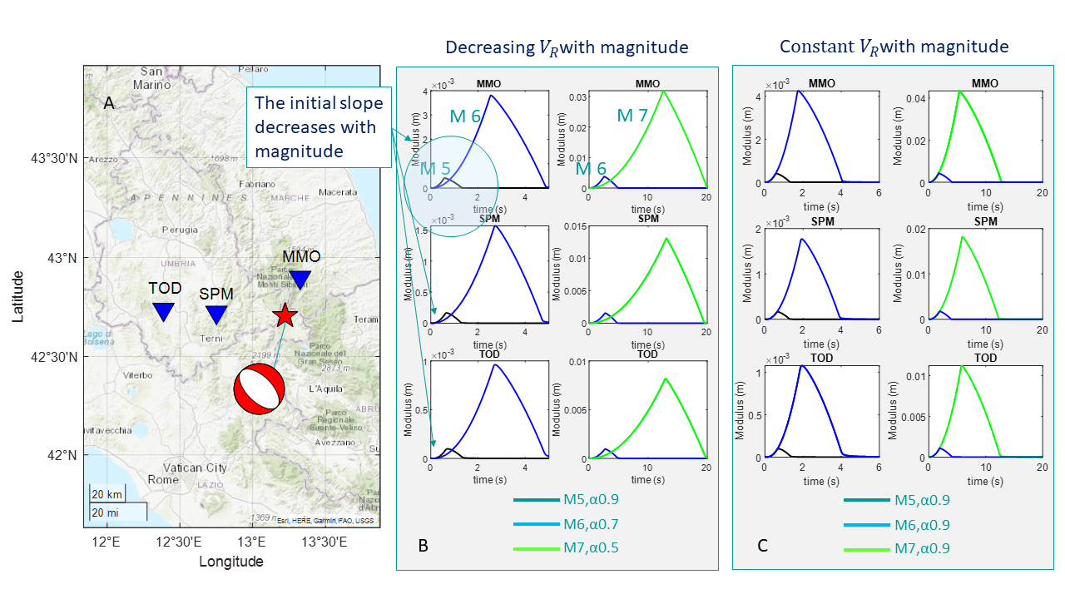

Figure S5. Numerical simulations. The figure displays the S&H displacement pulse waveforms simulated at three stations of the network (panel A). The effect on waveforms of variable or constant rupture velocity with magnitude is clearly represented in panels B and C. The larger rupture velocity produces faster initial rise of the displacement waveform for smaller magnitude events that is not observed when rupture velocity is taken constant with magnitude.

SATO, T. & HIRASAWA, T. Body wave spectra from propagating shear cracks. Journal of Physics of the Earth 21, 415–431 (1973).

