Supplementary Information

Manuscript title:
ZC3H4 promotes silica-induced pulmonary fibrosis via an ER stress-related positive feedback loop

Authors: Hammad Ghafoor, Han Chu, Jie Huang, Menglin Chen, Zhangyan Wang, Sha Wang and Jie Chao

Table of Contents
Supplementary Figure S1 2
Supplementary Figure S2 3
Supplementary Figure S3 4
Supplementary Figure S4 5-6
Supplementary Figure S5 7

Supplementary Figure S1
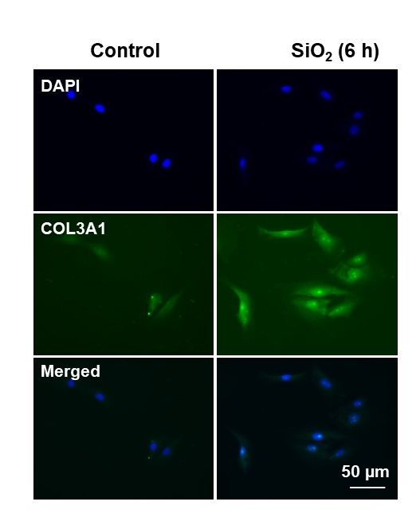
Figure S1. SiO₂ increases pulmonary fibroblast activation. Demonstrative immunocytochemistry assay representing the effect of SiO₂ that increased the expression level of the fibroblast inducer COL3A1 in MLg cells, scale bar= 50 µm.

Supplementary Figure S2
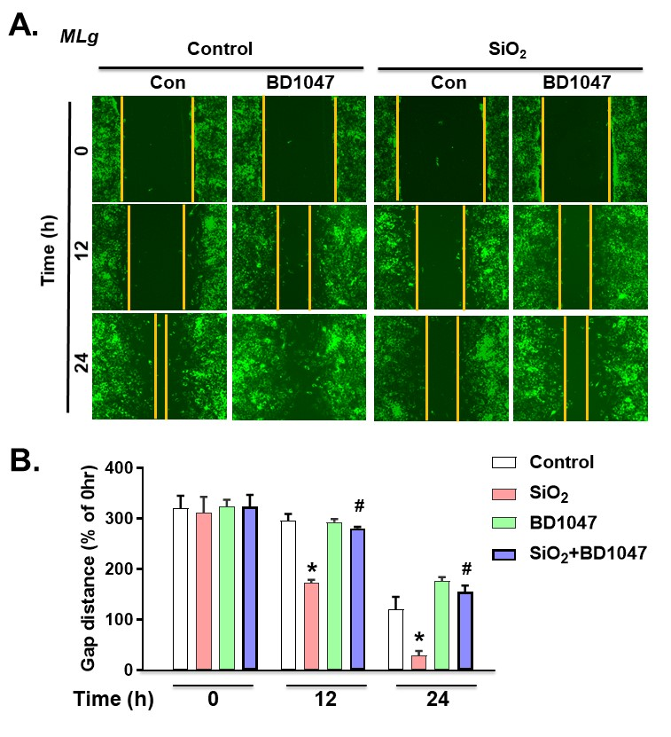
Figure S2. Use of ERS inhibitor after SiO₂ exposure in pulmonary fibroblasts. A. The demonstrative 2D scratch assay represents the induced migratory characteristics of MLg cells exposed to SiO₂ that were attenuated by BD1047. B. Quantification of the gap (scratch) width was observed in a 2D nested matrix assay from five independent experiments. *p< 0.05 vs. the control group, #p< 0.05 vs. the SiO₂ group..

Supplementary Figure S3
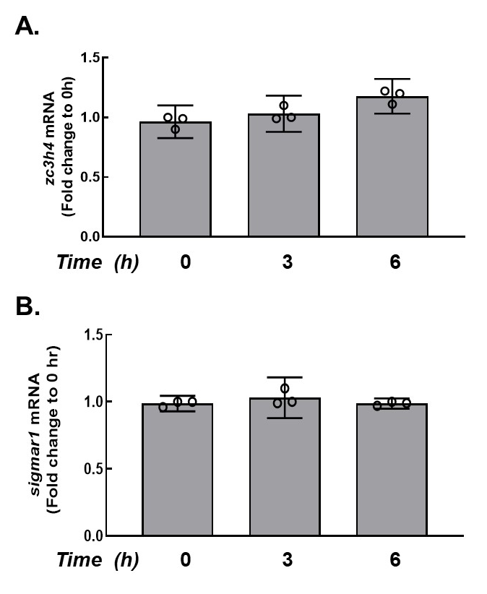
Figure S3. SiO₂ on Mrna lexpression of ZC3H4/Sigmar1 in pulmonary fibroblasts. A. RT-PCR results confirmed that the mRNA expression level of the ZC3H4 after SiO₂ exposure in MLg cells. B. RT-PCR results confirmed that the mRNA expression level of the sigmar1 protein after SiO₂ exposure in mouse MLg cells.

Supplementary Figure S4
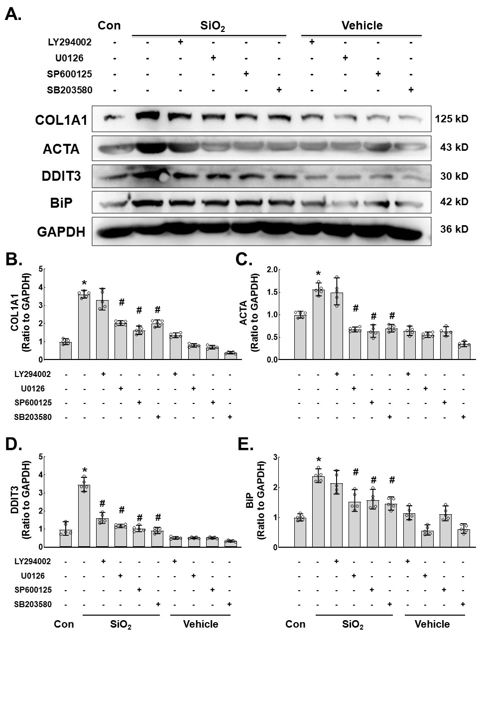
Figure S4. SiO₂ induces the MAPKinase (JNK, P38 and p42/44) and P13K/Akt phosphorylation pathways in pulmonary fibroblasts. A. Demonstrative immunoblotting assay demonstrating the effects of SiO₂ that increased the expression levels of COL1A1 (COL I), ACTA1 (α-SMA), DDIT3 and BiP was attenuated by pretreatment with MAPKinase (JNK, P38 and p42/44) or P13K/Akt phosphorylation pathway inhibitors. B. Densitometric analyses representing the effects of SiO₂ that increased the expression levels of COL1A1 (B), ACTA1 (C), DDIT3 (D) and BiP (E) were attenuated by pretreatment with MAPK (JNK, P38 and p42/44) and P13K/Akt phosphorylation pathway inhibitor，*p< 0.05 vs. the control group, #p< 0.05 vs. the SiO₂ group.
Supplementary Figure S5
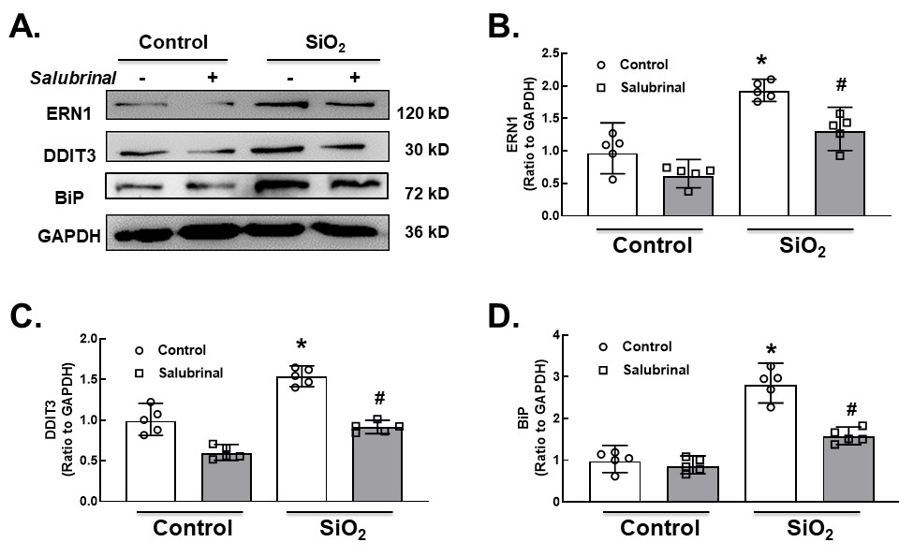
Figure S5. Use of an ERS inhibitor after SiO₂ exposure in pulmonary fibroblasts. A. Immunoblotting assay demonstrating the effect of the endoplasmic reticulum stress inhibitor salubrinal (10 µM) on pulmonary fibroblast cells and after SiO₂ exposure to identify elevated ERN1, DDIT3 and BiP pathway proteins in mouse lung fibroblasts. B. Densitometric analyses of ERN1(B), DDIT3 (C) and BiP (D), n=5, *p< 0.05 vs. the control group, #p< 0.05 vs. the SiO₂ group.

