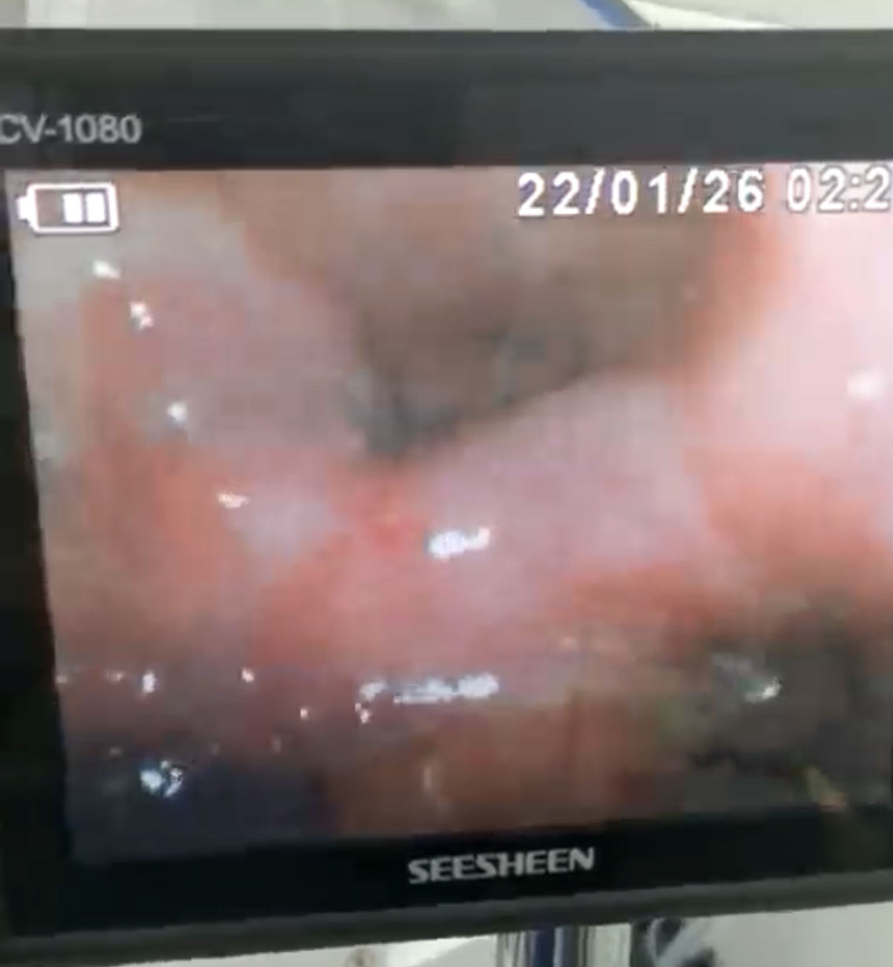
Figure 1: The bronchoscope is at the glottis

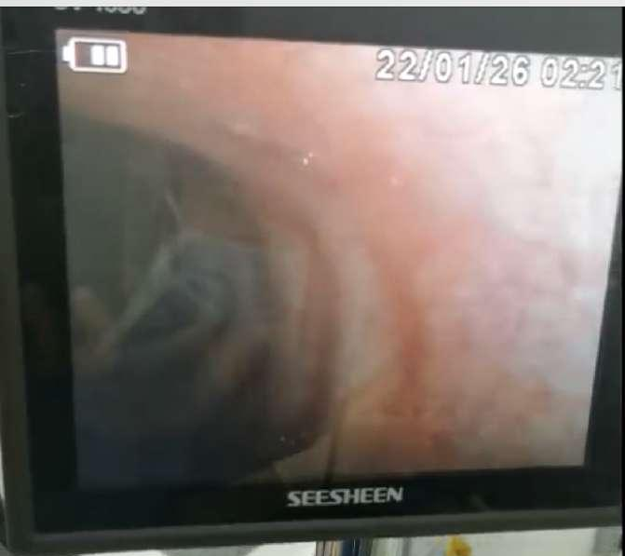
Figure 2: The bronchoscope is in the trachea
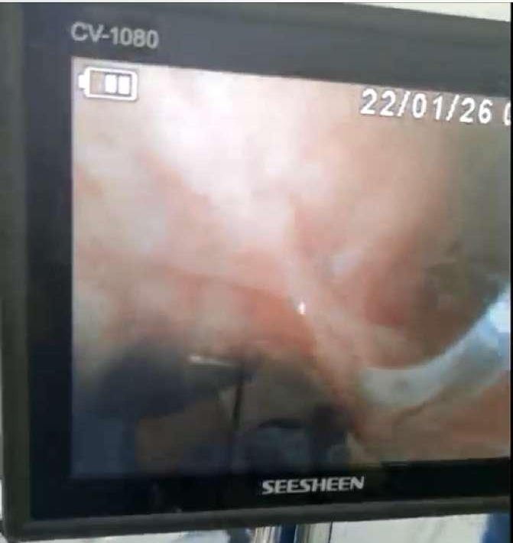
Figure 3: The bronchoscope at the trachea carina
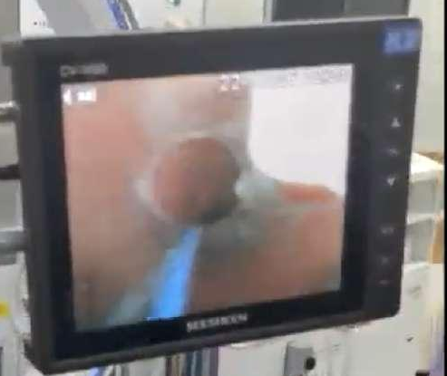
Figure 4: The tracheal tube is inside the trachea

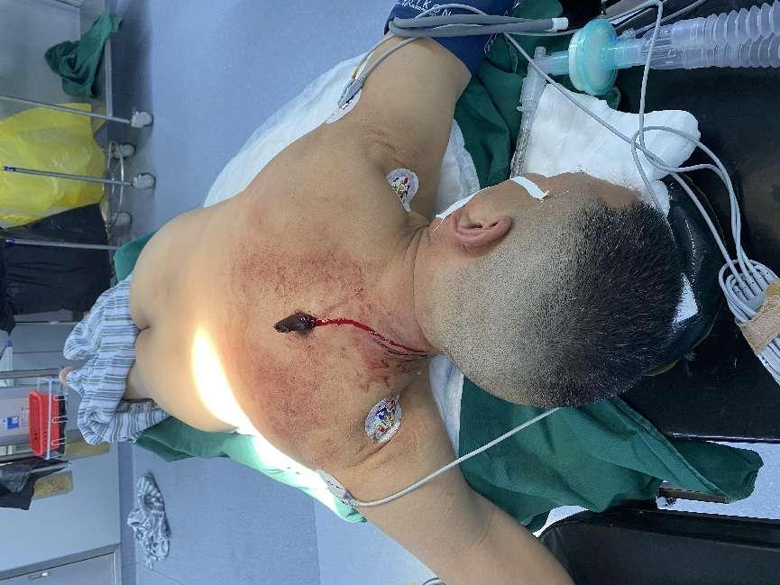
Figure 5: The patient was intubated in prone position

