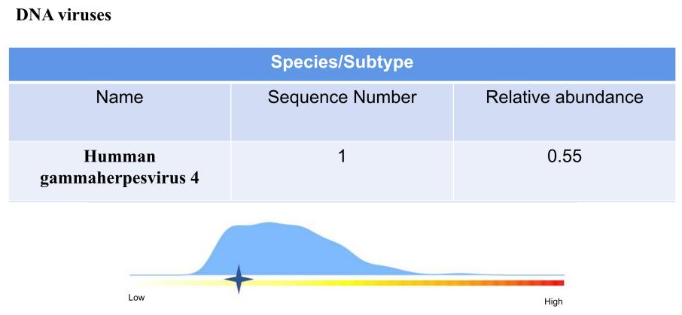
Supplement File 1
In our first NGS examination, we detected a positive result for human herpesvirus 4 (Epstein-Barr virus)

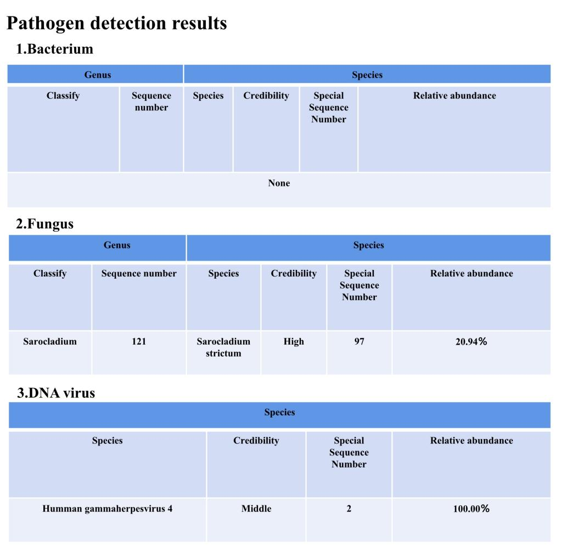
Supplement File 2
In the second NGS examination, S. strictum revealed a positive result.
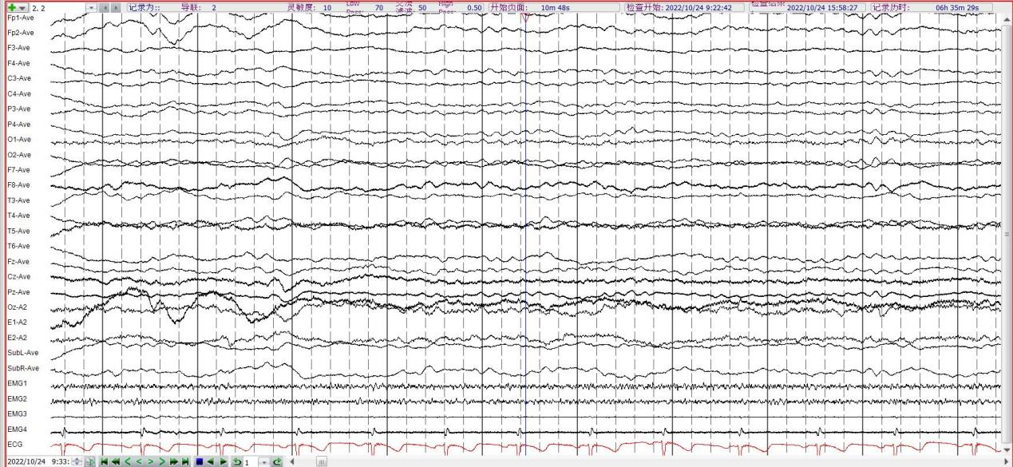
Supplement File 3
The EEG results revealed the absence of the basic α rhythm, instead presenting a 6-7 Hz θ rhythm, with a minimal amount of 2-2.5 Hz δ waves, and no epileptic waves.

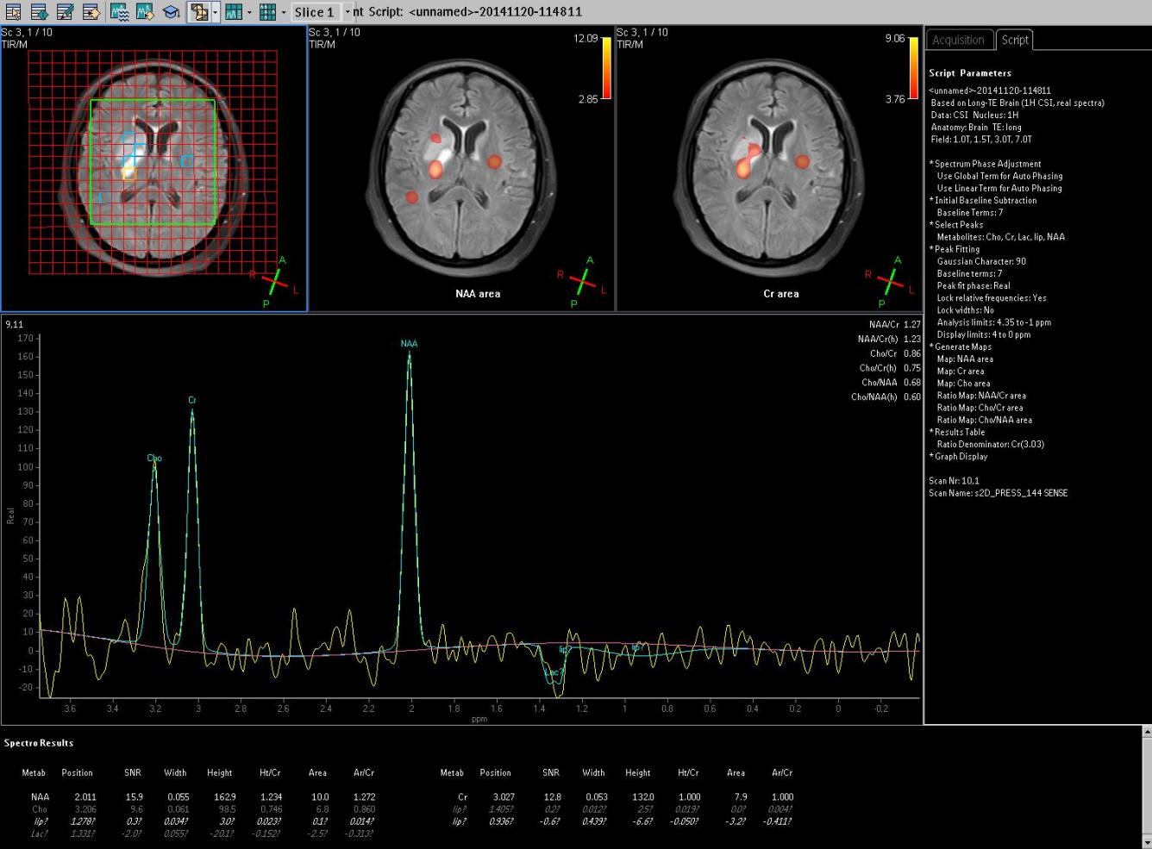
Supplement File 4
The MRS imaging of the right basal ganglia shows decreased NAA peak and the appearance of inverted Lac peak, suggesting ischemic brain injury.

