Supplementary Data

Anti-psoriasis inflammation and anti-oxidation of the extract from the flower of Datura metel L.

Yanyan Wang ¹, Hui Zhang ¹, Zhibin Wang ¹, Yonghai Meng ¹, Binyou Yang ¹, Tingli Li ¹ and Haixue Kuang ^{2,}*
¹ Key Laboratory of Chinese Materia Medica (Ministry of Education), Heilongjiang University of Chinese Medicine, No. 24, Heping Road, Harbin 15 0040, P. R. China
² School of Traditional Chinese Medicine, Guangdong Pharmaceutical University, Guangzhou, P.R. China.

Figure of Contents

1. Figure S1-S2 S2

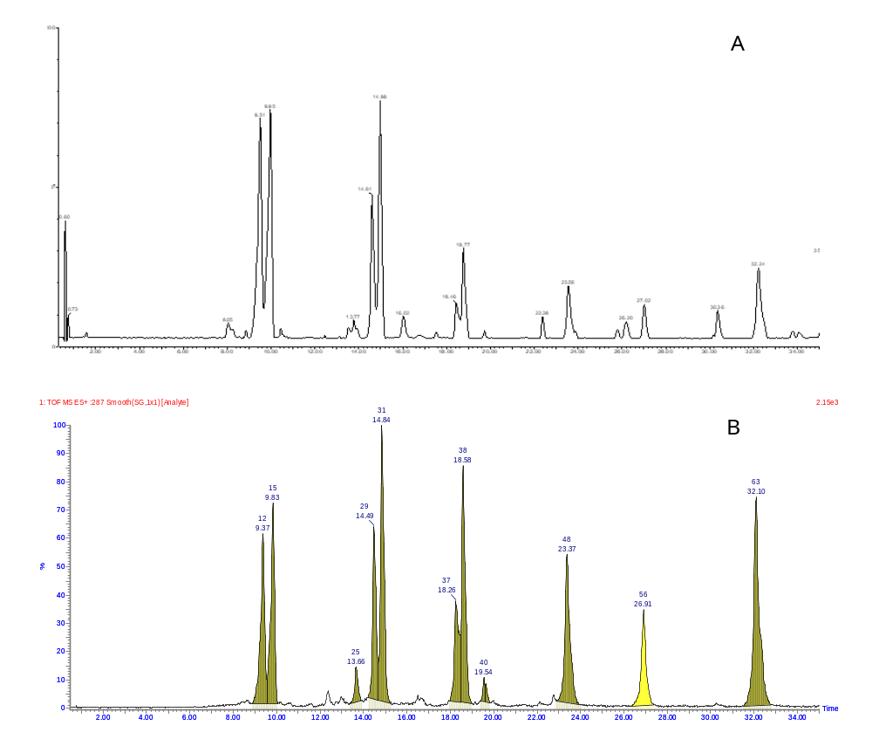
Figure S1 UPLC-Q/TOF-MS Chromatography of Flavonoids from Datura metel L.
- UPLC detects UV absorption spectrum with λ of 264 nm; B. Metabolynx analysis chart)
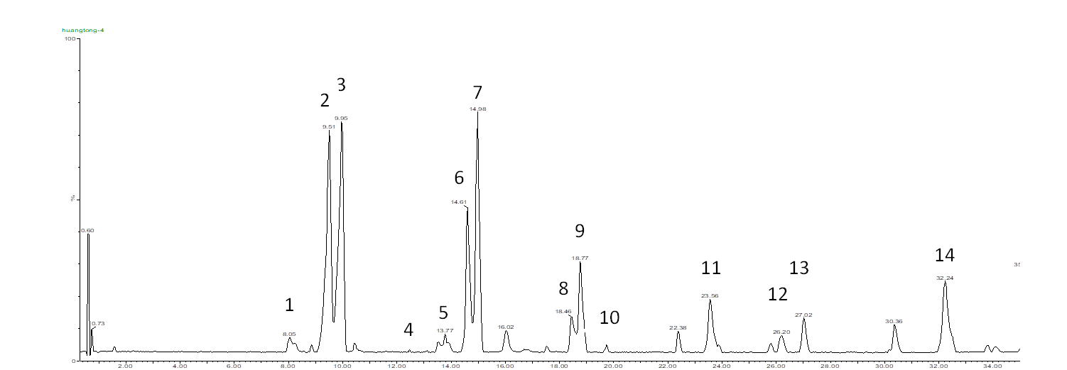

Figure S2 UPLC-Q/TOF-MS chromatogram of Flavonoids from Datura metel L.

