Folate mediates cognitive impairment of aged people with periodontitis
Fei Liu¹, Jian-Song Mei¹, Jia-Shuo Zhao¹, Yu-Heng Feng¹, Yan-Yan Zhang¹, Qing Pan², Jie-Fei Shen¹

Affiliations:
- State Key Laboratory of Oral Diseases & National Clinical Research Center for Oral Diseases & National Center for Stomatology & West China School of Stomatology & West China Hospital of Stomatology, Sichuan University, Chengdu 610041, China
- Medical Device Regulatory Research and Evaluation Center, West China Hospital, Sichuan University, Chengdu 610041, China

Appendix Figures
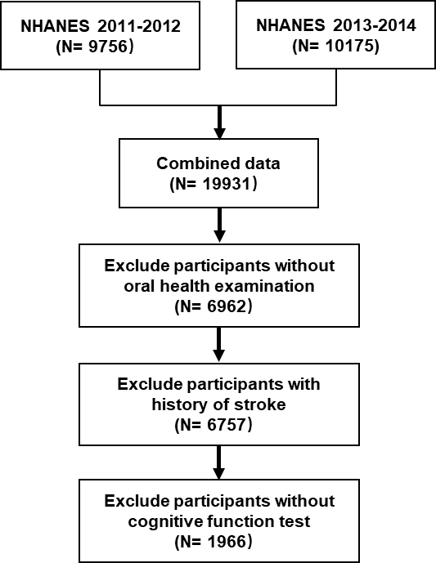
Appendix Figure 1. Flow chart of the screening process for the selection of eligible participants.
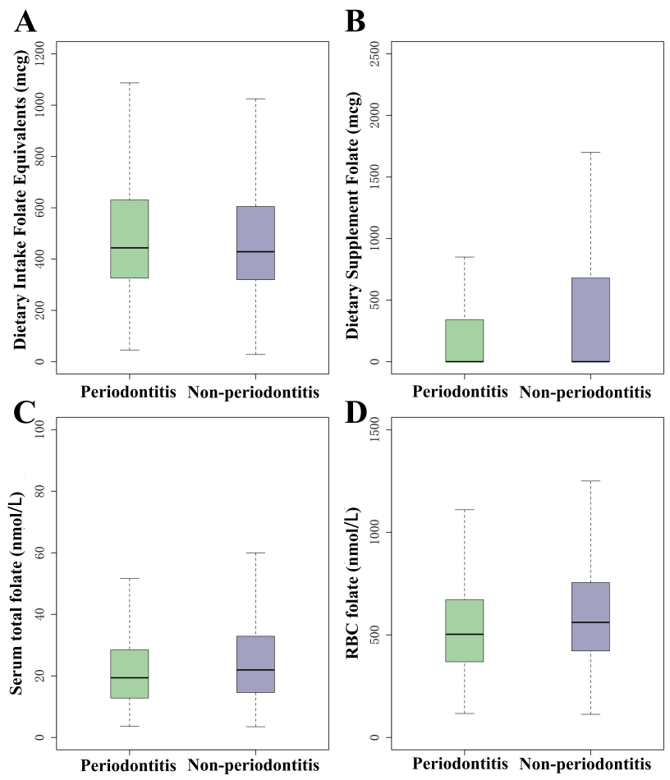
Appendix Figure 2. Comparisons of folates between periodontitis and non-periodontitis (A: Dietary intake folate equivalents; B: Dietary supplement folate; C:Serum total folate; D: RBC folate).

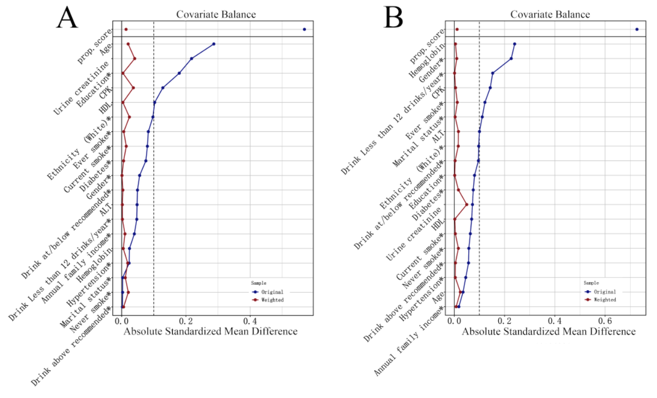
Appendix Figure 3. The absolute standardized mean difference/ absolute correlation coefficients between covariates and periodontitis before and after (generalized) propensity score weighting (A: Dietary supplement folate and covariates; B: Dietary intake folate equivalents and covariates).

Appendix Tables
Appendix Table 1. The absolute standardized mean difference/ absolute correlation coefficients between covariates and four variables before and after (generalized) propensity score weighting
Covariates | Periodontitis |  | Dietary Supplement Folate |  | Serum total folate |  | RBC folate
Covariates | Before | After | Before | After | Before | After | Before | After
Age | -0.202 | -0.005 | 0.095 | -0.001 | 0.227 | 0.010 | 0.233 | -0.087
Gender | -0.159 | -0.001 | 0.068 | -0.001 | 0.085 | 0.023 | 0.136 | -0.075
Ethnicity | -0.100 | 0.003 | 0.100 | 0.016 | 0.211 | 0.030 | 0.176 | -0.116
Marital status | 0.018 | 0.001 | 0.020 | -0.030 | 0.030 | 0.005 | -0.005 | 0.052
HDL | -0.126 | -0.001 | 0.093 | 0.010 | 0.006 | -0.023 | 0.100 | -0.006
Hypertension | 0.019 | <0.001 | 0.011 | -0.003 | -0.088 | -0.038 | -0.043 | -0.060
Diabetes | -0.004 | <0.001 | 0.031 | -0.053 | -0.040 | 0.016 | -0.016 | 0.009
UA | 0.063 | -0.007 | -0.097 | -0.002 | -0.133 | -0.024 | -0.166 | -0.017
Glycohemoglobin | 0.199 | -0.004 | -0.009 | -0.003 | -0.093 | -0.001 | -0.090 | -0.060
ALT | 0.125 | 0.020 | 0.006 | 0.008 | 0.034 | 0.046 | 0.010 | 0.012
CPK | 0.152 | 0.002 | -0.080 | -0.025 | -0.093 | 0.052 | -0.074 | 0.136
At/below recommended | 0.020 | 0.002 | 0.046 | -0.025 | 0.005 | -0.015 | -0.003 | -0.069
Above recommended | 0.026 | <0.001 | 0.022 | 0.011 | -0.029 | -0.019 | -0.051 | <0.001
Less than 12 drinks/year | -0.045 | -0.002 | -0.061 | 0.013 | 0.021 | 0.031 | 0.048 | 0.063
Annual family income | 0.021 | -0.001 | -0.033 | 0.030 | -0.027 | -0.032 | 0.001 | -0.016
Ever | 0.008 | <0.001 | 0.018 | 0.011 | 0.037 | 0.042 | -0.008 | -0.004
Never | -0.111 | 0.001 | 0.016 | -0.010 | 0.062 | -0.004 | 0.098 | -0.112
Current | 0.103 | <0.001 | -0.053 | -0.002 | -0.155 | -0.059 | -0.144 | 0.185
Education | 0.099 | -0.002 | -0.110 | -0.020 | -0.079 | -0.006 | -0.071 | -0.024
Note: Propensity score weighting (PSW) was used to balance the covariates when estimate the association between periodontitis and cognitive score, and generalized propensity score weighting (GPSW) was used to balance the covariates when estimate the associations between Serum total folate and RBC folate and cognitive scores. Before: demonstrating before propersity score weighting; After: demonstrating after propensity score weighting.

Appendix Table 2. Direct and indirect effect of the three forms of folate for the association between periodontitis and cognitive function
Mediator | Cognitive function | Effect | B | SE | Z value | P value
Dietary Supplement Folate | General cognition score | NDE | -0.206 | 0.101 | -2.032 | 0.042
Dietary Supplement Folate | General cognition score | NIE | -0.019 | 0.009 | -2.121 | 0.034
Dietary Supplement Folate | General cognition score | TE | -0.225 | 0.102 | -2.203 | 0.028
Dietary Supplement Folate | CERAD_IR | NDE | -0.255 | 0.221 | -1.154 | 0.249
Dietary Supplement Folate | CERAD_IR | NIE | -0.010 | 0.015 | -0.669 | 0.504
Dietary Supplement Folate | CERAD_IR | TE | -0.265 | 0.221 | -1.198 | 0.231
Dietary Supplement Folate | CERAD_DR | NDE | -0.066 | 0.110 | -0.600 | 0.549
Dietary Supplement Folate | CERAD_DR | NIE | -0.010 | 0.008 | -1.296 | 0.195
Dietary Supplement Folate | CERAD_DR | TE | -0.076 | 0.109 | -0.695 | 0.487
Dietary Supplement Folate | CERAD_WL | NDE | -0.320 | 0.283 | -1.132 | 0.258
Dietary Supplement Folate | CERAD_WL | NIE | -0.020 | 0.022 | -0.916 | 0.360
Dietary Supplement Folate | CERAD_WL | TE | -0.341 | 0.284 | -1.202 | 0.229
Dietary Supplement Folate | AFT | NDE | -0.288 | 0.262 | -1.099 | 0.272
Dietary Supplement Folate | AFT | NIE | -0.029 | 0.021 | -1.372 | 0.170
Dietary Supplement Folate | AFT | TE | -0.317 | 0.262 | -1.210 | 0.226
Dietary Supplement Folate | DSST | NDE | -1.788 | 0.707 | -2.531 | 0.011
Dietary Supplement Folate | DSST | NIE | -0.187 | 0.075 | -2.485 | 0.013
Dietary Supplement Folate | DSST | TE | -1.975 | 0.715 | -2.762 | 0.006
Serum total folate | General cognition score | NDE | -0.208 | 0.099 | -2.094 | 0.036
Serum total folate | General cognition score | NIE | -0.021 | 0.010 | -2.100 | 0.036
Serum total folate | General cognition score | TE | -0.229 | 0.099 | -2.319 | 0.020
Serum total folate | CERAD_IR | NDE | -0.265 | 0.210 | -1.262 | 0.207
Serum total folate | CERAD_IR | NIE | -0.020 | 0.019 | -1.047 | 0.295
Serum total folate | CERAD_IR | TE | -0.284 | 0.209 | -1.361 | 0.174
Serum total folate | CERAD_DR | NDE | -0.072 | 0.105 | -0.681 | 0.496
Serum total folate | CERAD_DR | NIE | -0.005 | 0.010 | -0.475 | 0.634
Serum total folate | CERAD_DR | TE | -0.076 | 0.104 | -0.730 | 0.465
Serum total folate | CERAD_WL | NDE | -0.336 | 0.309 | -1.088 | 0.277
Serum total folate | CERAD_WL | NIE | -0.024 | 0.026 | -0.944 | 0.345
Serum total folate | CERAD_WL | TE | -0.361 | 0.309 | -1.166 | 0.244
Serum total folate | AFT | NDE | -0.264 | 0.270 | -0.98 | 0.327
Serum total folate | AFT | NIE | -0.055 | 0.027 | -2.065 | 0.039
Serum total folate | AFT | TE | -0.320 | 0.268 | -1.192 | 0.233
Serum total folate | DSST | NDE | -1.859 | 0.700 | -2.656 | 0.008
Serum total folate | DSST | NIE | -0.132 | 0.065 | -2.046 | 0.041
Serum total folate | DSST | TE | -1.991 | 0.700 | -2.844 | 0.004
RBC folate | General cognition score | NDE | -0.208 | 0.096 | -2.154 | 0.031
RBC folate | General cognition score | NIE | -0.021 | 0.01 | -2.148 | 0.032
RBC folate | General cognition score | TE | -0.229 | 0.097 | -2.369 | 0.018
RBC folate | CERAD_IR | NDE | -0.267 | 0.208 | -1.284 | 0.199
RBC folate | CERAD_IR | NIE | -0.003 | 0.016 | -0.19 | 0.849
RBC folate | CERAD_IR | TE | -0.270 | 0.208 | -1.295 | 0.195
RBC folate | CERAD_DR | NDE | -0.061 | 0.106 | -0.580 | 0.562
RBC folate | CERAD_DR | NIE | -0.011 | 0.008 | -1.309 | 0.190
RBC folate | CERAD_DR | TE | -0.072 | 0.106 | -0.683 | 0.495
RBC folate | CERAD_WL | NDE | -0.329 | 0.304 | -1.081 | 0.280
RBC folate | CERAD_WL | NIE | -0.014 | 0.023 | -0.583 | 0.560
RBC folate | CERAD_WL | TE | -0.342 | 0.303 | -1.129 | 0.259
RBC folate | AFT | NDE | -0.287 | 0.264 | -1.089 | 0.276
RBC folate | AFT | NIE | -0.046 | 0.023 | -2.006 | 0.045
RBC folate | AFT | TE | -0.334 | 0.264 | -1.262 | 0.207
RBC folate | DSST | NDE | -1.806 | 0.713 | -2.532 | 0.011
RBC folate | DSST | NIE | -0.180 | 0.077 | -2.333 | 0.020
RBC folate | DSST | TE | -1.986 | 0.716 | -2.775 | 0.006
Note: CERAD_IR: CERAD Word Learning for immediate recall; CERAD_DR: CERAD Word Learning for delayed recall; CERAD_WL: CERAD Word Learning; AFT: animal fluency test; DSST: digit symbol substitution test. NIE: natural indirect effect; NDE: natural direct effect; TE: total effect. P values in bold font are less than 0.05.

Appendix Table 3. Comparisons of characteristics between periodontitis without and with dietary supplement folate
Characteristics | Without supplement folate (n = 605) | With supplement folate (n = 264) | t | P
Dietary supplement folate | 0.00 ± 0.00 | 704.88 ± 417.12 | 27.457 | 0.000
General cognition score | -0.34 ± 2.35 | 0.23 ± 2.17 | 3.2772 | 0.001
CERAD_IR | 18.52 ± 4.88 | 19.28 ± 4.43 | 2.1814 | 0.029
CERAD_DR | 5.90 ± 2.33 | 6.10 ± 2.31 | 1.1847 | 0.236
CERAD_WL | 24.41 ± 6.86 | 25.38 ± 6.27 | 1.9556 | 0.051
AFT | 16.48 ± 5.52 | 17.25 ± 5.27 | 1.9027 | 0.057
DSST | 44.46 ± 17.26 | 50.58 ± 15.29 | 5.1344 | 0.000
Serum total folate | 17.50 ± 8.88 | 32.16 ± 12.67 | 16.536 | 0.000
RBC folate | 471.91 ± 189.13 | 735.77 ± 279.85 | 13.758 | 0.000

Appendix Table 4. The absolute standardized mean difference between covariates and dietary supplement folate (Yes vs. No) before and after propensity score weighting
Covariates | Type | Before adjusted | After adjusted | State
Age | Continuous | -0.287 | 0.020 | Balanced
Gender | Binary | -0.056 | -0.001 | Balanced
Ethnicity | Binary | -0.097 | 0.024 | Balanced
Marital status | Binary | 0.003 | 0.011 | Balanced
HDL | Continuous | -0.103 | -0.004 | Balanced
Hypertension | Binary | -0.023 | -0.019 | Balanced
Diabetes | Binary | -0.075 | 0.006 | Balanced
UA | Continuous | 0.218 | -0.041 | Balanced
Glycohemoglobin | Continuous | 0.024 | 0.005 | Balanced
ALT | Continuous | 0.048 | -0.002 | Balanced
CPK | Continuous | 0.128 | 0.036 | Balanced
At/below recommended | Binary | -0.049 | 0.004 | Balanced
Above recommended | Binary | 0.002 | -0.006 | Balanced
Less than 12 drinks/year | Binary | 0.047 | 0.002 | Balanced
Annual family income | Binary | 0.039 | 0.010 | Balanced
Ever | Binary | -0.083 | -0.006 | Balanced
Never | Binary | 0.003 | 0.021 | Balanced
Current | Binary | 0.080 | -0.014 | Balanced
Education | Binary | 0.179 | -0.004 | Balanced

Appendix Table 5. Propensity score weighting linear regression for association between dietary supplement folate (Yes vs. No) and cognitive scores
Cognitive Scores | B | SE | t | P value
General cognition score | -0.571 | 0.181 | -3.162 | 0.002
CERAD_IR | -0.53 | 0.356 | -1.489 | 0.137
CERAD_DR | -0.097 | 0.179 | -0.543 | 0.587
CERAD_WL | -0.627 | 0.504 | -1.244 | 0.214
AFT | -0.699 | 0.433 | -1.613 | 0.107
DSST | -5.938 | 1.324 | -4.484 | <0.001

Appendix Table 6. Comparisons of characteristics between periodontitis without and with dietary intake folate
Characteristics | Without low dietary intake folate (n = 420) | With high dietary intake folate (n = 318) | t | P
Dietary intake folate | 327.35 ± 98.89 | 711.73 ± 205.54 | -30.762 | 0.000
General cognition score | -0.16 ± 2.36 | 0.20 ± 2.16 | -2.0967 | 0.036
CERAD_IR | 19.01 ± 4.75 | 19.19 ± 4.37 | -0.52479 | 0.600
CERAD_DR | 6.09 ± 2.27 | 6.15 ± 2.23 | -0.36596 | 0.715
CERAD_WL | 25.10 ± 6.61 | 25.34 ± 6.18 | -0.50765 | 0.612
AFT | 16.65 ± 5.39 | 17.55 ± 5.42 | -2.2360 | 0.026
DSST | 46.26 ± 16.91 | 49.06 ± 16.28 | -2.2440 | 0.025
Serum total folate | 21.00 ± 12.61 | 24.22 ± 11.62 | -3.4595 | 0.001
RBC folate | 530.95 ± 244.07 | 607.81 ± 267.53 | -3.9916 | 0.000

Appendix Table 7. The absolute standardized mean difference between covariates and dietary intake folate (Equal to or Above vs. Below average level) before and after propensity score weighting
Covariates | Type | Before adjusted | After adjusted | State
Age | Continuous | -0.035 | -0.024 | Balanced
Gender | Binary | -0.227 | -0.010 | Balanced
Ethnicity | Binary | 0.097 | -0.016 | Balanced
Marital status | Binary | 0.111 | -0.004 | Balanced
HDL | Continuous | -0.069 | 0.002 | Balanced
Hypertension | Binary | 0.046 | 0.004 | Balanced
Diabetes | Binary | 0.076 | -0.017 | Balanced
UA | Continuous | -0.072 | 0.050 | Balanced
Glycohemoglobin | Continuous | 0.240 | -0.005 | Balanced
ALT | Continuous | 0.100 | -0.017 | Balanced
CPK | Continuous | 0.143 | -0.005 | Balanced
At/below recommended | Binary | 0.096 | 0.003 | Balanced
Above recommended | Binary | 0.057 | -0.005 | Balanced
Less than 12 drinks/year | Binary | -0.153 | 0.001 | Balanced
Annual family income | Binary | 0.018 | -0.008 | Balanced
Ever | Binary | 0.122 | -0.012 | Balanced
Never | Binary | -0.058 | 0.016 | Balanced
Current | Binary | -0.064 | -0.004 | Balanced
Education | Binary | -0.081 | 0.002 | Balanced

Appendix Table 8. Propensity score weighting linear regression for association between dietary intake folate (Equal to or Above vs. Below average level) and cognitive scores
Cognitive Scores | B | SE | t | P value
General cognition score | 0.400 | 0.177 | 2.265 | 0.024
CERAD_IR | 0.218 | 0.350 | 0.623 | 0.534
CERAD_DR | 0.037 | 0.176 | 0.210 | 0.834
CERAD_WL | 0.255 | 0.494 | 0.516 | 0.606
AFT | 1.104 | 0.422 | 2.617 | 0.009
DSST | 2.734 | 1.311 | 2.086 | 0.037

