Supplementary Materials For
Observation of Giant Spin Splitting and d-wave Spin Texture in Room Temperature Altermagnet RuO₂

Zihan Lin^{1, †}, Dong Chen^{2,3, †}, Wenlong Lu^{1, †}, Xin Liang¹, Shiyu Feng¹, Kohei Yamagami⁴, Jacek Osiecki⁵, Mats Leandersson⁵, Balasubramanian Thiagarajan⁵, Junwei Liu⁶, Claudia Felser³, Junzhang Ma^{1,7,*}
¹Department of Physics, City University of Hong Kong, Kowloon, Hong Kong, China
²College of Physics, Qingdao University, Qingdao 266071, China
³Max Planck Institute for Chemical Physics of Solids, 01187 Dresden, Germany
⁴Materials Sciences Research Center, Japan Atomic Energy Agency, Sayo, Hyogo 679-5148, Japan
⁵MAX IV laboratory, Fotongatan 8, 22484 Lund, Sweden
⁶Department of Physics, The Hong Kong University of Science and Technology, Hong Kong, China.
⁷City University of Hong Kong Shenzhen Research Institute, Shenzhen, China

†The authors contributed equally to this work.
*Corresponding to: Junzhang Ma (junzhama@cityu.edu.hk)

These Supplementary Materials contain:
Supplementary Sections 1-5.
S1. Determining photon energies versus out-of-plane k_{z}.
S2. The nature of a flat band on the Fermi level.
S3. SOC and long-range magnetic order.
S4. Bulk band splitting in soft X-ray data.
S5. EDC fitting of spin resolved data.
Supplementary Figures 1 to 8.

S1. Determining photon energies versus out-of-plane k_{z}
In the main text, we used UV light for the spin texture validation due to its high energy resolution and photon intensity. Low photon energy, however, causes a stronger k_{z} broadening effect and strengthens surface states, making the determination of out-of-plane k_{z} relatively difficult compared to soft X-ray data. Accurately determining the momentum in 3D reciprocal space is important for d-wave altermagnetism in RuO₂ since the spin texture represents bulk information. To obtain accurate determination of the right photon energy and locations in momentum space, both UV and soft X-ray photon energy-dependent mappings were carried out, as shown in Fig. 2b and c in the main text. An important feature for verifying the accuracy of k_{z} is the central point which alters with photon energy between Γ and M. Photon energies versus k_{z} were easily determined with the use of soft X-ray ARPES data in Fig. 2c, which clearly reveals a clear periodic structure as illustrated in Fig. S1c. The periodic structure is in good alignment with the lattice parameter along the out-of-plane direction, which allows us to identify the Γ plane at 521 eV, the M plane at 621 eV, and the Γ plane again at 725 eV.
On the other hand, the out-of-plane dispersion in UV ARPES data is weaker but still noticeable as shown in Fig. 2b, where we identified 37 eV as the Γ plane, 74 eV as the M plane, and 115 eV as the Γ plane once more. This determination is consistent with the extension of the hv- k_{z} curve from the soft X-ray region to the UV region, as seen in Fig. S1c. Additionally, the bands that cross the BZ center should cycle between MΓM and ΓMΓ, providing compelling evidence that the k_{z} determination is accurate. In Fig. S1 d-h, we plotted the ARPES spectra crossing the BZ center at photon energies of 37, 74, 115, 521, and 621 eV. As expected, the slopes’ sign of the (β, γ) bands alternates between positive and negative, as denoted with green dotted lines in Fig. S1 d-h. Therefore, the determination of the 3D BZ band the bulk band nature is guaranteed by the combination of soft X-ray and UV ARPES data.
S2. The nature of α flat band on the Fermi level and surface states
The bulk band character of the β, γ and δ bands can be confirmed by the band structure altering between MΓM and ΓMΓ at different photon energies, in previous discussions. Nevertheless, the α flat band on the Fermi level is not visible in the soft X-ray data. Fig. S2 provides the results of a surface band structure projection calculation to examine if the α band indicates a surface state. The calculations reveal no discernible evidence of surface bands near the Fermi level along the ΓM direction. Instead, the broad projection of the α band, indicated by the dotted ellipse, demonstrates its bulk nature.
In an earlier study, a drum-head surface state is claimed to result from the bulk nodal line, on the Fermi level at the same position of the α flat band⁵⁷. Our computational investigation, however, does not reveal any unique surface band separated from bulk bands at the Fermi level. This implies that such surface states, if they exist, are topologically unprotected and overlap with the bulk band projection. They can be viewed as a top layer extension of the wavefunction of the same bulk flat band. This observation suggests that the α band mainly consists of bulk spectra. The disappearance of the α band in the soft X-ray data is attributed to a little chemical potential shift between the surface and bulk area caused by the band bending effect. This phenomenon is commonly observed in other materials, such as the conduction bulk band in the topological insulator Bi₂Se₃⁶⁹.
On the other hand, our calculation does show surface states along the ΓM direction, as indicated by SS in Fig. S2b. The lower surface band is located at around -0.25 eV which is above the δ band. Our experimental data also show the presence of such a surface band. Fig. S3 plots the cuts with three different photon energies hv = 54 eV, 74 eV and 94 eV and with three polarizations, i.e., circular plus (CP), linear horizontal (LH), and linear vertical (LV), respectively. The α-δ bands are observed within LH data and show good agreement with the calculations. On the other hand, in the LV data, one additional band is significantly apparent above δ band located at around -0.25 eV. The position and dispersion agree well with the surface band predicted in Fig. S2b. According to the experimental findings, surface bands are strengthened under LV polarization while bulk bands are apparent under LH polarization along ΓM direction. Circular polarization, on the other hand, has both surface and bulk states.
S3. Spin-Orbit Coupling (SOC) and long-range magnetic order
In the main text, we highlighted the difference between band calculations of the paramagnetic and altermagnetic phases, arguing that band splitting provides strong evidence of long-range magnetic order. Meanwhile, a relevant question arises: Is it possible for SOC to be responsible for band splitting in a non-magnetic order instead of just being caused by magnetic order? To address this concern, we carried out band structure calculations in the paramagnetic phase with SOC, as shown in Fig. S4. Six cuts in the ΓMAZ plane were plotted, revealing no band splitting in all calculations.
On the other hand, band structure calculations in the altermagnetic phase with SOC, as shown in Fig. S5c, revealed that SOC does not introduce additional bands but instead enhanced band hybridization, as indicated by the black ellipse. Fig. S5d shows the same cut without SOC for comparison. Upon a thorough analysis of the experimental data, we observed a similar hybridization between the α and β bands in the ARPES data, as shown in Fig. S5a and b. It should be noted that SOC was not considered in the calculations shown in the main text, because doing so would have rendered spin an invalid good quantum number.
In summary, the band splitting observed in our experiments provides unambiguous proof of the long-range magnetic order in RuO₂.
S4. Investigation of Bulk band splitting in soft X-ray data
We provided a thorough examination of the band structure in the ΓMAZ plane in the main text, demonstrating band spin splitting that is in good agreement with first principle calculations in the altermagnetic phase. Analogous studies were carried out inside the soft X-ray spectrum. We focused on data acquired at 521 eV photon energy, concentrating on band structure within the same plane. Fig. S7a-c shows the relevant BZ and Fermi surface. A set of bands labelled as cut 1-6 that run parallel to the direction of the ΓM are shown for the experimental data in Fig. S7d-i and for the calculations in Fig. 7j-o.
Despite the lower energy resolution and broader bands in the soft X-ray experimental data, the general band dispersion remains consistent with that acquired using UV light. The band splitting predicted by the calculations is visible in cut 1-4, as highlighted in the data. This comprehensive comparison provides robust evidence supporting the agreement between the experimental observations and theoretical predictions under the altermagnetic phase.

S5. EDC fitting of spin resolved data
One notable feature of the spin EDCs shown in Fig. 4 of the main text is the prominent background, which could cause the spin polarization to be underestimated. To remove this negative impact, we applied a fitting process for each of the four EDCs, which included a simple linear background and Gaussian peaks multiplied by a Fermi-Dirac function. Fig. S8a, c, e, and g show the fitting results. The main goal of the fitting is to extract the linear background. Black dotted lines represent the fitted backgrounds (multiplied by Fermi-Dirac function). Interestingly, both the upper and lower points show a broad peak at approximately -1 eV, whereas the left and right points show no such peak. As the calculation predicted, these peaks are attributed to the valence bands below the δ band. These bands are too weak to be seen in the left and right points due to matrix element effects. An equal linear background was subtracted for both spin-up and spin-down EDCs at the same position of the four points to remove the influence of the background on the spin difference between the spin up and down of EDCs. As seen by the blue curves in Fig. S8b, d, f, and h, this background reduction greatly increased the spin polarization, with the maximum reaching up to 20% for both the upper and lower points.

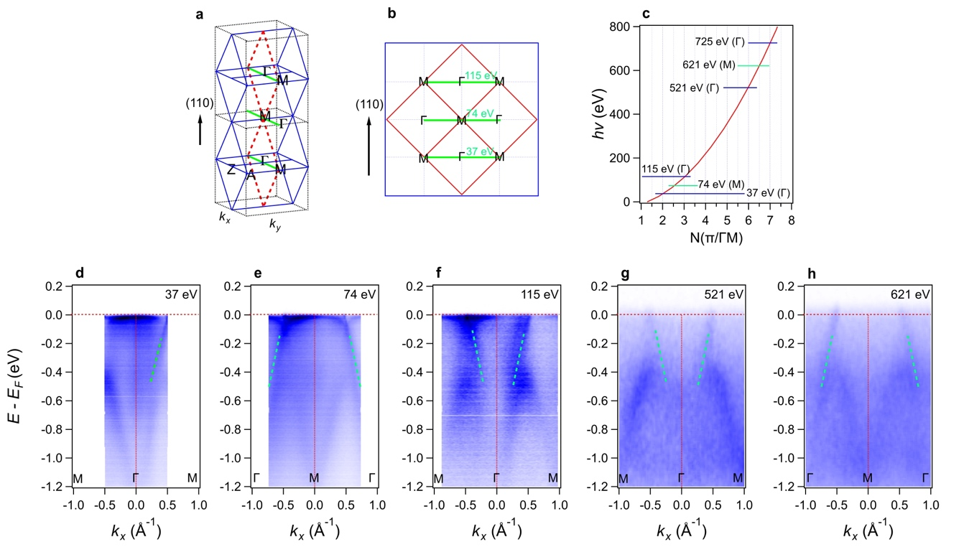
Fig. S1. Relationship between photon energy and out-of-plane k_{z}. a, Schematic of the 3D BZs stacked along the out-of-plane direction. The green lines represent cuts along k_{x}, alternating versus photon energy between ΓM and MΓ. b, Cross-section of the Brillouin zone along the out-of-plane direction. c, The relationship between photon energy and k_{z} for RuO₂ obtained from the photon energy-dependent data, as shown in Fig. 2 b, c in the main text. d-h, ARPES spectra along k_{x} under photon energies of 37 eV, 74 eV, 115 eV, 521 eV, and 621 eV, respectively.

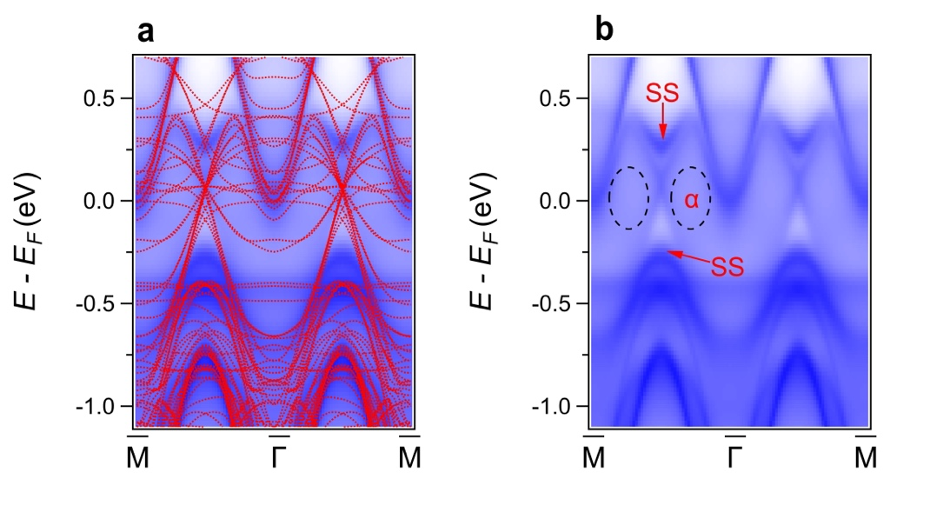
Fig. S2. (110) Direction projected surface states calculations including SOC. a, Surface-projected band structure with bulk bands (11 k_{z} evenly distributed between k_{z} = 0 and $\sqrt{2}π$/a) plotted alongside for comparison. b, Pure surface-projected band structure. The black dotted area represents the projection of the bulk α band without any sharp surface signature.

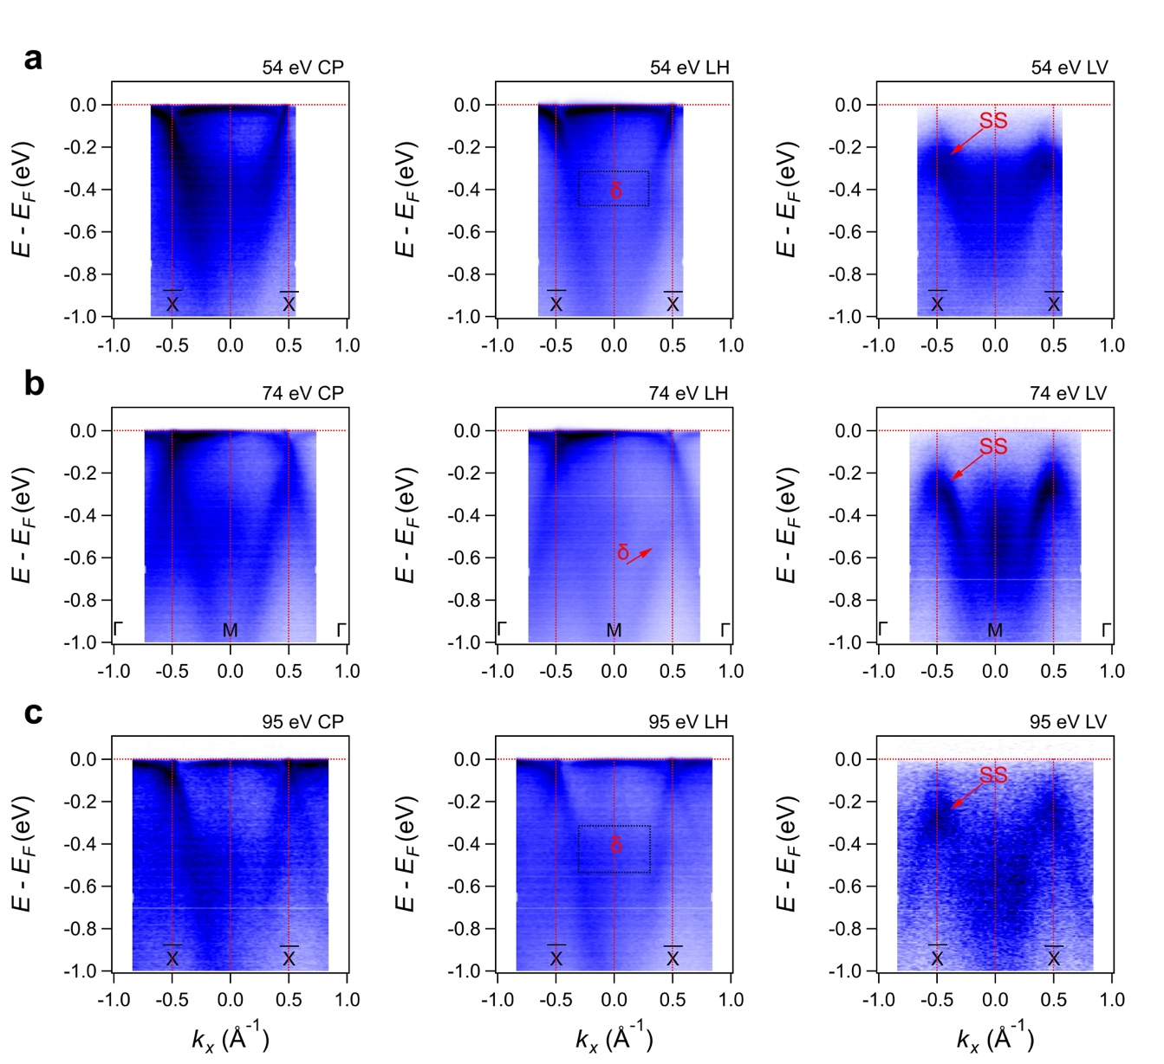
Fig. S3. Light polarization dependent cuts at 54 eV a, 74 eV b and 95 eV c with circular plus (CP), linear horizontal (LH) and linear vertical (LV) photons, respectively. SS denotes surface states.

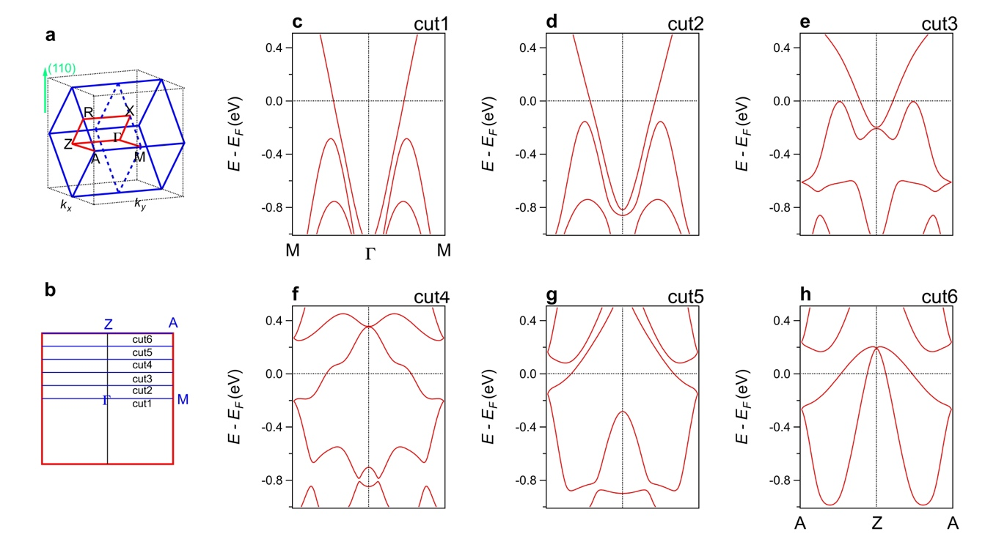
Fig. S4. Band structure calculations for non-magnetic RuO₂, indicating no band splitting in the whole BZ. a, Schematic diagram of the BZ. b, Cross-section of the BZ along the k_{x} – k_{y} plane. c-h, Non-magnetic DFT-calculated bands including SOC for cut1 to cut6, respectively. No band splitting is observed.

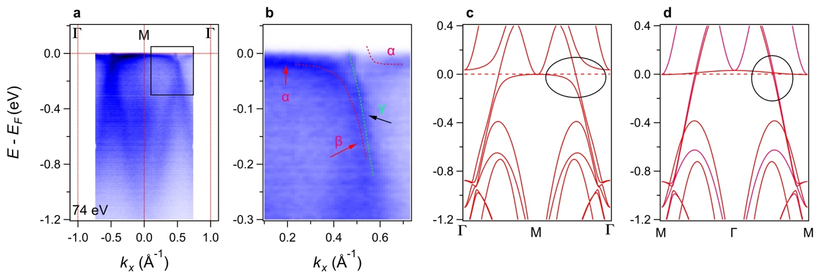
Fig. S5. SOC-induced band hybridization gap. a, b, ARPES spectra and its zoomed-in view along ΓMΓ direction acquired with hv = 74 eV. c, Calculated band structure along ΓMΓ direction under the altermagnetic phase considering SOC. d, Same as c but without considering SOC.

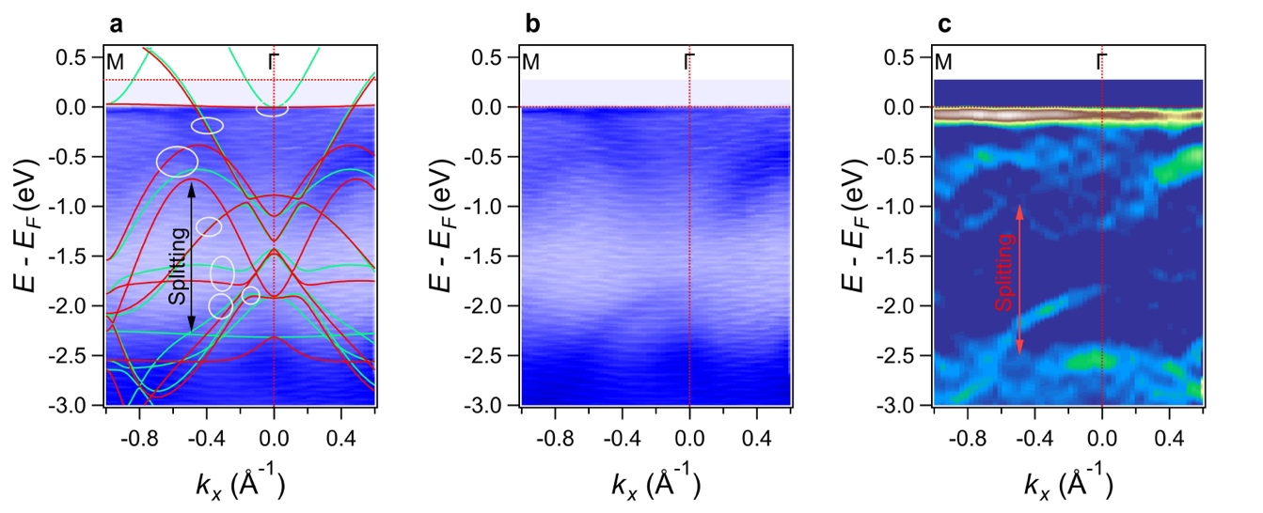

Fig. S6. Giant spin splitting of the occupied bands along ΓM direction. a, APRES spectra with a wide energy range along ΓM direction. The calculated band structure is overlaid for comparison. The spin splitting is indicated by the double arrow. The gray ellipses mark the Kramer pairs. b, Pure ARPES spectra same as in a. c, Curvature intensity plot of the experimental data. The double arrow points to the signature of the band splitting.

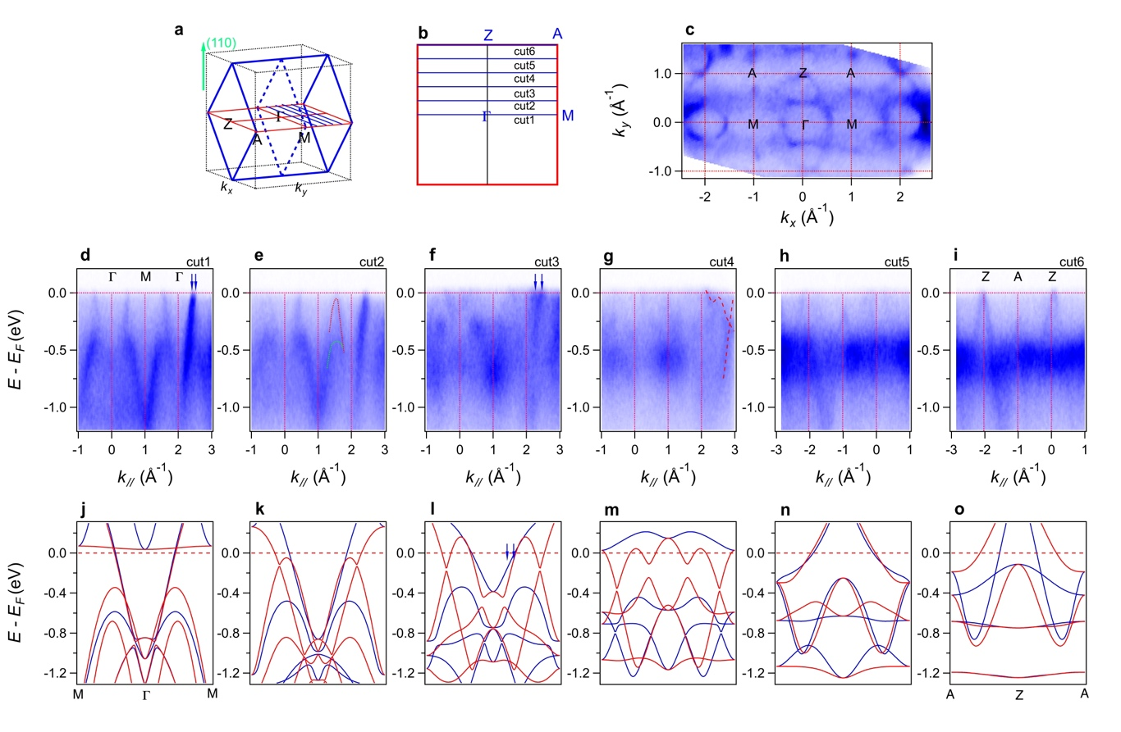
Fig. S7. Soft X-ray ARPES Data in ΓMAZ Plane. a, b, Three-dimensional BZ of RuO₂ and the two-dimensional cross-section in the ΓMAZ plane. c, Fermi surfaces in the ΓMAZ plane acquired with hv = 521 eV. d-i, ARPES spectra of cuts parallel to the ΓM direction with an equal k_{z} offset of 0.2*ΓZ between each. j-o, Calculated band structure along cut1-6 under the altermagnetic phase. The red color denotes spin up, and the blue color denotes spin down. The bands are shifted up by 0.41 eV for comparison with soft X-ray ARPES data.

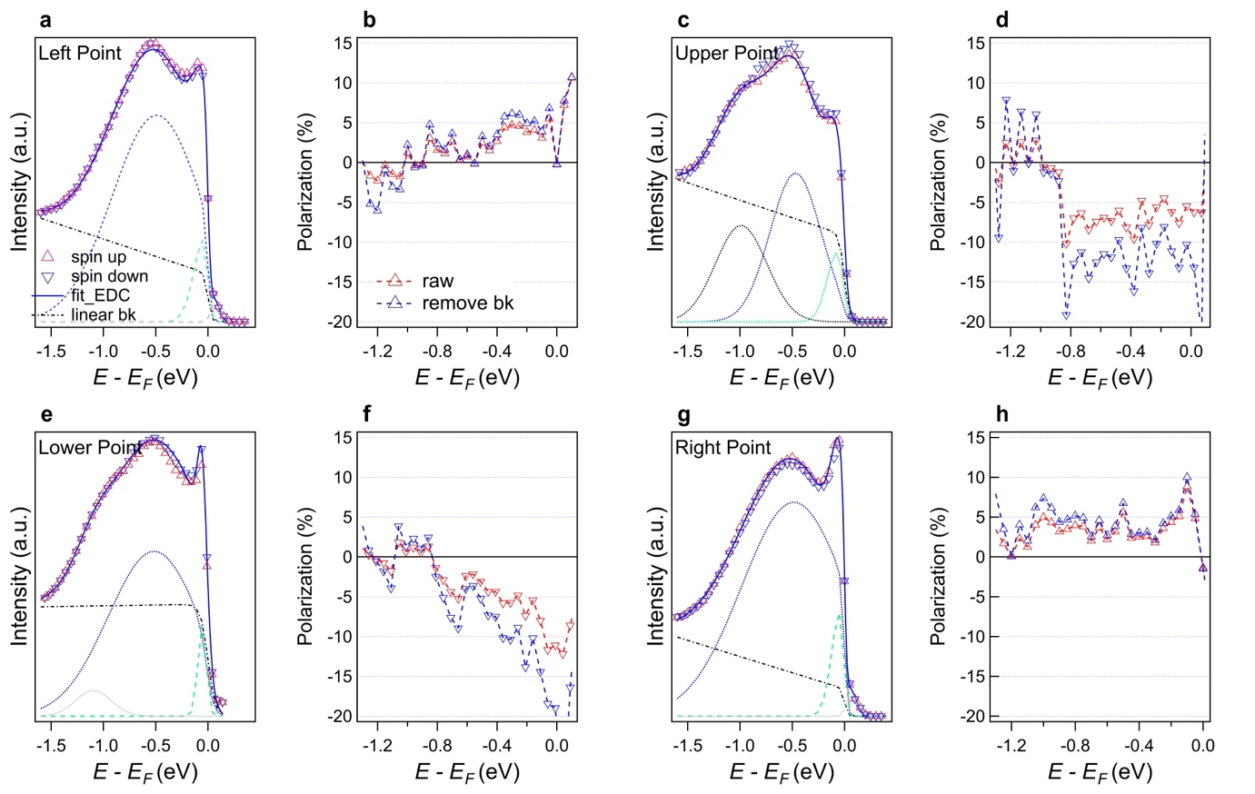
Fig. S8. Spin-polarized EDCs and polarization after removing linear background. a, Spin-resolved EDC of the left point, where the triangle point represents the raw data, dashed line represents the linear background, and the solid line represents the fitted EDC. The blue and green dotted lines represent the fitted peaks. b, The polarization EDCs. The red dotted curve denotes the pristine polarization, and the blue dotted curve denotes the polarization derived after removing the linear background. c-d, e-f, g-h, Same as a-b, but for the upper point, lower point, and right point, respectively.

