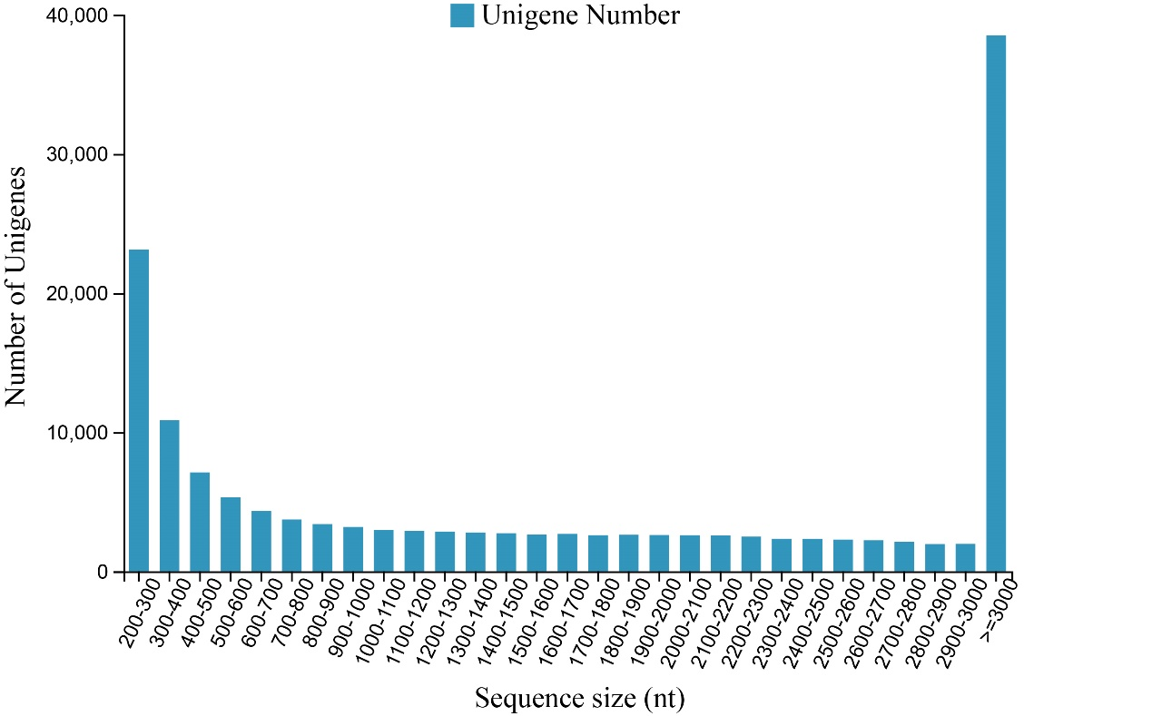
Figure S1. The length distribution of the unigenes.

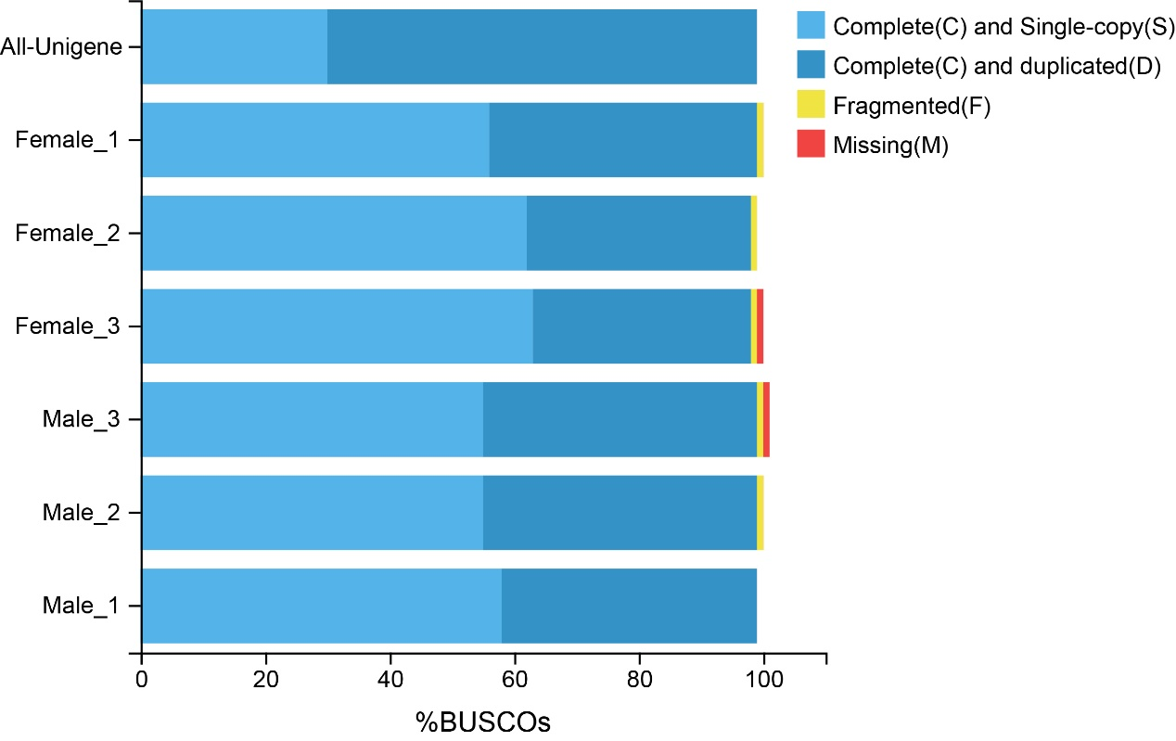
Figure S2. Completeness of the assembly and annotations.

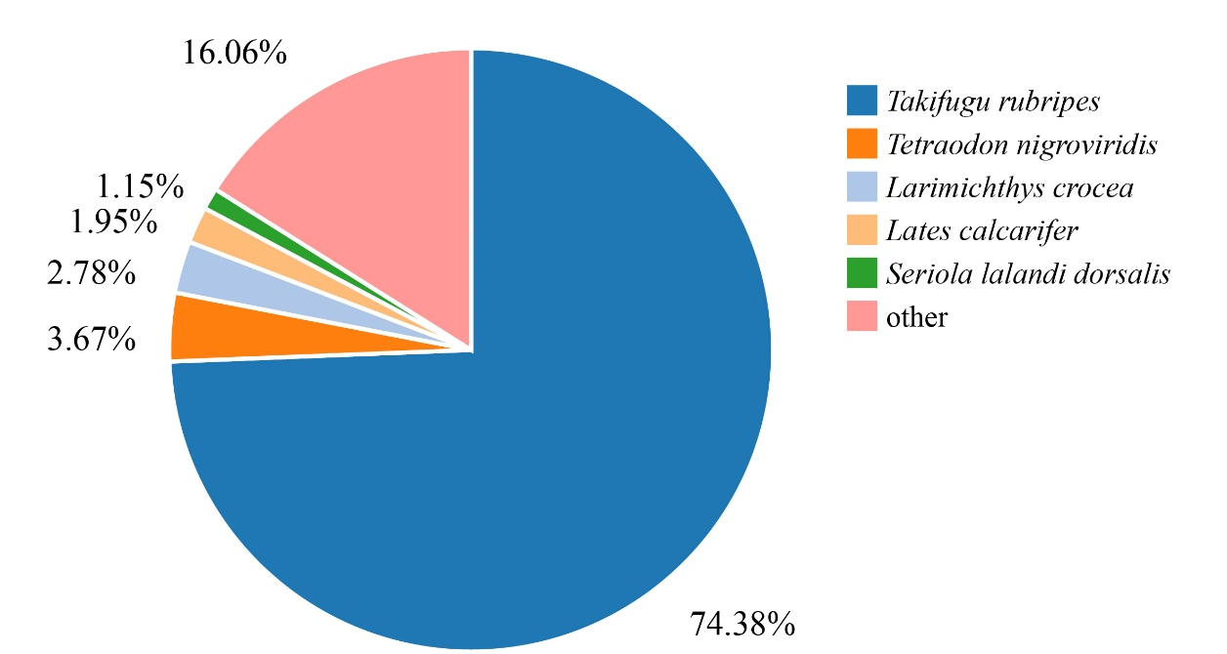
Figure S3. Distribution of the unigene hits by species in the NR database.

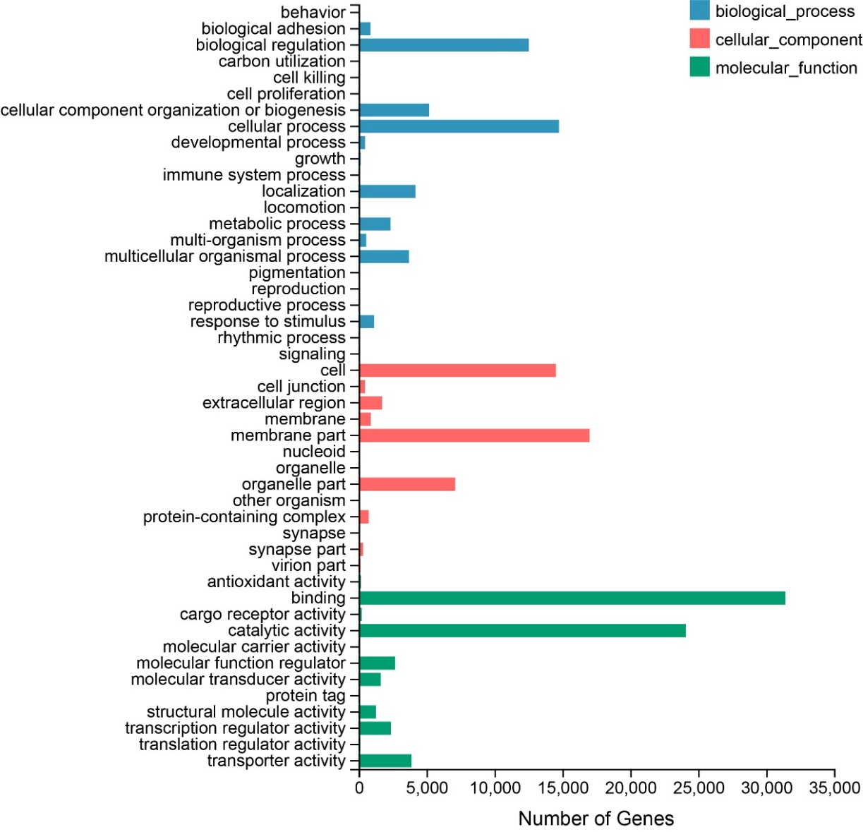
Figure S4. GO terms for the DEGs in the biological process, cellular component, and molecular function categories.
Table S1. Specific primers for the selected unigenes and reference genes.
Primers | Sequences (5'to3')
191-1.CL12876-F | ACAGCAAAGAGGTGGTGGCA
191-1.CL12876-R | TTCTCCATTACAGTCGCGGC
191-2.Unigene147-F | TCTTGCTGTTTGGCCTTGGA
191-2.Unigene147-R | CCCAATTGTGTGCCTTGACC
191-3.CL212-F | CAATGTGCGGAAGCAGATGT
191-3.CL212-R | GCCATACAATGCCACCCTCT
191-4.Unigene16662-F | CCGCCAGATGACCTTGTGTT
191-4.Unigene16662-R | CCAGCCCCTTGATCTCATCA
191-5.Unigene15730-F | GTTTCAGCAATGGTGCGGTC
191-5.Unigene15730-R | AGCGGCTGCAACAAGACAGT
191-6.CL5341-F | CGGTGTTTTTGCTCCTTTGC
191-6.CL5341-R | TGGAACCAAATACCCGATGC
191-7.CL1574-F | TGACGCAACCACTGGATTCA
191-7.CL1574-R | CAGATTGAGCCGCAGAAAGG
191-8.CL2700-F | ATGGTATCGGCTGGCTGACA
191-8.CL2700-R | GCTCCCCTCGTATGGCTTGT
191-9.CL10581-F | GCTCATCTGATTCCCGCTCA
191-9.CL10581-R | GCACATGCAGGTGTTGCATC
191-10.Unigene17155-F | CATTTTTCTGGCGACCATCG
191-10.Unigene17155-R | ATCTGCGCCGTCACAATGTT
191-11.β-actin-F | CAGCATCATGAAGTGCGACG
191-11.β-actin-R | TTCTGCATCCTGTCGGCAAT
191-12.18S-F | AAGCGAAAGCATTTGCCAAG
191-12.18S-R | GGCATCGTTTATGGTCGGAA

Table S2. Top 20 GO pathways.
Access number | Classifications | Unigenes number
GO:0016021 | Integral component of membrane | 1093
GO:0005524 | ATP binding | 520
GO:0005634 | Nucleus | 388
GO:0046872 | Metal ion binding | 221
GO:0003677 | DNA binding | 220
GO:0003676 | Nucleic acid binding | 182
GO:0008270 | Zinc ion binding | 175
GO:0004672 | Protein kinase activity | 138
GO:0005737 | Cytoplasm | 132
GO:0005509 | Calcium ion binding | 125
GO:0003723 | RNA binding | 117
GO:0003700 | DNA-binding transcription factor activity | 103
GO:0005525 | GTP binding | 93
GO:0005886 | Plasma membrane | 90
GO:0004674 | Protein serine/threonine kinase activity | 88
GO:0043565 | Sequence-specific DNA binding | 77
GO:0005576 | Extracellular region | 77
GO:0003924 | GTPase activity | 74
GO:0006355 | Regulation of transcription, DNA-Templated | 70
GO:0003779 | Actin binding | 68

