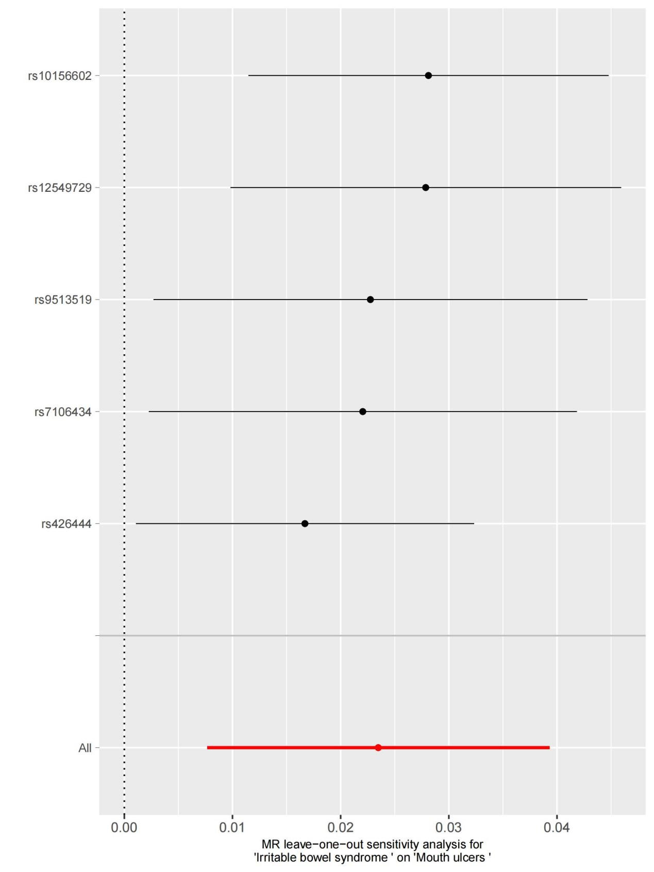

Supplement figure 1. Forest plot of irritable bowel syndrome versus mouth ulcers.

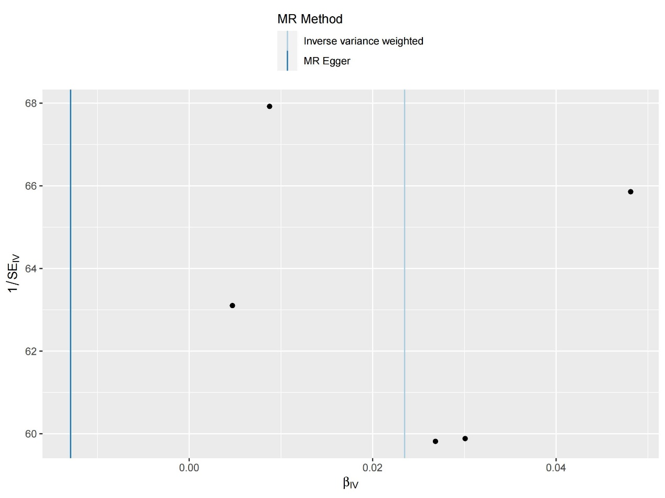
Supplement figure 2. Funnel plot analysis of irritable bowel syndrome versus mouth ulcers.

