Supplementary information

Gene | Forward primer (5’- 3’) | Reverse primer (5’- 3’) | Reference
C/EBPα | CGCAAGAGCCGAGATAAAGC | CGGTCATTGTCACTGGTCAACT | ⁵⁰
PPARγ | GAAAGACAACGGACAAATCACC | GGGGGTGATATGTTTGAACTTG | ⁵¹
KLF2 | CTGCGTACACACACAGGTGA | GTGGCACTGAAAGGGTCTGT | ⁵²
PDK1 | CACCACGCGGACAAAGG | GCCCAGCGTGACGTGAA | ⁵³
FABP4 | CATGGCCAAGCCCAACAT | CGCCCAGTTTGAAGGAAATC | ⁵⁰
GLUT4 | AGAGTCTAAAGCGCCT | CCGAGACCAACGTGAA | ⁵⁴
ADIPOQ | TGTTCCTCTTAATCCTGCCCA | CCAACCTGCACAAGTTCCCTT | ⁵⁵
ADIPOR2 | CACAACCTTGCTTCA | ATACTGAGGGGTGGC | ⁵⁶
LEP | GAGACCCCTGTGTCGGTTC | CTGCGTGTGTGAAATGTCATTG | ⁵⁷
GPAM | GAGGAGTCTTCAGTGACAGTTG | CAGTCCTCACTGGTGTGTTT | ⁵⁸
β-Actin | TGTCCACCTTCCAGCAGATGT | AGCTCAGTAACAGTCCGCCTAGA | ⁵⁹
Table S1. Primer sequences used for quantitative real-time PCR

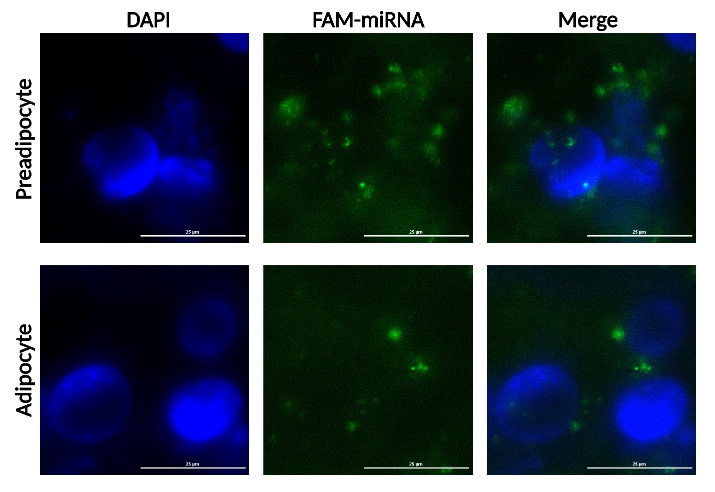
Figure S1. Transfection efficiency of FAM-labeled bta-miR-375 mimic in 3T3-L1 cells (scale bar, 25 μm).

