Supplementary Information

S1 Experimental set-up diagram
The litter bag method was used for litter decomposition experiment, and freshly collected lotus leaves were thoroughly washed and air-dried under natural conditions for 72 h, then the plant samples were subjected at 105 ℃ for 15 min to terminate any biological activity and dried at 80 ℃ to a constant weight. The treated lotus leaves were cut into 10 cm pieces and packed into 300 mesh nylon mesh bags with the dimension of 15×20 cm. An acrylic tube was used as the experimental container, filled with 1.2 L of water and placed inside a nylon mesh bag contained aforementioned plant pieces (Fig S1). Four experimental treatment groups were set up, incorporating two influencing factors, among which the temperature factor included group A (20℃) and group B (35℃), the nutrient factor include ammonia nitrogen (NH₃-N) concentration (0.8 and 1.2 mg/L) and sediment.
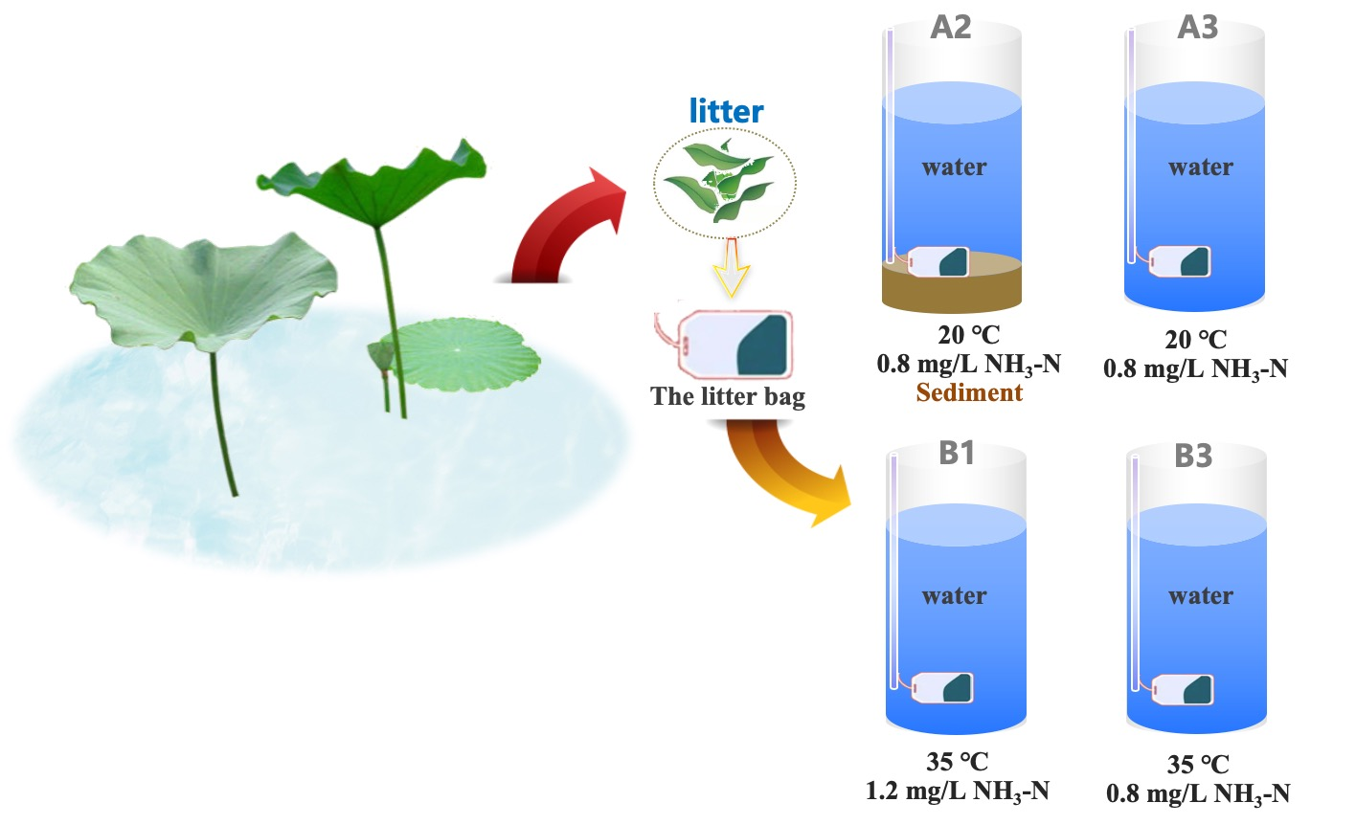
Fig. S1 Experimental set-up diagram

S2 Spatial and temporal variation of bacterial community diversity in water
The sequence detection data of all the samples in the 72 h and 648 h of the whole experimental cycle were statistically analyzed (Table S1), and the results after sequencing showed that the range of the number of sequences of all the valid sequenced genes was 39310~74772, and the sum of the number of sequences of all the valid genes was 434778. The number of OTUs of the samples was in the range of 83~315, and the difference in the number of OTUs indirectly showed the difference in the amount of biological information, and the amount of information of the organisms within the samples of different real groups also differed. In the same experimental group, the number of OTUs at 72 h was significantly lower than that at 648 h. A comparison of A2 and A3 showed that the number of OTUs in the group with added substrate was higher than that in the group without added substrate; a comparison of A3 and B3 showed that the number of OTUs in the group with high temperature was higher; a comparison of B1 and B3 showed that the number of OTUs in the group with high content of NH3-N was higher.
Fig S2a shows the dilution curve of Shannon diversity index, the number of sequences gradually rises, the curve rises along with it, and then tends to flatten, and is always smooth state, representing that the change of the number of sequences can be enough to respond to the information of the diversity of bacteria within the sample. It can be used to continue the analysis. Fig S2b is the Sobs diversity index dilution curve, from the figure can be seen Sobs index dilution curve, the number of sequences increases, Sobs curve rises, and then slowly flattens out, representing the number of samples OUT of the increasing value of the number of close to the flat, indicating that the amount of sequencing has a reasonable amount of sequencing can be used to reflect the level of diversity of microorganisms within the experimental setup.

Table S1 The sequencing data
Group | sequence number | nucleobase number | Average sequence length | OUT number
A2-1 | 39310 | 16499002 | 419.7 | 170
A2-2 | 74772 | 31516391 | 421.5 | 315
A3-1 | 44400 | 18944030 | 426.7 | 121
A3-2 | 61517 | 25992378 | 422.5 | 215
B1-1 | 42085 | 17942714 | 426.3 | 98
B1-2 | 72959 | 30281201 | 415.0 | 298
B3-1 | 42665 | 18005597 | 422.0 | 83
B3-2 | 57070 | 23747852 | 416.1 | 210

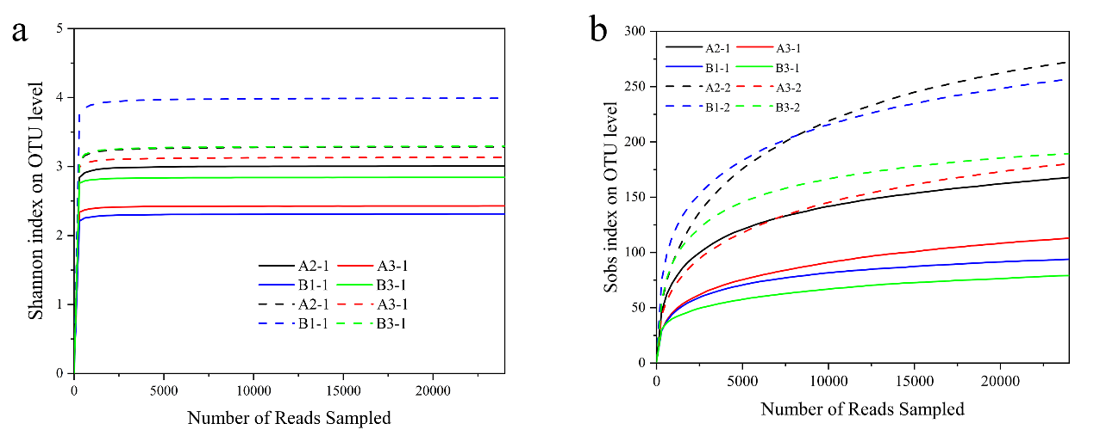
Fig. S2 Sobs (a) and Shannon (b) rarefaction curves
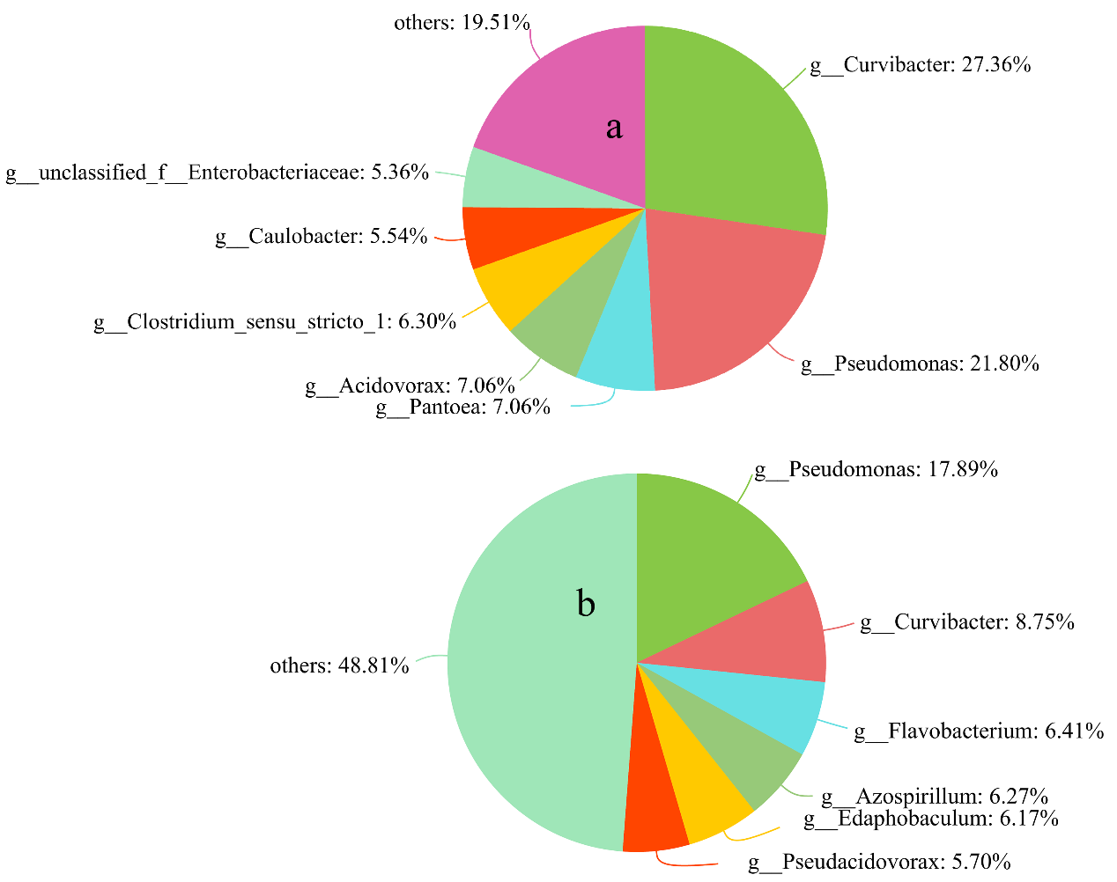
Fig. S3 Microbial community pie plot in 72h(a); Microbial community pie plot in 648h(b).

