APPENDIX
APPENDIX A - Ethical Approval
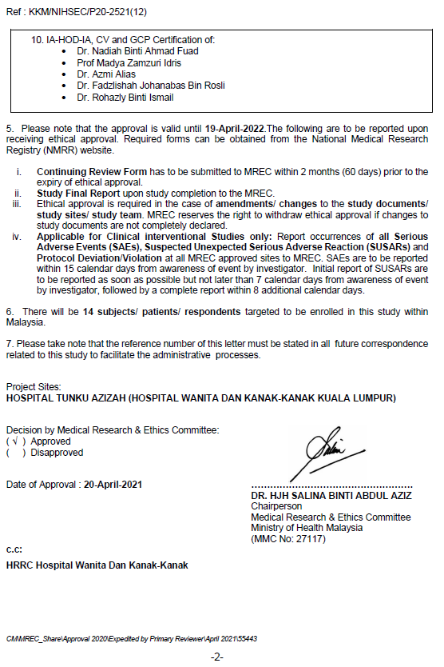

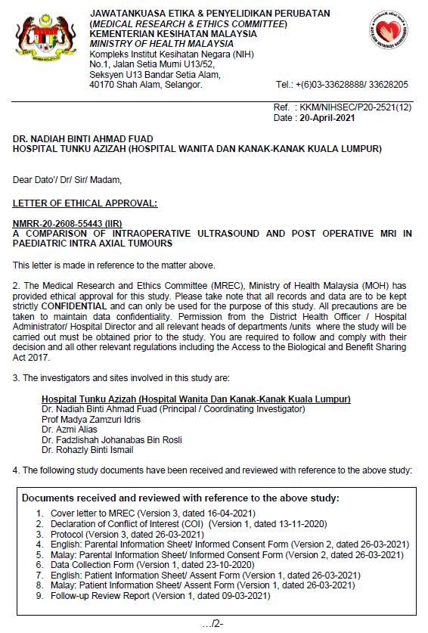
Appendix B - Annual Ethical Renewal for 2022
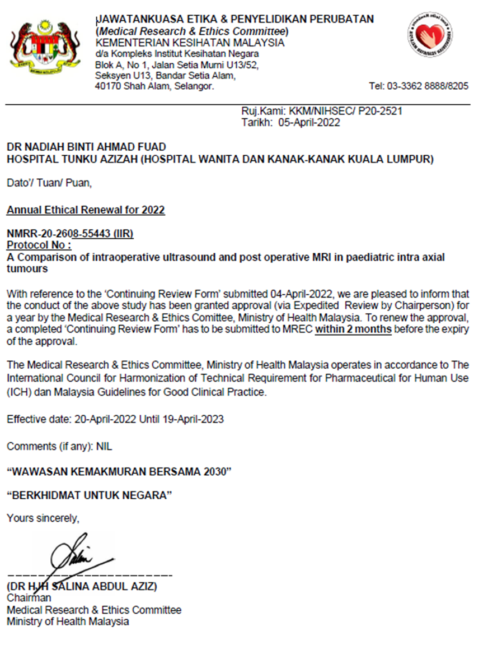

Appendix C - Study protocol
STUDY PROTOCOL:
A comparison of intraoperative ultrasound and post-operative MRI in paediatric intra axial tumours

Protocol number, version number and date:
55443 Version 3.0, 26/03/2021

Name and Institution of Principal investigator:
Dr Nadiah Ahmad Fuad, Hospital Tunku Azizah, Kuala Lumpur

Name and Institution of Co-Investigators:
Dr. Azmi bin Alias Tunku Azizah, Kuala Lumpur
Dr. Fadzlishah Johanabas bin Rosli, Hospital Tunku Azizah, Kuala Lumpur
Dr. Rohazly binti Ismail, Hospital Tunku Azizah, Kuala Lumpur
Prof. Dr. Zamzuri Idris, Universiti Sains Malaysia, Kubang Kerian, Kelantan

Name and address of Sponsor:
Nil. Investigator initiated research, self-sponsor.

Study site/s:
Hospital Tunku Azizah, Kuala Lumpur

LIST OF ABBREVIATIONS

IOUS | Intraoperative ultrasound
CNS | Central Nervous System
MRI | Magnetic resonance imaging
GCS | Glasgow Coma Scale
GTR | Gross total resection

Research Synopsis
Study title | A comparison of intraoperative ultrasound and post operative MRI in pediatric intra axial tumors
Study Population | Pediatric patients <12 years old with intra axial tumors undergoing elective surgery for tumor resection in Hospital Tunku Azizah between 1 Dec 2019- 30 Nov 2021
Study Design | A prospective observational study.
General Objective | To study the equivalance of intraoperative ultrasound for intra axial tumors post resection, in comparison with post-operative MRI.
Specific Objectives | a. To evaluate intraoperative ultrasound as a realtime navigation, as an adjunct in surgical excision of intra axial tumors in pediatric patients  b. To observe findings in post resection IOUS with post operative MRI in pediatric intra axial tumors
Study endpoints/outcomes | a. Findings of post resection IOUS compared with Post-operative MRI brain
Sample Size | 14
Study Duration | 1 Dec 2019- 30 Nov 2021

- INTRODUCTION & LITERATURE REVIEW
Malignant tumours of the CNS is the second most common paediatric malignancy, following haematological disorders. It is generally accepted that positive outcomes in paediatric CNS tumours depend significantly on the extent of tumour resection. In light of this, techniques to improve resection results have significant clinical implications in the paediatric population. [10-11] In the past decade, few methods of intraoperative adjuncts to aid in tumour resection have been applied. Amongst them are neuro-navigation, intraoperative ultrasound, intraoperative CT/ MRI and 5-aminolevulinic acid. These methods help to localise and identify tumour borders, as well as aiding in maximum tumour resection. [2] In recent years, intraoperative ultrasound has evolved into a widespread neuroimaging tool that offers real-time surgical guidance, and is a widely accessible imaging modality with minimal identified risk or additional operative time. [1,10] In this study, we would like to observe the accuracy of intraoperative ultrasound performed pre and post resection. Post resection ultrasound is then compared with postoperative MRI. This study is primarily aimed to evaluate the correlation between findings in IOUS with postoperative MRI to provide further support for the role of IOUS in enhancing tumour surgery especially in paediatric population. Most of the IOUS applications in brain tumours derive from adult series, hence our study is aimed to replicate the positive results in the paediatric population instead.
The goal of cerebral glioma surgery is not only maximal but also safe tumour resection, in which the maximum neurologically permissible tumour volume should be resected, but eloquent areas must be spared and neurological damage minimised. [1,4] Image-guided surgery based on neuronavigation is widely used and has become an essential tool in this recent decade. [9] The accuracy of neuronavigation systems are based on pre operative data limited to intraoperative changes. These limitations can be addressed by intraoperative MRI and CT however both modalities require long acquisition time and enormous economic investment. These intraoperative modalities significantly lengthen operating time, require additional staff to run the scanners, increase the risk of breaks in sterility, and have much higher overhead and running costs. Contrast is required for tissue demarcation, and ionising radiation is emitted in the case of intraoperative CT. Furthermore, intraoperative CT is rarely acceptable for paediatric patients due to the ionising radiation. [3,27,28] In a review of IOUS as effective neuronavigation in paediatric tumour surgery, safe maximal tumour resection can be achieved through accurate localization and intraoperative mapping of eloquent areas required for functions such as language, sensation, or movement. [3] The main advantage of IOUS in brain tumour surgery lies in its real time property. It can generate a complete overview of the tumour and the surrounding structures within seconds. IOUS also can repeatedly evaluate the extent and location of residual tumour tissue at any stage of the surgery. The ability to depict real time anatomic data during a surgical procedure is very useful for surgical decision making. [4,5,7] IOUS is an effective way to localise and characterise lesions and to assist with the monitoring of the surgical field for the improvement of resectability and reduction of the risk of parenchymal injury. [4] In a retrospective study of 260 patients by Sweeney et al., treated for brain tumour with IOUS performed and post operative MRI done within 1 week, authors reported an intended gross tumour resection rate of 81% across diverse cases. IOUS was able to correctly identify residual tumour in 100% of cases. [1] IOUS provided useful intraoperative information, allowing the surgeon to visualise the extent of residual tumour when making the decision to proceed or conclude the resection based on the benefit/risk ratio. [3] In cases of deep-seated tumours, IOUS helps in finding a cleavage plane for resection. In epilepsy surgery, it is difficult for the surgeon to distinguish dysplastic lesions from normal cortex. In cases like this, IOUS can depict cortical dysplasia with high resolution. Post resection, IOUS can be used to identify tumour residuals. [15-18] Roth et al., reported that the majority of glial tumours in paediatric patients are low-grade tumours. In this group of tumours (e.g. pilocytic astrocytoma), prognosis is directly related to the extent of resection. Quite frequently, low grade tumours include a subtle component, which may be hard to differentiate from the normal surrounding brain tissue. In addition, during surgery of deep-seated ventricular lesions, as well as periventricular lesions, a large amount of cerebrospinal fluid may be removed. Thus, a real-time imaging modality combined with navigational capabilities may be helpful. [5] Also, precise skin incisions, smaller craniotomies and easy localization of intracranial pathologies are fundamental applications of neuronavigation systems in neurosurgery in general and paediatric neurosurgery in particular. [10,21]
The neuro-oncological paediatric population has several peculiarities when compared to adults, including a larger variety of histological subtypes and lesions are frequently located in the posterior fossa. As most studies are derived from the adult population, therefore there is a gap in evaluation of the IOUS usefulness for paediatric intra axial tumour resection. [28] The pivotal role of accurate assessment of residual tumour in paediatric patients is underlined by the International Society for Paediatric Oncology of a new scale to quantify both the operator’s assessment and the postoperative imaging data. This new scale has guided us to objectively compare our IOUS resection evaluation with early postoperative MRI findings. [28] In our practice, IOUS is used routinely in adult and paediatric patients with intra axial tumours, but we acknowledge that IOUS has some limitations. A practical limitation is user dependency. As with many aspects of neurosurgery, user dependency is subject to a steep learning curve, but this limitation can be overcome readily over time. IOUS is therefore an essential adjunct in modern neurosurgery.
2. OBJECTIVES
2.1 General objective:
To study the equivalence of intraoperative ultrasound for intra axial tumours post resection, in comparison with post-operative MRI.

2.2 Specific objectives:
a. To evaluate intraoperative ultrasound as a realtime navigation, as an adjunct in surgical excision of intra axial tumours in paediatric patients.
b. To observe findings in post resection IOUS with post operative MRI in paediatric intra axial tumours.

3.STUDY DESIGN AND METHODOLOGY

3.1 Study Type and Design

This is a 2 years prospective observational study based in Hospital Tunku Azizah Kuala Lumpur, between 1 December 2019 until 30 November 2021, with a target sample size of 14. This study involves paediatric patients aged < 12 years old who were admitted to neuroscience ward 11C, diagnosed with intra axial axial tumours from preoperative MRI, and undergoing elective surgery for tumour resection. The general research objective is to compare the correlation and reliability of the ultrasound as compared to MRI for tumour resection in paediatrics population. We also evaluate intraoperative ultrasound as a real-time navigation, as an adjunct in surgical excision of intra axial tumours in paediatric patients and we observe findings in post resection IOUS with early postoperative MRI that is performed within 24 -72 hours in paediatric intra axial tumours.
Patients who fulfil the inclusion and exclusion criteria will be recruited for this study. Patients recruited must be < 12 years old, have intra axial brain tumour located in the supra tentorial or infratentorial region, undergoing elective tumour resection and have postoperative MRI within 24-72 hours post-surgery. Patients undergoing emergency tumour resection and postoperative MRI performed > 72 hours post-surgery, were not recruited in this study. All recruited patients were consented by their parents and assent form was also provided for the patients.
All children underwent craniotomy and microsurgical resection of tumour. Intraoperative ultrasound (Hitachi Aloka MP-2450) equipped with micro convex linear transducer was used before and after dura opening to confirm relationship of the tumour to the brain landmarks, during resection at surgeon’s discretion, at the end of the resection to confirm microsurgical impression of reaching the planned resection. Post-operative imaging was performed on a 3T Siemens MRI machine. Extent of resection was evaluated according to the latest recommendation of the International Society of Paediatric Oncology (SIOP), which integrates a surgical grading with a MRI grading. Surgical impression on resection was graded from SR0 to SR3 as follows: SR0 (complete resection), SR1 (rim-like residual), SR2 (bulky residual), SR3 (biopsy). Radiological assessment was graded MR0 to MR3: MR0 (complete resection), MR1 (rim-like residual ≤3mm), MR2 (residual >3mm in any section), MR3 (residual >50% of initial volume). To reduce inter-operator variability, surgery performed by three surgeons, intraoperative ultrasound performed by two experienced paediatric radiologists, and postoperative MRI were reviewed by 2 different paediatric radiologists.
The radiologist accompanied the neurosurgeon during each procedure and in each of the cases, the insonation was performed prior to and after dural opening. The selected probe was draped in a sterile cover filled with sterile jelly and all air bubbles were ensured to be eliminated. Throughout the insonation procedure, sterile irrigation with saline was performed as well to ensure optimal coupling. The radiologist would adjust the probe frequency using the variable frequency probe to suitably insonate both superficial and deep structures as required. The best image showing the whole lesion was measured and the length, width, and height of the lesion measured and written down on the data collection sheet. Prior to closure as well, the resection cavity will be assessed to see any suspicious residual tumour or bleed. Once the surgeon is satisfied with the resection, the final assessment will be done and any residual tumour if any will be documented as well.
Utility scoring system was also employed prior to our procedure whereby we identified various parameters to reflect different aspects of the perceived utility of the IOUS. These parameters were then assessed and documented in our surgical notes. The parameters assessed include:
- Lesion identification
- Lesion delineation
- Utility in craniotomy modification
- Use in durotomy planning
- Use in corticectomy planning
- Use for assessment of extent of resection
- Visualisation of adjacent structures

Each parameter was given a score of 0 (no utility) or 1 (useful). These individual scores were totalled to obtain an overall “utility score” (maximum 7 and minimum 0). This scoring system is used as a guiding tool to ensure that all the parameters were assessed intraoperatively and hence each procedure was done in a similar fashion intraoperatively.

As mentioned above, this is an observational study, with no intervention required. Therefore, no additional risk. Patient treatment is not affected whether they join the study or not, and study will be done in accordance to good clinical practise. Minors are recruited into the study, however an assent form will be given to participants. For those unable to consent, consent will be taken from a legal guardian.

Flow chart for methodology
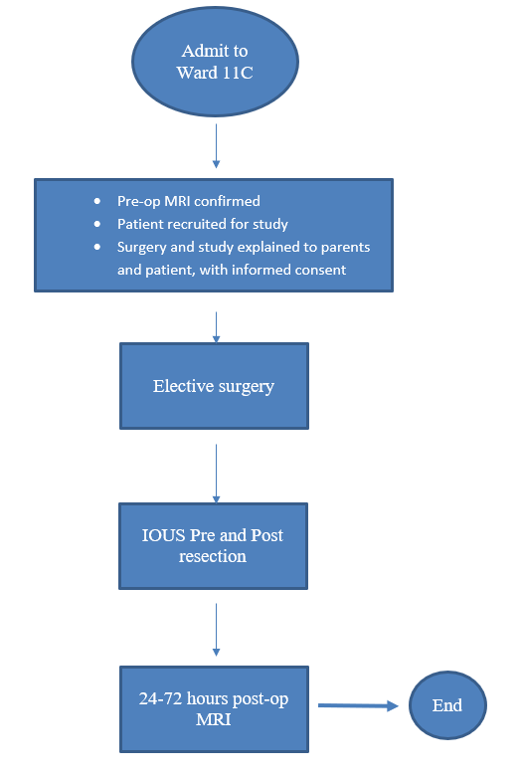

3.2 Study Population
Paediatric patients undergoing elective surgery for intra axial tumour resection in Hospital Tunku Azizah during the period 1 Dec 2019- 30 Nov 2021

3.3 Inclusion Criteria
Age: < 12 years old
Tumor location: Supra tentorial and infra tentorial; intra axial
Type of surgery: Elective
Post operative MRI: 24-72 hours

3.4 Exclusion Criteria
Type of surgery: Emergency
Post operative MRI: > 72 hours post surgery

3.5 Withdrawal Criteria
The subject or their parents are allowed to withdraw from this study at any point of time. If at any point of time, the subject or their parents would like to drop out of this study, their treatment will not be affected.

3.6 Sample Size
Sample size estimation was calculated using a single correlation formula. Prior data by Sweeney et al. in Efficacy of intraoperative ultrasonography in neurosurgical tumour resection, indicate that the correlation coefficient between IOUS and post operative MRI was 0.693. Thus, a minimum sample size of 14 samples to be able to reject the null hypothesis with probability (power) 0.8. The Type I error probability associated with this test of this null hypothesis is 0.05. Pearson's product-moment correlation will be used to evaluate this null hypothesis.
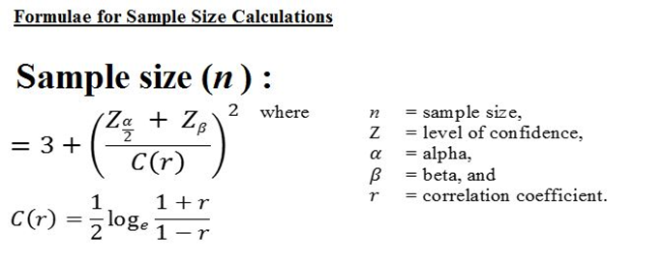
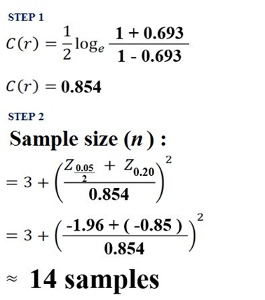

3.7 Study Duration and Timeline
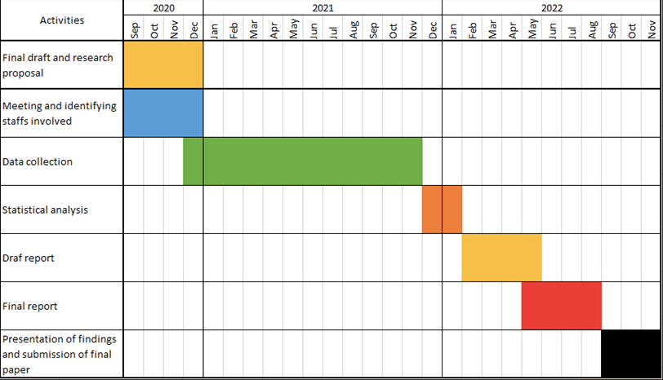
3.8 Study Visits and Procedures
Study will be done only at Hospital Tunku Azizah

3.9 Statistical Analysis Plan
Statistical analyses will be performed using Statistical Package for Social Sciences for Windows (SPSS, Chicago, IL, USA).Data collected will be tabulated and the agreement between intraoperative ultrasound and post operative MRI will be measured with Fleiss’ kappa agreement. Categorical variables are shown as numbers (with percentages) and continuous variables are shown as absolute numbers and percentages OR (mean ±standard deviation or median (interquartile range) unless otherwise stated.) Concordance analysis would then be interpreted as high, moderate or disagreement of k.

3.10 Risk and benefit to study participants
As stated in the literature above, there will be no extra risks on the subject, as well as added surgery time is low with minimal technical difficulties. As mentioned in the literature review above, Sweeney et. al mentioned that real-time navigation from IOUS will aid in resection and this is specifically important in paediatric tumours as it is well documented that outcome relies on the extent of tumour resection. Apart from guiding the neurosurgeon in gross total resection, intraoperative ultrasound could determine important borders and it is less time consuming as compared to other modalities especially intraoperative MRI, also a much more economical modality.

3.11 Risk Benefit Assessment
As mentioned in 3.10 the benefit outweighs risk, we hope this study can be approved.
3.12 Ethics of Study
Study will be conducted in compliance with ethical principles outlined in the Declaration of Helsinki and Malaysian Good Clinical Practice Guideline

3.13 Informed Consent/Assent Process
Patients and their parents will be informed of the study during pre-operative assessment on admission. Risk and benefits explained and they are allowed to ask additional questions and if they would like to bring back to discuss on this study with family members, they are allowed to do so. If they are willing to participate (in this case via the consent of their parents) consent/ assent will be obtained.

3.14 Privacy and Confidentiality
Subject’s names will be kept on a password-protected database and will be linked only with a study identification number for this research. The identification number instead of patient identifiers will be used on subject data sheets. All data will be entered into a computer that is password-protected. On completion of the study, data in the computer will be copied to external hard drive and the data in the computer erased. External hard drive and any hardcopy data will be stored in locked offices of the investigators and maintained for a minimum of three years and a maximum of twelve years after the completion of the study, after which period the study data will be destroyed. Subjects will not be allowed to view their personal information and study data, as the data will be consolidated into a database. Subjects can write to the investigators to request access to study findings.

3.15 Conflict of Interest
The investigators declare they have no conflict of interest.

3.16 Publication Policy
No personal information will be disclosed, and subjects will not be identified when the findings of the survey are published.

3.17 Termination of Study
The researcher may decide to terminate the study at any time if there is any unforeseen adverse event. Subjects will be informed if the study is terminated, however post-operative follow-up visits will be arranged as per practice.

4.0 REFERENCES
- Sweeney, J. F., Smith, H., Taplin, A. L., Perloff, E., & Adamo, M. A. (2018). Efficacy of intraoperative ultrasonography in neurosurgical tumour resection. Journal of Neurosurgery: Pediatrics, 21(5), 504–510.
- Nagaty, A., Elsabaa, A., & Anwer, H. (2019). Efficacy of Intraoperative Ultrasound in Resection of Posterior Fossa Lesions. International Journal of Neurosurgery, 3(2), 13.
- Cheon, J. E. (2015). Intraoperative neurosonography revisited: Effective neuronavigation in pediatric neurosurgery. Ultrasonography, 34(2), 79–87.
- Moiyadi A. V., Shetty P. and Degaonkar A. (2017). Resection of pediatric brain tumours: Intraoperative ultrasound revisited. JNS Pediatrics, 12(1), 19-23.
- Roth, J., Biyani, N., Beni-Adani, L., & Constantini, S. (2007). Real-time neuronavigation with high-quality 3D ultrasound SonoWand® in pediatric neurosurgery. Pediatric Neurosurgery, 43(3), 185–191.
- Lachin, J. M. (1981). Introduction to sample size determination and power analysis for clinical trials. Controlled Clinical Trials, 2(2), 93–113.
- Elmesallamy, W. A. E. A. (2019). The role of intraoperative ultrasound in gross total resection of brain mass lesions and outcome. Egyptian Journal of Neurology, Psychiatry and Neurosurgery, 55(1).
- Foster, M. T., Harishchandra, L. S., & Mallucci, C. (2018). Pediatric central nervous system tumors: State-of-the-art and debated aspects. Frontiers in Pediatrics, 6(November), 1–8.
- Ulrich, N. H., Burkhardt, J. K., Serra, C., Bernays, R. L., & Bozinov, O. (2012). Resection of pediatric intracerebral tumors with the aid of intraoperative real-time 3-D ultrasound. Child’s Nervous System, 28(1), 101–109.
- Smith, H., Taplin, A., Syed, S., & Adamo, M. A. (2016). Correlation between intraoperative ultrasound and postoperative MRI in pediatric tumor surgery. Journal of Neurosurgery: Pediatrics, 18(5), 578–584.
- Linabery, A. M., & Ross, J. A. (2008). Trends in childhood cancer incidence in the U.S. (1992-2004). Cancer, 112(2), 416–432.
- Ostrom, Q. T., De Blank, P. M., Kruchko, C., Petersen, C. M., Liao, P., Finlay, J. L., … Barnholtz-Sloan, J. S. (2014). Alex’s Lemonade stand foundation infant and childhood primary brain and central nervous system tumors diagnosed in the United States in 2007-2011. Neuro-Oncology, 16, x1–x35.
- Mahboob, S., McPhillips, R., Qiu, Z., Jiang, Y., Meggs, C., Schiavone, G., … Eljamel, S. (2016). Intraoperative Ultrasound-Guided Resection of Gliomas: A Meta-Analysis and Review of the Literature. World Neurosurgery, 92, 255–263.
- Upadhyay P. K. and Tiwary G. (2010). Real-time intraoperative ultrasonography in the surgical resection of brain lesions: A cheap, effective, and quick alternative. Journal of Neurosciences in Rural Practice, 1(2), 127-128.
- El Beltagy, M. A., Aggag, M., & Kamal, M. (2010). Role of intraoperative ultrasound in resection of pediatric brain tumors. Child’s Nervous System, 26(9), 1189–1193.
- Lam A. M. and Newell D.W. (1996). Intraoperative use of transcranial Doppler ultrasonography. Neurosurgery Clinics of North America, 7(4), 709-722.
- Seibert, J. J., Avva, R., Hronas, T. N., Mocharla, R., Vanderzalm, T., Cox, K., … Knight, K. L. (1998). Use of Power Doppler in Pediatric Neurosonography: A Pictorial Essay. Radiographics, 18(4), 879–890.
- Cohen, L. (1994). Review Article Advances in Perinatal Neurosonography, 801–810.
- Gerard, I. J., Kersten-Oertel, M., Hall, J. A., Sirhan, D., & Collins, D. L. (2021). Brain Shift in Neuronavigation of Brain Tumors: An Updated Review of Intra-Operative Ultrasound Applications. Frontiers in Oncology, 10(February), 1–11.
- Singhal, A., Ross Hengel, A., Steinbok, P., & Doug Cochrane, D. (2015). Intraoperative ultrasound in pediatric brain tumors: does the surgeon get it right? Child’s Nervous System, 31(12), 2353–2357.
- Regelsberger J., Lohmann F., Helmke K. and Westphal M. (2000). Ultrasound-guided surgery of deep seated brain lesions. European Journal of Ultrasound, 12(2), 115-121.
- Ivanov, M., Wilkins, S., Poeata, I., & Brodbelt, A. (2010). Intraoperative ultrasound in neurosurgery - A practical guide. British Journal of Neurosurgery, 24(5), 510–517.
- Pino, M. A., Imperato, A., Musca, I., Maugeri, R., Giammalva, G. R., Costantino, G., … Villa, A. (2018). New hope in brain glioma surgery: The role of intraoperative ultrasound. A review. Brain Sciences, 8(11).
- Hammoud M. A., Lee Ligon B. and Elsouki R. (1996). Use of intraoperative ultrasound for localizing and determining the extent of resection: a comparative study with magnetic resonance imaging. Journal of Neurosurgery, 84(5), 737-741.
- Shinoura, N., Takahashi, M., & Yamada, R. (2005). Letter to the Editor Diagnosis of Broncho-Pleural Fistula: Is There a Role for Sonography?, 177–183.
- Tronnier, V. M., Bonsanto, M. M., Staubert, A., Knauth, M., Kunze, S., & Wirtz, C. R. (2001). Comparison of intraoperative MR imaging and 3D-navigated ultrasonography in the detection and resection control of lesions. Neurosurgical Focus, 10(2), 11–14.
- Roth J., Beni-Adani L., Biyani N. and Constatini S. (2006) Classical and real-time neuronavigation in pediatric neurosurgery. Childs Nervous System, 22(9), 1065-1071.
- Carai, A., De Benedictis, A., Calloni, T., Onorini, N., Paternò, G., Randi, F., … Marras, C. E. (2021). Intraoperative Ultrasound-Assisted Extent of Resection Assessment in Pediatric Neurosurgical Oncology. Frontiers in Oncology, 11(April), 1–7.

Appendix D - Data collection form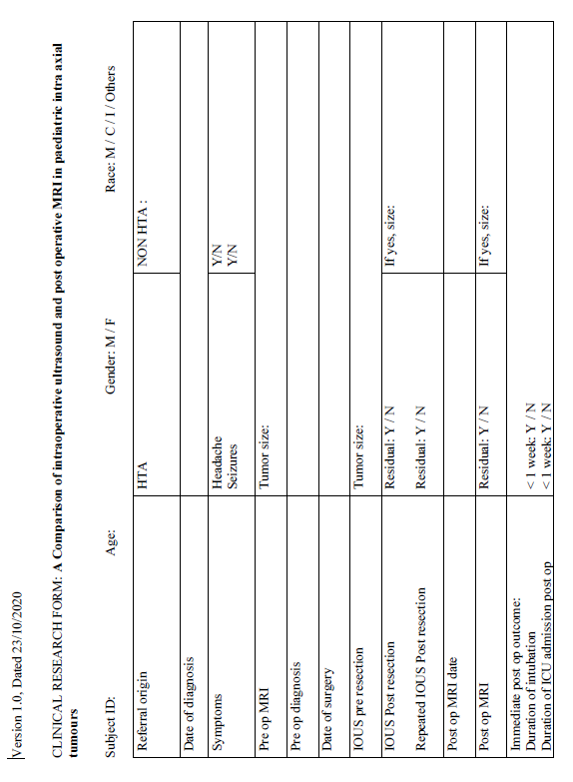
Appendix E - Informed consent form (English)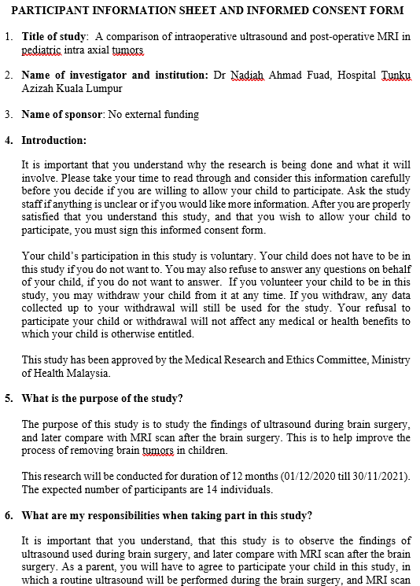
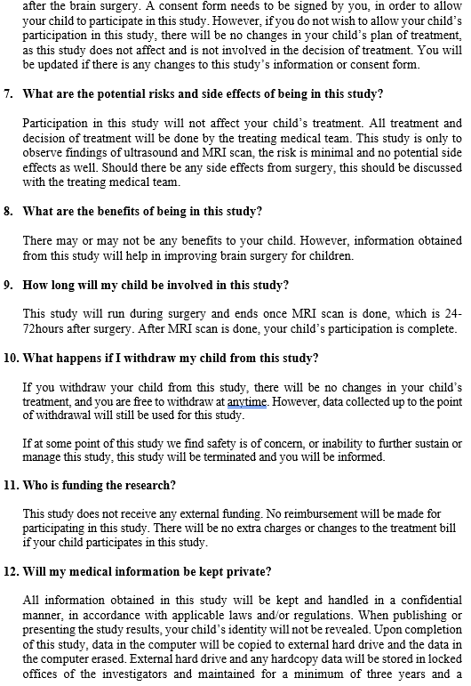
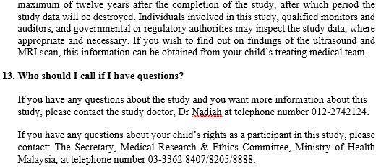
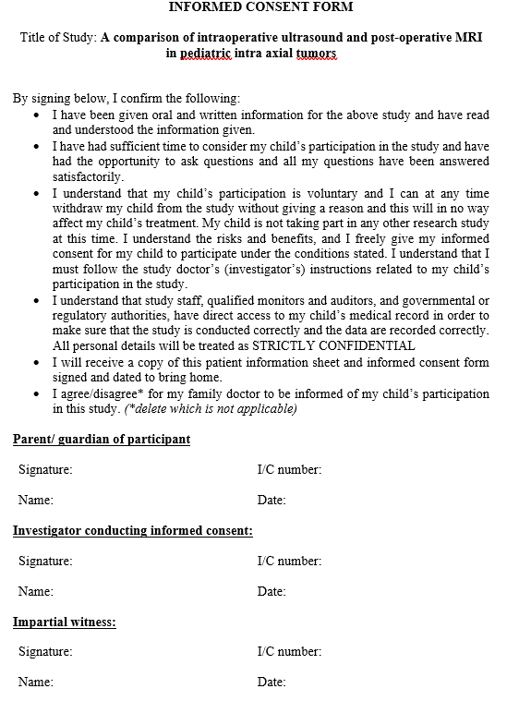
Appendix F - Informed consent form (Malay)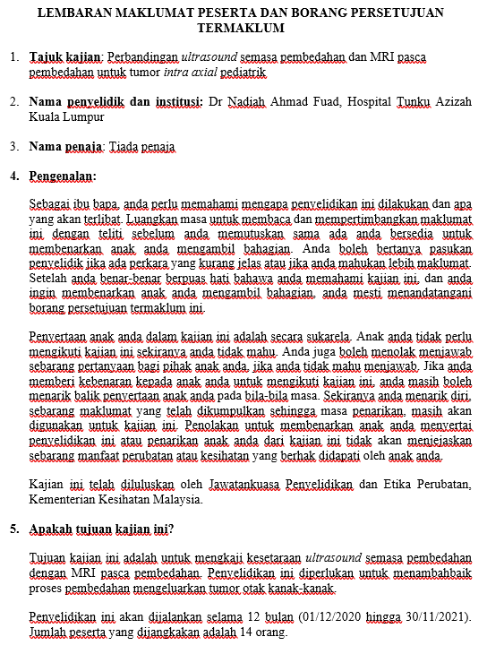
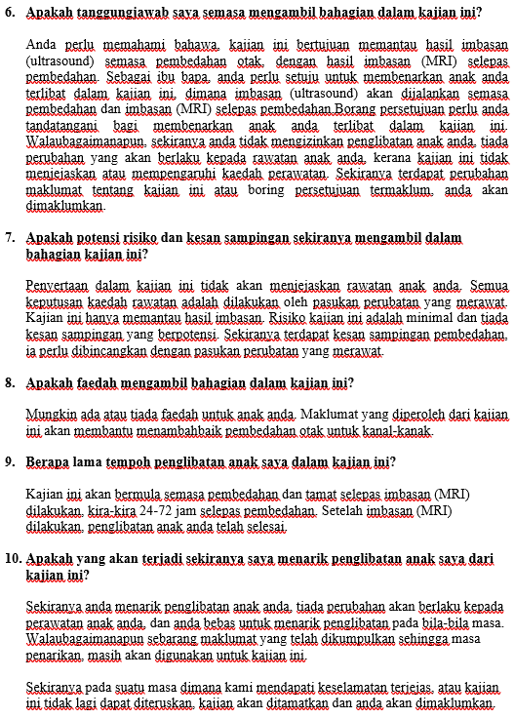
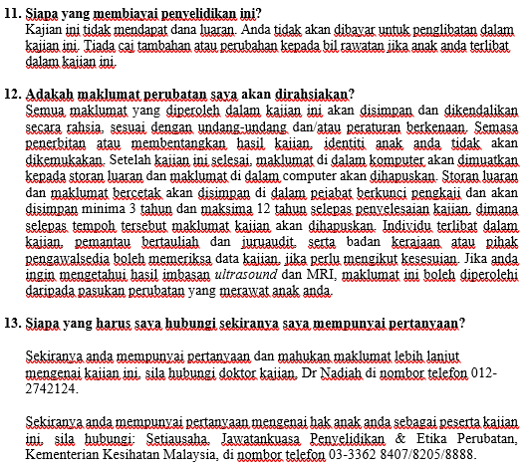
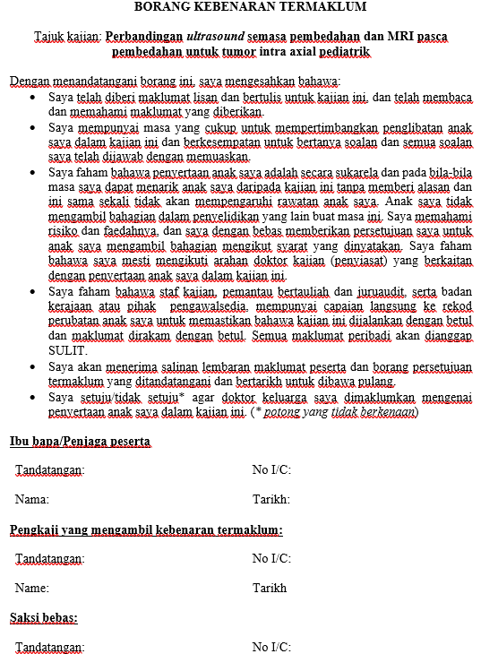
Appendix G - Assent Form (English)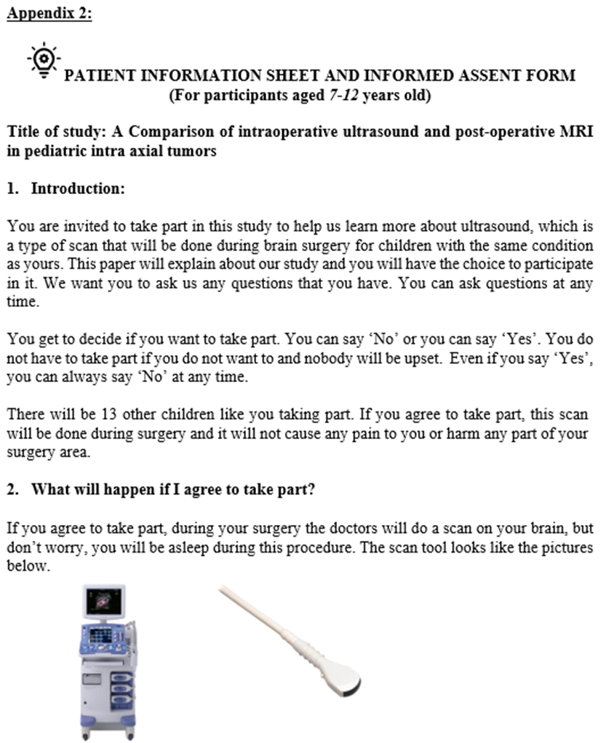
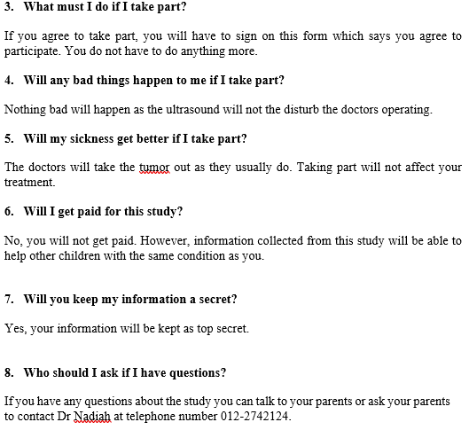
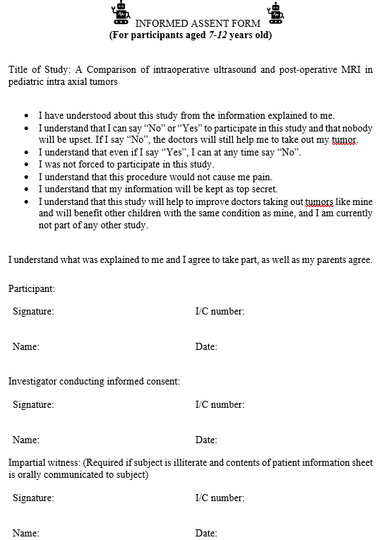
Appendix H - Assent Form (Malay)