“Solid-state synthesis, drug inclusion and 3D structure elucidation of a M₁₂L₈ cage-catenane”

Stefano Elli†, Antonino Famulari†,#, Javier Martí-Rujas*,†

† Dipartimento di Chimica Materiali e Ingegneria Chimica ‘‘Giulio Natta’’, Politecnico di Milano, Via L. Mancinelli 7, 20131 Milan, Italy.
# INSTM Consorzio Interuniversitario Nazionale per la Scienza e Tecnologia dei Materiali
*E-mail: javier.marti@polimi.it

Contents
Materials and methods
Powder X-Ray Diffraction Experiments
TG experiments
Solid state synthesis of amorphous M₁₂L₈ poly-[n]-catenane using mechanochemistry via neat grinding.
Gas-solid reactions using amorphous phase of poly-[n]-catenane.
¹H NMR protocol for the quantification of paracetamol included in the M₁₂L₈ nanocages.
Density Functional Theory Calculations
Materials and Methods.
All the reagents used for the synthesis of the mechanically interlocked materials were obtained from vendors and used without further purification.

Powder X-Ray diffraction experiments.
All the powder X-ray diffraction experiments were carried out using a Bruker D2-Phaser diffractometer equipped with Cu radiation (λ = 1.54184 Å) using Bragg-Brentano geometry. The experiments were performed at room temperature.

TG experiments.
Thermogravimetrical analyses were carried out using a Perkin Elmer Thermal Analysis instrument at the Laboratorio Analisi Chimiche at the Dipartimento di Chimica, Materiali ed Ingegneria Chimica, Politecnico di Milano. The analyzed microcrystalline samples were heated within the temperature range from 30 °C to 700 °C using a heating rate of 10 °C/min.

Solid state synthesis of amorphous M₁₂L₈ poly-[n]-catenane using mechanochemistry via neat grinding.

The synthesis of the amorphous phases a1-a3 were carried out by neat grinding following the literature procedure.

Gas-solid reactions using amorphous phase of poly-[n]-catenane.

The gas solid experiments were carried out in a small-sealed chamber in which the amorphous phase was exposed to vapors of methanol and o-DCB. The amorphous solid was introduced in a vial placed in the chamber which contains a second vial with ca. 6 ml of o-DCB and 2 ml of methanol.

¹H NMR protocol for the quantification of paracetamol included in the M₁₂L₈ nanocages.

To quantify the paracetamol included in the M₁₂L₈ poly-[n]-catenanes the following procedure has been carried out:
A small amount of the microcrystalline catenane (ca. 5mg) is placed in an NMR test tube. Then 0.5 mL of deuterium oxide (D₂O) is added to the tube. Two drops of deuterated sulfuric acid D₂SO₄ are added to the tube. The solution is then shaken, the catenane structure is disassembled, paracetamol and ZnX₂ are soluble in water so are dissolved. TPB is protonated and so goes into the solution. The solution inside the NMR test tube becomes clear and transparent.
In the ¹H NMR spectrum TPB shows three peaks at high ppm (around 7.5-8.5 ppm), two doublets and one singlet. Paracetamol shows three peaks, two doublets at high ppm (around 5.5-6.5 ppm) and one singlet.
To calculate the amount of paracetamol, the singlet peak (two hydrogens) of the TPB (around 7.5 ppm) and one doublet peak (three hydrogens) of the paracetamol (around 5.5-6.5 ppm) are considered and integrated. In this way the ratio between the two can be computed. Knowing that in each cage there are 8 molecules of TPB, one can calculate the number of paracetamol molecules per cage.

Figure S1. Plot showing the solution state crystallization and the rarely exploited fast crystallization experiments using solid-state synthesis. Kinetic control is achieved by fast crystallization that leads to amorphous materials as in the present case (a1) and 1^{IS-1} and 1^{IS-2}.

Figure S2. Gas solid reaction by exposing a1 to vapours of methanol and o-dichlorobenzene for 2 days.
Paracetamol inclusion using TPB-ZnI₂ amorphous phase (a1) of M₁₂L₈ poly-[n]-catenane.
Figure S3. Powder XRD patterns of the amorphous a1 (a), after being suspended in a saturated methanol solution of paracetamol overnight (12h) and after 2 days (c). Experiment number 1-a1.
Figure S4. ¹H NMR spectrum in a sample suspended in the saturated solution of paracetamol for 2d. The included paracetamol molecules per M₁₂L₈ cage is 1.44 according to the proton integrals. Experiment number 1-a1.
Figure S5. Powder XRD patterns of the amorphous a1 (a), after being suspended in a saturated methanol solution of paracetamol overnight (12h) and after 2 days (c). Experiment number 2-a1.
Figure S6. ¹H NMR spectrum in a sample suspended in the saturated solution of paracetamol for 2d from experiment number 2-a1. The included paracetamol molecules per M₁₂L₈ cage is 6.12 according to the proton integrals.
Figure S7. Powder XRD patterns of the amorphous a1 (a), after being suspended in a saturated methanol solution of paracetamol overnight (12h) and after 2 days (c). Experiment number 3-a1.

Figure S8. ¹H NMR spectrum in a sample suspended in the saturated solution of paracetamol for 2d from experiment number 3-a1. The included paracetamol molecules per M₁₂L₈ cage is 1.32 according to the proton integrals.

Figure S9. Powder XRD patterns after being suspended a1 in a saturated methanol solution of paracetamol overnight (a) and after 2 days (c). Experiment number 4-a1.
Figure S10. ¹H NMR spectrum in a sample suspended in the saturated solution of paracetamol for 2d from experiment number 4-a1. The included paracetamol molecules per M₁₂L₈ cage is 3 according to the proton integrals.

Paracetamol inclusion using TPB-ZnBr₂ amorphous phase (a2) of M₁₂L₈ poly-[n]-catenane.

Figure S11. Powder XRD patterns of the amorphous a2 (a), after being suspended in a saturated methanol solution of paracetamol overnight (12h) and after 2 days (c). Experiment number 1-a2.

Figure S12. ¹H NMR spectrum in a sample suspended in the saturated solution of paracetamol for 2d from experiment number 1-a2. The included paracetamol molecules per M₁₂L₈ cage is 4.32 according to the proton integrals.
Figure S13. Powder XRD patterns of the amorphous a2 (a), after being suspended in a saturated methanol solution of paracetamol overnight (12h) and after 2 days (c). Experiment number 2-a2.
Figure S14. ¹H NMR spectrum in a sample suspended in the saturated solution of paracetamol for 2d from experiment number 2-a2. The included paracetamol molecules per M₁₂L₈ cage is 2.04 according to the proton integrals.
Figure S15. Powder XRD patterns of the amorphous a2 (a), after being suspended in a saturated methanol solution of paracetamol overnight (12h) and after 2 days (c). Experiment number 3-a2.
Figure S16. ¹H NMR spectrum in a sample suspended in the saturated solution of paracetamol for 2d from experiment number 3-a2. The included paracetamol molecules per M₁₂L₈ cage is 2.16 according to the proton integrals.
Figure S17. Powder XRD patterns of the amorphous a2 (a), after being suspended in a saturated methanol solution of paracetamol overnight (12h) and after 2 days (c). Experiment number 4-a2.
Figure S18. ¹H NMR spectrum in a sample suspended in the saturated solution of paracetamol for 2d from experiment number 4-a2. The included paracetamol molecules per M₁₂L₈ cage is 2.88 according to the proton integrals.

Paracetamol inclusion using TPB-ZnCl₂ amorphous phase (a3) of M₁₂L₈ poly-[n]-catenane.

Figure S19. Powder XRD patterns of the amorphous a3 (a), after being suspended in a saturated methanol solution of paracetamol overnight (12h) and after 2 days (c). Experiment number 1-a3.
Figure S20. ¹H NMR spectrum in a sample suspended in the saturated solution of paracetamol for 2d from experiment number 1-a3. The included paracetamol molecules per M₁₂L₈ cage is 3.84 according to the proton integrals.
Figure S21. Powder XRD patterns of the amorphous a3 (a), after being suspended in a saturated methanol solution of paracetamol overnight (12h) and after 2 days (c). Experiment number 2-a3.
Figure S22. ¹H NMR spectrum in a sample suspended in the saturated solution of paracetamol for 2d from experiment number 2-a3. The included paracetamol molecules per M₁₂L₈ cage is 4.32 according to the proton integrals.
Figure S23. Powder XRD patterns of the amorphous a3 (a), after being suspended in a saturated methanol solution of paracetamol overnight (12h) and after 2 days (c). Experiment number 3-a3.
Figure S24. ¹H NMR spectrum in a sample suspended in the saturated solution of paracetamol for 2d from experiment number 3-a3. The included paracetamol molecules per M₁₂L₈ cage is 3.84 according to the proton integrals.
Figure S25. Powder XRD patterns of the amorphous a3 (a), after being suspended in a saturated methanol solution of paracetamol overnight (12h) and after 2 days (c). Experiment number 4-a3.
Figure S26. ¹H NMR spectrum in a sample suspended in the saturated solution of paracetamol for 2d from experiment number 4-a3. The included paracetamol molecules per M₁₂L₈ cage is 3.12 according to the proton integrals.

Table S1. Included paracetamol guest molecules per M₁₂L₈ nanocage as determined by ¹H NMR analysis.
Experiment | a1 TPB-ZnI₂ | a2 TPB-ZnBr₂ | a3 TPB-ZnCl₂
1 | 1.44 | 4.32 | 3.84
2 | 6.12 | 2.04 | 4.32
3 | 1.32 | 2.16 | 3.84
4 | 3.00 | 2.88 | 3.12
*All the amorphous M₁₂L₈ poly-[n]-catenane samples were prepared via neat grinding at ambient conditions.

Structure solution using powder XRD data.

The powder XRD data used for the structure solution from powder XRD was measured in a Bruker D2 diffractometer at room temperature using the Bragg-Brentano geometry. The sample was exposed for 10 s per step covering from 4° to 30° in 2θ/° with a step-size of 0.016226°.

Structure solution was carried out by the simulated annealing (SA) method using the program DASH. Due to the severe peak overlap the indexing step was done introducing the unit cell and the trigonal space group R-3 of a poly-[n]-catenane previously determined by single crystal XRD data. Structure solution was carried out using twenty runs of 1.5x10⁷ Monte Carlo moves. Two structural fragments were selected for the direct-space calculations. The first structural fragment (SF1) was taken from one of the previous M₁₂L₈ poly-[n]-catenanes single crystal structures containing 1.3 TPB ligand and two ZnI₂ units. The paracetamol molecule was taken from the CDS database with code (COTYOA02) and used as structural fragment two (SF2).
From the twenty structures, the best structure had the lowest profile χ² = 32.42 and was taken as starting structural model for the Rietveld refinement.

Figure S27. Crystal structure of 1_{local} obtained from DASH showing the asymmetric unit (a) and the “almost” formed M₁₂L₈ cages including paracetamol (b). Note that one of the pyridine rings is not bonded to the Zn and the symmetry generated benzene ring is not an ideal hexagonal aromatic ring.
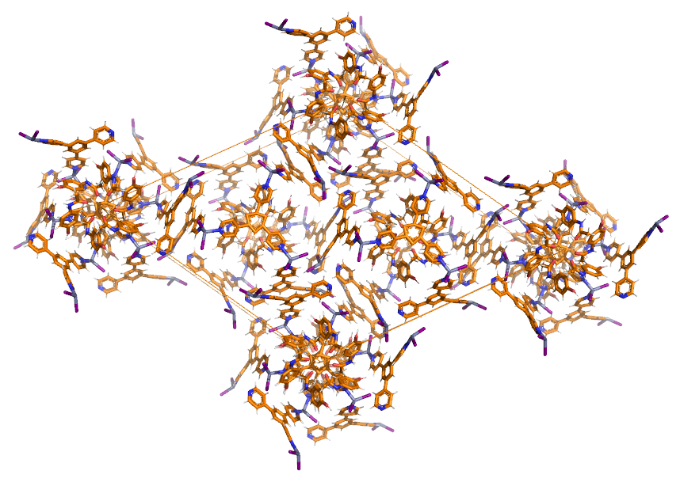
Figure S28. Crystal structure of 1_{local} obtained from DASH showing the M₁₂L₈ cages including paracetamol in the unit cell packing. The structure can be considered non-interlocked.

Figure S29. LeBail (a) and Rietveld (b) refinements of 1_{global}.

Structural information from powder XRD.

The final lattice cell parameters from the Rietveld refinement of 1_{global} are:
a = b = 38.45(4) Å; c = 15.825(32); α = β = 90 ° and γ = 120 °; V = 20263.6 Å³.

The final (78) atomic coordinates (Å) and thermal parameters of all the refined atoms are shown in Table S2.

Table S2. Atomic coordinates and thermal parameters of 1_{global}.
Name | X | Y | Z | Ui/Ue*100
C1a | 0.641967 | 0.191664 | 0.281306 | 40
C2a | 0.652659 | 0.220406 | 0.342566 | 40
C3a | 0.668635 | 0.216503 | 0.421509 | 40
C4a | 0.671066 | 0.182311 | 0.437959 | 40
C5a | 0.659951 | 0.153599 | 0.375434 | 40
C6a | 0.64423 | 0.158316 | 0.29999 | 40
C7a | 0.628457 | 0.226271 | 0.173692 | 40
C8a | 0.6113 | 0.225645 | 0.083251 | 40
N1a | 0.619193 | 0.187705 | 0.202342 | 40
O1a | 0.686673 | 0.176494 | 0.515685 | 40
O2a | 0.638119 | 0.255763 | 0.222271 | 40
H2a | 0.647602 | 0.243402 | 0.336251 | 48
H3a | 0.678353 | 0.240444 | 0.468803 | 48
H5a | 0.658992 | 0.125541 | 0.388362 | 48
H6a | 0.636599 | 0.135976 | 0.250012 | 48
H8a | 0.60537 | 0.19928 | 0.0475 | 48
H8b | 0.63085 | 0.2537 | 0.04771 | 48
H8c | 0.58419 | 0.22563 | 0.0962 | 48
H1b | 0.609479 | 0.166297 | 0.156219 | 48
H1a | 0.67453 | 0.18068 | 0.5669 | 48
Zn1 | 0.702624 | 0.978897 | 0.765336 | 5.67
Zn2 | 0.556946 | 0.836668 | 0.037688 | 5.67
I1 | 0.728148 | 0.966868 | 0.908637 | 10.37
I2 | 0.744394 | 1.040205 | 0.662994 | 10.37
I3 | 0.558829 | 0.9028 | 0.090966 | 10.37
I4 | 0.59425 | 0.825329 | -0.082683 | 10.37
N1 | 0.679976 | 0.926726 | 0.692126 | 5.63
N2 | 0.565366 | 0.815211 | 0.151717 | 5.63
N3 | 0.634325 | 0.65952 | 0.539868 | 5.63
N4 | 0.494925 | 0.793391 | 0.029281 | 5.63
C1 | 0.670023 | 0.928412 | 0.609784 | 7.33
C2 | 0.651338 | 0.894433 | 0.55845 | 7.33
C3 | 0.635631 | 0.856091 | 0.59631 | 7.33
C4 | 0.643117 | 0.854747 | 0.683089 | 7.33
C5 | 0.664614 | 0.890081 | 0.729265 | 7.33
C6 | 0.615723 | 0.819364 | 0.543304 | 7.33
C7 | 0.598888 | 0.820307 | 0.465213 | 7.33
C8 | 0.587371 | 0.78966 | 0.404268 | 7.33
C9 | 0.594183 | 0.757886 | 0.422471 | 7.33
C10 | 0.609017 | 0.755121 | 0.501659 | 7.33
C11 | 0.622718 | 0.787318 | 0.558212 | 7.33
C12 | 0.577459 | 0.797256 | 0.31738 | 7.33
C13 | 0.560989 | 0.766935 | 0.253301 | 7.33
C14 | 0.550518 | 0.775924 | 0.174458 | 7.33
C15 | 0.587257 | 0.845264 | 0.209531 | 7.33
C16 | 0.59523 | 0.837187 | 0.289634 | 7.33
C17 | 0.616454 | 0.721629 | 0.519057 | 7.33
C18 | 0.590895 | 0.682791 | 0.486356 | 7.33
C19 | 0.599632 | 0.651608 | 0.499625 | 7.33
C20 | 0.659267 | 0.697194 | 0.5711 | 7.33
C21 | 0.651601 | 0.728406 | 0.560995 | 7.33
C22 | 0.471085 | 0.79774 | 0.087709 | 7.33
C23 | 0.430683 | 0.768188 | 0.097021 | 7.33
C24 | 0.415541 | 0.731017 | 0.053449 | 7.33
C25 | 0.440755 | 0.726822 | -0.00733 | 7.33
C26 | 0.481053 | 0.757759 | -0.016119 | 7.33
C27 | 0.374384 | 0.697568 | 0.067404 | 7.33
C28 | 0.343449 | 0.706455 | 0.076568 | 7.33
H1 | 0.683072 | 0.955527 | 0.585207 | 8.8
H2 | 0.647342 | 0.898252 | 0.495876 | 8.8
H4 | 0.632578 | 0.82896 | 0.712664 | 8.8
H5 | 0.671025 | 0.889709 | 0.791136 | 8.8
H7 | 0.595621 | 0.843752 | 0.452657 | 8.8
H9 | 0.5854 | 0.735567 | 0.382248 | 8.8
H11 | 0.63227 | 0.784441 | 0.613854 | 8.8
H13 | 0.54901 | 0.738231 | 0.268407 | 8.8
H14 | 0.537654 | 0.75453 | 0.126815 | 8.8
H15 | 0.59816 | 0.874065 | 0.189886 | 8.8
H16 | 0.608886 | 0.860505 | 0.33039 | 8.8
H18 | 0.564809 | 0.676328 | 0.456367 | 8.8
H19 | 0.582252 | 0.622864 | 0.472861 | 8.8
H20 | 0.681422 | 0.700055 | 0.606978 | 8.8
H21 | 0.669409 | 0.753436 | 0.588033 | 8.8
H22 | 0.484412 | 0.824957 | 0.119096 | 8.8
H23 | 0.412385 | 0.774422 | 0.129641 | 8.8
H25 | 0.430301 | 0.701288 | -0.041835 | 8.8
H26 | 0.501117 | 0.757254 | -0.059743 | 8.8
H28 | 0.35029 | 0.737396 | 0.084684 | 8.8
Figure S30. Crystal structure of 1_{global}: (a) the asymmetric unit (b) the completed M₁₂L₈ nanocage and one paracetamol guest.

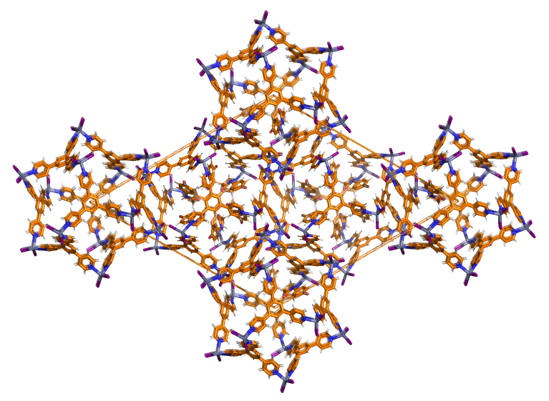
Figure S31. Crystal structure of 1_{global} obtained from DASH showing the M₁₂L₈ cages including paracetamol in the unit cell packing.

Figure S32. View of the included paracetamol (space-fill model) in 1_{global} in cage B, that interacts (black dashed lines) with cages A and C.
Figure S33. Multi-step approach using X-ray diffraction data and DFT calculations for solving a challenging structure from powder XRD data.

DFT-calculations
Structure optimization from powder XRD using DFT.
Solid-state density functional theory (DFT) calculations were accomplished by using the well-known GGA PBE functional., A numerical basis set (centered on atoms) of double zeta quality was used, with polarisation functions on all atoms (comparable with the more usual 6-31G** gaussian set) and effective core potentials (ECP) on metals. Empirical van der Waals corrections were also implemented to include important subtle inter and intra-particle interactions., The DMol³ program was employed for all the calculations here presented. This paradigm showed very good results in a number of recent studies related to molecular modelling simulations of similar or different solid phase crystalline systems.,
As mentioned above, we have recently studied M₁₂L₈ poly-[n]-catenanes.,, In all the cases, we used experimental data obtained from X-ray measurements (single crystal XRD). Well defined structures were available by the complete refinement procedures. In the present work, we proceeded by alternating steps of X-ray diffraction refinements and solid phase DFT calculations. In particular, we performed the simulations by fixing unit cell parameters obtained by X-ray powder diffraction while optimising the geometry of the system, leaving atomic coordinates of all atoms free to relax. The space group symmetry (R-3) was maintained. Paracetamol guest molecules were also included, allowing them to relax into the framework of the crystalline architecture. The strategy here adopted showed a very good efficiency: the refinement of the overall structure was achieved in 2/3 of these synergic steps.
The strategy shown so far could potentially applied in many studies were the refinement from powder X-ray diffraction data of a structure present difficulties. For example, provided that the unit cell is correctly assigned but high-quality X-ray diffraction data are not available and/or when crystallite dimensions into the investigated samples are not large enough to fulfil the diffraction minimal crystalline size requirements.
Figure S33. DFT maps of electrostatic potential (MEPs) computed for TPB and paracetamol. The electropositive and electronegative regions are depicted in blue and red respectively.

Host-guest energy stabilization of paracetamol using DFT.

To assess the role and the stability of the paracetamol molecule inside the M₁₂L₈ cages, we evaluate the interaction energy of paracetamol molecules with the host crystalline architecture (MOCs). With this purpose we calculated this key parameter with two different schemes.
Gas-phase calculations: As a second step, (the first step, periodic conditions, is described in the article) we estimated the stabilisation energy per guest molecule into a single cage. We calculated the interaction energy as the difference between the energy of a single M₁₂L₈ cage (extracted from the crystalline architecture and containing the guests) and the sum of the energy of an empty cage and that of paracetamol molecules, i.e. 6 molecules. The obtained value is 38 kcal/mol, lower by about 8 kcal/mol with respect to the solid phase calculations. This difference is reasonable and can be easily rationalized by considering the dense structure under investigation which results in a higher host-guest interaction energy in the solid-state framework.

Figure S34. View of the voids left in 1_{global} with 6 paracetamol molecules per cage (a) and the total void per cell after manually removing the guests (b). The voids have been calculated using Mercury version 2022.1.0 using a 1.2 Å probe radius.

Figure S35. Pictures taken during the instant synthesis using a TPB-paracetamol solution at room temperature. Image of the stirring TPB-paracetamol homogenous solution in chloroform/methanol before adding the ZnI₂ (a) and after adding the metal salt still stirring (b). Deposition of the white precipitate in the mother solution after stopping the stirring (c) and the product after filtration using low vacuum pump (d).
Figure S36. Diffractograms of 1^{IS-1} (a) and 1^{IS-2} (b) measured on the dry products obtained upon the two instant synthesis experiments carried out using paracetamol in the TPB solution.

Figure S37. TG plots of the solids obtained by instant synthesis 1^{IS-1} and 1^{IS-2} using paracetamol in the solution (templating guest). The weight loss is 14 % and corresponds to ca. 6.8 paracetamol guests for 1^{IS-1} (left) and for 1^{IS-2} the number of guests is 6.4 paracetamol molecules for a weight loss of 13.3 % (right).
References

Martí-Rujas, J., Elli, S., Sacchetti, A. and Castiglione, F. Mechanochemical synthesis of mechanical bonds in M₁₂L₈ poly-[n]-catenanes. Dalton Trans., 51, 53-58 (2022).
Stone, K. H., Lapidus S. H. and Stephens, P. W. Implementation and use of robust refinement in powder diffraction in the presence of impurities. J. Appl. Cryst., 42, 385–391 (2009).
Perdew, J. P., Burke, K. and Ernzerhof, M. E. Generalized gradient approximation made simple. Phys. Rev. Lett., 77, 3865–3868 (1996).
Perdew, J. P., Burke, K. and Ernzerhof, M. E. Generalized gradient approximation made simple. Phys. Rev. Lett., 78, 1396–1396 (1997).
Grimme, S. Semiempirical hybrid density functional with perturbative second-order correlation. J. Chem. Phys., 124, 34108 (2006).
Baggioli, A. et al. Intramolecular CH/π interactions in alkylaromatics: Monomer conformations for poly(3-alkylthiophene) atomistic models. Int. J. Quantum Chem., 113, 2154-2162 (2013).
Baggioli, A. and Famulari, A. On the inter-ring torsion potential of regioregular P3HT: a first principles reexamination with explicit side chains. Phys. Chem. Chem. Phys., 16, 3983-3994 (2014).
Delley, B. From molecules to solids with the DMol³ approach. J. Chem. Phys., 113, 7756-7764 (2000).
Catalano, L. et al. Dual-mode light transduction through a plastically bendable organic crystal as an optical waveguide. Angew. Chem. Int. Ed., 57, 17254-17258 (2018).
Famulari, A. et al. A solid state density functional study of crystalline thiophene-based oligomers and polymers. J. Phys. Chem. B, 116, 14504-14509 (2012).
Torresi, S., Famulari, A. and Martí-Rujas, J. Kinetically controlled fast crystallization of M₁₂L₈ poly-[n]-catenanes using the 2,4,6-Tris(4-pyridyl)benzene ligand and ZnCl₂ in an aromatic environment. J. Am. Chem. Soc. 142, 9537-9543 (2020).
Martí-Rujas, J., Ma, S. and Famulari, A. Experimental X-ray and DFT structural analyses of M₁₂L₈ poly-[n]-catenanes using exotridentate ligands. Inorg. Chem. 61, 10863-10871 (2022).
Martí-Rujas, J. Elli, S. and Famulari, A. Kinetic trapping of 2,4,6-Tris(4-pyridyl)benzene and ZnI₂ into M₁₂L₈ poly-[n]-catenanes using solution and solid-state processes. Sci. Rep., 13, 5605-5616 (2023).

