Supplementary information
- Data processing
We removed the data before the minimum point among the first 30 points (ca. 27 s) (Fig. 2a; left open circle) and after the maximum point near the end of the time series (Fig. 2a; right open circle) (Data 1). Then, we removed the data before the point associated with the largest slope among the first 30 data points in Data 1 (Data 2), which was identified as the largest flux in the smoothed flux dataset (Fig. 2a; before the gray-filled circle). Next, we removed the data before the point associated with the smallest slope (smallest flux) among the first 30 data points in Data 2 (Fig. 2a; before the black-filled circle). The first process extracted the chamber deployment time period, and the second and third processes extracted stable data.

- Observed and converted datasets at different steps in the data analysis
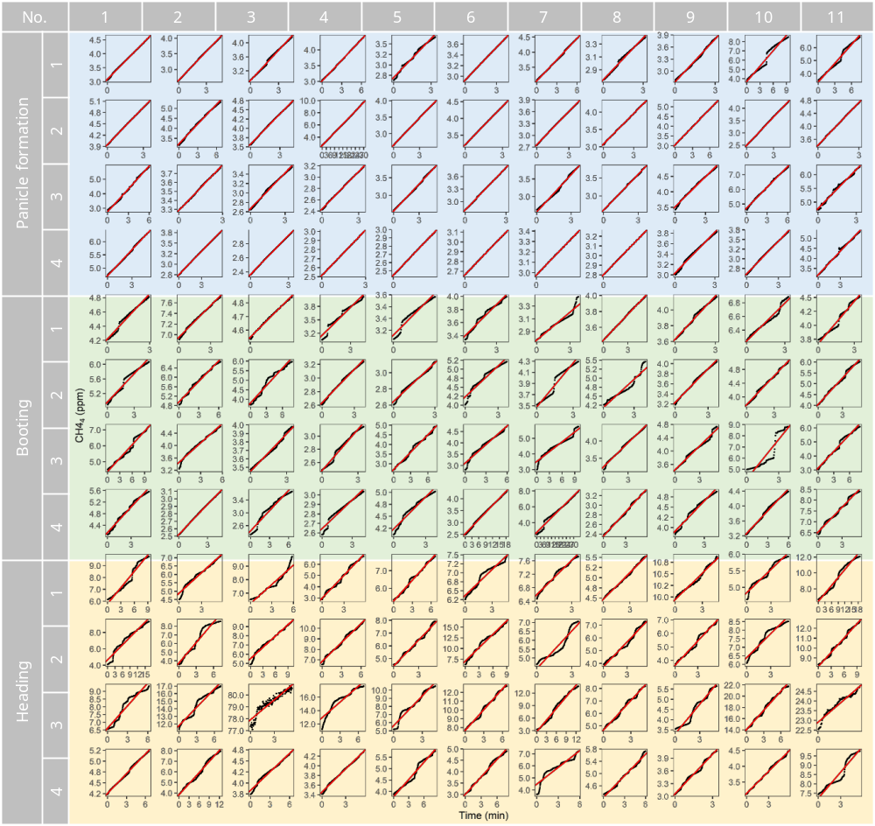
Fig. S1. Time series of [CH4] in the chamber (processed [CH4], Fig. 1) and linear regression lines for calculation of the total CH₄ flux in each of the 132 flux datasets (11 plots × 4 replicates × 3 stages). r² range = 0.85–1.00.

Fig. S2. Temporal changes in the CH₄ flux (original data, gray lines; smoothed data, black lines) and the estimated plant-mediated flux (red lines) in the 132 flux datasets (11 plots × 4 replicates × 3 stages).

Fig. S3. Kernel density distributions of the CH₄ fluxes shown in Fig. S2 and estimation of the plant-mediated flux. Dotted red lines show peaks in the distribution, and solid red lines show the minimum flux among the selected peaks, assumed to represent the plant-mediated emission, corresponding to the red lines in Fig. S2.

- Contribution of ebullition during the entire growth period
We roughly estimated total seasonal CH₄ emissions via rice plants and ebullition by the following procedure. We assumed zero emission at transplanting, May 14, and the median values of observed fluxes at the PF, BT, and HD stages on July 1, July 23, and August 6, respectively. We linearly interpolated the pathway-dependent fluxes and assumed that the emission observed at HD continued until the field was drained on August 15. We further assumed that no bubbling emission occurred at night (10 h).

Table S1. Estimation of CH₄ emission for the entire growing season.
 | Emission | Percentage
 | (g-C CH4 m^{–2}) | (%)
Bubbles | 2.5 | 26
Plants | 7.3 | 74

