Design, Synthesis and Antiviral Activity of Indole Derivatives Containing quinoline moiety
Bangcan He, Yuzhi Hu, Yishan Qin, Yufang Zhang, Xingping Luo, Zhenchao Wang*, Wei Xue*
National Key Laboratory of Green Pesticide, Key Laboratory of Green Pesticide and Agricultural Bioengineering, Ministry of Education, Center for R&D of Fine Chemicals of Guizhou University, Guiyang, 550025, China.
*Corresponding author
Tel.: 0086-851-88292090, Fax: 0086-851-88292090.
E-mail: zcwang@gzu.edu.cn (Zhenchao Wang), wxue@gzu.edu.cn (Wei Xue)

- Crystal data of W14
Compound | W14
Deposition Number | 2269080
Empirical formula | C26H20Cl2N2OS
Formula weight | 479.40
Temperature/K | 273.15
Crystal system | monoclinic
Space group | P21/c
a / Å | 14.3576(10)
b / Å | 18.7339(14)
c / Å | 8.4190(7)
α / ° | 90
β / ° | 99.709(3)
γ / ° | 80
Volume / Å³ | 2232.1(3)
Z | 4
ρ_{calc} g/cm³ | 1.427
μ / mm⁻¹ | 3.665
F(000) | 992.0
Radiation | CuKα (λ = 1.54178)
2θ range range for data collection/° | 6.246 to 94.558
Index ranges | -13 ≤ h ≤ 13, -17 ≤ k ≤ 17, -8 ≤ l ≤8
Reflections collected | 7336
Independent reflections | 2009 [Rint = 0.0859, Rsigma = 0.0751]
Data/restraints/parameters | 2009/0/291
Goodness-of-fit on F² | 1.041
Final R indexes [I>=2σ (I)] | R1 = 0.0788, wR2 = 0.2014
Final R indexes [all data] | R1 = 0.1044, wR2 = 0.2269
Largest diff. peak/hole / e Å⁻³ | 0.65/-0.30

- NMR and HRMS spectrogram data of target compounds W1-W21.
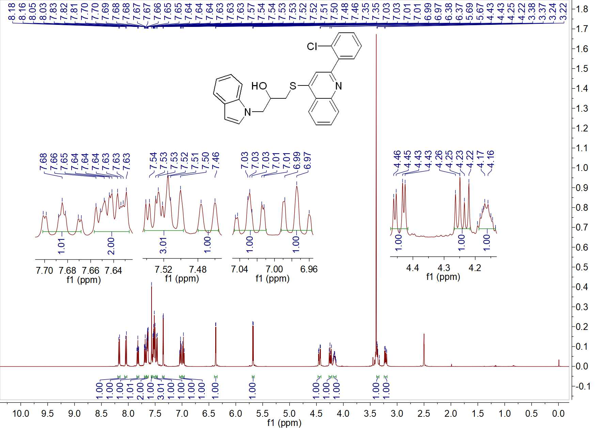

Fig. 1 ¹H NMR spectrum of W1
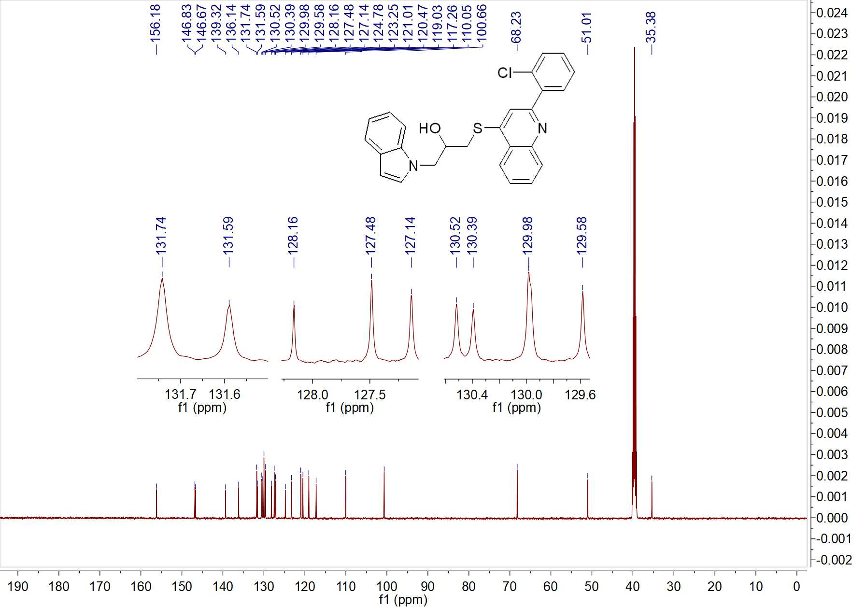

Fig. 2 ¹³C NMR spectrum of W1

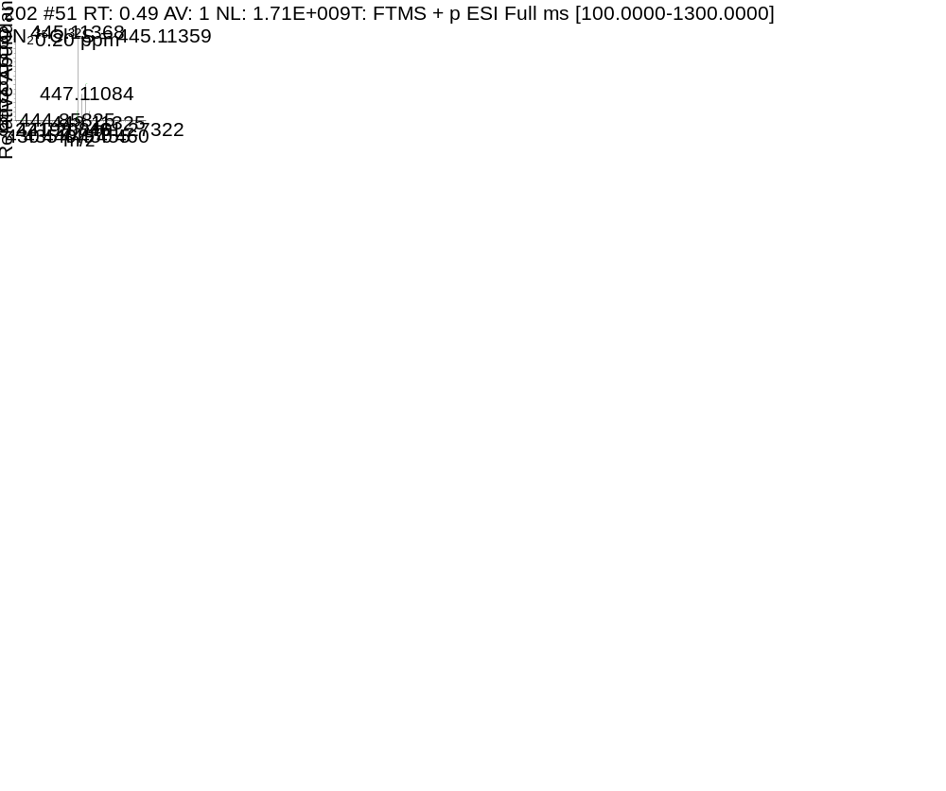Fig. 3 HRMS spectrum of W1
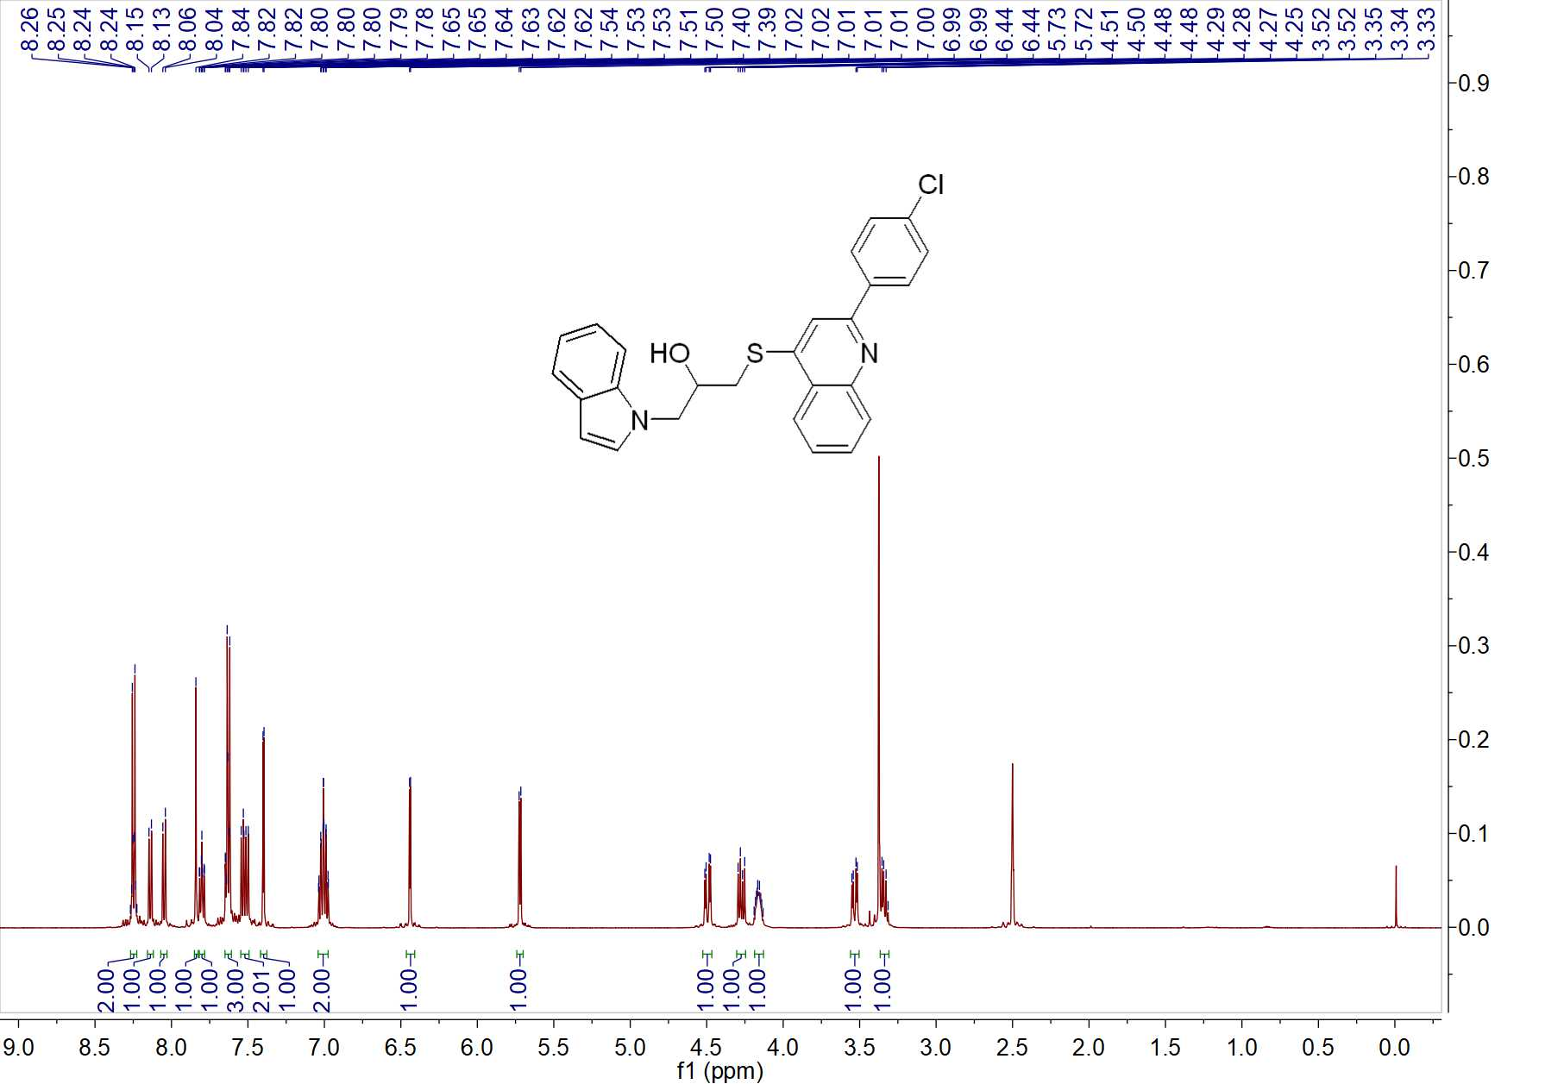

Fig. 4 ¹H NMR spectrum of W2
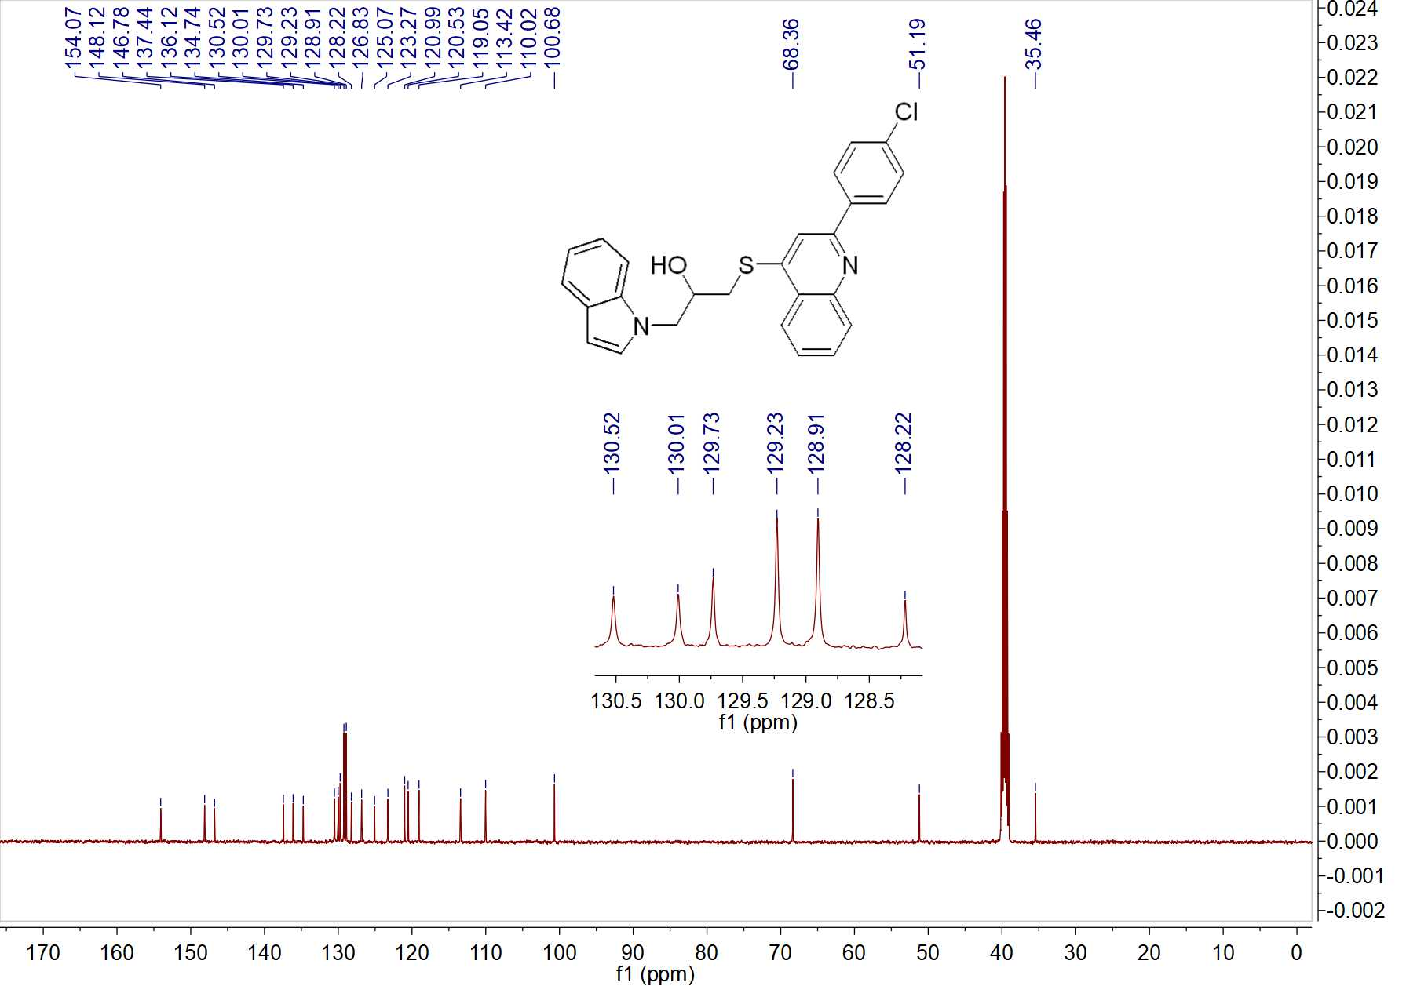

Fig. 5 ¹³C NMR spectrum of W2
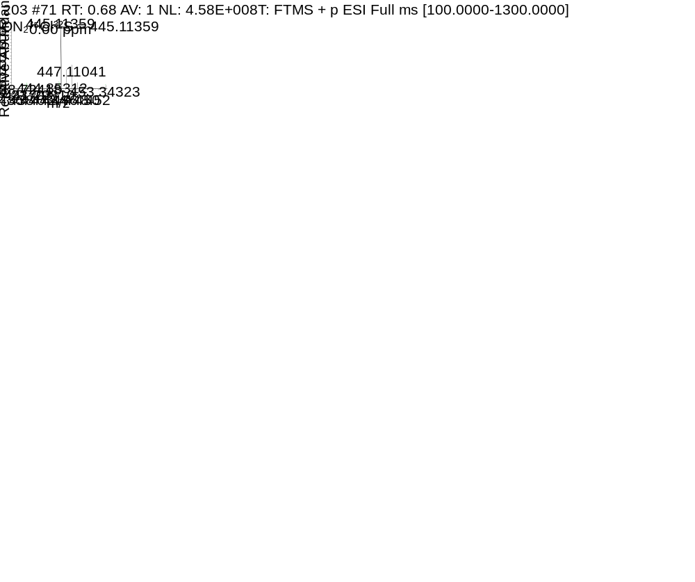

Fig. 6 HRMS spectrum of W2
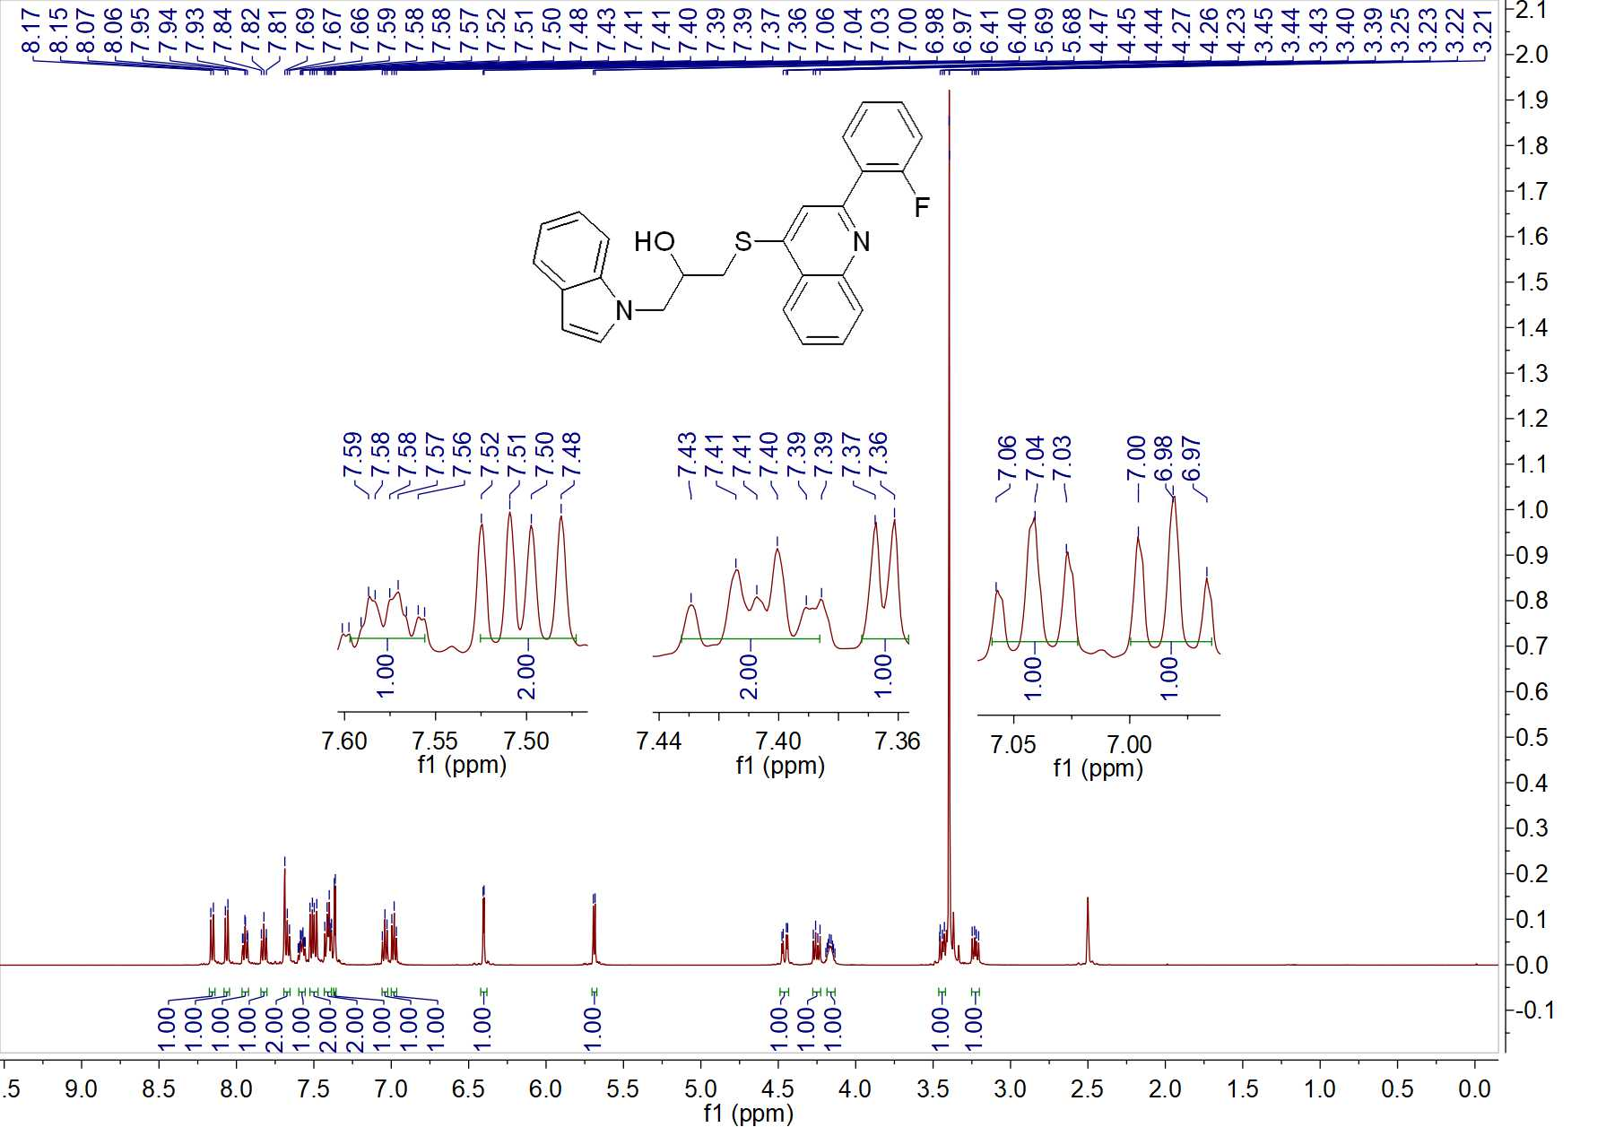

Fig. 7 ¹H NMR spectrum of W3
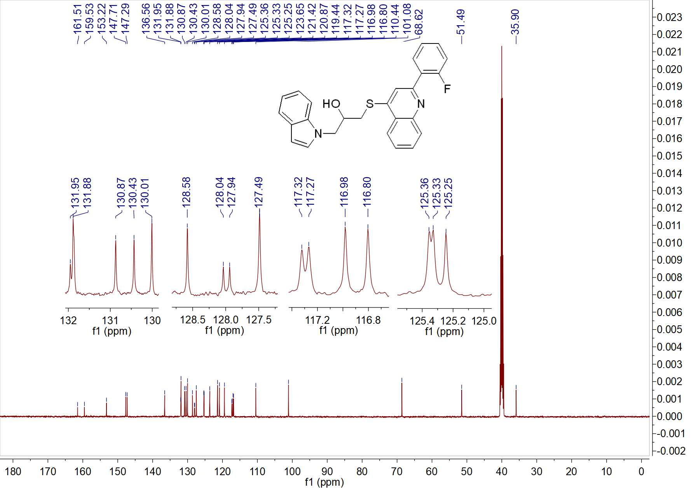

Fig. 8 ¹³C NMR spectrum of W3

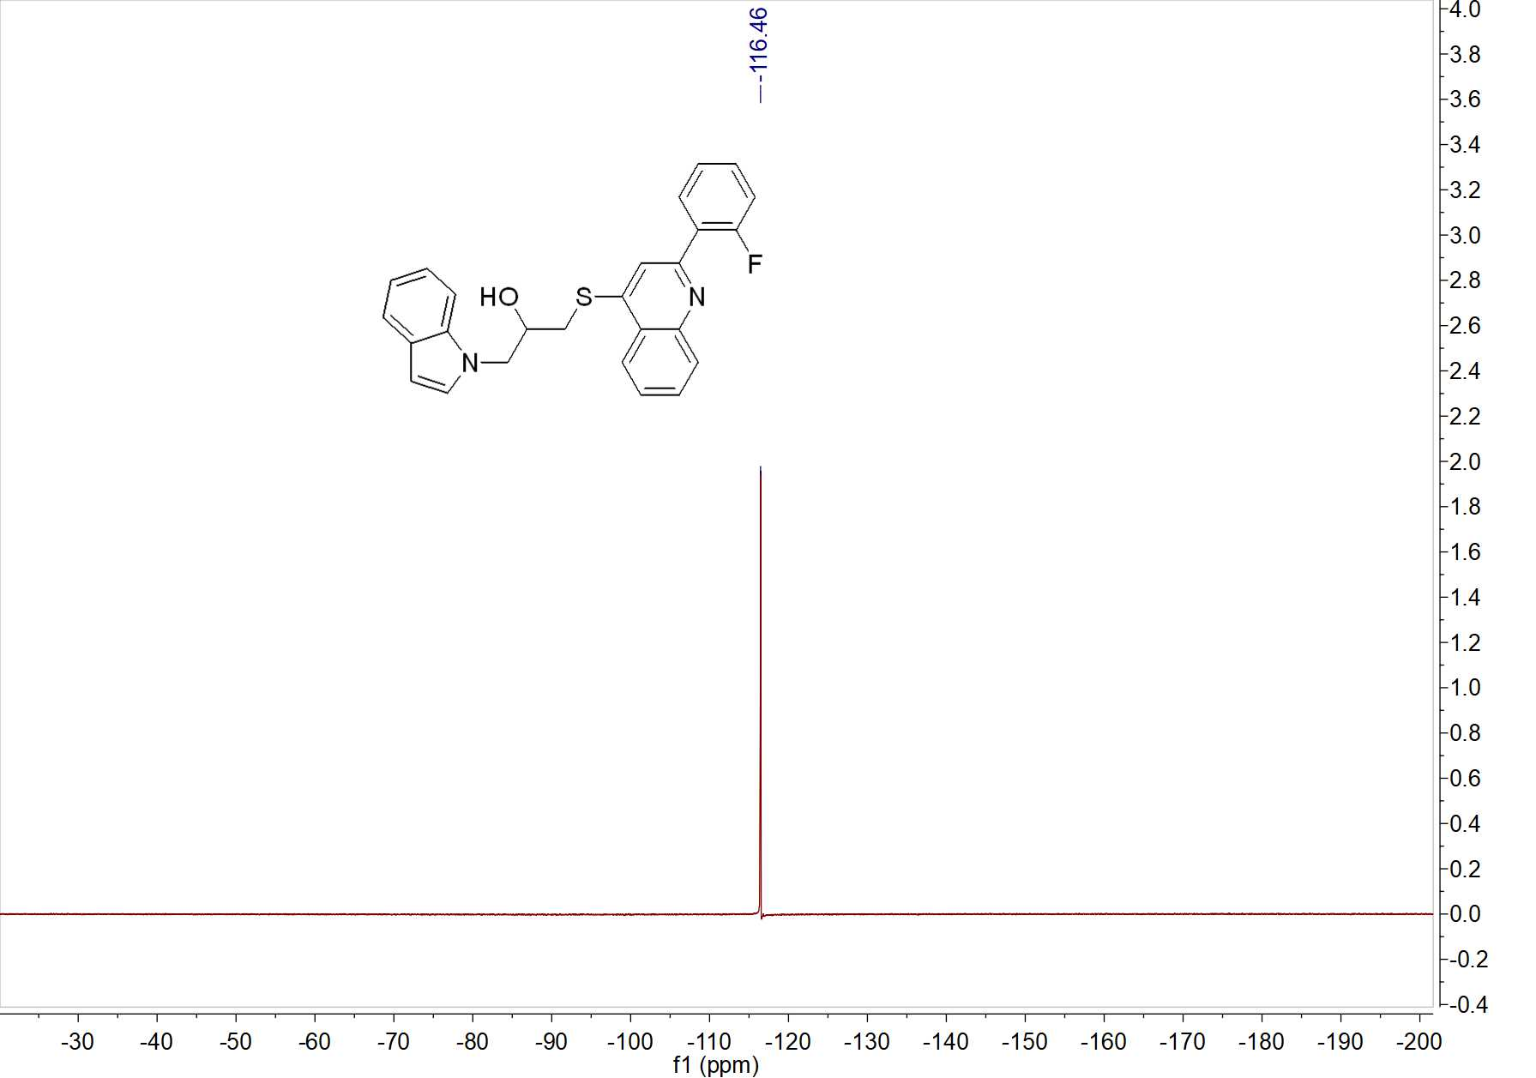

Fig. 9 ¹⁹F NMR spectrum of W3

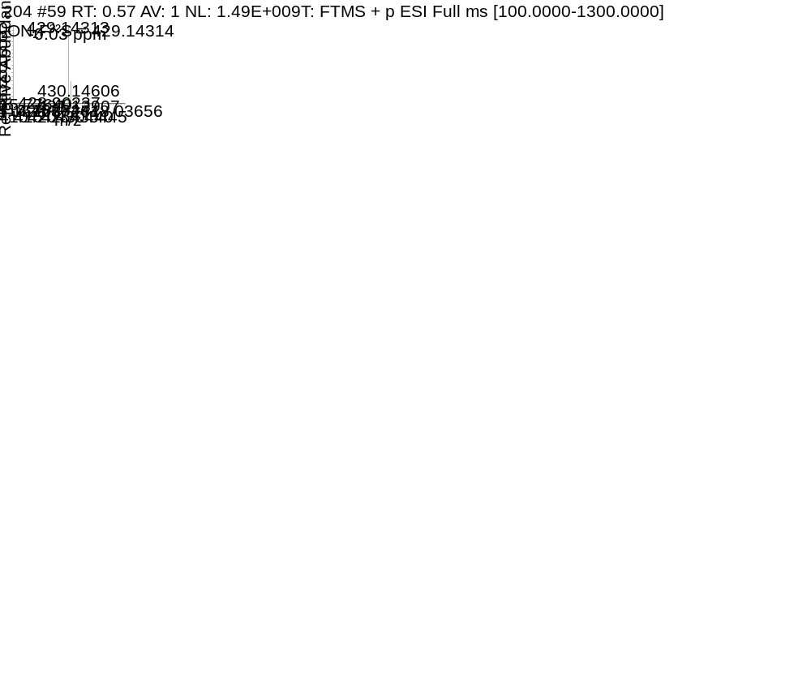

Fig. 10 HRMS spectrum of W3
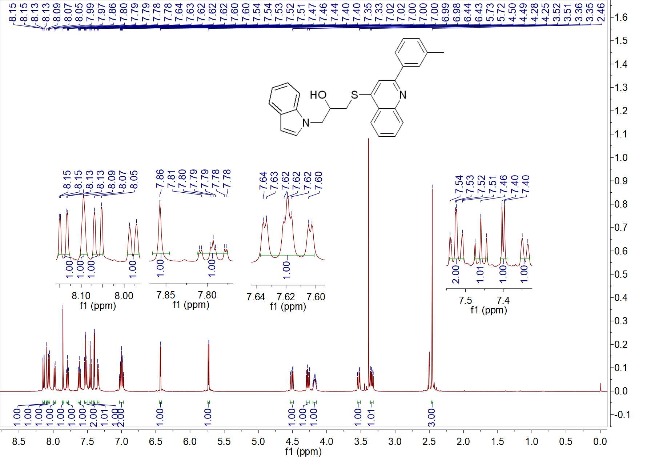

Fig. 11 ¹H NMR spectrum of W4
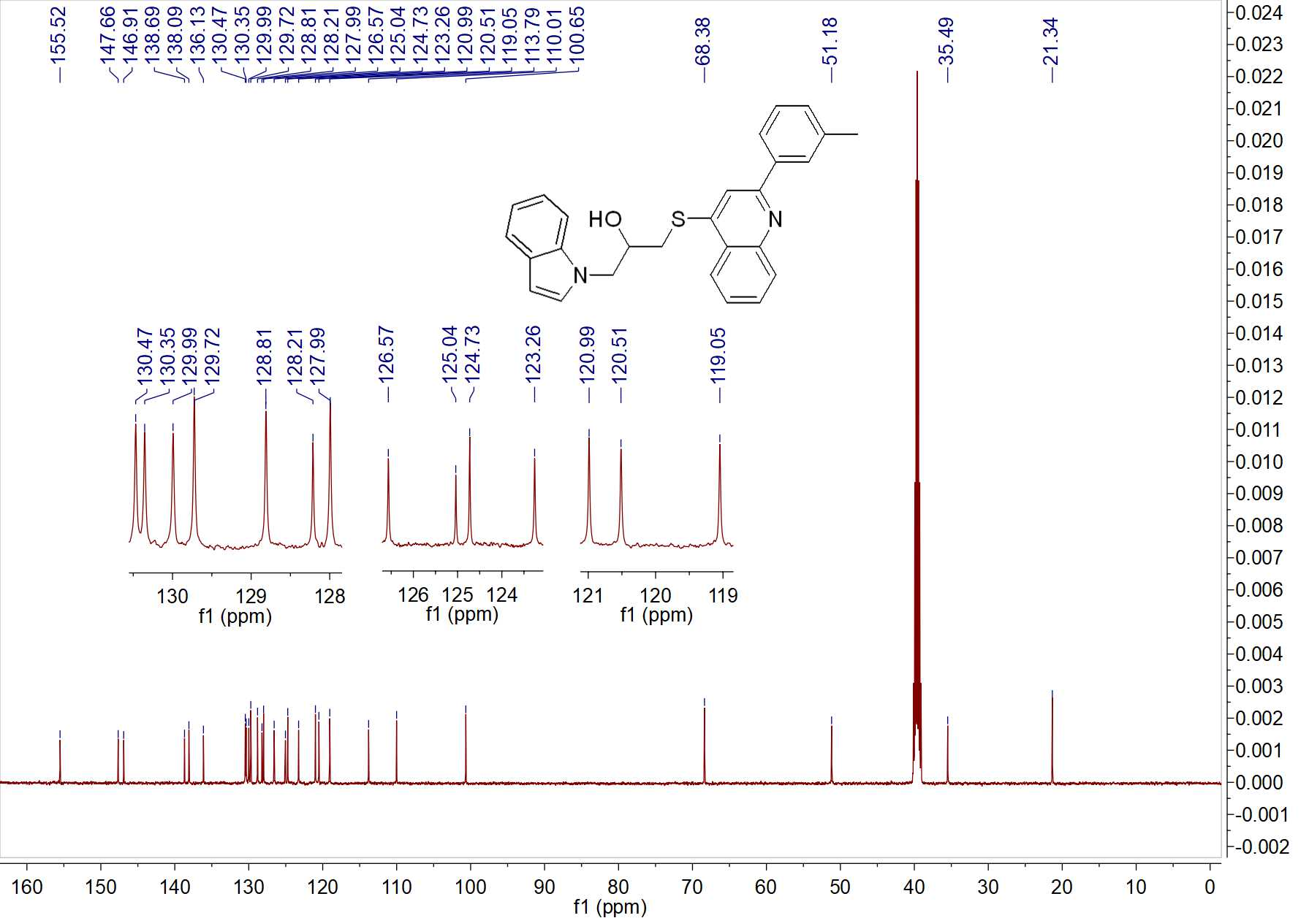

Fig. 12 ¹³CNMR spectrum of W4
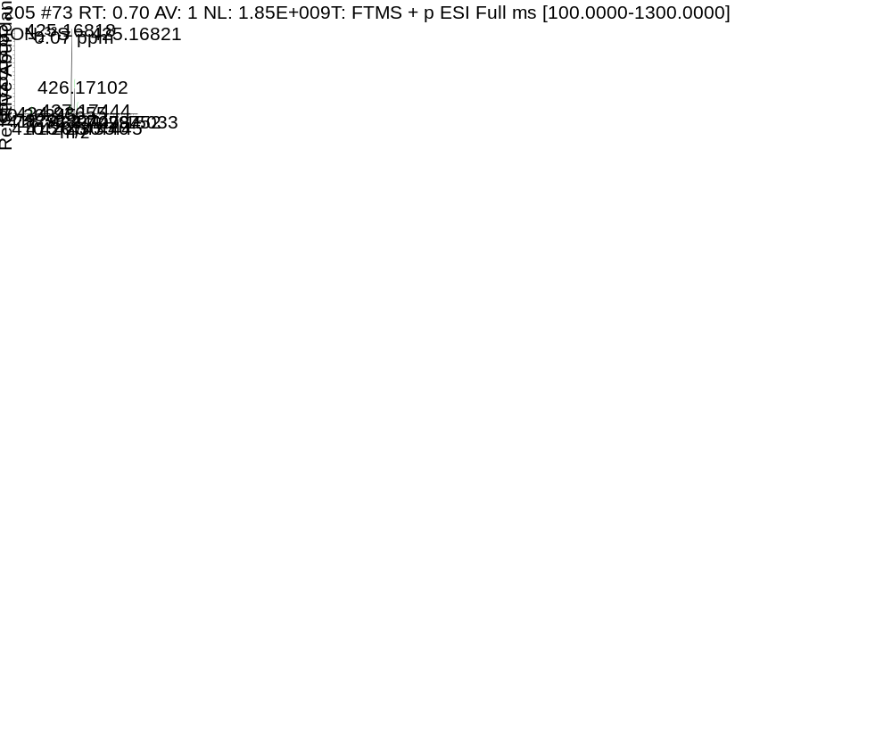

Fig. 13 HRMS spectrum of W4
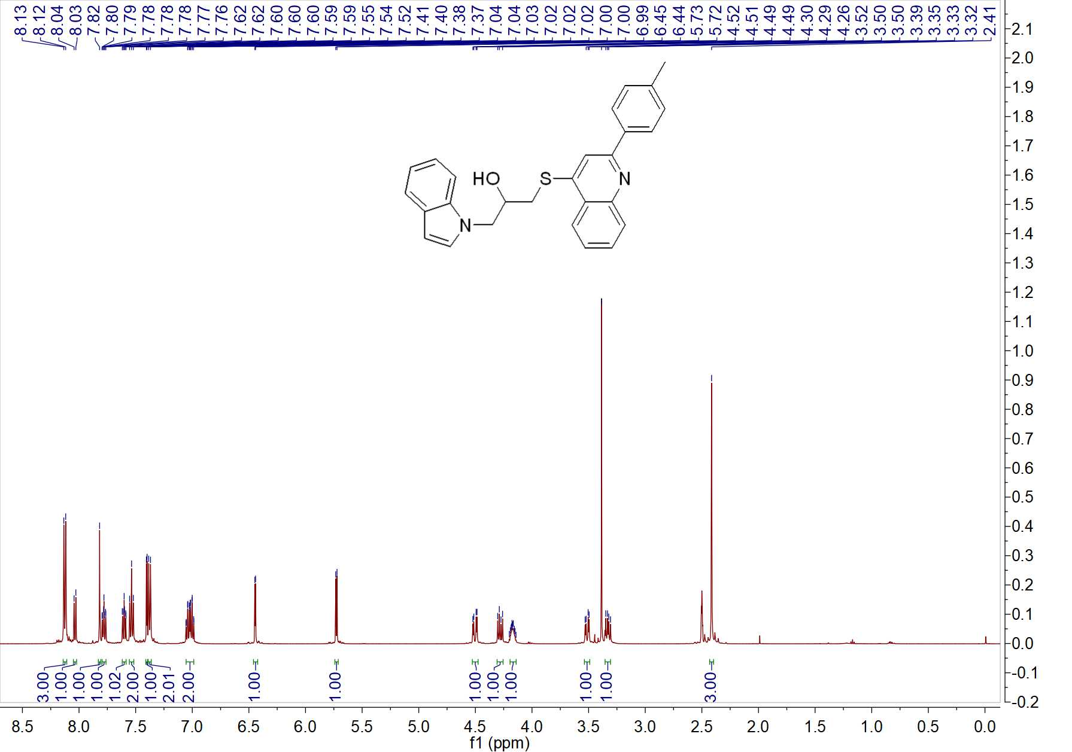

Fig. 14 ¹H NMR spectrum of W5
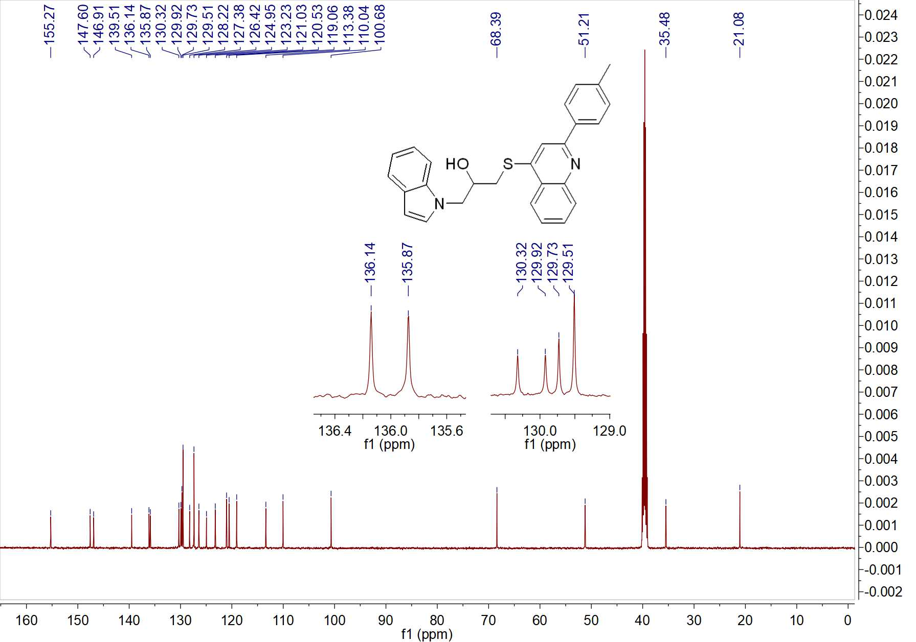

Fig. 15 ¹³C NMR spectrum of W5

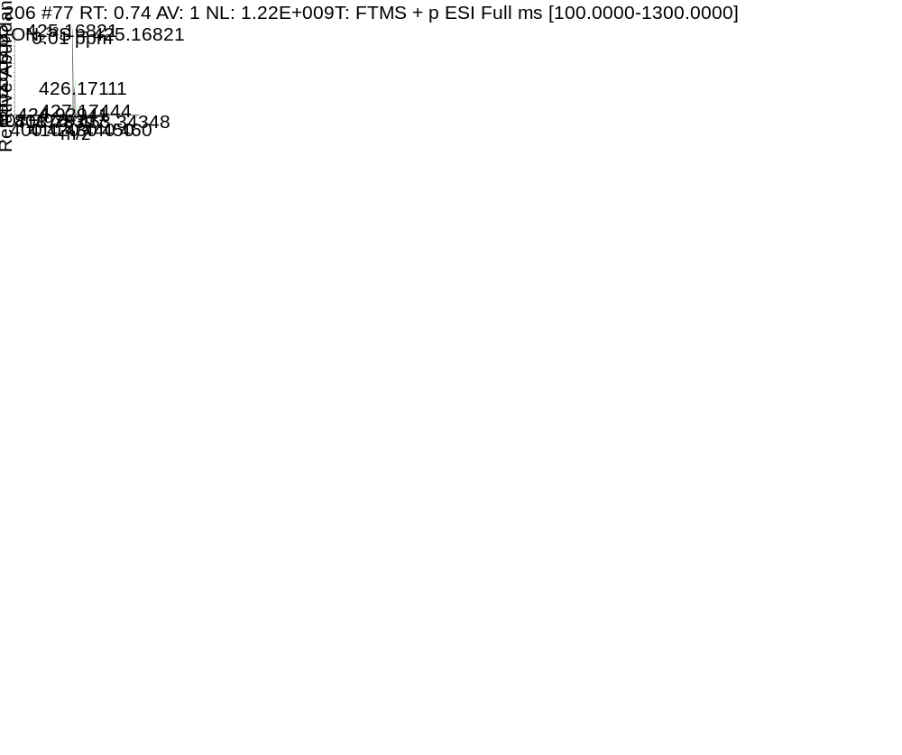

Fig. 16 HRMS spectrum of W5

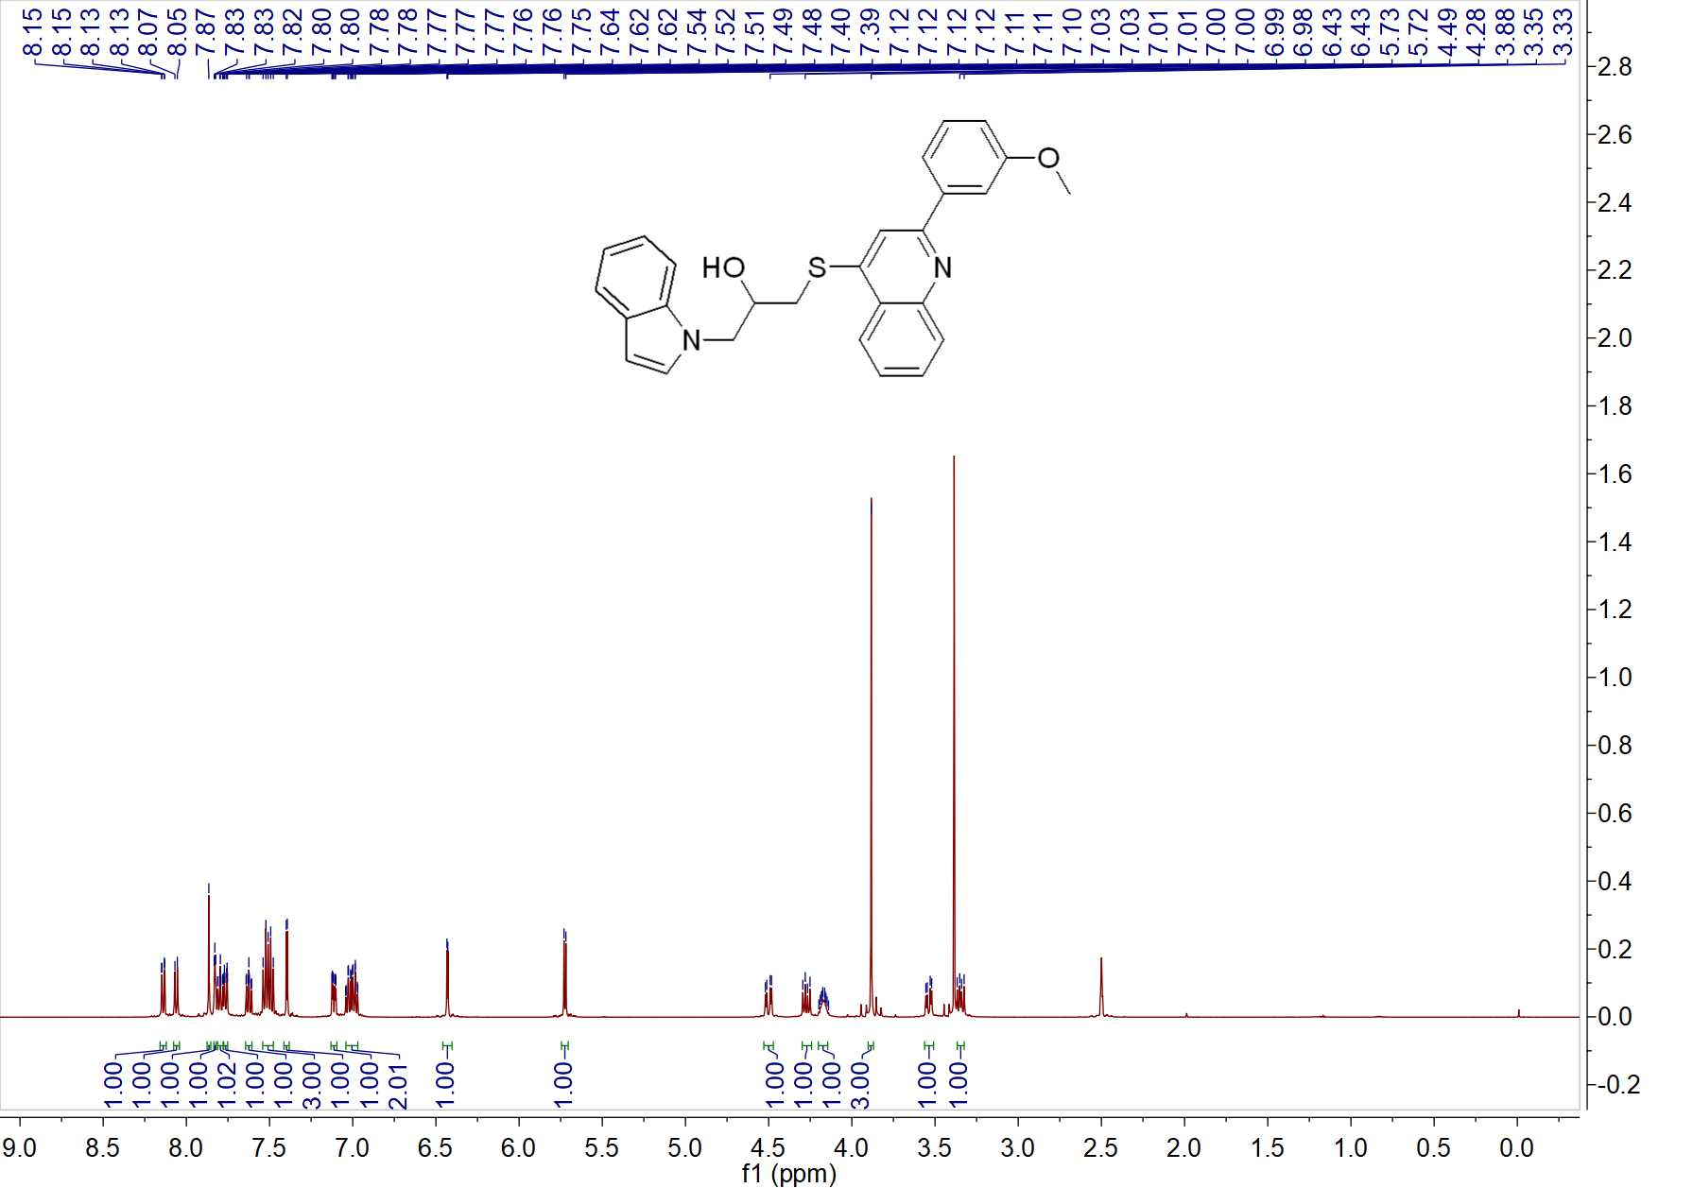

Fig. 17 ¹H NMR spectrum of W6
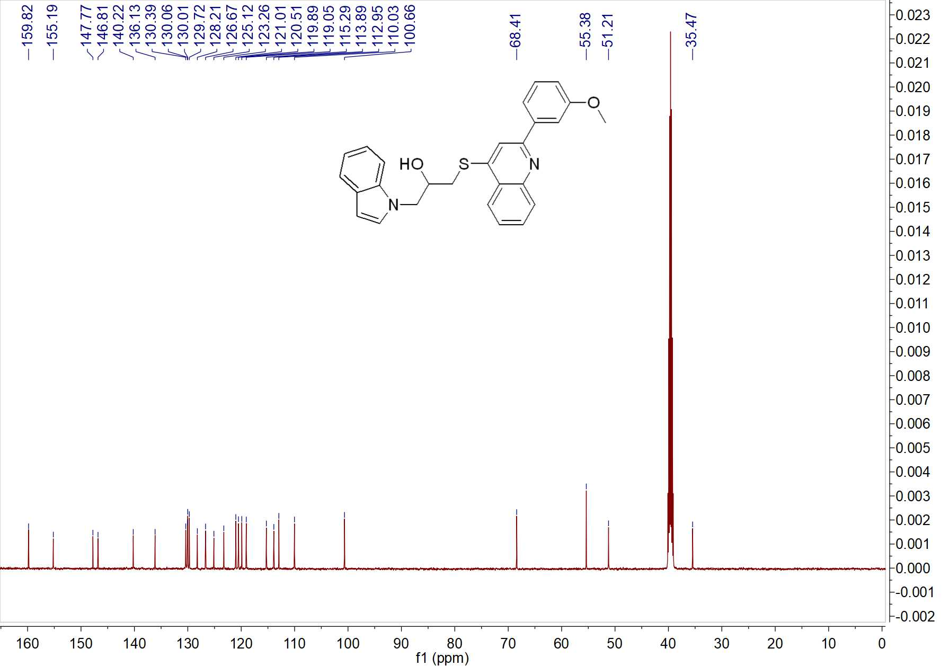

Fig. 18 ¹³C NMR spectrum of W6

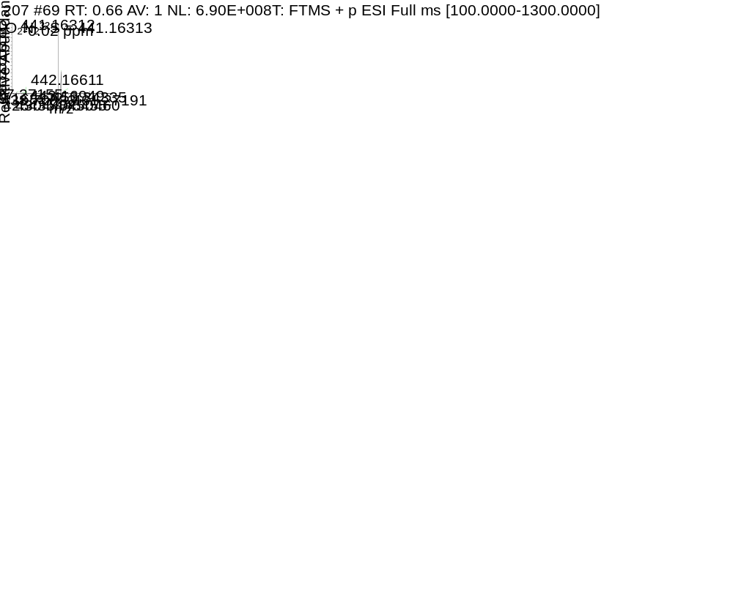

Fig. 19 HRMS spectrum of W6
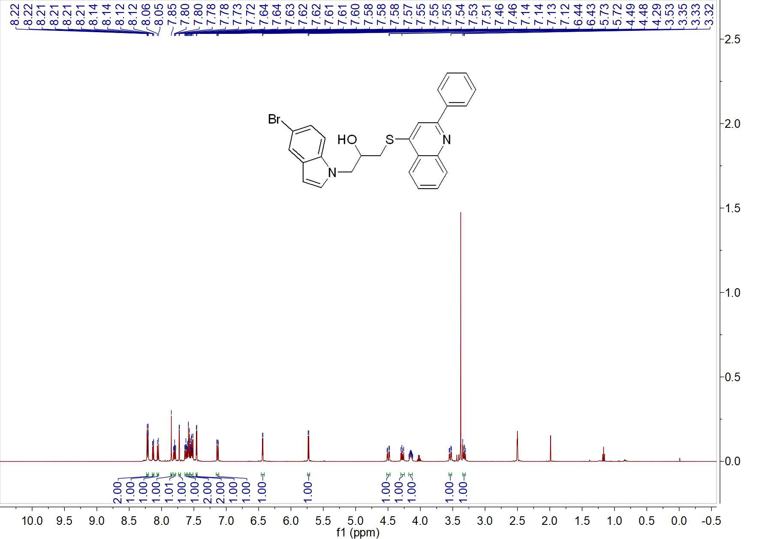

Fig. 20 ¹H NMR spectrum of W7
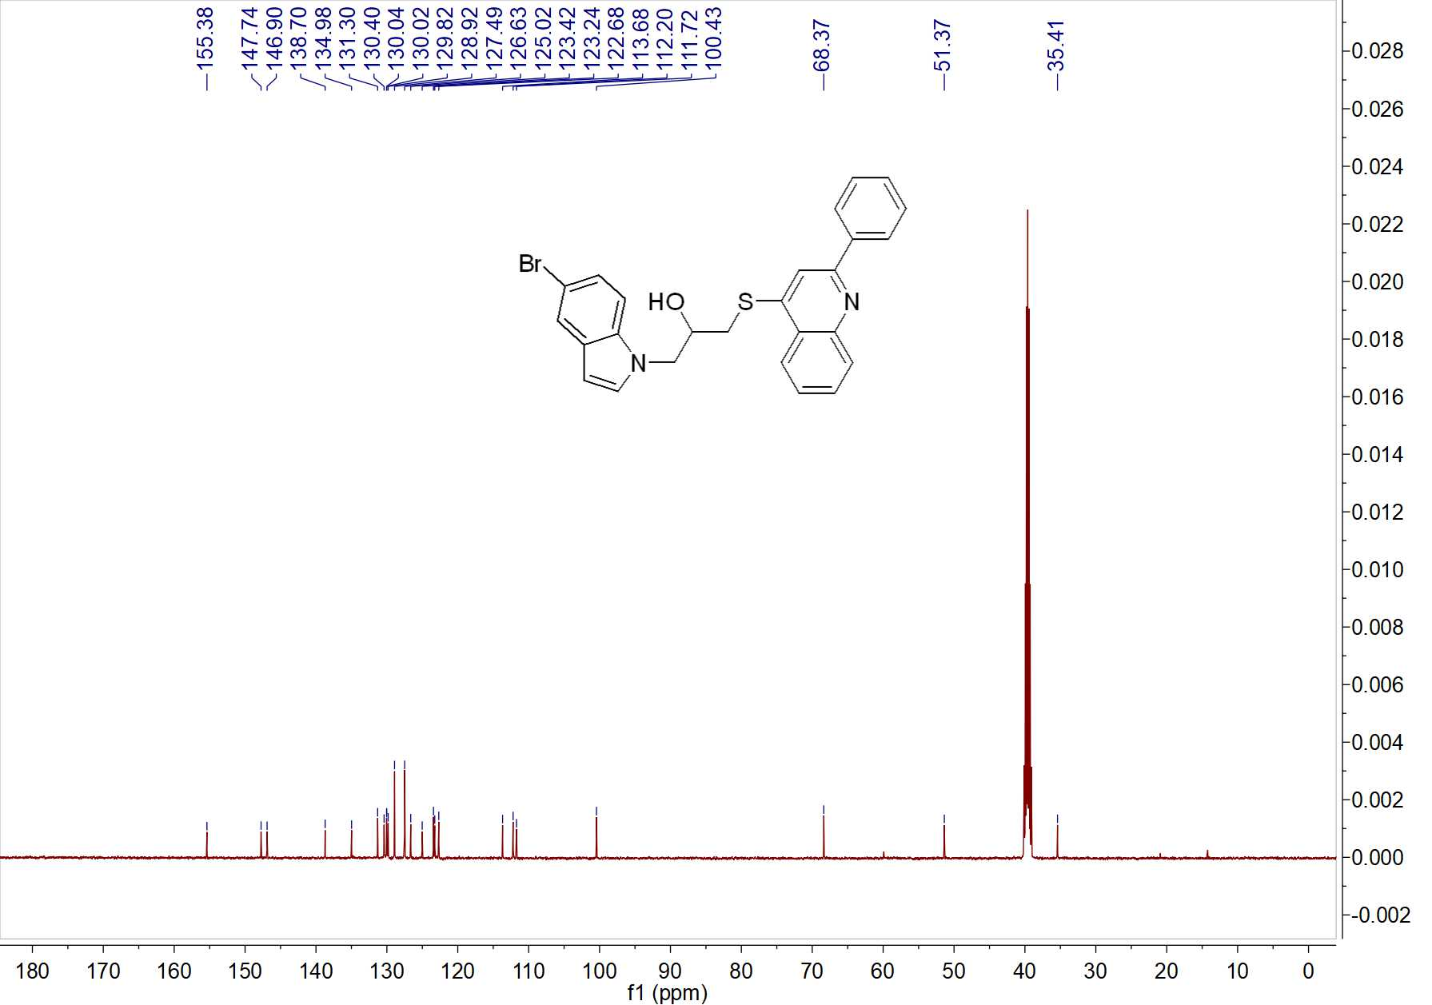

Fig. 21 ¹³C NMR spectrum of W7

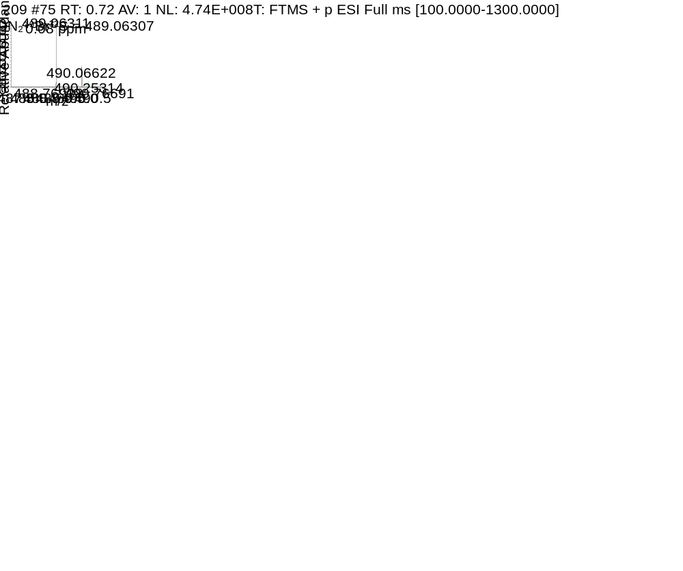

Fig. 22 HRMS spectrum of W7
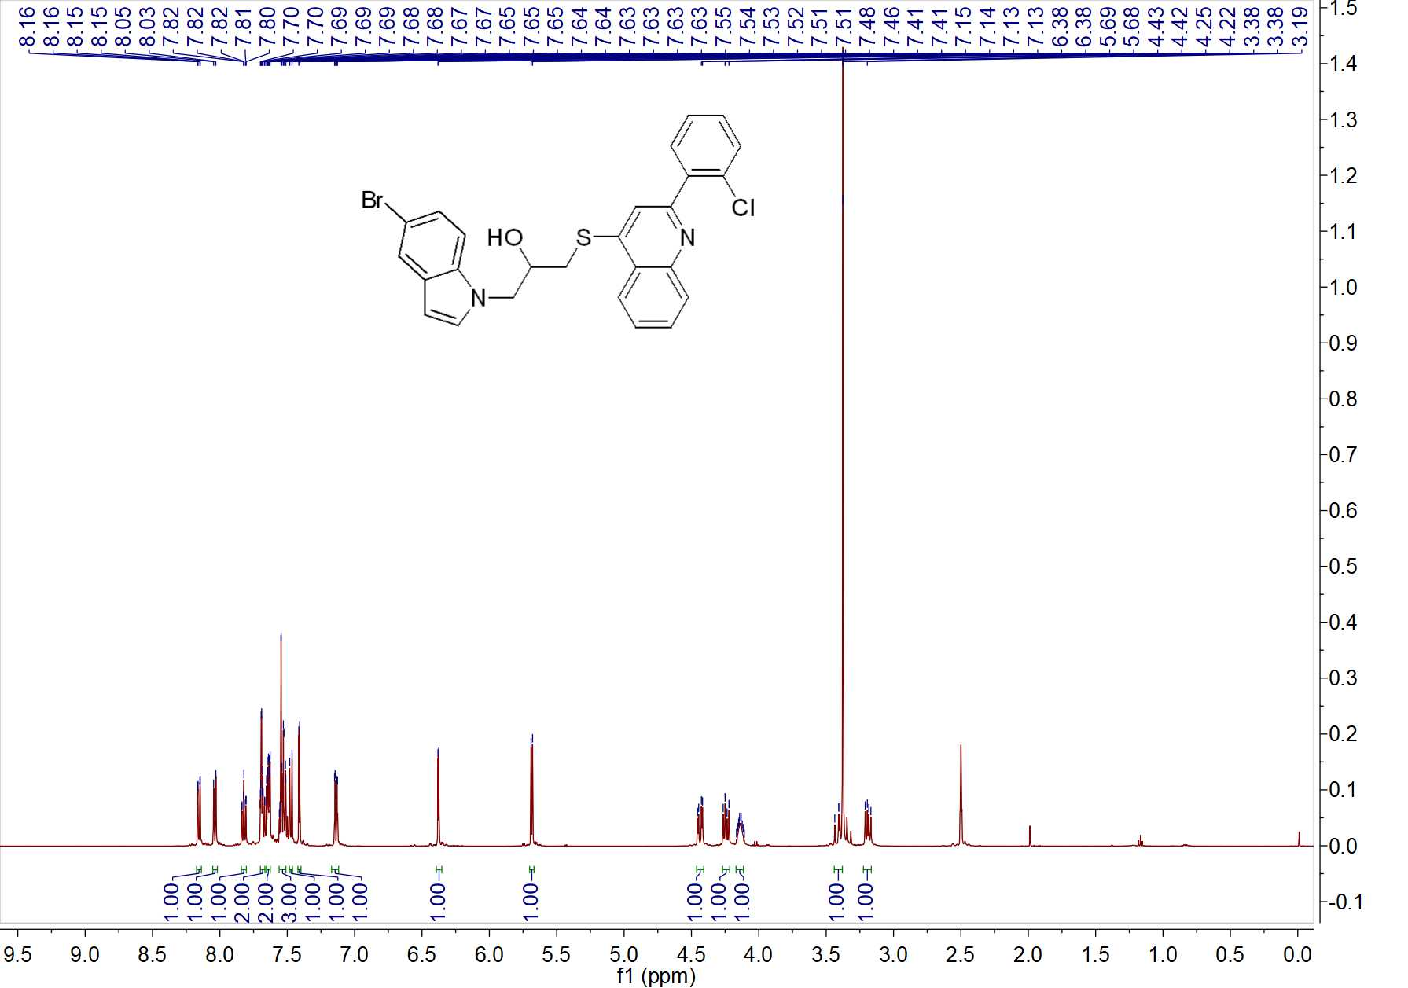

Fig. 23 ¹H NMR spectrum of W8
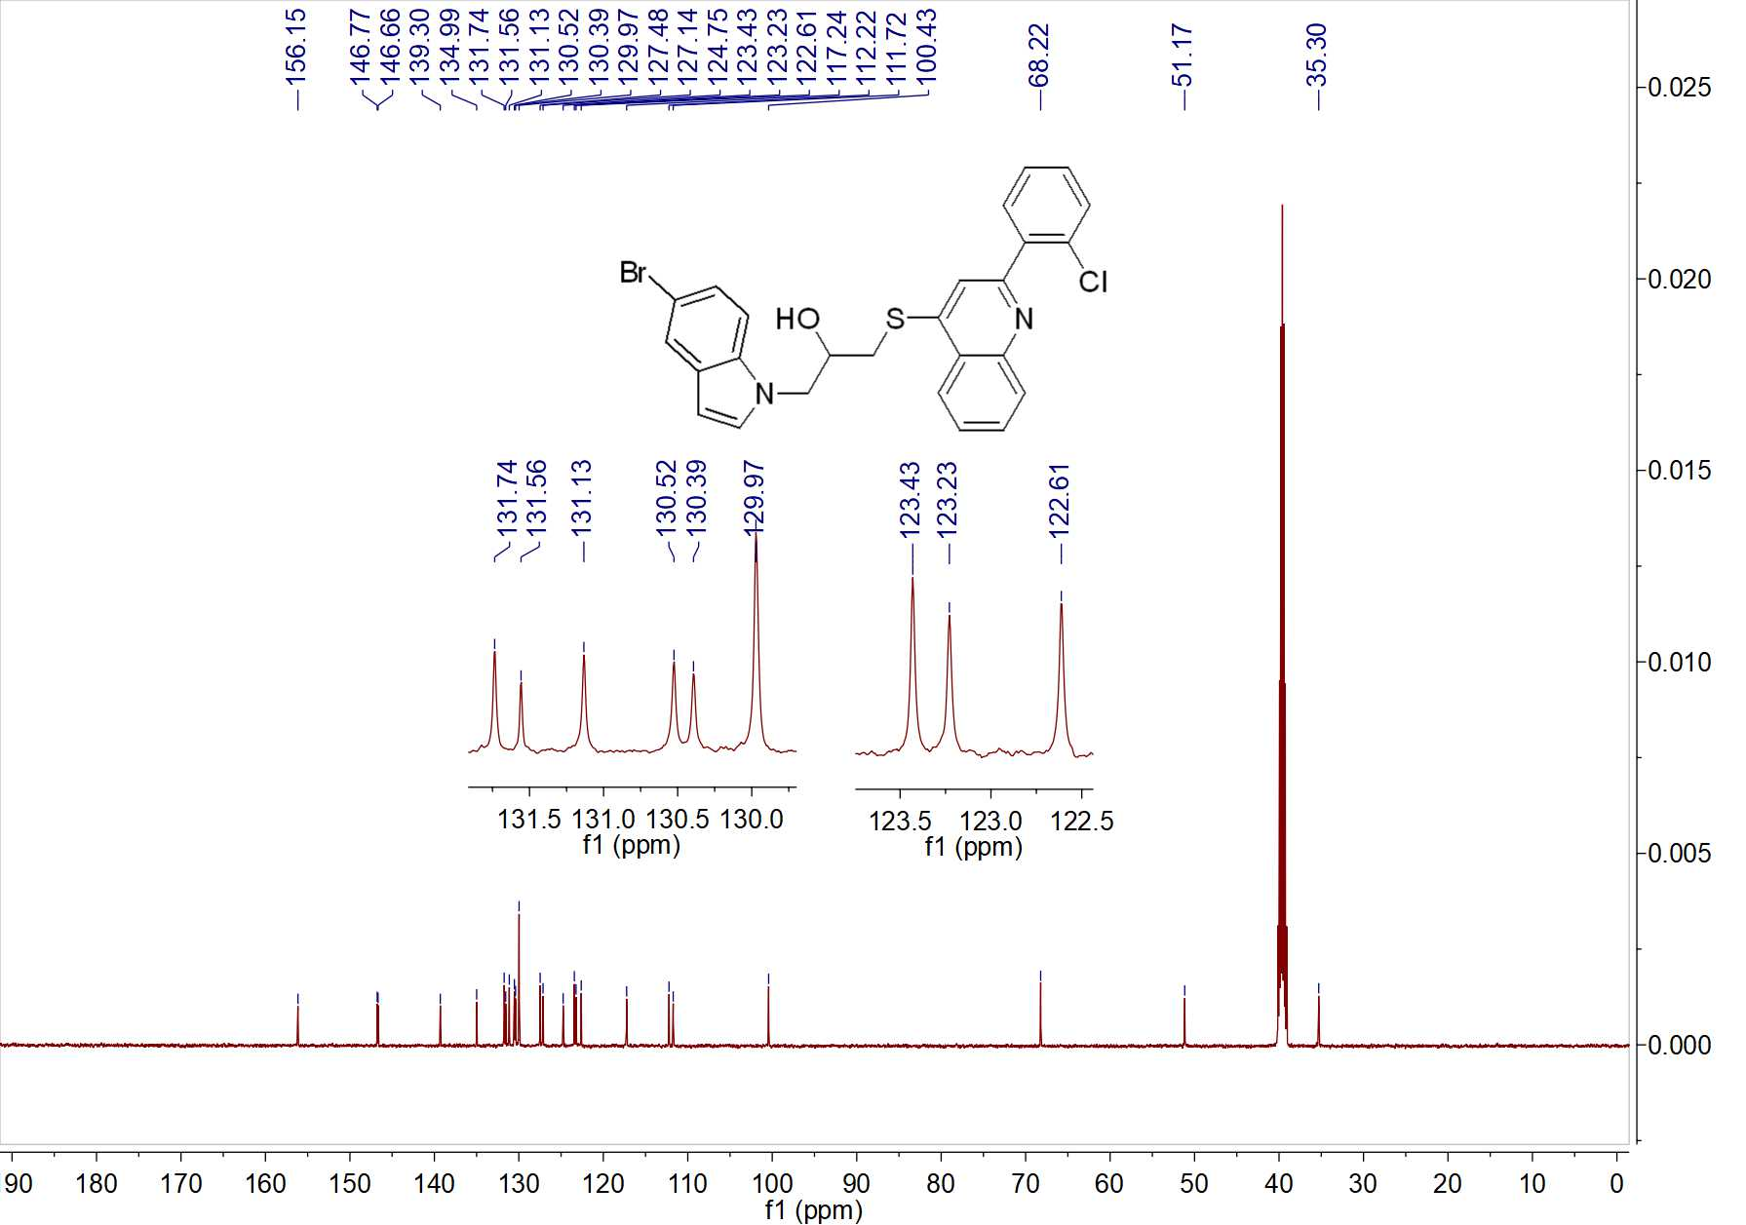

Fig. 24 ¹³C NMR spectrum of W8

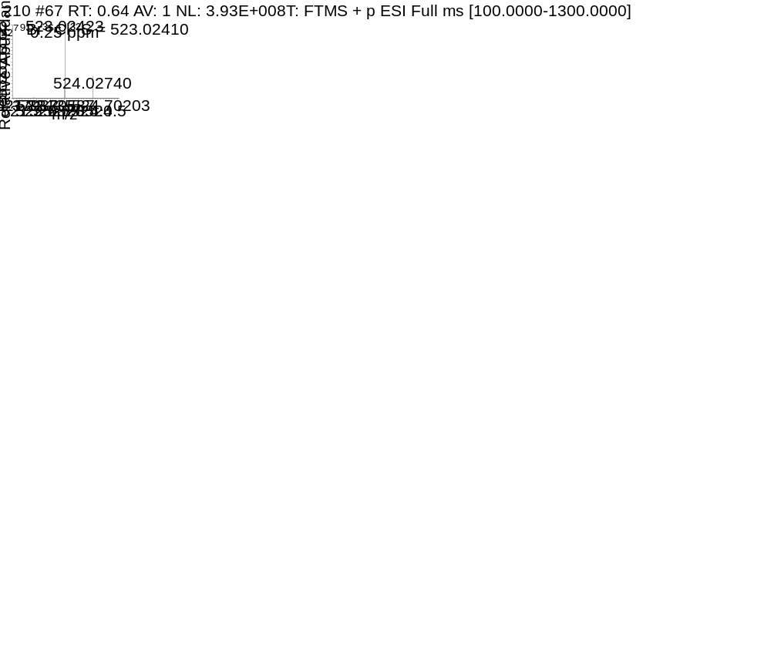

Fig. 25 HRMS spectrum of W8
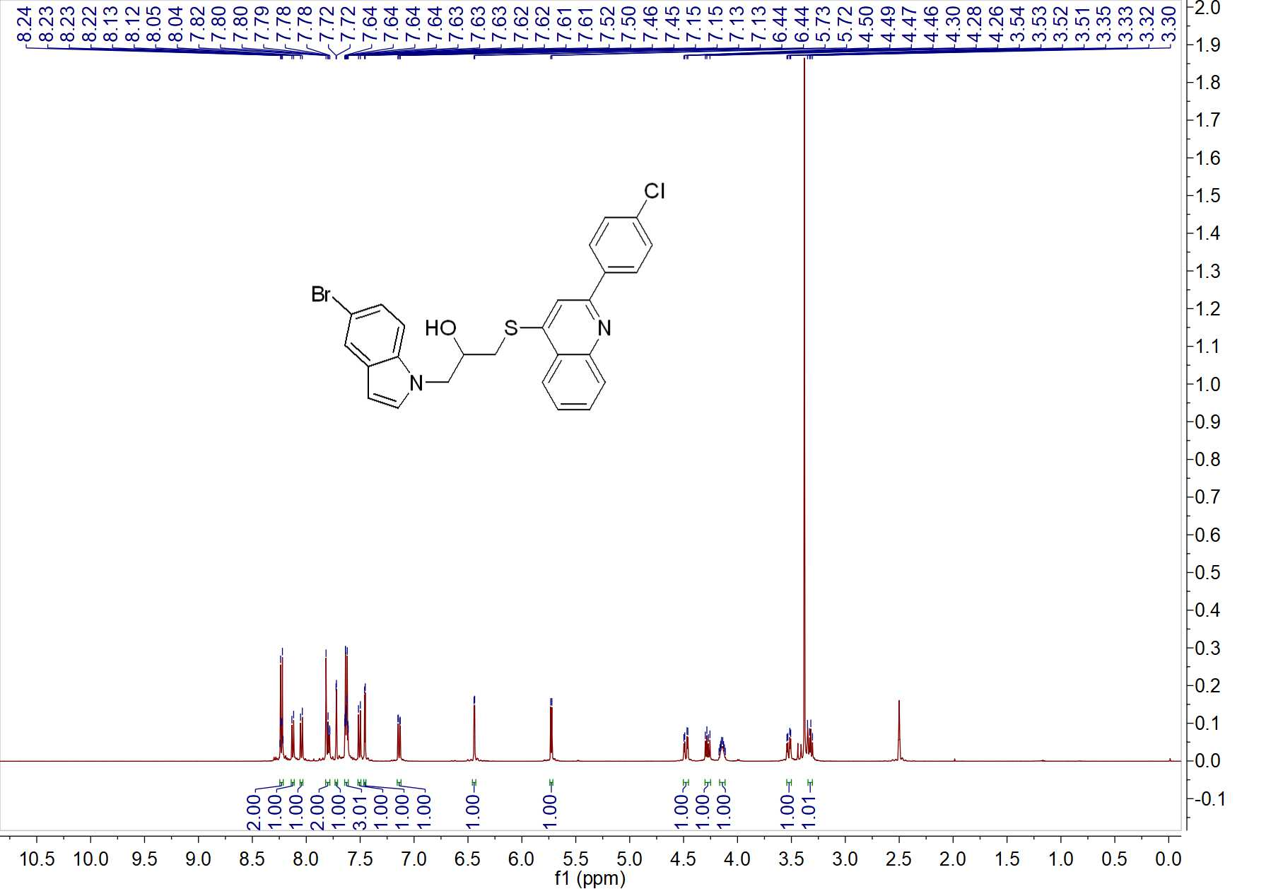

Fig. 26 ¹H NMR spectrum of W9
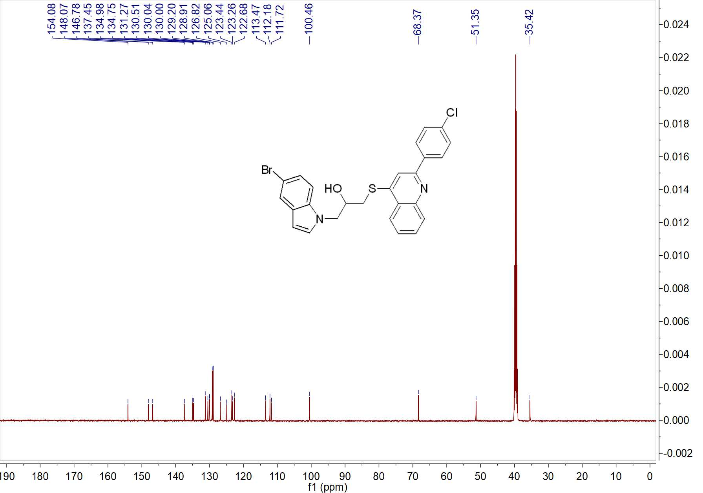

Fig. 27 ¹³C NMR spectrum of W9

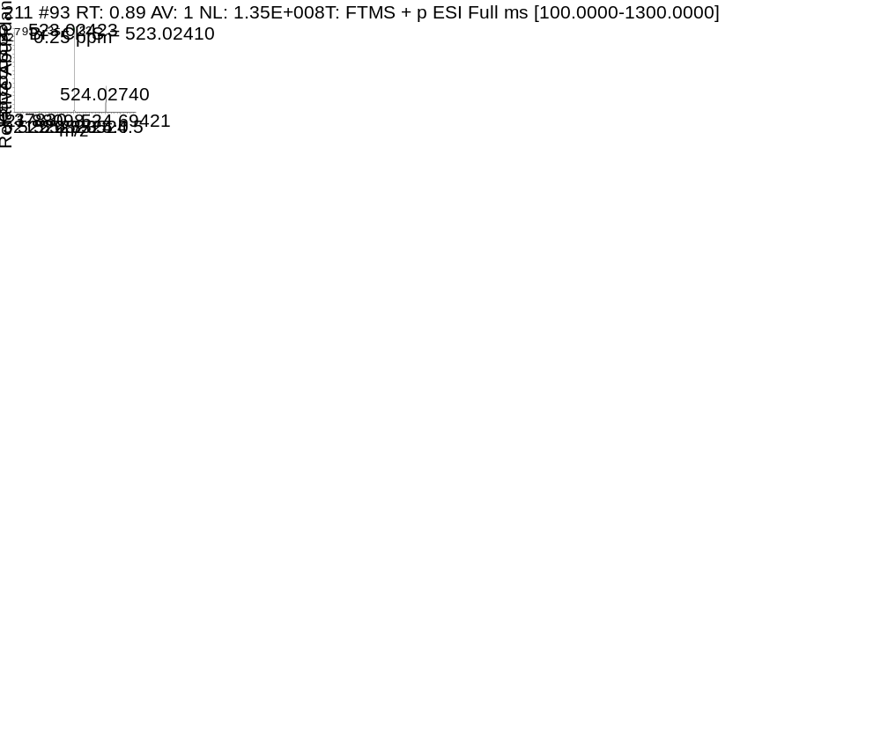

Fig. 28 HRMS spectrum of W9
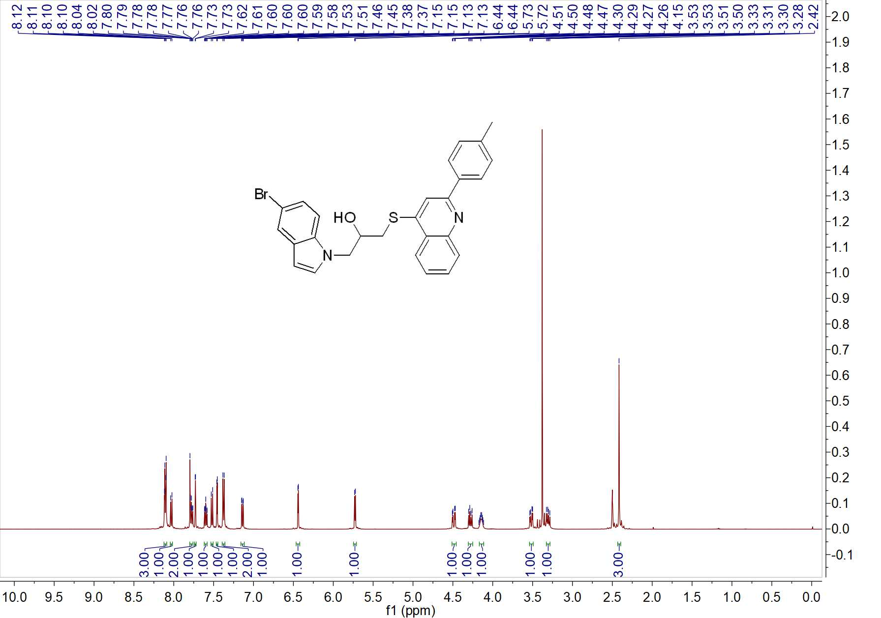

Fig. 29 ¹H NMR spectrum of W10
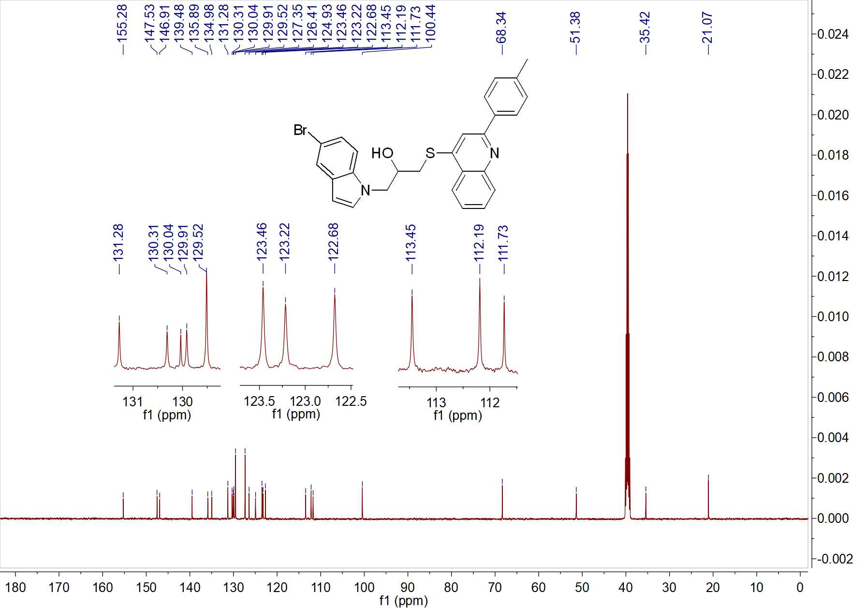

Fig. 30 ¹³C NMR spectrum of W10

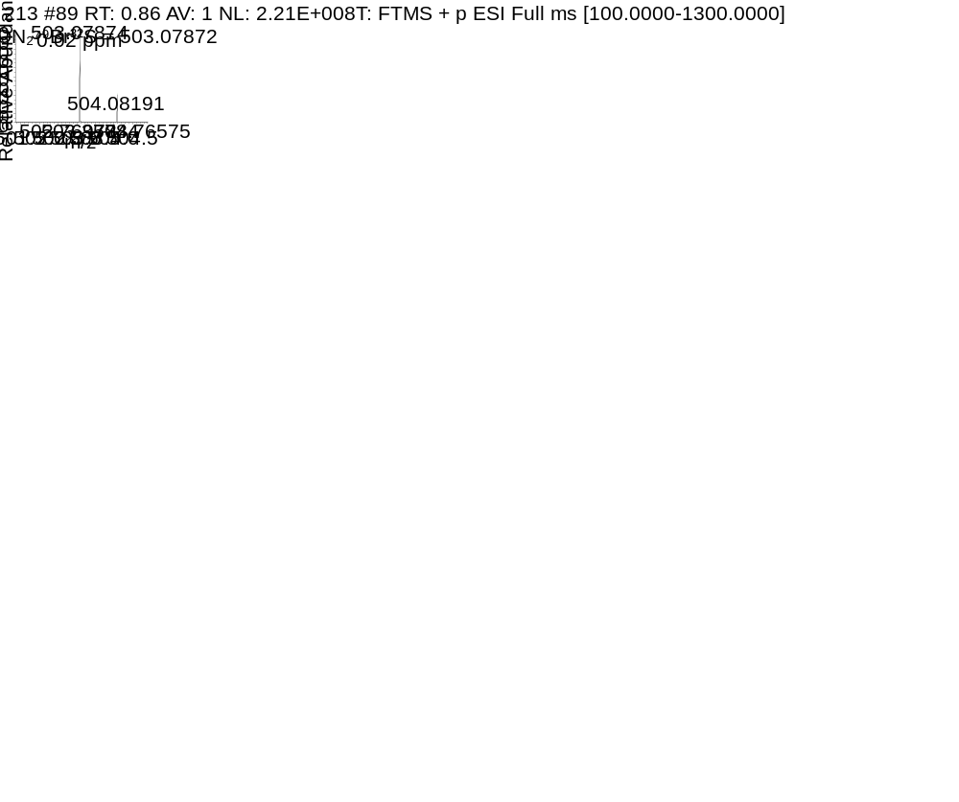

Fig. 31 HRMS spectrum of W10

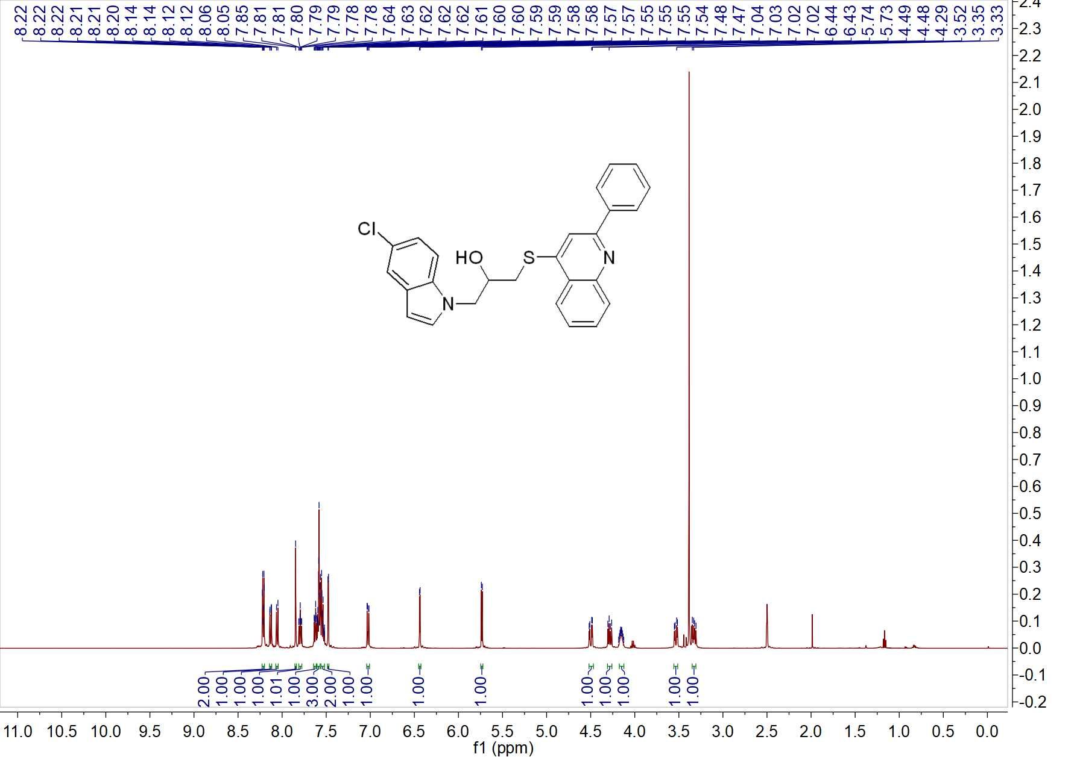

Fig. 32 ¹H NMR spectrum of W11
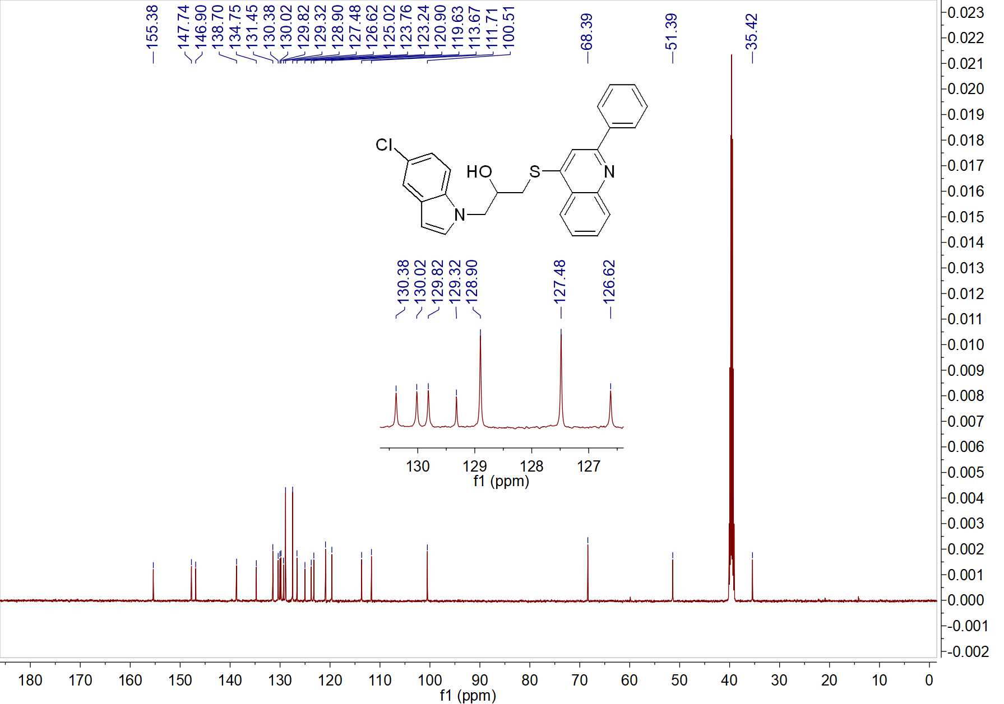

Fig. 33 ¹³C NMR spectrum of W11

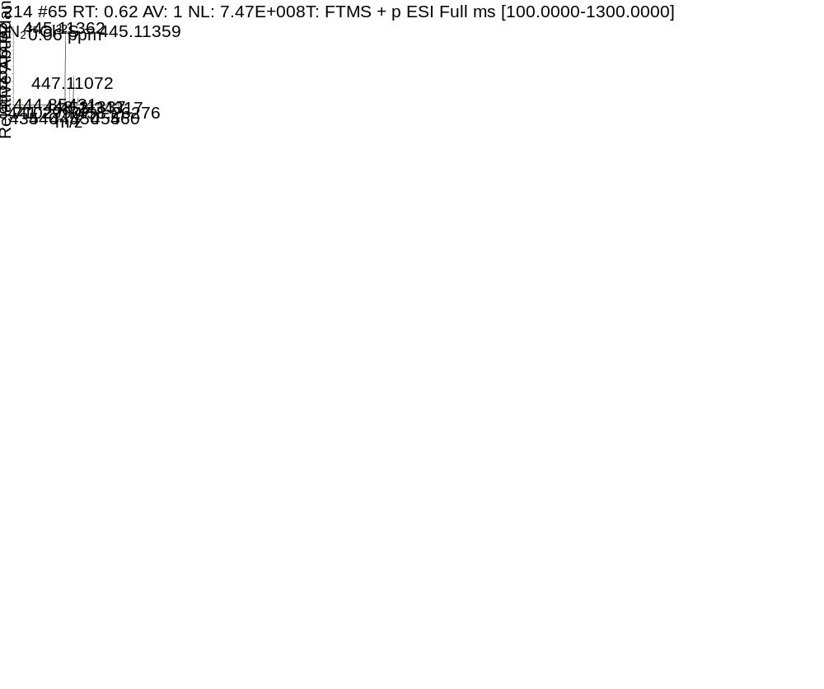

Fig. 34 HRMS spectrum of W11
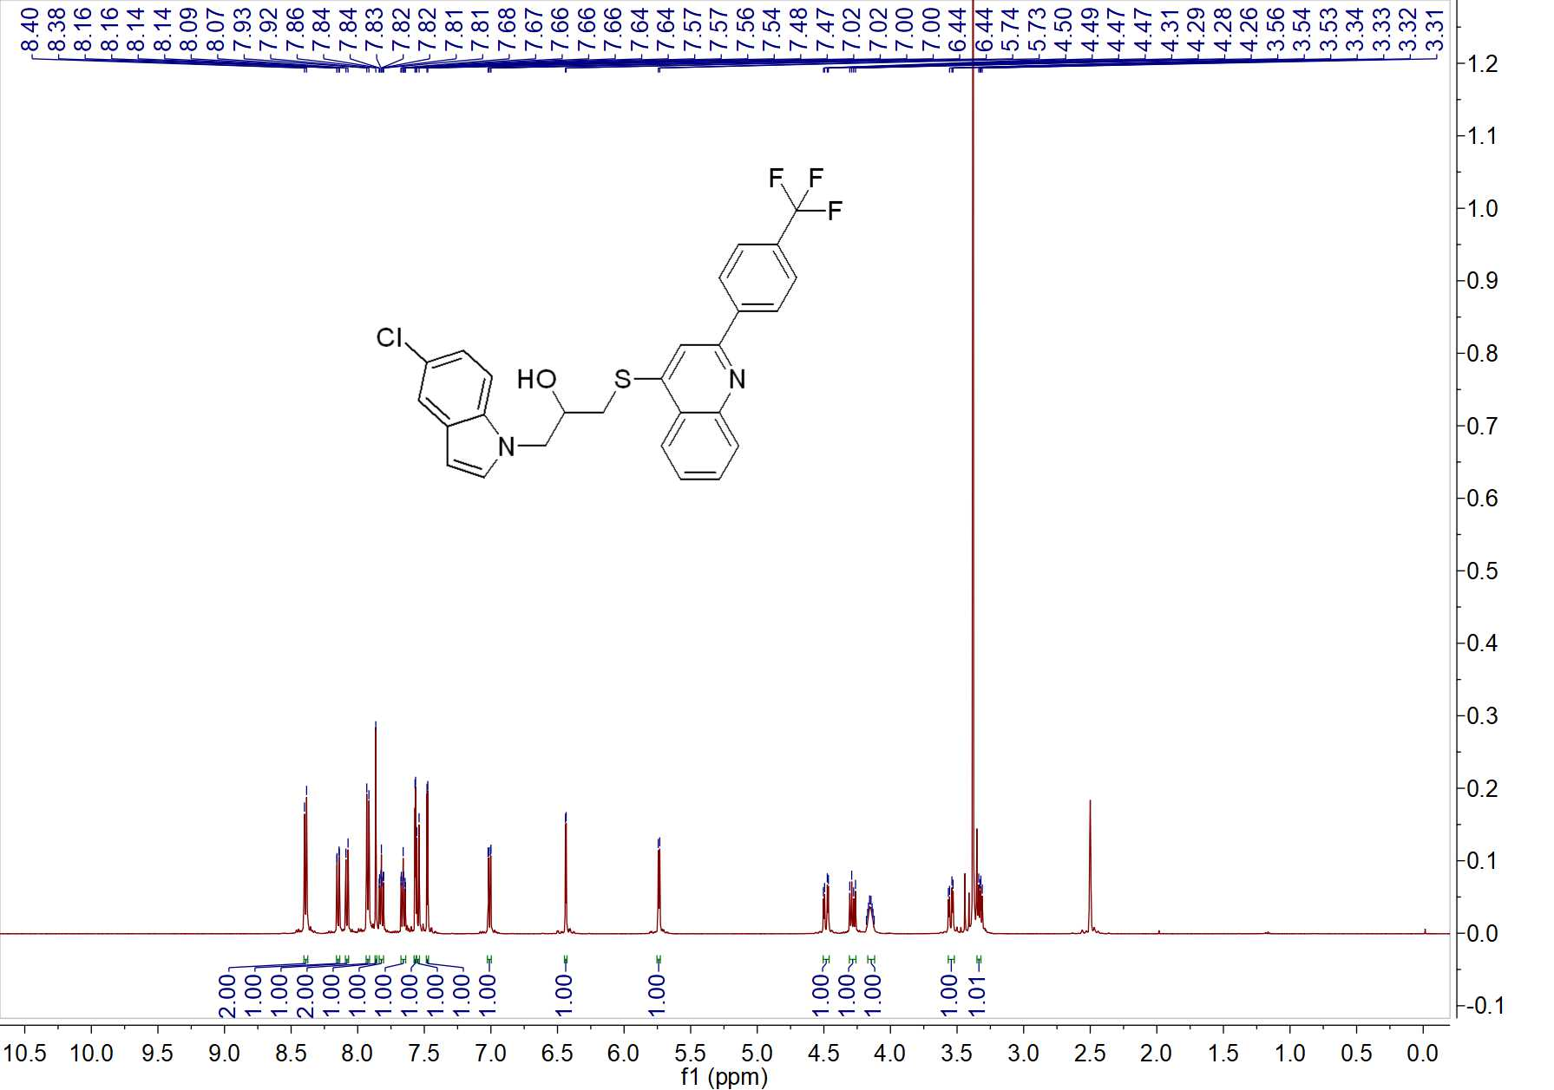

Fig. 35 ¹H NMR spectrum of W12
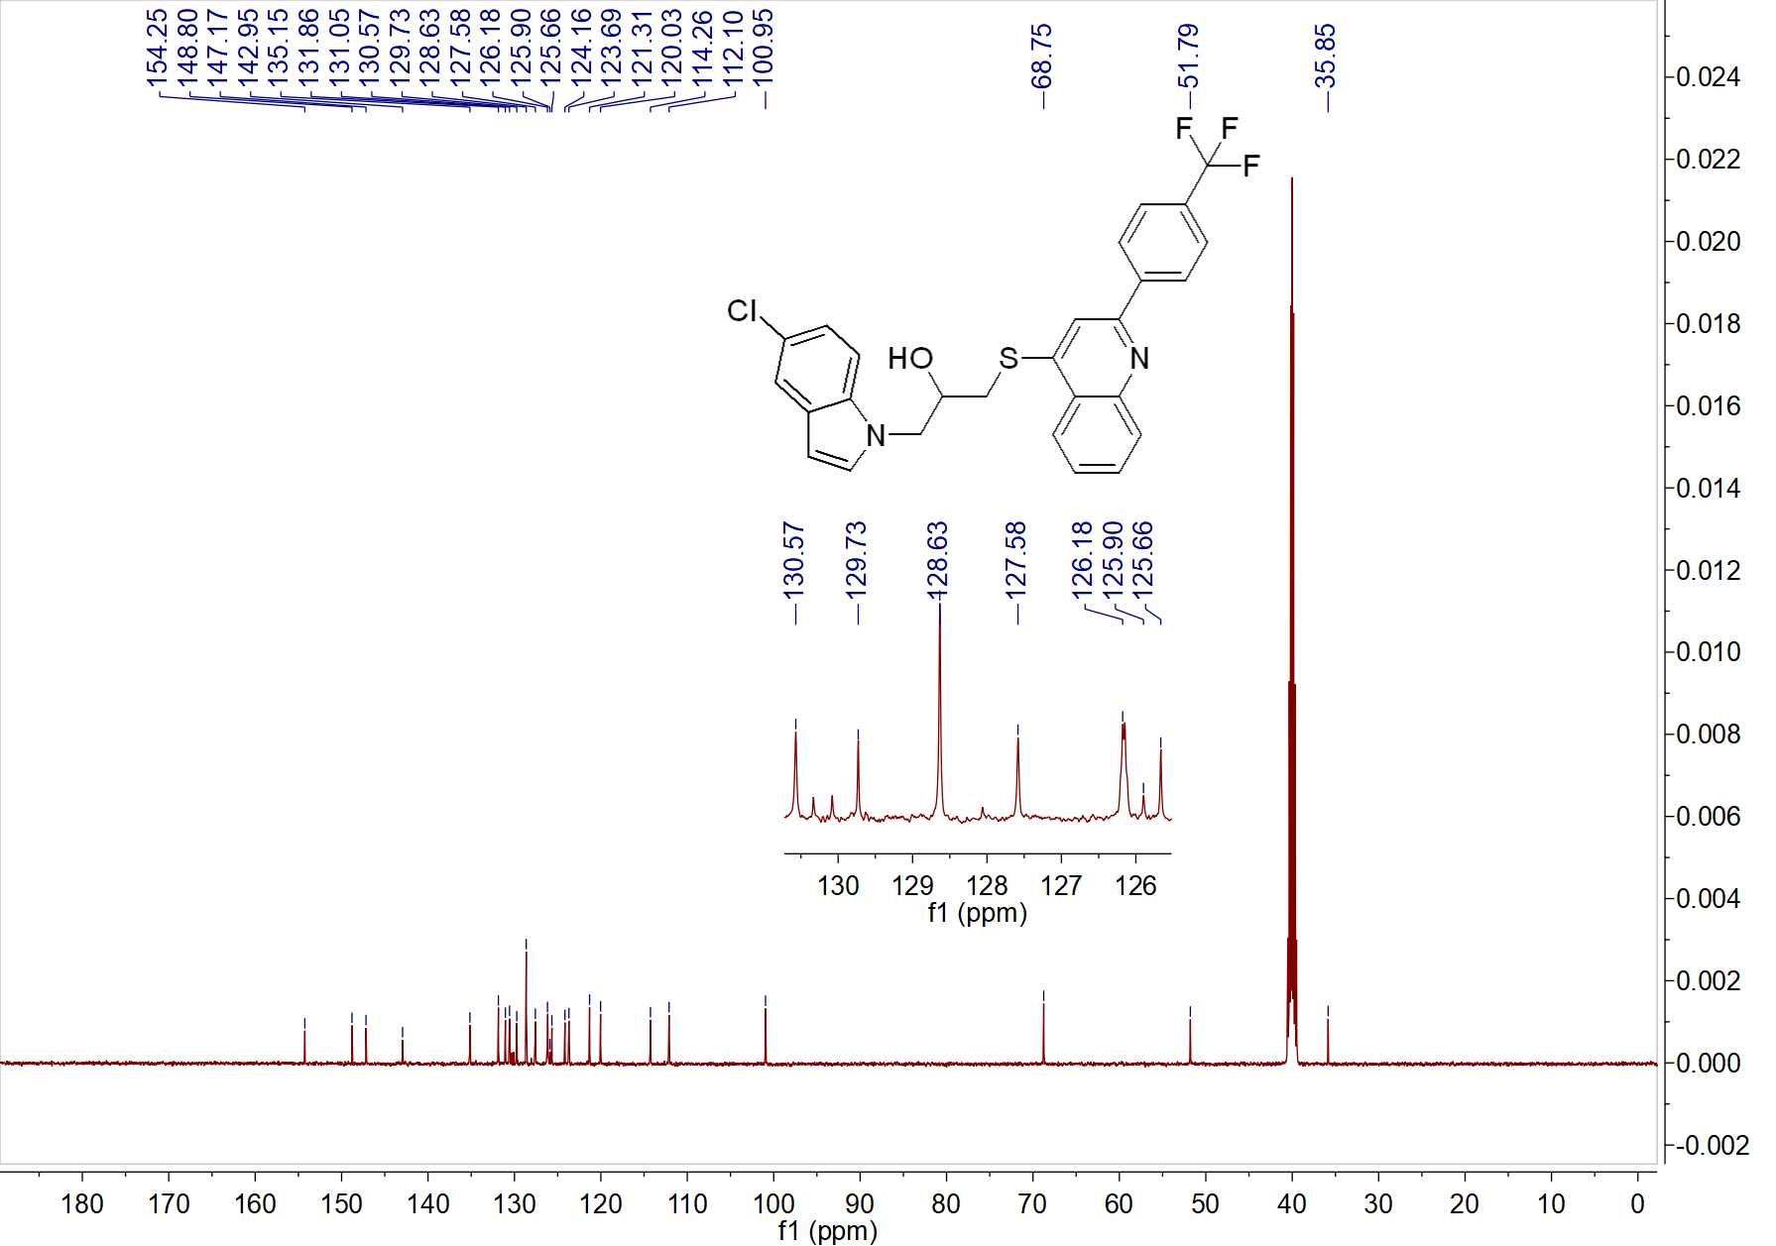

Fig. 36 ¹³C NMR spectrum of W12

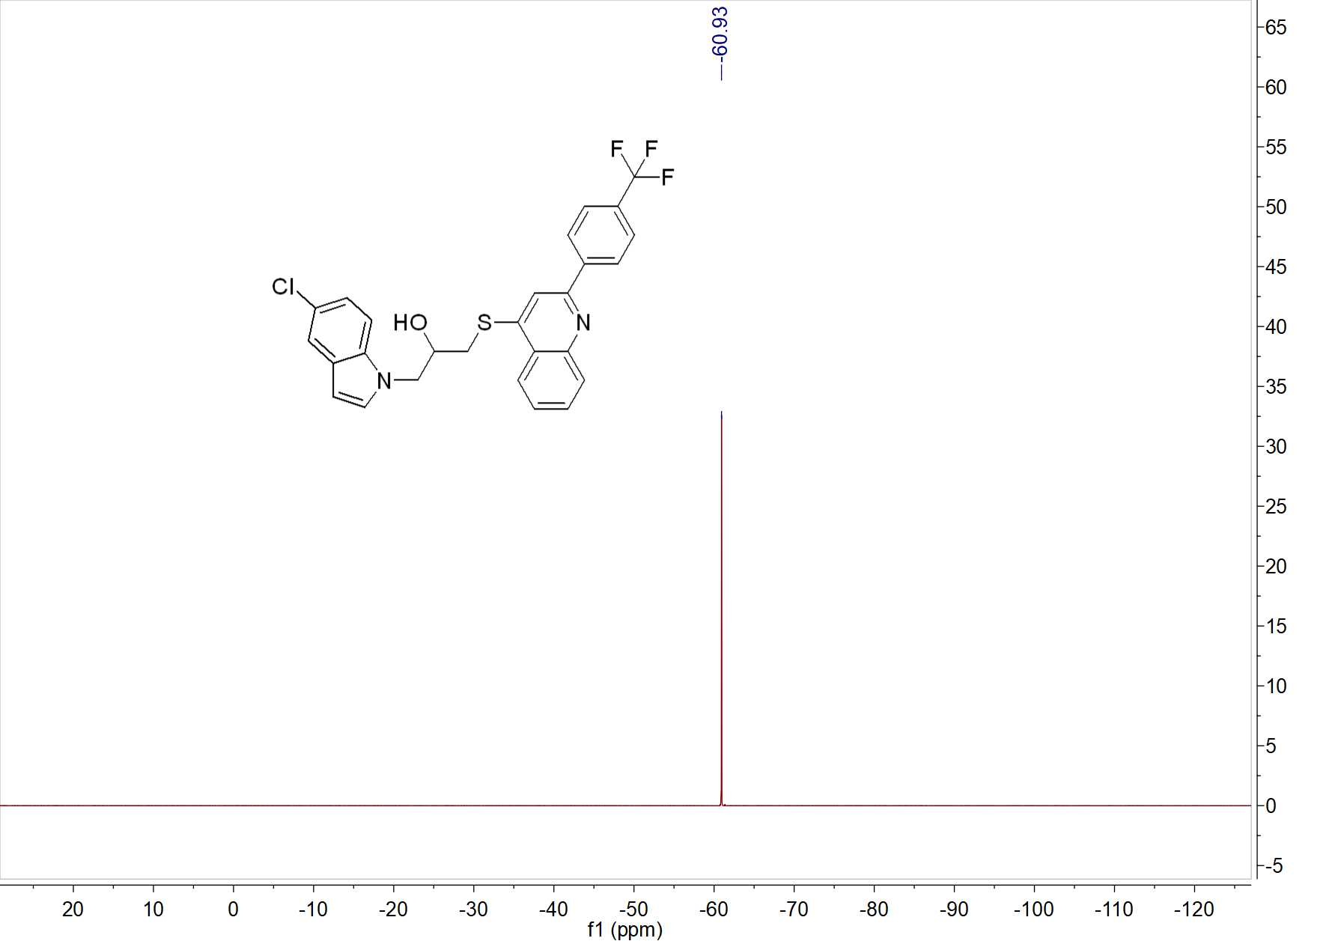

Fig. 37 ¹⁹F NMR spectrum of W12

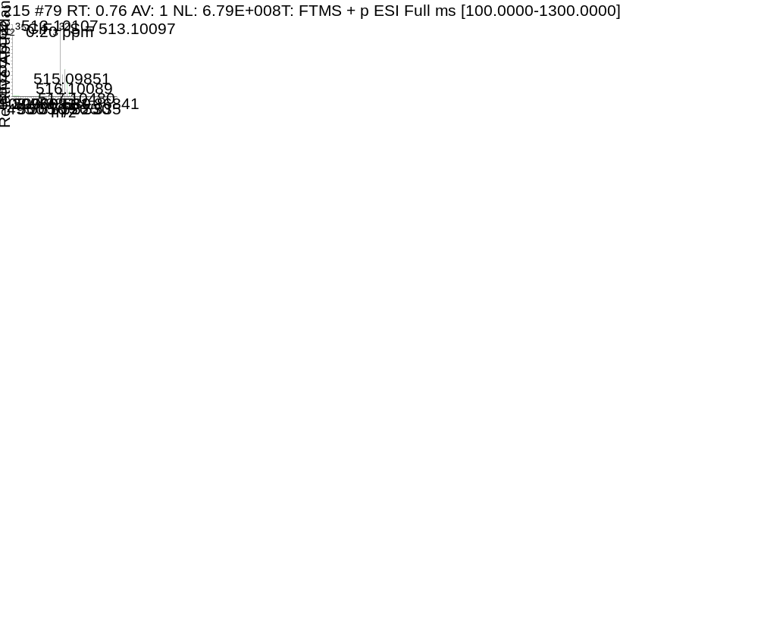

Fig. 38 HRMS spectrum of W12

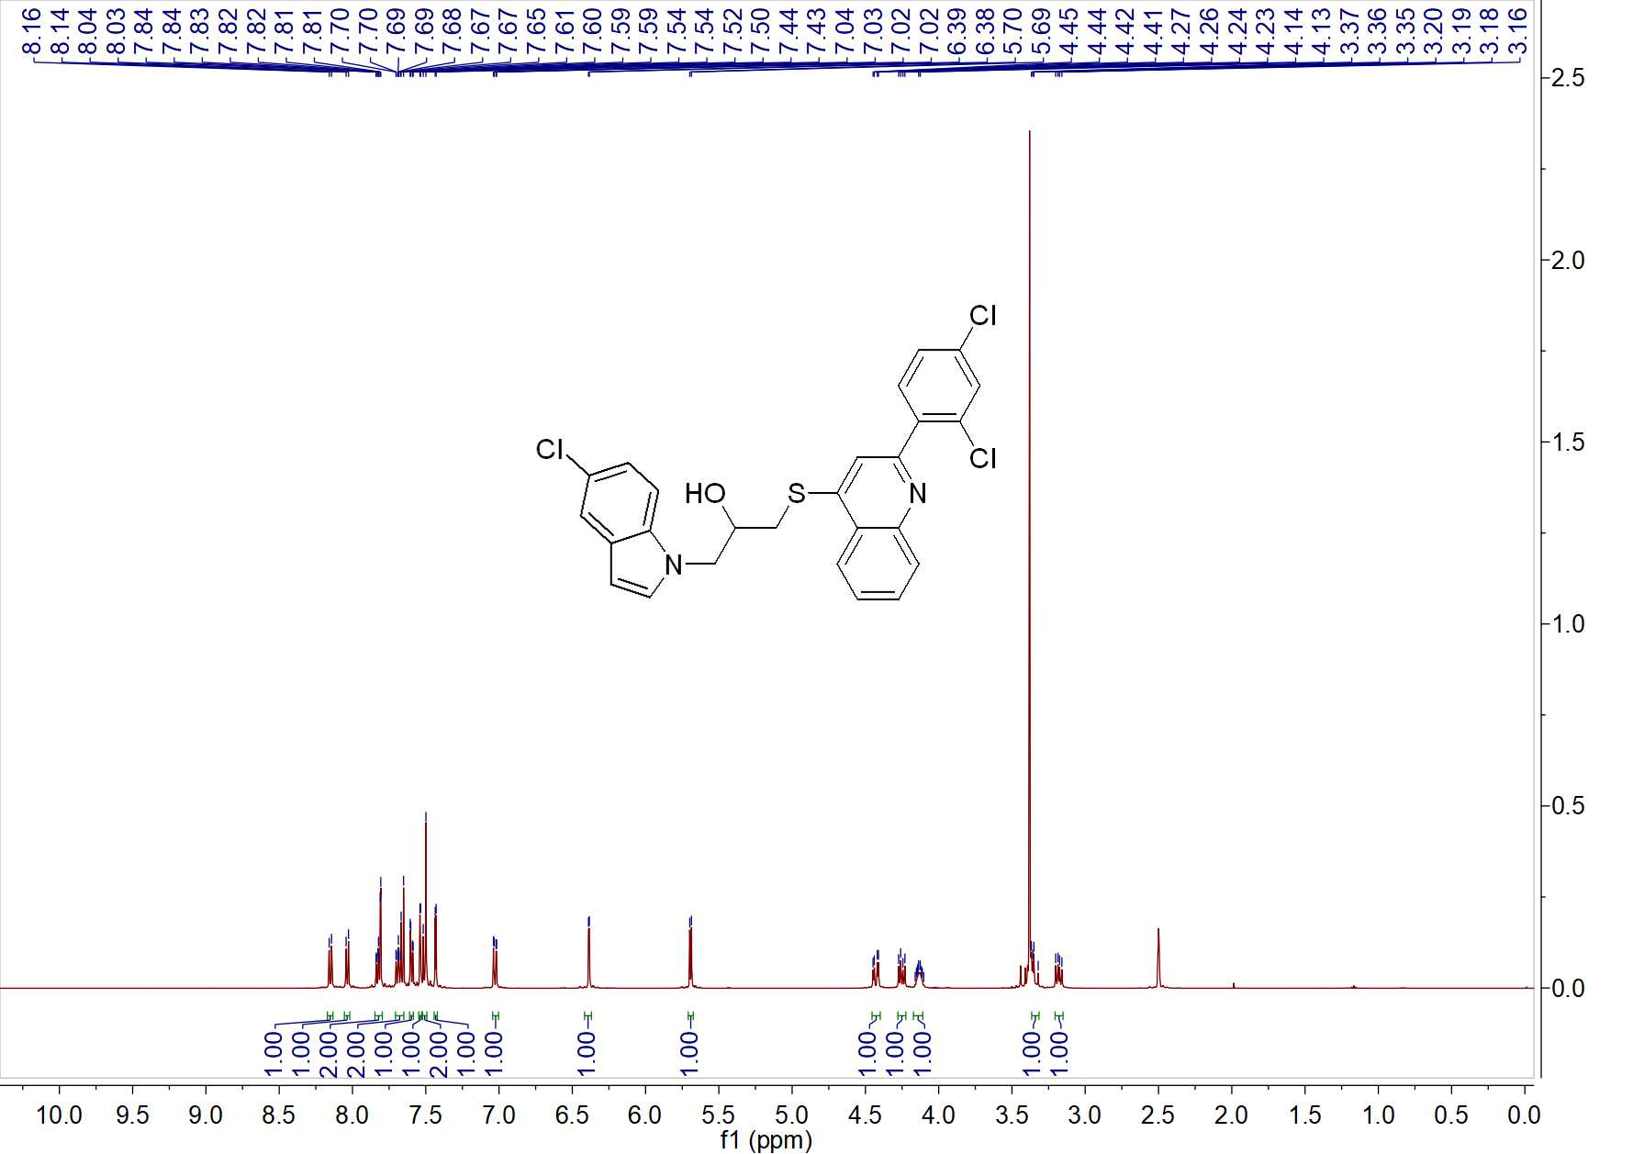

Fig. 39 ¹H NMR spectrum of W13

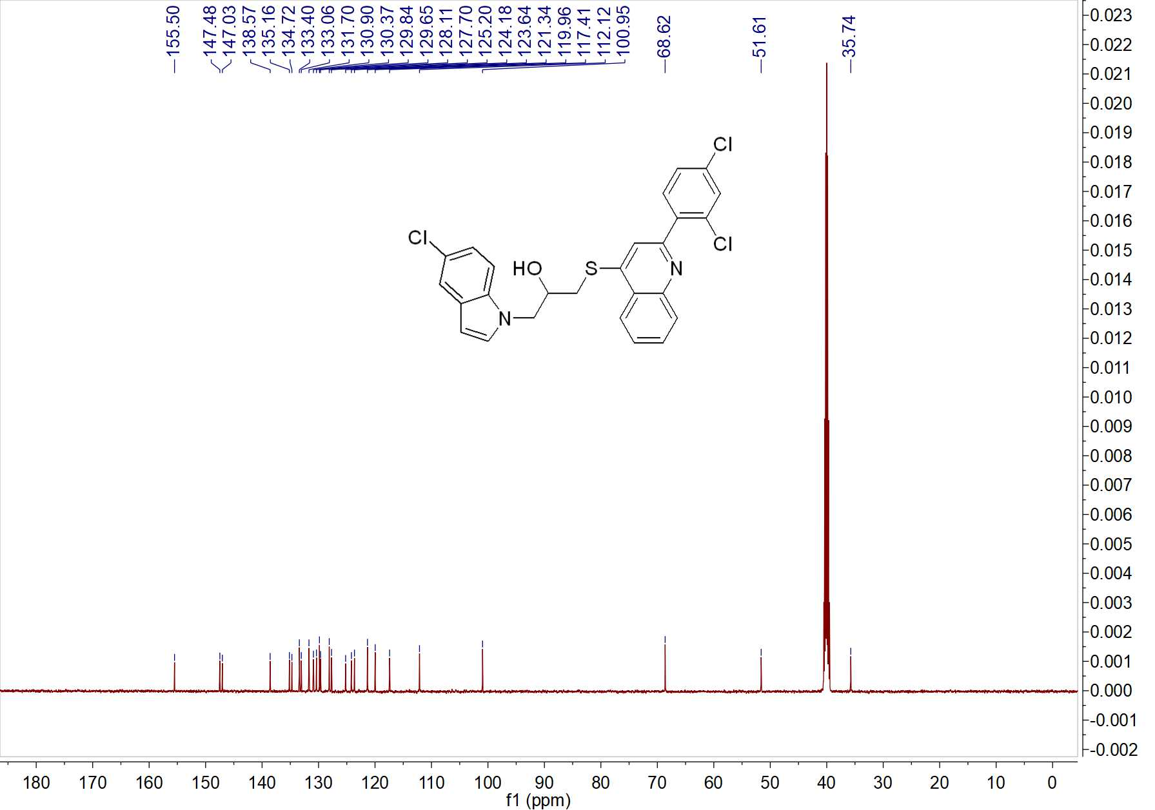

Fig. 40 ¹³C NMR spectrum of W13

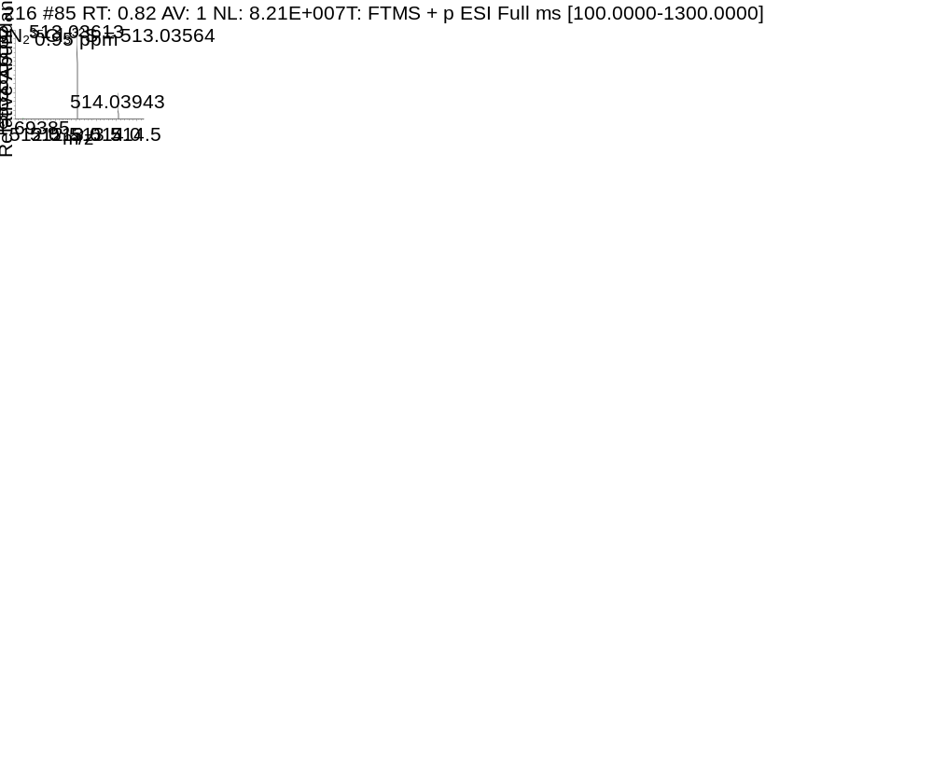

Fig. 41 HRMS spectrum of W13

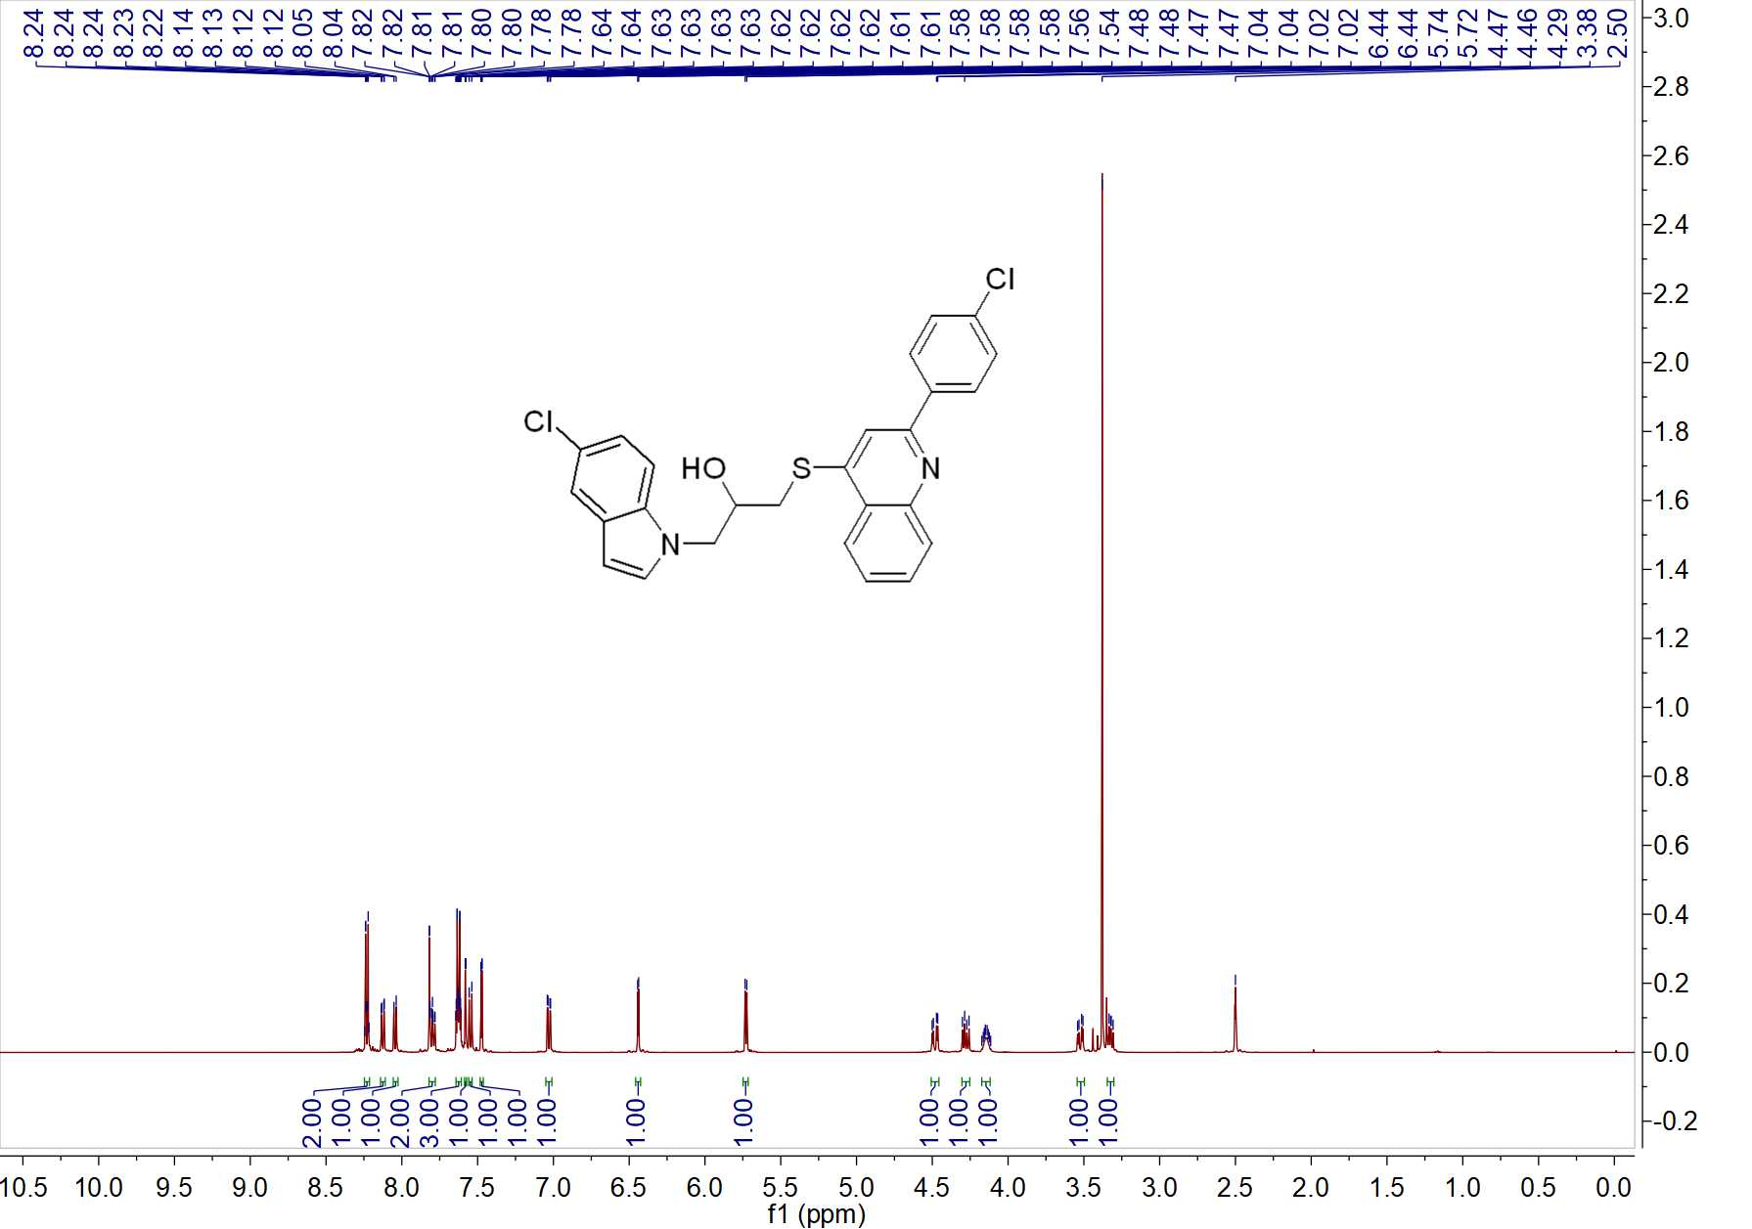

Fig. 42 ¹H NMR spectrum of W14

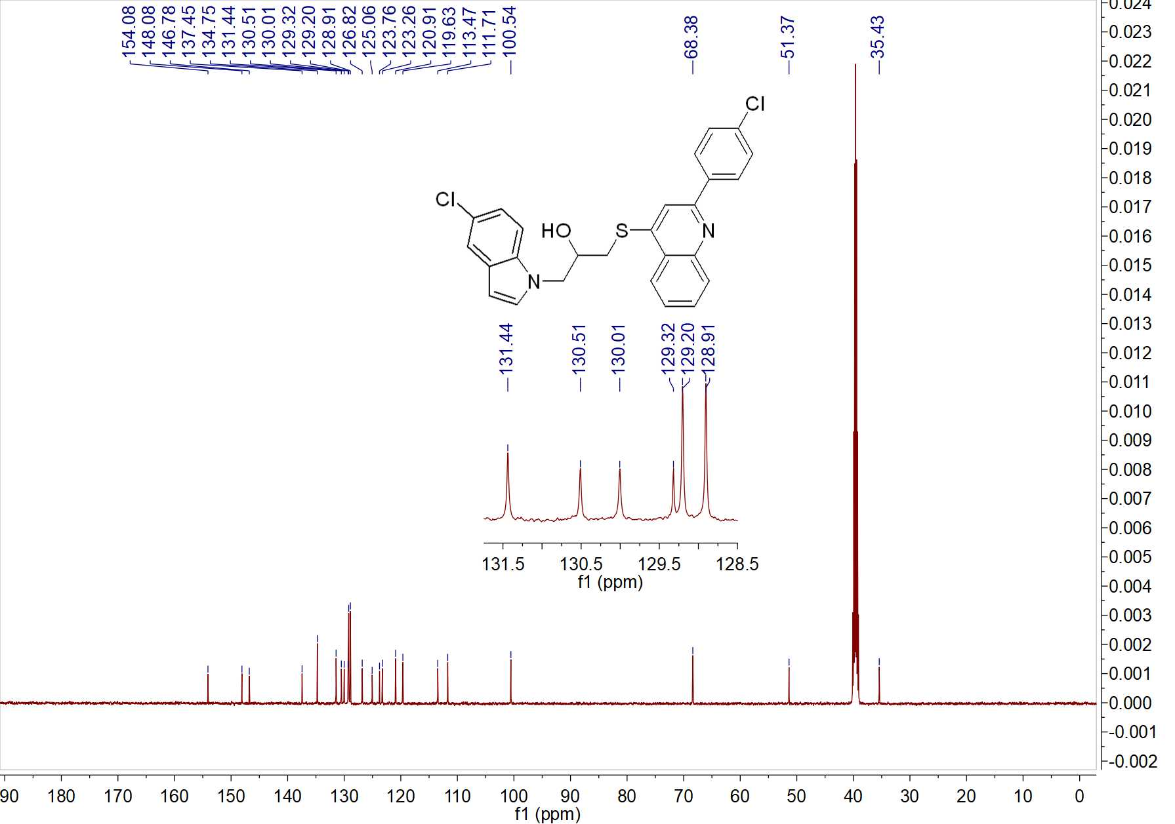

Fig. 43 ¹³C NMR spectrum of W14

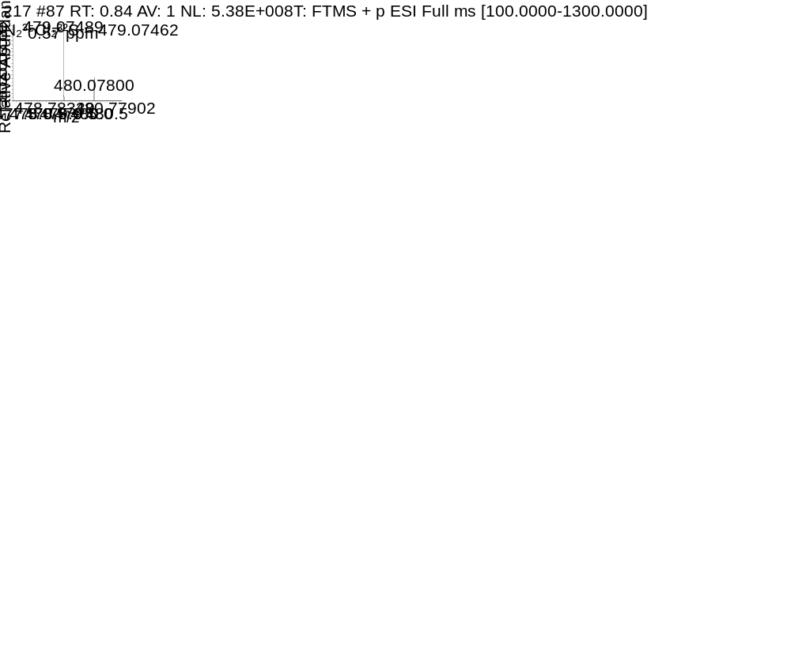

Fig. 44 HRMS spectrum of W14

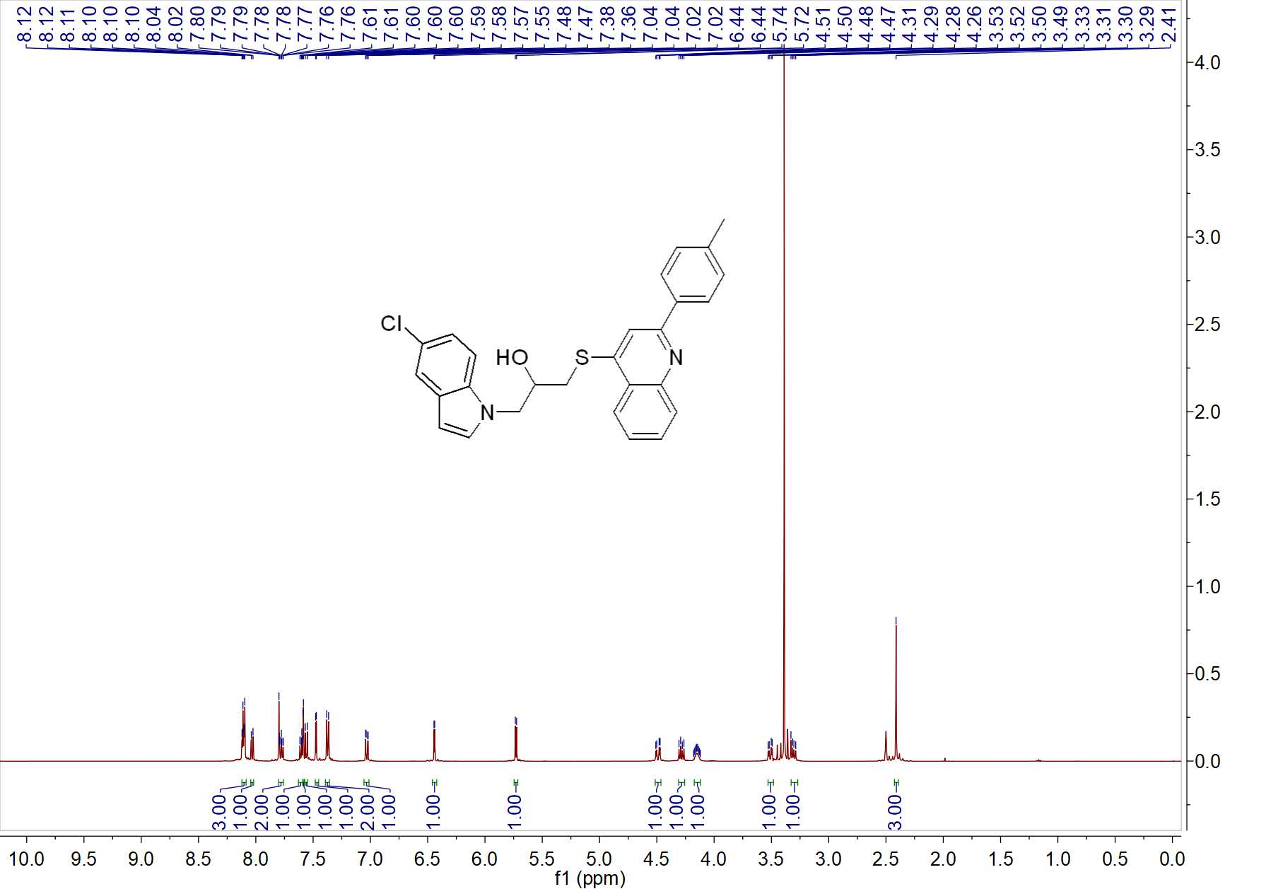

Fig. 45 ¹H NMR spectrum of W15

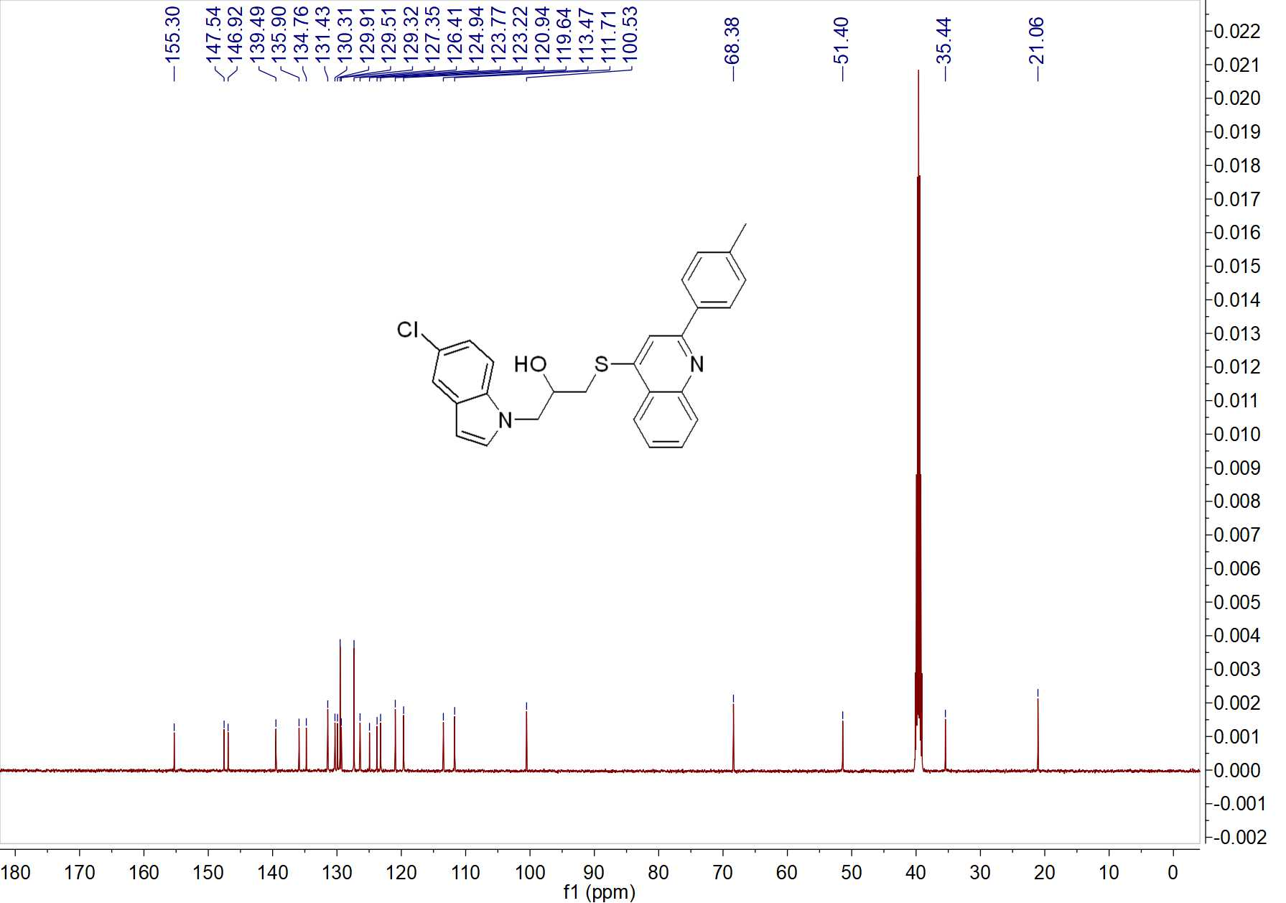

Fig. 46 ¹³C NMR spectrum of W15

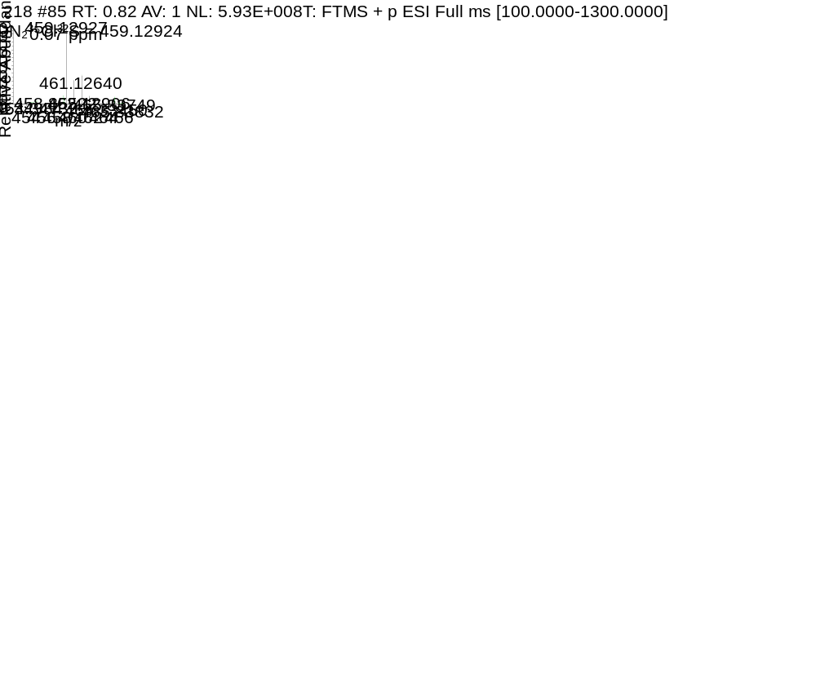

Fig. 47 HRMS spectrum of W15

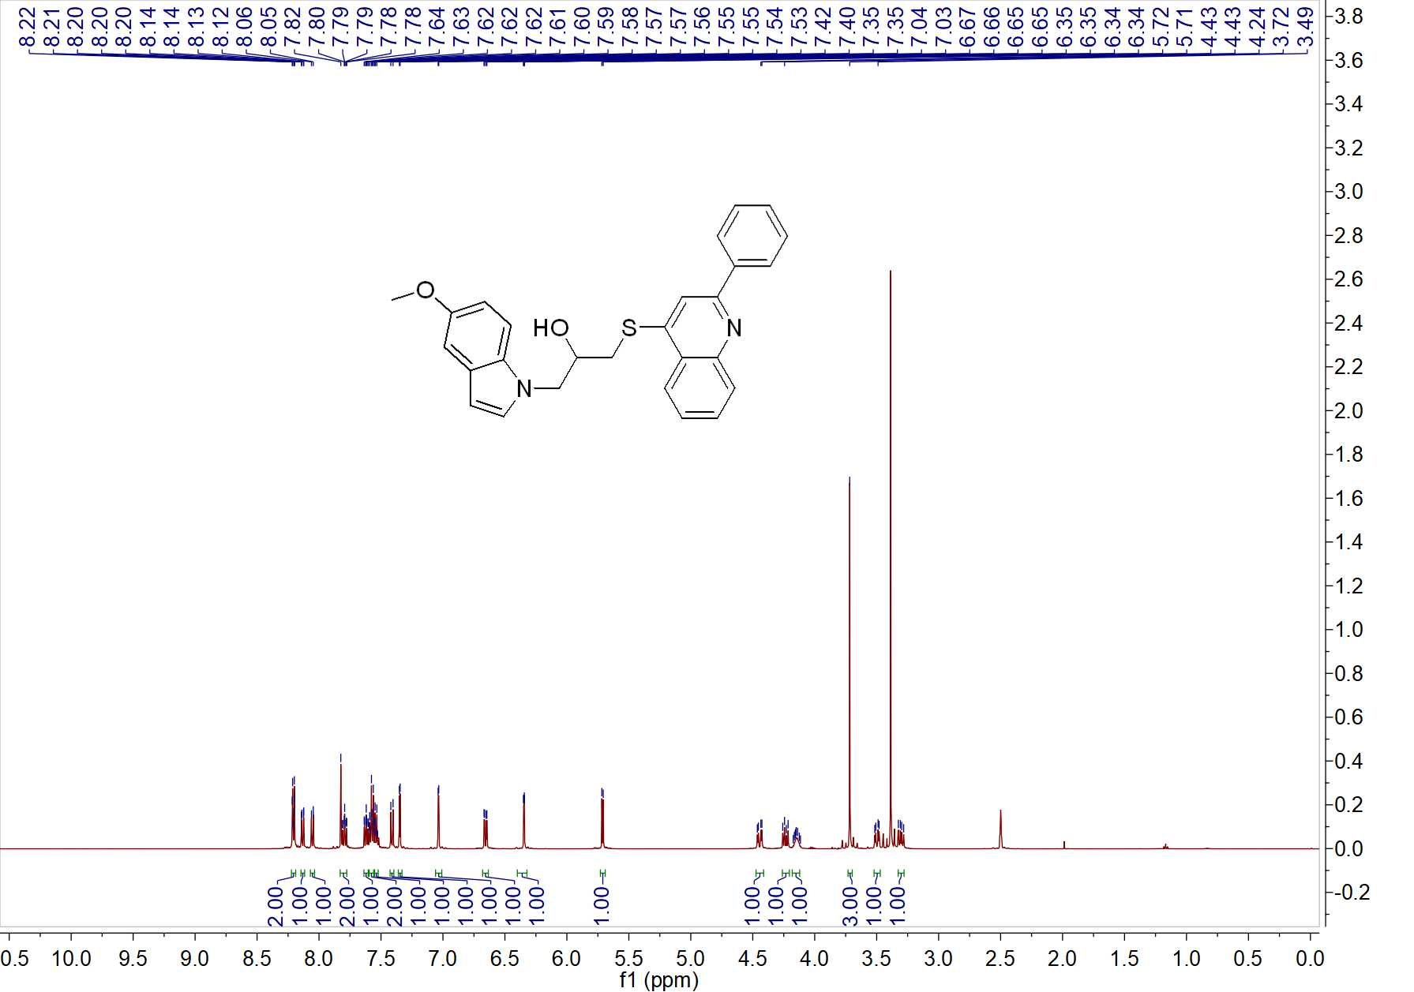

Fig. 48 ¹H NMR spectrum of W16

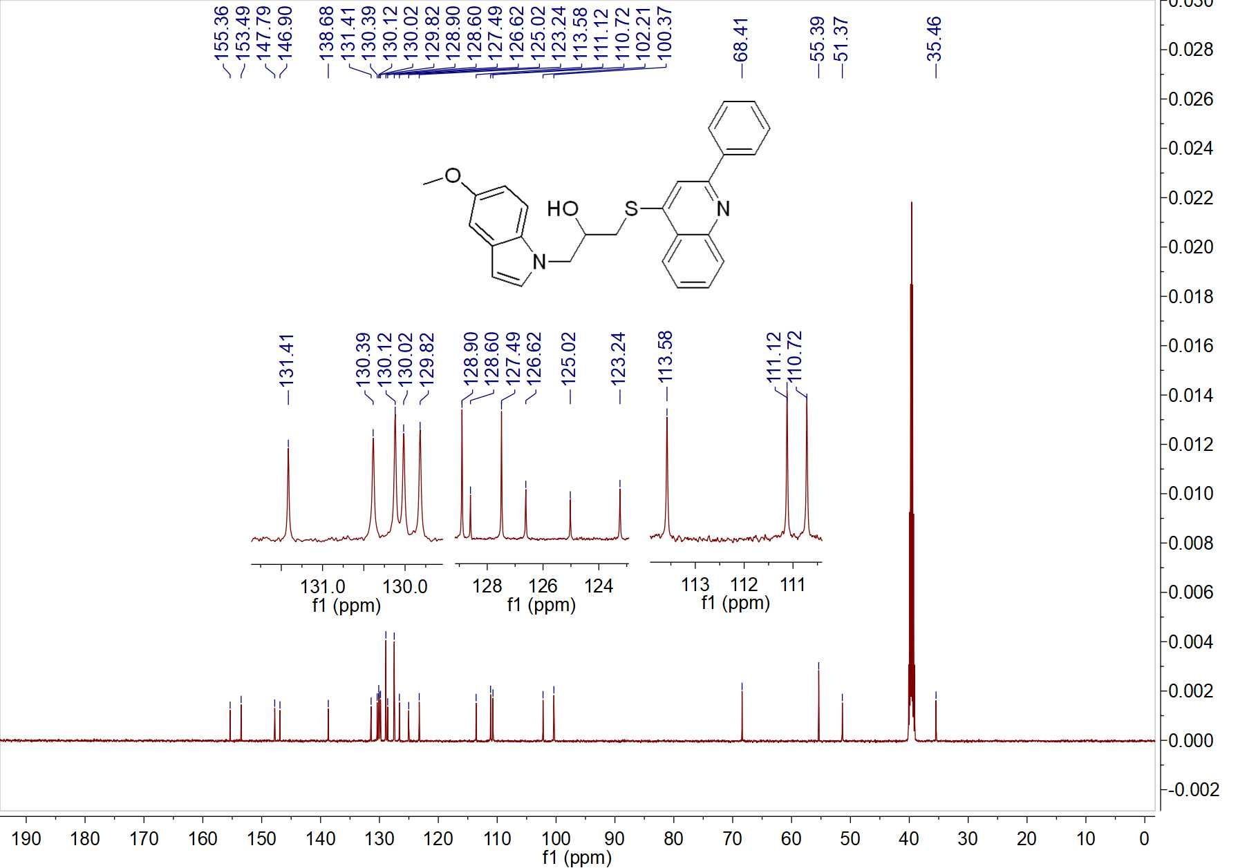

Fig. 49 ¹³C NMR spectrum of W16

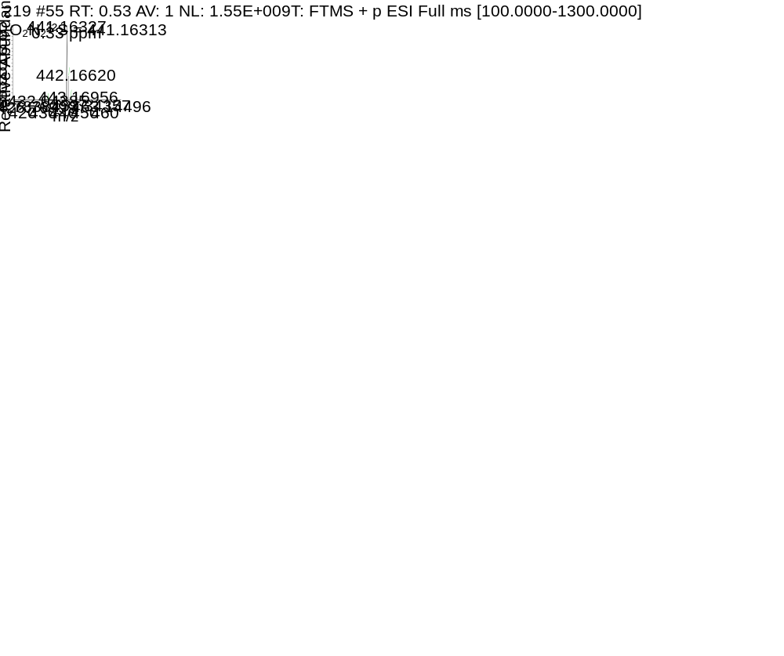

Fig. 50 HRMS spectrum of W16

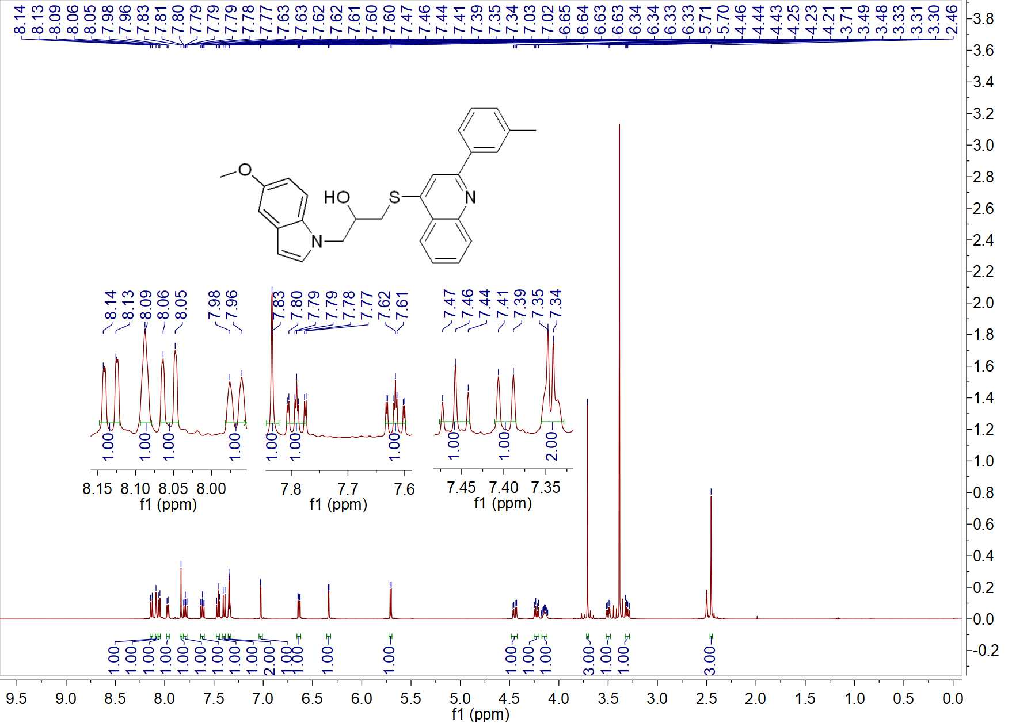

Fig. 51 ¹H NMR spectrum of W17

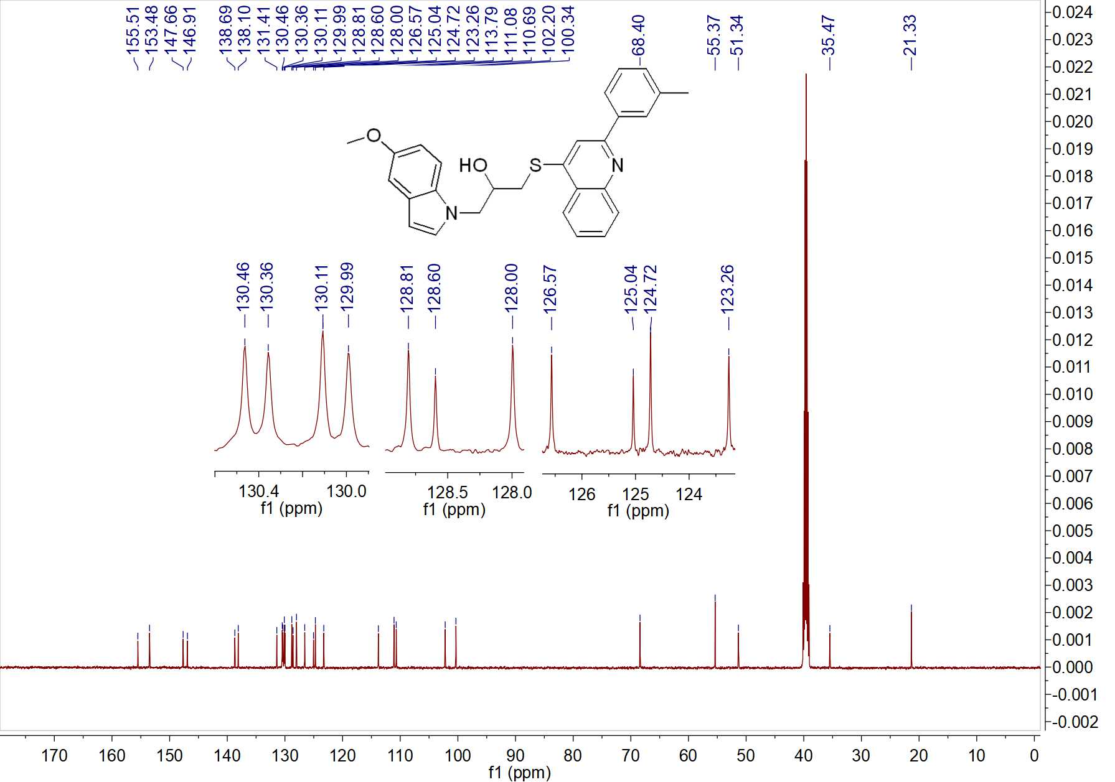

Fig. 52 ¹³C NMR spectrum of W17

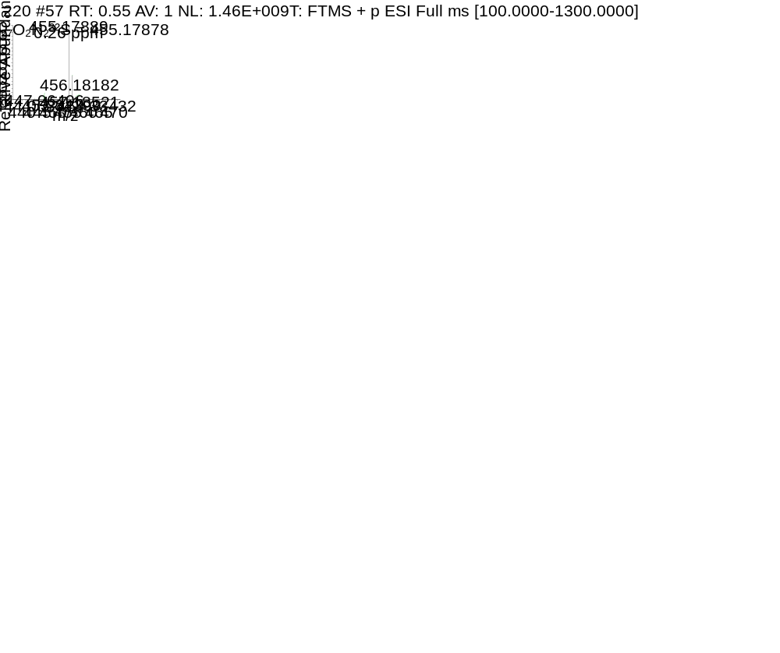

Fig. 53 HRMS spectrum of W17

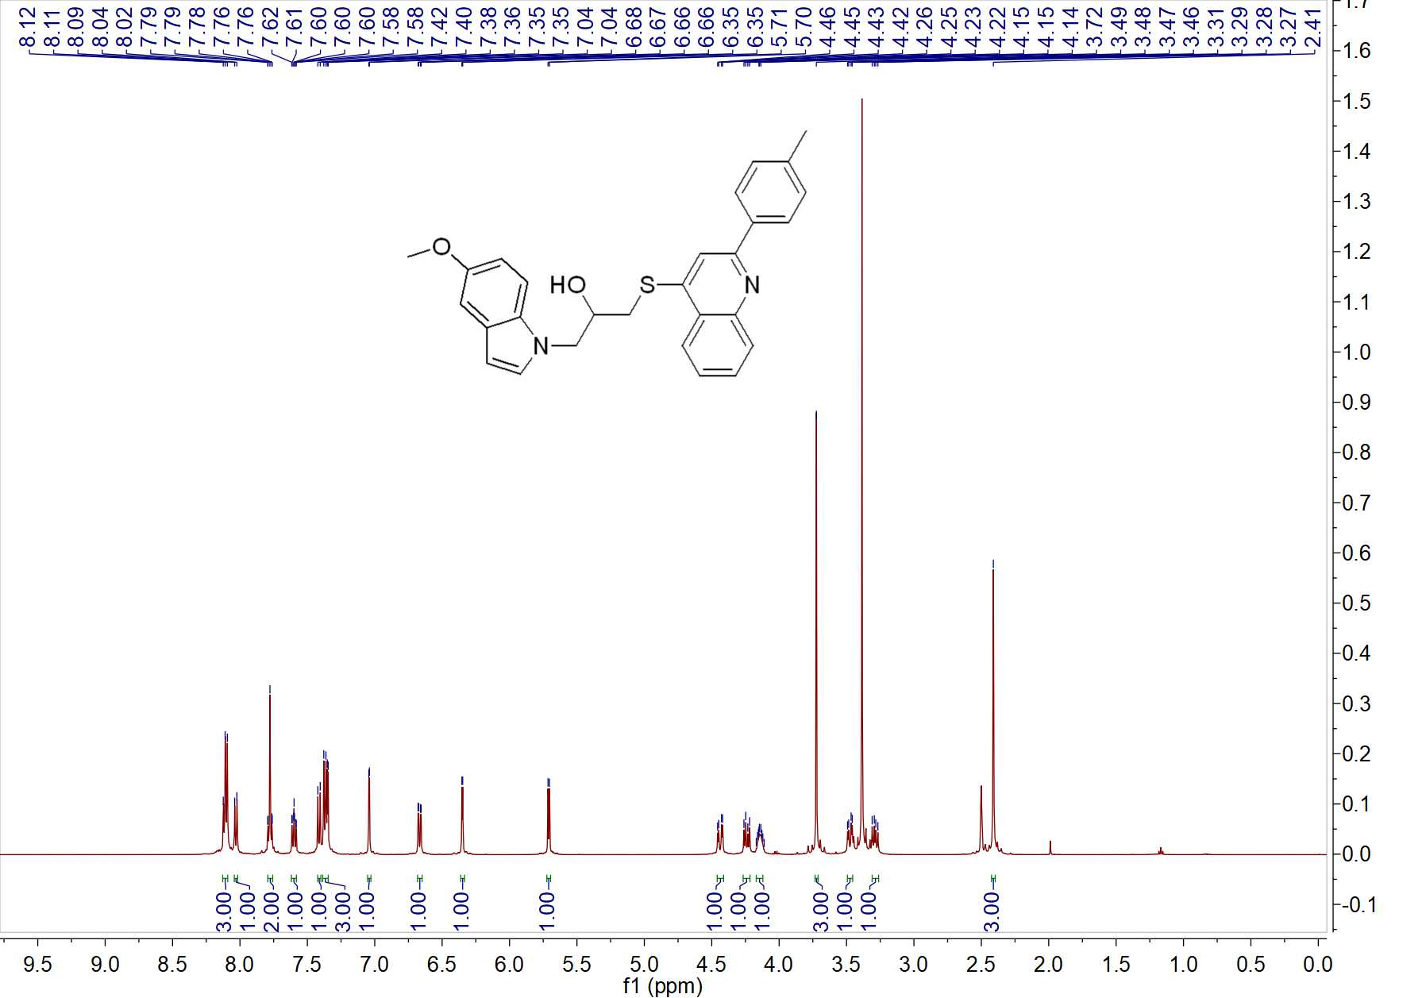

Fig. 54 ¹H NMR spectrum of W18

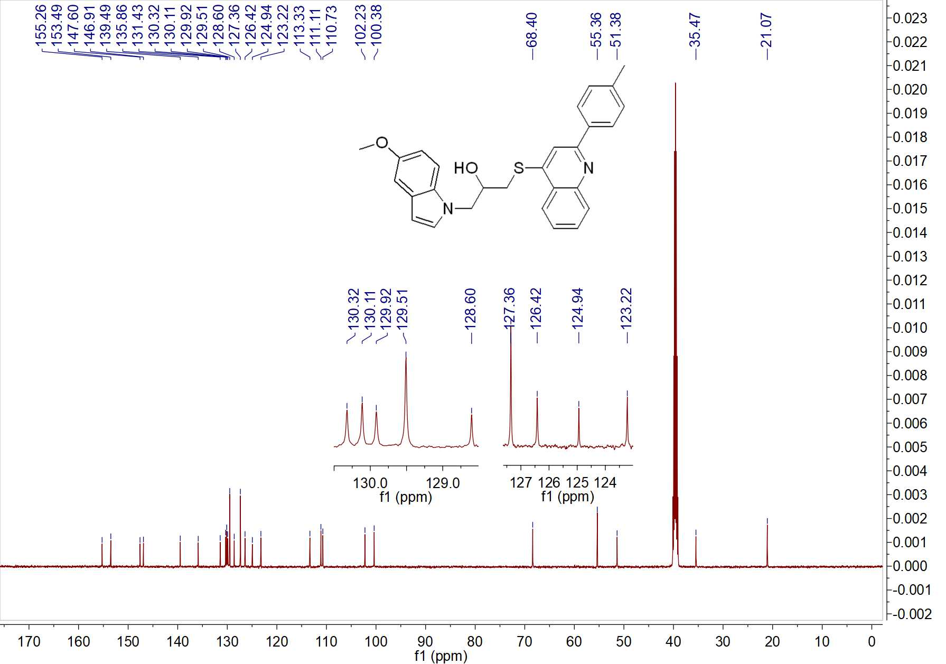

Fig. 55 ¹³C NMR spectrum of W18

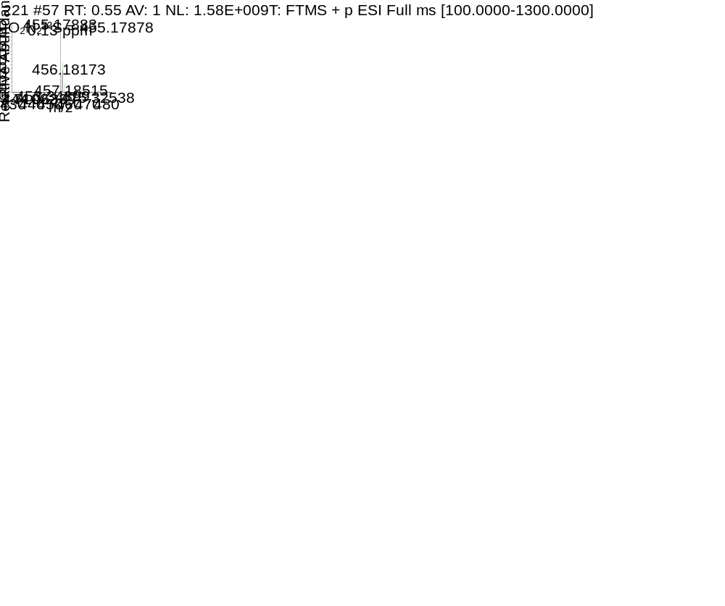

Fig. 56 HRMS spectrum of W18

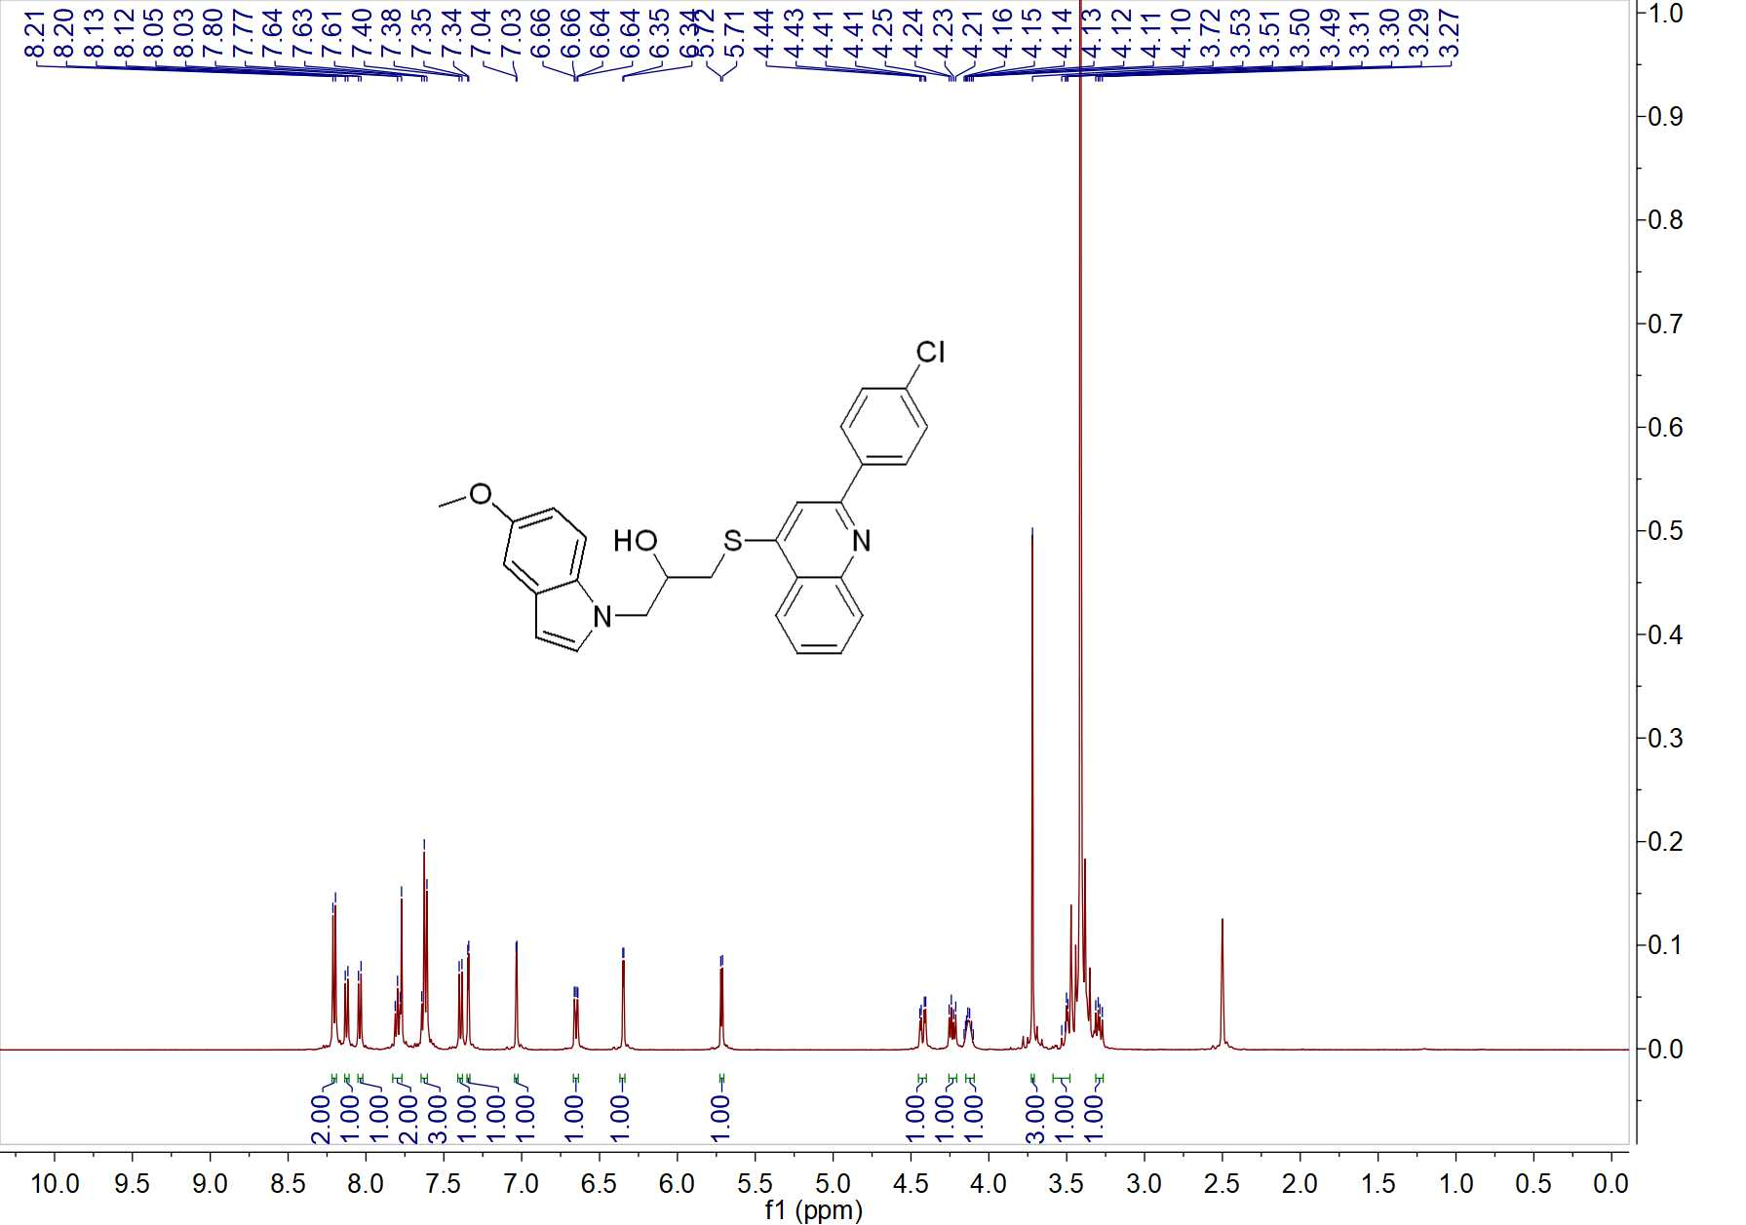

Fig. 57 ¹³C NMR spectrum of W19

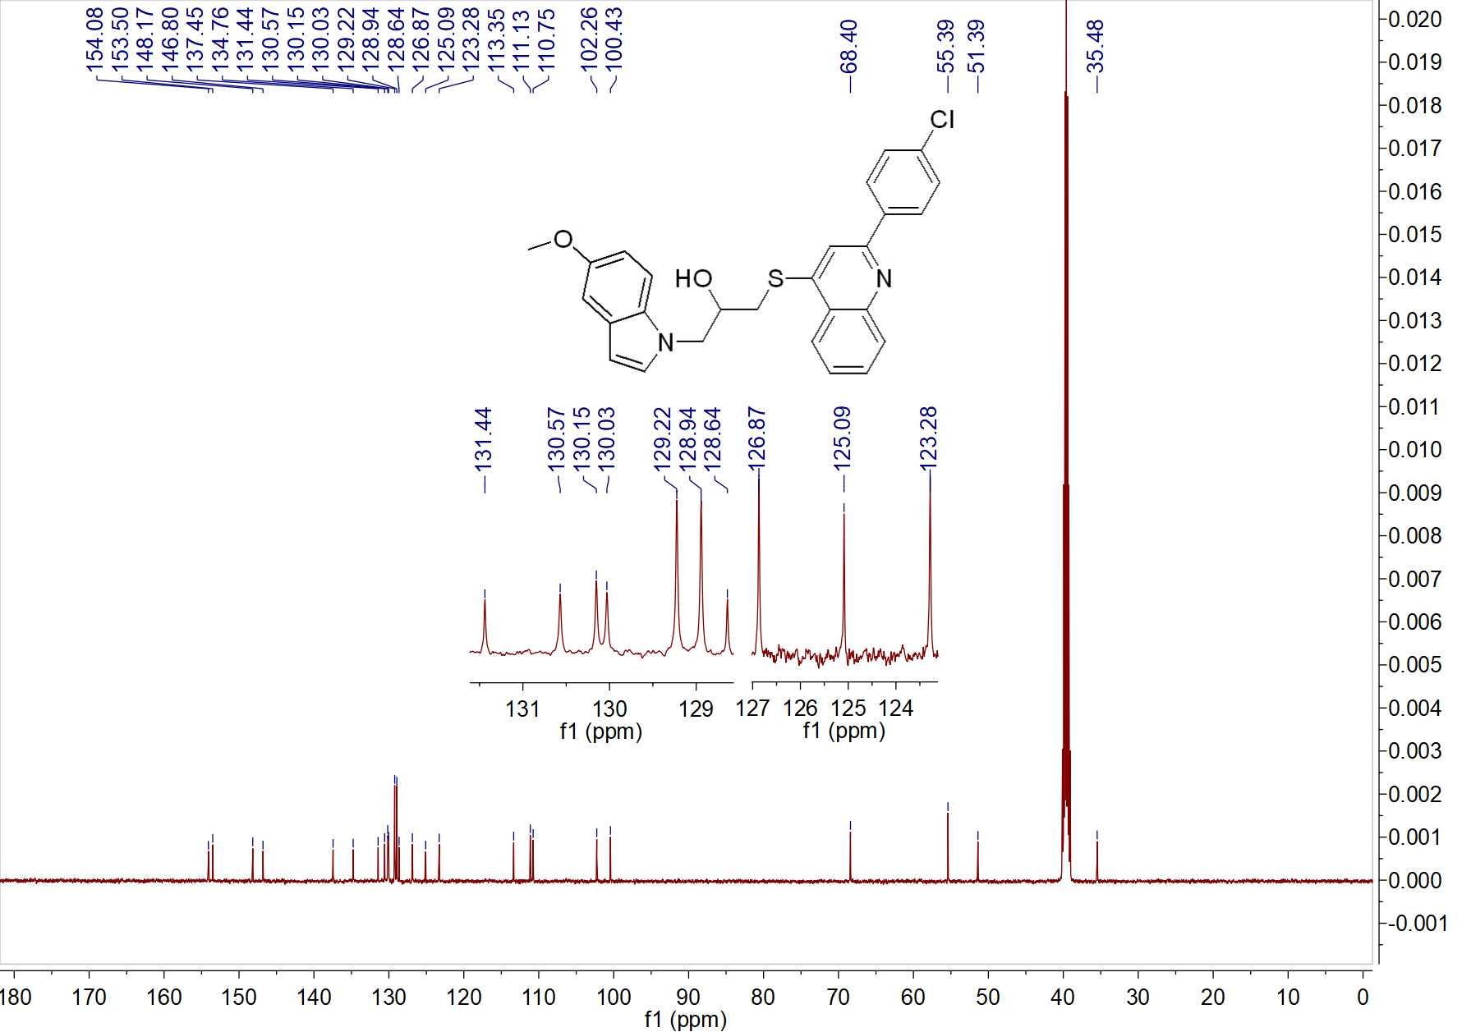

Fig. 58 ¹³C NMR spectrum of W19

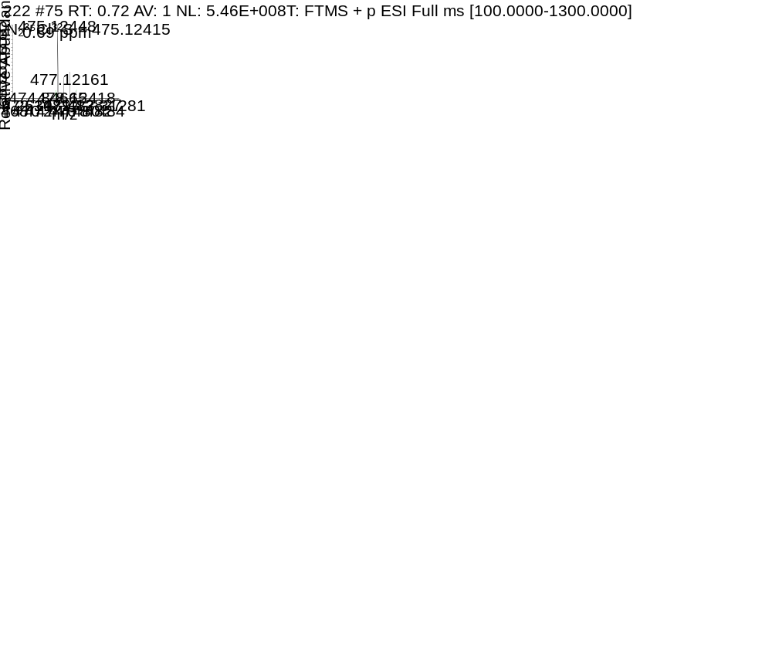

Fig. 59 HRMS spectrum of W19

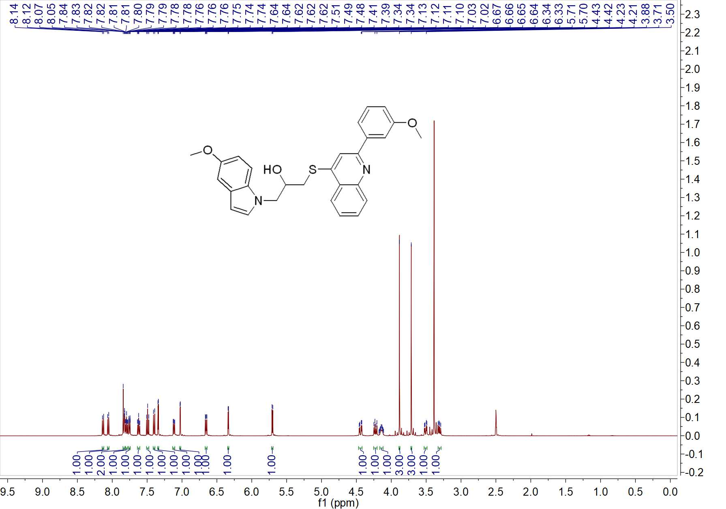

Fig. 60 ¹H NMR spectrum of W20

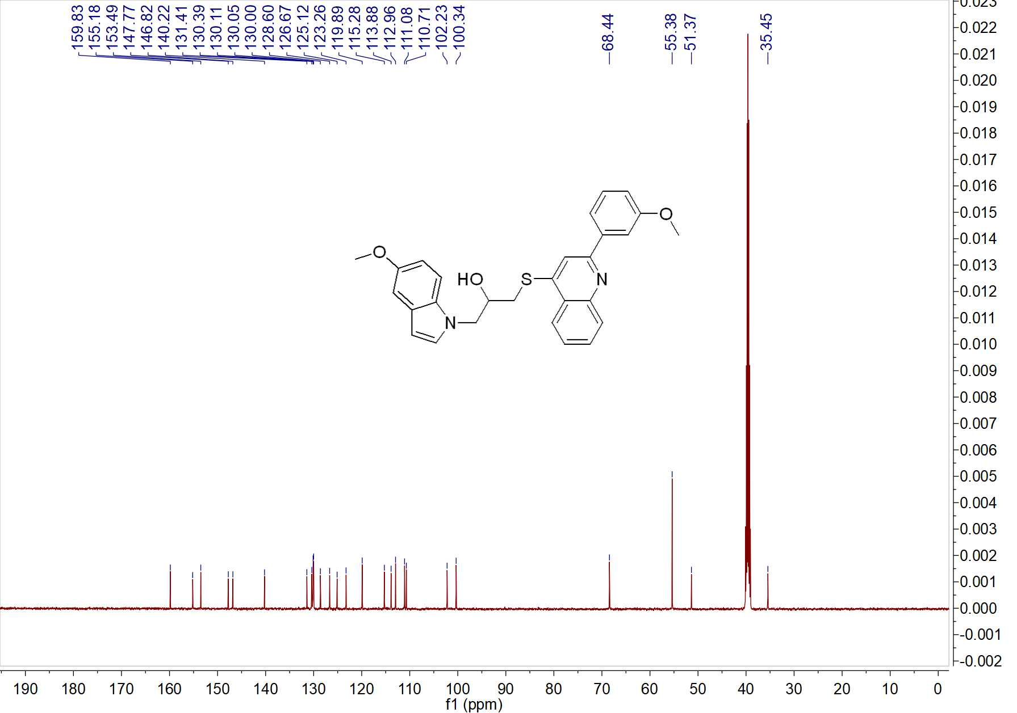

Fig. 61 ¹³C NMR spectrum of W20

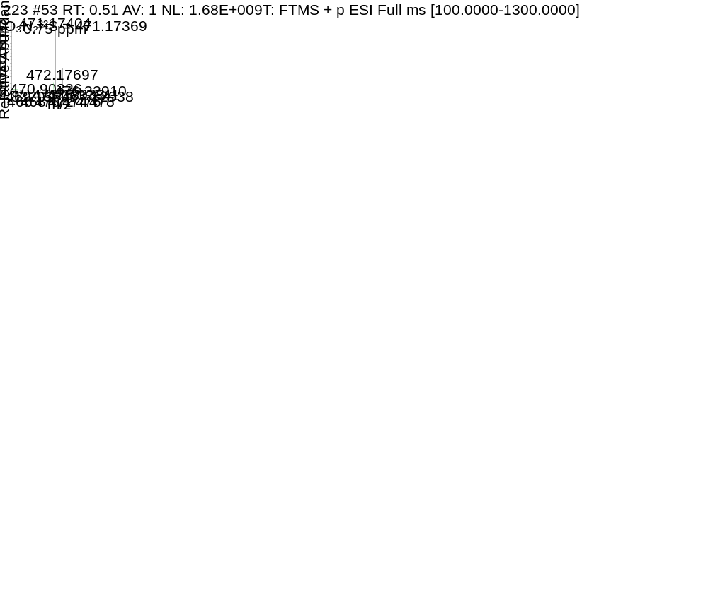

Fig. 62 HRMS spectrum of W20

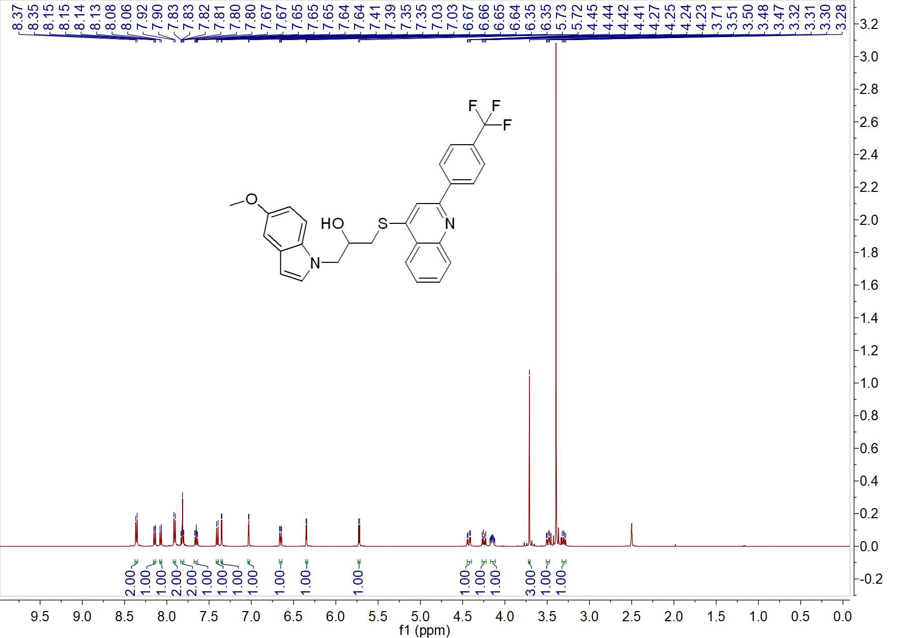

Fig. 63 ¹H NMR spectrum of W21

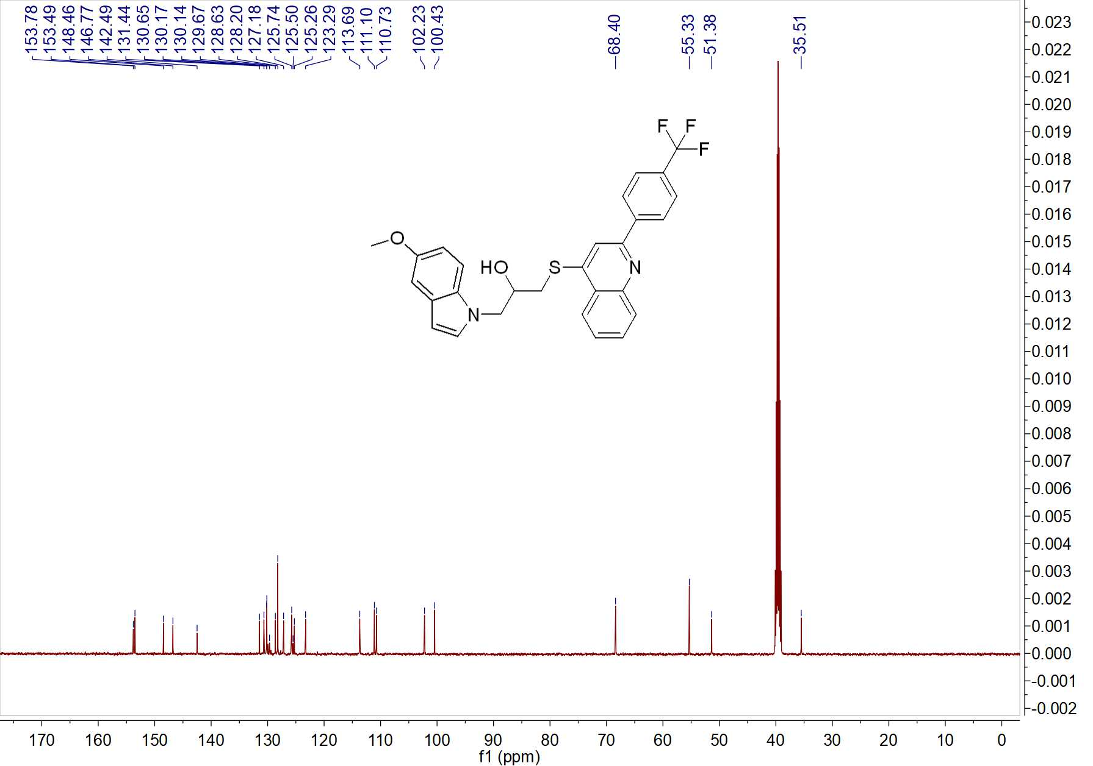

Fig. 64 ¹³C NMR spectrum of W21

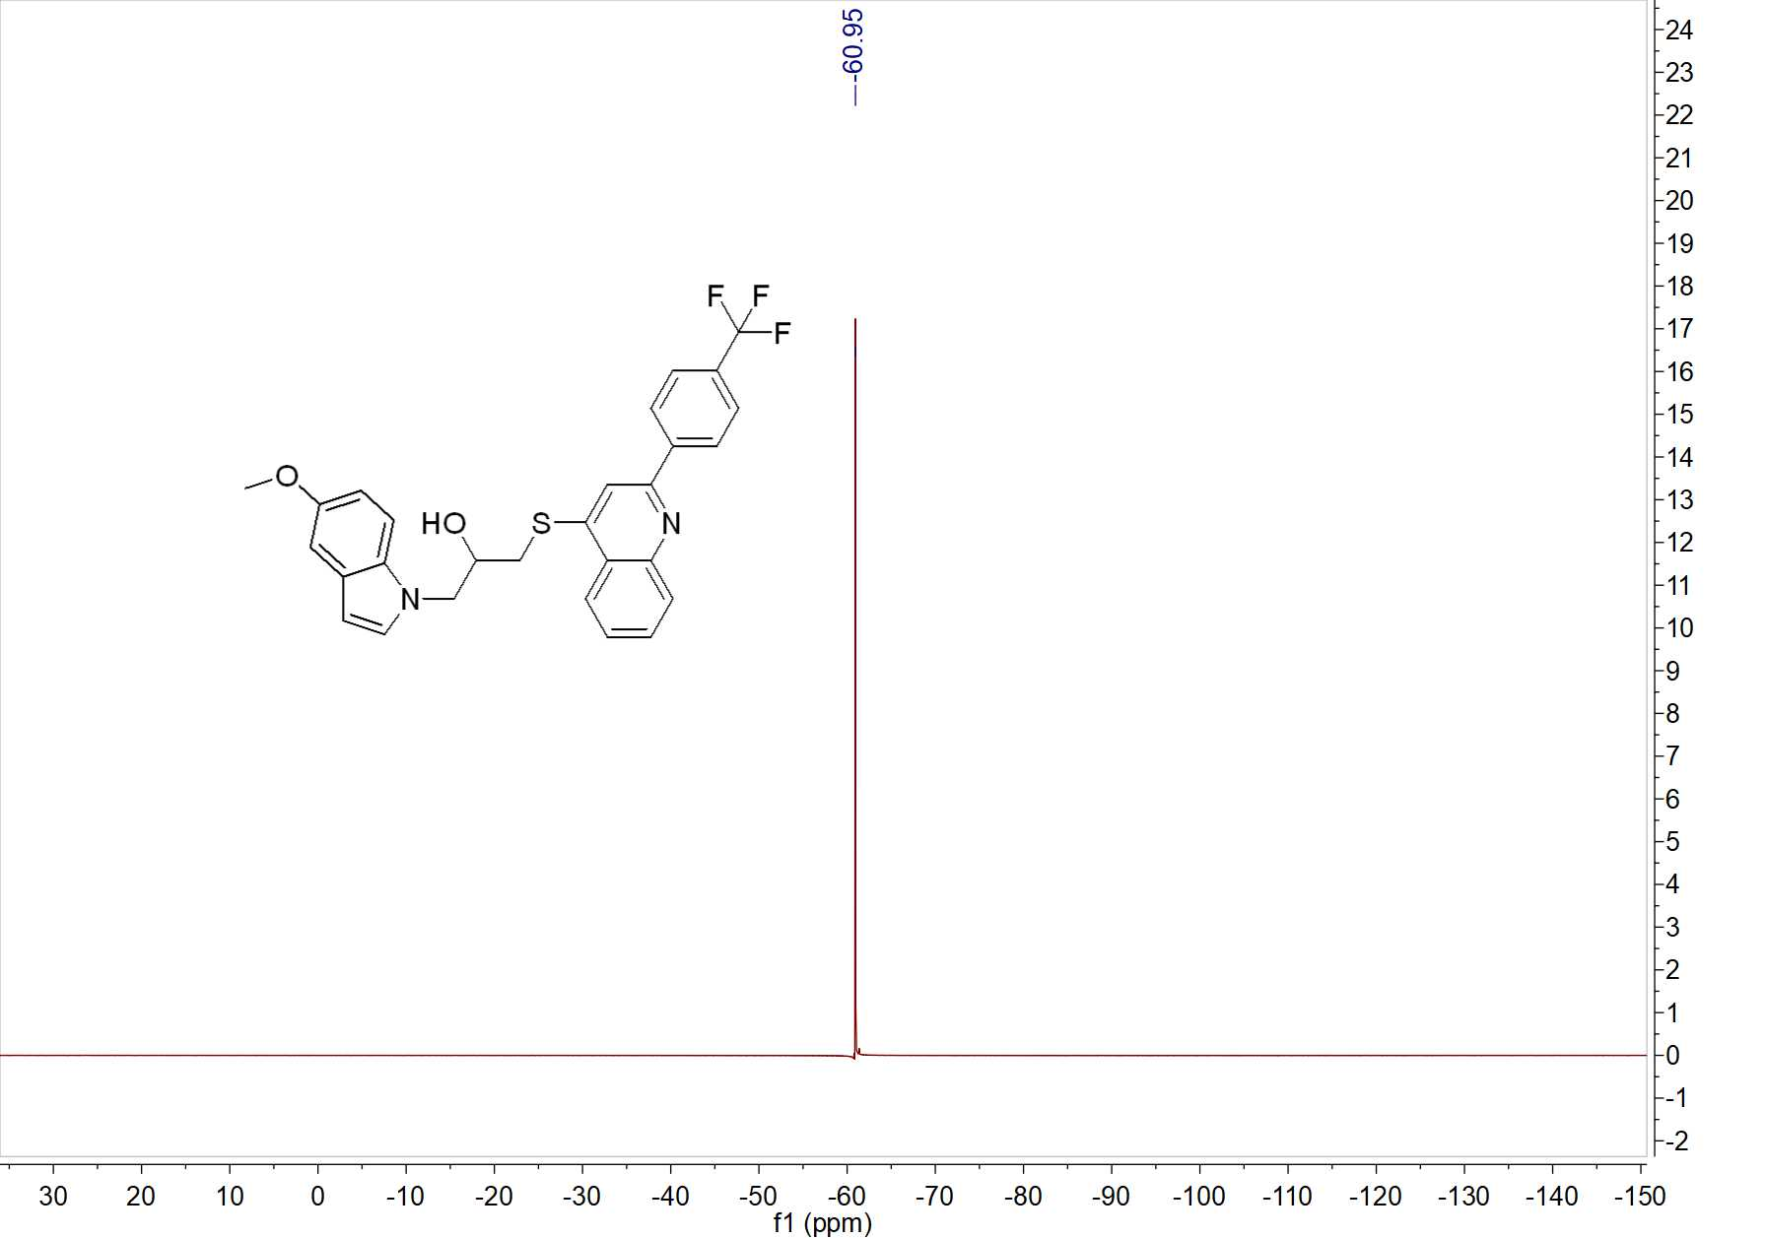

Fig. 65 ¹⁹F NMR spectrum of W21

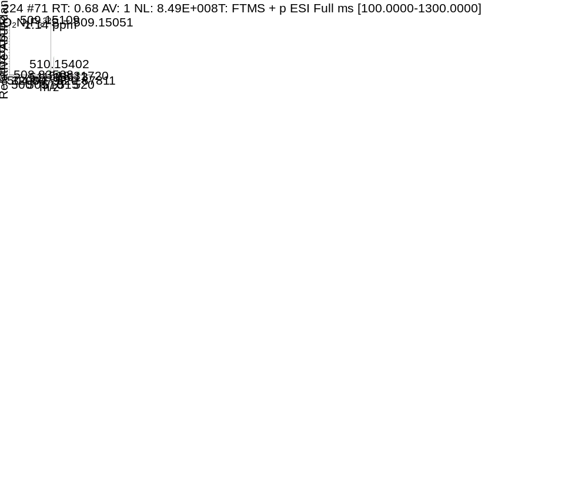

Fig. 66 HRMS spectrum of W21

