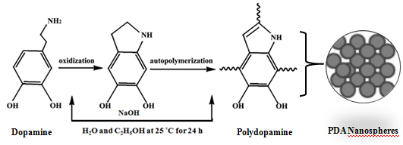

Scheme 1. Pictorial representation of the synthesis of PDA NPs

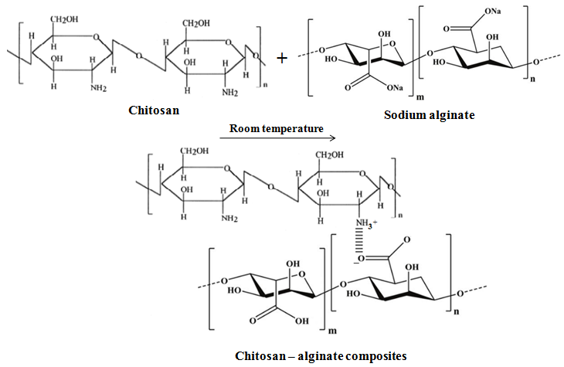
Scheme 2. Schematic representation of Ch/Alg Scaffolds

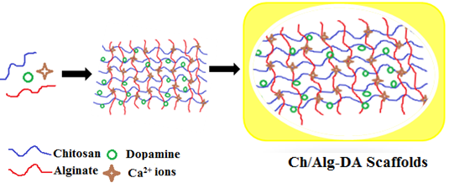
Scheme 3. Schematic representation of Ch/Alg-DA Scaffolds

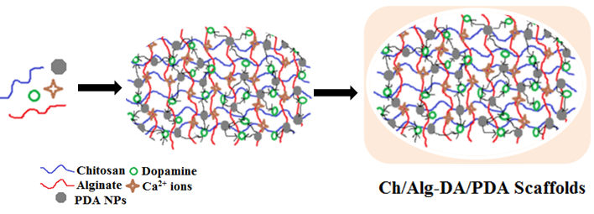
Scheme 4. Schematic representation of Ch/Alg-DA/PDA Scaffolds

