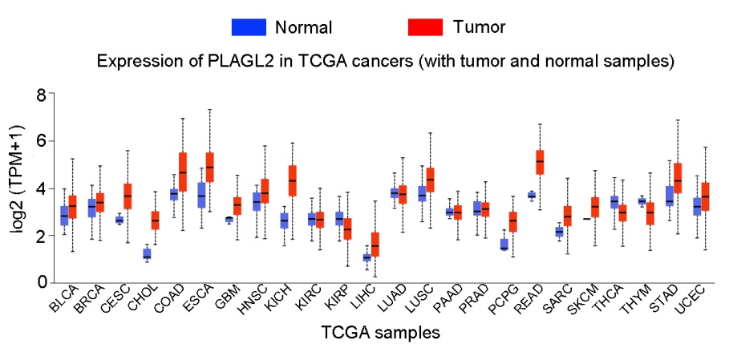
Figure S1. Expression of PLAGL2 in TCGA cancers. PLAGL2 is highly expressed in various cancers, including bladder cancer, breast cancer, cervical cancer, stomach adenocarcinoma, and rectum adenocarcinoma. BLCA, bladder cancer; BRCA, breast cancer; CESC, cervical cancer, CHOL, cholangiocarcinoma; COAD, colon cancer; ESCA, esophageal cancer; GBM, glioblastoma; HNSC, head and neck cancer; KICH, kidney chromophobe; KIRC, kidney clear cell carcinoma; KIRP, kidney papillary cell carcinoma; LIHC, liver cancer; LUAD, lung adenocarcinoma; LUSC, lung squamous cell carcinoma; PAAD, pancreatic adenocarcinoma; PRAD, prostate adenocarcinoma; PCPG, pheochromocytoma and paraganglioma; READ, rectum adenocarcinoma; SARC, sarcoma; SKCM, skin cutaneous melanoma; THCA, thyroid carcinoma, THYM, thymoma; STAD, stomach adenocarcinoma; UCEC, uterine corpus endometrial carcinoma.

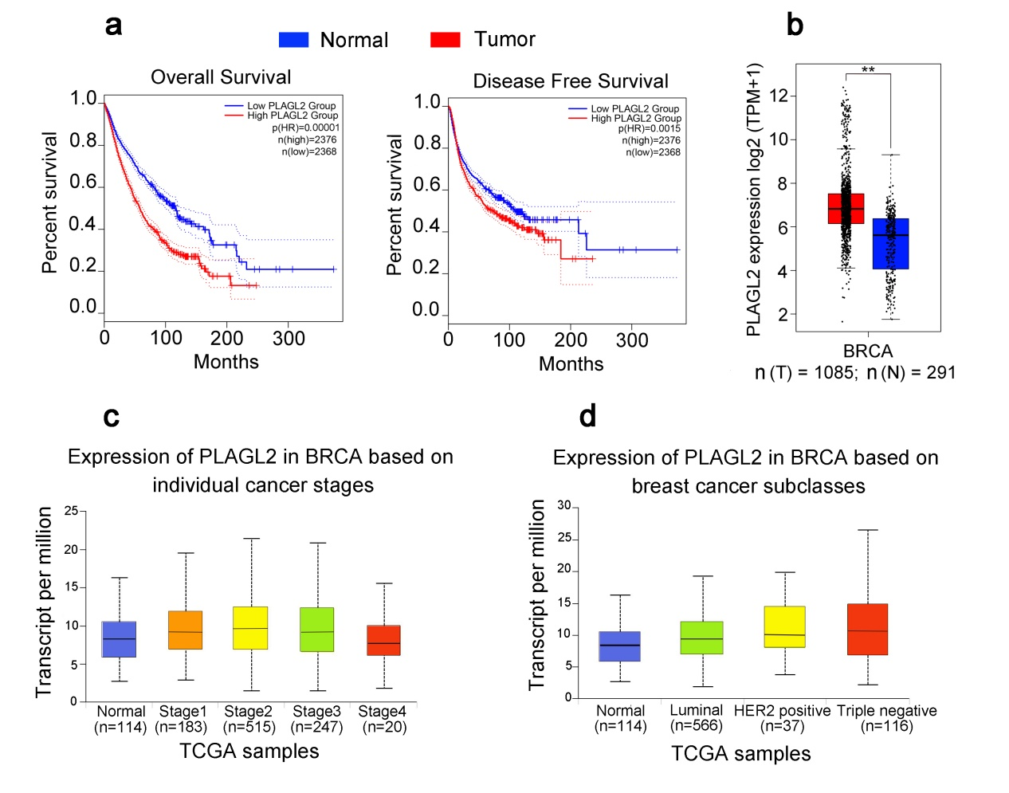
Figure S2. Bioinformatics analysis of PLAGL2 in breast cancer. (a) The relationship of PLAGL2 level and overall survival (OS), as well as disease free survival (DFS) in breast cancer patients. High PLAGL2 expression indicates low OS and DFS in the patients. (b) PLAGL2 levels in normal breast and breast cancers. (c) PLAGL2 level in I ∼ IV stages of breast cancer patients. (d) PLAGL2 levels in breast cancers, including Luminal, HER2 positive, and Triple negative, are significant higher than that in normal tissues.

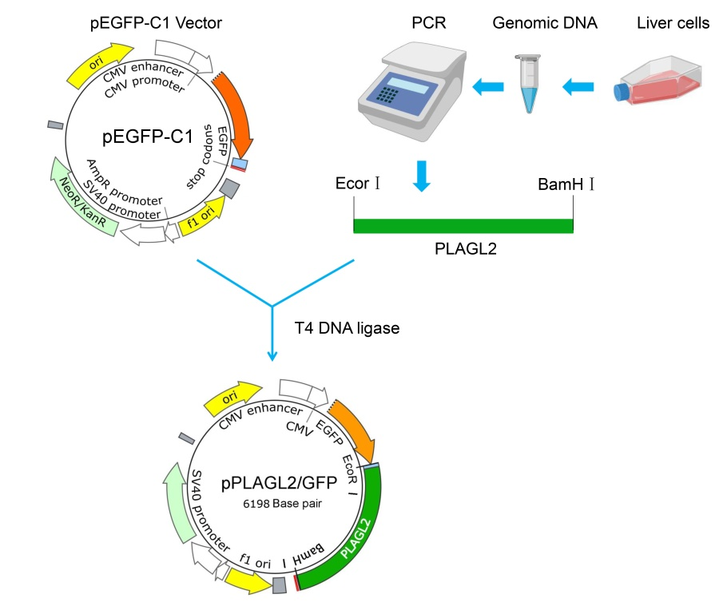
Figure S3. Diagram of pPLAGL2/GFP Construction. Extraction and purification of genomic DNA from liver cells for PCR to obtain the PLAGL2 fragment. The fragment and pEGFP-C1 were respectively digested by EcoR I and BamH I. and then linked with T4 DNA ligase.

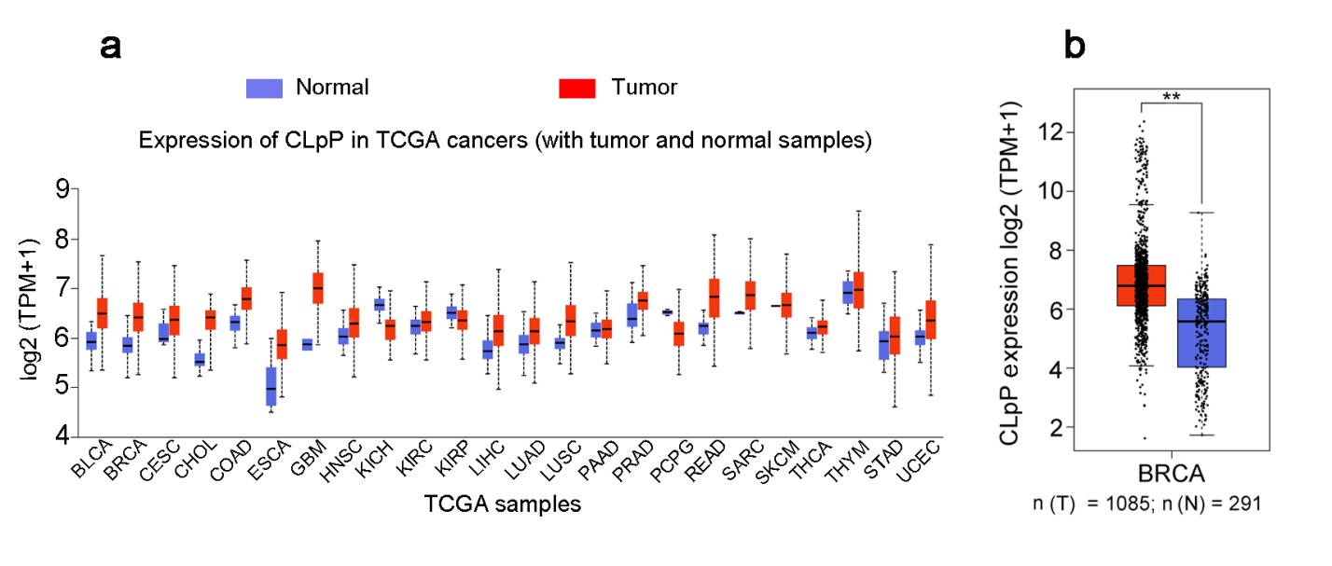
Figure S4. CLpP is highly expressed in various cancers. (a) The CLpP levels are higher in pan-cancers than normal tissues. (b) Significant high CLpP level in breast cancers relative to normal breast.

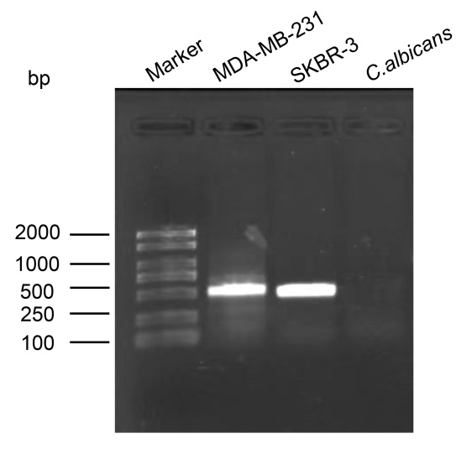
Figure S5. PCR of PLAGL2 gene in breast cancer cells and C. albicans. The genomic DNA of breast cancer cells and C. albicans were extracted for PCR, and the PCR samples were separated by 0.8% agarose gel. The result shows that PLAGL2 gene exists in breast cancer cells, but not in C. albicans.

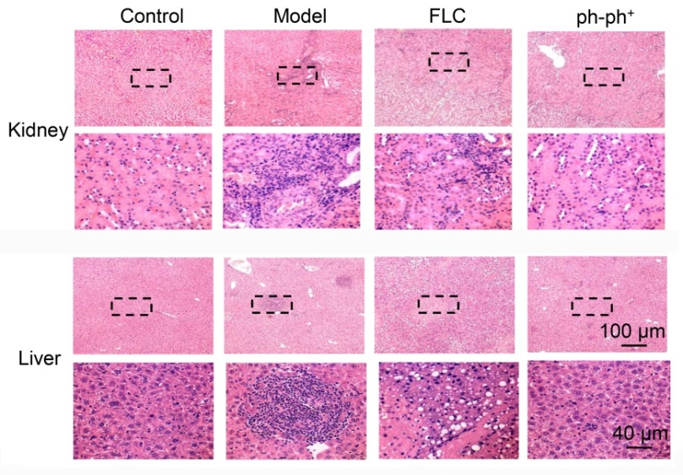
Figure S6. Representative images of HE staining in the kidney and liver of ph-ph⁺-treated mice with disseminated candidiasis. Inflammation caused by C. albicans infection appeared in the model mice, while the inflammation alleviated after FLC and ph-ph⁺ treatment.

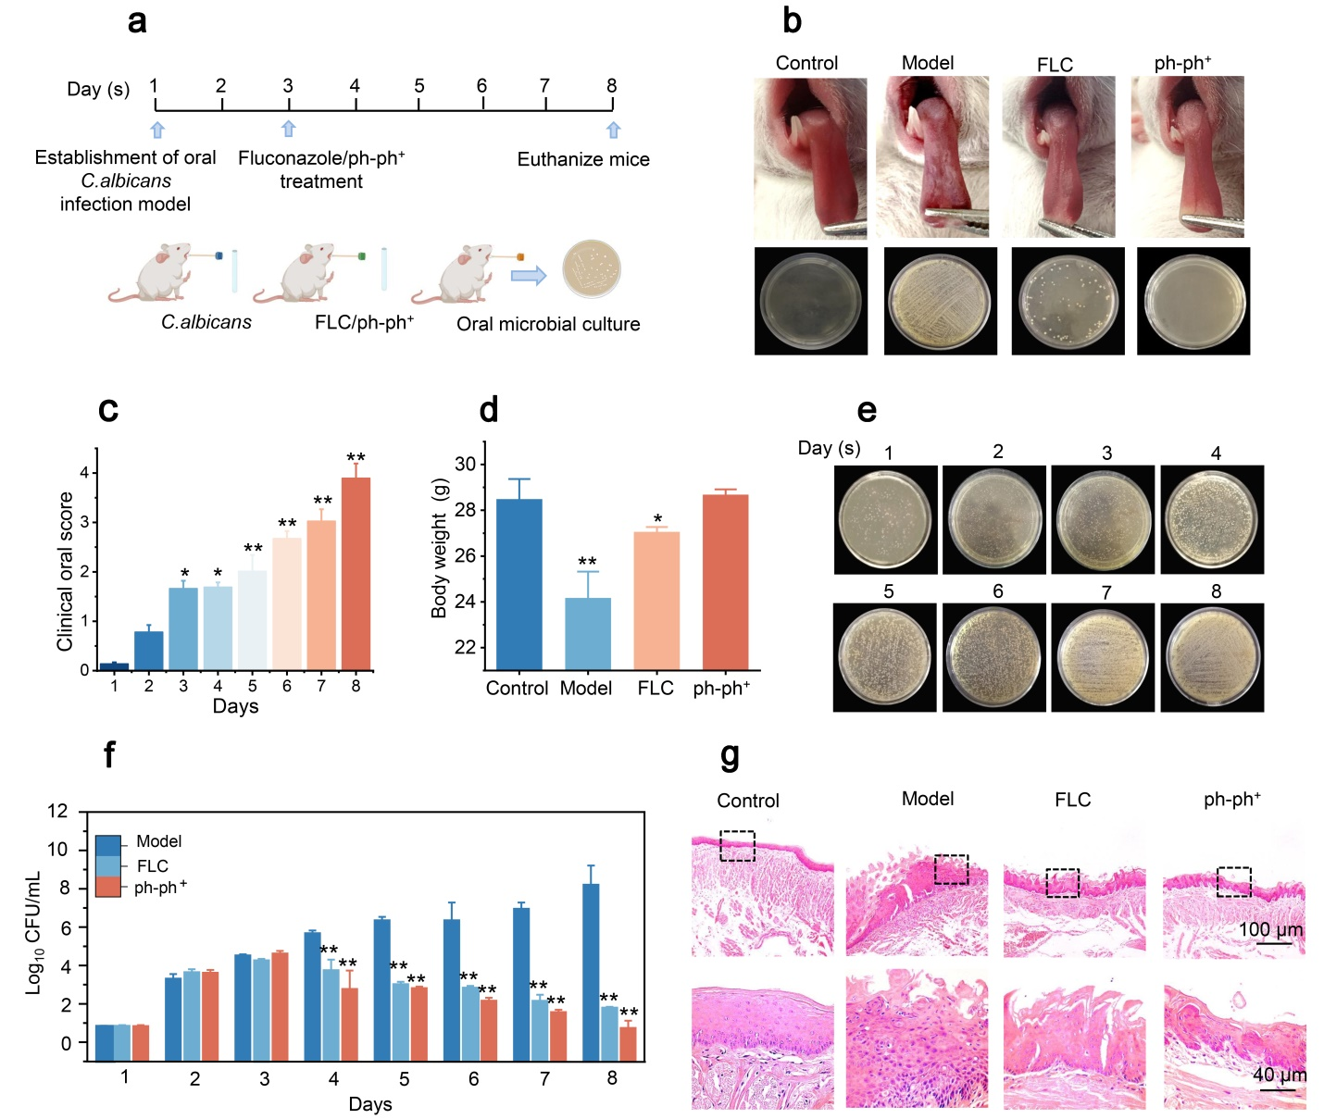
Figure S7. Ph-ph⁺ treatment for local C. albicans infection in the oral cavity of mice. (a) Schematic diagram for the treatment. (b) Representative images of each group. c Clinical scores of oral infection with C. albicans in mice. the higher the score, the more severe the infection. (d) Body weight in each group. (e) Daily microbial culture in the oral cavity of mice showed that the number of C. albicans in the model mice increased over days. (f) ph-ph⁺ prevented the proliferation of C. albicans in the mice, showing excellent therapeutic effect on the local fungal infection. (g) Representative images of tongue HE staining in each group. There were 32 mice in total, and eight mice were assigned in each group (n = 8). *p<0.05, **p<0.01.
Table S1. List of antibodies used in Western blot (WB)
Antibody | Provider | Catalog number | WB dilution | Observed MW
Bax | Beyotime | AF0057 | 1:500 - 1:1000 | 21 kDa
Bcl-2 | Beyotime | AF0060 | 1:500 - 1:1000 | 26 kDa
Beta-catenin | proteintech | 51067-2-AP | 1:5000 - 1:50000 | 90 kDa
Beta-tubulin | Servicebio | GB11017-100 | 1:1000 - 1:2000 | 55 kDa
caspase-3 | Servicebio | GB11767C-100 | 1:500 - 1:1000 | 35 kDa
caspase-9 | Servicebio | GB11053-1-100 | 1:800 - 1:1000 | 35 kDa
PLAGL2 | proteintech | 11540-1-AP | 1:1000 - 1:4000 | 55 kDa
Wnt | Beyotime | AG3570 | 1:500 - 1:1000 | 36 kDa

