Supplementary information
Selective Bias Virtual Screening for Discovery of Promising Antimalarial Candidates targeting Plasmodium N-Myristoyltransferase
Authors: Bruna K. P. Sousa^{1,2}, Sunniva S. Sigurdardottir², Catarina Bourgard^{2,3} , Joyce V. B. Borba^{1,3}, Leandro da C. Clementino³, Luis C. Salazar³, Rachael Zigweid ^{4,5}, Monique Khim^{4,5}, Sophia Groustra^{4,5}, Bart Staker^{4,5}, Fábio T. M. Costa³, Leif A. Erikson², Per Sunnerhagen^{2*}, Carolina H. Andrade^{1,6,7*}
- Laboratory of Molecular Modeling and Drug Design (LabMol), Faculty of Pharmacy, Universidade Federal de Goiás, Goiânia, GO, Brazil.
- Department of Chemistry and Molecular Biology, University of Gothenburg, Gothenburg, Sweden.
- Laboratory of Tropical Diseases, Institute of Biology, UNICAMP, Campinas, SP, Brazil.
- Seattle Structural Genomics Center for Infectious Disease, Seattle, Washington, United States.
- Seattle Children's Research Institute, Seattle, Washington, United States.
- Center for Excellence in Artificial Intelligence (CEIA), Institute of Informatics, Universidade Federal de Goiás, Goiânia, GO, Brazil.
- Center for the Research and Advancement in Fragments and molecular Targets (CRAFT), School of Pharmaceutical Sciences at Ribeirao Preto, University of São Paulo, Ribeirão Preto, SP, Brazil.

Table of Contents

- Figure S1. 2D diagrams of redockings of compound 2-(3-piperidin-4-yloxy-1-benzothiophen-2-yl)-5-[(1,3,5-trimethylpyrazol-4-yl) methyl]-1,3,4-oxadiazole) and its interaction with Plasmodium and human isoforms (I and II).

- Figure S2. Correlation between PvNMT inhibitors and predicted values of predicted MMGBSA-ΔG and docking score during the protocol validation.

- Table S1. Virtual hits selected during the virtual screening.

- Figure S3. In vitro growth inhibition of asexual blood stage P. falciparum (3D7) for NMT compounds.

- Figure S4. In vitro growth inhibition of asexual blood stage P. falciparum (3D7 and Dd2) for NMT compounds.

- Figure S5. Hemolytic effects for NMT compounds at 20 µM.

- Figure S6. 2-Point-screen Human NMT-1 and control 2(DDD85646).

- Figure S7. IC₅₀’s curves of LabMol-394 against Human NMT-1 and control 2 (DDD85646).

Figure S1. 2D diagrams of redockings of compound 2-(3-piperidin-4-yloxy-1- benzothiophen-2-yl)-5-[(1,3,5-trimethylpyrazol-4-yl) methyl]-1,3,4-oxadiazole and its interaction with Plasmodium and human isoforms (1 and 2). In the red circles it’s highlighted the equivalent residues in vivax and human.
Figure S2. Correlation between PvNMT inhibitors and predicted values of predicted ΔG and docking score during the protocol validation. In red, it highlighted the value obtained from the molecule used in the construction of the shape-based model of PvNMT.

Table S1. Virtual hits selected during the virtual screening. Here is described their ID, Docking score, MMGBSA-ΔG values and the malaria QSAR predictions.
Compound ID | SMILES | Docking score* |  | MMGBSA-ΔG* |  | Malaria QSAR
Compound ID | SMILES | P. vivax | H. sapiens | P. vivax | H. sapiens | 3D7 | W2
LabMol-373 | CC1NC(C[NH+]2CCC3C(CCC(=O)N3CC3CC[NH2+]CC3)C2)CO1 | -10.01 | -9.04 | -76.89 | -40.97 | Active | Inactive
LabMol-374 | CCN1C(CC2CC[NH2+]CC2)NN(CC2NC(COC)NO2)C1=O | -10.22 | -8.16 | -76.34 | -42.34 | Active | Inactive
LabMol-375 | CC1CC(N2CCNC2-C2CCC(OCCCC[NH+]3CCOCC3)CC2)CC[NH2+]1 | -9.89 | -8.61 | -72.28 | -12.43 | Active | Inactive
LabMol-376 | CC1CC(C(=O)N2CCC(C3[NH+]CCN3CC3CSCN3)CC2)NC(C)N1 | -9.70 | -8.37 | -107.21 | 4.07 | Active | Inactive
LabMol-377 | O=C(C1CCC(CN2CC[NH+]C2)O1)N1CC[NH+](CC2CCC(CL)CC2)CC1 | -11.06 | -9.05 | -105.02 | -42.28 | Active | Inactive
LabMol-378 | CC1[NH+]CCN1CC1CCCCC1NC(=O)C1C2C=CC3(CN(C)C(=O)C13)O2 | -10.76 | -9.50 | -88.95 | -47.03 | Active | active
LabMol-379 | NC1CNCC(-C2CCCC(C(=O)N3CCCC(C[NH+]4CCOCC4)C3)C2)C1 | -9.83 | -8.38 | -80.50 | -42.13 | Active | Inactive
LabMol-380 | NC1CC[NH+]CC1-C1CCCC(C(=O)NCC2CC[NH+](C3CCCC3)C2)C1 | -9.93 | -7.93 | -81.20 | -37.50 | Active | Inactive
LabMol-381 | CCC(=O)N1CCC2[NH]C[NH+]C2C12CCN(C(=O)C1CC(C(C)C)N[NH]1)CC2 | -10.11 | -7.31 | -78.23 | -20.00 | Active | Inactive
LabMol-382 | CC1C[NH2+]CCN1C(=O)CN1NC(CC2CC2)NC1C([NH3+])CC1CCCCC1 | -10.77 | -9.26 | -82.28 | -24.07 | Active | active
LabMol-383 | [NH3+]CCOC1CCC(CL)CC1C(=O)NC1CCCN(C2CNCCN2)C1 | -10.58 | -8.26 | -76.80 | -36.07 | Active | Inactive
LabMol-384 | CC1[NH+]CCN1CC1CCCCC1NC(=O)C(N)CC1C[NH]C2CCCCC12 | -10.30 | -8.40 | -76.89 | -9.87 | Active | active
LabMol-385 | [NH3+]C1CC(C2CC(NCCCN3CC[NH+]C3)NC(C3CC3)N2)C1 | -10.29 | -10.31 | -83.22 | -31.41 | Active | active
LabMol-386 | CN(C)S(=O)(=O)CC1CN(C(=O)C2NCCCC2OCC[NH3+])CC1O | -10.06 | -8.05 | -80.98 | -29.58 | Active | Inactive
LabMol-387 | COC1CC(-C2ONC(N(C)C)C2C(=O)NC2CC[NH2+]C2)CCC1F | -9.74 | -9.93 | -74.65 | -45.50 | Active | Inactive
LabMol-388 | COCC1NC(NCCCN2C(C)CCCC2=O)CC(C2CC([NH3+])C2)N1 | -10.98 | -9.57 | -71.78 | -28.13 | Active | Inactive
LabMol-389 | CC1CC(N2CCC(O)(C3CCCNC3)CC2)NC(-C2CCCCC2[O-])[NH+]1 | -9.38 | -6.79 | -86.66 | -48.73 | Active | Inactive
LabMol-390 | CCN1C(CC2CC[NH2+]CC2)NN(CCC2CCCC[NH+]2C)C1=O | -10.15 | -9.04 | -86.54 | -43.53 | Active | Inactive
LabMol-391 | OCCN1C(N2CC(O)C(CC3CCNC4CCCCC34)C2)[NH+]C2CCCCC21 | -10.66 | -8.70 | -82.13 | -45.41 | Active | Active
LabMol-392 | OCCCNCC(O)CN1C2CCC(BR)CC2C2CC(BR)CCC21 | -7.27 | -7.10 | -81.29 | -55.09 | Active | Active
LabMol-393 | CC1OC2C(C1C(=O)NCCCN1CCNC1)C(=O)C1CCCCC1C2=O | -9.51 | -9.71 | -50.57 | -24.46 | Active | Active
LabMol-394 | OC1C(C(NC2CCCCN2)C2CCCNC2)CCC2CCCNC12 | -8.6 | -4.60 | -86.48 | -12.79 | Active | Active
LabMol-395 | CC1CCCN2C(=O)C3CC(C(=O)NC4CCCCC4)C(=N)N(CCCN4CCNC4)C3NC12 | -9.14 | -10.19 | -120.63 | -65.89 | Active | Active

* Values expressed in Kcal/mol.

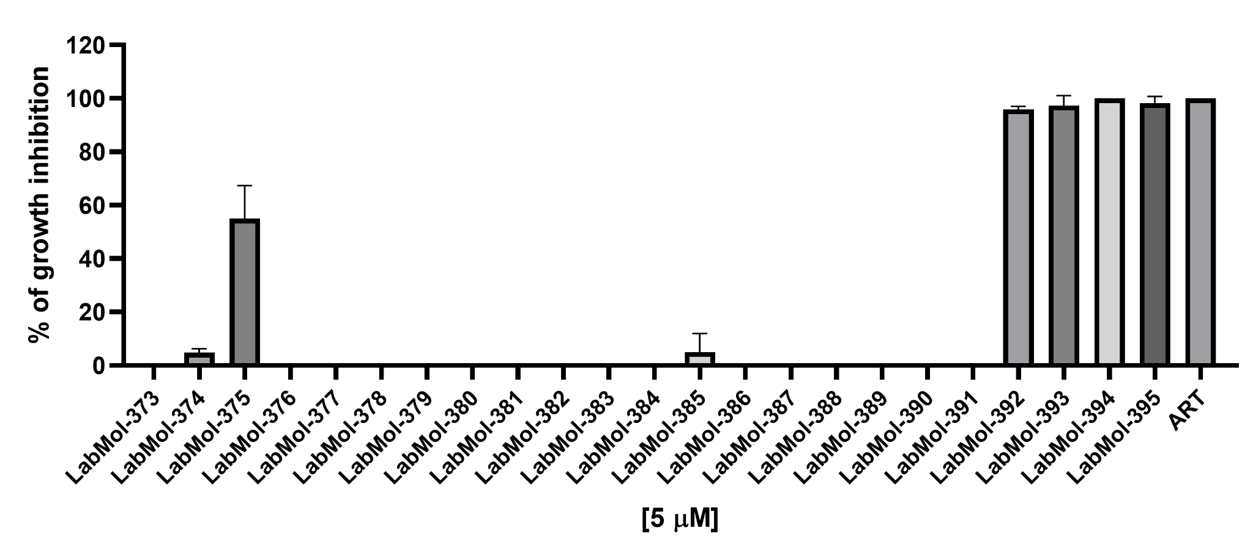
Figure S3. In vitro growth inhibition of asexual blood stage P. falciparum (3D7) for NMT compounds. The inhibitory potential of different compounds was tested at a concentration of 5 μM and the inhibition of parasitemia was measured after 72 hours of incubation. The data is from at least three independent experiments shown as the average ± standard deviation. Art – Artesunate 5 µM.

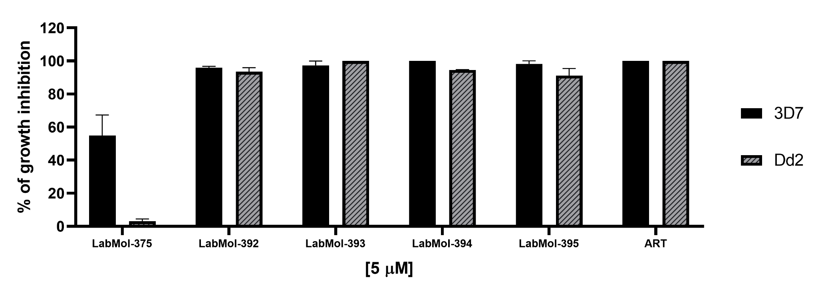
Figure S4. In vitro growth inhibition of asexual blood stage P. falciparum (3D7 and Dd2) for NMT compounds. The inhibitory potential of different compounds was tested at a concentration of 5 μM and the inhibition of parasitemia was measured after 72 hours of incubation. The data is from at least three independent experiments shown as the average ± standard deviation. Art – Artesunate 5 µM.

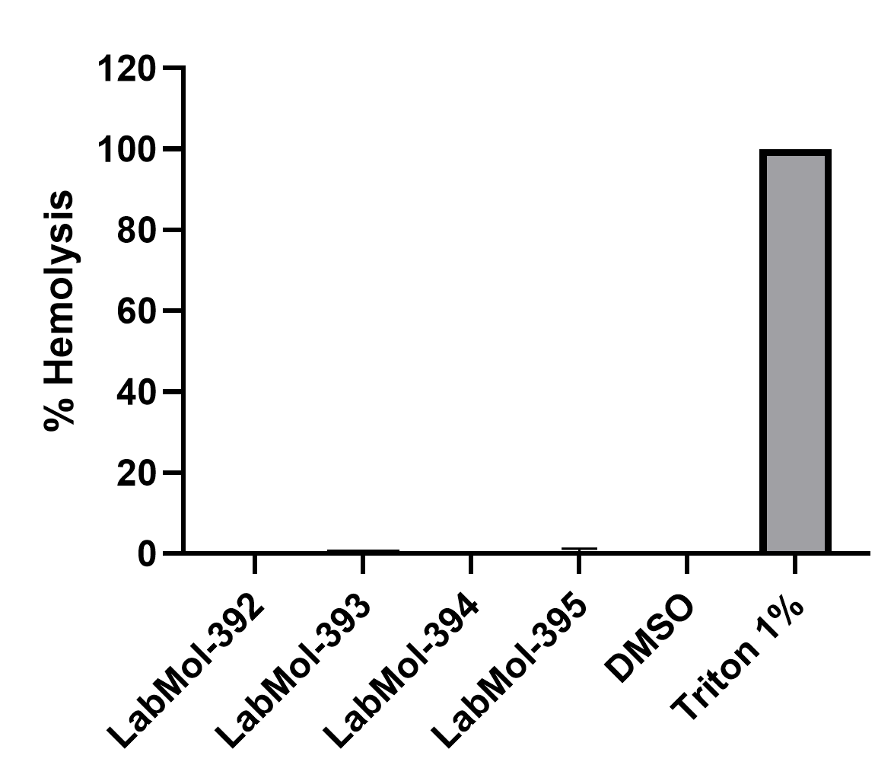
Figure S5. Hemolytic effects for NMT at 20 µM. Data from two independent experiments, as the average ± standard deviation. The hemolytic rate was calculated in relation to the hemolysis of erythrocytes in Triton X100 1% which was taken as 100%, after 4 hours of incubation.
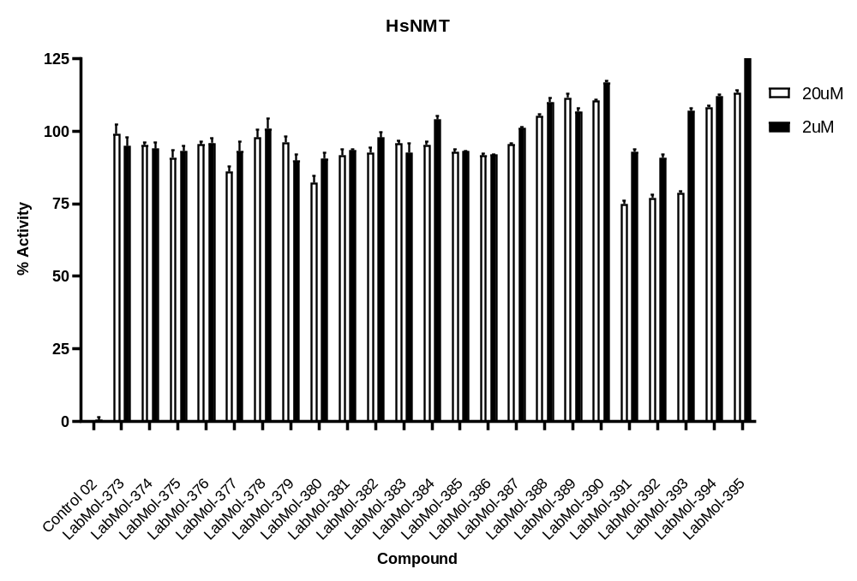
Figure S6. 2-Point-screen Human NMT-1 and control 2(DDD85646).

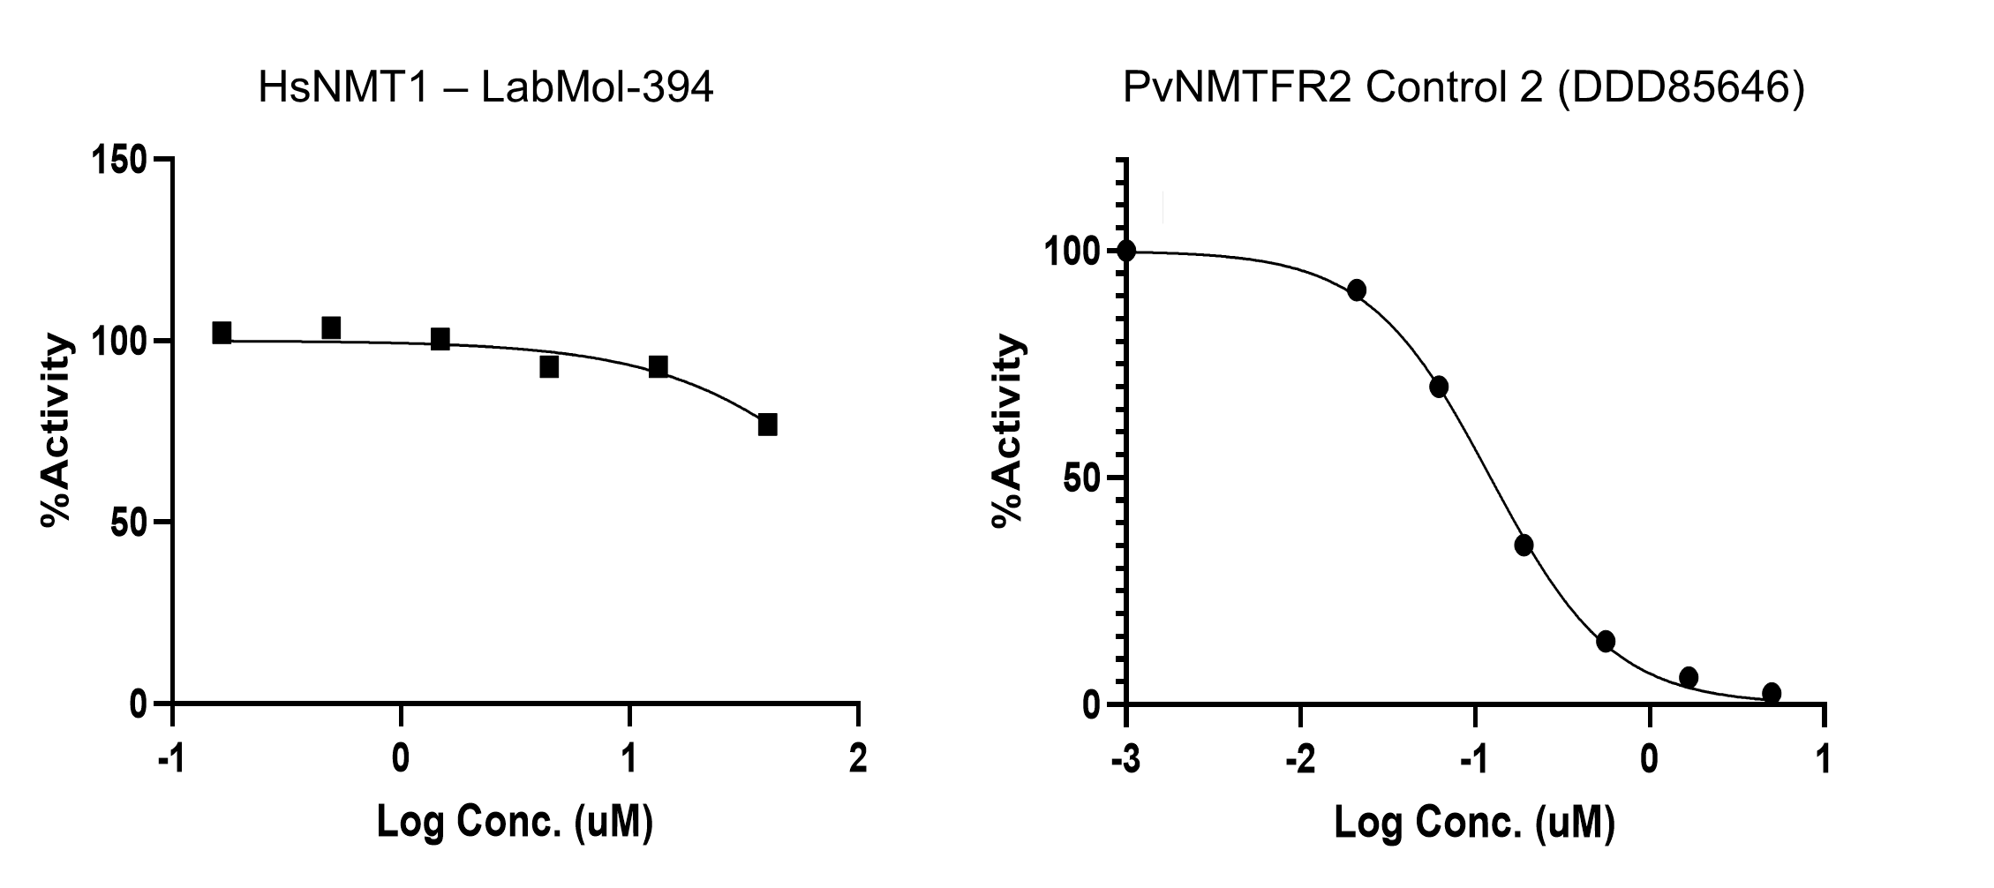

Figure S7. IC₅₀’s curves of LabMol-394 against Human NMT-1 and control 2(DDD85646). LabMol-394 doesn’t inhibit the human isoform 1 (40 – 0.16 µM), and the control for the assay displays a curve of inhibition on tested concentrations from 5 – 0.021 µM.

