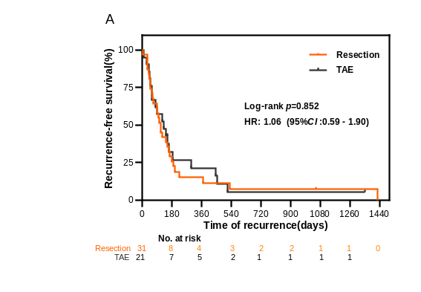
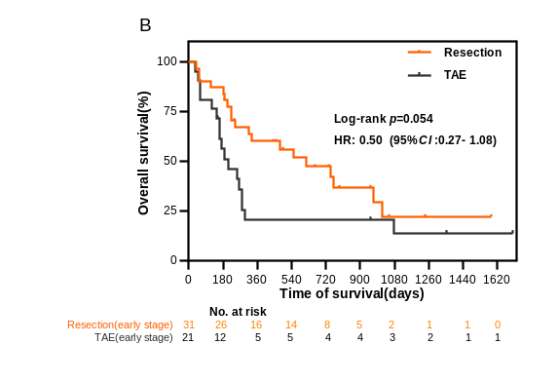
Additional files
Additional Figure S1 A, Kaplan–Meier analysis of RFS between the TAE group and resection group. B, Kaplan–Meier analysis of OS between the TAE group and resection group. All P-values are calculated using the log-rank test for each comparison without adjustments. TAE, trans-arterial embolisation; RFS, recurrence-free survival; OS, overall survival.

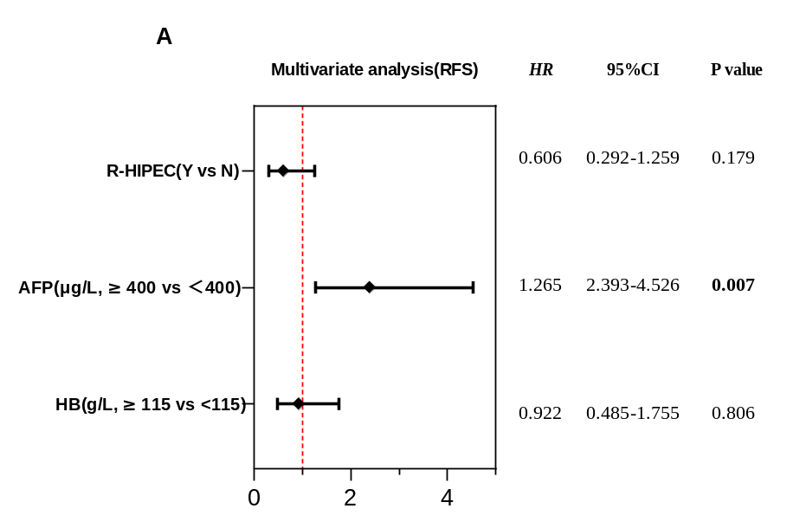

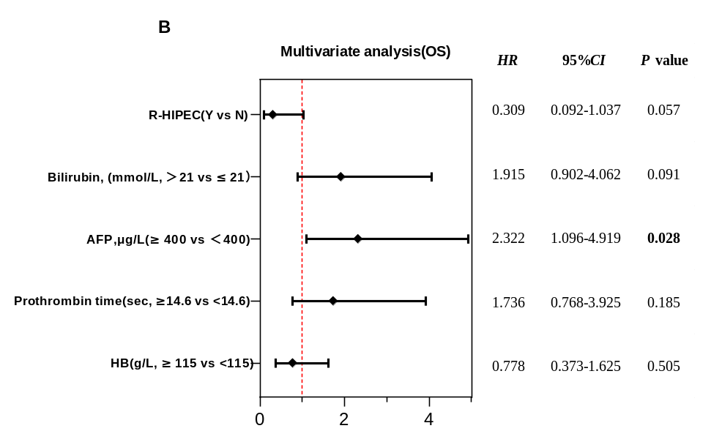

Additional Figure S2 A, Multivariate Cox regression model for RFS in all patients; B, Multivariate Cox regression model for OS in all patients. 95%CI, 95% confidence intervals; HR, hazard ratio; R-HIPEC, resection combined with hyperthermic intraperitoneal chemotherapy; AFP, alpha-fetoprotein; Hb, haemoglobin; RFS, recurrence-free survival; OS, overall survival.

Additional Table S1 Baseline clinical characteristics of patients with TAE or Resection
Characteristics | TAE, (n=21),  N (%) | Resection (n=31),  N (%) | P-value
Gender (male) | 19 (90.5) | 25 (84.6) | 0.57
Age (years, ≥60) | 10 (47.6) | 10 (38.5) | 0.26
Hepatitis (positive) | 19 (90.5) | 26 (83.9) § | 0.36
Platelet (10 ⁹/L, ≥100) | 17 (81.0) | 28 (90.3) | 0.58
Hb (g/L, ≥115) | 8 (38.1) | 12 (38.7) | 0.96
Serum ALT (U/L, <40) | 10 (47.6) | 22 (71.0) | 0.09
Bilirubin (mmol/L, >21) | 7 (33.3) | 8 (25.8) | 0.56
Albumin (g/L, ≥35) | 9 (42.9) | 17 (54.8) | 0.40
Cirrhosis (yes) | 11 (52.4) | 9 (29.0) | 0.09
Prothrombin time  (sec, ≥14.6) | 6 (28.6) | 5 (16.1) | 0.46
AFP (μg/L, ≥400) ¶ | 7 (35.0) | 16 (51.6) | 0.24
Tumour size (cm, ≥10) | 6 (28.6) | 6 (19.4) | 0.66
Child–Pugh stage |  |  | 0.73
A | 19 (90.5) | 30 (96.8)
B | 2 (9.5) | 1 (3.2)
§, there are two patients with HCV (positive); ¶, two patients' data are deleted; TAE, trans-arterial embolisation; Hb, haemoglobin; ALT, alanine aminotransferase; AFP, alpha-fetoprotein; HCV, hepatitis C virus.

