Supplementary File S1. Risk score for patients in the TCGA dataset.

Supplementary File S2. Risk score for patients in the GSE21501 dataset.

Supplementary File S3. Risk score for patients in the GSE57495 dataset.

Supplementary File S4. Risk score for patients in the GSE62542 dataset.

Supplementary File S5. Risk score for patients in the GSE71729 dataset.

Supplementary File S6. Risk score for patients in the GSE79668 dataset.

Supplementary File S7. Risk score for patients in the ICGC PACA dataset.

Supplementary File S8. Genes significantly correlated with risk scores.

Supplementary File S9. The immune-system-related metagene clusters.

Supplementary Table S1. Clinical characteristics of the PC patients at high and low risk in the TCGA dataset
Variables | High  (n = 35) | Low  (n = 143) | p value
Age, years (%)
<65 | 15 (42.9) | 67 (46.9) | 0.813
≥65 | 20 (57.1) | 76 (53.1)
Gender (%)
Female | 16 (45.7) | 64 (44.8) | 1
Male | 19 (54.3) | 79 (55.2)
Grade (%)
G1/G2 | 22 (62.9) | 104 (72.7) | 0.342
G3/G4 | 13 (37.1) | 37 (25.9)
NA | 0 (0.0) | 2 (1.4)
Stage (%)
I/II | 34 (97.1) | 133 (93.0) | 0.604
III/IV | 1 (2.9) | 10 (7.0)
Pathologic_T (%)
T1/T2 | 3 (8.6) | 28 (19.6) | 0.226
T3/T4 | 32 (91.4) | 113 (79.0)
NA | 0 (0.0) | 2 (1.4)
Pathologic_M (%)
M0 | 18 (51.4) | 62 (43.4) | 0.418
M1 | 0 (0.0) | 5 (3.5)
NA | 17 (48.6) | 76 (53.1)
Pathologic_N (%)
N0 | 6 (17.1) | 44 (30.8) | 0.271
N1 | 28 (80.0) | 95 (66.4)
NA | 1 (2.9) | 4 (2.8)
NA, not applicable.

Supplementary Figure S1
Survival analysis of patients with high vs. low-risk group based on the IL based expression pattern in the TCGA dataset
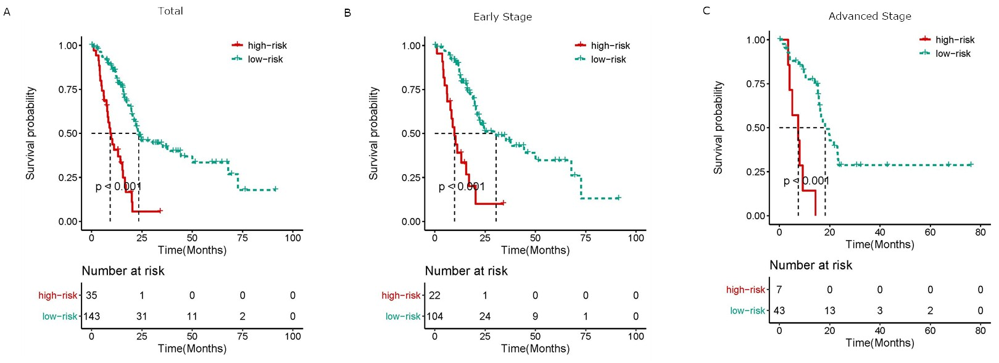
(A) Kaplan-Meier curves of OS in patients in the PAAD cohort stratified into high- and low-risk groups by IL family–based risk score. Kaplan-Meier curves of OS in patients with (B) early-stage (stage I and II) and (C) late-stage (stage III and IV) disease in the PAAD cohort stratified into high- and low-risk groups by IL family–based risk score.

