Supplementary Table 1. Multivariate Cox regression model of treatment response
Factor | Coef | S.E. | Wald Z | Pr(>|Z|)
Age | -0.015 | 0.006 | 6.115 | 0.013
Treatment
CNI | Ref.
CTX | 0.338 | 0.219 | 2.380 | 0.123
RTX | 0.449 | 0.209 | 4.596 | 0.032
Serum albumin | 0.030 | 0.016 | 3.506 | 0.061
Follow-up | 0.032 | 0.009 | 11.919 | 0.001

Supplementary Table 2. Baseline characteristics in patients treated with CNI.
Characteristic | CNI-GC, n=51 | CNI alone, n=35 | p
Age, yr | 57 (40, 62.5) | 62 (51, 66) | 0.081
Male, n (%) | 38 (74.5) | 23 (65.7) | 0.378
Systolic BP, mmHg | 124 (113, 135) | 131 (115,139.5) | 0.444
Diastolic BP, mmHg | 78.9±16.2 | 79.9±13.1 | 0.169
Serum cholesterol, mmol/L | 7.95±2.42 | 7.01±2.00 | 0.205
Serum creatinine, μmol/L | 83.9±20.5 | 82.1±20.8 | 0.895
Serum albumin, g/L | 23.8±5.1 | 25.8±5.8 | 0.596
eGFR, mL/min/1.73m² | 88.10±20.05 | 84.56±19.91 | 0.907
UPCR, g/g | 4.24 (3.65, 5.29) | 4.12 (3.56, 5.14) | 0.802
PLA2R-Ab-positive, n (%)ª | 20/28 (71.4) | 17/20 (85) | 0.270
PLA2R-Ab titer, RU/ml | 28.0 (2.0,102.1) | 61.1 (16.0, 81.1) | 0.398
ACE inhibitor/ARB use, n (%) | 21 (41.2) | 21 (60) | 0.086
Prior immunosuppressive  therapy, n (%) | 3 (5.9) | 2 (5.7) | 0.974
Follow-up, month | 12 (12, 21) | 12 (6, 18) | 0.563
Data are shown as n (%), median (IQR), or mean ± SD. ªA part of patients lack baseline PLA2R-Ab tests, are shown as n/N.
ACE, angiotensin-converting enzyme; ARB, angiotensin 2 receptor blocker; BP, blood pressure; CNI, calcineurin inhibitor; eGFR, estimated glomerular filtration rate; GC, glucocorticoids; PLA2R-Ab, M-type phospholipase A2 receptor antibody; UPCR, urine protein-to-creatinine ratio.

Supplementary Table 3. Primary and secondary endpoints in the CNI group.
Primary and secondary endpoints | CNI-GC, n=51 | CNI alone, n=35 | p
Complete remission
6 months, n (%) | 5/51 (9.8) | 0 | 0.056
12 months, n (%) | 5/40 (12.5) | 0 | 0.066
End of follow-up, n (%) | 10/51 (19.6) | 1/35 (2.9) | 0.024
Complete or partial remission
6 months, n (%) | 19/51 (37.3) | 8/35 (22.9) | 0.158
12 months, n (%) | 17/40 (42.5) | 8/25 (32) | 0.397
End of follow-up, n (%) | 25/51 (49) | 14/35 (40) | 0.409
Relapse
Relapse, n (%) | 8/25 (32) | 6/14 (42.9) | 0.498
Time from remission to relapse, months | 11.9±9.5 | 5.8±5.2 | 0.375
Renal function progression
≥25% decline in eGFR, n (%) | 18/51 (35.5) | 13/35 (37.1) | 0.861
≥50% decline in eGFR, n (%) | 6/51 (11.8) | 7/35 (20) | 0.295
ESRD/dialysis, n (%) | 1/51 (2) | 3/35 (8.6) | 0.153
Data are shown as n/N (%) or mean ± SD.
CNI, calcineurin inhibitor; eGFR, estimated glomerular filtration rate; ESRD, end-stage renal disease; GC, glucocorticoids.

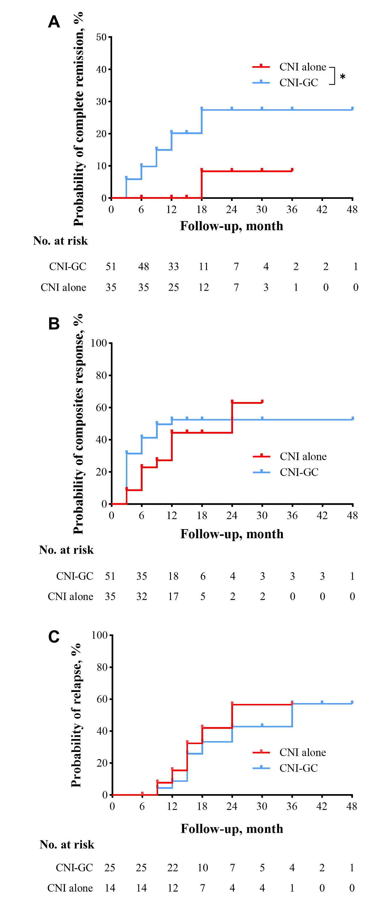
Supplementary Figure 1. Kaplan-Meier analysis of (A) complete remission (B) complete or partial remission, and (C) relapse rate in patients treated with CNI. *p<0.05. Cumulative Complete remission rate: CNI-GC vs CNI alone (Log-rank HR 7.75, 95%CI 2.35-25.5, p=0.019).
CNI, calcineurin inhibitor; GC, glucocorticoids.

