Table S1 Instrumental variables in MR analysis for CD3+CD8+ TD Tcell on colorectal cancer(P<10⁻⁶).
SNP | EA | OA | beta | eaf | pval | samplesize | se | R2 | F | meanF
rs10860204 | A | G | 0.4505 | 0.0186 | 6.39E-06 | 2911 | 0.0996 | 0.0070 | 20.4279 | 23.3610
rs111666485 | A | C | 0.3232 | 0.0414 | 3.26E-06 | 2911 | 0.0693 | 0.0074 | 21.7296 | 23.3610
rs115208823 | T | C | -0.4444 | 0.023 | 2.29E-06 | 2911 | 0.0939 | 0.0076 | 22.4021 | 23.3610
rs116008125 | T | C | 0.2624 | 0.0565 | 9.44E-06 | 2911 | 0.0591 | 0.0067 | 19.6728 | 23.3610
rs11678793 | G | A | -0.1388 | 0.2559 | 7.06E-06 | 2911 | 0.0308 | 0.0069 | 20.2419 | 23.3610
rs117286362 | T | C | -0.2026 | 0.1048 | 4.89E-06 | 2911 | 0.0443 | 0.0071 | 20.9296 | 23.3610
rs141566851 | A | G | -0.5141 | 0.0149 | 5.55E-06 | 2911 | 0.1130 | 0.0071 | 20.6843 | 23.3610
rs146793472 | C | T | -0.3492 | 0.0326 | 6.47E-06 | 2911 | 0.0773 | 0.0070 | 20.3987 | 23.3610
rs147934227 | T | C | -1.264 | 0.0024 | 3.51E-06 | 2911 | 0.2719 | 0.0074 | 21.5962 | 23.3610
rs182175045 | T | G | -0.4056 | 0.024 | 6.84E-06 | 2911 | 0.0900 | 0.0069 | 20.3006 | 23.3610
rs2949669 | T | C | 0.2073 | 0.472 | 2.49E-14 | 2911 | 0.0271 | 0.0198 | 58.6468 | 23.3610
rs4689428 | G | C | -0.1861 | 0.2056 | 3.64E-08 | 2911 | 0.0337 | 0.0104 | 30.4924 | 23.3610
rs472594 | C | T | -0.1616 | 0.1889 | 4.21E-06 | 2911 | 0.0351 | 0.0072 | 21.2305 | 23.3610
rs55823840 | A | G | 0.1402 | 0.2736 | 3.96E-06 | 2911 | 0.0303 | 0.0073 | 21.3527 | 23.3610
rs57740770 | G | T | -0.1714 | 0.2547 | 1.14E-06 | 2911 | 0.0352 | 0.0081 | 23.7479 | 23.3610
rs6419642 | A | G | 0.2739 | 0.9438 | 4.41E-06 | 2911 | 0.0596 | 0.0072 | 21.1408 | 23.3610
rs72785901 | T | C | -0.4361 | 0.0211 | 6.52E-06 | 2911 | 0.0965 | 0.0070 | 20.3920 | 23.3610
rs73158979 | C | T | -0.2201 | 0.0878 | 6.56E-06 | 2911 | 0.0487 | 0.0070 | 20.3868 | 23.3610
rs74596366 | C | T | 0.4633 | 0.0187 | 4.68E-06 | 2911 | 0.1010 | 0.0072 | 21.0273 | 23.3610
rs77727789 | C | G | -0.2467 | 0.0646 | 9.20E-06 | 2911 | 0.0555 | 0.0067 | 19.7306 | 23.3610
rs945668 | T | C | 0.1663 | 0.2071 | 9.88E-07 | 2911 | 0.0339 | 0.0082 | 24.0484 | 23.3610
SNP, single nucleotide polymorphism; se, standard error; eaf, effect allele frequency.

Table S2 Instrumental variables in MR analysis for colorectal cancer on CD3+CD8+ TD Tcell (P<10⁻⁵).
SNP | EA | OA | beta | eaf | pval | samplesize | se | R2 | F | meanF
rs113035410 | T | C | -0.1809 | 0.0504 | 3.43E-05 | 6509 | 0.0437 | 6.43E-06 | 17.1661 | 23.7209
rs115559424 | A | G | -0.3712 | 0.0130 | 4.69E-05 | 6509 | 0.0912 | 6.21E-06 | 16.5687 | 23.7209
rs116123666 | G | A | 0.2257 | 0.0284 | 1.14E-05 | 6509 | 0.0514 | 7.22E-06 | 19.2665 | 23.7209
rs12369392 | A | G | 0.2555 | 0.0191 | 1.33E-05 | 6509 | 0.0587 | 7.10E-06 | 18.9606 | 23.7209
rs12418845 | A | G | 0.1736 | 0.0541 | 5.59E-06 | 6509 | 0.0382 | 7.73E-06 | 20.6242 | 23.7209
rs12975964 | A | G | 0.4375 | 0.9896 | 1.80E-05 | 6509 | 0.1020 | 6.89E-06 | 18.3951 | 23.7209
rs142480583 | A | C | 0.5021 | 0.0048 | 5.22E-06 | 6509 | 0.1102 | 7.78E-06 | 20.7532 | 23.7209
rs145191148 | A | C | -0.1621 | 0.0720 | 1.20E-05 | 6509 | 0.0370 | 7.18E-06 | 19.1584 | 23.7209
rs182818929 | G | T | 0.2943 | 0.0149 | 1.39E-05 | 6509 | 0.0677 | 7.08E-06 | 18.8868 | 23.7209
rs199245 | G | A | -0.0825 | 0.2841 | 4.56E-05 | 6509 | 0.0202 | 6.23E-06 | 16.6214 | 23.7209
rs2071945 | C | G | -0.0845 | 0.3746 | 9.37E-06 | 6509 | 0.0191 | 7.36E-06 | 19.6353 | 23.7209
rs2174047 | T | C | 0.0816 | 0.6984 | 3.87E-05 | 6509 | 0.0198 | 6.34E-06 | 16.9329 | 23.7209
rs2735940 | G | A | 0.1291 | 0.5294 | 1.07E-12 | 6509 | 0.0181 | 1.90E-05 | 50.7151 | 23.7209
rs355523 | A | G | -0.1101 | 0.6919 | 1.01E-08 | 6509 | 0.0192 | 1.23E-05 | 32.8177 | 23.7209
rs3847137 | T | C | -0.1483 | 0.5681 | 2.97E-16 | 6509 | 0.0181 | 2.50E-05 | 66.8207 | 23.7209
rs41402548 | A | G | 0.1871 | 0.0417 | 2.44E-05 | 6509 | 0.0443 | 6.67E-06 | 17.8071 | 23.7209
rs6020498 | T | C | -0.0790 | 0.3943 | 2.11E-05 | 6509 | 0.0186 | 6.78E-06 | 18.0855 | 23.7209
rs62312629 | A | C | 0.0779 | 0.4431 | 1.79E-05 | 6509 | 0.0182 | 6.89E-06 | 18.4003 | 23.7209
rs7178114 | C | G | 0.2216 | 0.9639 | 1.55E-05 | 6509 | 0.0513 | 7.00E-06 | 18.6714 | 23.7209
rs7905484 | C | T | 0.1424 | 0.1426 | 1.17E-08 | 6509 | 0.0250 | 1.22E-05 | 32.5346 | 23.7209
rs80062901 | A | G | -0.3419 | 0.0187 | 1.11E-05 | 6509 | 0.0778 | 7.24E-06 | 19.3163 | 23.7209
SNP, single nucleotide polymorphism; se, standard error; eaf, effect allele frequency.

Table S3 Instrumental variables in MR analysis for CD3+CD8+ TD Tcell on VEGF-A (P<10⁻⁶).
SNP | EA | OA | beta | eaf | pval | samplesize | se | R2 | F | meanF
rs10860204 | A | G | 0.4505 | 0.0186 | 6.39E-06 | 2911 | 0.0996 | 0.0070 | 20.4279 | 23.2806
rs111666485 | A | C | 0.3232 | 0.0414 | 3.26E-06 | 2911 | 0.0693 | 0.0074 | 21.7296 | 23.2806
rs114241106 | A | T | -0.9152 | 0.0053 | 1.01E-06 | 2911 | 0.1868 | 0.0082 | 23.9872 | 23.2806
rs115208823 | T | C | -0.4444 | 0.023 | 2.29E-06 | 2911 | 0.0939 | 0.0076 | 22.4021 | 23.2806
rs116008125 | T | C | 0.2624 | 0.0565 | 9.44E-06 | 2911 | 0.0591 | 0.0067 | 19.6728 | 23.2806
rs11678793 | G | A | -0.1388 | 0.2559 | 7.06E-06 | 2911 | 0.0308 | 0.0069 | 20.2419 | 23.2806
rs117286362 | T | C | -0.2026 | 0.1048 | 4.89E-06 | 2911 | 0.0443 | 0.0071 | 20.9296 | 23.2806
rs141566851 | A | G | -0.5141 | 0.0149 | 5.55E-06 | 2911 | 0.1130 | 0.0071 | 20.6843 | 23.2806
rs146793472 | C | T | -0.3492 | 0.0326 | 6.47E-06 | 2911 | 0.0773 | 0.0070 | 20.3987 | 23.2806
rs147934227 | T | C | -1.264 | 0.0024 | 3.51E-06 | 2911 | 0.2719 | 0.0074 | 21.5962 | 23.2806
rs182175045 | T | G | -0.4056 | 0.024 | 6.84E-06 | 2911 | 0.0900 | 0.0069 | 20.3006 | 23.2806
rs2949669 | T | C | 0.2073 | 0.472 | 2.49E-14 | 2911 | 0.0271 | 0.0198 | 58.6468 | 23.2806
rs4689428 | G | C | -0.1861 | 0.2056 | 3.64E-08 | 2911 | 0.0337 | 0.0104 | 30.4924 | 23.2806
rs472594 | C | T | -0.1616 | 0.1889 | 4.21E-06 | 2911 | 0.0351 | 0.0072 | 21.2305 | 23.2806
rs55823840 | A | G | 0.1402 | 0.2736 | 3.96E-06 | 2911 | 0.0303 | 0.0073 | 21.3527 | 23.2806
rs57740770 | G | T | -0.1714 | 0.2547 | 1.14E-06 | 2911 | 0.0352 | 0.0081 | 23.7479 | 23.2806
rs6419642 | A | G | 0.2739 | 0.9438 | 4.41E-06 | 2911 | 0.0596 | 0.0072 | 21.1408 | 23.2806
rs6584354 | C | A | -0.1287 | 0.5634 | 2.71E-06 | 2911 | 0.0274 | 0.0075 | 22.0958 | 23.2806
rs72785901 | T | C | -0.4361 | 0.0211 | 6.52E-06 | 2911 | 0.0965 | 0.0070 | 20.3920 | 23.2806
rs73158979 | C | T | -0.2201 | 0.0878 | 6.56E-06 | 2911 | 0.0487 | 0.0070 | 20.3868 | 23.2806
rs74596366 | C | T | 0.4633 | 0.0187 | 4.68E-06 | 2911 | 0.1010 | 0.0072 | 21.0273 | 23.2806
rs77727789 | C | G | -0.2467 | 0.0646 | 9.20E-06 | 2911 | 0.0555 | 0.0067 | 19.7306 | 23.2806
rs7905582 | G | T | 0.2379 | 0.0737 | 2.72E-06 | 2911 | 0.0506 | 0.0075 | 22.0722 | 23.2806
rs945668 | T | C | 0.1663 | 0.2071 | 9.88E-07 | 2911 | 0.0339 | 0.0082 | 24.0484 | 23.2806
SNP, single nucleotide polymorphism; se, standard error; eaf, effect allele frequency.

Table S4 Instrumental variables in MR analysis for VEGF-A on colorectal cancer(P<10⁻⁶).

SNP | EA | OA | beta | eaf | pval | samplesize | se | R2 | F | meanF
rs10822155 | A | C | 0.0838 | 0.4155 | 7.93E-13 | 14744 | 0.0117 | 0.0035 | 51.2929 | 71.2949
rs114694170 | T | C | -0.1625 | 0.9462 | 1.16E-09 | 14728 | 0.0267 | 0.0025 | 37.0361 | 71.2949
rs115245427 | A | G | -0.2204 | 0.0257 | 5.04E-06 | 14738 | 0.0483 | 0.0014 | 20.8195 | 71.2949
rs117976551 | C | G | -0.2163 | 0.9739 | 1.45E-06 | 13809 | 0.0449 | 0.0017 | 23.2037 | 71.2949
rs11953790 | T | C | -0.1842 | 0.028 | 8.43E-07 | 14730 | 0.0374 | 0.0016 | 24.2536 | 71.2949
rs1203834 | T | C | 0.1174 | 0.069 | 3.48E-06 | 13232 | 0.0253 | 0.0016 | 21.5293 | 71.2949
rs1256278 | A | G | 0.0514 | 0.4743 | 9.38E-06 | 14742 | 0.0116 | 0.0013 | 19.6314 | 71.2949
rs12784822 | A | G | -0.3266 | 0.0091 | 4.93E-06 | 14296 | 0.0715 | 0.0015 | 20.8622 | 71.2949
rs138648222 | C | G | 0.1981 | 0.0248 | 6.04E-07 | 14739 | 0.0397 | 0.0017 | 24.8960 | 71.2949
rs143420877 | T | C | 0.1357 | 0.039 | 8.05E-06 | 14737 | 0.0304 | 0.0014 | 19.9229 | 71.2949
rs144037665 | A | C | -0.2779 | 0.9871 | 4.05E-06 | 11969 | 0.0603 | 0.0018 | 21.2359 | 71.2949
rs145703410 | T | C | -0.2475 | 0.0153 | 4.39E-06 | 14296 | 0.0539 | 0.0015 | 21.0820 | 71.2949
rs145846107 | T | C | 0.2736 | 0.0162 | 2.59E-06 | 13422 | 0.0582 | 0.0016 | 22.0964 | 71.2949
rs16883415 | T | C | -0.22 | 0.9797 | 1.48E-06 | 14744 | 0.0457 | 0.0016 | 23.1715 | 71.2949
rs2050256 | A | G | -0.0734 | 0.8126 | 1.37E-06 | 14739 | 0.0152 | 0.0016 | 23.3156 | 71.2949
rs34536806 | T | G | 0.0992 | 0.9024 | 1.85E-06 | 14296 | 0.0208 | 0.0016 | 22.7424 | 71.2949
rs349853 | A | G | 0.0815 | 0.1816 | 7.53E-06 | 12412 | 0.0182 | 0.0016 | 20.0494 | 71.2949
rs4875579 | C | G | -0.0741 | 0.8345 | 2.73E-06 | 14296 | 0.0158 | 0.0015 | 21.9918 | 71.2949
rs61818787 | T | C | -0.0759 | 0.8114 | 2.92E-07 | 14732 | 0.0148 | 0.0018 | 26.2967 | 71.2949
rs62401205 | A | C | -0.2112 | 0.0429 | 2.26E-10 | 14296 | 0.0333 | 0.0028 | 40.2197 | 71.2949
rs62496673 | T | C | -0.0579 | 0.2957 | 7.18E-06 | 14728 | 0.0129 | 0.0014 | 20.1427 | 71.2949
rs6582666 | C | G | -0.1288 | 0.9341 | 1.17E-06 | 11791 | 0.0265 | 0.0020 | 23.6193 | 71.2949
rs6921438 | A | G | -0.4343 | 0.4867 | 1.00E-200 | 14733 | 0.0113 | 0.0911 | 1476.9433 | 71.2949
rs6993770 | A | T | 0.1231 | 0.7319 | 4.06E-20 | 14296 | 0.0134 | 0.0059 | 84.3812 | 71.2949
rs75756626 | A | C | 0.0997 | 0.0763 | 9.37E-06 | 14726 | 0.0225 | 0.0013 | 19.6321 | 71.2949
rs7688836 | A | G | -0.0685 | 0.2065 | 2.31E-06 | 14742 | 0.0145 | 0.0015 | 22.3145 | 71.2949
rs77998976 | A | G | 0.1842 | 0.9765 | 9.06E-06 | 13870 | 0.0415 | 0.0014 | 19.6979 | 71.2949
rs7852409 | C | G | 0.0677 | 0.2413 | 5.53E-06 | 14296 | 0.0149 | 0.0014 | 20.6416 | 71.2949
rs9472184 | A | G | -0.0602 | 0.5217 | 1.20E-06 | 14296 | 0.0124 | 0.0016 | 23.5662 | 71.2949
rs9603455 | T | C | 0.1461 | 0.966 | 7.90E-06 | 14743 | 0.0327 | 0.0014 | 19.9593 | 71.2949
rs9893371 | A | C | 0.142 | 0.9646 | 8.53E-06 | 14742 | 0.0319 | 0.0013 | 19.8124 | 71.2949
SNP, single nucleotide polymorphism; se, standard error; eaf, effect allele frequency.

Table S5 The heterogeneity of instrumental variables.
exposure | outcome | method | Q | Q_df | Q_pval | I2
CD3+CD8+ TD Tcell | colorectal cancer | MR Egger | 14.9807 | 19 | 0.7238 | 0.2683
CD3+CD8+ TD Tcell | colorectal cancer | Inverse variance weighted | 16.1571 | 20 | 0.7068 | 0.2378
colorectal cancer | CD3+CD8+ TD Tcell | MR Egger | 22.6670 | 19 | 0.2523 | 0.1618
colorectal cancer | CD3+CD8+ TD Tcell | Inverse variance weighted | 22.7490 | 20 | 0.3013 | 0.1208
CD3+CD8+ TD Tcell | VEGF-A | MR Egger | 20.8567 | 22 | 0.5296 | 0.0548
CD3+CD8+ TD Tcell | VEGF-A | Inverse variance weighted | 20.9217 | 23 | 0.5859 | 0.0993
VEGF-A | colorectal cancer | MR Egger | 31.8572 | 29 | 0.3262 | 0.0897
VEGF-A | colorectal cancer | Inverse variance weighted | 31.9312 | 30 | 0.3707 | 0.0605
Df, degree of freedom.

Table S6 Directional horizontal pleiotropy assessed by intercept term in MR Egger regression
exposure | outcome | Egger_intercept | se | pval
CD3+CD8+ TD Tcell | colorectal cancer | 0.0150 | 0.0139 | 0.2917
colorectal cancer | CD3+CD8+ TD Tcell | 0.0075 | 0.0285 | 0.7959
CD3+CD8+ TD Tcell | VEGF-A | 0.0021 | 0.0081 | 0.8011
VEGF-A | colorectal cancer | -0.0022 | 0.0085 | 0.7971
SE, standard error.

Table S7 MR-PRESSO analysis of the association between CD3+CD8+ TD Tcell with VEGF-A and CRC.

exposure | outcome | MR Analysis | Causal Estimate | SD | T | P-value | RSSobs | Distortion Test P-value
CD3+CD8+ TD T cell | colorectal cancer | MR-PRESSO | 0.0517 | 0.0216 | 2.3870 | 0.0270 | 18.0773 | 0.6990
colorectal cancer | CD3+CD8+ TD T cell | MR-PRESSO | -0.0589 | 0.0521 | -1.1298 | 0.2719 | 24.7835 | 0.4330
CD3+CD8+ TD T cell | VEGF-A | MR-PRESSO | 0.0368 | 0.0152 | 2.4241 | 0.0236 | 23.0552 | 0.6020
VEGF-A | colorectal cancer | MR-PRESSO | 0.0865 | 0.0346 | 2.5026 | 0.0180 | 33.5337 | 0.4490
SD, standard deviation; RSSobs, observed residual sum of squares.

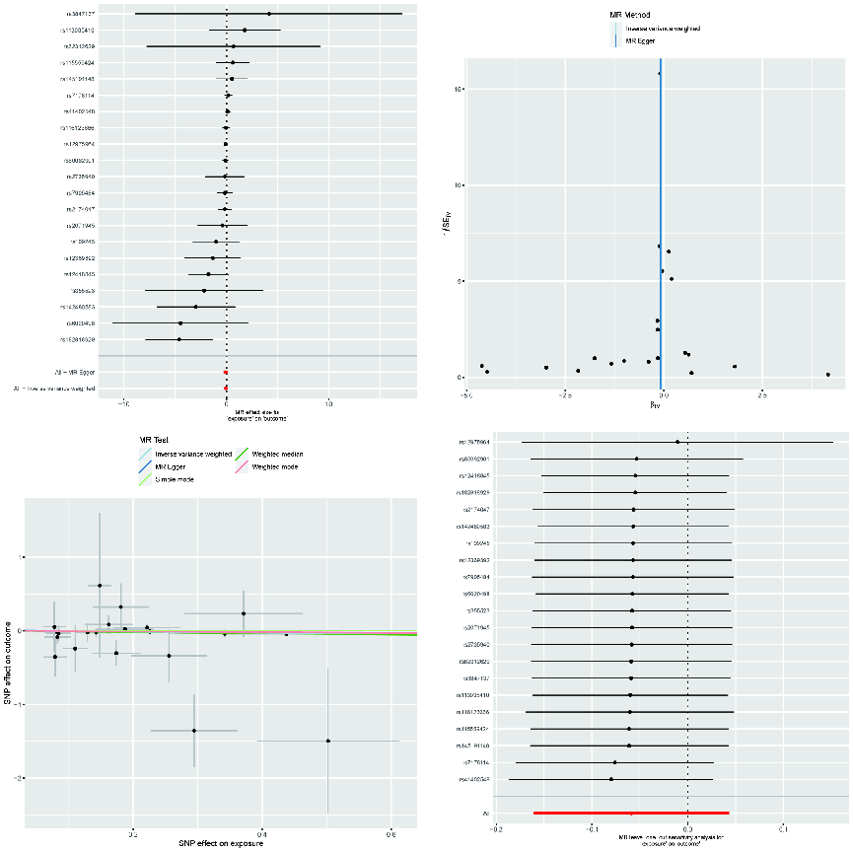
Figue S1 Visualize the results of Mendelian randomization analysis of colorectal cancer on CD3+CD8+TD T cell. Top left: Forest Plot. Top right: Funnel Plot. Lower left: Scatter Plot. Lower right: Leave-one-out Analysis

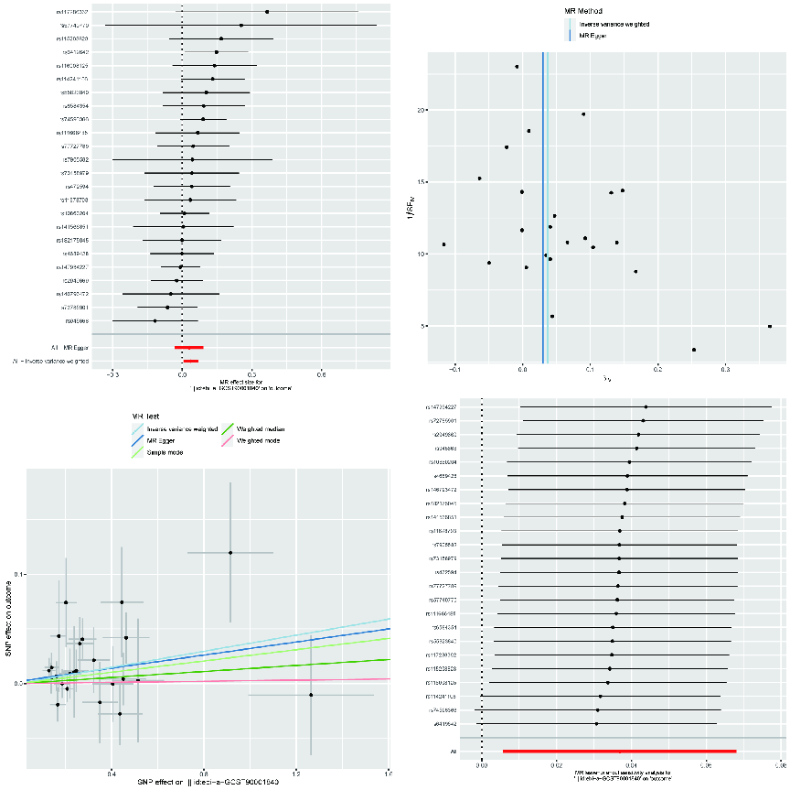

Figue S2 Visualize the results of Mendelian randomization analysis of CD3+CD8+TD T cell on VEGF-A. Top left: Forest Plot. Top right: Funnel Plot. Lower left: Scatter Plot. Lower right: Leave-one-out Analysis

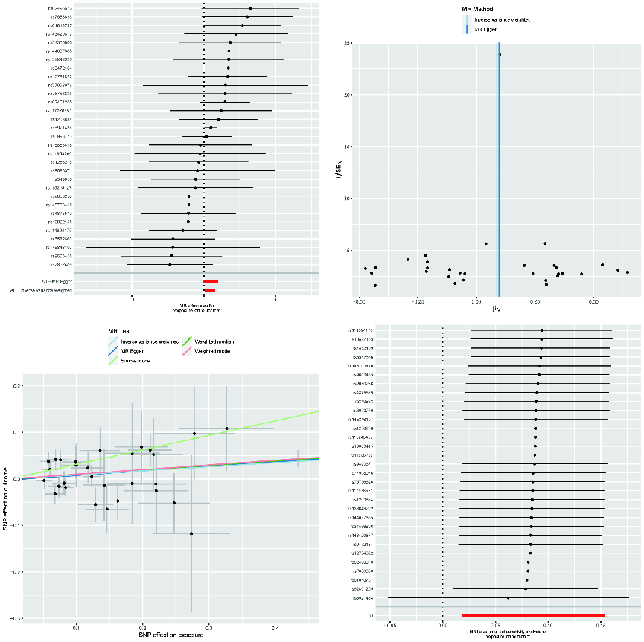

FigueS3 Visualize the results of Mendelian randomization analysis of VEGF-A on colorectal cancer. Top left: Forest Plot. Top right: Funnel Plot. Lower left: Scatter Plot. Lower right: Leave-one-out Analysis

