Supplementary Information
Mirror-like and large grain graphite film: Synthesis and properties
Liyuan Zhang,^{1§,5} Meihui Wang,^{1§} Dongho Jeon,^{1,2§} Yongqiang Meng,^{1,2} Sun Hwa Lee,¹ Myeonggi Choe,^{1,3} Yunqing Li,^{1,2} Mengran Wang,^{1,5} Sherilyn J. Lu,¹ Zonghoon Lee,^{1,3} Won Kyung Seong^{1†}, Rodney S. Ruoff^{1,2,3,4†}
¹Center for Multidimensional Carbon Materials (CMCM), Institute for Basic Science (IBS), Ulsan, Republic of Korea.
²Department of Chemistry, Ulsan National Institute of Science and Technology (UNIST), Ulsan, Republic of Korea.
³Department of Materials Science and Engineering, Ulsan National Institute of Science and Technology (UNIST), Ulsan, Republic of Korea.
⁴School of Energy and Chemical Engineering, Ulsan National Institute of Science and Technology (UNIST), Ulsan, Republic of Korea.
⁵Present address: School of Metallurgy and Environment, Central South University, Changsha, 410083, Hunan Province, P.R. China.
† Correspondence to Prof. Rodney S. Ruoff, ruofflab@gmail.com or rsruoff@ibs.re.kr; Dr. Won Kyung Seong, one2rang@gmail.com.
§ These authors made major contribution to this work.

Methods
Joule heating system
This is one of our home-built systems that can be used for rapid heating and cooling of materials or various programmed (T, t) profiles. The maximum working temperature is 3200 °C. Heating/cooling rates can reach ~100 °C/s (if useful/needed). There is a water-cooling system and therefore, the cooling time is extremely fast (cooling from 2250 °C to close to room temperature takes about 12 s). Fig. S1 shows photos of this system and some of its components in a schematic illustration and Fig. S2 shows the real image of the graphite crucible and lid.
COMSOL modeling
The temperature of the crucible and the sample was obtained by modeling with COMSOL Multiphysics. The modeling results were compared with measured temperature values, which confirmed the accuracy of the simulation. Five physics fields were used in the simulation: Electric Currents, Heat Transfer in Solids, Surface to Surface Radiation, Solid Mechanics, and Laminar Flow. The corresponding Multiphysics (Electromagnetic Heating, Surface to Surface Radiation Heat Transfer, and Non-isothermal Flow) were generated to simulate the crucible temperature distribution.
Synthesis of graphite films in our home-built system
The graphite plates and carbon papers were firstly heated in an Ar atmosphere for 1 h at 600 °C in a tube furnace with the goal of removing any adsorbed moisture. To grow a mirror-like graphite film, Ni foil (042634-Alfa-0.05mm / NI00-FL-000113-Goodfellow-0.0125mm, ≥99.95%), Mo foil (M000-FL-00220-Goodfellow-0.025mm / M000-FL-000101-Goodfellow-0.01mm, 99.9%), graphite plate (FuelCellStore, 0.3mm, 99.99%), and carbon paper (FuelCellStore, TGP-H-090, 0.28mm, 99.9%) were stacked in a top-down sequence (Fig. 1a). The dimension for these raw materials is 12 mm by 13 mm. We found through parametric studies that an atomic percentage of Ni in the Ni-Mo alloy of 50-72 at% works well. The samples were heated following the temperature-time profile (T, t) profile in Fig. 1b in an Ar atmosphere (99.999 at%) at 770 Torr and 100 sccm flow rate. Other metal combinations (Ni-Ta, Ni-Re, Ni-Ir, Fe-Mo and Co-Mo) were also tested for graphite film growth, following the same method mentioned above. (Dimensions, purity, and supplier, of all metal foil pieces, graphite plate pieces and carbon paper that were used, are presented in Table S3 below.)
We attempted to prepare graphite films by using a single metal foil. The single metal foil (of pure Fe, or Co, Ni, Pt, Pd, V, or Mo) was put onto the graphite plate and other procedures were identical to the above. The results are shown in Fig. S10 and S11.
Synthesis of graphite films in the “Red Devil” (Webb (USA)) furnace
The metal foil pieces, and graphite plate and their stacking configuration are identical to those shown in the main text. The containment chamber was filled with Ar (g) to 1 atm prior to heating this furnace. Photos of this system are shown in Fig. S14a. The (T, t) profile used for experiments with the Red Devil Furnace is shown in Fig. S14b.
Separation of graphite films
After synthesis, there is a layer of metal alloy and randomly distributed graphite chunks attached to the bottom of the mirror-like graphite film. The metal alloy was first etched by aqua regia vapor, then the graphite was further treated by a heating treatment. Finally, the mirror-like graphite film was separated from the bottom graphite chunk by peeling, as illustrated in Fig. S8.
Acid vapor treatment. The whole sample was treated by aqua regia vapor at 150 °C for 10 h to etch the metals (Fig. S8a).
Heat treatment. The graphite film was heated in the graphite furnace (Nabertherm (German)). The pressure was 1 atm, and the heating profile is shown in Fig. S8b. A goal of this step was to release stresses perhaps present in the graphite film.
Peeling. The top surface of the mirror-like graphite film was adhered to double-sided tape. The double-sided tape was then adhered onto a scotch tape and a quartz plate was glued (epoxy glue) to this assembly. The bottom layer of the mirror-like graphite film was gently removed by tape peeling.
Dissolving the double-sided tape. The so-peeled mirror-like graphite film was immersed in tetrahydrofuran. After 6 h, the double-sided tape had sufficiently dissolved such that the film was separated from it.
Observing (monitoring) formation of graphite
The metal surface was recorded by a video camera through a quartz window on the top of the Joule heating system, see Movies S1. In other experiments, a spectropyrometer was used to simultaneously measure the emissivity of the surface. The emissivity of various relevant materials is summarized in Table S2.
To investigate what are referred in the main text as “intermediate samples”, the sample was “quenched” by a fast cooling (by turning off the electrical current to the crucible) when the crucible sidewall temperature reached a certain value (namely, 1605 °C, 1930 °C, and 2250 °C) and the corresponding sample temperature is 1549 °C, 1864 °C, and 2180 °C, respectively; see (T, t) profile in Fig. S17.
Basic properties
Mechanical properties from tensile loading
A dynamic mechanical analyzer (DMA Q800, TA Instruments) was used to analyze the mechanical properties of the mirror-like graphite film when prepared in dog bone shapes. The uniaxial tensile loading of the specimen was done at a rate of 0.4 N/min with preload of 0.05 N, to obtain the stress-strain curves.
Electrical conductivity from the test by physical properties measurement system
The resistivity of the mirror-like graphite was studied by using a Physical Properties Measurement System (PPMS, Quantum Design). For four-probe resistivity measurements, samples were made with a rectangular shape (10 mm × 10 mm). The samples were attached to the resistivity measurement puck of the PPMS by using G-varnish, which is an excellent electrical insulator with good thermal conductivity, adherence, and strength at low temperatures.
Density
The density of the mirror-like graphite films was measured by Archimedes’ principle. The graphite film was settled in dibromomethane (ρ=2.477 g/cm³ at 25 ºC), while it was floated on chloroform (ρ=1.492 g/cm³ at 25 ºC). After placing the graphite film in the mixed solution of 75.0 mL dibromomethane and 25.0 mL chloroform, we slowly added dibromomethane until the graphite film was floating in the middle of the solution (See Fig. S34). The density of the graphite film was calculated as the total mass/volume of dibromomethane and chloroform mixture displaced.
Characterization
SEM (FEI Verios 460 FE-SEM) imaging and EDS spectra were used to investigate the graphite films and the side products. The electron backscatter diffraction (EBSD) mapping was performed on an Ametek Hikari camera attached to the SEM, at 6.4 nA and 20 kV. Atomic force microscopy (AFM, Bruker Dimension Icon system) was used to study the surface texture of the graphite film. Raman (Wi-Tec micro-Raman instrument) spectroscopy was performed by using a 532 nm laser. The crystallinity of the graphite film and other samples from control experiments was studied by using a Rigaku SmartLab powder X-ray diffractometer. Laue patterns were obtained by a MWL120 Real-Time Back-Reflection Laue Camera System (Multiwire Laboratories). Atomic-resolution TEM images and SAED patterns were obtained using an aberration-corrected TEM (FEI Titan G2 60-300) with an acceleration voltage of 80 kV. The sample for TEM was prepared by a standard focused ion beam (FIB) technique (FEI Quanta 3D FEG).
Supplementary Text
Synthesis of graphite films with only single metal in either molten or solid state
We attempted growing graphite by using a single metal as the substrate and found that the flat graphite film with controllable shape and size could not be obtained. We used V, Mo, Fe, Co, Ni, Pt, and Pd. The metal foils all shrunk when they melted, which produced a curved metal surface with irregular shape and size (Fig. S10). In contrast, the Ni-Mo combination yielded a flat metal surface with a graphite film precipitating on the top surface (Fig. S10), and this film retained the shape and size of the metal foils used.
We also investigated growing graphite by using solid metals (Fig. S11). A flat metal surface was maintained, and the shape and size did not change in the reaction, but we found that the flat graphite film is heavily wrinkled. We also found that the graphite film did not grow uniformly on the solid metal foil. Note that the Raman peaks of graphite were observed on the surface of these single solid metals except for Fe (Fig. S11).
Synthesis of graphite films by using other metal mixtures
We selected one typical element, respectively, from the ⅤB, ⅦB, or ⅧB groups to replace the Mo (group VIB). Fe or Co was also chosen since these two metals have been commonly used for graphite growth, too. Thus, binary metal combinations (Ni-Ta, Ni-Re, Ni-Ir, Fe-Mo and Co-Mo) were used for attempted graphite growths. Flat mirror-like graphite films were obtained on Fe-Mo and Co-Mo, but not on Ni-Ta, Ni-Re, or Ni-Ir.
Ni-Ta: As soon as the Ni foils became liquid, the alloy liquid dewetted the graphite plate. EDS and Raman spectra indicate that the metal balls consist of Ni and tantalum carbide. No graphite signal was observed in the Raman spectrum (Fig. S12).
Ni-Re: One corner of the alloy melted and shrunk after Ni melting. Raman spectrum indicates graphite on the other regions (Fig. S12).
Ni-Ir: Some regions of the metal foils (especially the edges) remained solid after Ni melting, resulting in a loose (poor) physical contact between the alloy foil and the graphite plate. Non-uniform graphite film with many large kink bands were observed on the alloy foil (Fig. S12).
Fe-Mo and Co-Mo: The graphite films synthesized on Fe-Mo and Co-Mo show flat, mirror-like surfaces, similar to that obtained on Ni-Mo (Fig. S13).
Synthesis of graphite films in the “Red Devil” (Webb (USA)) furnace
For our Joule heating stages the temperature gradient in the graphite crucible is one driving force for carbon diffusing from hot regions to cold regions (the other being the likely presence of a strong concentration gradient of carbon), resulting in the graphite formation. As a control experiment, we attempted to synthesize a graphite film in a commercial graphite furnace (Webb) (Fig. S14a), which has a relatively uniform heating zone in the chamber (close to isothermal condition). Fig. S14b presents the (T, t) profile. The as-grown graphite is heavily wrinkled (Fig. S14c).
Characterizations of the intermediates that were made to further study the reaction process
- Top surface analysis of the intermediates. The ‘intermediate samples’ were prepared by quenching the whole system at certain temperatures (sample T = 1549 °C, 1864 °C, and 2180 °C), named as intermediate-Ⅰ, intermediate-Ⅱ, intermediate-Ⅲ, respectively. The (T, t) profiles are shown in Fig. S17a. In Fig. S16a, the area ratio of kink bands to the whole surface of the intermediates increased when the temperature was raised from 1549 °C to 1864 °C then decreased for 2180 °C. The Raman spectra (Fig. S17c) and XRD patterns (Fig. S17d) show the formation of graphite films. The ‘alloy layer’ is composed of graphite particles, Ni, and molybdenum carbide for all three samples.
- Bottom surface analysis of the intermediates. The bottom sides of intermediate-Ⅰ and intermediate-Ⅱ are still isotropic graphite plates (Fig. S24a-c), indicating limited reaction between alloy and isotropic graphite plate when the temperature is relatively low (for the time used). In contrast, the isotropic graphite plate was entirely dissolved by the alloy on the bottom side of intermediate-Ⅲ. The corresponding EDS spectrum of intermediate-Ⅲ (Fig. S24h-j) shows C, Ni and Mo elements on the bottom side.
- Cross-sectional analysis of the intermediates. The cross-section SEM image of intermediate-Ⅰ (Fig. S20a) includes graphite film layer, alloy layer, and graphite plate layer from top to bottom. The graphite film layer is about 2 µm thick (Fig. S20b). In the alloy layer (Fig. S20c), the oval solid marks Mo grains (numbered as “1”), and the bright shell surrounding the Mo grains is Ni (numbered as “2-8”). It is apparent that the Ni diffuses primarily through Mo grain boundaries, as was also seen in TEM data (Fig. S23). In intermediate-Ⅱ, the thickness of graphite film is about 25 µm (Fig. S21b). The alloy layer contains not only metals but also graphite particles (Fig. 21c). This makes the original alloy layer discontinuous, which possibly weakens mechanical interaction (such as adhesion) between the precipitated graphite film and the alloy layer. In intermediate-Ⅲ (Fig. S22b), the thickness of graphite film was larger than 100 µm and as mentioned, the graphite plate was entirely consumed; the original compact alloy layer converted to a highly porous and discontinuous layer; the adhesion between the graphite and this porous/discontinuous layer is likely dramatically lowered.
Ni evaporation and control experiments on kink formation
How can the ‘alloy layer’ be made to be (or become) porous? We found the answer by i) observing evaporation of Ni as a deposit on the top quartz window in the Joule heating system (Fig. S1a,b), and by ii) examination of the as-deposited Ni (Fig. S26). After the reaction, about 62 wt.% of Ni was evaporated, which created “holes” in this alloy layer.
We describe here a control experiment that shows the importance of metal evaporation:
Ni foil was replaced by Pt foil (Ni vapor pressure is 1,074 Pa at ~2127 °C,¹ and Pt vapor pressure is about 45 Pa at 2500 °C)². Essentially no Pt evaporation was found by using Pt-Mo binary catalyst (Fig. S27). Even though we increased the crucible temperature to 2500 °C, the final graphite film product is still heavily wrinkled (Fig. S27b and S27c). We suggest that Ni evaporation and the resulting porous alloy layer helps to decrease the density of graphite kink bands. A continuous alloy layer that is strongly adhered to the graphite film will strongly thermally contract during cooling (due to the relatively large thermal expansion coefficient); this applies a compressive stress on the graphite film that can drive the formation of wrinkles and kink bands.
That is: Our strategy was to evaporate much of the Ni to render the alloy layer porous and ideally not ‘connected’ at all to the precipitated graphite film, in terms of being able to exert compressive interface stress.

Supplementary Figures
Fig. S1. Illustration of the home-built Joule heating system. (a) Schematic of our home-made Joule heating system. (b) Photographs of the reaction chamber, side view (left) and top view (right). (c) Schematic of the graphite crucible.

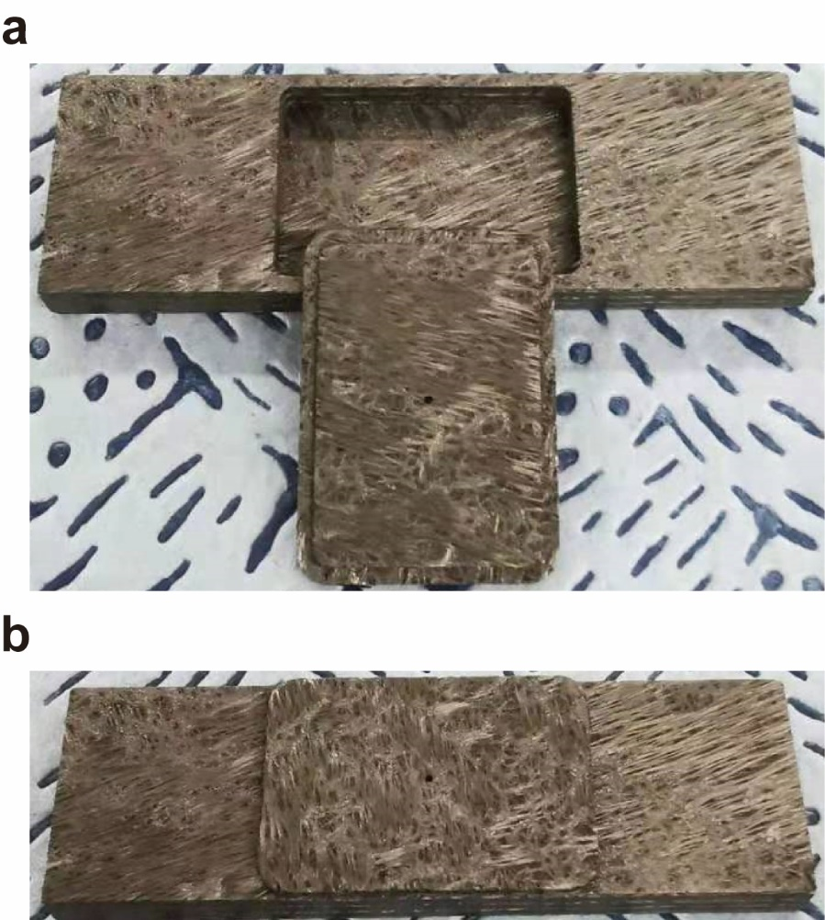
Fig. S2. Photographs of graphite crucibles: (a) with lid standing next to the crucible, and (b) with lid covering the crucible.

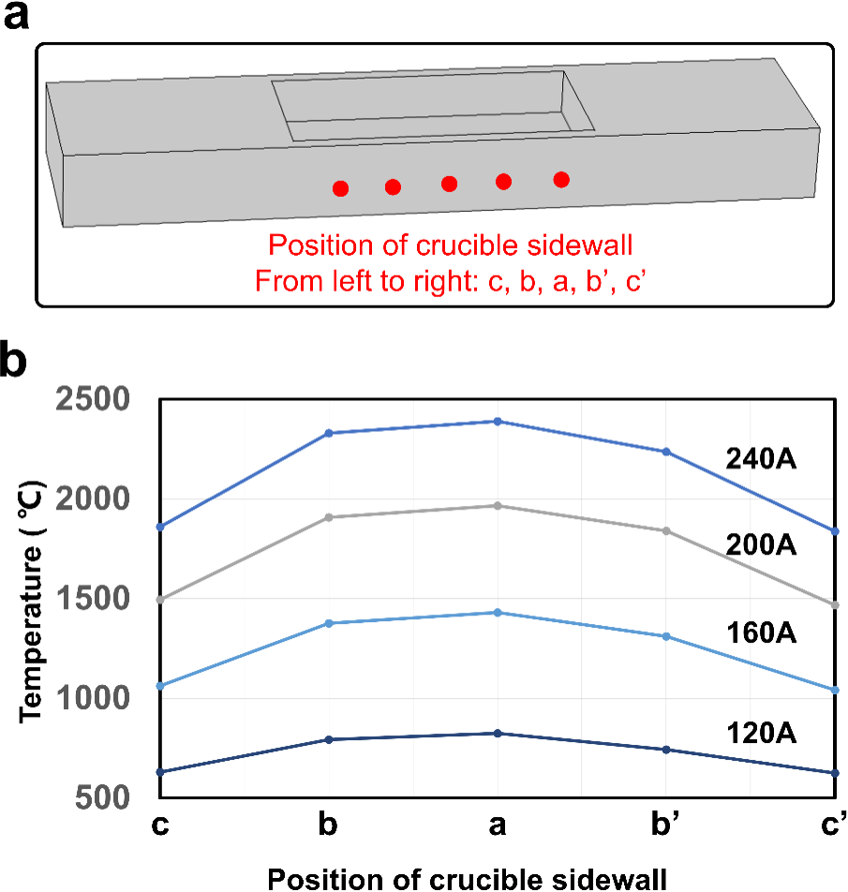
Fig. S3. Temperature measured on the sample surface with lid at different positions. Configuration (a) is without crucible lid, (b) Temperature measurements at different positions of the graphite crucible in configuration (a): temperature of the crucible side wall (b).

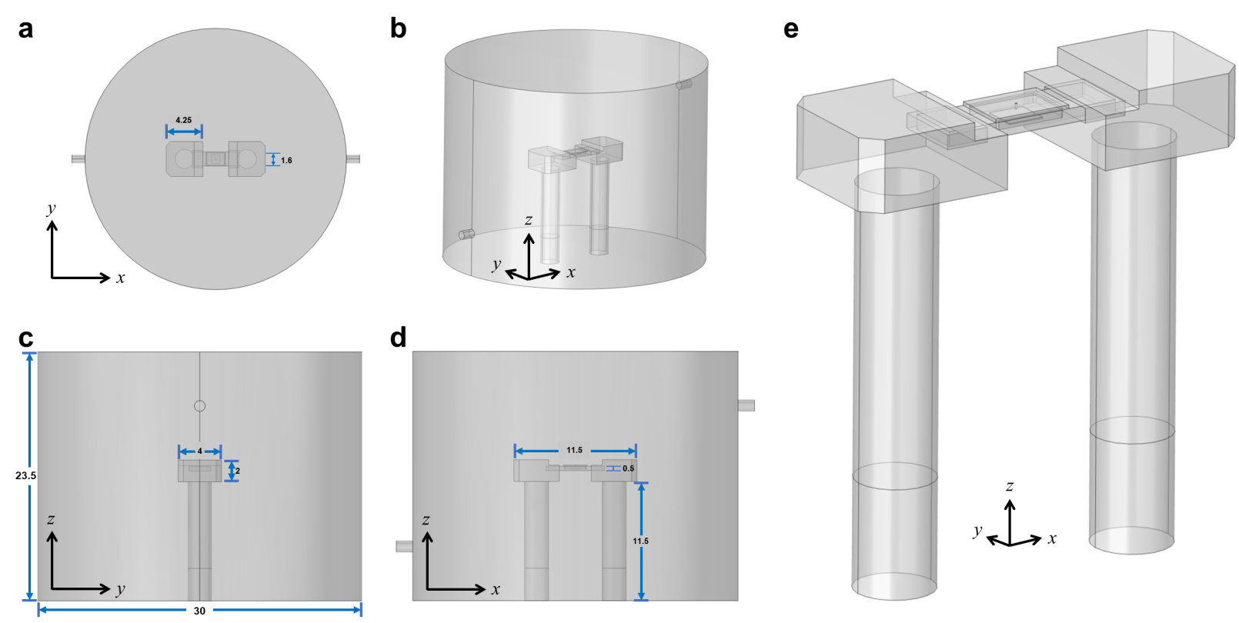
Fig. S4. Schematic of COMSOL modeling. (a-d) Top view (a), side views (b, d) (front view (d)) of the whole reaction chamber. (e) Side view of the graphene crucible and the electrodes. Unit of the length values is cm.

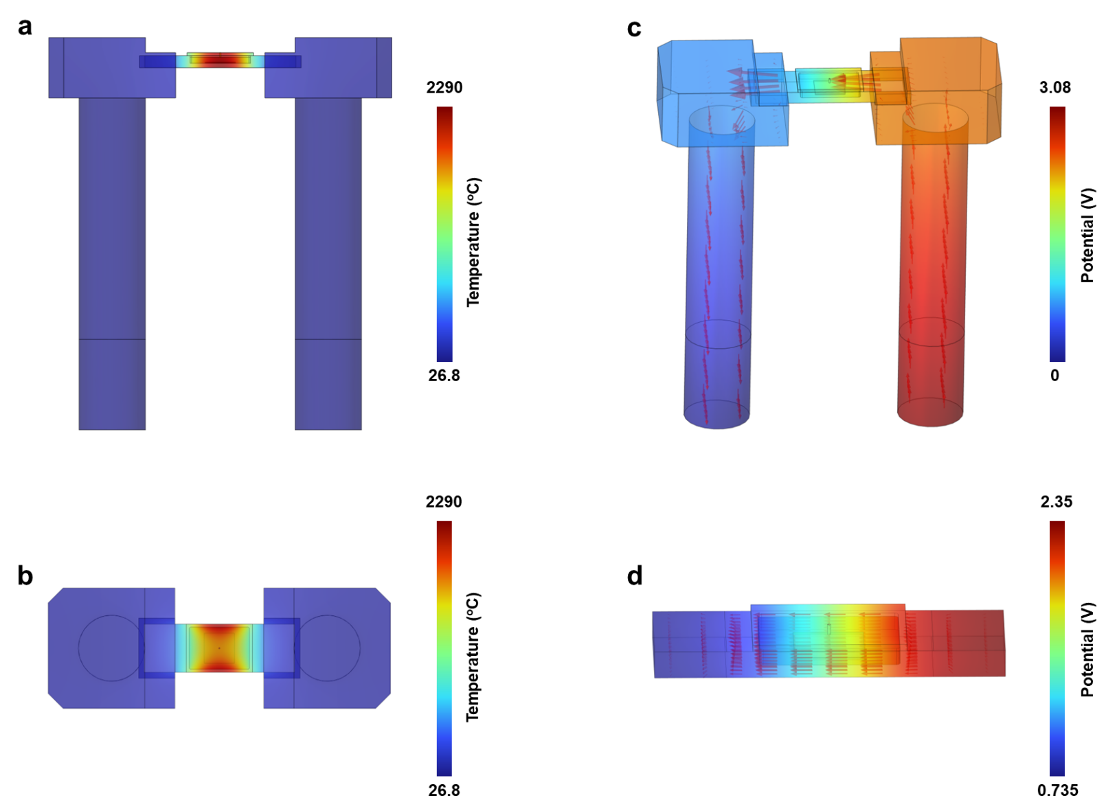
Fig. S5. COMSOL modeling results of (a,b) temperature distribution and (c,d) electric filed over the whole graphite crucible and the electrode. (a,c) Side views and (b,d) top views.

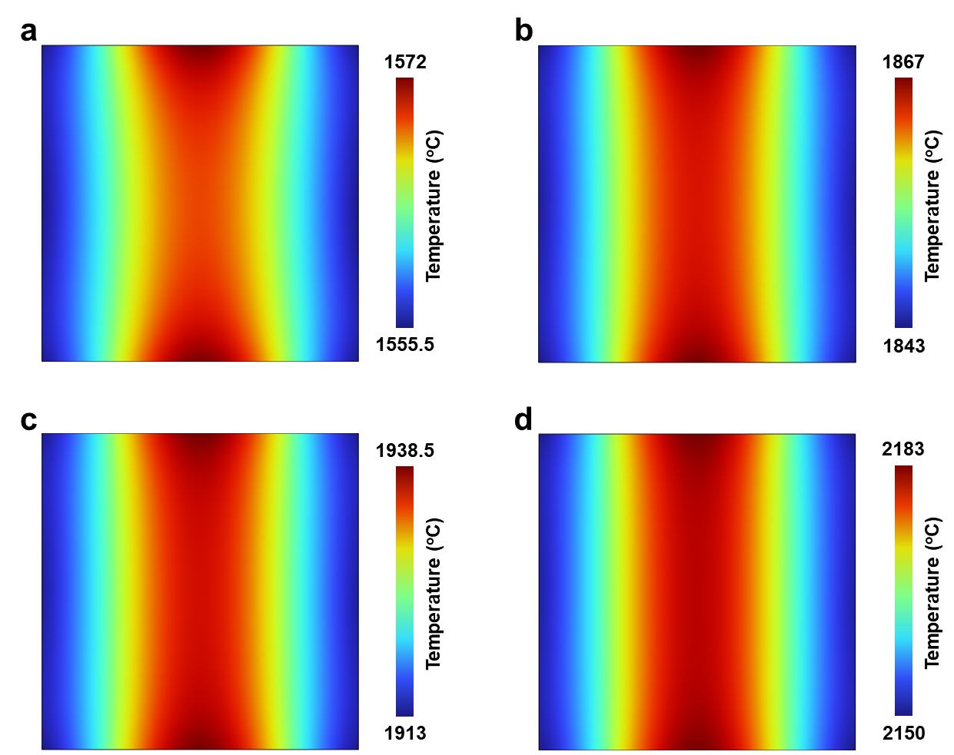
Fig. S6. COMSOL modeling results of the temperature distributions over the metal foils when the temperature of graphite crucible sidewall reaches (a) 1605 °C, (b) 1930 °C, (c) 2000 °C and (d) 2250 °C.

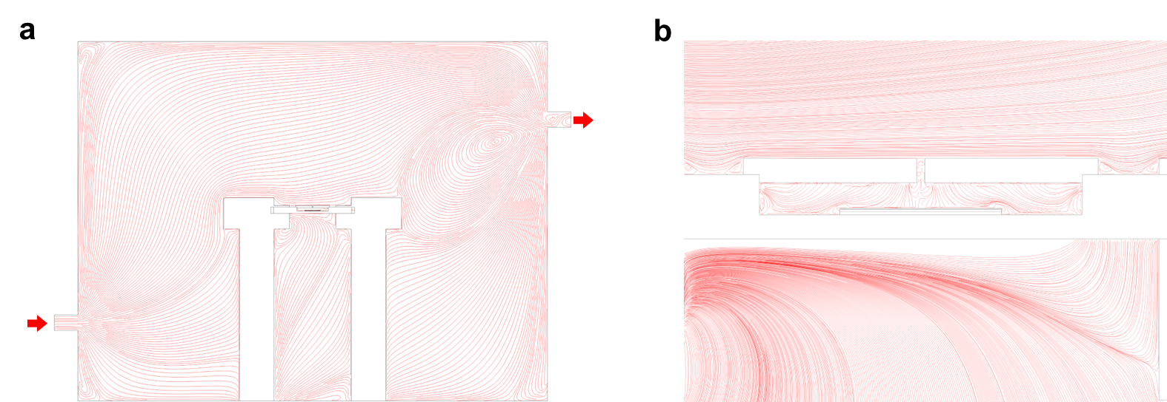
Fig. S7. COMSOL modeling results of fluid field (a) in the whole chamber and (b) around graphite crucible.

Fig. S8. Separation of the mirror-like graphite film. Mirror-like flat graphite film was separated by (a) acid vapor treatment to remove the metals in the substrate, (b) heat treatment by graphite furnace in Ar (1 atm) at 2250 ºC, (c) peeling off the substrate then dissolving the double stick tape in tetrahydrofuran. (d) Photographs of obtained free-standing mirror-like graphite films.
Fig. S9. Characterization of the intermediate obtained by quenching the experiment as soon as the shiny spots emerged and the screen shots from the Media S1 at different time. (a) SEM image, and (b) Raman spectra of the intermediate. (c) The screen shots at 413 s, 420 s, and 427 s and the corresponding emissivity.

Fig. S10. Illustration of metal shrinkage when using a single metal (molten state) as the catalyst (a-h) Metals before and after melting: (a) Fe foil, (b) Co foil, (c) Ni foil, (d) Pt foil, (e) Pd foil, (f) V foil, (g) Mo foil, and (h) Ni-Mo binary catalyst: Ni foil standing on the top of Mo foil.
Noting about Fig. S10: We quenched the experiment as soon as we observed the melting of the metal.

Fig. S11. Illustration of graphite growth using a single metal (solid state) as the catalyst and the corresponding characterizations (the center one is Raman spectrum and the right one is SEM image). (a) Fe foil, (b) Ni foil, (c) Co foil, (d) Mo foil.
Note about Fig. S11: The graphite crucible was heated up to 1300 ºC and held for 10 h for Fe, Co, and Ni. For Mo, the crucible temperature was 2200 ºC and the holding time was also 10 h. At these relatively low temperatures (for these metals, respectively), the metal foils stayed in the solid state.
No graphite signal was observed in the Raman spectra of Fe foil (10 h), while a signal of defective graphite was found for the Co foil (10 h). The Raman spectra of high-quality graphite were observed for Ni foil (10 h) and Mo foil (10 h).
Fig. S12. Illustration of graphite film synthesis by other binary combinations and the corresponding characterizations. (a) Ni-Ta combination. (b) Ni-Re combination. (c) Ni-Ir combination. The right-most images in (a), (b), and (c) is the corresponding SEM images. (d) The corresponding Raman spectra of the products.
Brief method for Fig. S12: We quenched the experiment as soon as we observed the melting of the metal.
Note: The metal did not shrink in Ni-Ir combination, but the alloy is partially in solid state (typically the edge). Therefore, even after running the whole (T, t) profile in Fig. 1b, we still cannot produce a mirror-like graphite film with regular shape and size (as given below).
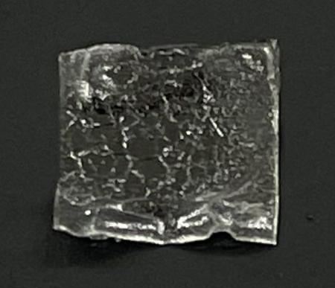
Further note related to Fig. S12. The photograph of the final product by Ni-Ir synthesized based on (T, t) profile in Fig. 1b.

Fig. S13. Synthesis of the mirror-like graphite film by Fe-Mo and Co-Mo binary catalysts. (a, b) Photograph of the graphite film by Fe-Mo binary catalyst (a), and by Co-Mo binary catalyst (b). The (T, t) profile for these two binaries is identical to Ni-Mo combination in Fig. 1b. (c) Raman spectra of graphite films grown by Fe-Mo and Co-Mo binary catalysts.

Fig. S14. Synthesis of graphite films by graphite furnace with uniform heating zone. (a) Photograph of a graphite furnace with uniform heating zone, called Red Devil. (b) (T, t) profile for graphite growth. (c, d) Photographs of the final product: top view (c) and bottom view (d).

Fig. S15. AFM characterization of the mirror-like graphite film. (a, b) AFM height images of the mirror-like graphite film. (c) Height profile along the black line shown in (b).

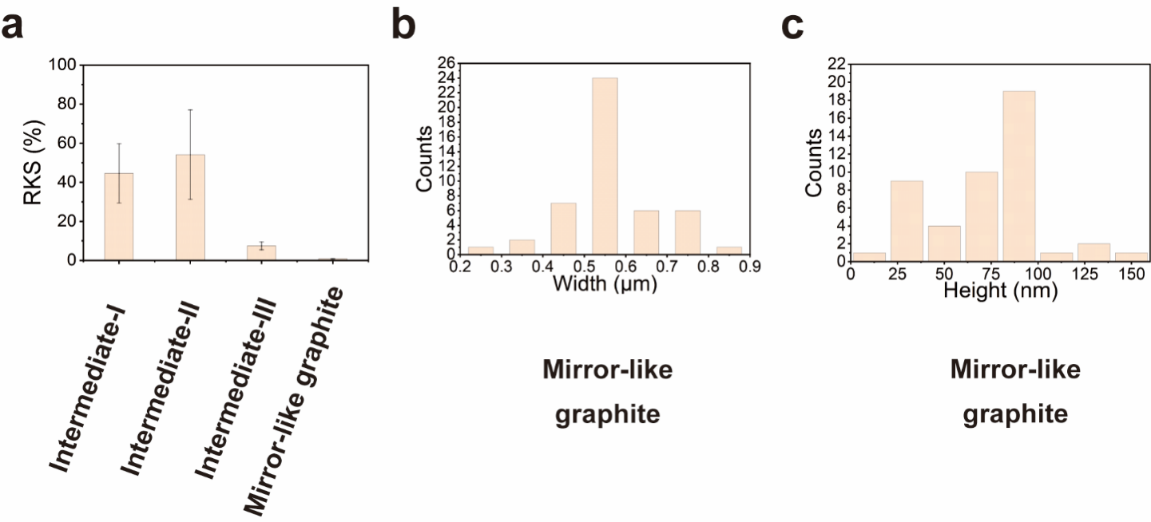
Fig. S16. Kink bands in the mirror-like graphite films. (a) Area ratio of nano-kink regions to the whole surface of mirror-like graphite film (RKS in brief in y-axis) and the three intermediates. (b, c) Number distributions of the widths (b) and the heights (c) of the nano kink on the mirror-like graphite film. The definition of intermediate was given in main text.
Fig. S17. Characterizations of the intermediates. (a) (T, t) profile for the preparation of the intermediates. (b-d) Photographs (b), corresponding Raman spectra (c) and XRD patterns (d) of the intermediates.

Fig. S18. AFM characterization of the intermediates. (a-c) AFM height images of intermediate-Ⅰ (a), -Ⅱ (b), and -Ⅲ (c). (d-f) Height profiles of intermediate-Ⅰ (d), intermediate -Ⅱ (e), and intermediate -Ⅲ (f), along the black lines shown in (a), (b) and (c), respectively.
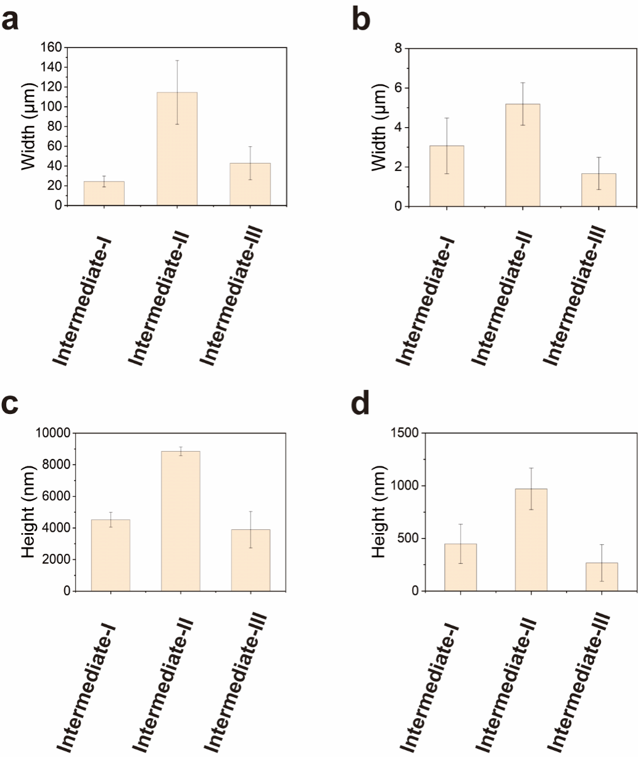
Fig. S19. Number distributions of kink widths and heights of the intermediates. (a, b) Number distributions of the widths (a) and the heights (b) of the large kink bands in the intermediates. (c, d) Number distributions of the widths (c) and the heights (d) of the micro kink bands in the intermediates.

Fig. S20. Cross-section analysis of intermediate-Ⅰ. (a, b) SEM images of the cross section of intermediate-Ⅰ. (c) SEM image and EDS spectra of the alloy layer.

Fig. S21. Cross-section analysis of intermediate-Ⅱ. (a, b) SEM images of the cross section of intermediate-Ⅱ. (c) SEM image and EDS spectra of the alloy layer.

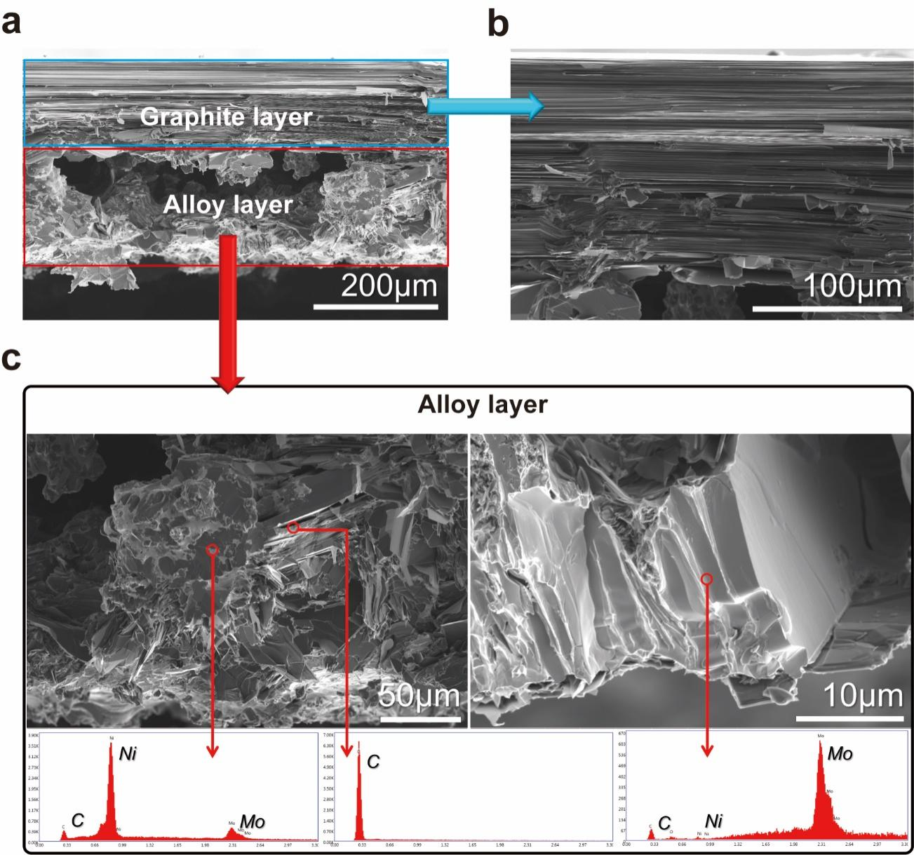
Fig. S22. Cross-section analysis of intermediate-Ⅲ. (a, b) SEM images of the cross section of intermediate-Ⅲ. (c) SEM images and EDS spectra of the alloy layer.

Fig. S23. TEM analysis of the cross section of the intermediates. (a, b) Bright field TEM images and corresponding ESD line scanning results of intermediate-Ⅰ (a) and intermediate-Ⅱ (b). The samples for cross section analysis were prepared by FIB technique.

Fig. S24. Characterizations of the intermediates from the bottom side. (a) Photographs of the bottom sides of the intermediates. (b, c) Raman spectra (b) and XRD patterns (c) of the bottom sides of the intermediates. (d-j) SEM images and corresponding EDS spectra of the bottom sides of intermediate-Ⅰ (d, e), intermediate-Ⅱ (f, g), and intermediate-Ⅲ (h-j).

Fig. S25. XRD characterization of the alloy layer of the intermediates. Peaks of pure nickel and Mo₂C were observed in the alloy layer of intermediate-Ⅰ and intermediate-Ⅱ. The graphite film on these two intermediates was removed by tape peeling to expose the alloy layer.

Fig. S26. Evaporation of Ni in the reaction process. (a, b) SEM image (a) and EDS spectrum (b) of the evaporated materials collected from the top quartz window in the Joule heating system (top window in Fig. S1a).

Fig. S27. Graphite synthesized by using Pt-Mo binary catalyst. (a) (T, t) profile. (b-d) Photograph (b), SEM image (c) and Raman spectrum (d) of the as-grown graphite film.
Note: The crucible sidewall temperature for the (T, t) profile was increased to 2500 °C due to the high melting temperature of platinum (1768 °C).

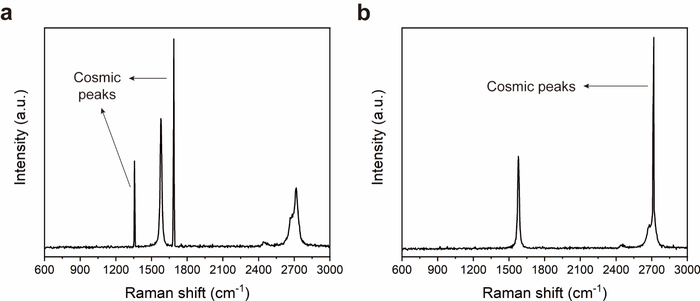
Fig. S28. Raman characterization of the mirror-like graphite film. (a, b) ‘Cosmic ray peaks’ are observed in the Raman maps (Fig. 3b and 3d).

Fig. S29. XRD characterization in “the basal plane direction” of the mirror-like graphite film.

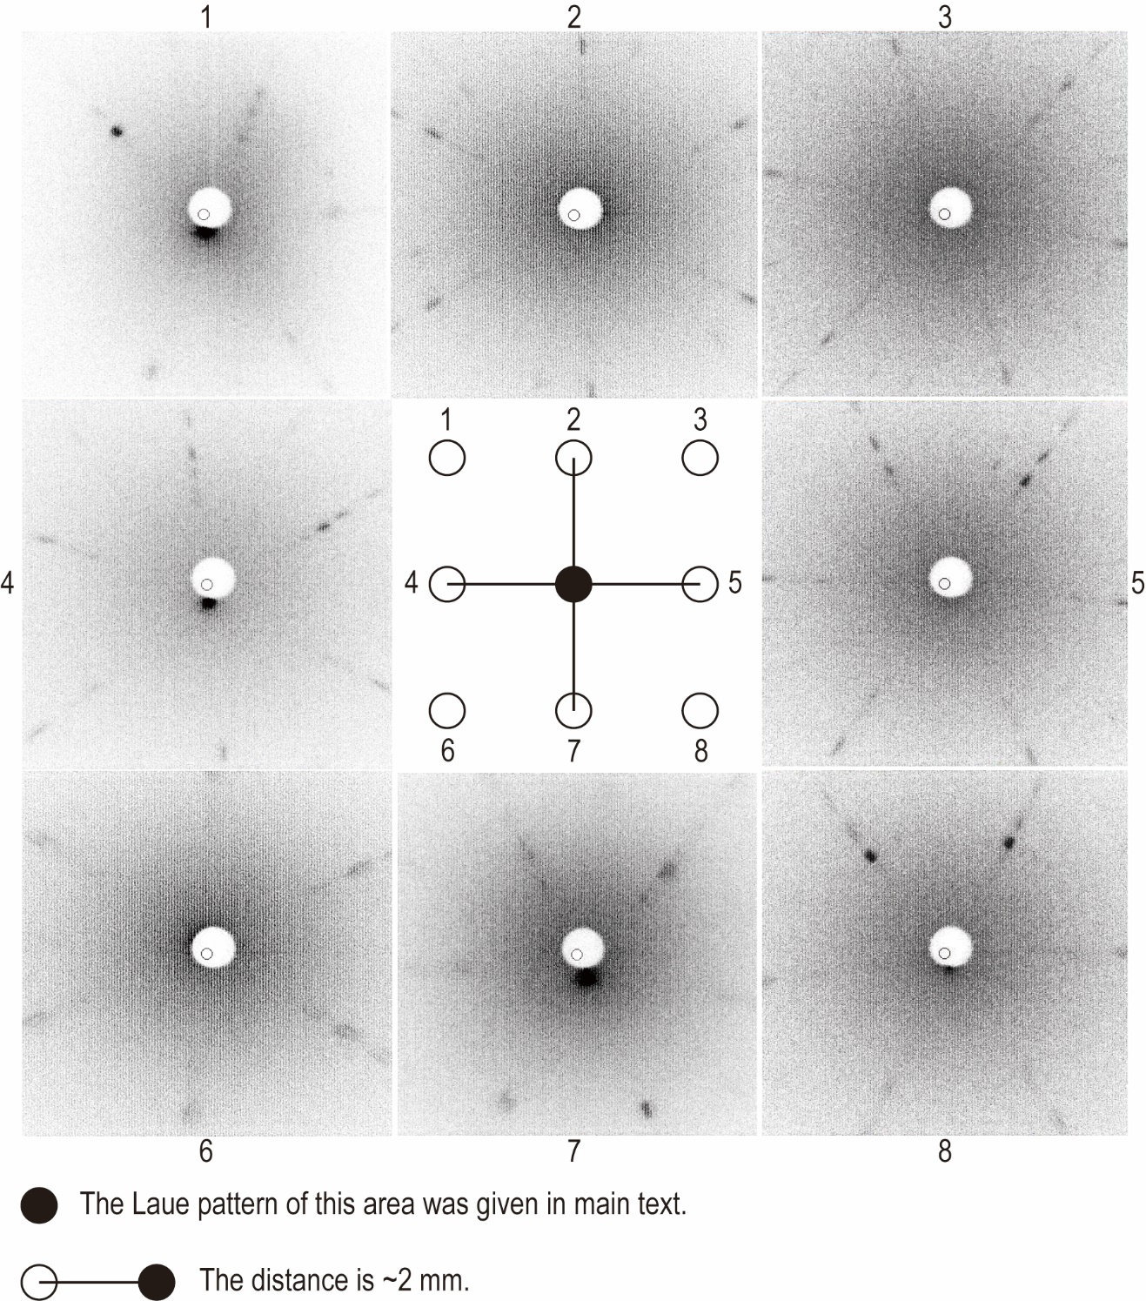
Fig. S30. The eight Laue patterns of the areas nearby the region shown in Fig. 3h. The aperture of the hole is 1 mm.

Fig. S31. EBSD characterizations of HOPG. (a) Laue pattern of HOPG. (b) EBSD characterization of HOPG. As compared with Fig. 3i, the unique grain color map of HOPG sample indicates that grain sizes (<20 μm) in HOPG (supplied by SPI, Grade ZYA) is much smaller than that in our mirror-like graphite films. The quasi ring-like appearance of the (100) PF of HOPG also demonstrates the small grains in HOPG. The dispersive points shown in the IPF image and colorful regions shown in the grain color map of HOPG indicate the discontinuous structure of the HOPG sample.

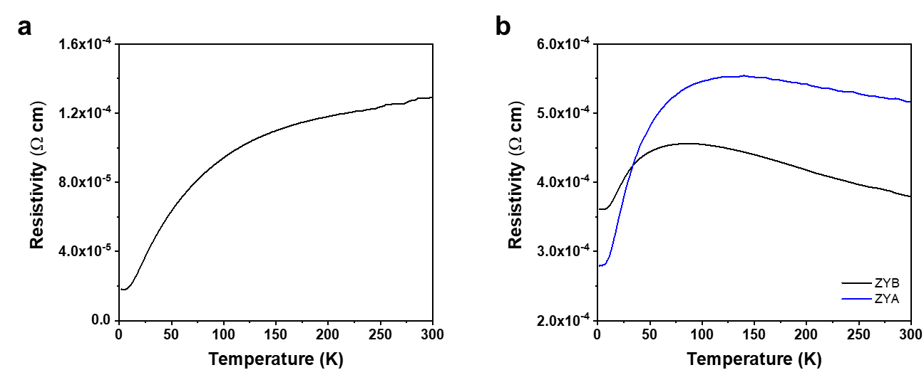
Fig. S32. Temperature dependence of in-plane resistivity for (a) the mirror-like graphite film and (b) HOPG (ZYA and ZYB grades).

Fig. S33. Tensile strength-stress profiles of the mirror-like graphite film.

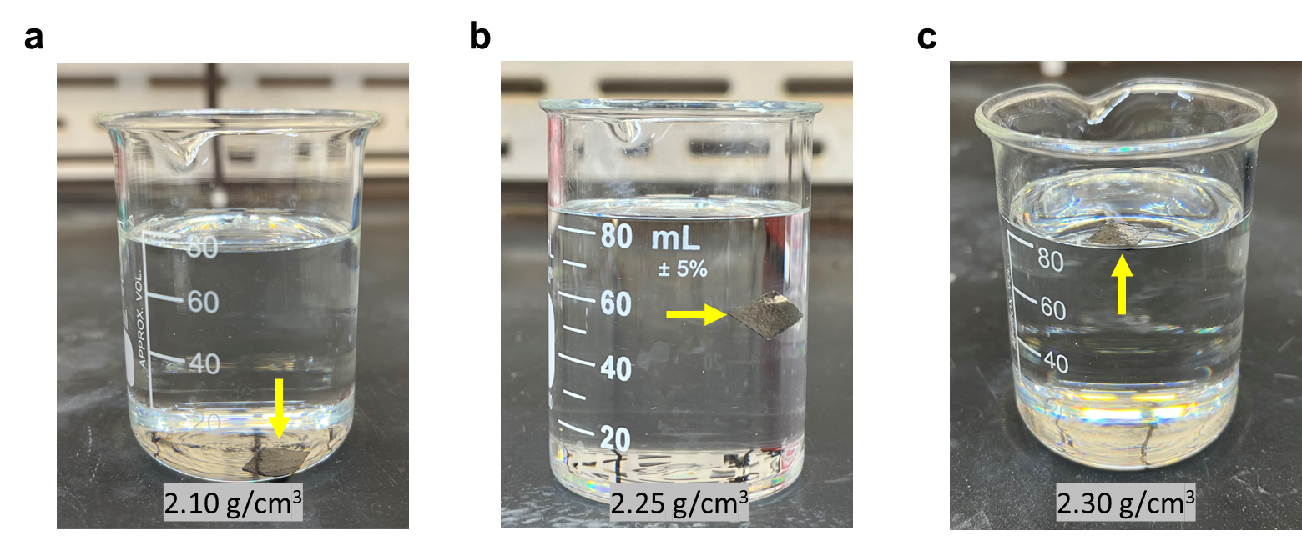
Fig. S34. Photos of the mirror-like graphite films in the mixed solutions of dibromomethane and chloroform with densities of (a) 2.10 g/cm³, (b) 2.25 g/cm³ and (c) 2.30 g/cm³, respectively. The position of the graphite films is indicated by the yellow arrows.

Supplementary Tables
Table S1. Correlation of crucible temperature with sample surface temperature based on spectropyrometer measurements and COMSOL simulation.
Crucible Temperature ª (ºC) | 1605 | 1930 | 2000 | 2250
Sample Temperature ^{b} (ºC) | 1546 | 1872 | 1932 | 2177
Sample Temperature ^{c} (ºC) | 1549 | 1864 | 1936 | 2180
ª The position to measure the crucible temperature was marked in Fig. 1a by an orange spot.
^{b} The sample temperature was measured by pyrometer on the position illustrated in Fig. S3a (x=0, y=0, z=0).
^{c} The sample temperature was taken from the COMSOL modeling on the position illustrated in Fig. 1c (x=0, y=0, z=0).

Table S2. Emissivity of standard materials measured by spectropyrometer.
Materials | Emissivity | Temperature (°C)
HOPG | 0.717±0.006 | 1763
Isotropic graphite (coarse surface) | 0.716±0.007 | 1744
Isotropic graphite (smooth surface) | 0.649±0.010 | 1846
Ni foil | 0.132±0.002 | 971
Mo foil | 0.209±0.005 | 1807

Table S3. Information of the metal foils, graphite plates and carbon papers for the synthesis of mirror-like graphite film.
Materials | Thickness (mm) | Stated Purity (wt%) | Supplier
Fe foil | 0.05 | 99.99+ | Good Fellow
Co foil | 0.05 | 99.95 | Alfa
Ni foil | 0.01~0.05 | ≥99.95 | Alfa / Good Fellow
Mo foil | 0.01~0.05 | 99.9 | Goodfellow
Graphite plate | 0.3 | 99.99 | FuelCellStore
Carbon paper | 0.23 | 99.9 | FuelCellStore
Ir foil | 0.05 | 99.9 | Goodfellow
Re foil | 0.05 | 99.9 | Goodfellow
Ta foil | 0.05 | 99.9 | Goodfellow

Table S4. Collection of the tensile properties of the graphite specimens based on Fig. S33.
Sample | Tensile strength (GPa) | Young’s modulus (GPa) | Yield strain (%)
#1 | 1.63 | 996 | 0.225
#2 | 1.22 | 1010 | 0.143
#3 | 1.09 | 1020 | 0.208
#4 | 1.22 | 850 | 0.172
Average | 1.29 | 969 | 0.187

Table S5. Collection of the tensile properties of the graphite specimens with relatively low performance.
Sample | Tensile strength (MPa) | Strain (%) | Young’s modulus (GPa)
#1 | 10.1 | 0.056 | 18.2
#2 | 236.8 | 0.117 | 183.1
#3 | 94.2 | 0.084 | 113.9
#4 | 9.9 | 0.020 | 50.7
#5 | 68.5 | 0.073 | 99.4
#6 | 166.5 | 0.086 | 198.6
#7 | 22.4 | 0.018 | 128.9
#8 | 4.4 | 0.036 | 30.1
#9 | 183.1 | 0.065 | 292.3
#10 | 8.9 | 0.015 | 54.4
#11 | 1.8 | 0.008 | 29.0
#12 | 165.1 | 0.062 | 280.9
#13 | 39.9 | 0.009 | 454.2
#14 | 8.3 | 0.019 | 44.1
#15 | 226.8 | 0.118 | 219.4
#16 | 378.8 | 0.226 | 337.6
#17 | 111.1 | 0.190 | 135.3
#18 | 7.4 | 0.012 | 65.9
#19 | 241.4 | 0.106 | 323.6
#20 | 508.6 | 0.081 | 970.1
#21 | 148.9 | 0.113 | 136.8
#22 | 130.8 | 0.386 | 858.8
#23 | 299.5 | 0.047 | 3106.6
#24 | 226.8 | 0.118 | 219.4
#25 | 179.9 | 0.064 | 292.3
#26 | 389.1 | 0.105 | 365.3
#27 | 12.2 | 0.019 | 24.4
#28 | 26.5 | 0.071 | 45.8
#29 | 107.2 | 0.061 | 126.2
#30 | 85.5 | 0.036 | 148.4

Note: The possible reason for obtaining the low strength values is then when loading these samples onto the DMA system (due to the movement of the bottom clamp) they were damaged. “Sliding” of the graphite film is another problem we encountered in some tensile loading measurements.

Table S6. Summary of the performance of film made of graphene, reduced graphene oxide, or polymer precursor.
Refs | Tensile strength  (GPa) | Young’s modulus  (TPa) | Electric conductivity  (10⁵ S m⁻¹)
Adv. Mater. 2019, 31, 1903039 | 0.51 | 0.0511 | 2.2
Adv. Mater. 2018, 30, 1802733 | 0.821 | - | 0.416
J. Am. Chem. Soc. 2015, 137, 9077 | 0.224 | 0.01 | 0.015
Carbon, 2019, 155, 462 | 0.0167 | 0.00032 | 4.2
Mater. Today, 2019, 30, 17-25 | 1 | - | -
Matter 2019, 1, 389 | 1.054 | 0.0233 | 1.192
ACS Nano 2020, 14, 14731 | 0.15 | 0.0214 | -
Adv. Mater. 2020, 32, 1907411 | 0.145 | - | 1.34
Nat. Commun., 2020, 11, 2645 | 1.1 | 0.06027 | 1.1
Carbon, 2021, 181, 40 | 0.2 | - | -
Carbon, 2021, 181, 348 | 5.34 | 0.102 | 0.181
Carbon, 2018, 132, 294 | 0.07 | 0.022 | 3.1
Nat. Mater., 2021, 20, 624 | 1.55 | 0.0645 | 1.394
ACS Nano 2022, 16, 8869 | 0.448 | 0.051 | -
Adv. Mater. 2019, 31, 1903039 | 0.51 | 0.0511 | 2.2
This Work | 1.29 | 0.969 | 55.9
-: Not provided.

Table S7. Density of the mirror-like graphite films measured by Archimedes’ principle. The averaged density of the mirror-like graphite films is 2.25 g/cm³.
Sample | dibromomethane | chloroform | Density (g/cm³)
#1 | 83.3 mL | 25.0 mL | 2.25
#2 | 81.5 mL | 25.0 mL | 2.25
#3 | 84.2 mL | 25.0 mL | 2.25
Average |  |  | 2.25

*Density of solvents at 25 ºC: dibromomethane: 2.477 g/cm³, chloroform: 1.492 g/cm³.

Reference-SI
1 Desai, P. D. Thermodynamic properties of nickel. Int. J. Thermophys. 8, 763-780 (1987).
2 Hampson, R. F., Jr. & Walker, R. F. Vapor Pressures of Platinum, Iridium, and Rhodium. J. Res. Natl. Bur. Stand. A Phys. Chem. 65a, 289-295 (1961).

