Supplementary Tables & Figures

Part 1: Tables corresponding to analyses in manuscript

Table S1: Experiment 1 ACMEs
feature | level | estimate | std.error | p | lower | upper
Distance | 50 miles (not likely to be visible from your home, school, or workplace) | 0.000 | NA | NA | NA | NA
Distance | 10 miles (potentially visible during drives or commutes in and out of the area) | 0.011 | 0.022 | 0.621 | -0.032 | 0.054
Distance | 5 miles (potentially visible from your home, school, or workplace) | -0.018 | 0.022 | 0.415 | -0.061 | 0.025
Distance | 2 miles (likely visible from your home, school, or workplace) | -0.073 | 0.020 | 0.000 | -0.113 | -0.034
Jobs | No changes to number of local energy jobs | 0.000 | NA | NA | NA | NA
Jobs | 50 jobs lost due to retirement of an old plant | -0.122 | 0.019 | 0.000 | -0.159 | -0.084
Jobs | Creation of 50 permanent jobs with union-scale wages | 0.123 | 0.021 | 0.000 | 0.082 | 0.164
Jobs | Creation of 50 temporary hourly-wage jobs during construction | 0.045 | 0.020 | 0.027 | 0.005 | 0.085
Benefits | Reduced energy costs for all local residents | 0.000 | NA | NA | NA | NA
Benefits | Increased access to affordable clean energy in marginalized communities | -0.020 | 0.020 | 0.320 | -0.061 | 0.020
Benefits | Increased overall economic activity in the community | -0.057 | 0.019 | 0.002 | -0.094 | -0.020
Benefits | Reduced local air pollution | -0.049 | 0.020 | 0.013 | -0.087 | -0.010
Ownership | Owned by an American private company | 0.000 | NA | NA | NA | NA
Ownership | Owned by a foreign private company | -0.173 | 0.025 | 0.000 | -0.223 | -0.124
Ownership | Owned by state government | -0.039 | 0.024 | 0.107 | -0.087 | 0.008
Ownership | Owned cooperatively by community | 0.052 | 0.024 | 0.032 | 0.005 | 0.100
Site | Low visual impact on scenic resources | 0.000 | NA | NA | NA | NA
Site | Agricultural land | -0.002 | 0.023 | 0.939 | -0.048 | 0.044
Site | Decommissioned mining or industrial site | 0.015 | 0.024 | 0.534 | -0.032 | 0.061
Site | Low impact on wildlife habitats | 0.047 | 0.025 | 0.062 | -0.002 | 0.095
Type | Natural gas power plant with carbon capture and storage (CCS) | 0.000 | NA | NA | NA | NA
Type | Large-scale onshore wind turbines | 0.012 | 0.022 | 0.588 | -0.031 | 0.055
Type | Large-scale solar energy farm | 0.072 | 0.023 | 0.002 | 0.027 | 0.117
Type | Nuclear power plant | -0.060 | 0.023 | 0.009 | -0.106 | -0.015

Table S2: Experiment 1 marginal means by respondent party (see CSV pasample_bypolparty_mm.csv on OSF)) and differences in marginal means (see CSV pasample_bypolparty_mmdiff.csv on OSF)

Table S3: Local elected official ACMEs (Experiment 2)
feature | level | estimate | std.error | p | lower | upper
Distance | 50 miles | 0.000 | NA | NA | NA | NA
Distance | 2 miles | 0.068 | 0.038 | 0.072 | -0.006 | 0.142
Jobs | No net increase of permanent jobs | 0.000 | NA | NA | NA | NA
Jobs | Net decrease of 50 permanent jobs | -0.002 | 0.059 | 0.974 | -0.117 | 0.113
Jobs | Net increase of 50 permanent jobs | 0.081 | 0.059 | 0.169 | -0.034 | 0.195
Benefits | Reduced residential energy costs | 0.000 | NA | NA | NA | NA
Benefits | Increased economic activity | -0.081 | 0.046 | 0.074 | -0.171 | 0.008
Ownership | Owned by an American private company | 0.000 | NA | NA | NA | NA
Ownership | Owned by a foreign private company | -0.286 | 0.050 | 0.000 | -0.383 | -0.188
Ownership | Owned by state government | -0.047 | 0.060 | 0.434 | -0.163 | 0.070
Ownership | Owned cooperatively by a community | 0.033 | 0.052 | 0.523 | -0.068 | 0.134
Site | Minimal impact on scenic views | 0.000 | NA | NA | NA | NA
Site | Minimal impact on agriculture | 0.042 | 0.056 | 0.446 | -0.067 | 0.151
Site | Minimal impact on wildlife habitats | 0.009 | 0.050 | 0.861 | -0.090 | 0.107
Type | Natural gas power plant with carbon capture and storage (CCS) | 0.000 | NA | NA | NA | NA
Type | Large-scale onshore wind turbines | -0.260 | 0.067 | 0.000 | -0.392 | -0.128
Type | Large-scale solar energy farm | -0.073 | 0.071 | 0.304 | -0.212 | 0.066
Type | Natural gas power plant | -0.191 | 0.074 | 0.010 | -0.335 | -0.046
Type | Nuclear power plant | -0.179 | 0.081 | 0.027 | -0.338 | -0.021

Table S4: Difference in marginal means by party (Experiment 2)
feature | level | estimate | std.error | p | lower | upper
Distance | 50 miles | -0.052 | 0.079 | 0.513 | -0.207 | 0.103
Distance | 2 miles | -0.057 | 0.071 | 0.422 | -0.197 | 0.083
Jobs | No net increase of permanent jobs | -0.077 | 0.099 | 0.440 | -0.272 | 0.118
Jobs | Net decrease of 50 permanent jobs | -0.084 | 0.088 | 0.337 | -0.257 | 0.088
Jobs | Net increase of 50 permanent jobs | -0.006 | 0.096 | 0.951 | -0.194 | 0.182
Benefits | Reduced residential energy costs | -0.035 | 0.076 | 0.647 | -0.184 | 0.114
Benefits | Increased economic activity | -0.069 | 0.070 | 0.320 | -0.206 | 0.067
Ownership | Owned by an American private company | 0.044 | 0.088 | 0.615 | -0.128 | 0.217
Ownership | Owned by a foreign private company | -0.114 | 0.094 | 0.224 | -0.297 | 0.070
Ownership | Owned by state government | -0.054 | 0.097 | 0.577 | -0.244 | 0.136
Ownership | Owned cooperatively by a community | -0.107 | 0.083 | 0.197 | -0.270 | 0.056
Site | Minimal impact on scenic views | -0.084 | 0.082 | 0.307 | -0.246 | 0.077
Site | Minimal impact on agriculture | 0.090 | 0.088 | 0.307 | -0.082 | 0.262
Site | Minimal impact on wildlife habitats | -0.170 | 0.078 | 0.030 | -0.324 | -0.016
Type | Natural gas power plant with carbon capture and storage (CCS) | 0.019 | 0.111 | 0.864 | -0.198 | 0.236
Type | Large-scale onshore wind turbines | -0.115 | 0.111 | 0.302 | -0.333 | 0.103
Type | Large-scale solar energy farm | -0.186 | 0.109 | 0.089 | -0.400 | 0.028
Type | Natural gas power plant | -0.124 | 0.119 | 0.297 | -0.356 | 0.109
Type | Nuclear power plant | 0.075 | 0.105 | 0.478 | -0.132 | 0.281

Table S5: Local elected official predictions of constituent preferences (Experiment 2)
feature | level | estimate | std.error | p | lower | upper
Distance | 50 miles | 0.000 | NA | NA | NA | NA
Distance | 2 miles | 0.015 | 0.042 | 0.726 | -0.068 | 0.097
Jobs | No net increase of permanent jobs | 0.000 | NA | NA | NA | NA
Jobs | Net decrease of 50 permanent jobs | -0.108 | 0.065 | 0.099 | -0.235 | 0.020
Jobs | Net increase of 50 permanent jobs | -0.042 | 0.061 | 0.491 | -0.163 | 0.078
Benefits | Reduced residential energy costs | 0.000 | NA | NA | NA | NA
Benefits | Increased economic activity | -0.029 | 0.050 | 0.565 | -0.126 | 0.069
Ownership | Owned by an American private company | 0.000 | NA | NA | NA | NA
Ownership | Owned by a foreign private company | -0.226 | 0.066 | 0.001 | -0.356 | -0.096
Ownership | Owned by state government | 0.032 | 0.058 | 0.583 | -0.083 | 0.147
Ownership | Owned cooperatively by a community | 0.041 | 0.069 | 0.554 | -0.094 | 0.175
Site | Minimal impact on scenic views | 0.000 | NA | NA | NA | NA
Site | Minimal impact on agriculture | -0.012 | 0.051 | 0.813 | -0.112 | 0.088
Site | Minimal impact on wildlife habitats | 0.044 | 0.054 | 0.414 | -0.062 | 0.149
Type | Natural gas power plant with carbon capture and storage (CCS) | 0.000 | NA | NA | NA | NA
Type | Large-scale onshore wind turbines | -0.155 | 0.074 | 0.036 | -0.299 | -0.010
Type | Large-scale solar energy farm | -0.134 | 0.084 | 0.109 | -0.299 | 0.030
Type | Natural gas power plant | -0.042 | 0.080 | 0.596 | -0.199 | 0.114
Type | Nuclear power plant | -0.036 | 0.078 | 0.647 | -0.188 | 0.117

Part 2: Additional subgroup analyses for Experiment 1

Figure S1: Gender marginal means (Experiment 1)
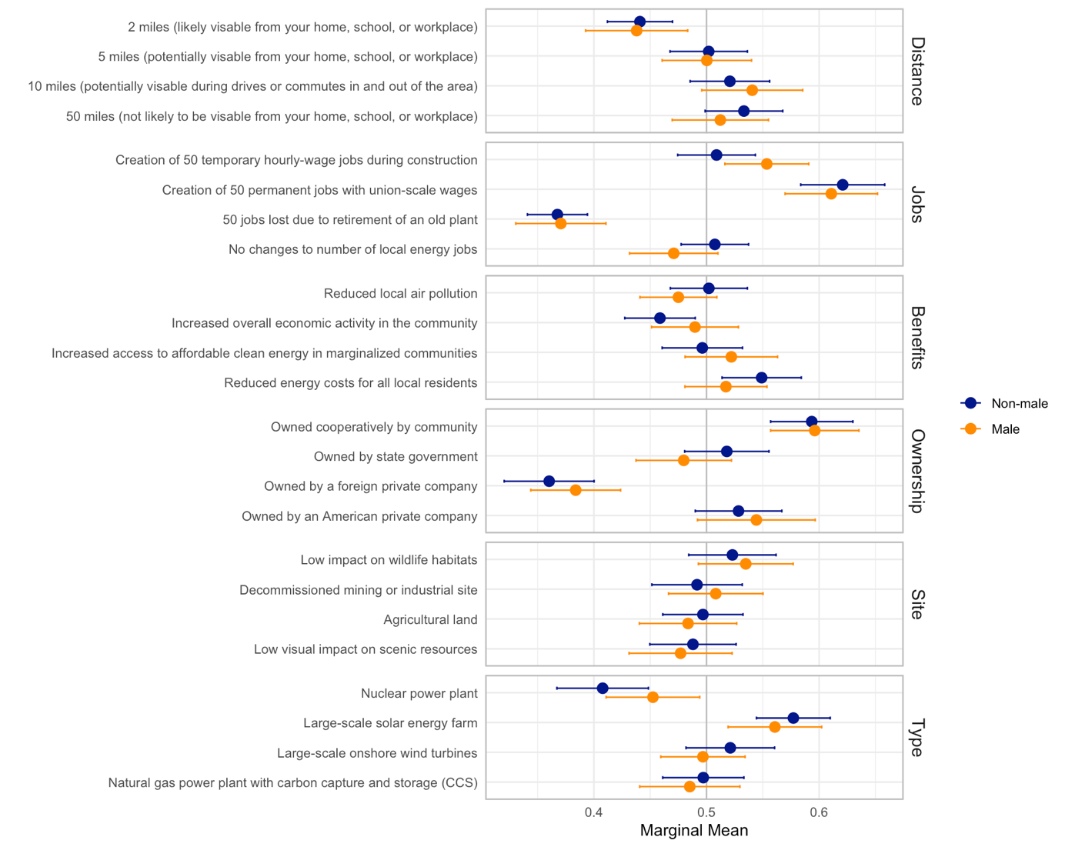

Figure S2: Education marginal means (Experiment 1) 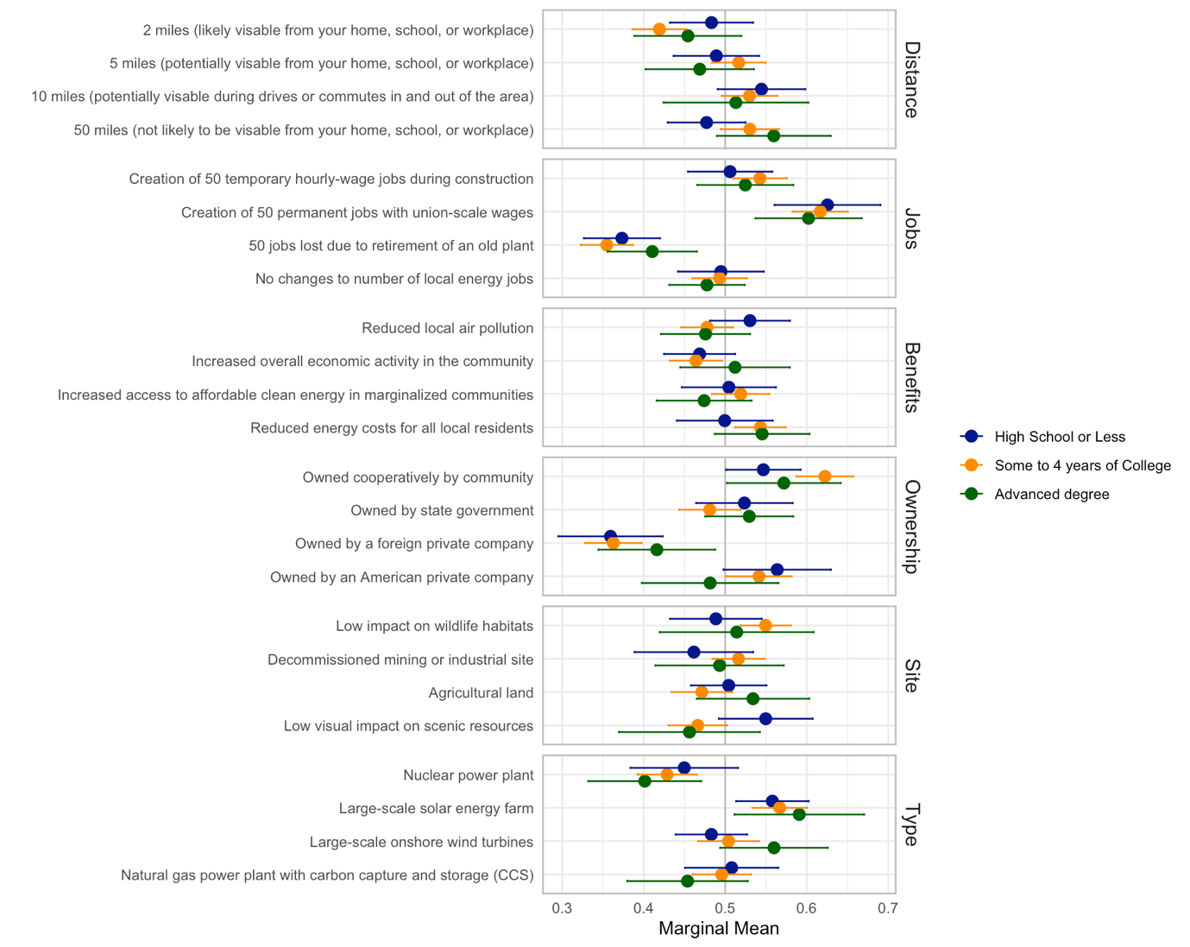

Figure S3: Income marginal means 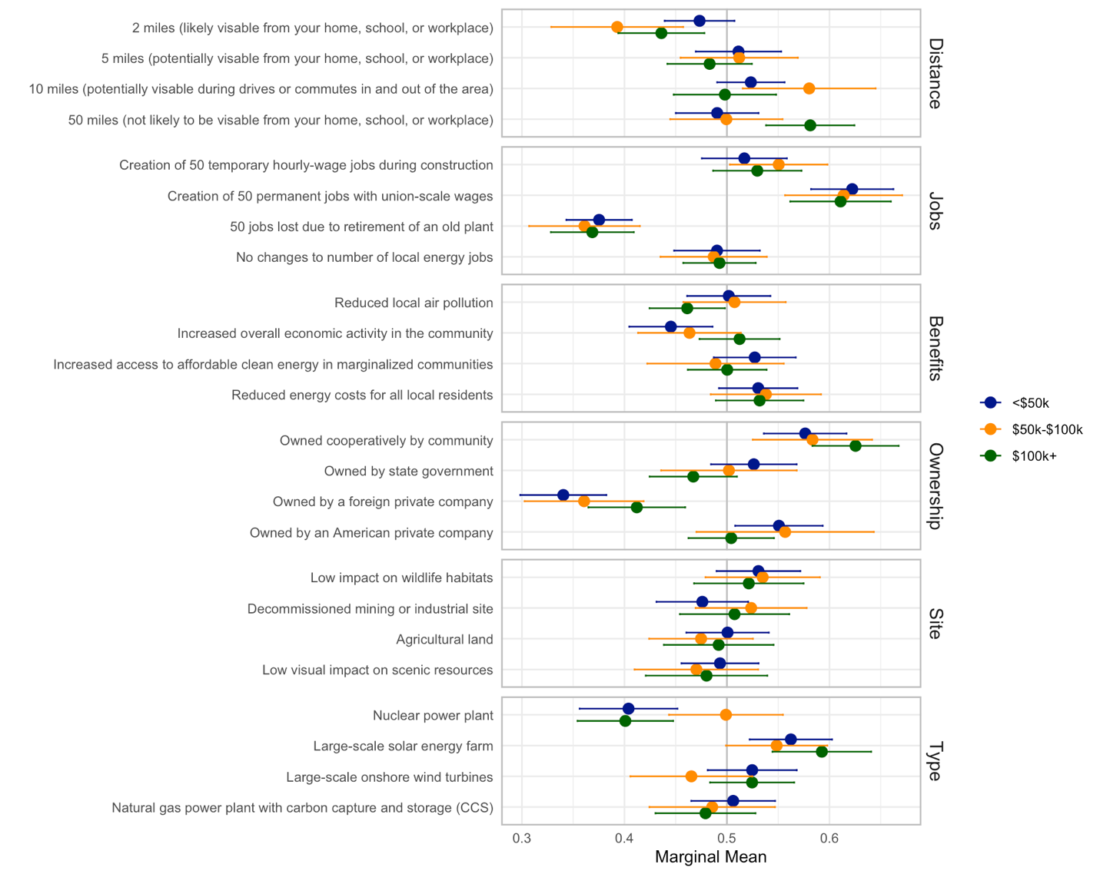

Table S4: Policy condition marginal means 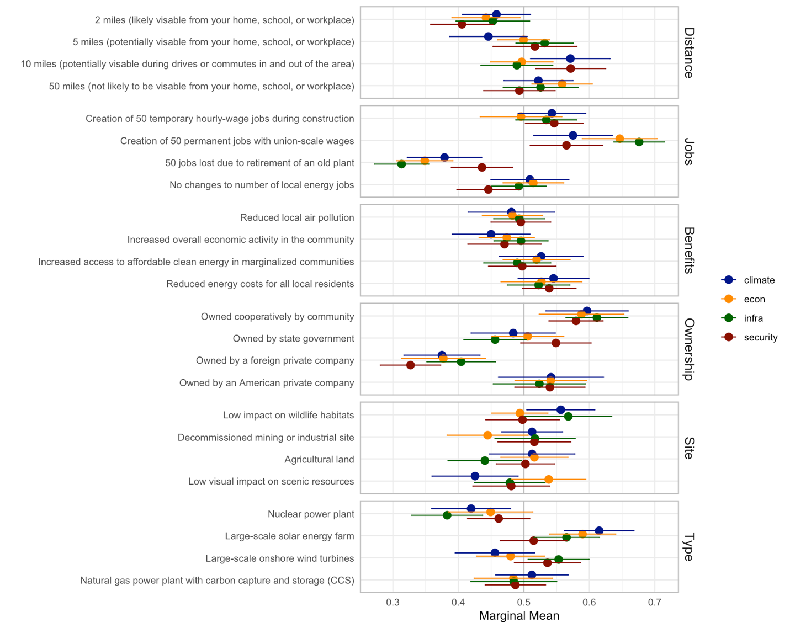
Note: We included a randomized framing message to respondents centered on climate, economy, infrastructure, or national security. Since there are few statistically significant differences across treatment groups, we pooled the data across experimental conditions for all analyses presented in the paper. The jobs attribute is the only category that showed statistically significant differences in marginal means as a function of experimental condition. Specifically, the infrastructure condition appeared to increase support for projects that create permanent jobs and reduce support for projects that remove jobs. The framing messages are outlined further in Part 4: Survey Design.

Robustness checks

Table S5: ACMEs by profile order (Experiment 1) 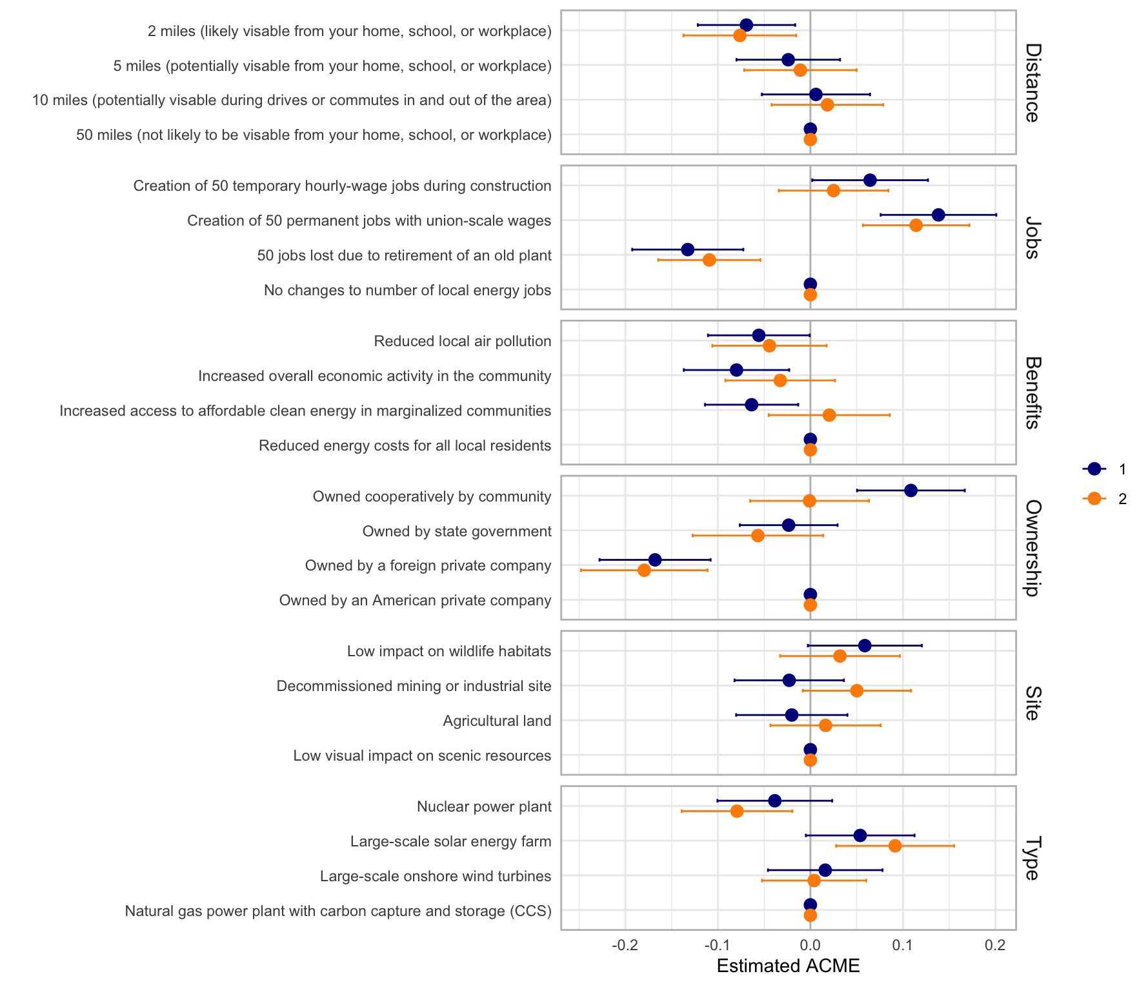

Table S5: ACMEs by attention check (Experiment 1)
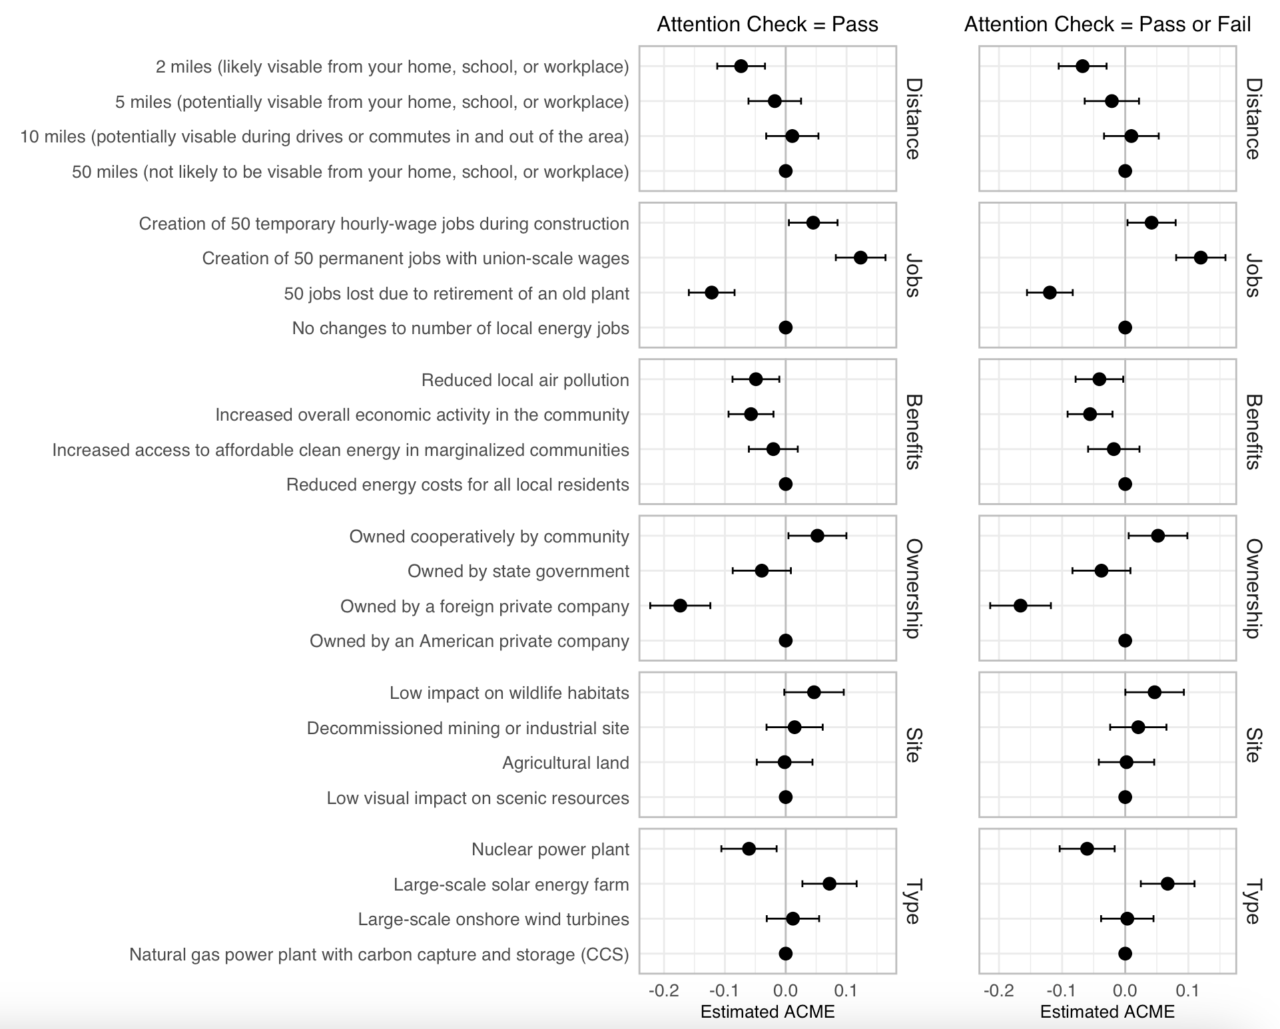

Part 3: Power Analyses

We used the framework proposed by Stefanelli & Lukac (2020) for calculating power for conjoint experiments using simulations techniques with their online tool for power analysis (https://mblukac.shinyapps.io/conjoints-power-shiny/).

Experiment 1: With 894 participants, 5 tasks, and 4 variable levels (attribute with the largest number of options), the experiment has a 94% power to detect an effect 0.05 and 81% power to detect an effect of 0.04.
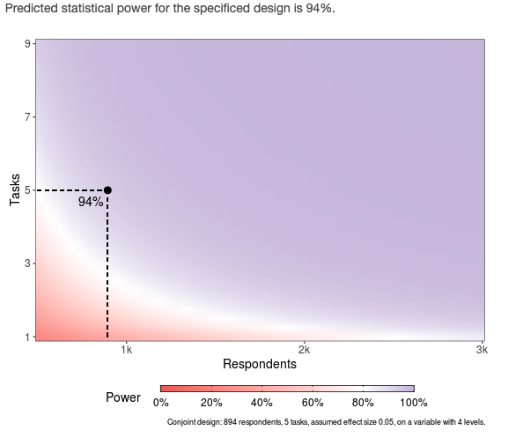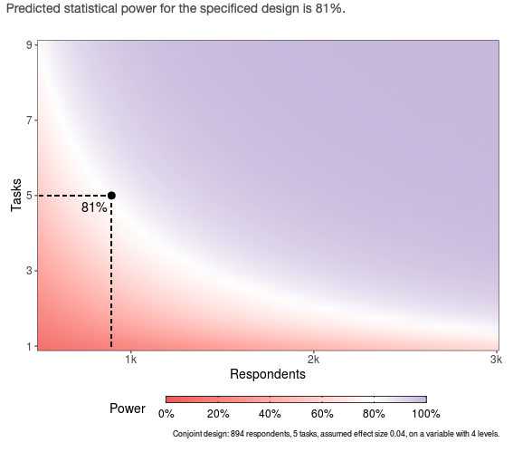

Experiment 2: With 206 participants, 4 tasks, and 4 variable levels, the experiment has a 78% power to detect an effect 0.07 and 42% power to detect an effect of 0.05.
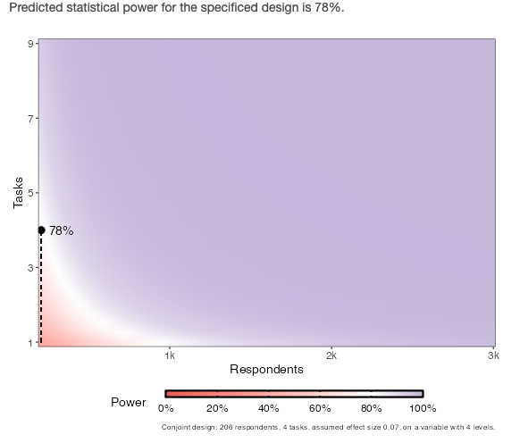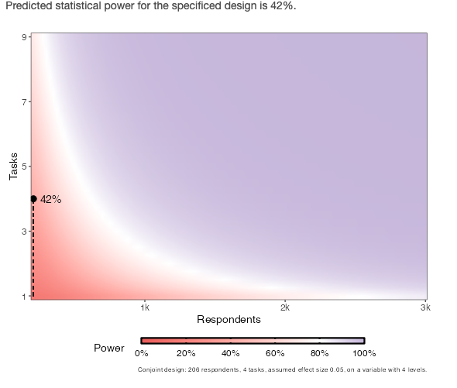

Part 4: Survey Design
Both surveys were approved by Princeton University’s Institutional Review Board (IRB#14367: “Origins, Functions, and Mechanisms of Coalitions for Change: Linking Individual Cognition and Collective Action, PI Elke Weber)

Experiment 1:
Respondents were recruited by the survey firm Lucid, drawing from their existing marketplace of participants and incentivized by their standards. All respondents completed the survey between February 7th and February 24th, 2022. 57 respondents who failed an attention check were removed from the sample and subsequent analyses.

Framing message: Before the conjoint experiment, respondents were randomly assigned to one of four framing messages. These results are displayed in Section 2.
- Policy: The next section presents various options for low emissions energy production projects that are being considered as part of a national effort to mitigate climate change.
- Infrastructure: The next section presents various options for low emissions energy production projects that are being considered as part of a national effort to invest in infrastructure development.
- Economy: The next section presents various options for low emissions energy production projects that are being considered as part of a national economic recovery and job creation effort.
- National security: The next section presents various options for low emissions energy production projects that are being considered as part of a national economic recovery and job creation effort.

After this message, all respondents saw an introduction to the conjoint block that read “Imagine that your feedback will be used to decide between projects in your area. On the following screen, you will see comparisons between two options at a time. They vary on several dimensions, including type of energy project, project site, ownership model, associated job opportunities, local project benefits, and distance from residential areas. Please evaluate these options carefully, and indicate which one you prefer.”

Example conjoint choice, where order of attributes is randomized by respondent:
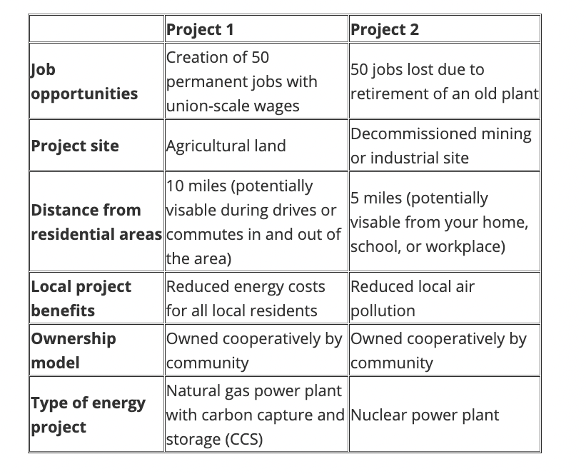
Experiment 2:
For Experiment 2, a sample of 219 local elected officials was recruited by the survey firm CivicPulse using the Qualtrics platform. 13 respondents did not complete the conjoint experiment portion of the survey, bringing the analysis sample to 206. The survey was fielded from September 20, 2022, to November 9, 2022. The sample of respondents consisted of elected policymakers in Pennsylvania from local governments (i.e., township, municipality, and county governments) with a population over 1,000 residents. Elected policy makers include top elected officials and governing board members. To provide additional information about the geographic areas in which respondents work, additional covariates were merged to the survey response data (99% match rate). To ensure anonymity of the respondent, some variables were coarsened by binning them into terciles. Terciles were created based on local governments in Pennsylvania.

Example of conjoint choice, where order of attributes is randomized by respondent: 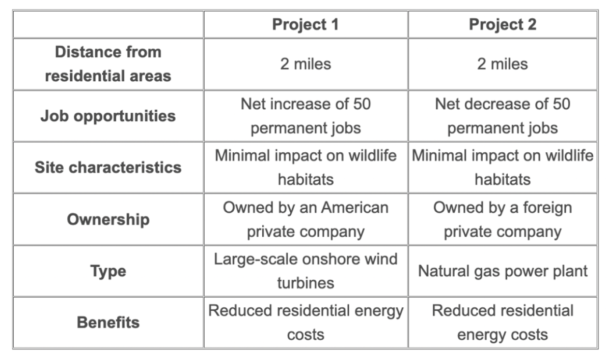
Question 1 (preference): Which of these projects would you choose for Pennsylvania?
Question 2 (perception): Which of these projects do you think more Pennsylvania residents would prefer?

