Supplementary Materials for
“Photoemission Evidence of a Novel Charge Order in Kagome Metal FeGe”
Zhisheng Zhao^{1,†}, Tongrui Li^{2,†}, Peng Li¹, Xueliang Wu³, Jianghao Yao¹, Ziyuan Chen¹, Yajun Yan¹, Shengtao Cui², Zhe Sun², Yichen Yang⁴, Zhicheng Jiang⁴, Zhengtai Liu⁵, Alex Louat⁶, Timur Kim⁶, Cephise Cacho⁶, Aifeng Wang³, Yilin Wang¹, Dawei Shen^{2,7}, Juan Jiang^{1,*} and Donglai Feng^{1,2,7,8,9,*}

¹ School of Emerging Technology and Department of Physics, University of Science and Technology of China, Hefei 230026, China
² National Synchrotron Radiation Laboratory and School of Nuclear Science and Technology, University of Science and Technology of China, Hefei, 230026, China
³ Low temperature Physics Laboratory, College of Physics and Center of Quantum Materials and Devices, Chongqing University, Chongqing 401331, China
⁴ State Key Laboratory of Functional Materials for Informatics, Shanghai Institute of Microsystem and Information Technology (SIMIT), Chinese Academy of Sciences, Shanghai 200050, China
⁵ Shanghai Synchrotron Radiation Facility, Shanghai Advanced Research Institute, Chinese Academy of Sciences, Shanghai 201210, China
⁶ Diamond Light Source Ltd., Harwell Science and Innovation Campus, Didcot, OX11 0DE, United Kingdom
⁷ New Cornerstone Science Laboratory, University of Science and Technology of China, Hefei, 230026, China
⁸ Collaborative Innovation Center of Advanced Microstructures, Nanjing, 210093, China
⁹ Shanghai Research Center for Quantum Sciences, Shanghai, 201315, China

- Absence of obvious CO gap at the $\overline{K}$ and $\overline{M}$ points
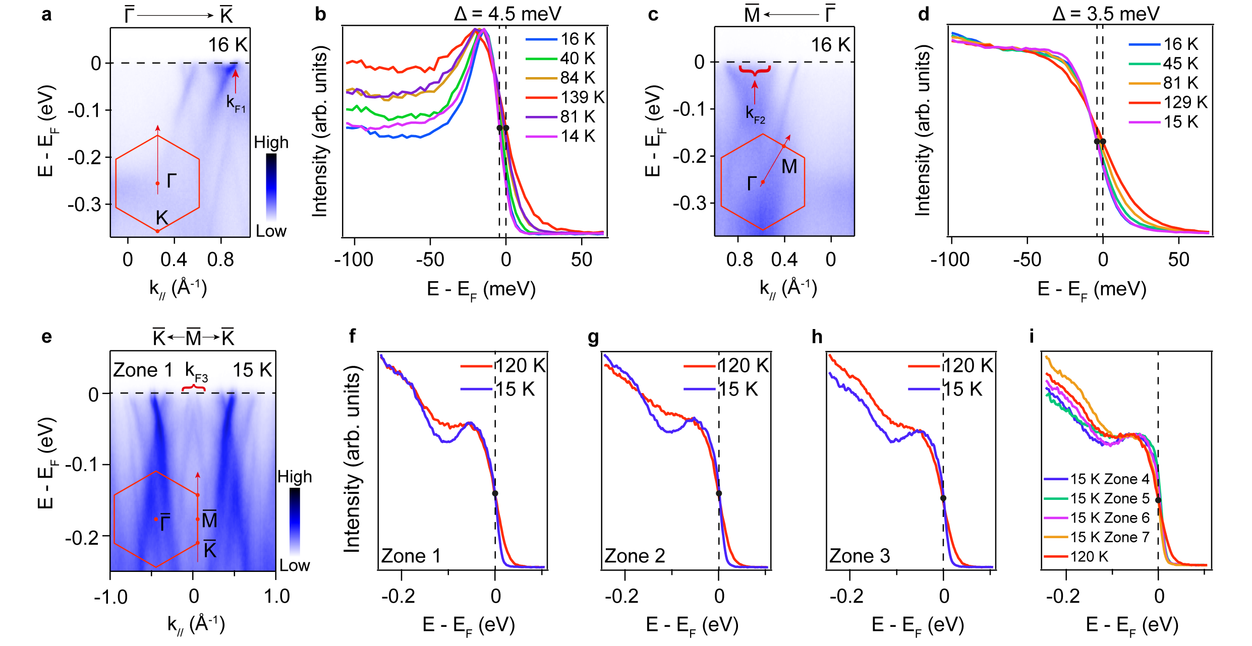
Fig. S1 | CO gap measurements at $\overline{K}$ and $\overline{M}$. a, Electronic structure along $\overline{Γ}$ - $\overline{K}$ measured at 16 K. b, Corresponding normalized integrated EDCs of a at k_{F1} which represents a Fermi crossing momentum position around the $\overline{K}$ point. c, Electronic structure along $\overline{Γ}$ - $\overline{M}$ measured at 16 K. d, Similar to b but at k_{F2} around the $\overline{M}$ point. e, Electronic structure along $\overline{K}$ - $\overline{M}$ - $\overline{K}$ measured at 15 K, which is detected at Zone 1 in the real space. f, Corresponding normalized integrated EDCs of e at k_{F3}. g, Similar to f but at another real space position named Zone 2. h, Similar to f but at another real space position named Zone 3. i, Summary of the results at other real space zones. The data from a to d are measured with 23 eV photons and the data from e to i are measured with 95 eV photons. The leading edge midpoints of EDCs at highest and lowest temperatures are marked by black dots in b, d and f to i.
Based on the leading edge analysis of the EDCs above, one could infer that it reveals a narrow gap of approximate 4.5 meV around the $\overline{K}$ point. We integrate the spectra of the states around $\overline{M}$ both along $\overline{Γ}$ - $\overline{M}$ and $\overline{K}$ - $\overline{M}$ - $\overline{K}$, around 3.5 meV leading edge shift along $\overline{Γ}$ - $\overline{M}$ and nearly no noticeable leading edge shift along $\overline{K}$ - $\overline{M}$ - $\overline{K}$ have been detected. The size of such tiny gaps can not be responsible for a 100 K CO, thus other origins of the CO mechanism need to be considered.

- Calculated and experimental zero-frequency JDOS results
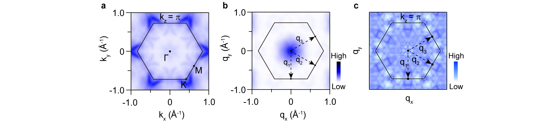
Fig. S2 | Calculated and experimental zero-frequency JDOS results. a, The symmetrized Fermi surface map acquired at 130 K with 95 eV photons, which is around the k_{z} = π plane. b, The zero-frequency JDOS obtained based on c. c, Calculated zero-frequency JDOS at EF with k_{z} = π. No pronounced peak related to the CO wave-vectors q_{i} (i = 1, 2 and 3) is observed in b and c.

- Photon energy dependence and core level results
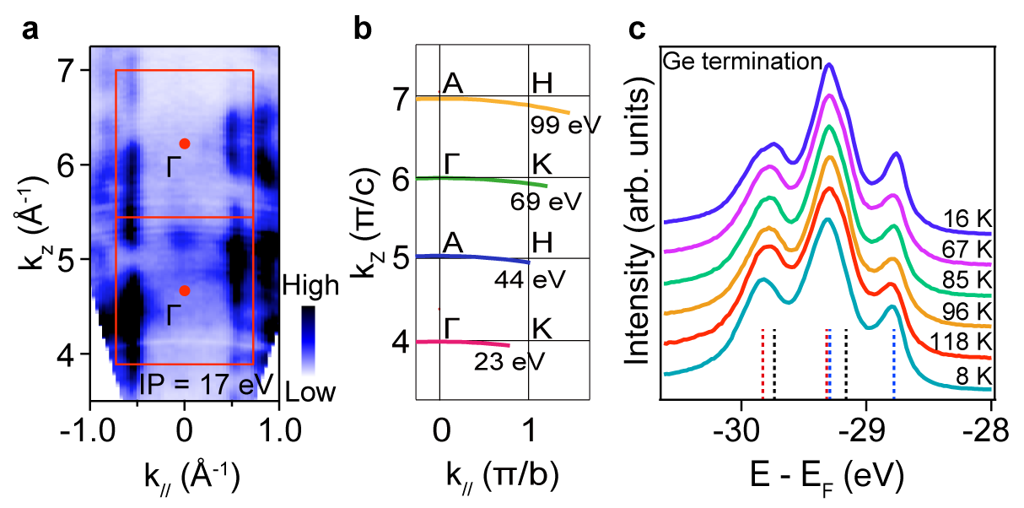
Fig. S3 | Photon-energy-dependent measurements and core level measurements. a, Photon-energy-dependent ARPES measurements of FeGe at 160 K utilizing photon energies ranging from 30 eV to 190 eV. b, A schematic diagram illustrating the determination of k_{z} on the k_{z} - k// plane based on our experimental data. c, Core level measurements at different temperatures related to Fig. 3.
According to the detailed photon-energy-dependent ARPES results in Fig. S3a, one can identify that the data taken with 23 eV and 69 eV photons are at the k_{z} = 0 plane while the data taken with 44 eV and 99 eV photons are at the k_{z} = π plane, with an inner potential of 17 eV.
Two terminations (kagome termination and Ge termination) of kagome metal FeGe have already been recognized based on the core level measurement¹. Our systematic core level data corresponding to temperature-dependent experiment illustrated in Fig. 3 are shown in Fig. S3c, which indicates all data are detected on the Ge termination featuring the extra surface peaks (marked by black dashed lines) besides two pairs of bulk Ge spin-orbit doublets (marked by red and blue dashed lines respectively).

- Extended data of the α band
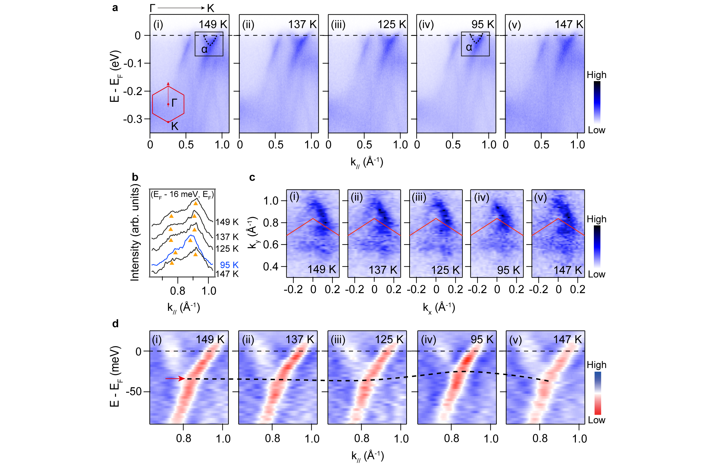
Fig. S4 | Temperature-dependent electronic structure along Γ - K with another sample. a, Temperature-dependent electronic structure along Γ - K crossing T_{CO}. b, Corresponding integrated MDCs acquired at (E_{F} - 16 meV, E_{F}) as indicated by the black frame of [a(i)]. The yellow triangles represent the temperature-dependent momentum positions of Fermi crossing. c, Temperature-dependent Fermi surface maps around the K point. (d) Zoom in second derivative spectra of the α band in the region highlighted by the black frame in [a(i)], which is measured at different temperatures crossing T_{CO}. All the data are measured with 23 eV photons.
In Fig. S4, we double-check the temperature-dependent evolution of the α band crossing T_{CO} with another sample, the result of which is consistent with the data shown in Fig. 2. Moreover, one can observe that both the α band and the Fermi surface pocket size perform negligible change crossing T_{CO}.
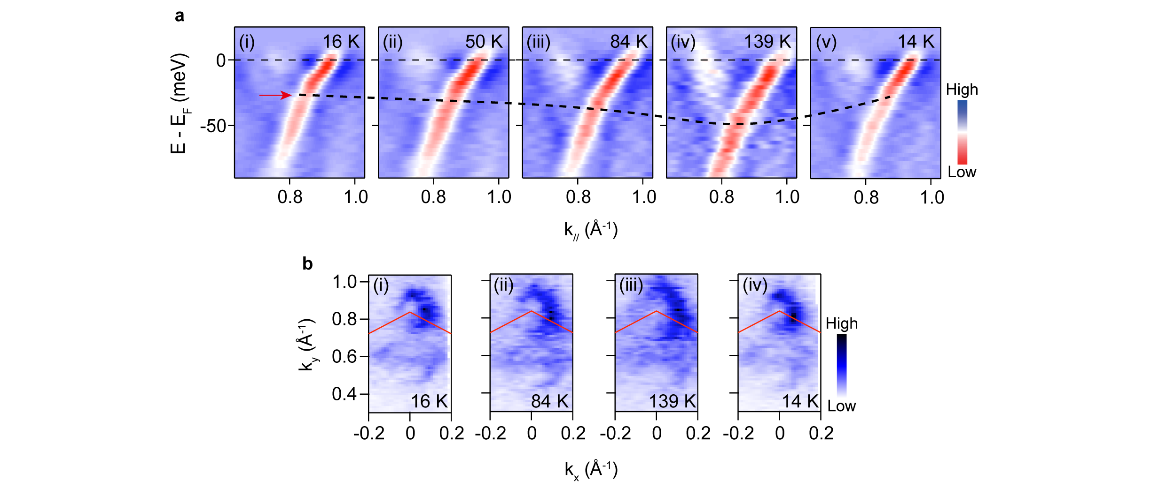
Fig. S5 | Temperature-dependent measurements of the α band. a, Temperature-dependent second derivative spectra of the α band crossing T_{CO}. b, Temperature-dependent Fermi surface maps around the K point. All the data are measured with 23 eV photons.

- Extended data of the β band
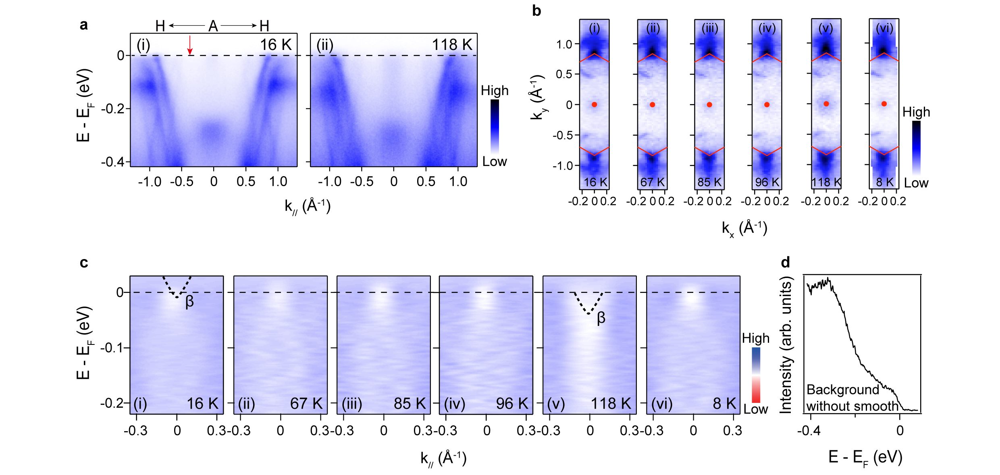
Fig. S6 | Background subtraction and temperature-dependent measurements of the β band. a, Raw electronic structure along H - A - H acquired at 16 K and 118 K. b, Temperature-dependent Fermi surface map around the A point. c, Temperature-dependent second derivative spectra of the β band crossing T_{CO}. d, The integrated EDC background without smooth treatment obtained at the momentum shown by the red arrow in [a(i)]. All the data are measured with 95 eV photons.
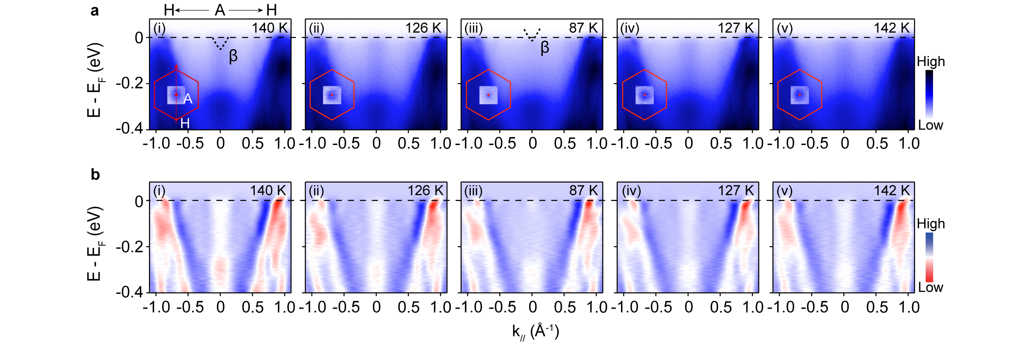
Fig. S7 | Temperature-dependent raw electronic structure along H - A - H with another sample. a, Temperature-dependent raw electronic structure along H - A - H crossing T_{CO} measured with 95 eV photons. The insets present the corresponding Fermi surface map around the A point. b, Temperature-dependent Fermi surface maps around the K point. All the data are measured with 23 eV photons.
In Fig. S7, we double-check the sudden evolution of the β band crossing T_{CO} with another sample, the result of which is consistent with the data shown in Fig. 3. Moreover, one can observe that both the β band and the Fermi surface pocket size perform negligible change crossing T_{CO}.

Supplementary References:
- Teng, X. et al. Magnetism and charge density wave order in kagome FeGe. Nat. Phys. 19, 814-822 (2023).

