Supplementary data
Supplementary data 1: Metabolites present in Callus samples.
S. No. | CID No. | Compound Name | Area | Area Percentage
 | 70 | 2-Ketoisocaproic acid | 2007530 | 0.12
 | 119 | 4-Aminobutyric acid | 14413156 | 0.85
 | 311 | Citric acid | 50288222 | 2.84
 | 469 | 2-Aminoadipic acid | 885662 | 0.05
 | 525 | Malic acid | 25944511 | 1.47
 | 612 | Lactic acid | 5747493 | 0.32
 | 700 | 2-Amino ethanol | 975101 | 0.06
 | 750 | Glycine | 1278822 | 0.08
 | 753 | Glycerol | 21465634 | 1.21
 | 971 | Oxalic acid | 918662 | 0.05
 | 985 | Palmitic acid | 49507392 | 2.8
 | 1004 | Phosphoric acid | 25747960 | 1.46
 | 1110 | Succinic acid | 1134905 | 0.06
 | 1123 | Taurine | 3022110 | 0.17
 | 1176 | Urea | 1033748 | 0.06
 | 5281 | Stearic acid | 39614839 | 2.24
 | 5793 | d-Glucose | 6400054 | 0.36
 | 5816 | Epinephrine | 835857 | 0.05
 | 5950 | Alanine | 3731991 | 0.21
 | 5951 | L-Serine | 5740868 | 0.32
 | 5960 | Aspartic acid | 34208055 | 1.93
 | 5961 | Glutamine | 3671224 | 0.22
 | 5988 | Sucrose | 183892723 | 10.39
 | 6262 | Ornithine | 4196812 | 0.25
 | 6267 | Asparagine | 14619472 | 0.83
 | 6287 | L-Valine | 1100272 | 0.07
 | 6288 | L-Threonine | 2109416 | 0.12
 | 6322 | Arginine | 8547093 | 0.51
 | 7405 | L-5-Oxoproline | 158420438 | 7.35
 | 7427 | Trehalose | 1053198 | 0.06
 | 7628 | Boric acid | 36505264 | 2.06
 | 8222 | Eicosane | 2695696 | 0.15
 | 8742 | Shikimic acid | 1857200 | 0.1
 | 9064 | Catechine | 54045722 | 3.05
 | 10465 | Heptadecanoic acid | 1812171 | 0.1
 | 10466 | Juniperic acid | 2158686 | 0.12
 | 10690 | D-Gluconic acid | 1059009 | 0.05
 | 11005 | Myristic acid | 3847830 | 0.22
 | 11458 | Melibiose | 2704971 | 0.15
 | 14871 | Monolaurin | 2114753 | 0.12
 | 14900 | 1-Monopalmitin | 292446571 | 16.53
 | 24699 | Glycerol monostearate | 204171477 | 11.54
 | 33032 | L-Glutamic acid | 4552963 | 0.26
 | 64689 | .beta.-D-Glucopyranose | 3662908 | 0.21
 | 68149 | 1,3-Dipalmitin | 3418620 | 0.16
 | 79050 | 1-Monomyristin | 15902011 | 0.9
 | 79075 | 2-Monostearin | 11199474 | 0.63
 | 91601 | Phenol,2,4-bis(1,1-dimethylethyl)-,phosphite | 10766891 | 0.61
 | 94715 | D-Glucuronic acid | 6904474 | 0.39
 | 98504 | Lanthionine | 1520236 | 0.09
 | 123409 | 2-Palmitoyl glycerol | 12560527 | 0.71
 | 127686 | AsterbatanosideA | 1982216 | 0.11
 | 222285 | Erythritol | 4294042 | 0.24
 | 345824 | Quininic acid | 2188976 | 0.12
 | 419223 | Tetrahydro-2H-pyran-4-amine | 1759701 | 0.1
 | 439242 | .alpha.-D-Glucopyranoside | 2209735 | 0.11
 | 439312 | Tagatose | 1214911 | 0.06
 | 439535 | 2,3,4-Trihydroxy butyric acid | 6083309 | 0.29
 | 441036 | Psicose | 10913182 | 0.62
 | 447347 | D-(-)-Ribofuranose | 9852926 | 0.47
 | 2723872 | Fructose | 13282216 | 0.63
 | 3246944 | 2,3-Dihydroxy propylico sanoate | 995148 | 0.06
 | 5283468 | 1-Monooleoylglycerol | 2071669 | 0.12
 | 5460672 | L-(+)-Threose | 8123443 | 0.46
 | 5460677 | Ribonic acid | 2586933 | 0.12
 | 12313291 | Neposide | 1819792 | 0.1
 | 54301978 | D-(+)-Turanose | 3523817 | 0.21
 | 129602196 | (2R,3S,4S,5R,6R)-2-(Hydroxymethyl)-6-(4-methylpentoxy)oxane-3,4,5-triol, | 10136744 | 0.48

Supplementary data 2: Metabolites present in Leaf samples.
S. No. | CID No. | Compound Name | Area | Area Percentage
 | 311 | Citric acid | 50288222 | 0.2
 | 370 | Gallic acid | 2015135 | 0.13
 | 499 | DL-Pyroglutamic acid | 17799700 | 0.41
 | 525 | Malic acid | 25944511 | 0.22
 | 612 | Lactic acid | 5747493 | 0.32
 | 752 | Glyceric acid | 2074541 | 0.05
 | 753 | Glycerol | 21465634 | 1.23
 | 892 | Scyllo-Inositol | 1706062 | 0.08
 | 964 | beta-Hydroxy pyruvic acid | 6350353 | 0.3
 | 971 | Oxalic acid | 918662 | 0.07
 | 985 | Palmitic acid | 49507392 | 2.9
 | 1004 | Phosphoric acid | 25747960 | 1.01
 | 1049 | Pyridine | 6473720 | 0.28
 | 1050 | Pyridoxal | 806939 | 0.05
 | 1110 | Succinic acid | 1134905 | 0.11
 | 1176 | Urea | 1033748 | 0.05
 | 2519 | Caffeine | 3350539 | 0.21
 | 3681 | Batylalcohol | 1723898 | 0.15
 | 3931 | 9,12-Octadecadienoic acid | 1420437 | 0.24
 | 5281 | Stearic acid | 39614839 | 2.22
 | 5793 | d-Glucose | 6400054 | 0.77
 | 5816 | Epinephrine | 835857 | 0.2
 | 5950 | Alanine | 3731991 | 0.05
 | 5951 | L-Serine | 5740868 | 0.15
 | 5960 | Aspartic acid | 34208055 | 0.1
 | 5961 | Glutamine | 3671224 | 0.21
 | 5988 | Sucrose | 183892723 | 3.94
 | 6036 | d-Galactose | 12724760 | 8.22
 | 6057 | Tyrosine | 1881438 | 0.22
 | 6134 | D-Lactose | 1574860 | 0.07
 | 6267 | Asparagine | 14619472 | 0.1
 | 6287 | L-Valine | 1100272 | 0.06
 | 6288 | L-Threonine | 2109416 | 0.05
 | 6306 | L-Isoleucine | 1140727 | 0.07
 | 6322 | Arginine | 8547093 | 0.13
 | 7405 | L-5-Oxoproline | 158420438 | 1.42
 | 7628 | Boric acid | 36505264 | 0.7
 | 8222 | Eicosane | 2695696 | 0.07
 | 8742 | Shikimic acid | 1857200 | 0.27
 | 9064 | Catechine | 54045722 | 2.82
 | 10712 | D - (+)-Cellobiose | 1073107 | 0.07
 | 14871 | Monolaurin | 2114753 | 0.1
 | 14900 | 1-Monopalmitin | 292446571 | 17.23
 | 24699 | Glycerol monostearate | 204171477 | 12.46
 | 33032 | L-Glutamic acid | 4552963 | 0.08
 | 72277 | Epigallocatechin | 1908431 | 0.09
 | 79050 | 1-Monomyristin | 15902011 | 0.87
 | 85782 | 3,4-Dihydroxy mandelic acid | 4438771 | 0.21
 | 91601 | Phenol,2,4-bis(1,1-dimethylethyl)-, phosphite | 10766891 | 0.63
 | 94715 | D-Glucuronic acid | 6904474 | 0.08
 | 95562 | 5-Hydroxynorvaline | 1504773 | 0.09
 | 99459 | D - (+)-Talose | 77079849 | 0.06
 | 108223 | Deoxyglucose | 2608186 | 0.16
 | 123409 | 2-Palmitoylglycerol | 12560527 | 0.74
 | 127686 | Asterbatanoside A | 1982216 | 0.09
 | 135191 | D - (+)-Xylose | 1527702 | 0.1
 | 151152 | Threonic acid | 1423307 | 0.07
 | 182230 | N-Acetyl glutamine | 1044593 | 1.47
 | 345824 | Quininic acid | 2188976 | 2.69
 | 439268 | 2-Deoxy-glucose | 839633 | 0.14
 | 439294 | Inosose | 799861 | 0.05
 | 439312 | Tagatose | 1214911 | 0.51
 | 440936 | beta-D-Glucopyranoside | 7264833 | 0.62
 | 441036 | Psicose | 10913182 | 0.59
 | 442154 | Afzelechin | 7575660 | 0.47
 | 444173 | beta-Arabinopyranose | 36369721 | 2.26
 | 445639 | Oleic acid | 3878304 | 0.09
 | 545303 | 7,9-Di-tert-butyl-1-oxaspiro (4, 5) deca-6,9-diene-2,8-dione | 6005018 | 0.29
 | 637517 | Elaidic acid | 3191983 | 0.26
 | 638072 | Squalene | 824391 | 0.07
 | 638122 | Pentenoicacid | 2136692 | 0.13
 | 1794427 | Chlorogenic acid | 9641554 | 0.6
 | 3246944 | 2,3-Dihydroxypropylicosanoate | 995148 | 0.37
 | 5460672 | L - (+)-Threose | 8123443 | 0.23
 | 10964471 | (R*, S*)-2,3-Dihydroxybutanoic acid | 1512971 | 0.18
 | 10975657 | Ribose | 7121304 | 0.64
 | 13220195 | 3,6-Epoxydodecanedioic acid | 1845496 | 0.26
 | 53413950 | tert-Butyl3-(aminomethyl) piperazine-1-carboxylate | 28398994 | 1.77
 | 54350893 | d-Erythro-pentose | 1117548 | 0.11
 | 85977274 | 5,5-Diethylpentadecane | 1425401 | 0.09

Supplementary data 3: Metabolites present in microshoot samples.
S. No. | CID No. | Compound Name | Area | Area Percentage
 | 119 | 4-Amino butyric acid | 36970290 | 2.67
 | 239 | beta-Alanine | 1254854 | 0.08
 | 311 | Citric acid | 42452759 | 3.06
 | 525 | Malic acid | 63564474 | 4.59
 | 612 | Lactic acid | 8518011 | 0.61
 | 750 | Glycine | 1526577 | 0.11
 | 752 | Glyceric acid | 1158208 | 0.08
 | 753 | Glycerol | 21559097 | 1.56
 | 892 | Inositol | 3066576 | 0.22
 | 971 | Oxalic acid | 20693504 | 1.49
 | 985 | Palmitic acid | 41475916 | 2.99
 | 1004 | Phosphoric acid | 11534616 | 0.83
 | 1045 | Putrescine | 2612874 | 0.17
 | 1110 | Succinic acid | 1216789 | 0.09
 | 1176 | Urea | 1346703 | 0.1
 | 3681 | Batylalcohol | 1185186 | 0.09
 | 5281 | Stearic acid | 31882380 | 2.3
 | 5793 | d-Glucose | 7651681 | 0.55
 | 5950 | Alanine | 6221110 | 0.45
 | 5951 | L-Serine | 3869345 | 0.28
 | 5960 | L-Aspartic acid | 5191435 | 0.37
 | 5961 | Glutamine | 27201406 | 1.96
 | 5988 | Sucrose | 95927447 | 6.92
 | 6262 | Ornithine | 12160100 | 0.88
 | 6267 | Asparagine | 3798331 | 0.27
 | 6287 | L-Valine | 831783 | 0.06
 | 6288 | L-Threonine | 1474156 | 0.11
 | 6322 | Arginine | 24383731 | 1.76
 | 7405 | Pyroglutamic acid | 2803776 | 0.2
 | 9064 | Catechine | 33320661 | 2.41
 | 9750 | L-Citrulline | 2603599 | 0.19
 | 10466 | Juniperic acid | 15121403 | 1.09
 | 11005 | Myristic acid | 1550920 | 0.11
 | 12398 | Heptadecane | 1832247 | 0.13
 | 14871 | Monolaurin | 2753741 | 0.2
 | 14900 | 1-Monopalmitin | 199244479 | 14.38
 | 18950 | d-Mannose | 1615005 | 0.11
 | 24699 | Glycerol monostearate | 142163151 | 10.26
 | 33032 | L-Glutamic acid | 10924250 | 0.79
 | 68149 | 1,3-Dipalmitin | 7224803 | 0.52
 | 68152 | Hydracrylic acid | 1078512 | 0.07
 | 72277 | Epigallocatechin | 15783449 | 1.14
 | 73323 | Xanthosine monophosphate | 1304821 | 0.09
 | 79050 | 1-Monomyristin | 12779379 | 0.92
 | 91601 | Phenol,2,4-bis(1,1-dimethylethyl)-, phosphite | 8268334 | 0.6
 | 94715 | Glucuronic acid | 4375814 | 0.32
 | 107812 | Hypotaurine | 1117303 | 0.08
 | 123409 | 2-Palmitoyl glycerol | 9743361 | 0.7
 | 135191 | Xylose | 4546426 | 0.33
 | 137938 | 2-Monomyristin | 10119241 | 0.73
 | 145742 | L-Proline | 1335191 | 0.1
 | 151152 | Threonic acid | 2189475 | 0.16
 | 169019 | Threitol | 1467127 | 0.1
 | 182230 | N-Acetylglutamine | 2897133 | 0.21
 | 222285 | Erythritol | 1637386 | 0.12
 | 439312 | Tagatose | 11642937 | 0.84
 | 441036 | Psicose | 12723975 | 0.92
 | 445969 | L-Threitol | 2070464 | 0.13
 | 511918 | (2R,3S,4S,5R,6R)-2-(Hydroxymethyl)-6-pentoxyoxane-3,4,5-triol | 31506179 | 2.27
 | 637517 | Elaidic acid | 2242403 | 0.15
 | 638122 | Pentenoic acid | 2160955 | 0.16
 | 3246944 | 2,3-Dihydroxypropylicosanoate | 1126933 | 0.07
 | 5283468 | 1-Monooleoylglycerol | 1169769 | 0.08
 | 5460032 | L - (+)-Erythrulose | 1384429 | 0.09
 | 5460672 | L - (+)-Threose | 16183819 | 1.05
 | 11727586 | Galactinol | 15804491 | 1.14
 | 13220195 | 3,6-Epoxydodecanedioic acid | 7661037 | 0.5
 | 19352763 | Cyclohexanediol | 1125921 | 0.08
 | 21572943 | Isopropyl beta-D-glucopyranoside | 1323273 | 0.1
 | 53413950 | tert-Butyl3-(aminomethyl) piperazine-1-carboxylate | 10713072 | 0.77
 | 54301978 | D - (+)-Turanose | 2835923 | 0.2
 | 129602196 | (2R,3S,4S,5R,6R)-2-(Hydroxymethyl)-6-(4-methylpentoxy)oxane-3,4,5-triol | 2346793 | 0.17

Supplementary data 4: Metabolites present in Stem samples.
S. No. | CID No. | Compound Name | Area | Area Percentage
 | 119 | 4-Aminobutyric acid | 1414295 | 0.08
 | 294 | beta-D-Lactose | 883138 | 0.05
 | 311 | Citric acid | 3473680 | 0.18
 | 370 | Gallic acid | 14525219 | 0.77
 | 525 | Malic acid | 3048512 | 0.16
 | 612 | Lactic acid | 3993600 | 0.21
 | 700 | 2-Amino ethanol | 919293 | 0.05
 | 753 | Glycerol | 22915453 | 1.22
 | 985 | Palmitic acid | 58861585 | 3.13
 | 1004 | Phosphoric acid | 15928820 | 0.85
 | 1049 | Pyridine | 4256052 | 0.23
 | 3931 | 9,12-Octadecadienoicacid | 1361998 | 0.07
 | 5281 | Stearic acid | 45570435 | 2.42
 | 5950 | Alanine | 1657648 | 0.09
 | 5951 | L-Serine | 1494353 | 0.08
 | 5960 | L-Aspartic acid | 1440198 | 0.08
 | 5961 | Glutamine | 4064069 | 0.22
 | 5988 | Sucrose | 59862454 | 3.18
 | 6057 | L-Tyrosine | 2164143 | 0.12
 | 6140 | Phenylalanine | 7453841 | 0.4
 | 6267 | Asparagine | 1550845 | 0.08
 | 6288 | L-Threonine | 1398614 | 0.07
 | 6305 | L-Tryptophan | 861193 | 0.05
 | 7405 | 5-Oxoproline | 75621163 | 4.02
 | 7628 | Boric acid | 9428177 | 0.5
 | 8742 | Shikimic acid | 8865990 | 0.47
 | 9064 | Catechine | 1179181 | 0.06
 | 10690 | Gluconic acid | 1442107 | 0.08
 | 11005 | Myristic acid | 4887969 | 0.26
 | 12398 | Heptadecane | 1793257 | 0.1
 | 12736 | Dodecanedioic acid | 11767375 | 0.63
 | 13849 | Pentadecanoic acid | 971213 | 0.05
 | 14871 | Monolaurin | 2300934 | 0.12
 | 14900 | 1-Monopalmitin | 298059700 | 15.84
 | 24699 | Glycerol monostearate | 208156414 | 11.07
 | 33032 | L-Glutamic acid | 2229269 | 0.12
 | 72277 | Epigallocatechin | 3225916 | 0.17
 | 79050 | 1-Monomyristin | 16392197 | 0.87
 | 86863 | Ritalinic acid | 1954233 | 0.1
 | 87653 | 2-(1,3-Thiazol-2-yl) ethanamine | 997992 | 0.06
 | 91601 | Phenol,2,4-bis(1,1-dimethylethyl)-, phosphite | 10042454 | 0.53
 | 94176 | D - (-)-Erythrose | 1946982 | 0.11
 | 94715 | Glucuronic acid | 1842482 | 0.1
 | 99823 | 2-Hydroxy isovaleric acid | 1236793 | 0.07
 | 119838 | 3-Hydroxy-2,3-dihydromaltol | 37376785 | 1.99
 | 123409 | 2-Palmitoyl glycerol | 12993679 | 0.69
 | 127686 | AsterbatanosideA | 1526420 | 0.08
 | 135191 | Xylose | 1391825 | 0.07
 | 167627 | 7-Hydroxoctanoic acid | 1893746 | 0.11
 | 283379 | 1,2,4,5-Tetrazine-3,6-diamine | 2703871 | 0.14
 | 345824 | Quininic acid | 120251834 | 6.39
 | 439192 | Sorbose | 7599938 | 0.44
 | 439268 | 2-Deoxy-glucose | 17254636 | 0.92
 | 545303 | 7,9-Di-tert-butyl-1-oxaspiro (4 ,5) deca-6,9-diene-2,8-dione | 5603851 | 0.32
 | 637517 | Elaidic acid | 3237995 | 0.17
 | 638122 | Pentenoic acid | 2712771 | 0.14
 | 3246944 | 2,3-Dihydroxypropylicosanoate | 5848576 | 0.31
 | 5280847 | beta-D-Glucopyranoside,4-[(1E)-3-hydroxy-1-propen-1-yl]phenyl | 25104772 | 1.33
 | 5283468 | 1-Monooleoylglycerol | 2680505 | 0.14
 | 5460672 | L - (+)-Threose | 2020622 | 0.11
 | 9798666 | 4-O-Caffeoylquinicacid | 13403382 | 0.71
 | 10975657 | Ribose | 1550716 | 0.08
 | 19352763 | Cyclohexanediol | 2112110 | 0.11
 | 53413950 | tert-Butyl3-(aminomethyl) piperazine-1-carboxylate | 95315445 | 5.07

Supplementary data 5: Common metabolites in all the four investigated samples.
S. No. | CID No. | Compound Name
 | 311 | Citric acid
 | 525 | Malic acid
 | 612 | Lactic acid
 | 753 | Glycerin
 | 985 | Palmitic acid
 | 1004 | Phosphoric acid
 | 5281 | Stearic acid
 | 5950 | Alanine
 | 5951 | Serine
 | 5960 | Aspartic acid
 | 5961 | Glutamine
 | 5988 | Sucrose
 | 6267 | Asparagine
 | 6288 | Threonine
 | 7405 | L-Pyroglutamic acid
 | 9064 | Cianidanol
 | 14871 | 2,3-Dihydroxypropyl dodecanoate
 | 14900 | 2,3-Dihydroxypropyl hexadecanoate
 | 24699 | Glyceryl Monostearate
 | 33032 | Glutamic acid
 | 79050 | 2,3-Dihydroxypropyl tetradecanoate
 | 91601 | Tris(2,4-di-tert-butylphenyl) phosphite
 | 94715 | D-Glucuronic acid
 | 123409 | 2-Palmitoylglycerol
 | 3246944 | 2,3-Dihydroxypropyl icosanoate
 | 5460672 | L-Threose
Supplementary data 6: Metabolites common in Callus, Leaf and Micro shoot
S. No. | CID No. | Compound Name
 | 971 | Oxalic acid
 | 1110 | Succinic acid
 | 1176 | Urea
 | 5793 | D-Glucose
 | 6287 | Valine
 | 6322 | Arginine
 | 439312 | D-Tagatose
 | 441036 | D-Psicose

Supplementary data 7: Metabolites common in Callus, Leaf, Stem
S. No. | CID No. | Compound Name
 | 7628 | Boric acid
 | 8742 | Shikimic acid
 | 127686 | Bungeiside C
 | 345824 | Quininic acid

Supplementary data 8: Metabolites common in Callus, Micro shoot stem

S. No. | CID No. | Compound Name
 | 119 | Gamma-Aminobutyric acid
 | 11005 | Myristic acid
 | 5283468 | Glyceryl monooleate

Supplementary data 9: Metabolites common in Leaf, Micro shoot, and Stem

S. No. | CID No. | Compound Name
 | 72277 | Epigallocatechin
 | 135191 | D-Xylose
 | 637517 | Elaidic acid
 | 638122 | 2-Pentenoic acid
 | 53413950 | tert-Butyl 3 (aminomethyl)piperazine-1-carboxylate

Supplementary data 10: Metabolites common in Callus and Leaf

S. No. | CID No. | Compound Name
1 | 5816 | Epinephrine
2 | 8222 | Eicosane

Supplementary data 11: Metabolites common in Callus and Micro shoots

S. No. | CID No. | Compound Name
 | 750 | Glycine
 | 6262 | L-ornithine
 | 10466 | 16-Hydroxyhexadecanoic acid
 | 68149 | Glyceryl 1,3-dipalmitate
 | 222285 | Erythritol
 | 54301978 | D-(+)-Turanose
 | 129602196 | (2R,3S,4S,5R,6R)-2-(hydroxymethyl)-6-(4-methylpentoxy)oxane-3,4,5-triol

Supplementary data 12: Metabolites common in Leaf and Stem

S. No. | CID No. | Compound Name
 | 370 | Gallic acid
 | 1049 | Pyridine
 | 3931 | 9,12-Octadecadienoic acid
 | 6057 | Tyrosine
 | 439268 | D-Arabino-2-deoxyhexose
 | 545303 | 7,9-Di-tert-butyl-1-oxaspiro[4.5]deca-6,9-diene-2,8-dione
 | 10975657 | D-Ribose

Supplementary data 13: Metabolites common in Micro shoots and Stem

S. No. | CID No. | Compound Name
1 | 12398 | Heptadecane
2 | 19352763 | Cyclohexane-1,1-diol

Supplementary data 14: Metabolites common in Callus and Stem

S. No. | CID No. | Compound Name
1 | 700 | Monoethanolamine
2 | 10690 | Gluconic acid
3 | 10975657 | D-Ribose

Supplementary data 15: Metabolites common in Leaf and Micro shoot

S.No. | CID No. | Compound Name
 | 752 | Glyceric acid
 | 892 | Inositol
 | 3681 | Batyl alcohol
 | 151152 | Threonic acid
 | 182230 | Aceglutamide
 | 13220195 | 6-[2-(2-Hydroxy-2-oxoethyl)tetrahydrofuran-5-yl]hexanoic acid

Supplementary data 16: Metabolites unique to Callus

S. No. | CID No. | Compound Name
 | 70 | 4-Methyl-2-oxopentanoic acid
 | 469 | 2-Aminohexanedioic acid
 | 1123 | Taurine
 | 7427 | Trehalose
 | 11458 | 6-O-beta-D-Galactopyranosyl-D-galactose
 | 64689 | beta-D-glucopyranose
 | 79075 | 2-Stearoylglycerol
 | 98504 | Lanthionine
 | 419223 | 4-Aminotetrahydropyran
 | 439242 | Raffinose
 | 439535 | 2,3,4-Trihydroxybutanoic acid
 | 447347 | beta-D-Ribofuranose
 | 2723872 | D-Fructose
 | 5460677 | D-ribonic acid
 | 12313291 | 1-[8-hydroxy-3-methyl-1-[(2S,3R,4S,5S,6R)-3,4,5-trihydroxy-6-(hydroxymethyl)oxan-2-yl]oxynaphthalen-2-yl]ethanone

Supplementary data 17: Metabolites unique to Leaf

S. No. | CID No. | Compound Name
 | 499 | DL-Pyroglutamic acid
 | 964 | 3-Hydroxypyruvic acid
 | 1050 | Pyridoxal
 | 2519 | Caffeine
 | 6036 | D-Galactose
 | 6134 | beta-Lactose
 | 6306 | l-Isoleucine
 | 10712 | D-(+)-Cellobiose
 | 85782 | 3,4-Dihydroxymandelic acid
 | 95562 | 2-Amino-5-hydroxypentanoic acid
 | 99459 | aldehydo-D-talose
 | 108223 | 2-deoxy-D-glucose
 | 439294 | 2,4,6/3,5-Pentahydroxycyclohexanone
 | 440936 | Arbutin
 | 442154 | Afzelechin
 | 444173 | beta-D-Arabinopyranose
 | 445639 | Oleic acid
 | 638072 | Squalene
 | 1794427 | Chlorogenic acid
 | 10964471 | 4-Deoxythreonic acid
 | 54350893 | 2-Deoxy-5-thio-D-erythro-pentose
 | 85977274 | 5,5-Diethylpentadecane

Supplementary data 18: Metabolites unique to Microshoot

S. No. | CID No. | Compound Name
 | 239 | beta-Alanine
 | 1045 | 1,4-Diaminobutane
 | 9750 | Citrulline
 | 18950 | D-Mannose
 | 68152 | 3-Hydroxypropionic acid
 | 73323 | Xanthosine-5'-monophosphate
 | 107812 | Hypotaurine
 | 137938 | 2-Monomyristin
 | 145742 | Proline
 | 169019 | D-Threitol
 | 445969 | l-Threitol
 | 511918 | (2R,3S,4S,5R,6R)-2-(hydroxymethyl)-6-pentoxyoxane-3,4,5-triol
 | 5460032 | L-Erythrulose
 | 11727586 | Galactinol
 | 21572943 | Isopropyl beta-D-glucopyranoside

Supplementary data 19: Metabolites unique to Stem

S. No. | CID No. | Compound Name
 | 294 | Cellobiose
 | 6140 | Phenylalanine
 | 6305 | Tryptophan
 | 12736 | Dodecanedioic acid
 | 13849 | Pentadecanoic acid
 | 86863 | Ritalinic acid
 | 87653 | 2-(2-Aminoethyl)thiazole
 | 94176 | D-Erythrose
 | 99823 | 2-Hydroxy-3-methylbutyric acid
 | 119838 | 4H-Pyran-4-one, 2,3-dihydro-3,5-dihydroxy-6-methyl-
 | 167627 | 7-Hydroxyoctanoic acid
 | 283379 | 1,2,4,5-Tetrazine-3,6-diamine
 | 439192 | L-Sorbose
 | 5280847 | p-Coumaryl alcohol 4-O-glucoside
 | 9798666 | Cryptochlorogenic acid

Supplementary data 20: One-way analysis of variance (ANOVA) conducted on metabolite data obtained from multiple samples, each measured in triplicate.
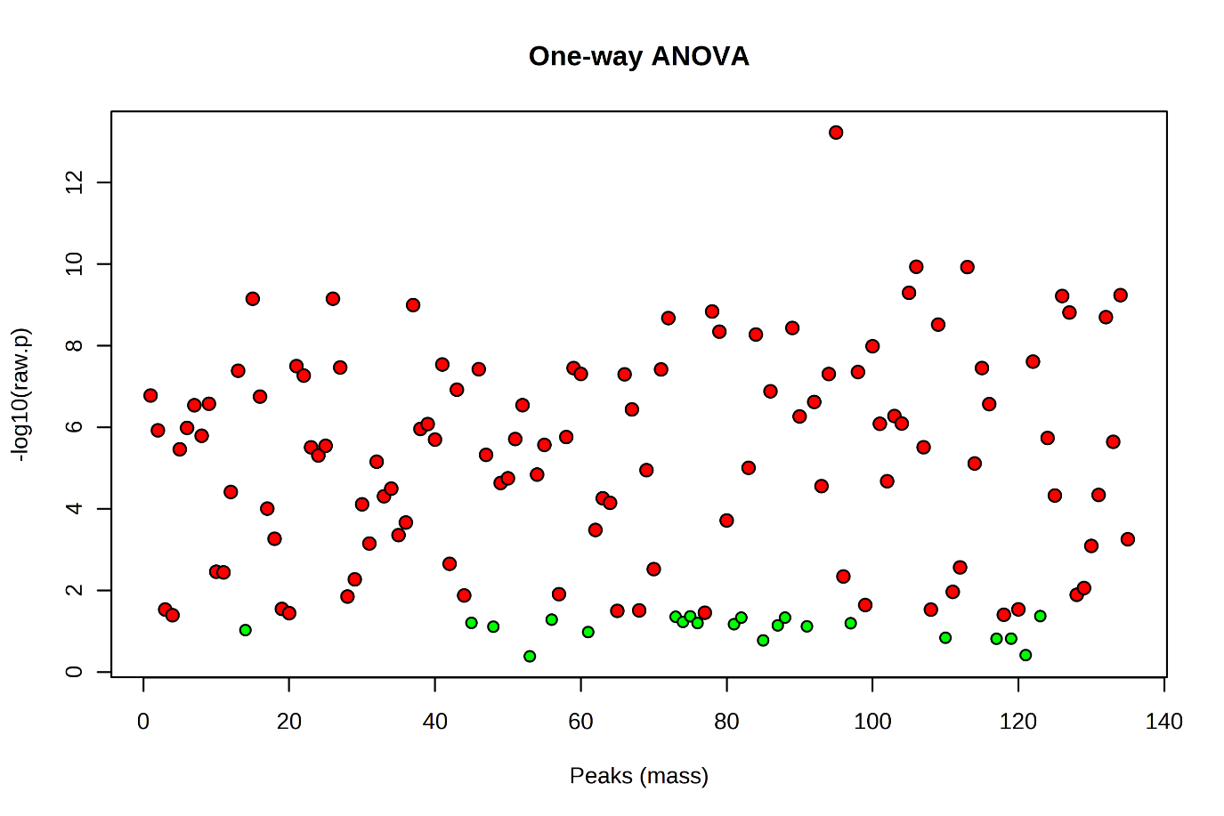

Supplementary data 21: Correlation of Caffeine with other Metabolites

S. No. | CID No. | Compound Name | Correlation | t-stat | p-value | FDR
 | 2519 | Caffeine | 1 | Inf | 0 | 0
 | 442154 | Afzelechin | 0.99999 | 609.19 | 3.50E-24 | 2.36E-22
 | 6036 | d-Galactose | 0.99998 | 461.8 | 5.58E-23 | 2.51E-21
 | 638072 | Squalene | 0.99924 | 80.846 | 2.05E-15 | 6.91E-14
 | 444173 | beta-Arabinopyranose | 0.99912 | 75.481 | 4.07E-15 | 1.10E-13
 | 85977274 | 5,5-Diethylpentadecane | 0.99858 | 59.292 | 4.52E-14 | 1.02E-12
 | 6306 | L-Isoleucine | 0.998 | 49.976 | 2.49E-13 | 4.80E-12
 | 85782 | 3,4-Dihydroxy mandelic acid | 0.99744 | 44.135 | 8.57E-13 | 1.45E-11
 | 1050 | Pyridoxal | 0.99623 | 36.328 | 5.94E-12 | 8.91E-11
 | 95562 | 5-Hydroxynorvaline | 0.99583 | 34.521 | 9.85E-12 | 1.33E-10
 | 440936 | .beta.-D-Glucopyranoside | 0.99442 | 29.807 | 4.22E-11 | 5.18E-10
 | 439294 | Inosose | 0.99336 | 27.311 | 1.00E-10 | 1.13E-09
 | 1794427 | Chlorogenic acid | 0.99252 | 25.71 | 1.82E-10 | 1.89E-09
 | 6134 | D-Lactose | 0.99175 | 24.461 | 2.97E-10 | 2.87E-09
 | 964 | .beta.-Hydroxy pyruvic acid | 0.99052 | 22.805 | 5.93E-10 | 5.33E-09
 | 10964471 | (R*,S*)-2,3-Dihydroxy butanoic acid | 0.98562 | 18.447 | 4.72E-09 | 3.98E-08
 | 108223 | Deoxyglucose | 0.98258 | 16.719 | 1.23E-08 | 9.75E-08
 | 10712 | D - (+) - Cellobiose | 0.98124 | 16.096 | 1.77E-08 | 1.33E-07
 | 499 | DL-Pyroglutamic acid | 0.97933 | 15.31 | 2.87E-08 | 2.04E-07
 | 54350893 | d-Erythro-pentose | 0.9775 | 14.656 | 4.37E-08 | 2.88E-07
 | 445639 | Oleic acid | 0.97739 | 14.618 | 4.48E-08 | 2.88E-07
 | 99459 | D-(+)-Talose | 0.9513 | 9.7587 | 1.99E-06 | 1.22E-05
 | 182230 | N-Acetylglutamine | 0.91552 | 7.197 | 2.94E-05 | 0.0001724
 | 10975657 | Ribose | 0.90418 | 6.6939 | 5.41E-05 | 0.000304
 | 892 | Scyllo-Inositol | 0.89946 | 6.5086 | 6.82E-05 | 0.0003683
 | 370 | Gallic acid | 0.75913 | 3.6878 | 0.004192 | 0.019514
 | 3681 | Batylalcohol | 0.72869 | 3.3648 | 0.007185 | 0.032331
 | 6057 | Tyrosine | 0.7116 | 3.2028 | 0.009446 | 0.041138
 | 72277 | Epigallocatechin | 0.66737 | 2.8338 | 0.017736 | 0.074824
 | 3931 | 9,12-Octadecadienoic acid | 0.64947 | 2.701 | 0.022274 | 0.088441
 | 545303 | 7,9-Di-tert-butyl-1-oxaspiro(4,5)deca-6,9-diene-2,8-dione | 0.63979 | 2.6325 | 0.025055 | 0.096639
 | 1049 | Pyridine | 0.58848 | 2.3017 | 0.044129 | 0.16101
 | 5816 | Epinephrine | 0.57767 | 2.2379 | 0.049179 | 0.17472
 | 13220195 | 3,6-Epoxydodecanedioic acid | 0.56565 | 2.1691 | 0.055251 | 0.19125
 | 752 | Glyceric acid | 0.52518 | 1.9516 | 0.079541 | 0.22847
 | 151152 | Threonic acid | 0.51563 | 1.9031 | 0.086186 | 0.24032
 | 135191 | D-(+)-Xylose | 0.51326 | 1.8912 | 0.087894 | 0.24032
 | 638122 | Pentenoic acid | 0.50096 | 1.8304 | 0.097112 | 0.25212
 | 439268 | 2-Deoxy-glucose | 0.49476 | 1.8004 | 0.10199 | 0.25497
 | 8742 | Shikimic acid | 0.48268 | 1.7428 | 0.11197 | 0.27484
 | 1110 | Succinic acid | 0.44435 | 1.5685 | 0.14783 | 0.35054
 | 971 | Oxalic acid | 0.42927 | 1.503 | 0.16375 | 0.37467
 | 637517 | Elaidic acid | 0.42522 | 1.4857 | 0.1682 | 0.37844
 | 8222 | Eicosane | 0.41859 | 1.4575 | 0.17565 | 0.38873
 | 439312 | Tagatose | 0.41387 | 1.4377 | 0.18108 | 0.38919
 | 5793 | d-Glucose | 0.4134 | 1.4357 | 0.18162 | 0.38919
 | 53413950 | tert-Butyl3-(aminomethyl)piperazine-1-carboxylate | 0.40429 | 1.3978 | 0.1924 | 0.39099
 | 612 | Lactic acid | 0.38405 | 1.3154 | 0.21775 | 0.39099
 | 345824 | Quininic acid | 0.37152 | 1.2654 | 0.23441 | 0.39099
 | 753 | Glycerol | 0.34832 | 1.1751 | 0.26719 | 0.42605
 | 1176 | Urea | 0.21985 | 0.71267 | 0.49234 | 0.68903
 | 9064 | Catechine | 0.20603 | 0.6658 | 0.5206 | 0.68903
 | 7628 | Boric acid | 0.18015 | 0.57914 | 0.57531 | 0.71999
 | 79050 | 1-Monomyristin | 0.15019 | 0.48039 | 0.64128 | 0.74736
 | 91601 | Phenol,2,4-bis(1,1-dimethylethyl)-, phosphite | 0.1274 | 0.40618 | 0.69317 | 0.76079
 | 6287 | L-Valine | 0.10403 | 0.33077 | 0.74764 | 0.79503
 | 3246944 | 2,3-Dihydroxypropylicosanoate | 0.073658 | 0.23356 | 0.82004 | 0.85158
 | 33032 | L-Glutamic acid | 0.056361 | 0.17851 | 0.86188 | 0.88147
 | 985 | Palmitic acid | 0.052705 | 0.1669 | 0.87078 | 0.88387
 | 525 | Malic acid | 0.001776 | 0.005616 | 0.99563 | 0.99563
 | 6322 | Arginine | -0.046205 | -0.14627 | 0.88661 | 0.89323
 | 7405 | L-5-Oxoproline | -0.069165 | -0.21924 | 0.83087 | 0.85624
 | 127686 | Asterbatanoside A | -0.074363 | -0.23581 | 0.81834 | 0.85158
 | 14900 | 1-Monopalmitin | -0.093737 | -0.29773 | 0.772 | 0.81422
 | 137938 | 2-Monomyristin | -0.10391 | -0.3304 | 0.74792 | 0.79503
 | 107812 | Hypotaurine | -0.10572 | -0.33619 | 0.74368 | 0.79503
 | 24699 | Glycerolmonostearate | -0.10866 | -0.34567 | 0.73675 | 0.79503
 | 511918 | (2R, 3S, 4S, 5R, 6R)-2-(Hydroxymethyl)-6-pentoxyoxane-3, 4, 5-triol | -0.13226 | -0.42194 | 0.68199 | 0.75466
 | 441036 | Psicose | -0.13757 | -0.4392 | 0.66986 | 0.74736
 | 5460032 | L - (+) - Erythrulose | -0.13871 | -0.44291 | 0.66726 | 0.74736
 | 239 | beta-Alanine | -0.1414 | -0.45168 | 0.66114 | 0.74736
 | 5460672 | L - (+) - Threose | -0.14171 | -0.45269 | 0.66043 | 0.74736
 | 445969 | L-Threitol | -0.14181 | -0.45303 | 0.6602 | 0.74736
 | 68152 | 3-Hydroxypropionic acid | -0.14568 | -0.46566 | 0.65143 | 0.74736
 | 1045 | Putrescine | -0.15208 | -0.48657 | 0.63705 | 0.74736
 | 99823 | 2-Hydroxyisovaleric acid | -0.15734 | -0.50382 | 0.6253 | 0.74704
 | 94176 | D - (-) - Erythrose | -0.16651 | -0.53402 | 0.605 | 0.72924
 | 439192 | Sorbose | -0.16669 | -0.53459 | 0.60461 | 0.72924
 | 167627 | 7-Hydroxyctanoic acid | -0.16782 | -0.53834 | 0.60212 | 0.72924
 | 87653 | 2-(1,3-Thiazol-2-yl) ethanamine | -0.17078 | -0.54811 | 0.59564 | 0.72924
 | 6305 | L-Tryptophan | -0.17983 | -0.57808 | 0.57599 | 0.71999
 | 145742 | L-Proline | -0.19071 | -0.61436 | 0.5527 | 0.70391
 | 9750 | L-Citrulline | -0.19154 | -0.61712 | 0.55095 | 0.70391
 | 11727586 | Galactinol | -0.19233 | -0.61977 | 0.54927 | 0.70391
 | 123409 | 2-Palmitoyl glycerol | -0.20286 | -0.65514 | 0.52716 | 0.69094
 | 5280847 | .beta.-D-Glucopyranoside,4-[(1E)-3-hydroxy-1-propen-1-yl]phenyl | -0.2075 | -0.67078 | 0.51755 | 0.68903
 | 86863 | Ritalinic acid | -0.20886 | -0.67536 | 0.51476 | 0.68903
 | 294 | beta-D-Lactose | -0.20886 | -0.67535 | 0.51476 | 0.68903
 | 6267 | Asparagine | -0.20895 | -0.67567 | 0.51457 | 0.68903
 | 9798666 | 4-O-Caffeoylquinic acid | -0.21062 | -0.68131 | 0.51114 | 0.68903
 | 21572943 | Isopropyl.beta.-D-glucopyranoside | -0.21976 | -0.71236 | 0.49253 | 0.68903
 | 5960 | Aspartic acid | -0.23993 | -0.78156 | 0.45258 | 0.64998
 | 119838 | 3-Hydroxy-2,3-dihydromaltol | -0.26149 | -0.85672 | 0.41166 | 0.59757
 | 5961 | Glutamine | -0.26202 | -0.85856 | 0.41069 | 0.59757
 | 283379 | 1,2,4,5-Tetrazine-3,6-diamine | -0.27363 | -0.89963 | 0.38947 | 0.57778
 | 6140 | Phenylalanine | -0.274 | -0.90093 | 0.38881 | 0.57778
 | 311 | Citric acid | -0.27538 | -0.90584 | 0.38632 | 0.57778
 | 12398 | Heptadecane | -0.28892 | -0.95436 | 0.3624 | 0.55596
 | 14871 | Monolaurin | -0.30775 | -1.0228 | 0.3305 | 0.51284
 | 419223 | Tetrahydro-2H-pyran-4-amine | -0.33141 | -1.1108 | 0.29265 | 0.45939
 | 19352763 | Cyclohexanediol | -0.3476 | -1.1723 | 0.26825 | 0.42605
 | 7427 | Trehalose | -0.36211 | -1.2285 | 0.2474 | 0.40239
 | 10465 | Heptadecanoic acid | -0.36926 | -1.2565 | 0.23749 | 0.39099
 | 469 | 2-Aminoadipic acid | -0.36971 | -1.2583 | 0.23688 | 0.39099
 | 70 | 2-Ketoisocaproic acid | -0.37021 | -1.2602 | 0.23619 | 0.39099
 | 1123 | Taurine | -0.37037 | -1.2609 | 0.23597 | 0.39099
 | 11458 | Melibiose | -0.37087 | -1.2628 | 0.2353 | 0.39099
 | 12313291 | Neposide | -0.37134 | -1.2647 | 0.23465 | 0.39099
 | 447347 | D-(-)-Ribofuranose | -0.37134 | -1.2647 | 0.23466 | 0.39099
 | 64689 | .beta.-D-Glucopyranose | -0.37218 | -1.268 | 0.23351 | 0.39099
 | 79075 | 2-Monostearin | -0.37251 | -1.2693 | 0.23307 | 0.39099
 | 439535 | 2,3,4-Trihydroxybutyricacid | -0.37306 | -1.2715 | 0.23232 | 0.39099
 | 98504 | Lanthionine | -0.37436 | -1.2767 | 0.23057 | 0.39099
 | 439242 | .alpha.-D-Glucopyranoside | -0.37473 | -1.2781 | 0.23008 | 0.39099
 | 5460677 | Ribonic acid | -0.3752 | -1.28 | 0.22944 | 0.39099
 | 2723872 | Fructose | -0.37526 | -1.2802 | 0.22936 | 0.39099
 | 10466 | Juniperic acid | -0.39643 | -1.3655 | 0.20202 | 0.39099
 | 5281 | Stearic acid | -0.4061 | -1.4053 | 0.19023 | 0.39099
 | 5950 | Alanine | -0.43055 | -1.5085 | 0.16236 | 0.37467
 | 94715 | D-Glucuronic acid | -0.44418 | -1.5678 | 0.148 | 0.35054
 | 6288 | L-Threonine | -0.49819 | -1.817 | 0.099269 | 0.25285
 | 6262 | Ornithine | -0.50145 | -1.8328 | 0.096727 | 0.25212
 | 10690 | D-Gluconic acid | -0.51173 | -1.8835 | 0.089006 | 0.24032
 | 129602196 | (2R, 3S, 4S, 5R, 6R)-2-(Hydroxymethyl)-6-(4-methylpentoxy)oxane-3,4,5-triol | -0.52823 | -1.9673 | 0.077492 | 0.22742
 | 750 | Glycine | -0.53096 | -1.9814 | 0.075693 | 0.22708
 | 1004 | Phosphoric acid | -0.53103 | -1.9818 | 0.075651 | 0.22708
 | 68149 | 1,3-Dipalmitin | -0.53309 | -1.9925 | 0.074309 | 0.22708
 | 700 | 2-Aminoethanol | -0.55356 | -2.1019 | 0.061875 | 0.19888
 | 54301978 | D-(+)-Turanose | -0.55491 | -2.1093 | 0.06111 | 0.19888
 | 222285 | Erythritol | -0.55893 | -2.1315 | 0.058869 | 0.19868
 | 5283468 | 1-Monooleoylglycerol | -0.61952 | -2.4957 | 0.031679 | 0.1188
 | 5951 | L-Serine | -0.66126 | -2.7875 | 0.019201 | 0.07855
 | 5988 | Sucrose | -0.76084 | -3.7076 | 0.004058 | 0.019514
 | 119 | 4-Aminobutyric acid | -0.77789 | -3.9145 | 0.002892 | 0.014459
 | 11005 | Myristic acid | -0.896 | -6.3807 | 8.03E-05 | 0.0004169

Supplementary data 22: Heatmap of correlation matrix involving metabolite datasets with corresponding columns.
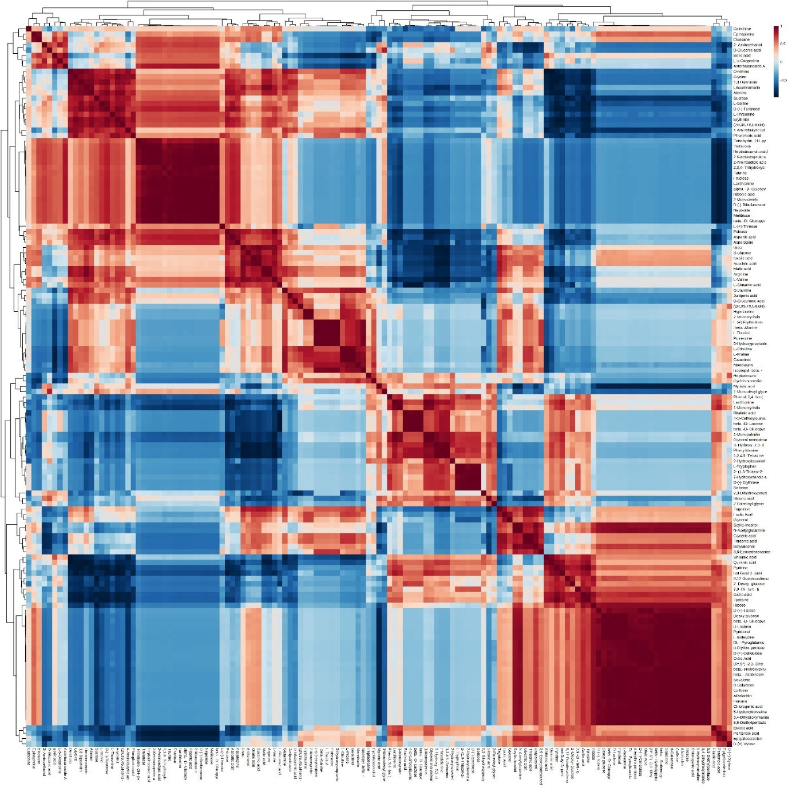

Supplementary data 23: Illustration on the interconnections among various metabolites investigated in this study.
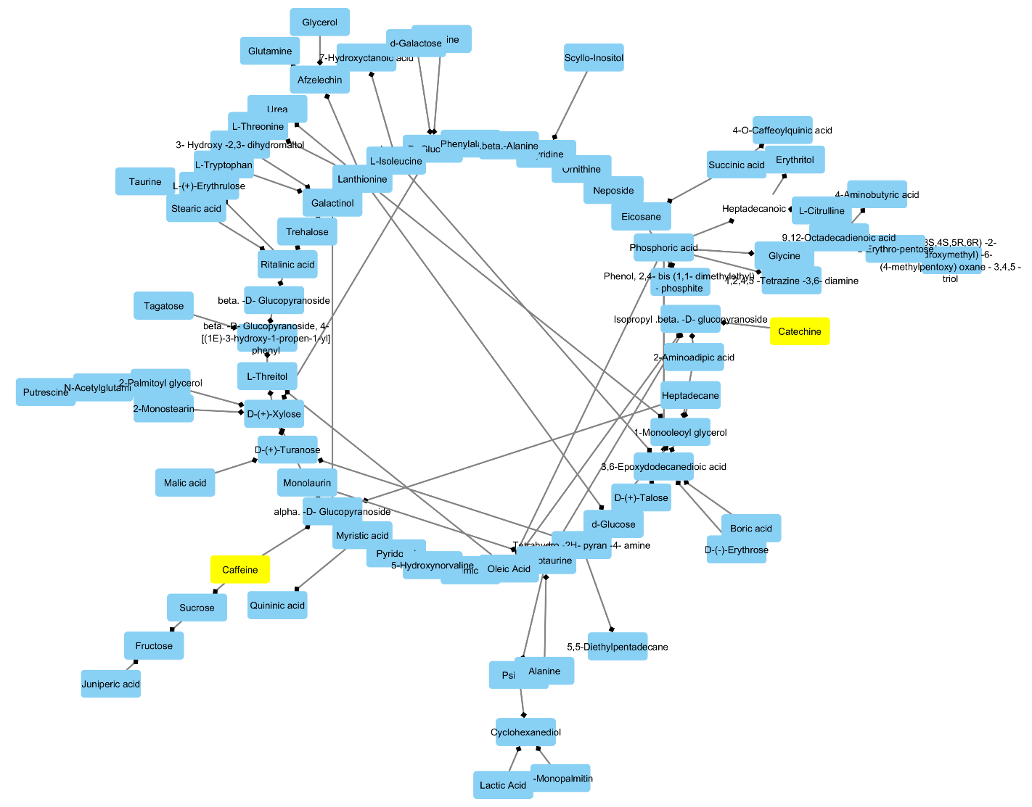

Supplementary data 24: Pathway involved in the biosynthesis of flavonoids.
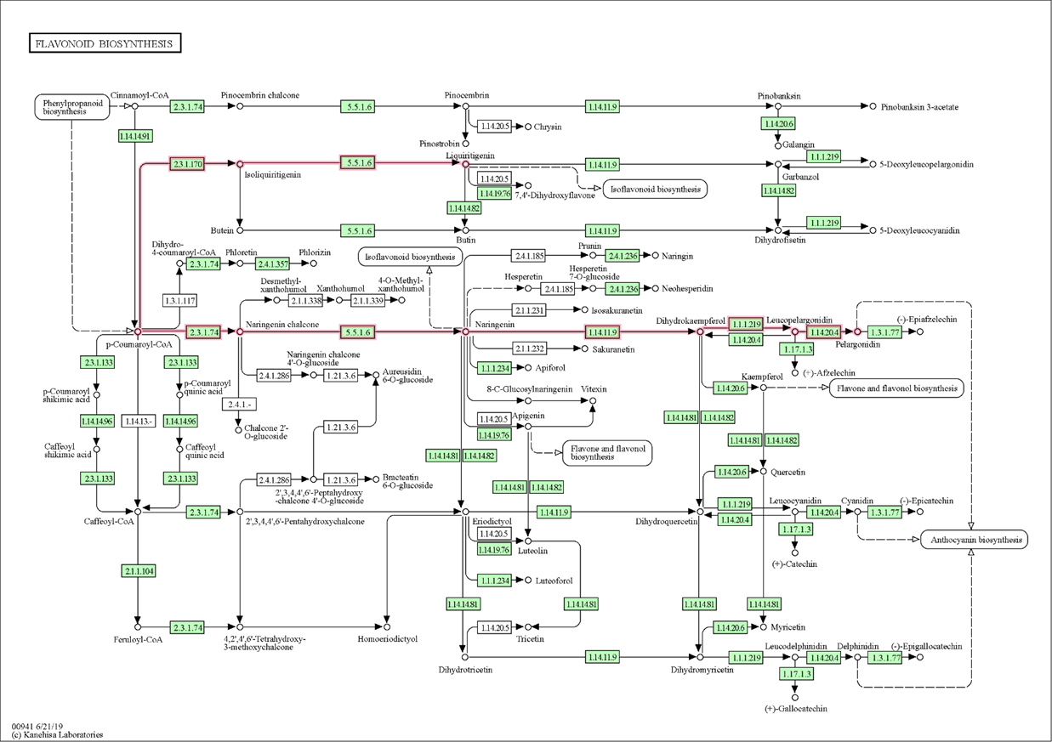

Supplementary data 25: Agarose gel electrophoresis of the SSR derived from TSC 2.

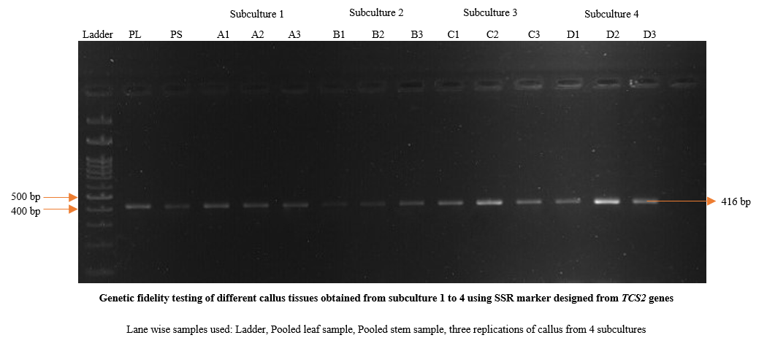

Supplementary data 26: Agarose gel electrophoresis of the SSR derived from TSC 3.

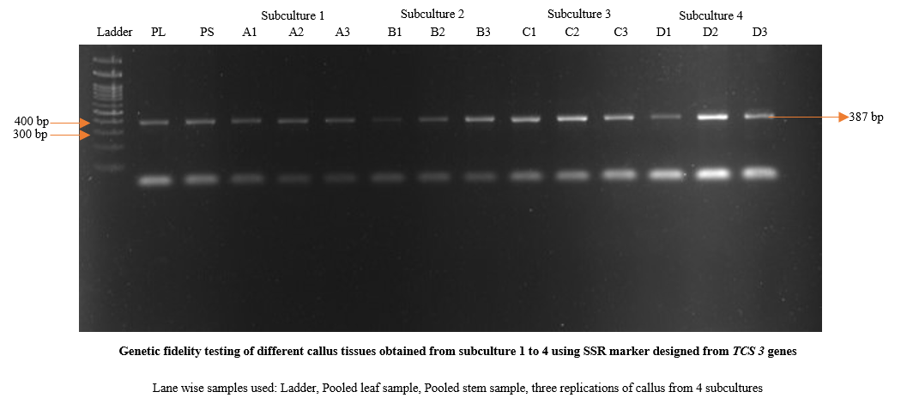

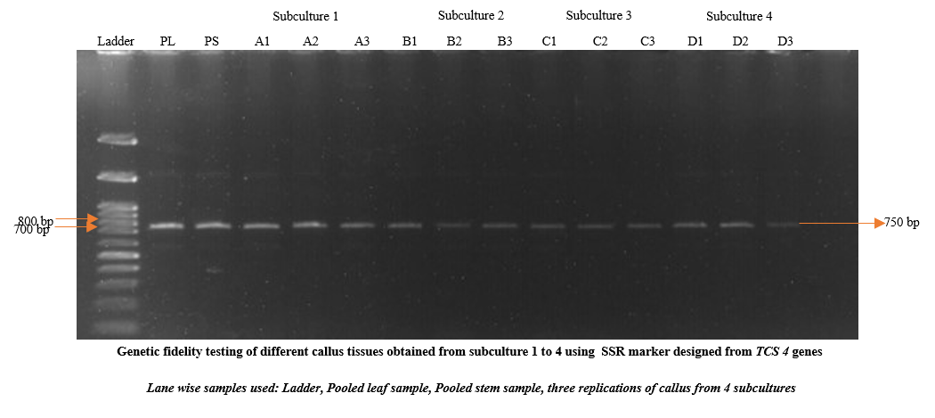
Supplementary data 27: Agarose gel electrophoresis of the SSR derived from TSC 4.

Supplementary data 28: Agarose gel electrophoresis of the SSR derived from TSC 5.
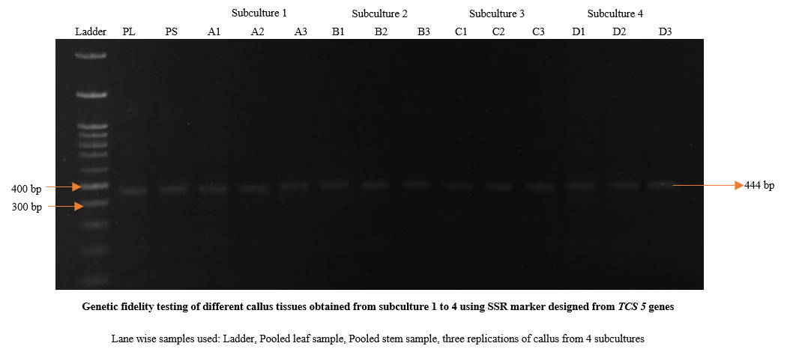

Supplementary data 29: Agarose gel electrophoresis of the SSR derived from TSC 6.

