Supplementary Figures

Association between Maternal Perinatal Stress and Depression on Infant DNA Methylation in the First Year of Life

Sarina Abrishamcar¹, Beryl C. Zhuang^{2,3,4}, Mara Thomas^{2,3}, Nicole Gladish^{2,3,4,5}, Julia L MacIsaac^{2,3,4}, Meaghan J. Jones⁶, Elinor Simons^{7,8}, Theo J. Moraes⁹, Piush Mandhane¹⁰, Jeffrey R. Brook¹¹, Padmaja Subbarao^{9,11,12}, Stuart E. Turvey¹³, Edith Chen^{14,15}, Gregory E Miller^{14,15}, Michael S. Kobor^{2,3,4}*, Anke Hüls^{1,16,17}*
* contributed equally to this work and shared last authorship

¹Department of Epidemiology, Rollins School of Public Health, Emory University, Atlanta, Georgia, USA
²Department of Medical Genetics, University of British Columbia, Vancouver, BC, Canada
³BC Children's Hospital Research Institute, Vancouver, BC, Canada
⁴ Edwin S.H. Leong Centre for Healthy Aging, Vancouver, BC, Canada
⁵Department of Epidemiology and Population Health, School of Medicine, Stanford University, Palo Alto, CA, United States
⁶Department of Biochemistry and Medical Genetics, University of Manitoba, and Children’s Hospital Research Institute of Manitoba, Winnipeg, MB, Canada
⁷Department of Pediatrics and Child Health, University of Manitoba, Winnipeg, MB, Canada
⁸Children’s Hospital Research Institute of Manitoba, Winnipeg, MB, Canada
⁹Division of Respiratory Medicine, Department of Pediatrics, Hospital for Sick Children & Research Institute, Toronto, ON, Canada
¹⁰Department of Pediatrics, University of Alberta, Edmonton, AB, Canada
¹¹Dalla Lana School of Public Health, University of Toronto, Toronto, ON, Canada
¹²Department of Physiology, University of Toronto, Toronto, ON, Canada
¹³Department of Pediatrics, BC Children’s Hospital, The University of British Columbia, Vancouver, BC, Canada
¹⁴Department of Psychology, Northwestern University, Evanston, IL, USA
¹⁵Institute for Policy Research, Northwestern University, Evanston, IL, USA
¹⁶Gangarosa Department of Environmental Health, Rollins School of Public Health, Emory University, Atlanta, Georgia, USA
¹⁷Department of Biostatistics and Bioinformatics, Rollins School of Public Health, Emory University, Atlanta, Georgia, USA

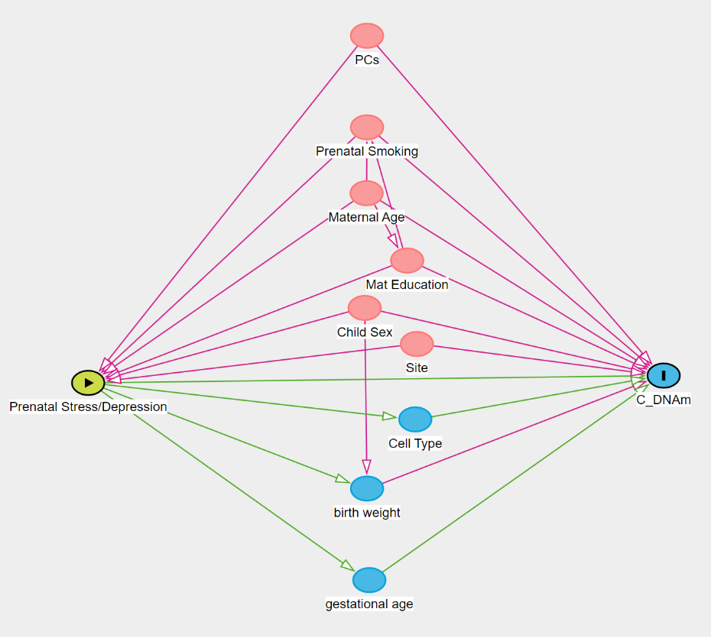
A

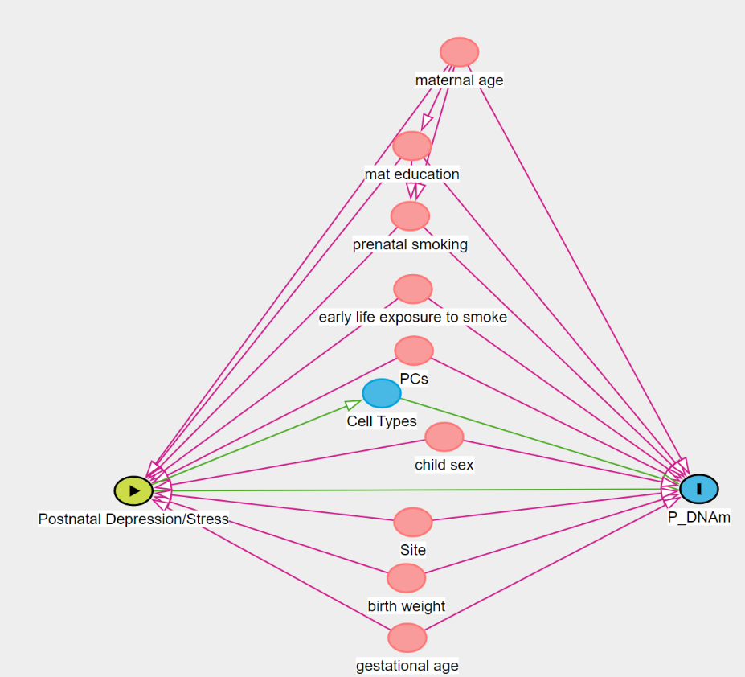
B

Figure S1: Directed acyclic graphs (DAGs) used for confounding assessment. S1A) Prenatal stress/depression – cord blood DNAm DAG. S1B) Postnatal stress/depression – whole blood DNAm DAG.

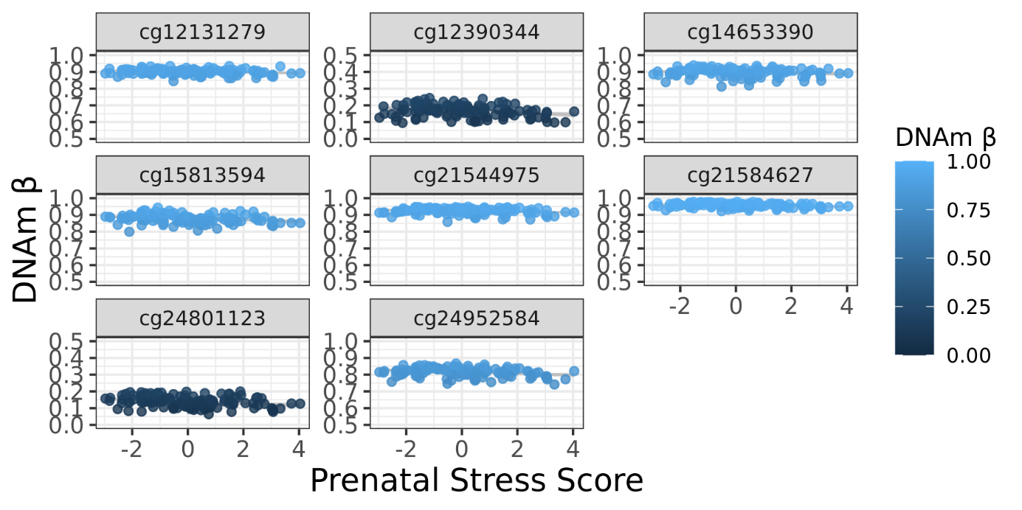
Figure S2: DNAm levels of significant CpG sites for the association between prenatal stress and CB-DNAm.
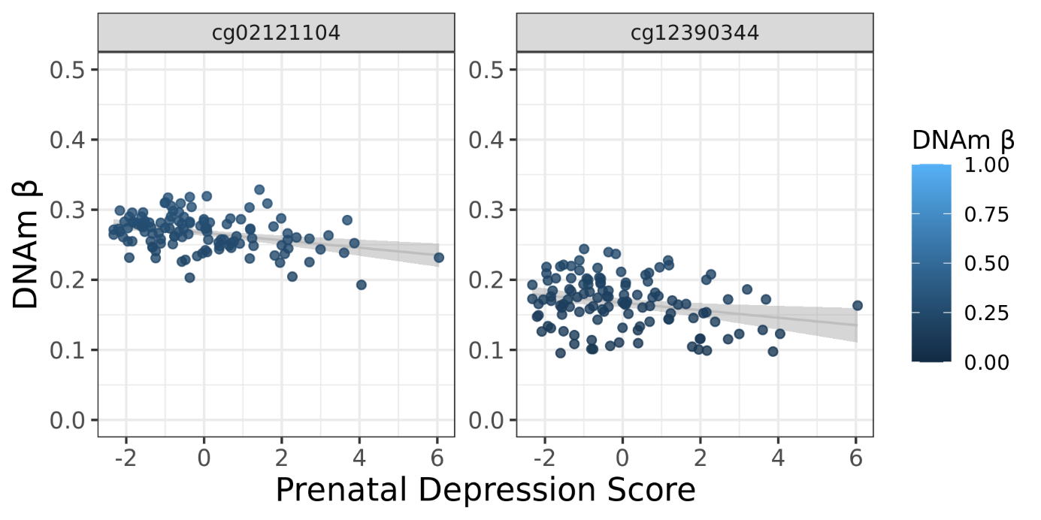

Figure S3: DNAm levels of significant CpG sites for the association between prenatal depression and CB-DNAm.
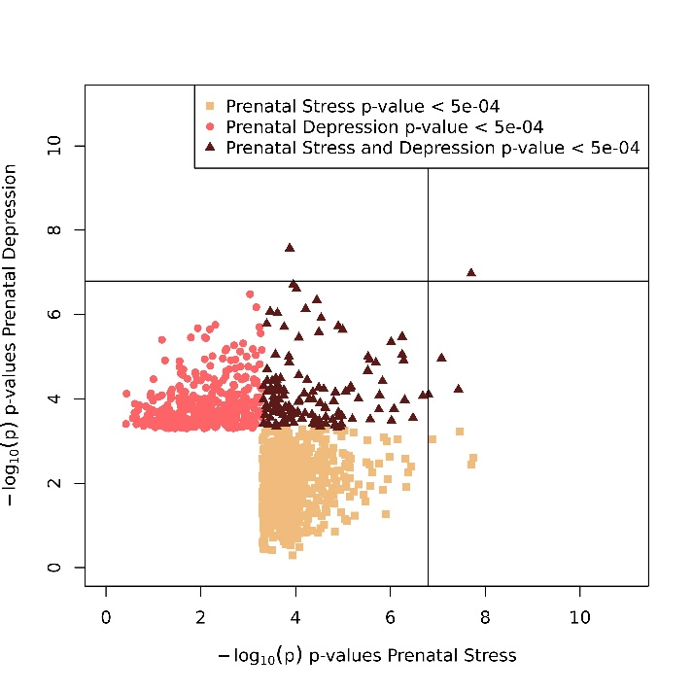
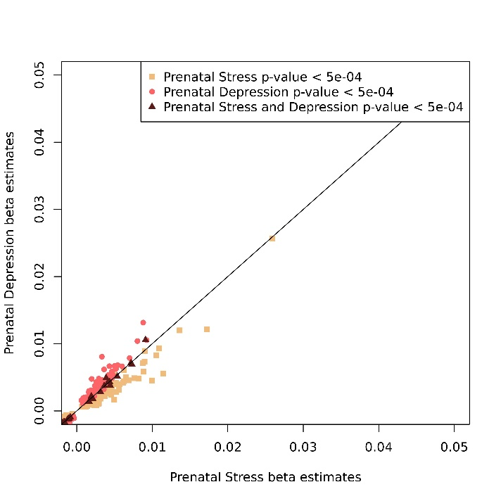
B
A

Figure S4: Correlated beta estimates and p-values of prenatal stress and depression CB-DNAm CpG sites with p-values less than 5.0E-04. S4A) Correlated beta estimates. S4B) Correlated p-values.

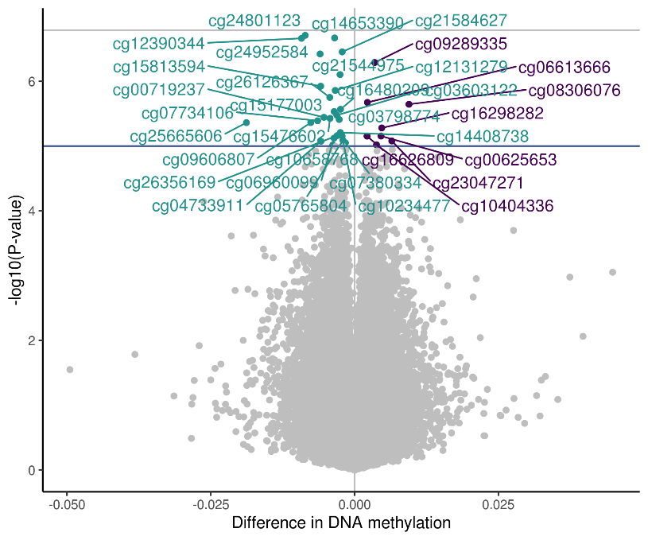
A
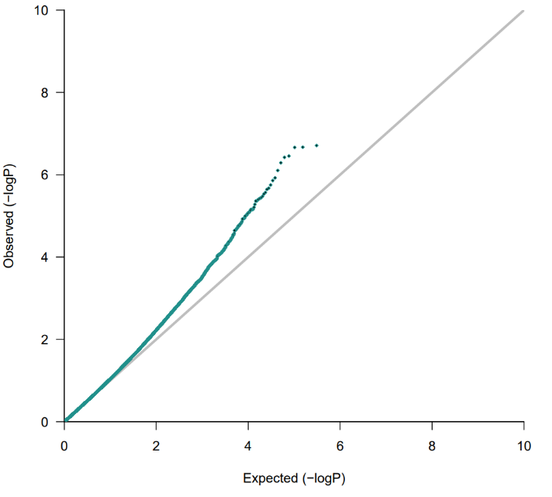

B

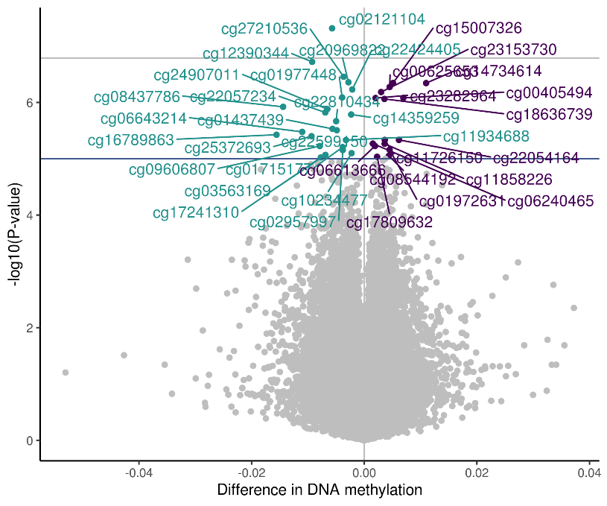
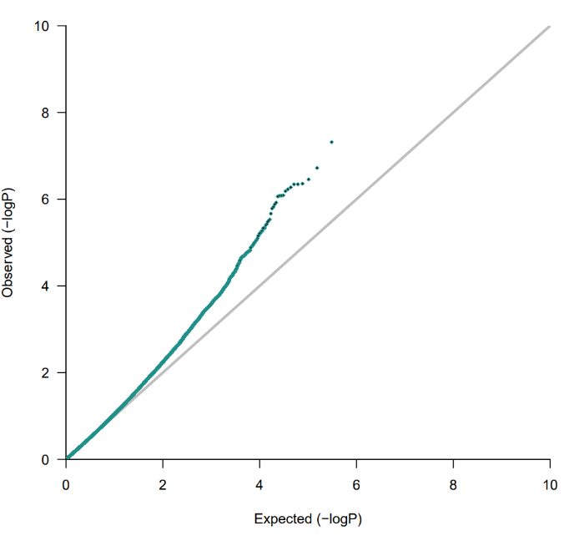

Figure S5: QQ and volcano plots for the associations between prenatal stress/depression and CB-DNAm adjusted for unmeasured confounding using bacon. S5A) Association between prenatal stress and CB-DNAm S5B) Association between prenatal depression and CB-DNAm. Models were adjusted for prenatal tobacco exposure, household income, child sex, maternal age, study center, genetic principal components, and cell type proportions. Bonferroni threshold-1.6e-07.

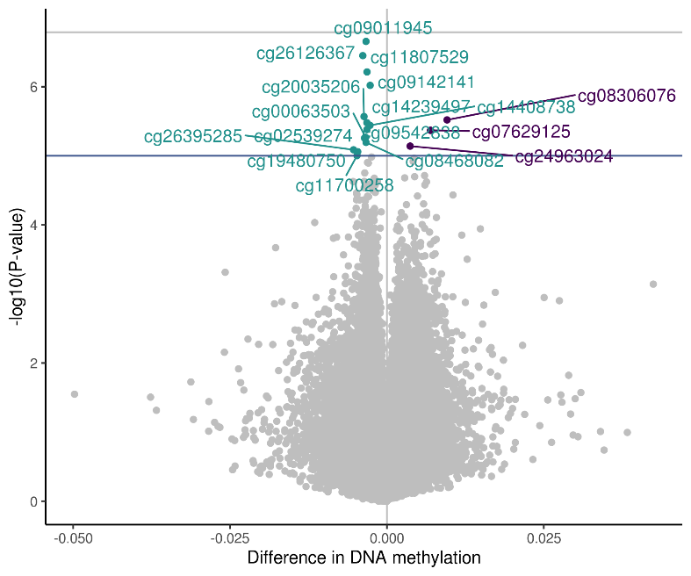
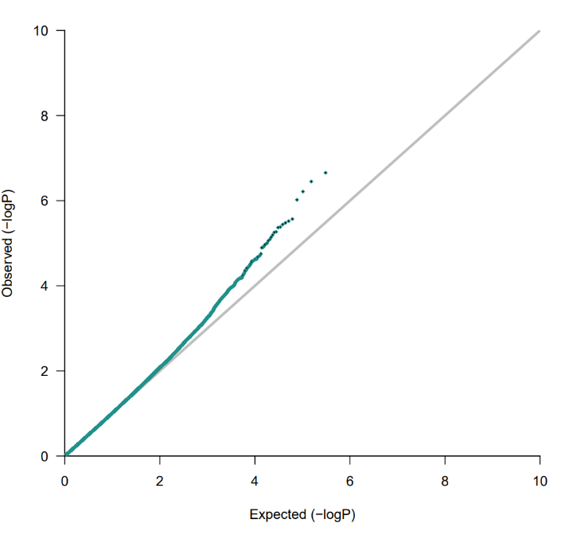
A

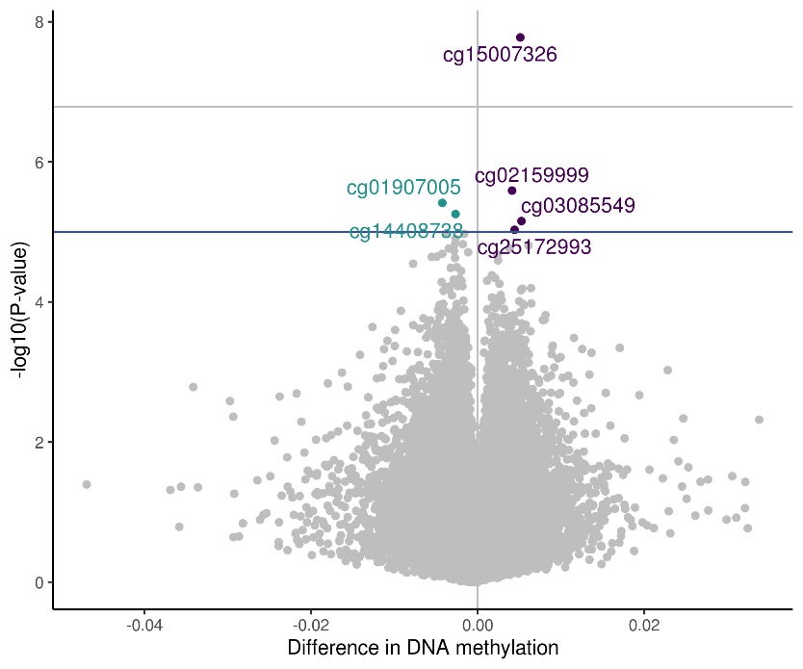
B
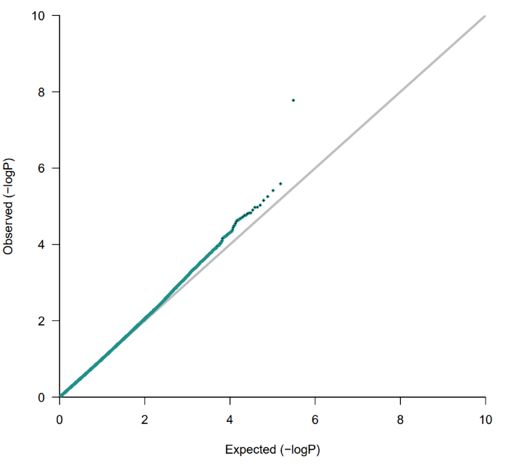

Figure S6: QQ and volcano plots for the associations between prenatal stress/depression and CB-DNAm, adjusted for unmeasured confounding using cate. S6A) Association between prenatal stress and CB-DNAm S6B) Association between prenatal depression and CB-DNAm. Models were adjusted for prenatal tobacco exposure, household income, child sex, maternal age, and study center. Bonferroni threshold-1.6e-07.

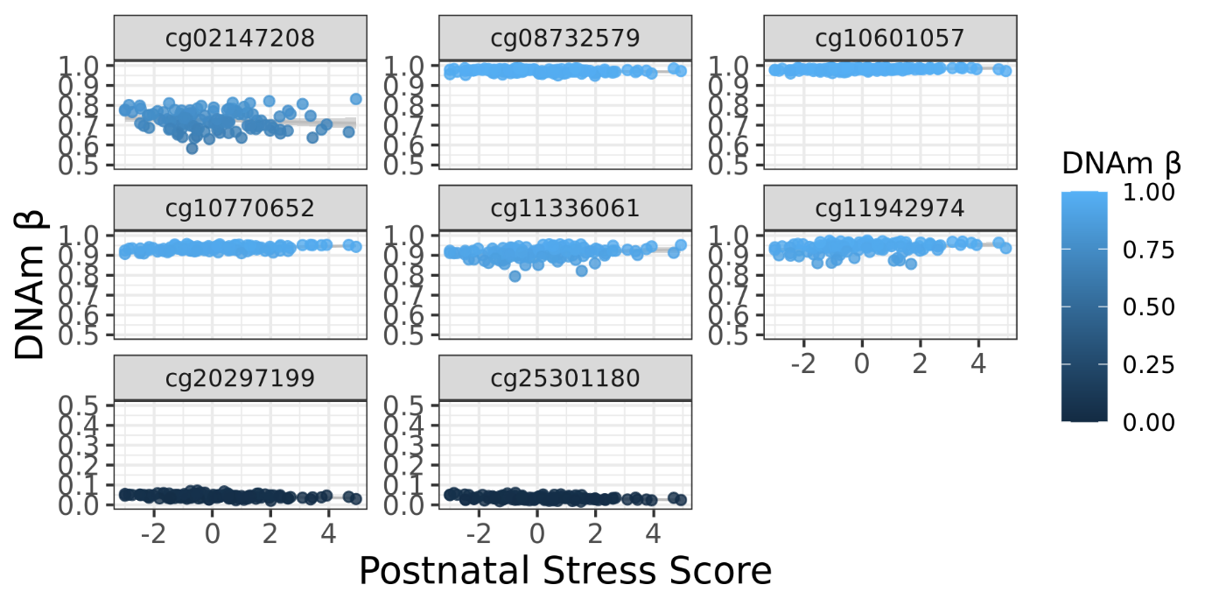

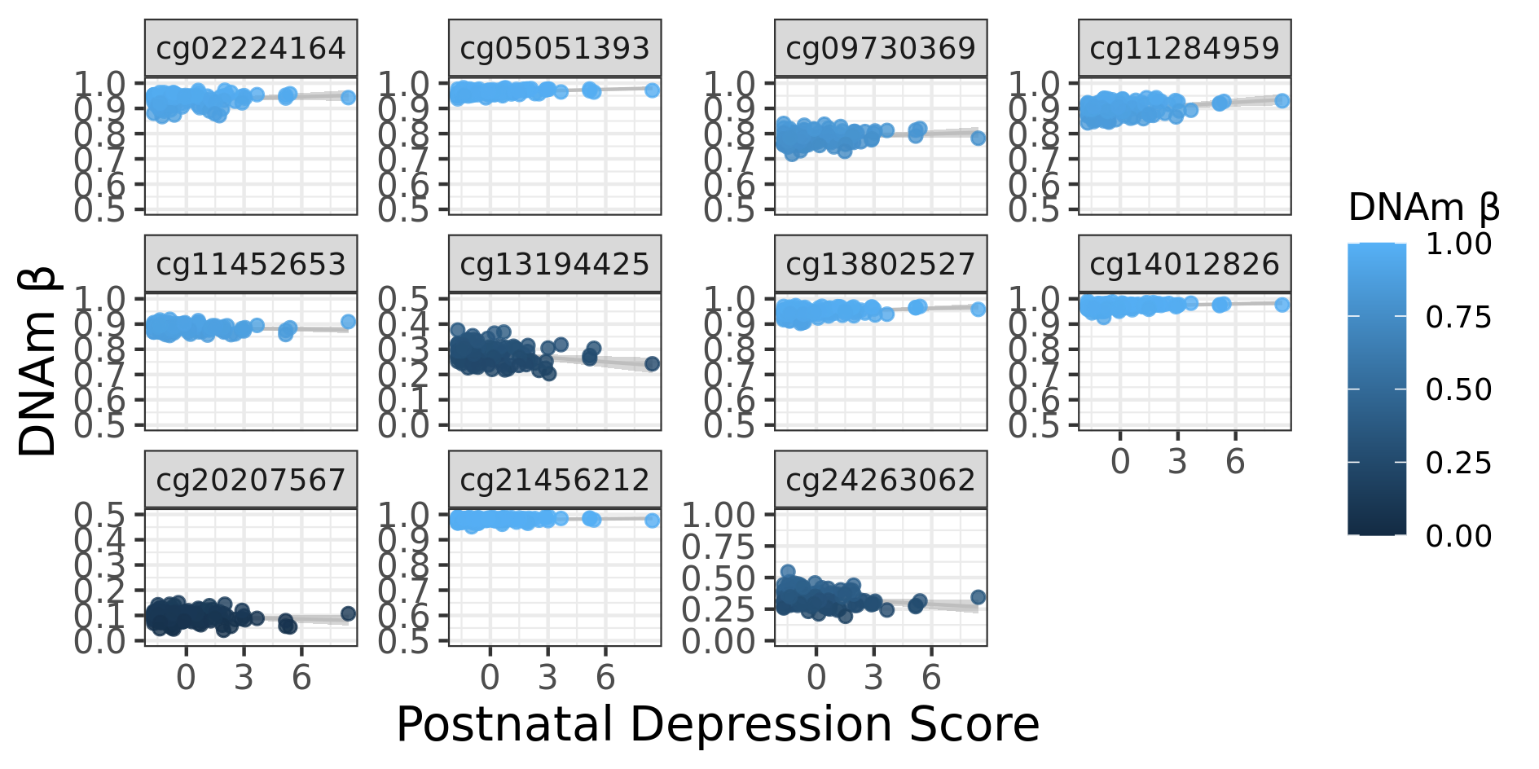
Figure S7: DNAm levels of significant CpG sites for the association between postnatal stress and PB-DNAm.

Figure S8: DNAm levels of significant CpG sites for the association between postnatal depression and PB-DNAm.
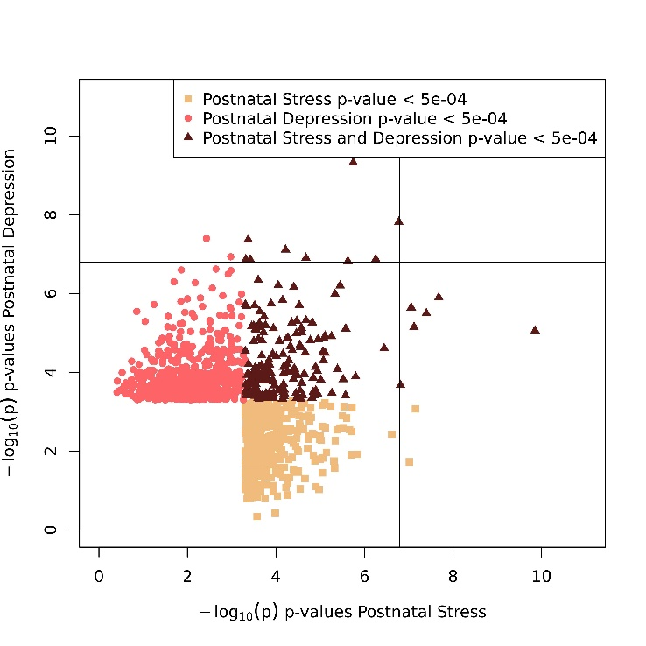
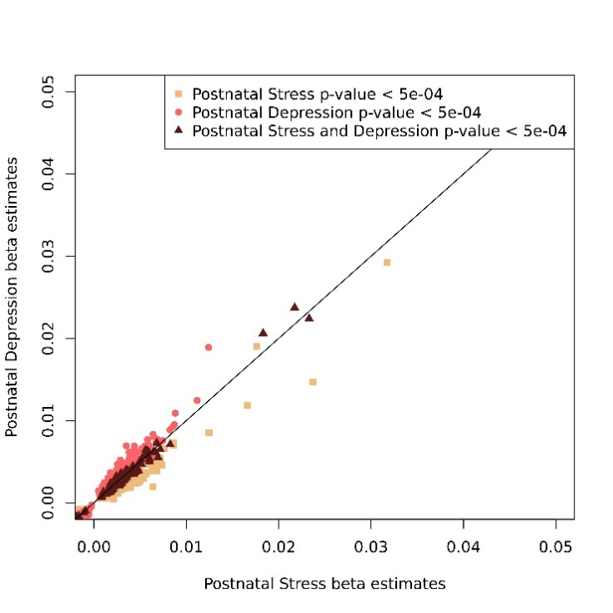
B
A

Figure S9: Correlated beta estimates and p-values of postnatal stress and depression PBMC-DNAm CpG sites with p-values less than 5.0E-04. S9A) Correlated beta estimates. S9B) Correlated p-values.

A
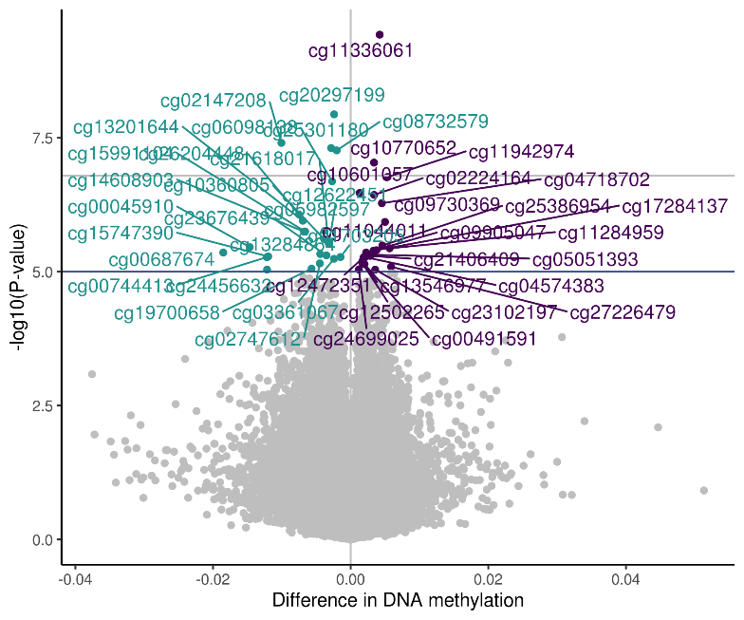
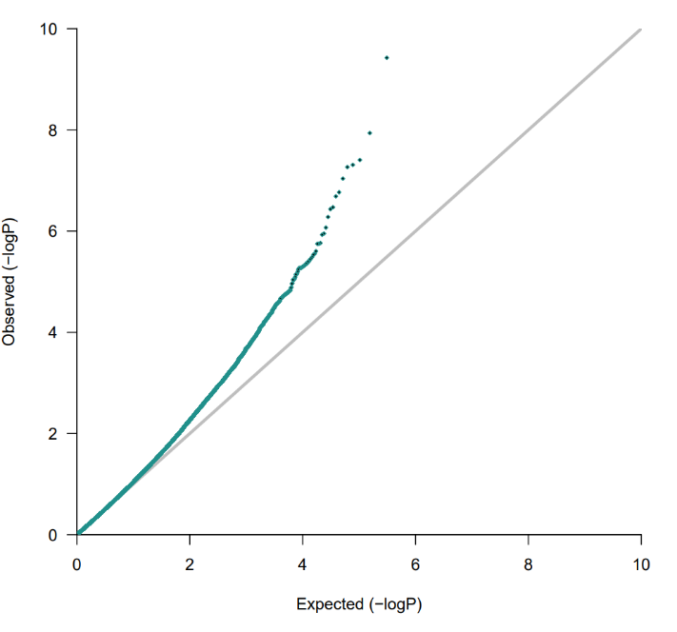

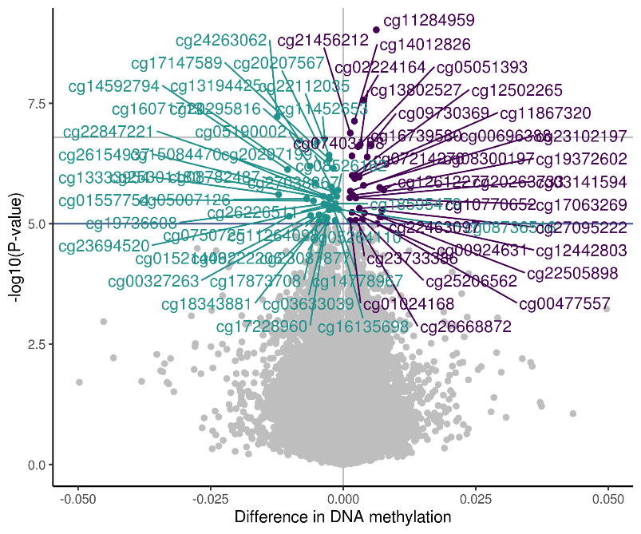
B
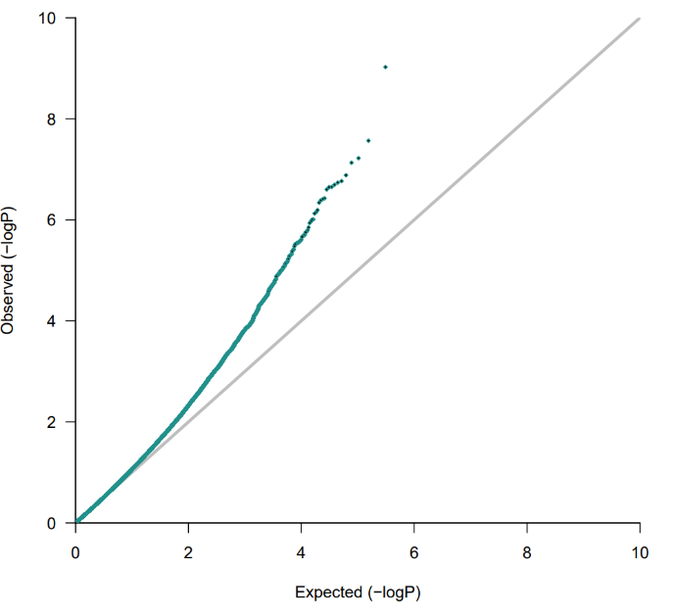

Figure S10: QQ and volcano plots for the associations between postnatal stress/depression and PBMC-DNAm adjusted for unmeasured confounding using bacon. S10A) Association between postnatal stress and WB-DNAm S10B) Association between postnatal depression and WB-DNAm. Models were adjusted for prenatal tobacco exposure, postnatal tobacco exposure, household income, child sex, maternal age, birth weight, study center, genetic principal components, and cell type proportions. Bonferroni threshold=1.6E-07.

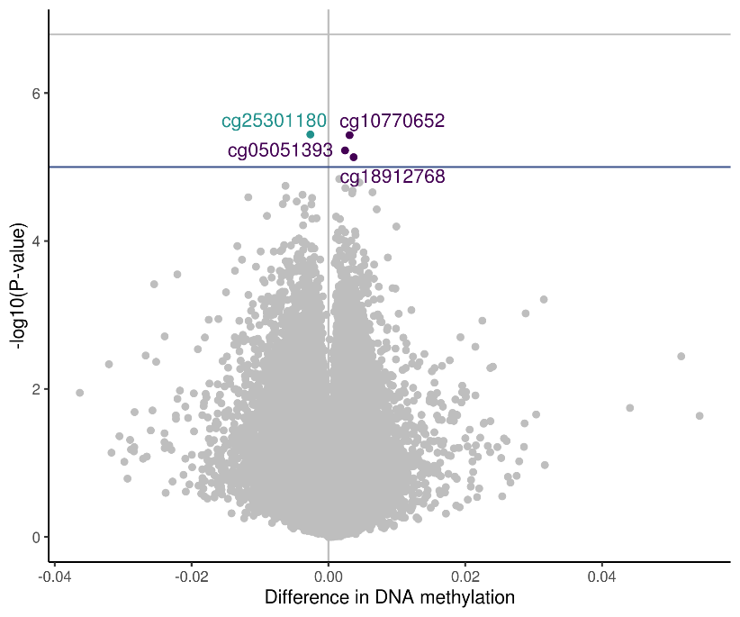
A
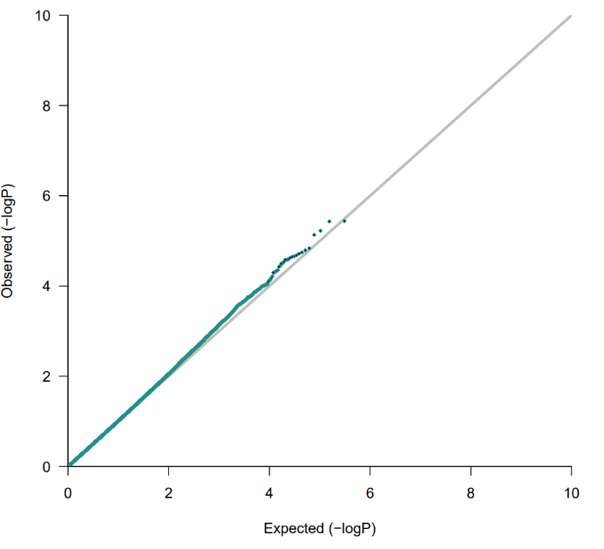

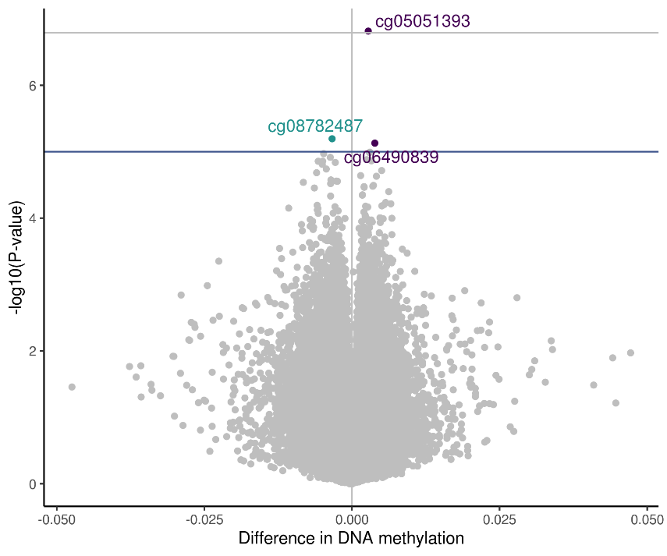
B
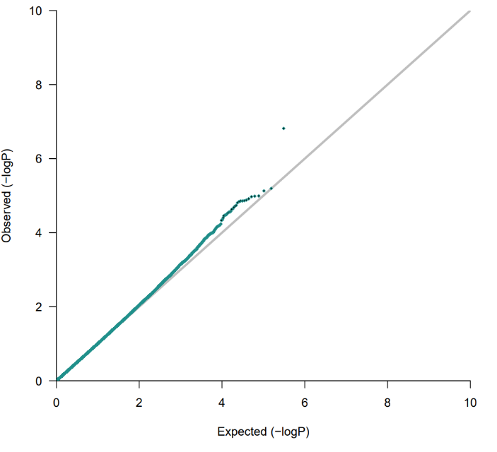

Figure S11: QQ and volcano plots for the associations between postnatal stress/depression and PBMC-DNAm adjusted for unmeasured confounding using cate. S11A) Association between postnatal stress and WB-DNAm S11B) Association between postnatal depression and WB-DNAm. Models were adjusted for prenatal tobacco exposure, postnatal tobacco exposure, household income, child sex, maternal age, birth weight, study center, genetic principal components, and cell type proportions. Bonferroni threshold=1.6E-07. Genome-wide suggestive threshold of 1E-05 shown.

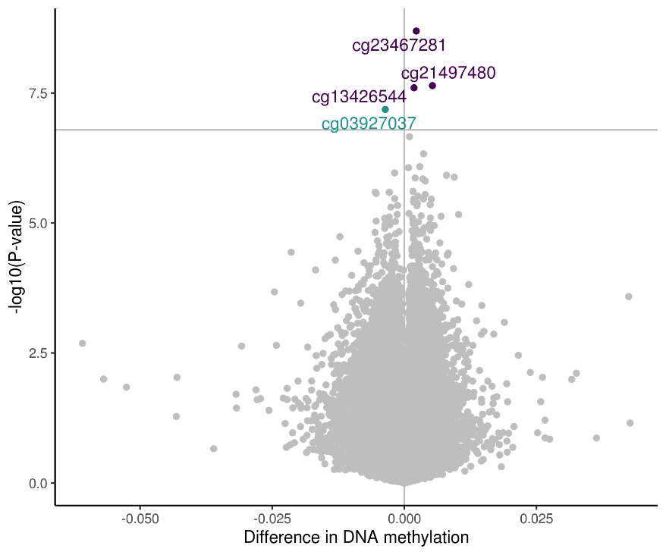
A
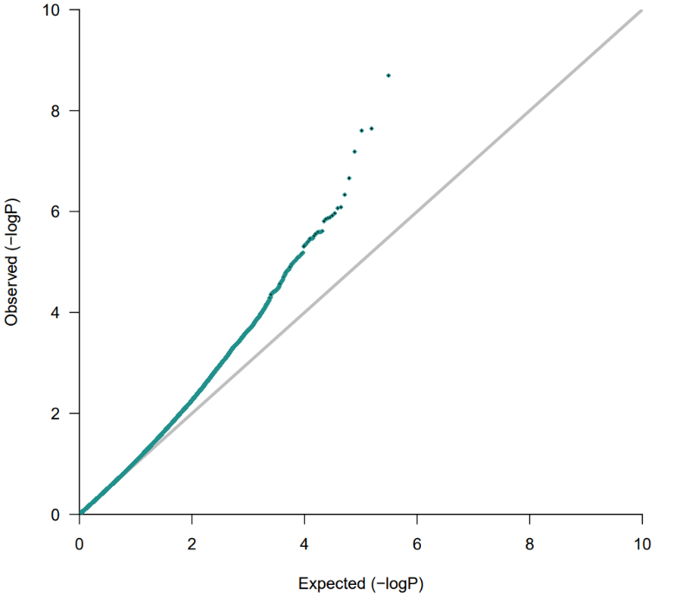

B
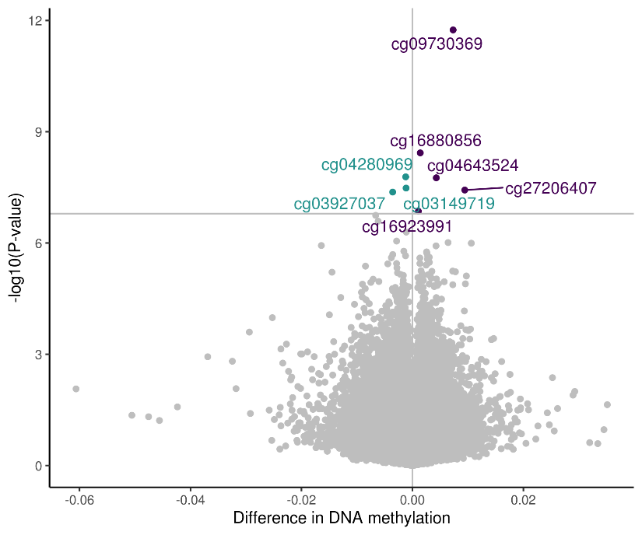
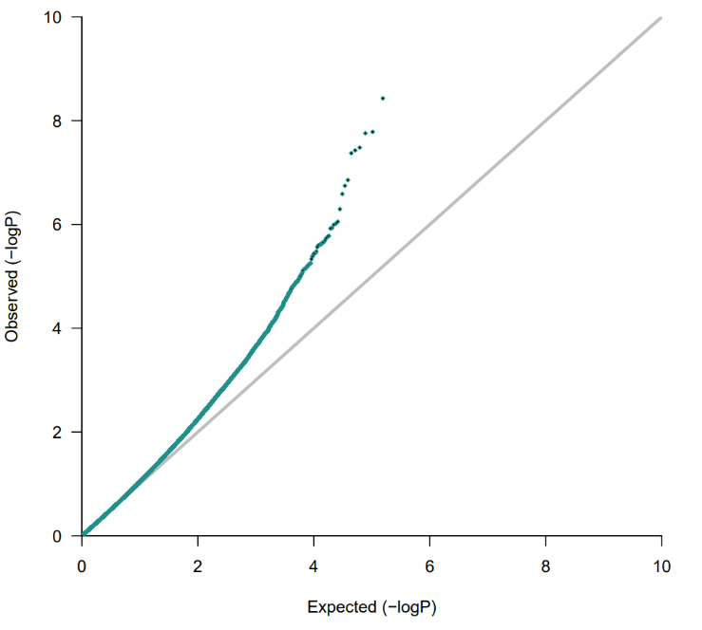

Figure S12: QQ and volcano plot for the association between prenatal stress/depression and PBMC-DNAm. S12A) Association between prenatal stress and PBMC-DNAm. S12B) Association between prenatal depression and PBMC-DNAm. Models were adjusted for prenatal tobacco exposure, postnatal tobacco exposure, household income, child sex, maternal age, birth weight, study center, genetic principal components, and cell type proportions. Bonferroni threshold=1.6E-07.
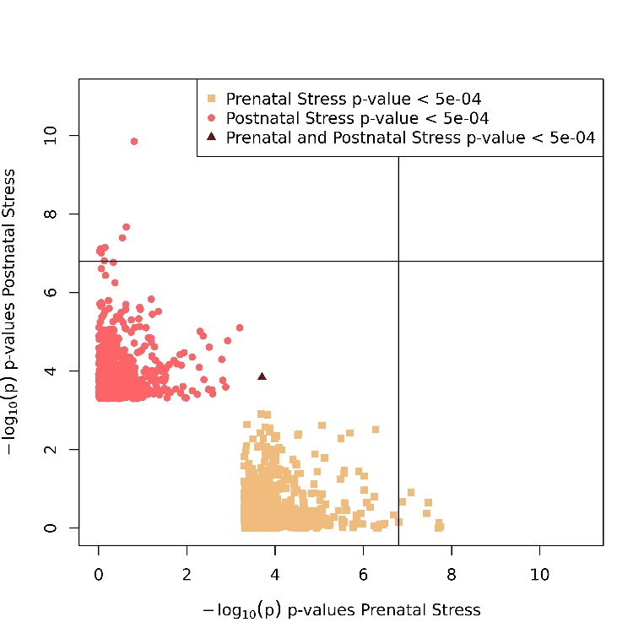
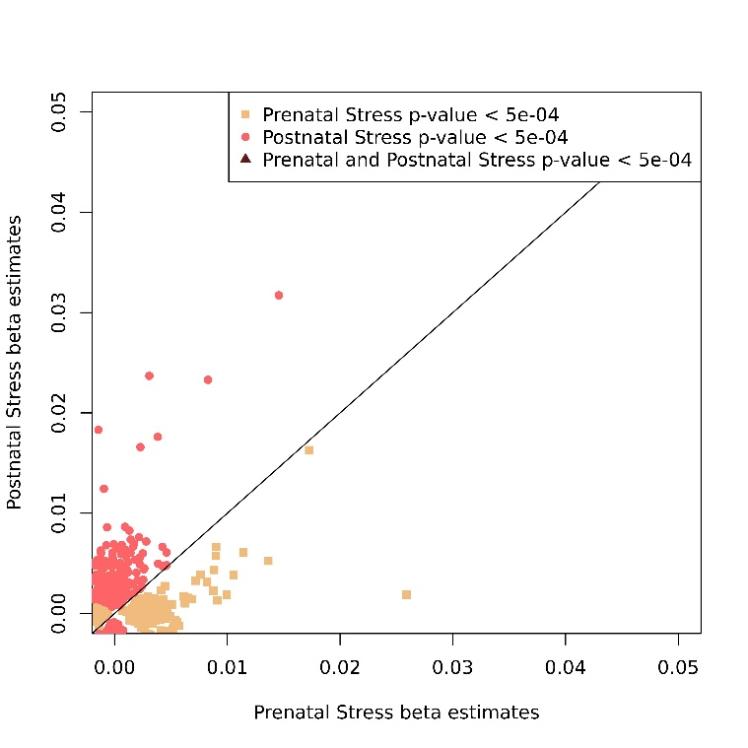
B
A

Figure S13: Correlated beta estimates and p-values of prenatal stress CB-DNAm CpG sites and postnatal stress PBMC-DNAm CpG sites with p-values less than 5.0E-04. S13A) Correlated beta estimates. S13B) Correlated p-values.
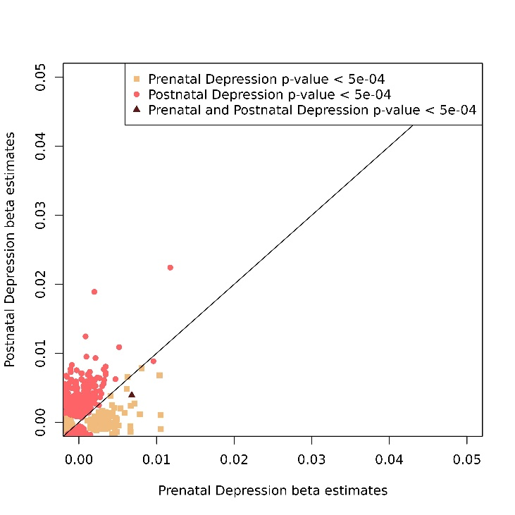
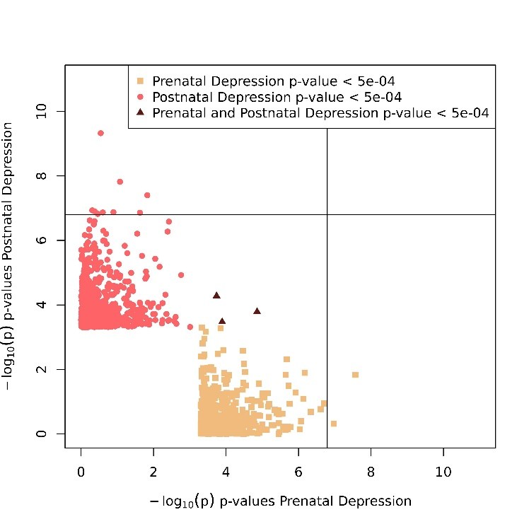

B
A

Figure S14: Correlated beta estimates and p-values of prenatal depression CB-DNAm CpG sites and postnatal depression PBMC-DNAm CpG sites with p-values less than 5.0E-04. S14A) Correlated beta estimates. S14B) Correlated p-values.

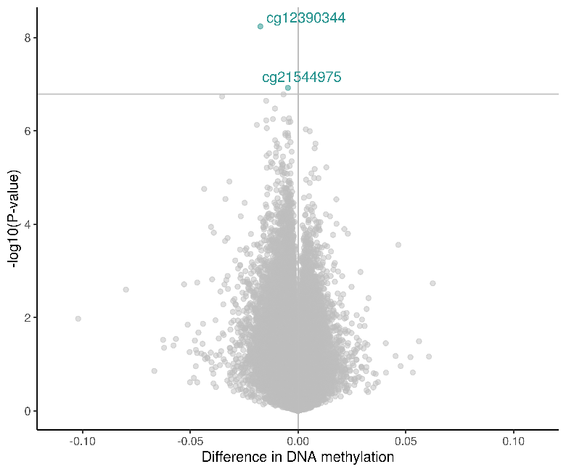
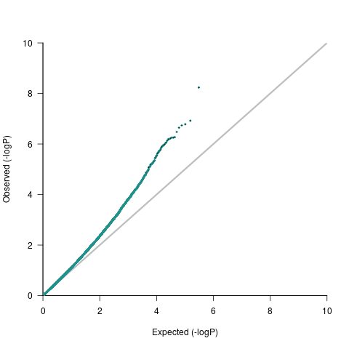

Figure S15: QQ and volcano plots for the associations between prenatal adversity score and CB-DNAm (lambda = 1.09). Models were adjusted for prenatal tobacco exposure, household income, child sex, maternal age, study center, genetic principal components, and cell type proportions. Bonferroni threshold-1.6e-07.
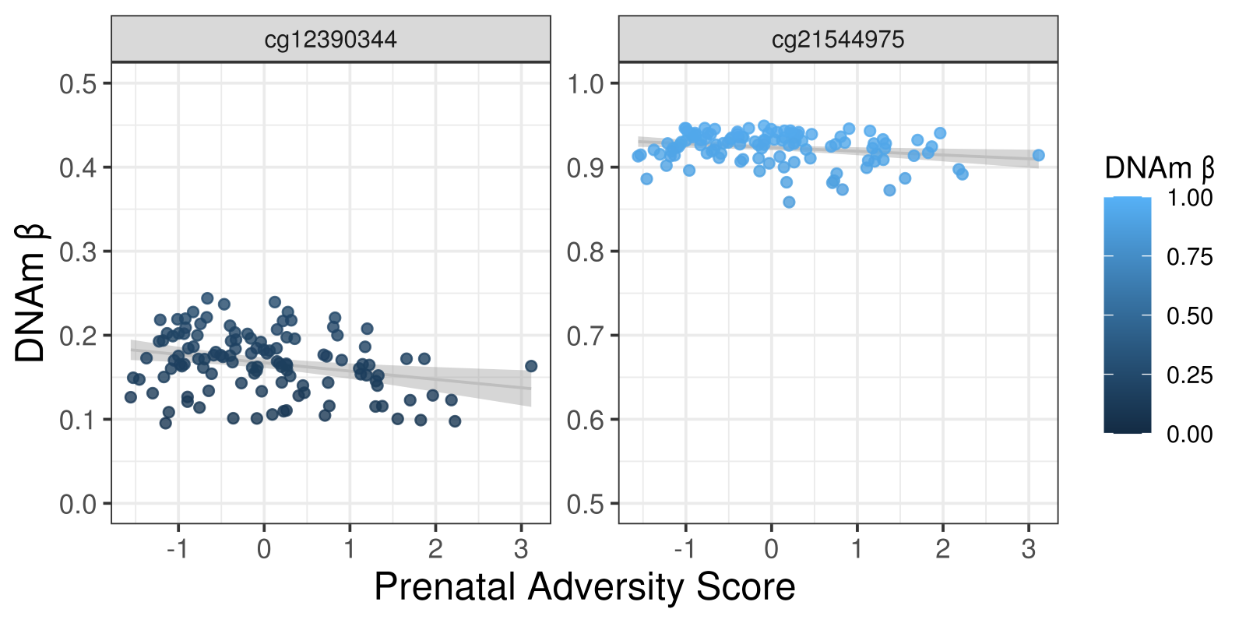

Figure S16: DNAm levels of significant CpG sites for the association between prenatal adversity and CB-DNAm.

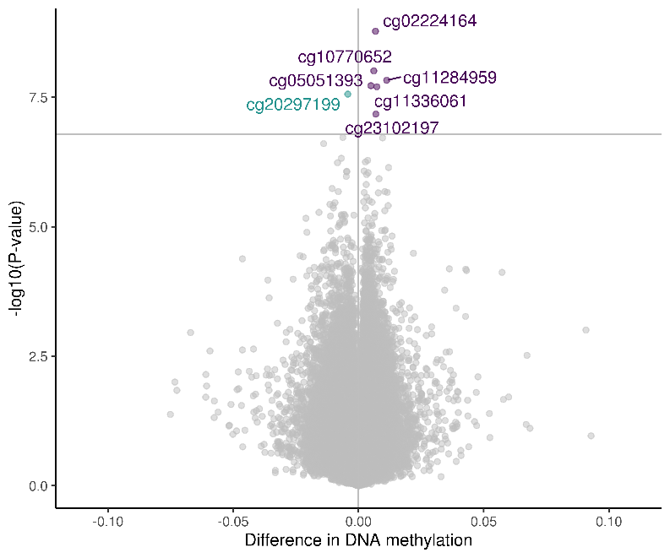
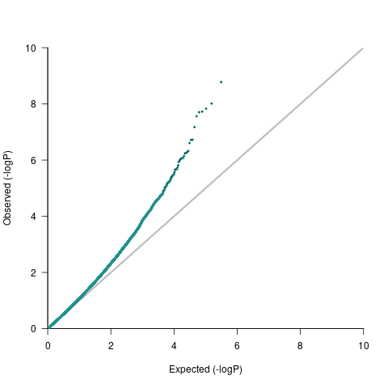

Figure S17: QQ and volcano plots for the association between postnatal adversity score and PBMC-DNAm (lambda = 1.02). Models were adjusted for prenatal tobacco exposure, postnatal tobacco exposure, household income, child sex, maternal age, birth weight, study center, genetic principal components, and cell type proportions. Bonferroni threshold=1.6E-07.

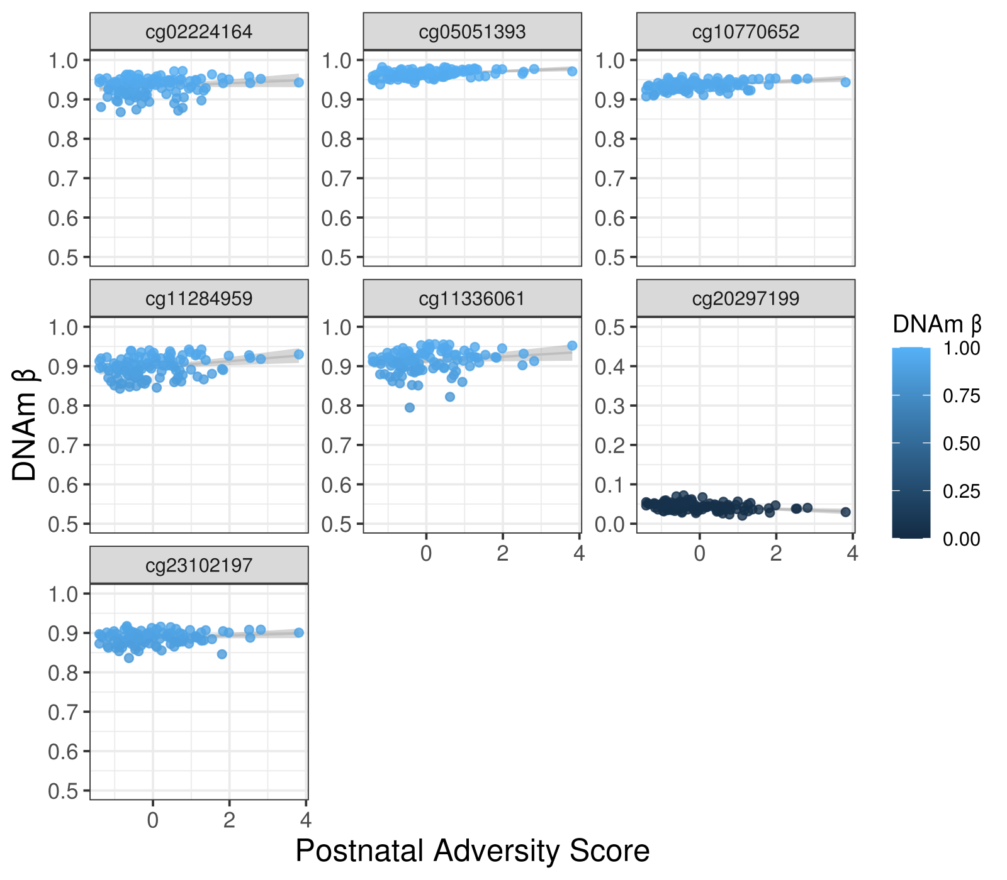

Figure S18: DNAm levels of significant CpG sites of the association between postnatal adversity score and PBMC-DNAm

