Supplementary material

Supplementary Figures 2
Supplementary Tables 7

Supplementary Figures
Figure S1: Interchromosomal Hi-C contact map of Syrian hamster genome.
The hamster genome contig contact matrix was built using Hi-C data with Lachesis (version-201701), juicerbox(version-.11.08) and 3D-DNA(180114). The intensity of each pixel represents the number of Hi-C links of 500kb resolution in the chromosomes. The color reflects the intensity of each contact, with darker red pixels denoting higher contact probabilities. The blocks represent the contacts between one location and another. Most interactions were observed within the chromosomes.

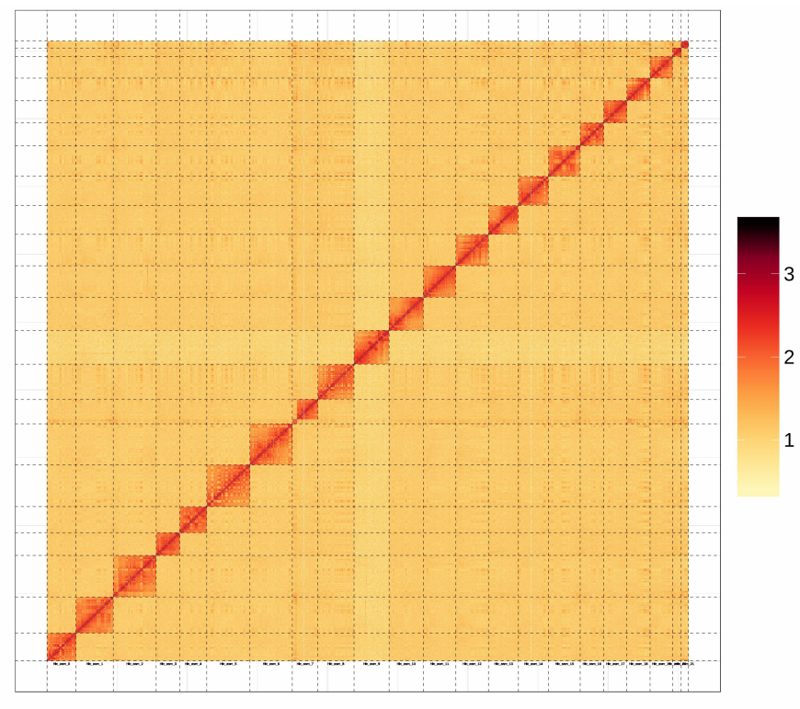

Figure S2: Heat map of genes expressed in the 15 tissues of the Syrian hamster.
The genes annotated from the 15 tissues were mapped to the assembled transcriptome of the Syrian hamster and the heatmap shows the expression level of each gene from those tissues; red color refers to up-regulated/high expression while blue color refers to down-regulated/low expression. 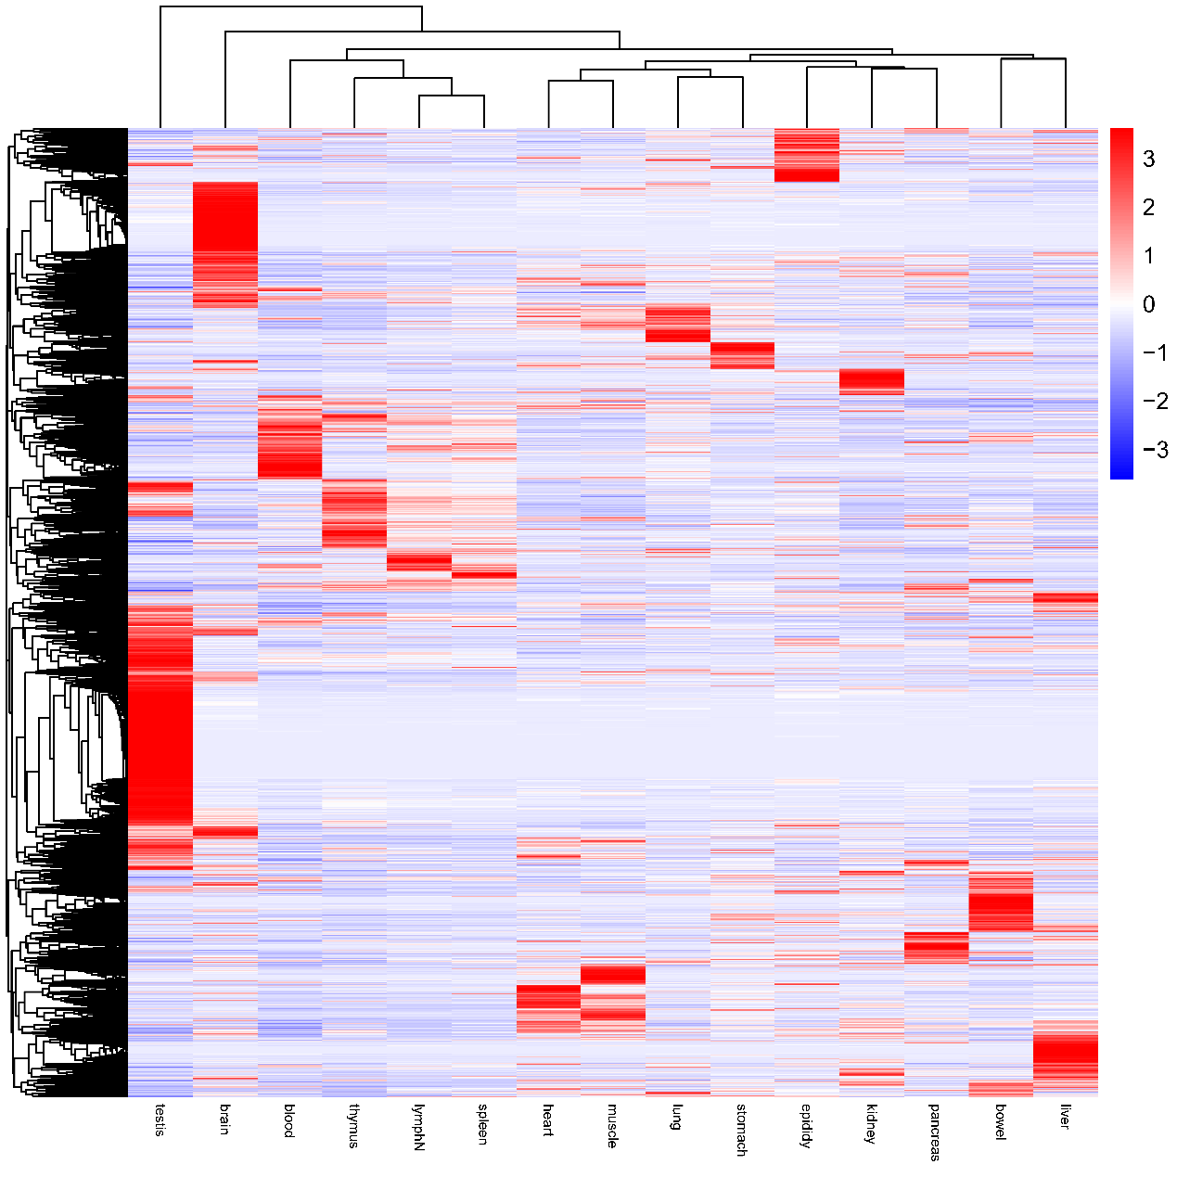
Figure S3: Expression of ACE2 in human, Syrian hamster, mouse, rat tissues and organs.
a. Homology alignment of ACE protein in human, mouse, rat, and Syrian hamster. b. The protein expression profile of ACE2 in human tissues and organs from the protein atlas database. c. Comparison of key binding sites of ACE2 from different species. d-f. Relative expression (protein and mRNA) of ACE2 in tissues and organs in Syrian hamster (d), mouse (e) and rat (f). 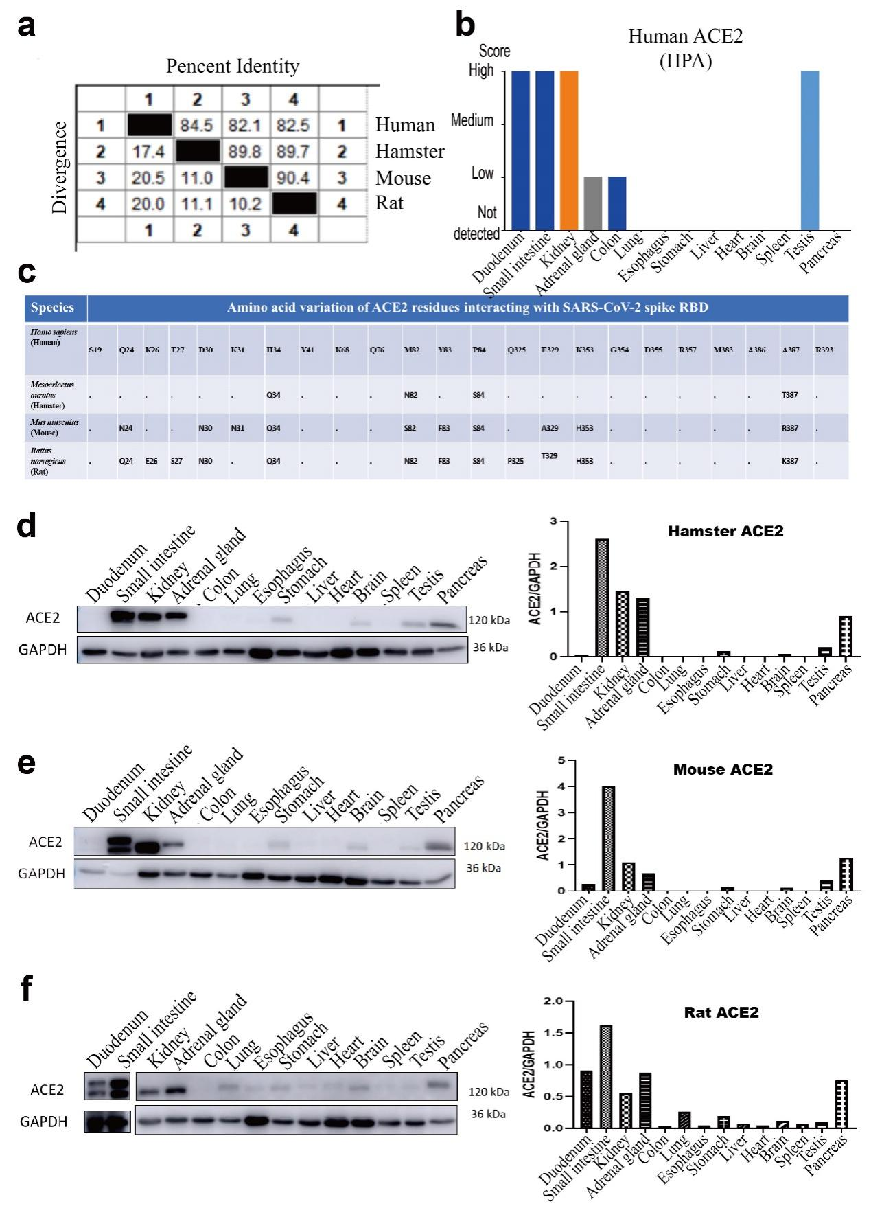

Figure S4: Characterization of Syrian hamster ACE2 receptor.
a. Potential binding affinity between different ACE2 variants and SARS-CoV2 spike RBD protein was analyzed with published ACE2 deep mutagenesis data. b. The protein expression of ACE2 in HEK-293 cells transfected with plasmids containing different ACE2 cDNA (human, mouse, rat or hamster) and different Syrian hamster-derived cell lines.
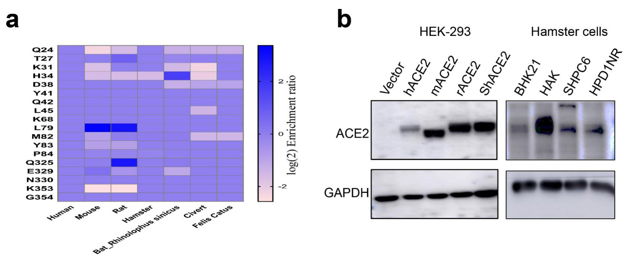

Figure S5: Characterization of Furin and MPRSS2 genes derived from different species.
a, Homology Alignment of Furin protease in human, mouse, rat, and Syrian hamster. b, Homology Alignment of TMPRSS2 protein in human, mouse, rat, and Syrian hamster. c, The functional domain of TMPRSS2 protease based on the public protein database. d, HEK-293T cells were transiently co-transfected with the plasmid expressing SARS-CoV2 spike protein and a plasmid expressing TMPRSS2 of either human, or mouse or hamster, 48 hours after transfection, total protein was harvested and detected by Western Blot using antibodies against Flag tag or S protein. 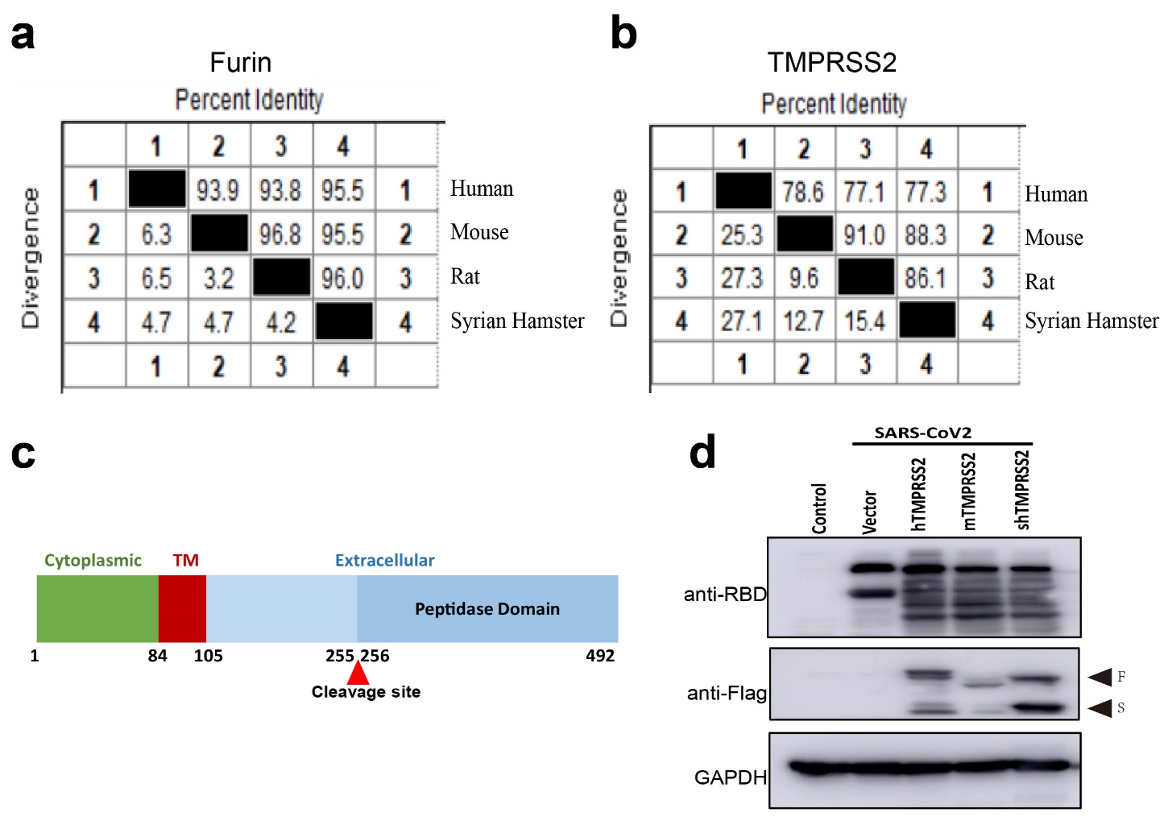

Supplementary Tables
Table S1: Estimation of genome size based on 17-mer statistics
Kmer | Depth | n_kmer | Genome_size(M) | Revised Genome_size(M) | Heterozygous_rate(%) | Repeat_rate(%)
17 | 50 | 157,769,234,231 | 3155.38 | 3130.53 | 0.22 | 64.65

Table S2: Summary of statistics of annotated repeats
 | Denovo+Repbase |  |  | TE proteins |  |  | Combined TEs
 | Length(bp) | Percent of sequence(%) |  | Length(bp) | Percent of sequence(%) |  | Length(bp) | Percent of sequence(%)
DNA | 6,525,330 | 0.25 |  | 90,746 | 0 |  | 6,603,284 | 0.26
LINE | 219,554,604 | 8.56 |  | 196,584,960 | 7.67 |  | 305,804,643 | 11.93
SINE | 16,653,125 | 0.65 |  | 0 | 0 |  | 16,653,125 | 0.65
LTR | 829,194,405 | 32.34 |  | 44,671,419 | 1.74 |  | 832,033,076 | 32.45
Simple_repeat | 792 | 0 |  | 0 | 0 |  | 792 | 0
Unknown | 25,350,712 | 0.99 |  | 0 | 0 |  | 25,350,712 | 0.99
Total | 1,044,958,128 | 40.75 |  | 241,312,878 | 9.41 |  | 1,052,652,418 | 41.05

Table S3: Summary of statistics of repeat annotation from different types
Type | Repeat Size(bp) | % of genome
Trf | 110,690,172 | 4.32
Repeatmasker | 1,044,958,128 | 40.75
Proteinmask | 241,312,878 | 9.41
Total | 1,078,170,882 | 42.05

Table S4: Comparison of Genome assembly statistics of Syrian hamster
 | Syrian hamster  MesAur2.0 -2020 | Syrian hamster  MesAur1.0 | Chinese hamster  CriGri_1.0
Assembly size (Gb) | 2.31 | 2.07 | 2.32
Genome size (Gb) | 2.57 | 2.50 | 2.40
Chromosomes | 44 (male) | 44(female)
Sequencing technology | Illumina;Nanopore;Hi-C | Illumina HiSeq | Illumina GA IIx
Coverage | 100×Illumina;  100×Nanopore;  100×Hi-C | 115×Illumina | 130×Illumina
Assembler | wtdbg2 | allpaths v. R44683 | SOAPdenovo v. 1.05
Contig N50 (bp) | 35,650,180 | 22,511 | 39,361
Number of contigs | 8,600 | 237,700 | 265,787
Scaffold N50 (bp) | 114,594,012 | 12,753,307 | 1,147,233
Number of scaffolds | 8,303 | 21,484 | 109,152
Total annotated gene | 21,193 | 18,257 | 21,298

Table S5: Summary of statistics of functional annotated protein-coding genes
Type | Number | Percent(%)
Total Predicted Genes | 21,387 | -
Swissprot | 18,700 | 87.4
Nr | 19,306 | 90.3
KEGG | 16,620 | 77.7
InterPro | 21,140 | 98.8
GO | 19,623 | 91.8
Pfam | 16,415 | 76.8
Total annotated | 21,193 | 99.1
Unannotated | 194 | 0.9

Table S6: Summary of statistics of predicted protein-coding genes
Gene set | Total number of gene | Average transcript length(bp) | Average CDS length(bp) | Average exons per gene | Average exon length(bp) | Average intron length(bp)
De novo
Augustus | 30,520 | 18,266.30 | 1,111.07 | 5.53 | 200.79 | 3,784.14
GlimmerHMM | 383,542 | 5,555.94 | 427.93 | 2.73 | 156.64 | 2,960.91
SNAP | 79,647 | 49,958.46 | 717.22 | 5.26 | 136.44 | 11,568.46
Geneid | 40,070 | 29,193.85 | 991.51 | 5.27 | 188.1 | 6,603.06
Genscan | 47,569 | 34,543.32 | 1,156.16 | 7 | 165.13 | 5,563.20
Homolog
Cgr | 37,537 | 13,070.07 | 1,142.64 | 5.17 | 220.99 | 2,859.99
Hsa | 32,857 | 15,196.53 | 1,156.65 | 5.55 | 208.51 | 3,087.55
Mca | 28,498 | 17,891.94 | 1,273.00 | 6.33 | 201.08 | 3,117.45
Mmu | 28,128 | 18,200.02 | 1,298.26 | 6.43 | 201.95 | 3,113.36
Moc | 28,394 | 18,066.77 | 1,282.80 | 6.39 | 200.62 | 3,111.46
Pma | 27,570 | 18,297.88 | 1,361.89 | 6.58 | 206.83 | 3,032.59
Rno | 36,489 | 14,692.09 | 1,238.03 | 5.42 | 228.22 | 3,040.73
RNAseq
PASA | 132,230 | 21,243.56 | 1,094.14 | 6.32 | 173.09 | 3,786.61
Cufflinks | 106,114 | 31,794.03 | 3,604.75 | 7.44 | 484.53 | 4,377.43
EVM | 37,268 | 17,477.57 | 1,023.02 | 5.46 | 187.24 | 3,686.28
Pasa-update* | 36,791 | 20,841.24 | 1,066.45 | 5.69 | 187.51 | 4,218.54
Final set** | 21,387 | 33,298.04 | 1,459.84 | 8.6 | 169.8 | 4,190.66

Table S7: Mammalian species that are closely related phylogenetically to Syrian hamsters
Scientific name | Assembly Version | Lineage( abbreviated )
Mesocricetus auratus | MesAur2.0 -2020 | Euarchontoglires; Glires; Rodentia; Myomorpha; Muroidea; Cricetidae; Cricetinae; Mesocricetus
Cricetulus griseus | ncbi.all.GCF_000223135.1 | Euarchontoglires; Glires; Rodentia; Myomorpha; Muroidea; Cricetidae; Cricetinae; Cricetulus
Microtus ochrogaster | ncbi.all.GCF_000317375.1 | Euarchontoglires; Glires; Rodentia; Myomorpha; Muroidea; Cricetidae; Arvicolinae; Microtus
Heterocephalus glaber | GCA_000247695.1 | Euarchontoglires; Glires; Rodentia; Hystricomorpha; Bathyergidae; Heterocephalus
Peromyscus maniculatus | ncbi.all.GCF_000500345.1 | Euarchontoglires; Glires; Rodentia; Myomorpha; Muroidea; Cricetidae; Neotominae; Peromyscus
Rattus norvegicus | ncbi.all.GCF_000001895.5 | Euarchontoglires; Glires; Rodentia; Myomorpha; Muroidea; Muridae; Murinae; Rattus
Mus musculus | ncbi.all.GCF_000001635.26 | Euarchontoglires; Glires; Rodentia; Myomorpha; Muroidea; Muridae; Murinae; Mus; Mus
Mus caroli | ncbi.all.GCF_900094665.1 | Euarchontoglires; Glires; Rodentia; Myomorpha; Muroidea; Muridae; Murinae; Mus; Mus
Cavia porcellus | ncbi.all.GCF_000151735.1 | Euarchontoglires; Glires; Rodentia; Hystricomorpha; Caviidae; Cavia
Spalax galili | ncbi.all.GCF_000622305.1 | Euarchontoglires; Glires; Rodentia; Myomorpha; Muroidea; Spalacidae; Spalacinae; Nannospalax
Sus scrofa | GCA_000003025.6 | Laurasiatheria; Artiodactyla; Suina; Suidae; Sus
Canis lupus familiaris | GCA_000002285.2 | Laurasiatheria; Carnivora; Caniformia; Canidae; Canis
Loxodonta africana | GCA_000001905.1 | Afrotheria; Proboscidea; Elephantidae; Loxodonta
Macaca mulatta | GCA_003339765.3 | Euarchontoglires; Primates; Haplorrhini; Catarrhini; Cercopithecidae; Cercopithecinae; Macaca
Macaca fascicularis | GCA_000364345.1 | Euarchontoglires; Primates; Haplorrhini; Catarrhini; Cercopithecidae; Cercopithecinae; Macaca
Homo sapiens | ncbi.all.GCF_000001405.38 | Euarchontoglires; Primates; Haplorrhini; Catarrhini; Hominidae; Homo

Table S8: Sequencing strategy and data availability in the genome assembling and annotation of Syrian hamster

 | NCBI BioProject | Sequencing methods | library/depth | sample types | Reviewer link
Genome DNA sequencing | PRJNA666008 | Illumina pair end | 350bp/98.25× | Syrian hamster: adult male muscle
 |  | Nanopore long reads | 100.44× | Syrian hamster: adult male muscle
 |  | HiC | 110.91× | Syrian hamster: adult male muscle
RNA-seq assisted gene model prediction | PRJNA736416 | RNA-seq on Illumina | 11 RNA-seq libraries from 11 tissue types | Syrian hamster: adult male ascending aorta, heart, liver, spleen, lung, kidney, pancreas, brain, muscle, testis, and peripheral blood monocyte cells | https://dataview.ncbi.nlm.nih.gov/object/PRJNA736416?reviewer=70o5t7vpuqafhi2n3efs8e9cnt
 |  | RNA-seq on PacBio | One mixed library of RNA samples from 8 tissue types | Syrian hamster: adult male heart, spleen, lung, kidney, brain, muscle, testis, and peripheral blood monocyte cells
Transcriptome analysis | PRJNA662719 | RNA-seq on Illumina | 45 RNA-seq libraries from 15 tissue types | Syrian hamster: adult male heart, liver, spleen, lung, kidney, pancreas, stomach, bowel, brain, muscle, testis, epididymis, lymph node, thymus and peripheral blood monocyte cells | https://dataview.ncbi.nlm.nih.gov/object/PRJNA662719?reviewer=3m986q5mimojbl0bi1rkahppl9

Table S9: BioSample information of BioProject PRJNA662719 a deep transcriptome sequencing of the Syrian hamster
Accession | Sample Name | SPUID | Tax ID | Strain | library_ID | title
SAMN16093387 | heart1 | heart1 | 10036 | LVG(syr) | FRAS202085839-1a | RNA-Seq of Syrian hamster: adult male heart
SAMN16093388 | heart2 | heart2 | 10036 | LVG(syr) | FRAS202085840-1a | RNA-Seq of Syrian hamster: adult male heart
SAMN16093389 | heart3 | heart3 | 10036 | LVG(syr) | FRAS202085841-1a | RNA-Seq of Syrian hamster: adult male heart
SAMN16093390 | liver1 | liver1 | 10036 | LVG(syr) | FRAS202085842-1a | RNA-Seq of Syrian hamster: adult male liver
SAMN16093391 | liver2 | liver2 | 10036 | LVG(syr) | FRAS202085843-1a | RNA-Seq of Syrian hamster: adult male liver
SAMN16093392 | liver3 | liver3 | 10036 | LVG(syr) | FRAS202085844-1a | RNA-Seq of Syrian hamster: adult male liver
SAMN16093393 | spleen1 | spleen1 | 10036 | LVG(syr) | FRAS202085845-1a | RNA-Seq of Syrian hamster: adult male spleen
SAMN16093394 | spleen2 | spleen2 | 10036 | LVG(syr) | FRAS202085846-1a | RNA-Seq of Syrian hamster: adult male spleen
SAMN16093395 | spleen3 | spleen3 | 10036 | LVG(syr) | FRAS202085847-1a | RNA-Seq of Syrian hamster: adult male spleen
SAMN16093396 | lung1 | lung1 | 10036 | LVG(syr) | FRAS202085848-1a | RNA-Seq of Syrian hamster: adult male lung
SAMN16093397 | lung2 | lung2 | 10036 | LVG(syr) | FRAS202085849-1a | RNA-Seq of Syrian hamster: adult male lung
SAMN16093398 | lung3 | lung3 | 10036 | LVG(syr) | FRAS202085850-1a | RNA-Seq of Syrian hamster: adult male lung
SAMN16093399 | kidney1 | kidney1 | 10036 | LVG(syr) | FRAS202085851-1a | RNA-Seq of Syrian hamster: adult male kidney
SAMN16093400 | kidney2 | kidney2 | 10036 | LVG(syr) | FRAS202085852-1a | RNA-Seq of Syrian hamster: adult male kidney
SAMN16093401 | kidney3 | kidney3 | 10036 | LVG(syr) | FRAS202085853-1a | RNA-Seq of Syrian hamster: adult male kidney
SAMN16093402 | pancre1 | pancre1 | 10036 | LVG(syr) | FRAS202096902-1r | RNA-Seq of Syrian hamster: adult male pancreas
SAMN16093403 | pancre2 | pancre2 | 10036 | LVG(syr) | FRAS202096903-1r | RNA-Seq of Syrian hamster: adult male pancreas
SAMN16093404 | pancre3 | pancre3 | 10036 | LVG(syr) | FRAS202096904-1r | RNA-Seq of Syrian hamster: adult male pancreas
SAMN16093405 | stomac1 | stomac1 | 10036 | LVG(syr) | FRAS202085857-1a | RNA-Seq of Syrian hamster: adult male stomach
SAMN16093406 | stomac2 | stomac2 | 10036 | LVG(syr) | FRAS202085858-1a | RNA-Seq of Syrian hamster: adult male stomach
SAMN16093407 | stomac3 | stomac3 | 10036 | LVG(syr) | FRAS202085859-1a | RNA-Seq of Syrian hamster: adult male stomach
SAMN16093408 | bowel1 | bowel1 | 10036 | LVG(syr) | FRAS202085860-1a | RNA-Seq of Syrian hamster: adult male bowel
SAMN16093409 | bowel2 | bowel2 | 10036 | LVG(syr) | FRAS202085861-1a | RNA-Seq of Syrian hamster: adult male bowel
SAMN16093410 | bowel3 | bowel3 | 10036 | LVG(syr) | FRAS202085862-1a | RNA-Seq of Syrian hamster: adult male bowel
SAMN16093411 | brain1 | brain1 | 10036 | LVG(syr) | FRAS202085863-1a | RNA-Seq of Syrian hamster: adult male brain
SAMN16093412 | brain2 | brain2 | 10036 | LVG(syr) | FRAS202085864-1a | RNA-Seq of Syrian hamster: adult male brain
SAMN16093413 | brain3 | brain3 | 10036 | LVG(syr) | FRAS202085865-1a | RNA-Seq of Syrian hamster: adult male brain
SAMN16093414 | muscle1 | muscle1 | 10036 | LVG(syr) | FRAS202085866-1a | RNA-Seq of Syrian hamster: adult male muscle
SAMN16093415 | muscle2 | muscle2 | 10036 | LVG(syr) | FRAS202085867-1a | RNA-Seq of Syrian hamster: adult male muscle
SAMN16093416 | muscle3 | muscle3 | 10036 | LVG(syr) | FRAS202085868-1a | RNA-Seq of Syrian hamster: adult male muscle
SAMN16093417 | testis1 | testis1 | 10036 | LVG(syr) | FRAS202085869-1a | RNA-Seq of Syrian hamster: adult male testis
SAMN16093418 | testis2 | testis2 | 10036 | LVG(syr) | FRAS202085870-1a | RNA-Seq of Syrian hamster: adult male testis
SAMN16093419 | testis3 | testis3 | 10036 | LVG(syr) | FRAS202085871-1a | RNA-Seq of Syrian hamster: adult male testis
SAMN16093420 | epidid1 | epidid1 | 10036 | LVG(syr) | FRAS202085872-1a | RNA-Seq of Syrian hamster: adult male epididymis
SAMN16093421 | epidid2 | epidid2 | 10036 | LVG(syr) | FRAS202085873-1a | RNA-Seq of Syrian hamster: adult male epididymis
SAMN16093422 | epidid3 | epidid3 | 10036 | LVG(syr) | FRAS202085874-1a | RNA-Seq of Syrian hamster: adult male epididymis
SAMN16093423 | lymphN1 | lymphN1 | 10036 | LVG(syr) | FRAS202085875-1a | RNA-Seq of Syrian hamster: adult male lymph node
SAMN16093424 | lymphN2 | lymphN2 | 10036 | LVG(syr) | FRAS202085876-1a | RNA-Seq of Syrian hamster: adult male lymph node
SAMN16093425 | lymphN3 | lymphN3 | 10036 | LVG(syr) | FRAS202096901-1r | RNA-Seq of Syrian hamster: adult male lymph node
SAMN16093426 | thymus1 | thymus1 | 10036 | LVG(syr) | FRAS202085878-1a | RNA-Seq of Syrian hamster: adult male thymus
SAMN16093427 | thymus2 | thymus2 | 10036 | LVG(syr) | FRAS202085879-1a | RNA-Seq of Syrian hamster: adult male thymus
SAMN16093428 | thymus3 | thymus3 | 10036 | LVG(syr) | FRAS202085880-1a | RNA-Seq of Syrian hamster: adult male thymus
SAMN16093429 | blood1 | blood1 | 10036 | LVG(syr) | FRAS20H100696-1b | RNA-Seq of Syrian hamster: adult male blood
SAMN16093430 | blood2 | blood2 | 10036 | LVG(syr) | FRAS20H100697-1r | RNA-Seq of Syrian hamster: adult male blood
SAMN16093431 | blood3 | blood3 | 10036 | LVG(syr) | FRAS20H100698-1r | RNA-Seq of Syrian hamster: adult male blood

