Asian Journal of Civil Engineering
Quantification and size classification of Microplastics leached from disposable beverage cups
Priya Agarwal¹ , Satyaprakash¹ and Gaurav Saini^{2*}
¹Department of Civil Engineering, Sharda University, Greater Noida, Uttar Pradesh, India
²Department of Civil Engineering, Netaji Subhas University of Technology, Delhi, India

*Corresponding Author: gauarav.saini@nsut.ac.in, 91-828-705-1260
ORCiD: 0000-0002-3975-346X
Address: Department of Civil Engineering, Netaji Subhas University of Technology, West Campus, Jafarpur, Delhi- 110073, India

Supplementary Material

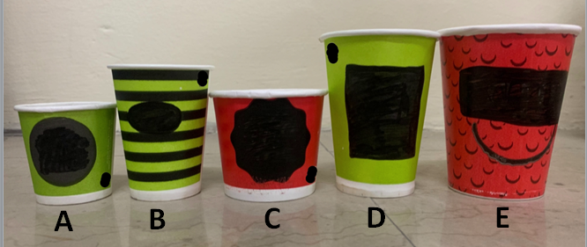
Fig. S1. Disposable cups commonly used for hot beverages

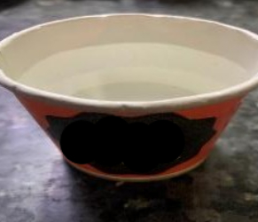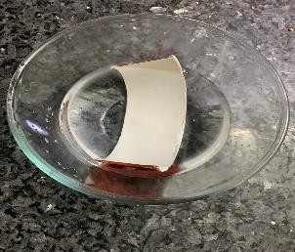
Fig. S2. Extraction of microplastics by: a) Hot MilliQ water allowed to rest for 15mins b) Disposable cup dipped in lukewarm MilliQ water

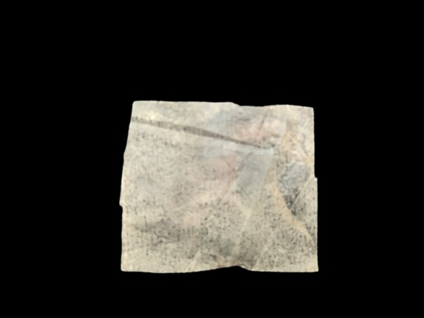

Fig. S3. An example of hydrophobic plastic film extracted from paper cups

