Additional file 2. Inclusion flow chart.

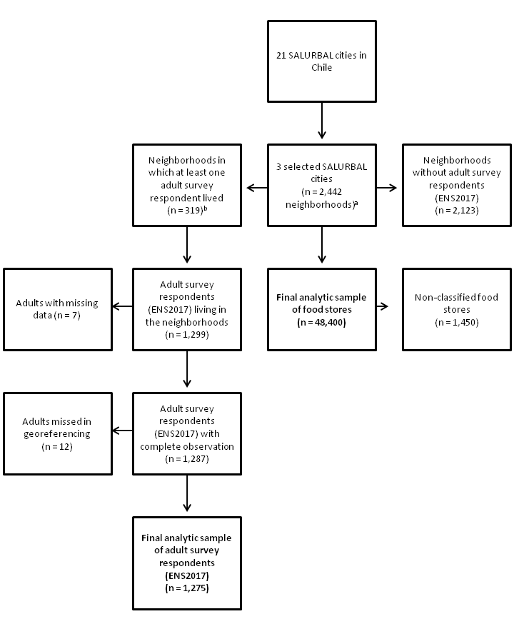

ªFinal analytic sample of neighbourhoods considered to describe the community retail food environment in the three cities. ^{b}Final analytic sample of neighbourhoods considered to analyse the community retail food environment of the survey respondents.

