Appendix 1: The 2007 regional tax policy in Italy
The appendix provides a brief description of the two Italian taxes involved in the treatment.

IRAP
From 1997 Italian corporate entities and individual natural persons generating income in the form of business income (Reddito d’impresa) as well as non-resident companies, but only on Italian source income, are subject to a regional production tax, IRAP. IRAP taxpayers include those carrying out business activities and self-employment, operating both individually and in partnership, private non-commercial entities as well as public administrations and other public bodies.
IRAP taxes the production activity, the exchange of goods and the supply of services. In the paper IRAP is viewed as an Income Tax in disguise because it is charged on the value of net production resulting from the business pursued within the region. For commercial business and professionals, state administrations, regions, provinces, municipalities and generally for public administrations whose main object is not commercial business, the basis of assessment is the value of remunerations. The 90% of its regional yield is destined to the financing of the health system in each regional (in addition to central transfers and other funds). As a rule, IRAP tax rates are fixed by the regional governments within an interval defined by the national law that leaves some degree of autonomy to the regional authorities. Hence, although the tax structure is completely defied by the parliamentary law of 1997, IRAP tax rates may vary across regions and time.

The regional Income Tax Surcharge
The Regional income tax surcharge was introduced in the Italian tax system in December 1997 (D.Lgs. number 446/1997) and it is applied from the 1998 tax year. The regional surcharge is a regional tax, whose rate is added on top of those rates taxing the income of natural persons at the national level (IRPEF). Then, it falls on the taxable income as it is defined for IRPEF purposes net of any applicable tax deductions and credits for incomes produced abroad. Tax rates vary from region to region and may increase in relation to the taxpayer's income bracket. The ordinary regional income tax rate ranges from 1.23% to 3.33%. In the event that the region decides not to adopt a single rate but a plurality of differentiated rates, the latter must be structured exclusively in relation to the same income brackets established for the IRPEF tax and then tax rates must be increasing according to each bracket. The regions can arrange tax deductions in favour of the family by increasing those already existing for national IRPEF purposes and can also adopt other economic support measures in favour of IRPEF subjects. During the period of the present study, the regional surcharge rates varied greatly between regions. In 2000, the surtax rate was determined for the entire Italian territory by the national law at the level of 0.9 but each regions had the power to increase that rate up to 1.4. In that year, only Lombardy, Marche and Veneto applied the additional taxation on a true progressive scale. At the end of our period (2021), some regions (Abruzzo, Basilicata, Calabria (t = 1.73), Campania (t = 2.03), Sardinia (t = 1.23), Sicily (t = 1.23), Valle d’Aosta (t = 1.23), Veneto (t = 1.23) maintained (or switched to) the proportional (constant tax rate) surcharge tax: https://www1.finanze.gov.it/ finanze2/ dipartimentopolitichefiscali/ fiscalita locale/ addregirpef/ sceltaregione.htm?cm= ).

The following figure gives a synthetic view of the Italian Income Tax Treatment introduced at the end of 2006. From 2007 taxpayers in treated regions faced a uniform increase of the IRAP and Regional Surcharge rates. Uniformity means that the statutory rates were increased by the same percentage for all treated taxpayers without differences related the value of the tax base for bottom- and top-income groups.

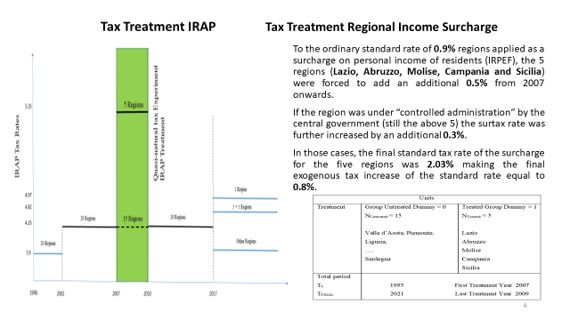
Figure A 1: The Italian Tax Treatment of the end of 2006. The chart describes how the tax rates of IRAP (left) and Regional Income Surcharge (right) have been modified by the Italian Budget Law of 2006 (Law 27/12/2006, n. 296, Disposizioni per la formazione del bilancio annuale e pluriennale dello Stato; legge finanziaria 2007).). The figure includes a box with the indication of the five treated regions and the time span of our DID model. The last year before treatment is 2006.

Appendix 2: Additional figures and results

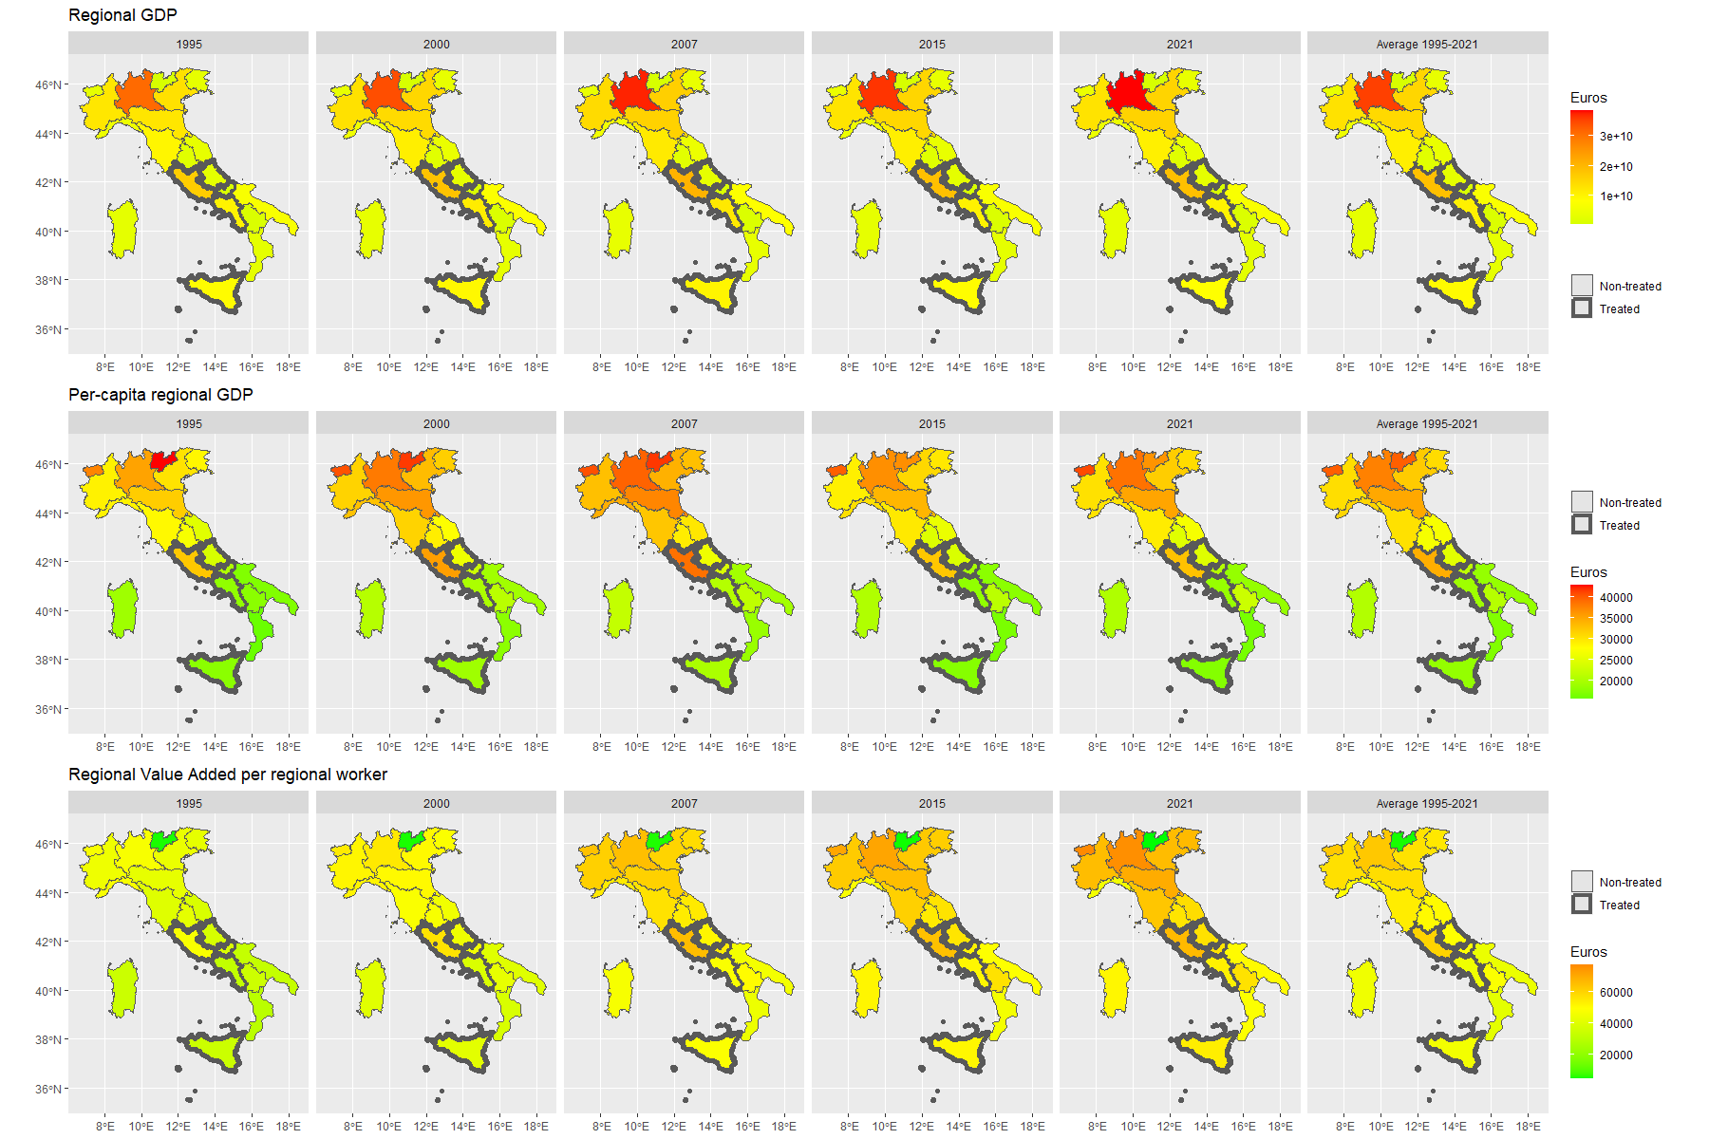
The appendix provides additional figures on the available data by depicting the regional distribution of the considered macroeconomic indicators from 1995 to 2021.
Figure A 2: Observed values of overall GDP, per capita GDP, and value added per worker across the Italian regions from 1995 to 2021. The last column depicts the regional average value 1995-2021. Regions with a marked border are those treated (Lazio, Campania, Abruzzo, Molise, and Sicily).

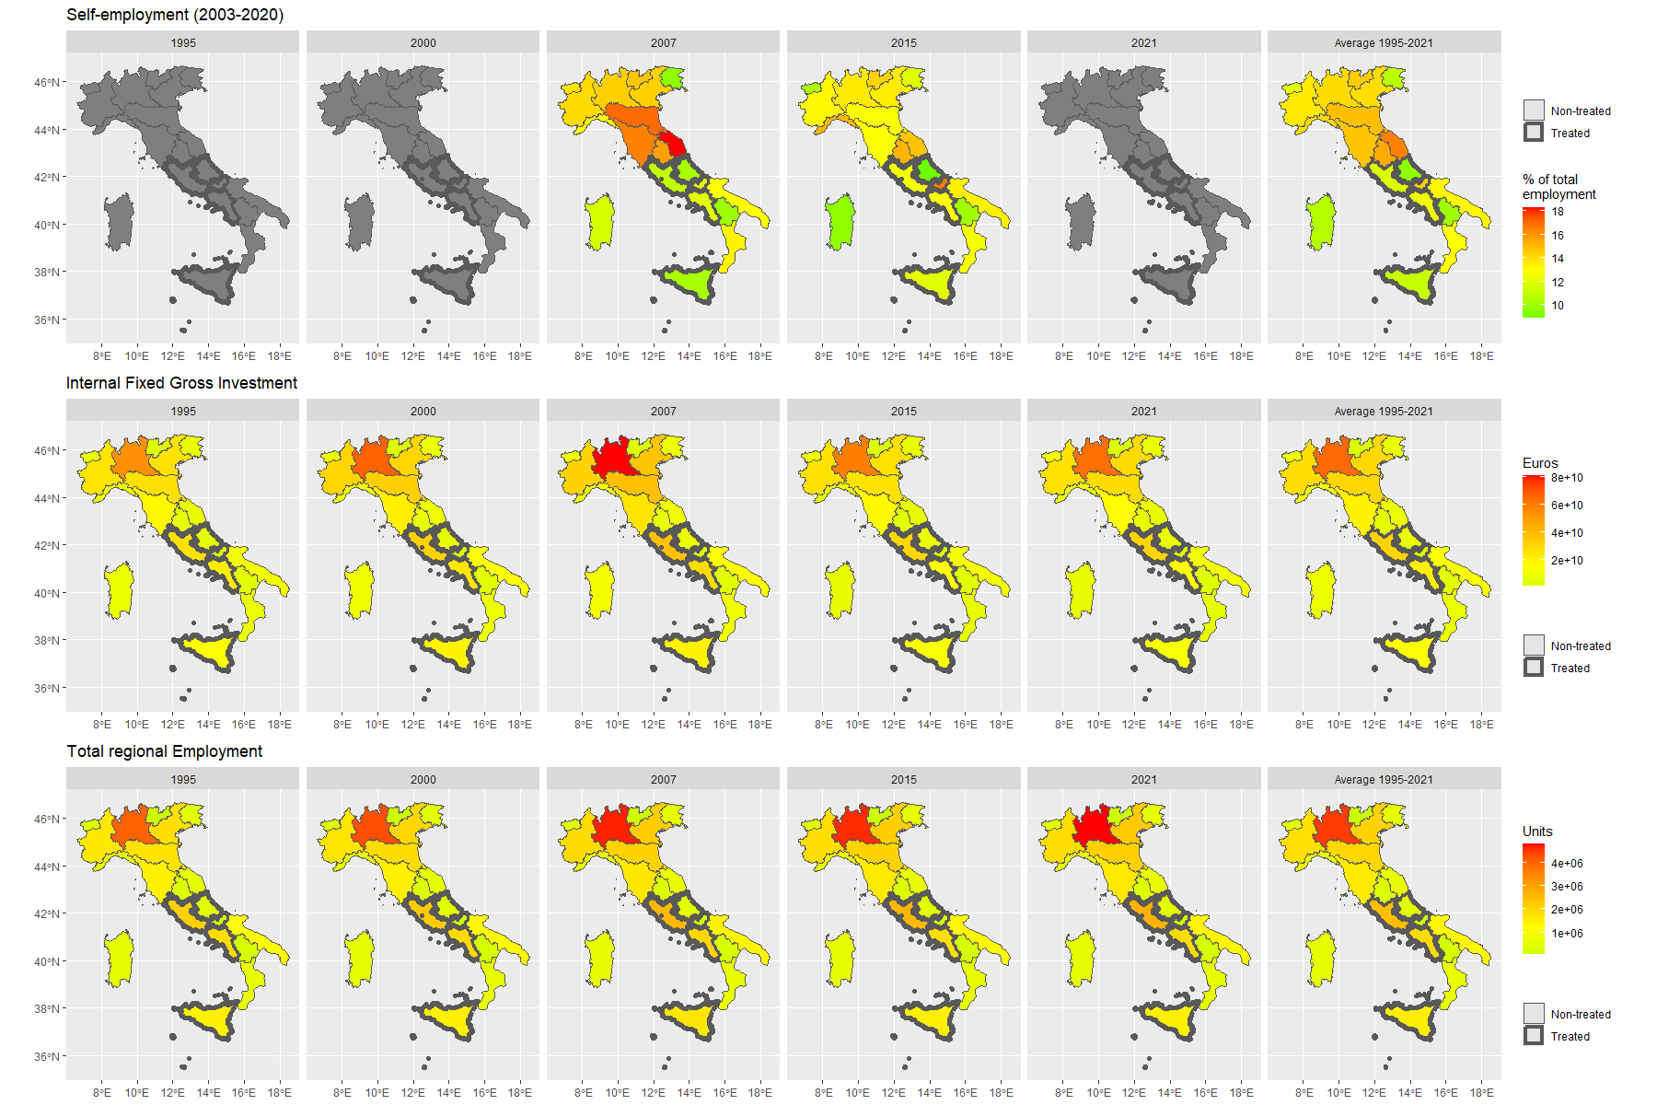
Figure A 3: Observed values of self-employment, internal fixed gross investment, and total employment across the Italian regions from 1995 to 2021. The last column depicts the regional average value 1995-2021. Regions with a marked border are those treated (Lazio, Campania, Abruzzo, Molise, and Sicily)

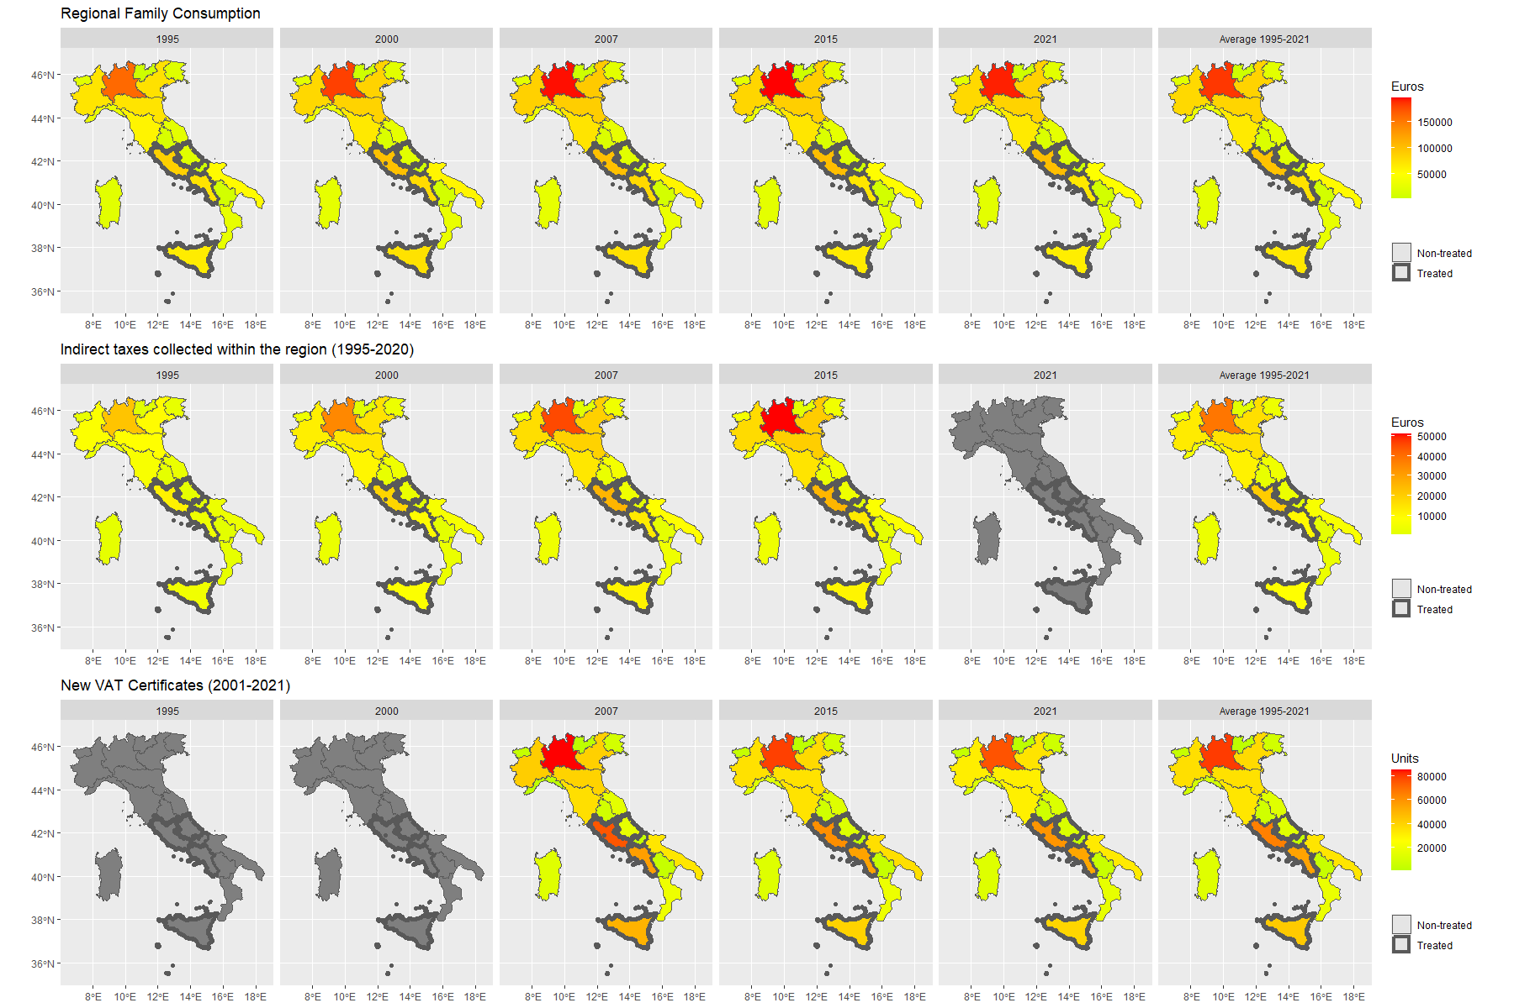
Figure A 4: Observed values of family consumption, indirect taxes collected, and new VAT certificates across the Italian regions from 1995 to 2021. The last column depicts the regional average value 1995-2021. Regions with a marked border are those treated (Lazio, Campania, Abruzzo, Molise, and Sicily).
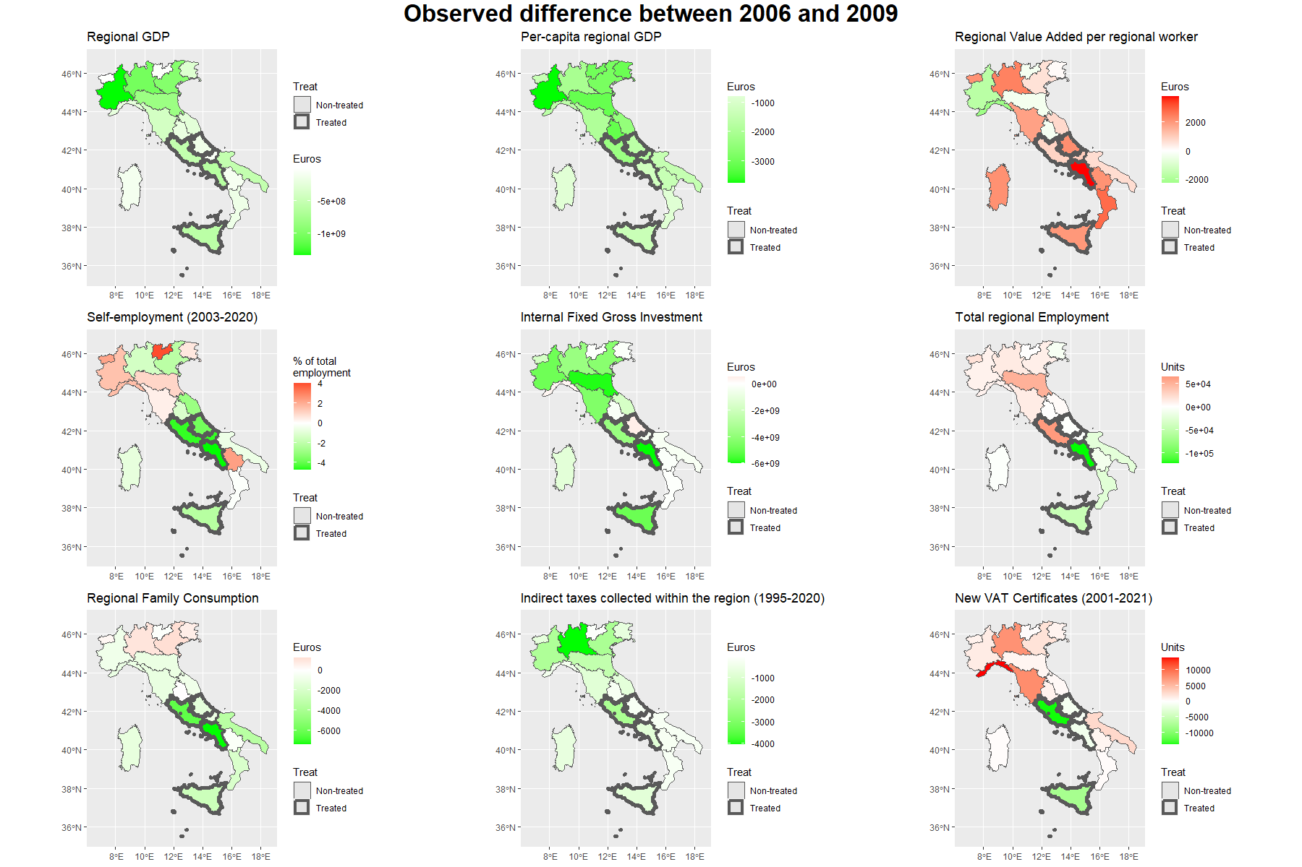
Figure A 5: Absolute variation from 2006 to 2009 for the available macroeconomic indicators at the regional level. The five treated regions are highlighted using bold regional borders.
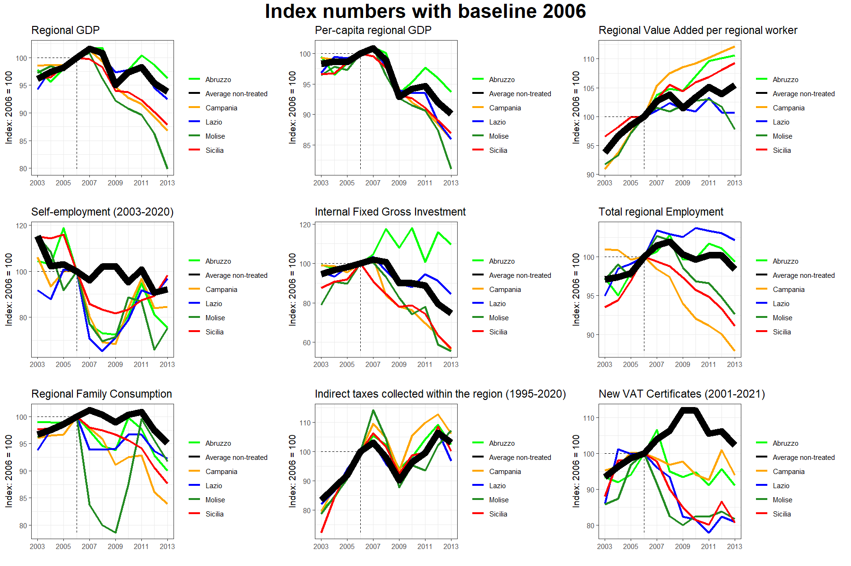
Figure A 6: Time series of index numbers with baseline 2006=100 for the available macroeconomic indicators. Abruzzo, Campania, Lazio, Molise and Sicilia are the five treated regions, while the non-treated regions are averaged across year (solid black lines).

