Supplementary Information
Electrochemical Deposition of Colored Ni/Cu₂O Bilayer Films on Large Area Plastic Substrates for Decorative Applications
Suleyman Can ¹, Alime Colak ², Huseyin Balci ², Cihan Kuru ^{1,*}
¹Department of Metallurgical and Materials Engineering, Bilecik Seyh Edebali University, Bilecik, 11230, Turkey
²Durden Plastic Products and Adhesive Films Inc., Bilecik, 11000, Turkey
* Corresponding Author: cihan.kuru@bilecik.edu.tr

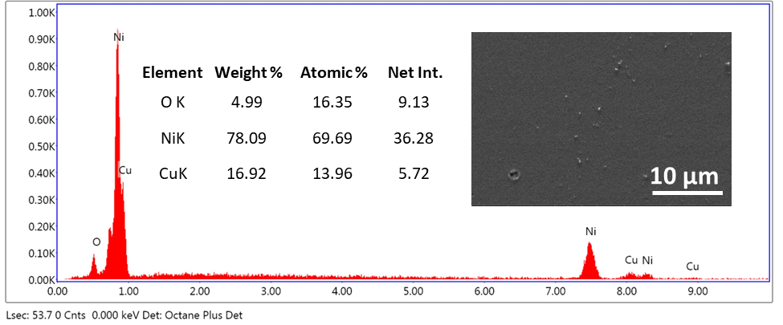
Fig. S1 EDX spectra of the Cu₂O film deposited on Ni coated ABS substrate at 70 ºC under a current value of 0.2 A for 45 s (Inset shows the weight and atomic percentage of the O, Ni and Cu elements and the SEM image of the film surface.).

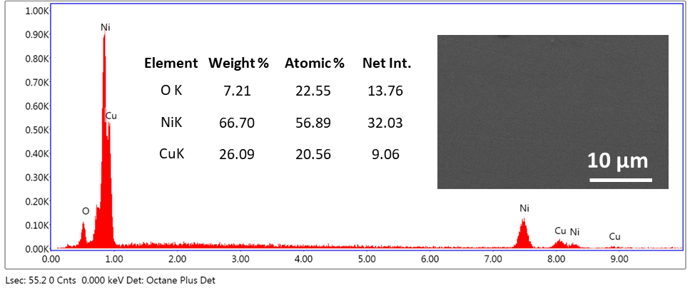
Fig. S2 EDX spectra of the Cu₂O film deposited on Ni coated ABS substrate at 50 ºC under a current value of 0.3 A for 45 s (Inset shows the weight and atomic percentage of the O, Ni and Cu elements and the SEM image of the film surface.).

