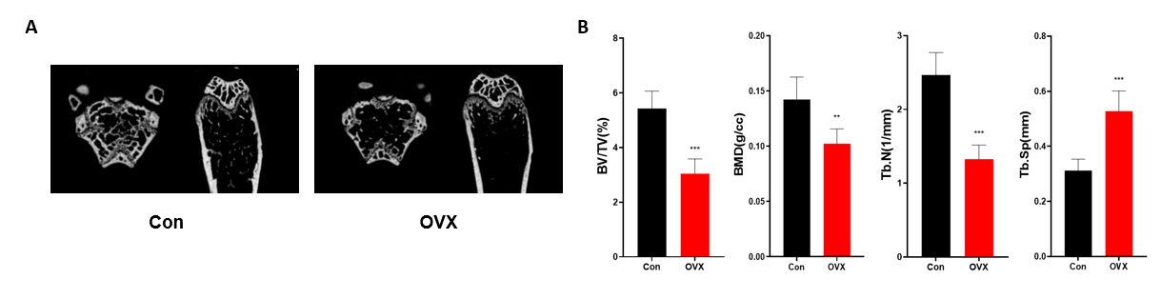
Figure S1. The alteration of bone mass in OVX mice. (A) Representative μCT images of femoral metaphysis of Control and OVX group. (B) Calculations of bone value / total value (BV/TV), trabecular bone mineral density (BMD), trabecular number (Tb.N) and trabecular space (Tb.Sp). n=6. Data are expressed as mean ± SD. * p < 0.05; ** p<0.01; *** p<0.001.

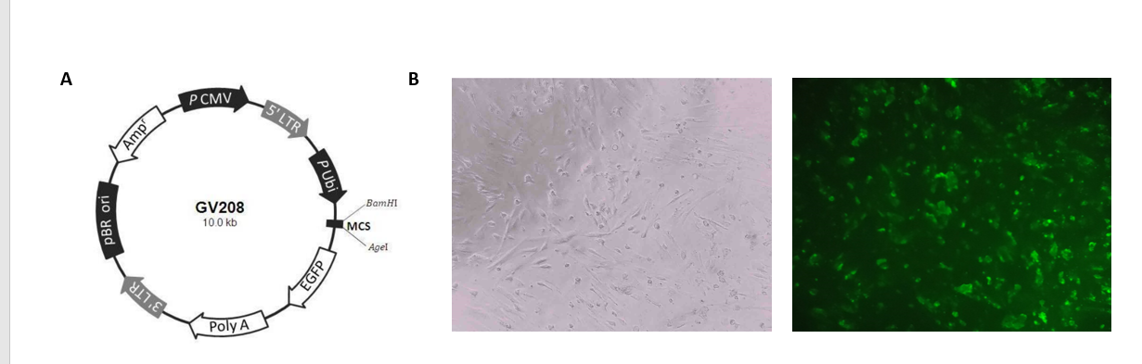
Figure S2. The construction and transfection of lentivirus. (A) The structure of CTNNBIP1 overexpression and control plasmids. (B) The images of EGFP expression at 72 hours after transfection.

