Supplementary Materials

Tables
Table S1. Species, individual IDs, sampling population and accession numbers for the four species from mainland and insular populations: red-billed chough, common chaffinch, dark-eyed junco and house finch.
Species | WGS ID | Individuals | Mainland/Island | Population | Accession number
Red-billed chough | MOCHO1 | 2ST | Mainland | Los Monegros, Iberia | SAMNXXXXXXX
Red-billed chough | MOCHO2 | 25W | Mainland | Los Monegros, Iberia | SAMNXXXXXXX
Red-billed chough | MOCHO3 | 14R | Mainland | Los Monegros, Iberia | SAMNXXXXXXX
Red-billed chough | MOCHO4 | 26X | Mainland | Los Monegros, Iberia | SAMNXXXXXXX
Red-billed chough | MOCHO5 | 28R | Mainland | Los Monegros, Iberia | SAMNXXXXXXX
Red-billed chough | MOCHO6 | 26C | Mainland | Los Monegros, Iberia | SAMNXXXXXXX
Red-billed chough | MOCHO7 | 26H | Mainland | Los Monegros, Iberia | SAMNXXXXXXX
Red-billed chough | MOCHO8 | 376 | Mainland | Los Monegros, Iberia | SAMNXXXXXXX
Red-billed chough | MOCHO9 | 28U | Mainland | Los Monegros, Iberia | SAMNXXXXXXX
Red-billed chough | MOCHO10 | 28T | Mainland | Los Monegros, Iberia | SAMNXXXXXXX
Red-billed chough | MOCHO11 | 26A | Mainland | Los Monegros, Iberia | SAMNXXXXXXX
Red-billed chough | MOCHO12 | 182 | Mainland | Los Monegros, Iberia | SAMNXXXXXXX
Red-billed chough | PACHO1 | 312 | Island | La Palma, Canary Islands | SAMNXXXXXXX
Red-billed chough | PACHO2 | 5J8 | Island | La Palma, Canary Islands | SAMNXXXXXXX
Red-billed chough | PACHO3 | 4C3 | Island | La Palma, Canary Islands | SAMNXXXXXXX
Red-billed chough | PACHO4 | 4XH | Island | La Palma, Canary Islands | SAMNXXXXXXX
Red-billed chough | PACHO5 | 5J3 | Island | La Palma, Canary Islands | SAMNXXXXXXX
Red-billed chough | PACHO6 | 311 | Island | La Palma, Canary Islands | SAMNXXXXXXX
Red-billed chough | PACHO7 | 4XX | Island | La Palma, Canary Islands | SAMNXXXXXXX
Red-billed chough | PACHO8 | 4X6 | Island | La Palma, Canary Islands | SAMNXXXXXXX
Red-billed chough | PACHO9 | 5J5 | Island | La Palma, Canary Islands | SAMNXXXXXXX
Red-billed chough | PACHO10 | 38A | Island | La Palma, Canary Islands | SAMNXXXXXXX
Red-billed chough | PACHO11 | 4CA | Island | La Palma, Canary Islands | SAMNXXXXXXX
Red-billed chough | PACHO12 | 4X2 | Island | La Palma, Canary Islands | SAMNXXXXXXX
Common chaffinch | CHASE1 | 16-130 | Mainland | Segovia, Iberia | SAMN16094451
Common chaffinch | CHASE2 | 16-135 | Mainland | Segovia, Iberia | SAMN16094452
Common chaffinch | CHASE3 | 16-100 | Mainland | Segovia, Iberia | SAMN16094453
Common chaffinch | CHASE4 | 18-812 | Mainland | Segovia, Iberia | SAMN16094454
Common chaffinch | CHASE5 | 18-813 | Mainland | Segovia, Iberia | SAMN16094455
Common chaffinch | CHASE6 | 18-814 | Mainland | Segovia, Iberia | SAMN16094456
Common chaffinch | CHASE7 | 18-815 | Mainland | Segovia, Iberia | SAMN16094457
Common chaffinch | CHASE8 | 18-816 | Mainland | Segovia, Iberia | SAMN16094458
Common chaffinch | CHASE9 | 18-826 | Mainland | Segovia, Iberia | SAMN16094459
Common chaffinch | CHATI1 | 16-003 | Island | La Palma, Canary Islands | SAMNXXXXXXX
Common chaffinch | CHATI2 | 16-006 | Island | La Palma, Canary Islands | SAMNXXXXXXX
Common chaffinch | CHATI3 | 16-007 | Island | La Palma, Canary Islands | SAMNXXXXXXX
Common chaffinch | CHATI4 | 16-008 | Island | La Palma, Canary Islands | SAMNXXXXXXX
Common chaffinch | CHATI5 | 16-009 | Island | La Palma, Canary Islands | SAMNXXXXXXX
Common chaffinch | CHATI6 | 16-011 | Island | La Palma, Canary Islands | SAMNXXXXXXX
Common chaffinch | CHATI7 | 16-012 | Island | La Palma, Canary Islands | SAMNXXXXXXX
Common chaffinch | CHATI8 | 16-013 | Island | La Palma, Canary Islands | SAMNXXXXXXX
Common chaffinch | CHATI9 | 16-015 | Island | La Palma, Canary Islands | SAMNXXXXXXX
Common chaffinch | CHATI10 | 16-016 | Island | La Palma, Canary Islands | SAMNXXXXXXX
Common chaffinch | CHATI11 | 16-019 | Island | La Palma, Canary Islands | SAMNXXXXXXX
Common chaffinch | CHATI12 | 16-021 | Island | La Palma, Canary Islands | SAMNXXXXXXX
Dark-eyed junco | ORJU1 | 14-0529 | Mainland | California | SAMNXXXXXXX
Dark-eyed junco | ORJU2 | 14-0530 | Mainland | California | SAMNXXXXXXX
Dark-eyed junco | ORJU3 | 14-0531 | Mainland | California | SAMNXXXXXXX
Dark-eyed junco | ORJU4 | 14-0532 | Mainland | California | SAMNXXXXXXX
Dark-eyed junco | ORJU5 | 14-0533 | Mainland | California | SAMNXXXXXXX
Dark-eyed junco | ORJU6 | 14-0534 | Mainland | California | SAMNXXXXXXX
Dark-eyed junco | ORJU7 | 14-0535 | Mainland | California | SAMNXXXXXXX
Dark-eyed junco | ORJU8 | 14-0536 | Mainland | California | SAMNXXXXXXX
Dark-eyed junco | ORJU9 | 14-0539 | Mainland | California | SAMNXXXXXXX
Dark-eyed junco | ORJU10 | 14-0542 | Mainland | California | SAMNXXXXXXX
Dark-eyed junco | ORJU11 | 14-0543 | Mainland | California | SAMNXXXXXXX
Dark-eyed junco | ORJU12 | 14-0544 | Mainland | California | SAMNXXXXXXX
Dark-eyed junco | GUJU1 | 17-218 | Island | Guadalupe | SAMNXXXXXXX
Dark-eyed junco | GUJU2 | 17-339 | Island | Guadalupe | SAMNXXXXXXX
Dark-eyed junco | GUJU3 | 17-358 | Island | Guadalupe | SAMNXXXXXXX
Dark-eyed junco | GUJU4 | 17-367 | Island | Guadalupe | SAMNXXXXXXX
Dark-eyed junco | GUJU5 | 17-396 | Island | Guadalupe | SAMNXXXXXXX
Dark-eyed junco | GUJU6 | 17-397 | Island | Guadalupe | SAMNXXXXXXX
Dark-eyed junco | GUJU7 | 17-398 | Island | Guadalupe | SAMNXXXXXXX
Dark-eyed junco | GUJU8 | 17-342 | Island | Guadalupe | SAMNXXXXXXX
Dark-eyed junco | GUJU9 | 17-343 | Island | Guadalupe | SAMNXXXXXXX
Dark-eyed junco | GUJU10 | 17-267 | Island | Guadalupe | SAMNXXXXXXX
Dark-eyed junco | GUJU11 | 17-275 | Island | Guadalupe | SAMNXXXXXXX
Dark-eyed junco | GUJU12 | 17-225 | Island | Guadalupe | SAMNXXXXXXX
House finch | CAHO1 | DX-2 | Mainland | California | SAMNXXXXXXX
House finch | CAHO2 | DV-34 | Mainland | California
House finch | CAHO3 | W-22 | Mainland | California
House finch | CAHO4 | DV-5 | Mainland | California
House finch | CAHO5 | W-10 | Mainland | California
House finch | CAHO6 | DX-42 | Mainland | California
House finch | CAHO7 | DX-29 | Mainland | California
House finch | CAHO8 | W-18 | Mainland | California
House finch | CAHO9 | 13-022 | Mainland | Sierra Juarez
House finch | CAHO10 | 13-023 | Mainland | Sierra Juarez
House finch | CAHO11 | W-29 | Mainland | California
House finch | CAHO12 | DX-45 | Mainland | California
House finch | GUHO1 | 17-228 | Island | Guadalupe
House finch | GUHO2 | 17-240 | Island | Guadalupe
House finch | GUHO3 | 17-246 | Island | Guadalupe
House finch | GUHO4 | 17-254 | Island | Guadalupe
House finch | GUHO5 | 17-274 | Island | Guadalupe
House finch | GUHO6 | 17-341 | Island | Guadalupe
House finch | GUHO7 | 17-344 | Island | Guadalupe
House finch | GUHO8 | 17-238 | Island | Guadalupe
House finch | GUHO9 | 17-419 | Island | Guadalupe
House finch | GUHO10 | 17-374 | Island | Guadalupe
House finch | GUHO11 | 17-235 | Island | Guadalupe
House finch | GUHO12 | 11-0126 | Island | Guadalupe

Table S2. Correspondence between the chromosomes of the Zebra finch (Taeniopygia guttata) genome assembly (bTaeGut2.pat.W.v2), including the chromosome name and Refseq ID and the scaffolds of the reference genomes for the common chaffinch (Fringilla coelebs), the junco (Junco hyemalis) and the New Caledonian crow (Corvus Moneduloides).
Chrom. | RefSeq Zebra finch | Common chaffinch assembly | Junco assembly | New Caledonian crow assembly
1 | NC_044998.1 | ScDMRwT_581_HRSCAF_676 | ScoVZU6_963__HRSCAF___984 | NC_045477.1
1A | NC_044999.1 | ScDMRwT_3155_HRSCAF_3635 | ScoVZU6_1238__HRSCAF___1266 | NC_045479.1
2 | NC_045000.1 | ScDMRwT_473_HRSCAF_551 | ScoVZU6_2668__HRSCAF___2714 | NC_045476.1
3 | NC_045001.1 | ScDMRwT_2155_HRSCAF_2491 | ScoVZU6_1491__HRSCAF___1522 | NC_045478.1
4 | NC_045002.1 | ScDMRwT_1738_HRSCAF_2009 | ScoVZU6_2655__HRSCAF___2701 | NC_045480.1
5 | NC_045004.1 | ScDMRwT_3240_HRSCAF_3767 | ScoVZU6_3544__HRSCAF___3601 | NC_045489.1
4A | NC_045003.1 | ScDMRwT_1904_HRSCAF_2197 | ScoVZU6_1225__HRSCAF___1252 | NC_045481.1
6 | NC_045005.1 | ScDMRwT_2188_HRSCAF_2528 | ScoVZU6_982__HRSCAF___1003 | NC_045483.1
7 | NC_045006.1 | ScDMRwT_1364_HRSCAF_1572 | ScoVZU6_3251__HRSCAF___3306 | NC_045482.1
8 | NC_045007.1 | ScDMRwT_804_HRSCAF_937 | ScoVZU6_2192__HRSCAF___2234 | NC_045484.1
9 | NC_045008.1 | ScDMRwT_200_HRSCAF_244 | ScoVZU6_201__HRSCAF___207 | NC_045485.1
10 | NC_045009.1 | ScDMRwT_1361_HRSCAF_1569 | ScoVZU6_4447__HRSCAF___4518 | NC_045488.1
11 | NC_045010.1 | ScDMRwT_1149_HRSCAF_1324 | ScoVZU6_3582__HRSCAF___3639 | NC_045487.1
12 | NC_045011.1 | ScDMRwT_2095_HRSCAF_2420 | ScoVZU6_4448__HRSCAF___4521 | NC_045486.1
13 | NC_045012.1 | ScDMRwT_1072_HRSCAF_1239 | ScoVZU6_2057__HRSCAF___2097 | NC_045490.1
14 | NC_045013.1 | ScDMRwT_2434_HRSCAF_2805 | ScoVZU6_3803__HRSCAF___3864 | NC_045491.1
15 | NC_045014.1 | ScDMRwT_1873_HRSCAF_2164 | ScoVZU6_4455__HRSCAF___4539 | NC_045493.1
17 | NC_045015.1 | ScDMRwT_2070_HRSCAF_2390 | ScoVZU6_1929__HRSCAF___1968 | NC_045496.1
18 | NC_045016.1 | ScDMRwT_1489_HRSCAF_1712 | ScoVZU6_582__HRSCAF___593 | NC_045494.1
19 | NC_045017.1 | ScDMRwT_2017_HRSCAF_2332 | ScoVZU6_2973__HRSCAF___3026 | NC_045495.1
20 | NC_045018.1 | ScDMRwT_211_HRSCAF_256 | ScoVZU6_1043__HRSCAF___1065 | NC_045492.1
21 | NC_045019.1 | ScDMRwT_1489_HRSCAF_1712 | ScoVZU6_3047__HRSCAF___3100 | NC_045497.1
22 | NC_045020.1 | ScDMRwT_1489_HRSCAF_1712 | ScoVZU6_1118__HRSCAF___1143 | NC_045502.1
23 | NC_045021.1 | ScDMRwT_1489_HRSCAF_1712 | ScoVZU6_300__HRSCAF___308 | NC_045498.1
24 | NC_045022.1 | ScDMRwT_1489_HRSCAF_1712 | ScoVZU6_957__HRSCAF___978 | NC_045500.1
25 | NC_045023.1 | ScDMRwT_1489_HRSCAF_1712 | ScoVZU6_1653__HRSCAF___1687 | NC_045504.1
26 | NC_045024.1 | ScDMRwT_1489_HRSCAF_1712 | ScoVZU6_3291__HRSCAF___3346 | NC_045499.1
27 | NC_045025.1 | ScDMRwT_1489_HRSCAF_1712 | ScoVZU6_3522__HRSCAF___3579 | NC_045501.1
28 | NC_045026.1 | ScDMRwT_1489_HRSCAF_1712 | ScoVZU6_4457__HRSCAF___4541 | NC_045503.1
Z | NC_045027.1 | ScGsoED_1_HRSCAF_2 | ScU1KuS_2__HRSCAF___21 | NC_045511.1

Table S3. Mean values (x̄), standard deviation (sd) and ANOVA test including F statistic, degrees of freedom (df) and p-value for the red-billed chough, common chaffinch, junco and house finch morphological traits and PC1 including all variables from the insular and mainland populations. The sample size for each population is specified for each species and treatment (n). The compared traits are wing length, tail length, tarsus length, culmen, exposed culmen, bill depth and bill width. Statistically significant p-values are in bold.

 | Red-Billed Chough |  |  |  | Common chaffinch
Trait | x̄_{island} ± sd | x̄_{continent} ± sd | F value _{df} | p-value | x̄_{island} ± sd | x̄_{continent} ± sd | F value _{df} | p-value
Trait | n=25 | n=25 | F value _{df} | p-value | n=25 | n=25 | F value _{df} | p-value
Wing length | 287.04 ± 8.18 | 296.24 ± 7.19 | 17.85 _{1,48} | <.0001 | 86.28 ± 1.52 | 85.94 ± 1.79 | 0.52 _{1,48} | 0.47
Tail length | 138.76 ± 5.74 | 143.6 ± 5.43 | 9.38 _{1,48} | <.01 | 75.05 ± 1.61 | 66.77 ± 2.72 | 171.3 _{1,48} | <.0001
Tarsus length | 52.96 ± 1.66 (n=24) | 56.42 ± 1.26 | 67.84 _{1,47} | <.0001 | 21.8 ± 0.54 | 18.26 ± 0.52 | 559 _{1,48} | <.0001
Culmen | 59.38 ± 2.54 (n=24) | 61.75 ± 2.85 | 9.37 _{1,47} | <.01 | 11.78 ± 0.44 | 9.76 ± 0.35 | 322.7 _{1,48} | <.0001
Exp. Culmen | - | - | - | - | 15.47 ± 0.61 | 12.53 ± 0.41 | 403.4 _{1,48} | <.0001
Bill depth | 13.29 ± 0.49 (n=24) | 13.32 ± 0.49 | 0.03 _{1,47} | 0.86 | 8.09 ± 0.26 | 6.73 ± 0.21 | 417.9 _{1,48} | <.0001
Bill width | 13.70 ± 0.66 (n=23) | 12.42 ± 0.69 | 42.90 _{1,46} | <.0001 | 6.24 ± 0.17 | 5.39 ± 0.22 | 242.6 _{1,48} | <.0001
PC1 | 1.18 ± 1.12 | -1.04 ± 1.01 | 50.7 _{1,45} | <.0001 | -2.26 ± 0.47 | 2.26 ± 0.47 | 923.3 _{1,48} | <.0001
 | Junco sp. |  |  |  | House finch
Trait | x̄_{island} ± sd | x̄_{continent} ± sd | F value _{df} | p-value | x̄_{island} ± sd | x̄_{continent} ± sd | F value _{df} | p-value
Trait | n=12 | n=12 | F value _{df} | p-value | n=8 | n=5 | F value _{df} | p-value
Wing length | 68.59 ± 1.31 | 71.38 ± 1.76 | 19.27 _{1,22} | <.0005 | 81.13 ± 1.57 | 79.4 ± 2.38 | 2.51 _{1,11} | 0.14
Tail length | 62.01 ± 2.06 | 62.77 ± 2.93 | 0.53 _{1,22} | 0.47 | 65.15 ± 1.65(n=7) | 62.86 ± 4.55 | 1.56 _{1,10} | 0.24
Tarsus length | 21 ± 0.41 | 20.11 ± 0.41 | 27.56 _{1,22} | <.0001 | 19.29 ± 0.51 | 17.5 ± 0.46 | 41.14 _{1,11} | <.0001
Culmen | 9.8 ± 0.42 | 8.68 ± 0.42 | 43.13 _{1,22} | <.0001 | 9.95 ± 0.33 | 8.3 ± 0.62 | 40.06 _{1,11} | <.0001
Exp. Culmen | 13.08 ± 0.46 | 11.52 ± 0.44 | 72.1 _{1,22} | <.0001 | 12.54 ± 0.37 | 10.88 ± 0.13 | 90.56 _{1,11} | <.0001
Bill depth | 6.14 ± 0.16 | 5.69 ± 0.28 | 23.08 _{1,22} | <.0001 | 10 ± 0.35 | 7.88 ± 0.20 | 145.2 _{1,11} | <.0001
Bill width | 4.43 ± 0.15 | 4.56 ± 0.22 | 2.66 _{1,22} | 0.12 | 7.71 ± 0.24 | 6.44 ± 0.19 | 97.74 _{1,11} | <.0001
PC1 | 1.72 ± 0.76 | -1.72 ± 0.63 | 145.2 _{1,22} | <.0001 | -2.44 ± 0.20 | 1.22 ± 1.63 | 19.14 _{1,10} | <.01

Table S4. Number of sites obtained in the variant calling for each species performed with BCFTOOLS, including the total number of sites (variant and invariant), only the variant sites and the total number of sites and variant sites after filtering.
Species | Total sites | Variant sites | Filtered dataset | Filtered variants
Red-billed chough | 1,026,780,642 | 13,411,090 | 1,013,391,645 | 4,626,766
Common chaffinch | 994,789,329 | 52,711,626 | 979,600,935 | 39,937,905
Dark-eyed junco | 1,001,453,032 | 42,444,447 | 987,515,496 | 31,060,630
House finch | 973,127,256 | 43,257,766 | 954,187,282 | 29,423,214

Table S5. Detection of chromosomal inversions. Outlier multidimensional scaling (MDS) values detected by locstruct for the dark-eyed junco, the common chaffinch and the house finch, considered as putative inversions.
MDS | Chr | Scaffold | Start | End | Outlier  windows | PC1  Variance  (%) | PC2  Variance  (%) | Proportion of  between clusters  sum of squares
Dark-eyed junco
MDS14 | 7 | ScoVZU6_3251_HRSCAF_3306 | 217052 | 1814797 | 27 | 47.58 | 11.78 | 0.96
MDS30 | 6 | ScoVZU6_982_HRSCAF_1003 | 11099520 | 12152631 | 34 | 57.15 | 34.83 | 0.996
Common chaffinch
MDS07 | 4 | ScDMRwT_1738_HRSCAF_2009 | 3482050 | 17162018 | 113 | 41.82 | 7.56 | 0.997
MDS15 | 2 | ScDMRwT_473_HRSCAF_551 | 10279761 | 125763279 | 88 | 44.19 | 9.27 | 0.996
House finch
MDS13 | 3 | ScDMRwT_2155_HRSCAF_2491 | 32963219 | 80679350 | 502 | 32.34 | 21.34 | 0.99
MDS19 | 1A | ScDMRwT_3155_HRSCAF_3635 | 20208302 | 61201276 | 34 | 55.76 | 27.6 | 0.91
MDS22 | 1 | ScDMRwT_581_HRSCAF_676 | 17057369 | 24751704 | 8 | 49.45 | 10.4 | 0.97
MDS24 | 1 | ScDMRwT_581_HRSCAF_676 | 87108777 | 88764953 | 6 | 57.37 | 22.24 | 0.95
MDS34 | 1 | ScDMRwT_581_HRSCAF_676 | 74088965 | 75085134 | 3 | 56.51 | 22.83 | 0.96

Table S6. Top ten GO terms associated to 5 out of the 14 outlier genes detected by XP-EHH in the island-mainland red-billed chough comparison. The analysis was performed using the topGO package with the weight01 algorithm and the fisher test under the ontology biological process. The table includes the GO term Accession (GO.ID), the term name, the number of annotated genes (Annot.), the number of significant genes (Sign.), the number of expected genes (Exp.) and the p-value of the Fisher test using the weight01 algorithm.

GO.ID | Term name | Annot. | Sign. | Exp. | Fisher
GO:0070130 | negative regulation of mitochondrial translation | 1 | 1 | 0 | 0.00058
GO:0002760 | positive regulation of antimicrobial humoral response | 1 | 1 | 0 | 0.00058
GO:0071922 | regulation of cohesin loading | 2 | 1 | 0 | 0.00116
GO:0072573 | tolerance induction to lipopolysaccharide | 2 | 1 | 0 | 0.00116
GO:0045875 | negative regulation of sister chromatid cohesion | 3 | 1 | 0 | 0.00174
GO:0060623 | regulation of chromosome condensation | 3 | 1 | 0 | 0.00174
GO:0035562 | negative regulation of chromatin binding | 5 | 1 | 0 | 0.00289
GO:0008156 | negative regulation of DNA replication | 10 | 1 | 0.01 | 0.00578
GO:0042273 | ribosomal large subunit biogenesis | 23 | 1 | 0.01 | 0.01325
GO:0048146 | positive regulation of fibroblast proliferation | 25 | 1 | 0.01 | 0.0144

Table S7. Top ten GO terms associated with 54 out of the 85 outlier genes detected by the F_{st} scan in the island-mainland common chaffinch comparison. The analysis was performed using the topGO package with the weight01 algorithm and the fisher test under the ontology biological process. The table includes the GO term Accession (GO.ID), the term name, the number of annotated genes (Annot.), the number of significant genes (Sign.), the number of expected genes (Exp.) and the p-value of the Fisher test using the weight01 algorithm.
GO.ID | Term name | Annot. | Sign. | Exp. | Fisher
GO:0007213 | G protein-coupled acetylcholine receptor signaling pathway | 7 | 2 | 0.04 | 0.00043
GO:0090668 | endothelial cell chemotaxis to vascular endothelial growth factor | 1 | 1 | 0.01 | 0.00463
GO:0043973 | histone H3-K4 acetylation | 1 | 1 | 0.01 | 0.00463
GO:1904980 | positive regulation of endosome organization | 1 | 1 | 0.01 | 0.00463
GO:1904702 | regulation of protein localization to cell-cell adherens junction | 1 | 1 | 0.01 | 0.00463
GO:0006430 | lysyl-tRNA aminoacylation | 1 | 1 | 0.01 | 0.00463
GO:0000972 | transcription-dependent tethering of RNA polymerase II gene DNA at nuclear periphery | 1 | 1 | 0.01 | 0.00463
GO:0032418 | lysosome localization | 26 | 2 | 0.14 | 0.00635
GO:0051893 | regulation of focal adhesion assembly | 29 | 2 | 0.15 | 0.00786
GO:0015966 | diadenosine tetraphosphate biosynthetic process | 2 | 1 | 0.01 | 0.00925

Table S8. Top ten GO terms associated with 16 out of the 24 outlier genes detected by the F_{st} scan in the island-mainland dark-eyed junco comparison. The analysis was performed using the topGO package with the weight01 algorithm and the fisher test under the ontology biological process. The table includes the GO term Accession (GO.ID), the term name, the number of annotated genes (Annot.), the number of significant genes (Sign.), the number of expected genes (Exp.) and the p-value of the Fisher test using the weight01 algorithm.
GO.ID | Term name | Annot. | Sign. | Exp. | Fisher
GO:1905793 | protein localization to pericentriolar material | 2 | 1 | 0 | 0.0028
GO:0006104 | succinyl-CoA metabolic process | 2 | 1 | 0 | 0.0028
GO:0048692 | negative regulation of axon extension involved in regeneration | 2 | 1 | 0 | 0.0028
GO:1904780 | negative regulation of protein localization to centrosome | 2 | 1 | 0 | 0.0028
GO:0045869 | negative regulation of single stranded viral RNA replication via double stranded DNA intermediate | 2 | 1 | 0 | 0.0028
GO:0090309 | positive regulation of methylation-dependent chromatin silencing | 2 | 1 | 0 | 0.0028
GO:0061034 | olfactory bulb mitral cell layer development | 2 | 1 | 0 | 0.0028
GO:0018401 | peptidyl-proline hydroxylation to 4-hydroxy-L-proline | 3 | 1 | 0 | 0.0042
GO:0046604 | positive regulation of mitotic centrosome separation | 3 | 1 | 0 | 0.0042
GO:0051968 | positive regulation of synaptic transmission, glutamatergic | 3 | 1 | 0 | 0.0042

Table S9. Top ten GO terms associated with 79 out of the 111 outlier genes detected by the F_{st} scan in the island-mainland house finch comparison. The analysis was performed using the topGO package with the weight01 algorithm and the fisher test under the ontology biological process. The table includes the GO term Accession (GO.ID), the term name, the number of annotated genes (Annot.), the number of significant genes (Sign.), the number of expected genes (Exp.) and the p-value of the Fisher test using the weight01 algorithm.
GO.ID | Term | Annot. | Sign. | Exp. | Fisher
GO:0035873 | lactate transmembrane transport | 5 | 3 | 0.05 | 0.00032
GO:0044154 | histone H3-K14 acetylation | 9 | 2 | 0.08 | 0.00193
GO:0043972 | histone H3-K23 acetylation | 1 | 1 | 0.01 | 0.0075
GO:0045218 | zonula adherens maintenance | 1 | 1 | 0.01 | 0.0075
GO:0072274 | metanephric glomerular basement membrane development | 1 | 1 | 0.01 | 0.0075
GO:2000845 | positive regulation of testosterone secretion | 1 | 1 | 0.01 | 0.0075
GO:0003429 | growth plate cartilage chondrocyte morphogenesis | 1 | 1 | 0.01 | 0.0075
GO:1905662 | negative regulation of telomerase RNA reverse transcriptase activity | 1 | 1 | 0.01 | 0.0075
GO:0006425 | glutaminyl-tRNA aminoacylation | 1 | 1 | 0.01 | 0.0075
GO:0090258 | negative regulation of mitochondrial fission | 1 | 1 | 0.01 | 0.0075

Figures
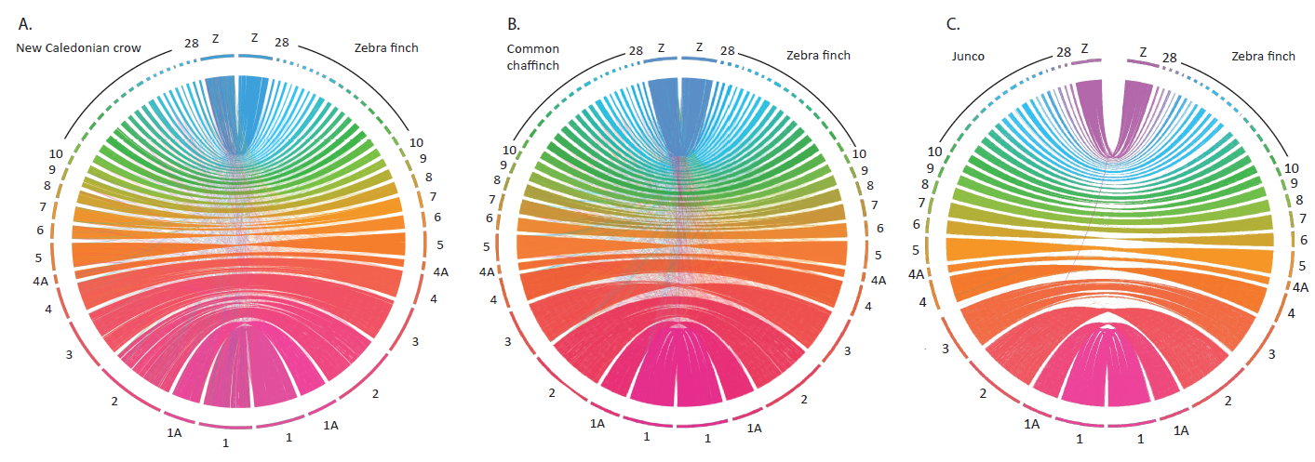
Figure S1. Synteny plots of the three reference genomes used, against the zebra finch genome (Taeniopygia guttata, bTaeGut2.pat.W.v2) performed with Circos (Krzywinski et al., 2009). (A) New Caledonian crow (Corvus moneduloides), (B) Common chaffinch (Fringilla coelebs) and (C) Dark-eyed junco (Junco hyemalis). The zebra finch is on the right hemisphere of each plot.

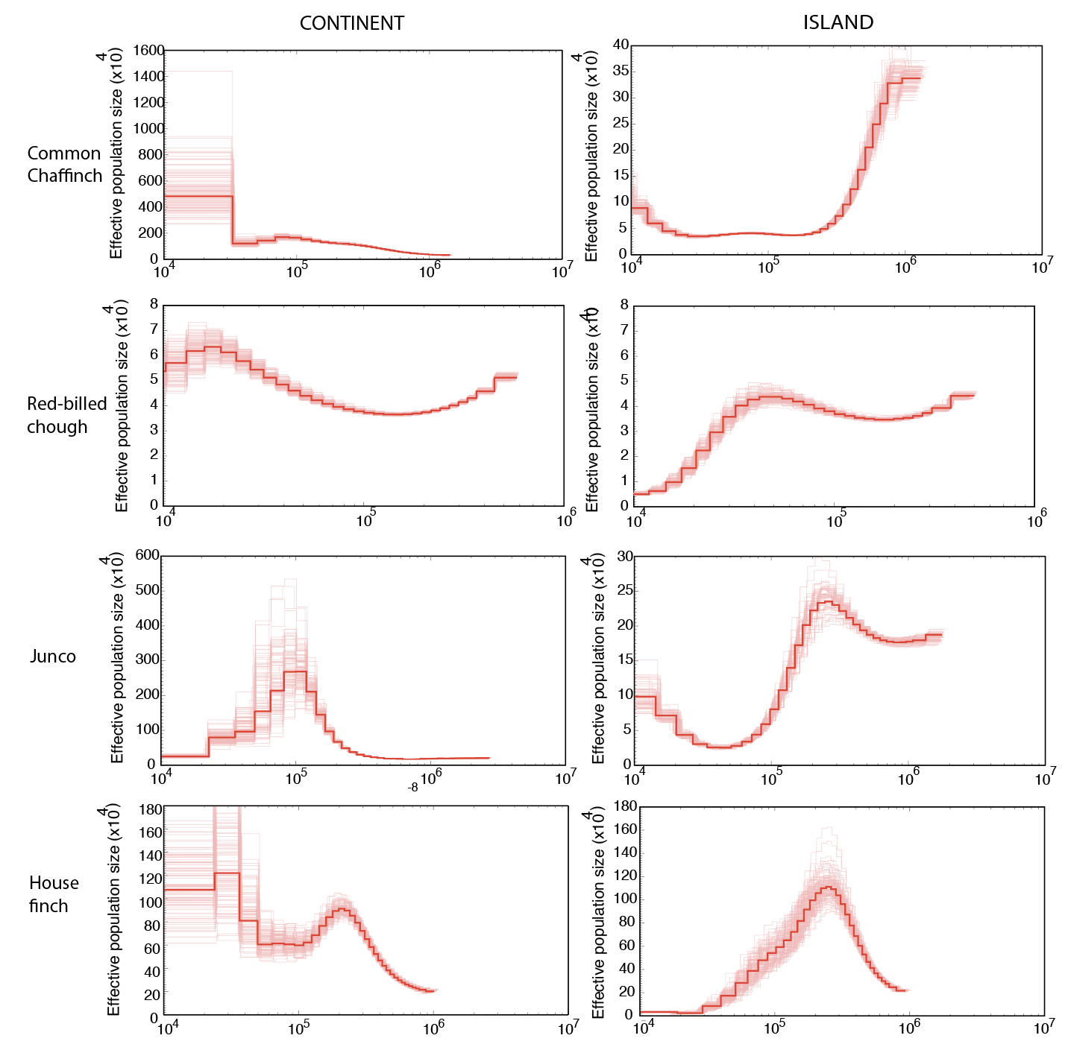
Figure S2. Demographic history of insular and mainland populations. The analysis was performed using Pairwise Sequentially Markovian Coalescent (PSMC). Demographic inference (dark red line) and 100 bootstrap replicates (lighter red lines) for one individual per treatment and species. The left and right columns correspond to the continent and the island individuals, respectively. The mutation rate used was of 4.6e-9 mutation/site/generation for all species, and the generation time used in all cases was two years.

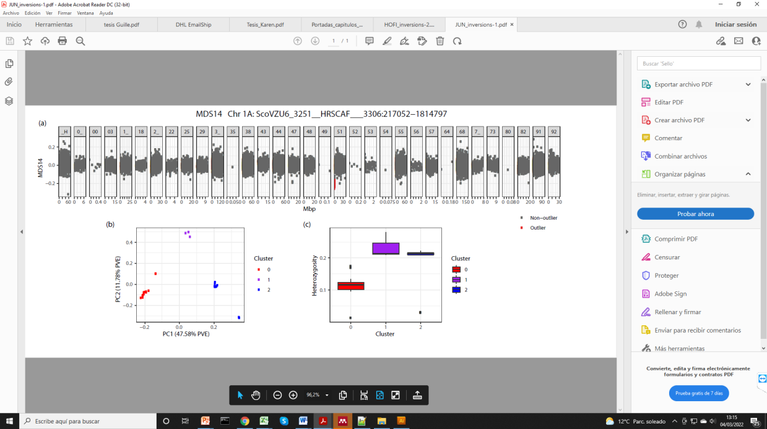
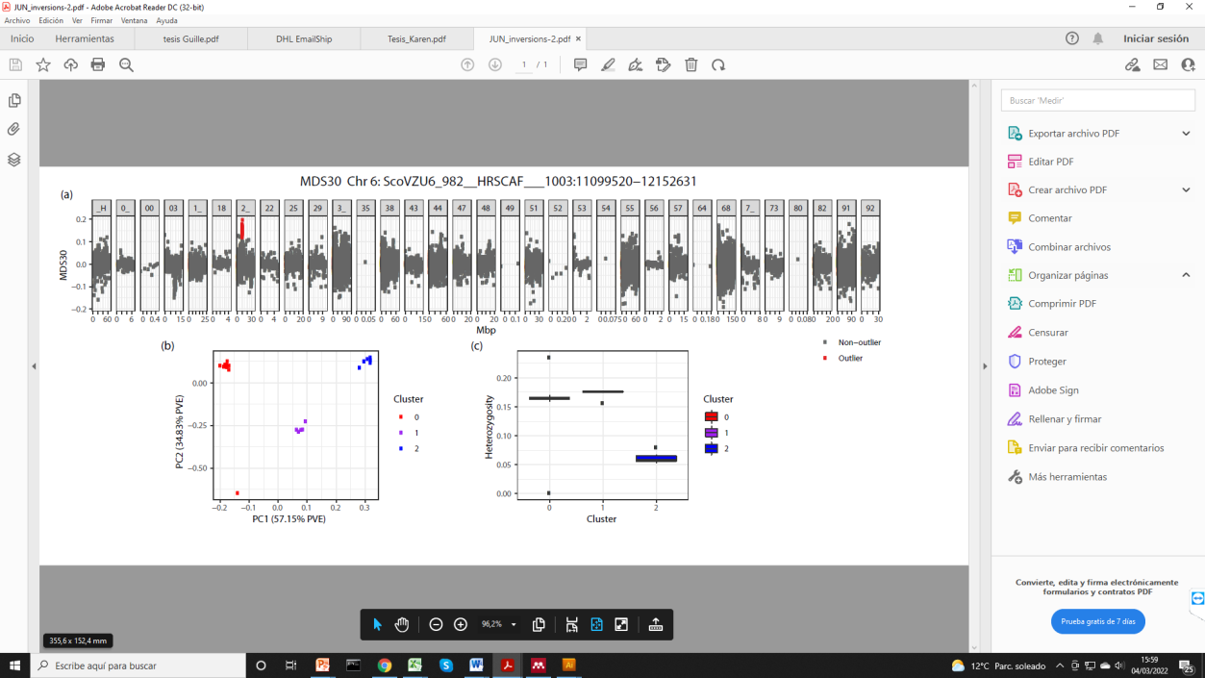
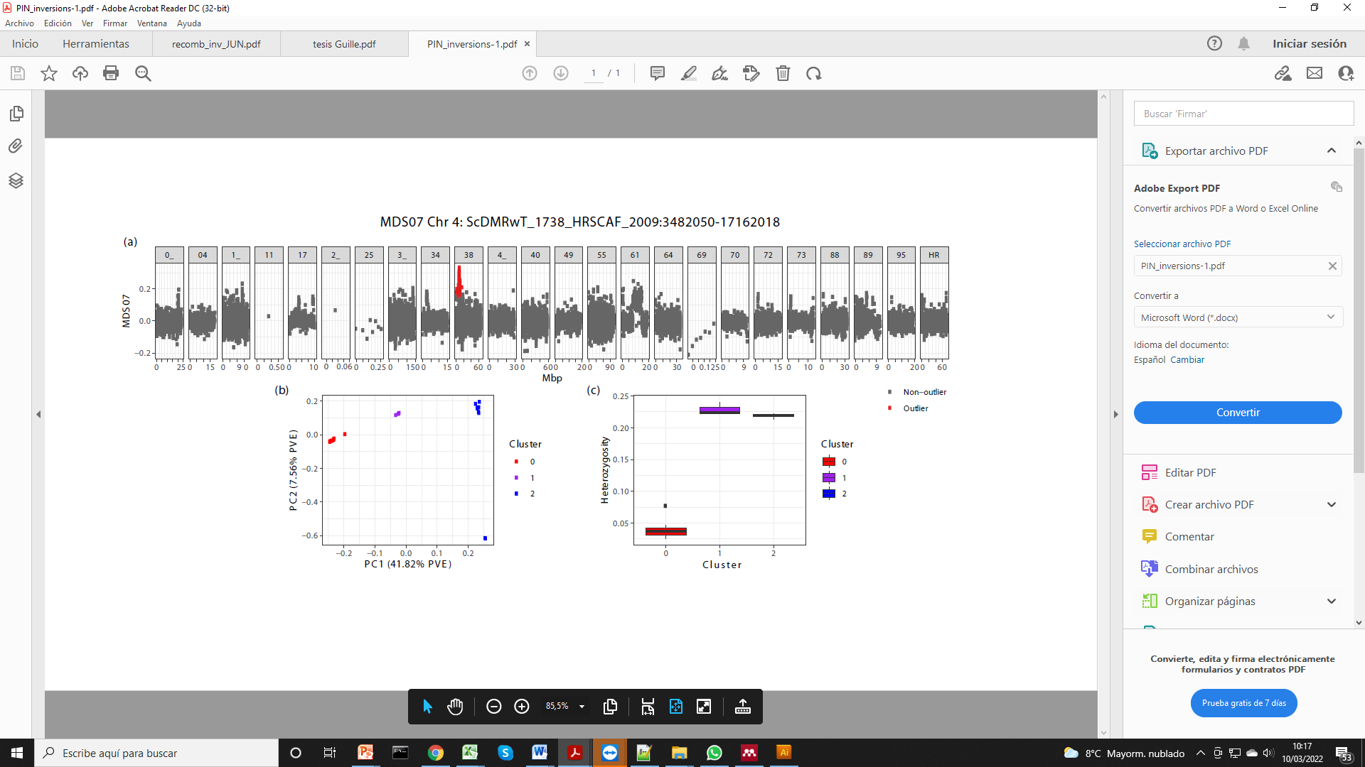
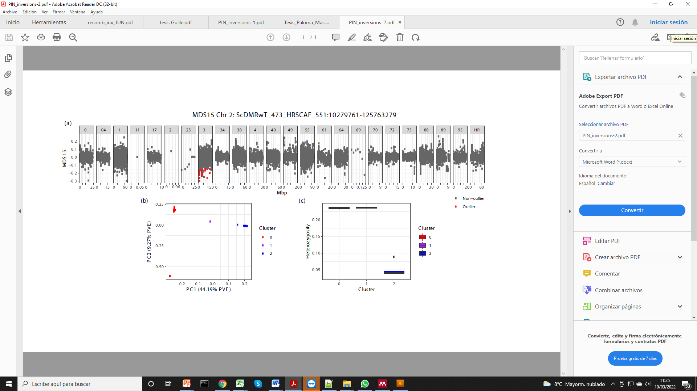
A.
B.
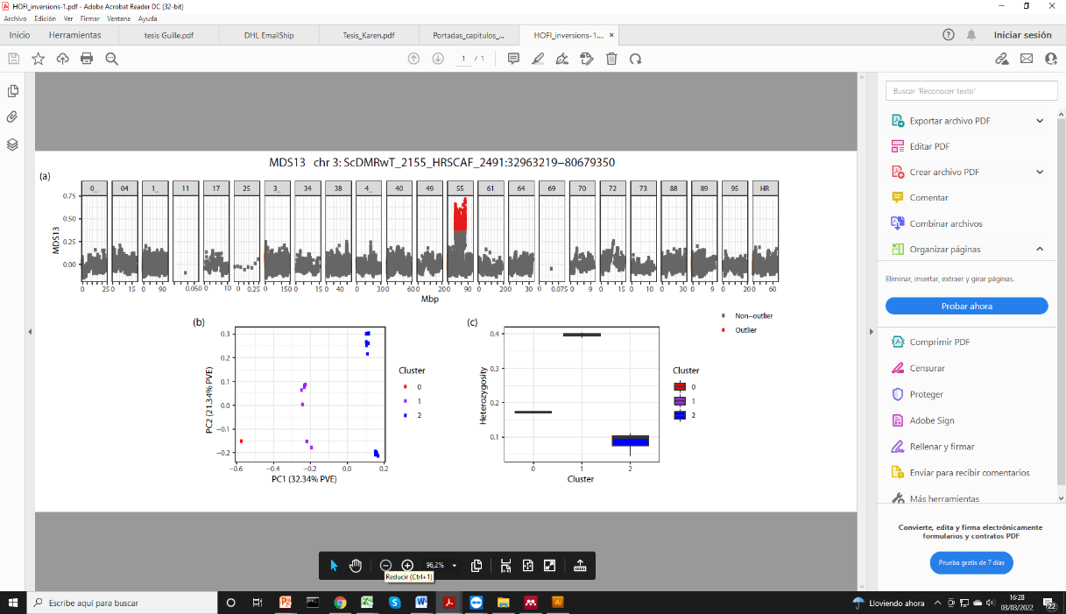
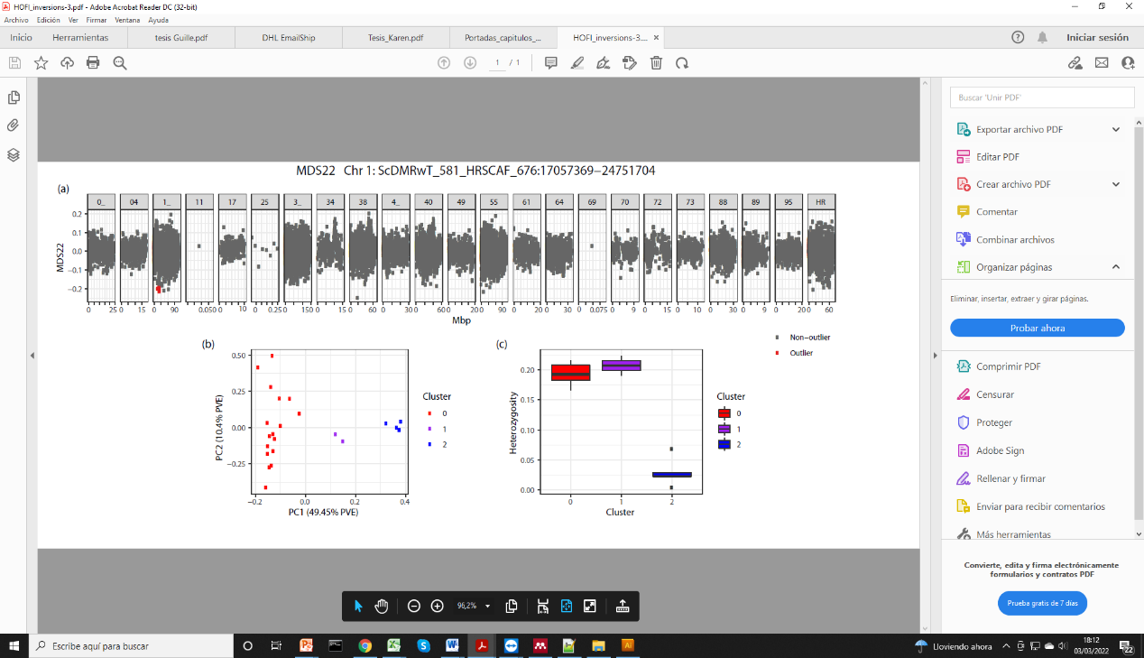
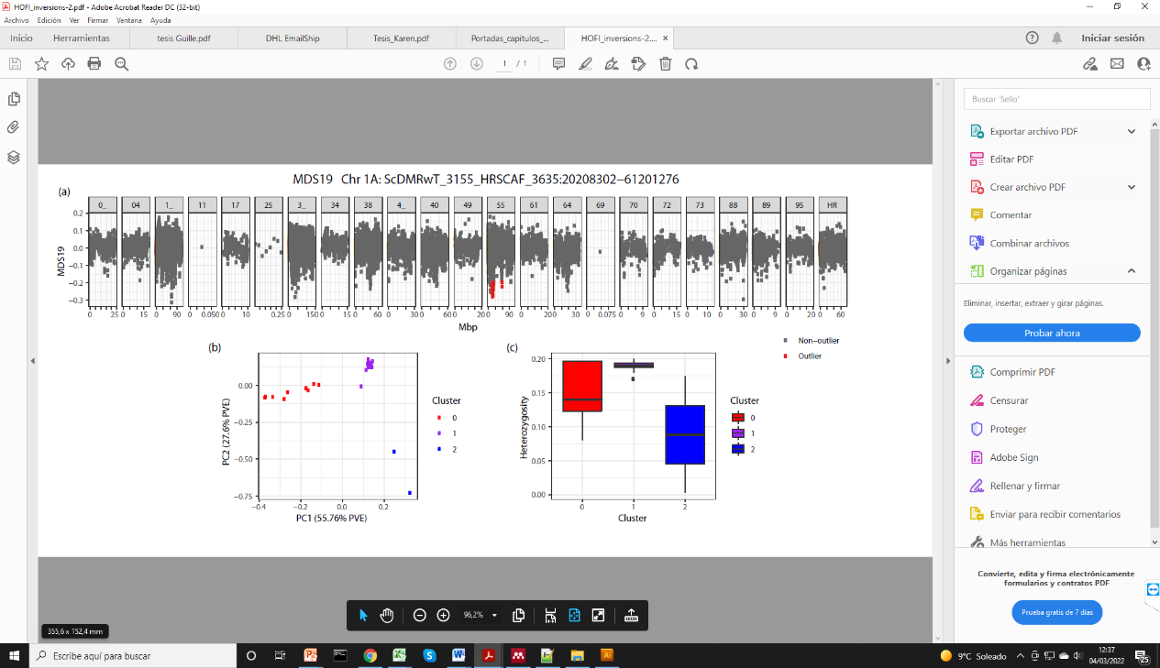
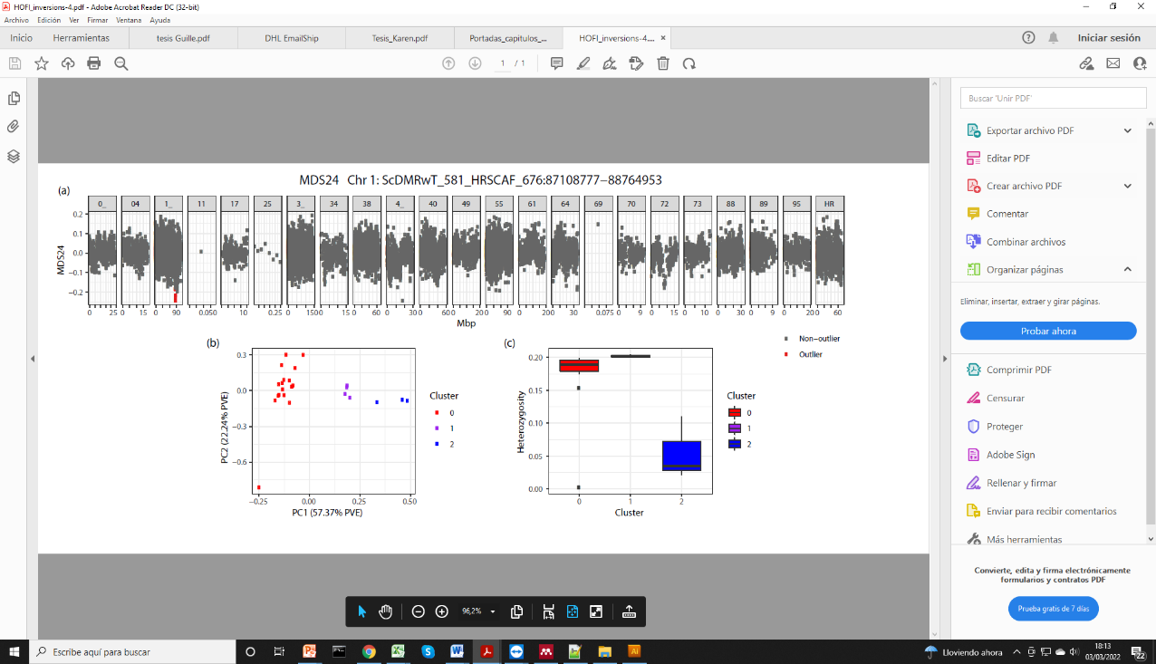
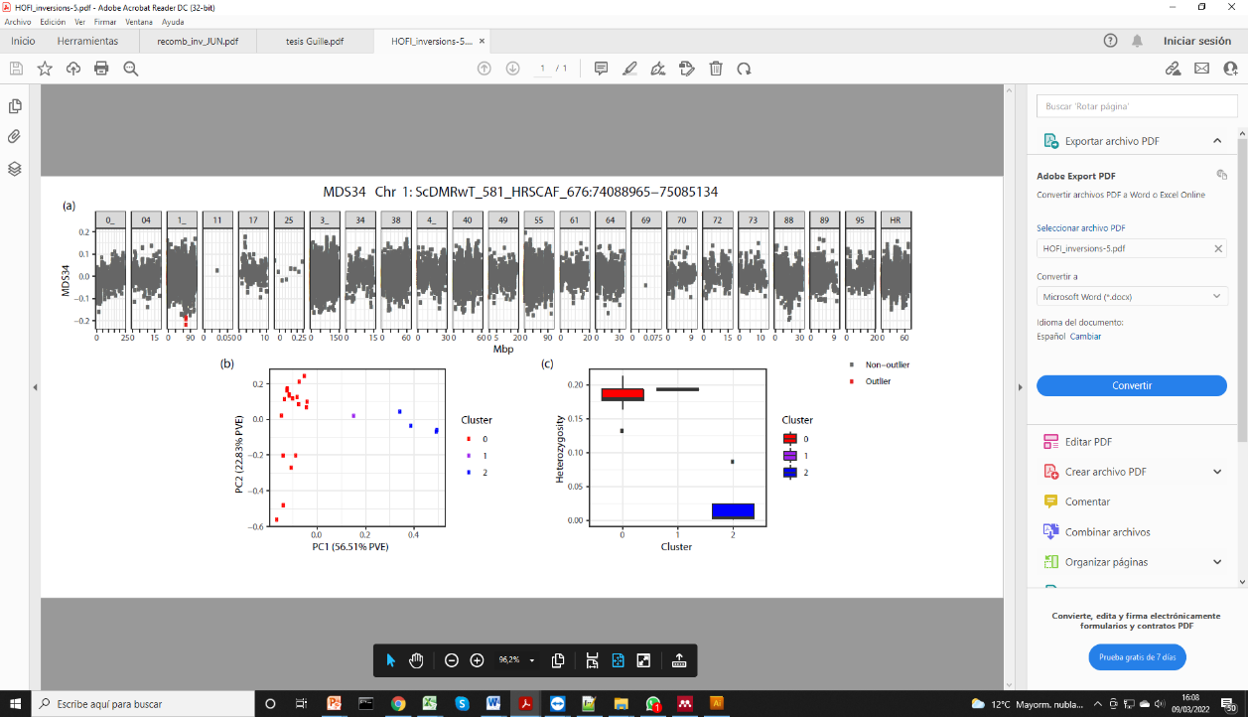
C.

Figure S3. Detection of chromosomal inversions using multidimensional scaling analysis (MDS). Information about the MDS outlier regions detected with LOSTRUCT for (A) the dark-eyed junco, (B) the common chaffinch and (C) the house finch. Within each species, (a) genome plot of MDS values for the chromosomes were inversions are detected, where each dot represents a window of 1,000 SNPs and outliers are in shown in red; (b) PCA performed with SNPs in the specific region. The three clusters correspond to the two homozygote groups (blue and red) and the heterozygote group (purple); and (c) heterozygosity values for each of the groups identified in the PCA.

