Design and Characterization of Gelatin-Coated Upconversion Nanoparticles: Insights into Structural, Relaxometric, Luminescent, and Cytotoxic Properties

Joyce Francine da Silva de Limaª, Giovanna Nogueira da Silva Avelino Oliveiraª, Dayane Kelly Dias do Nascimento Santosª, Giovannia Araújo de Lima Pereiraª, Rodrigo da Silva Viana^{b†} and Severino Alves Junior^{a†}

ªDepartment of Fundamental Chemistry, Federal University of Pernambuco, Av. Prof. Moraes Rego, 1235 - Cidade Universitária, Recife, Pernambuco 50670-901, Brazil
^{b}Technology Center, Federal University of Alagoas, Campus A.C. Simões, Tabuleiro dos Martins, Maceió, Alagoas, 57072-900, Brazil

†Corresponding authors:
SAJ: severino.alvesjr@ufpe.br// ORCID: 0000-0002-8092-4224
RSV:rs.vianarodrigo@gmail.com // ORCID: 0000-0003-1329-6958

Supplementary Information

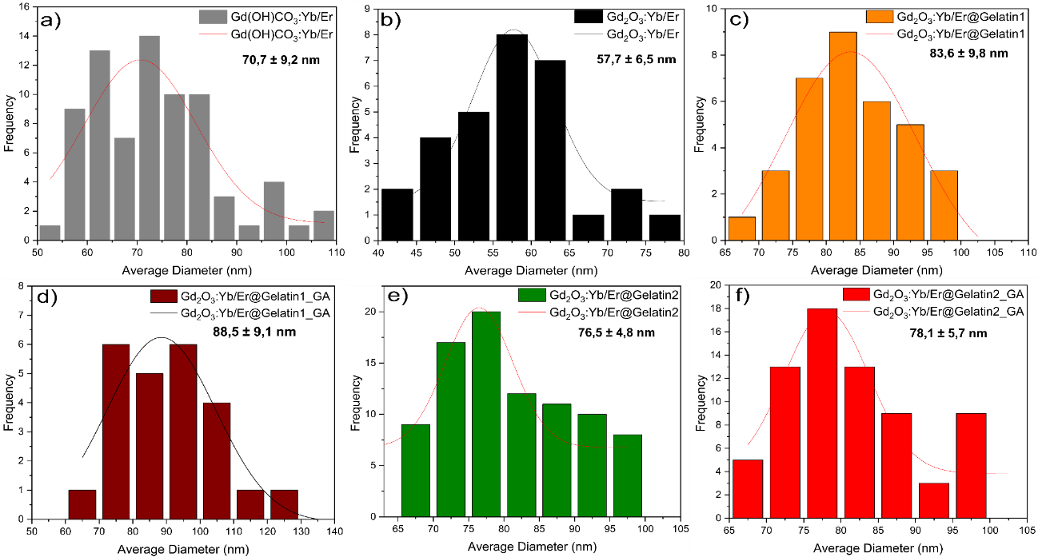
Figure S1: Histogram images for the compounds a) Gd(OH)CO₃:Yb/Er, b) Gd₂O₃:Yb/Er; c) Gd₂O₃:Yb/Er@Gelatin1, d) Gd₂O₃:Yb/Er@Gelatin1_GA, e) Gd₂O₃:Yb/Er@Gelatin2 e f) Gd₂O₃:Yb/Er@Gelatin2_GA.

