Appendix

Temperature and Moisture Boundary Conditions:
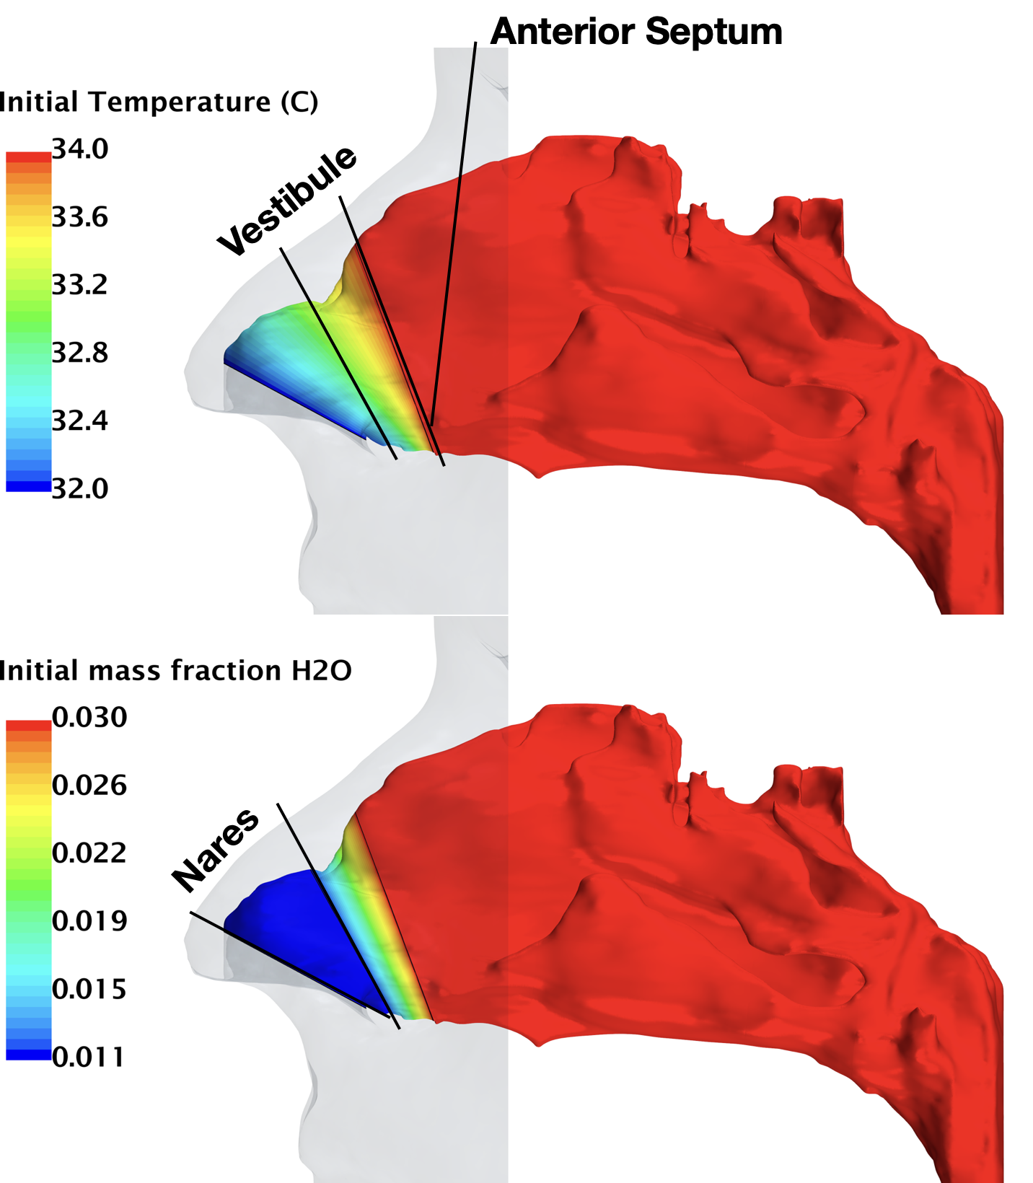
The initial temperature gradient is established from the front of the nares to the end of the vestibule, with a starting temperature of 32 $°C$ at the nares, incrementing linearly to 34 $°C$ at the vestibule end, proportional to the distance covered.
For moisture, the boundary condition within the vestibule follows a similar linear transition, distinct from the nares, which maintains a constant moisture level equivalent to the incoming air’s moisture content.
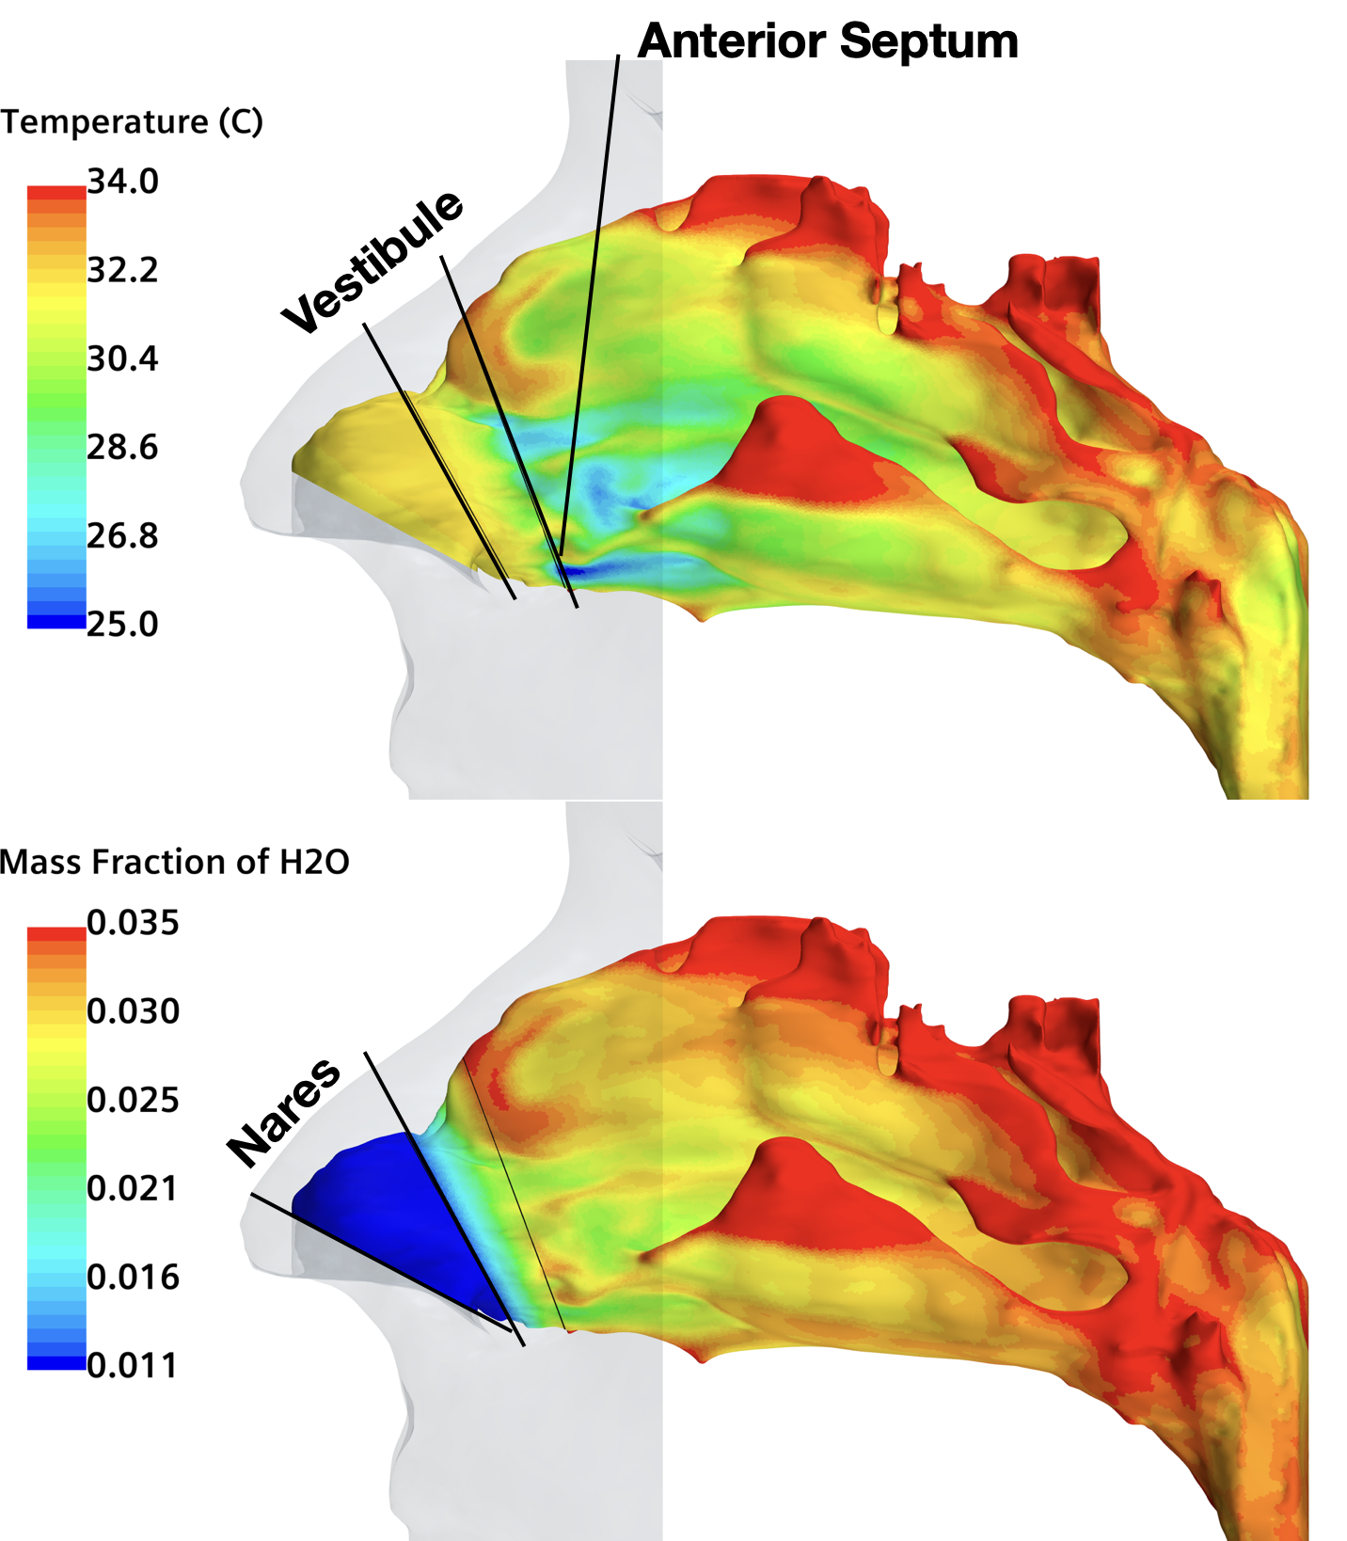

As the simulation finished, such as 25 °C 50% relative humidity inhaled air coming into the cavity, the inner surface of the nasal cavity settles with temperate and mass fraction of water as shown in the figures below:

