Supplementary Figure 1. Variable importance from random forest model.

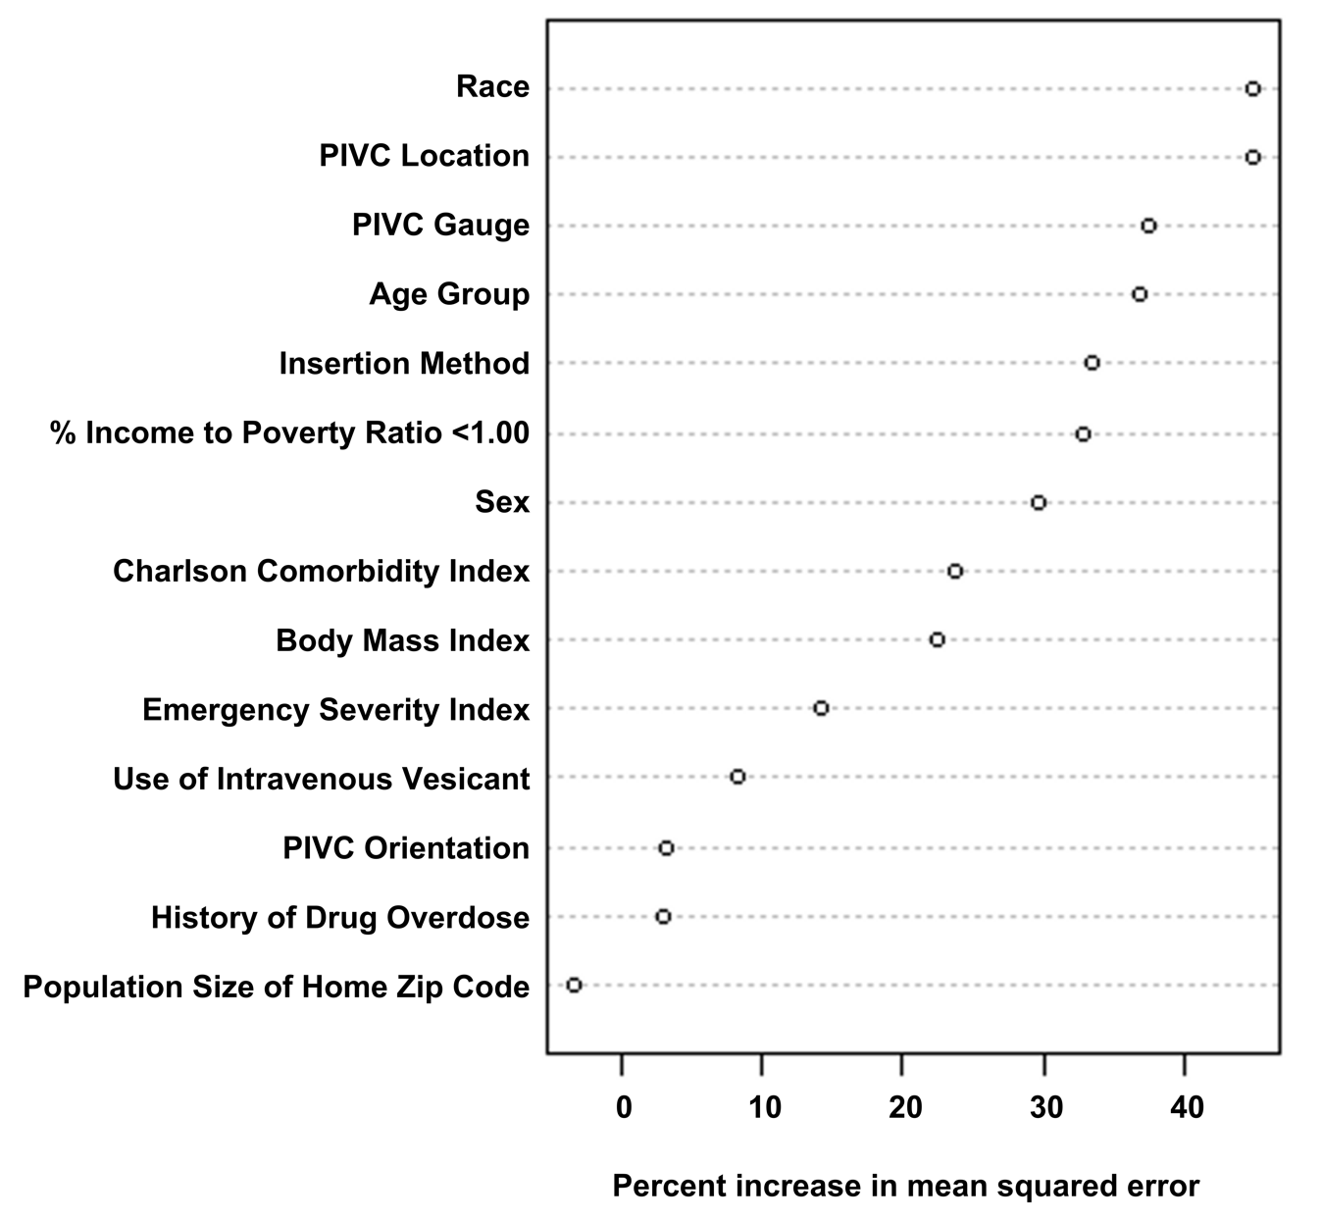

FIGURE CAPTION
List of variables included in the random forest model, ranked by importance. Increase in mean squared error quantifies how much a predictor variable contributes to the model’s predictive accuracy.

