Supplementary Information.

Table S1. Summary of Confusion matrix scores.

A specific cartilage layer identified from Raman Spectroscopy data | Accuracy of identification in Control cartilage | Accuracy of identification in OA cartilage
Superficial layer | 96% | 94%
Deep layer | 91% | 91%
Superficial layer in Control compared to OA | 80% | 84%
Deep layer in Control compared to OA | 80% | 87%
Superficial layer in under 60th | 53% | 81%
Deep layer in under 60th | 49% | 90%
Superficial layer in over 60th | 83% | 79%
Deep layer in OA over 60th | 76% | 78%
Superficial layer in Male | 68% | na
Superficial layer in Female | 65% | na
Deep layer in Male | 74% | na
Deep layer in Female | 78% | na

Table S2. Main spectral peaks from measurements of superficial and deep layers in human articular cartilage

Frequency (cm⁻¹) | Assignments to chemical bonds and molecules
855 | -C-C- Proline ring (P)
877 | -C-C- Hydroxyproline ring (HP)
921 | -C-C- Proline ring (P)
938 | -C-C- Hydroxyproline ring (HP)
1004  1046 | Phenylalanine ring breathing mode of collagen and proteoglycans
1033 | Phenylalanine ring breathing mode of collagen and proteoglycans, differences in collagen content
1064 | SO₃ stretching, Chondroitin sulphate (CH) (part of sGAG complex)  -C-C- skeletal saturated fatty acid
1085 | -C-C- skeletal unsaturated fatty acid
1101 | Hyaluronic acid (HA)  /Chondroitin sulphate (CS) /Heparan sulfate (HS)
1128 | HA  -C-C- skeletal saturated fatty acid
1245 | CN stretching of amide bond, Amide III, random coil (disordered)
1272 | NH deformation of amide bond, Amide III α-helix or coil (ordered)
1320 | CH₂, CH₃ twisting, Amide III, collagen twisting mode
1345 | CH₂ scissoring, Amide III, collagen bending mode. GAGS (Glycosaminoglycans)
1380 | Lipid  GAGS (Glycosaminoglycans)
1451 | CH₂, CH₃ scissoring, NH₂ deformation of amide bond, collagen and other proteins
1666 | NH₂ deformation, Amide I (Collagen)

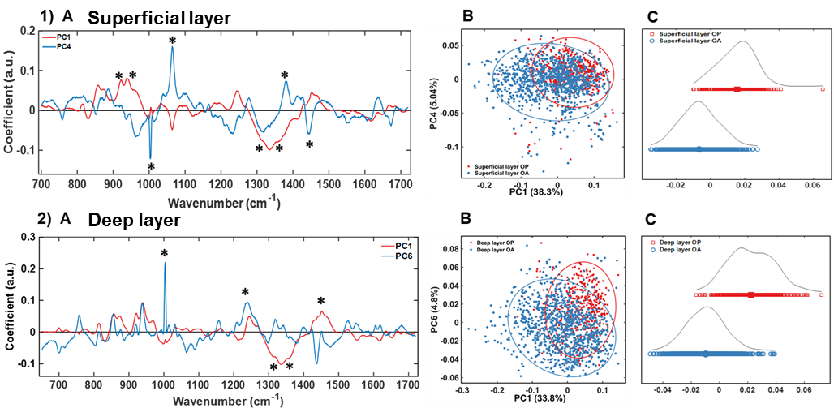

Figure S1 (supplement to Figure 4). Raman fingerprint for OA diagnosis of articular cartilage. 1) Superficial and 2) Deep layer (A) Loadings to demonstrate main peaks contributing to PCA of RS spectral points in 1) B and 2) B. 1) C superficial and 2) C deep layer LDA analysis separates spectra into positive and negative quadrants based on classes labels from PCA analysis in B). OA (blue) vs Control (red) cartilage. Peaks with the highest variability are framed. Confusion matrixes in (B) and (D) demonstrate Positive and negative scores in layers assignments.
“*” in (A) show spectral peaks contribution to PCA scores (B).

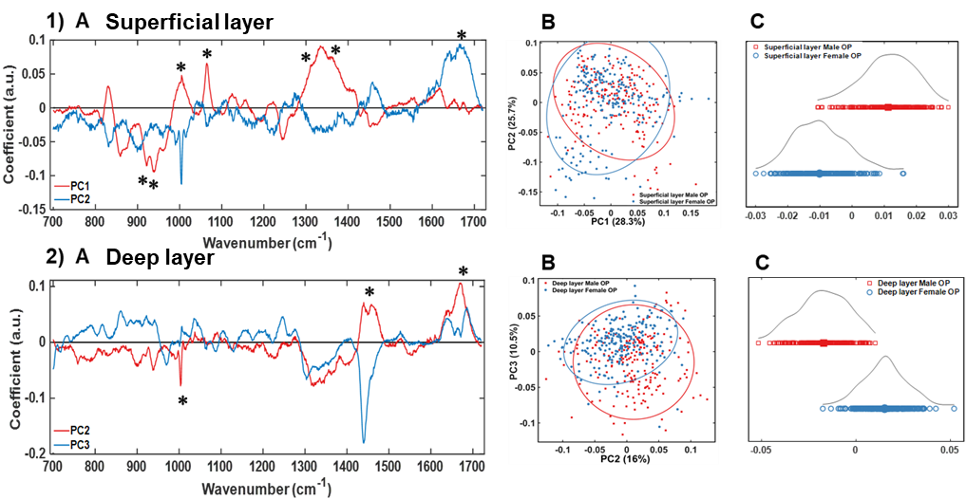
Figure S2 (supplement to Figure 5). Raman fingerprint for articular cartilage from gender related samples. 1 (A) superficial and 2 (A) deep layer Loadings to demonstrate main peaks contributing to PCA of RS spectral points in 1) B and 2 )B. 1) C superficial and 2) C deep layer LDA analysis separates spectra into positive and negative quadrants based on classes labels from PCA analysis in B). Cartilage samples from Male (red) vs Female (blue) samples. “*” in (A) show spectral peaks contribution to PCA scores (B).

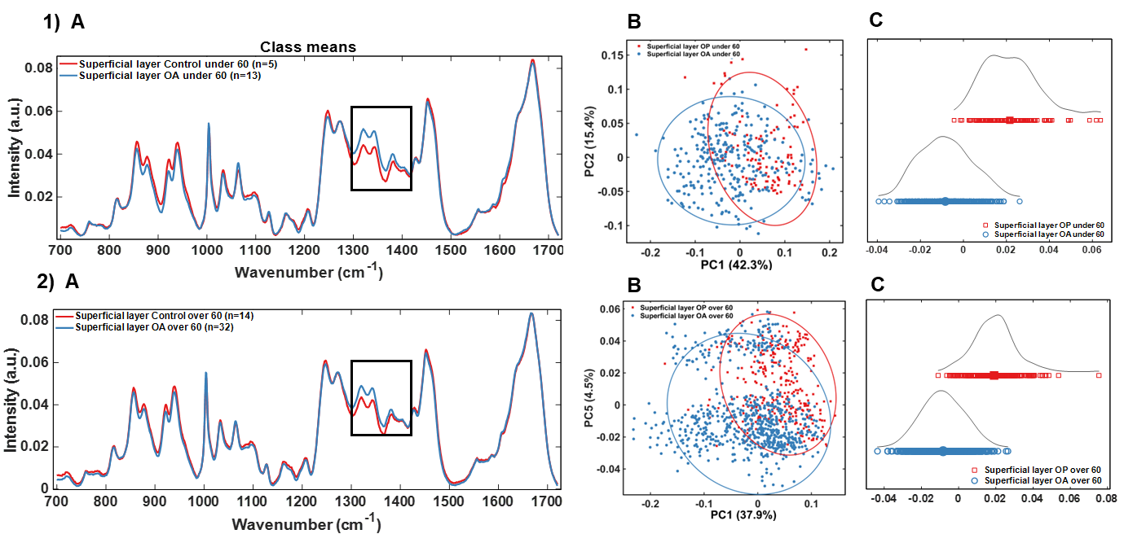
Figure S3 (supplement to Figure 6). Raman fingerprint from superficial layer of articular cartilage from age matched samples. RS of 1 (A) superficial layer, from under 60 years old (control n=5, OA n=13) and 2 (A) superficial layer, from over 60 years old (control n=14, OA n=32) individuals. Boxed spectra (1320cm⁻¹, 1345cm⁻¹, 1380cm⁻¹ peaks) show highest differences between control and OA samples. 1 (B) and 2 (B) 2-D representation of PCA analysis of RS spectral points from 1) A and 2) A. LDA 1-D representation of 1(C) superficial layer, from under 60 years old and 2 (C) superficial layer, from over 60 years old individuals separates spectra into positive and negative quadrants based on classes labels from PCA analysis in B). Cartilage samples from Controls 1 (A) superficial layer, from under 60 years old and 2 (A) superficial layer, from over 60 years old individuals. Male (red) vs Female (blue) samples.

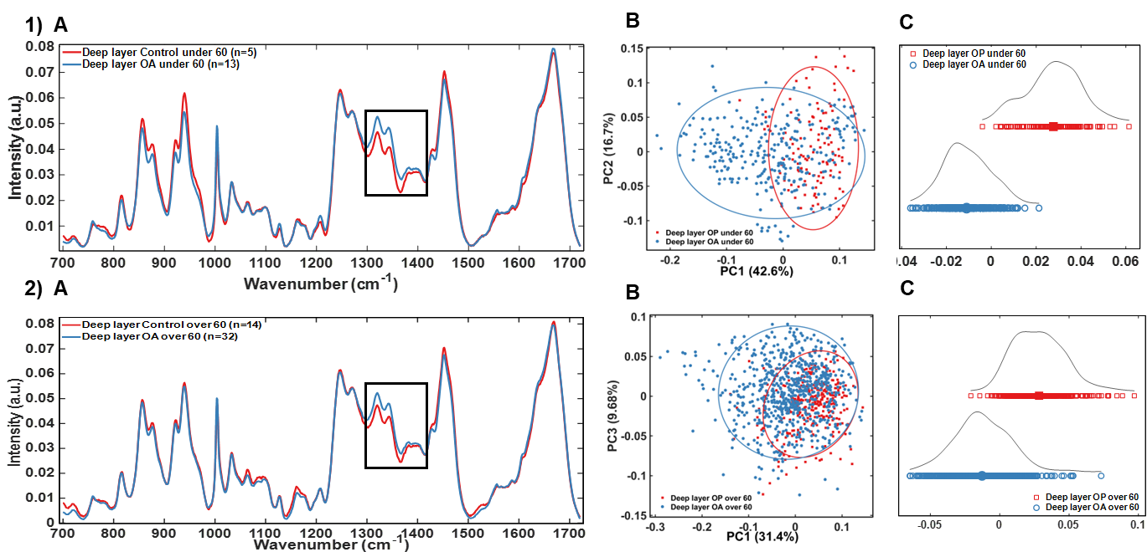
Figure S4 (supplement to Figure 6). Raman fingerprint from deep layer of articular cartilage from age matched samples. RS of 1(A) superficial layer, from under 60 years old (control n=5, OA n=13) and 2 (A) superficial layer, from over 60 years old (control n=14, OA n=32) individuals. Boxed spectra (1320cm⁻¹, 1345cm⁻¹, 1380cm⁻¹ peaks) show highest differences between control and OA samples. 2 (A) and 2 (B) 2-D representation of PCA analysis of RS spectral points from 1) A and 2) A. LDA 1-D representation of 1 (C) superficial layer, from under 60 years old and 2 (C) superficial layer, from over 60 years old individuals separates spectra into positive and negative quadrants based on classes labels from PCA analysis in B). Cartilage samples from Controls 1 (A) superficial layer, from under 60 years old and 2 (A) superficial layer, from over 60 years old individuals. Male (red) vs Female (blue) samples.
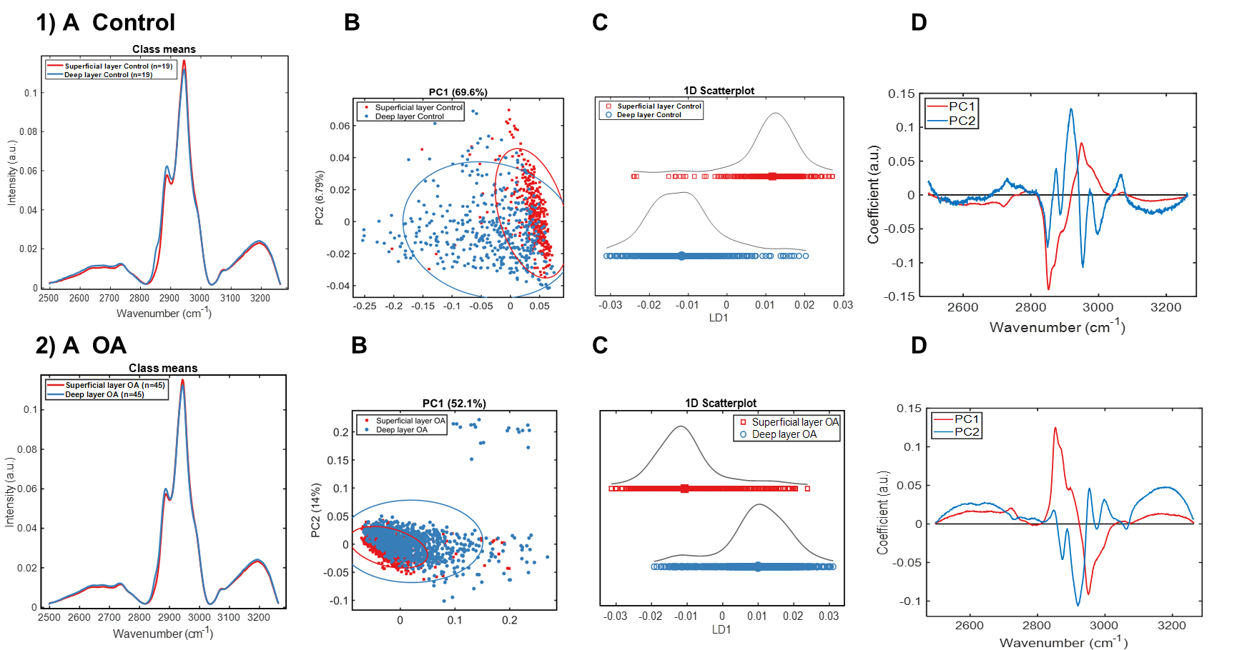

Figure S5. Raman spectra at CH₂/CH₃ region for comparison of superficial and deep layers of articular cartilage. Top panel (1) control samples (n=19), bottom panel (2) OA samples (n=45). 1, 2 (A) RS of CH region (2500 to 3300) of superficial (red) and deep (blue) layers of cartilage. 1, 2 (B) 2-D scatter plot demonstrating distribution of superficial and deep layer spectra along PC1 and PC2 axes. 1, 2 (C) LDA analysis shows further separation of superficial (red) and deep (blue) layers based on class labels from PCA. (D) Loadings from PC1 and PC2 PCA scores in B). Control samples: mean age 72 years, median age 78 years, n=19 (male=9, female=10). OA samples: mean age 69 years, median 73 years, n=45 (male=21, female=24).

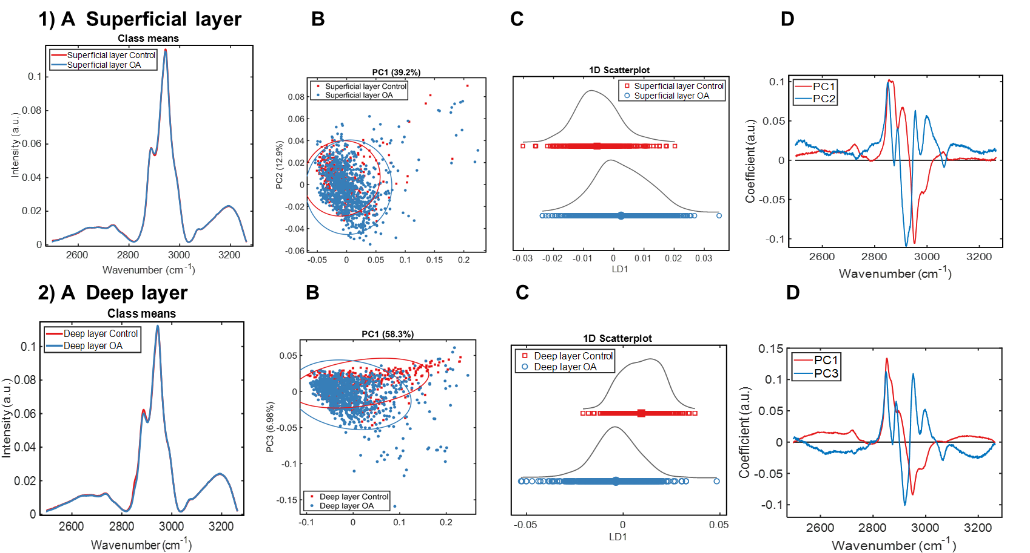

Figure S6. Raman spectra at CH₂/CH₃ region for OA diagnostics of articular cartilage. 1, 2 (A) RS of CH region (2500 to 3300) of control (red, n=19) vs OA (blue, n=45) samples; superficial layer in top panel (1), deep layer in bottom panel (2). 1, 2 (B) 2-D scatter plot demonstrating distribution of superficial and deep layer spectra along PC1/PC2 in (1 B) and PC1/PC3 in (2 B) axes. 1, 2 (C) 1-D LDA analysis of superficial (1 C) and deep (2C) control (red) and deep (blue) layers based on class labels. 1 (D) Loadings from PC1 and PC2; 2 (D) from PC1 and PC3 PCA scores in (B). Control samples: mean age 72 years, median age 78 years, n=19 (male=9, female=10). OA samples: mean age 69 years, median 73 years, n=45 (male=21, female=24).

