The relations between different factors of intolerance of uncertainty and symptoms of generalized anxiety disorder: a network analysis

Lei Ren^{1†}, Zihan Wei^{2†}, Ye Li³, Long-Biao Cui¹, Yifei Wang¹, Lin Wu¹, Xinyi Wei⁴, Jiaxi Peng⁵, Kuiliang Li⁶, Yinchuan Jin¹, Fengzhan Li¹, Qun Yang^{1*}, Xufeng Liu^{1*}

¹Department of Military Medical Psychology, Air Force Medical University, 710032, Xi’an, China
²Department of Neurology, Xijing Hospital, Air Force Medical University, 710032, Xi’an, China
³Psychological counseling center, Xijing University, 710100, Xi’an, China
⁴Department of Psychology, Renmin University of China, 100000, Beijing, China
⁵College of Teachers, Chengdu University, 610106, Chengdu, China
⁶Department of Psychology, Army Medical University, 400038, Chongqing, China

* Correspondence: yangqun1125@hotmail.com; lxf_fmmu@163.com
† Lei Ren and Zihan Wei contributed equally to this work

Supplementary Materials

- Table S1. Nonparametric Spearman rho correlation matrix of variables selected in the present network
- Figure S1. Accuracy of edge weights
- Figure S2. Bootstrapped difference test for edge weights
- Figure S3. Stability of node strengths
- Figure S4. Bootstrapped difference test for node strengths
- Figure S5. Stability of node bridge strengths
- Figure S6. Bootstrapped difference test for node bridge strengths

Table S1. Nonparametric Spearman rho correlation matrix of variables selected in the present network
 | PA | IA | A1 | A2 | A3 | A4 | A5 | A6 | A7
Prospective Anxiety (PA) | 1.00
Inhibitory Anxiety (IA) | 0.58* | 1.00
Nervous (A1) | 0.35* | 0.32* | 1.00
Control worry (A2) | 0.36* | 0.39* | 0.54* | 1.00
Worry too much (A3) | 0.41* | 0.42* | 0.56* | 0.57* | 1.00
Relax (A4) | 0.34* | 0.38* | 0.50* | 0.57* | 0.64* | 1.00
Restless (A5) | 0.27* | 0.38* | 0.44* | 0.54* | 0.46* | 0.55* | 1.00
Irritable (A6) | 0.31* | 0.32* | 0.51* | 0.50* | 0.57* | 0.59* | 0.51* | 1.00
Afraid (A7) | 0.33* | 0.35* | 0.47* | 0.49* | 0.52* | 0.48* | 0.58* | 0.54* | 1.00
* p < 0.01 (two-tailed)

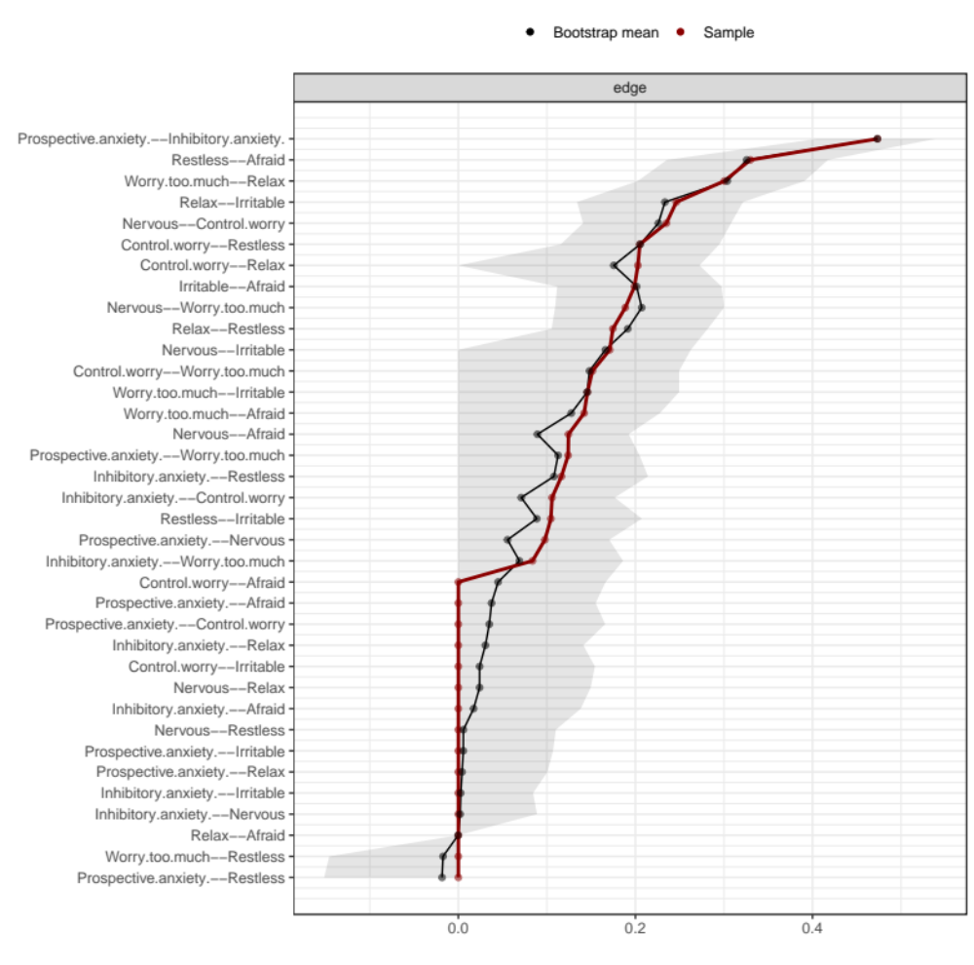
Figure S1. Accuracy of edge weights
Note: The red line depicts the sample edge weights and the gray bar depicts the bootstrapped confidence interval.

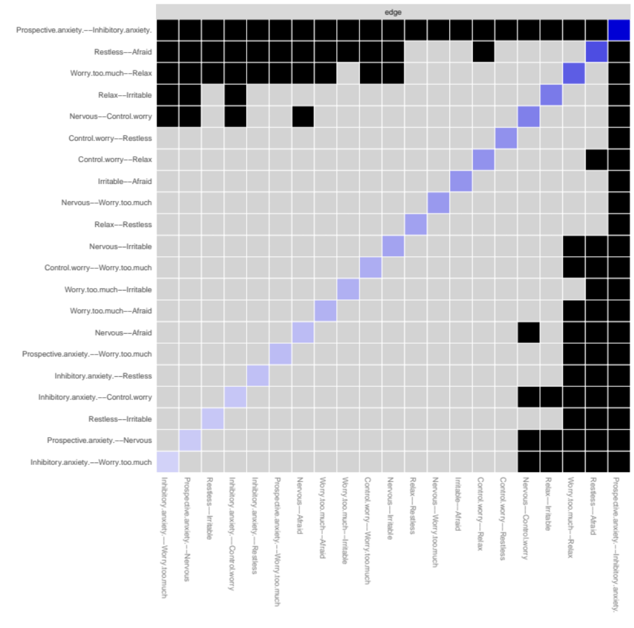
Figure S2. Bootstrapped difference test for edge weights
Note: Gray boxes indicate edge weights that do not differ significantly from one another, while black boxes indicate edge weights that do differ significantly. Blue and red boxes on the diagonal correspond to edge weights with positive and negative correlations, respectively.

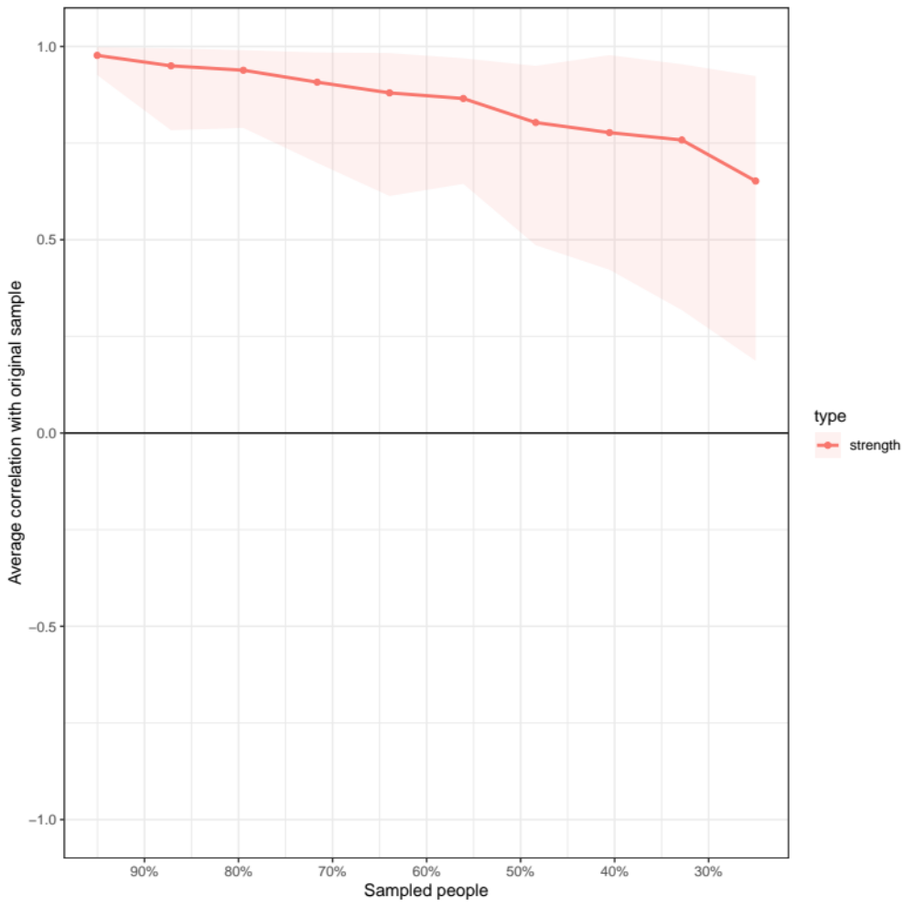
Figure S3. Stability of node strengths
Note: The red bar represents the average correlation between node strengths in the full sample and subsample with the red area depicting the 2.5th quantile to the 97.5th quantile.

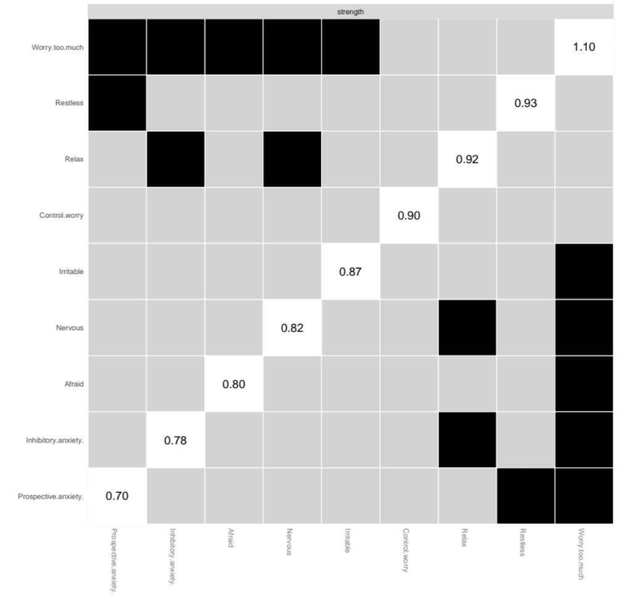
Figure S4. Bootstrapped difference test for node strengths
Note: Gray boxes indicate node strengths that do not differ significantly from one another, while black boxes indicate node strengths that do differ significantly. The number in the white boxes (i.e., diagonal line) represent the value of node strengths.

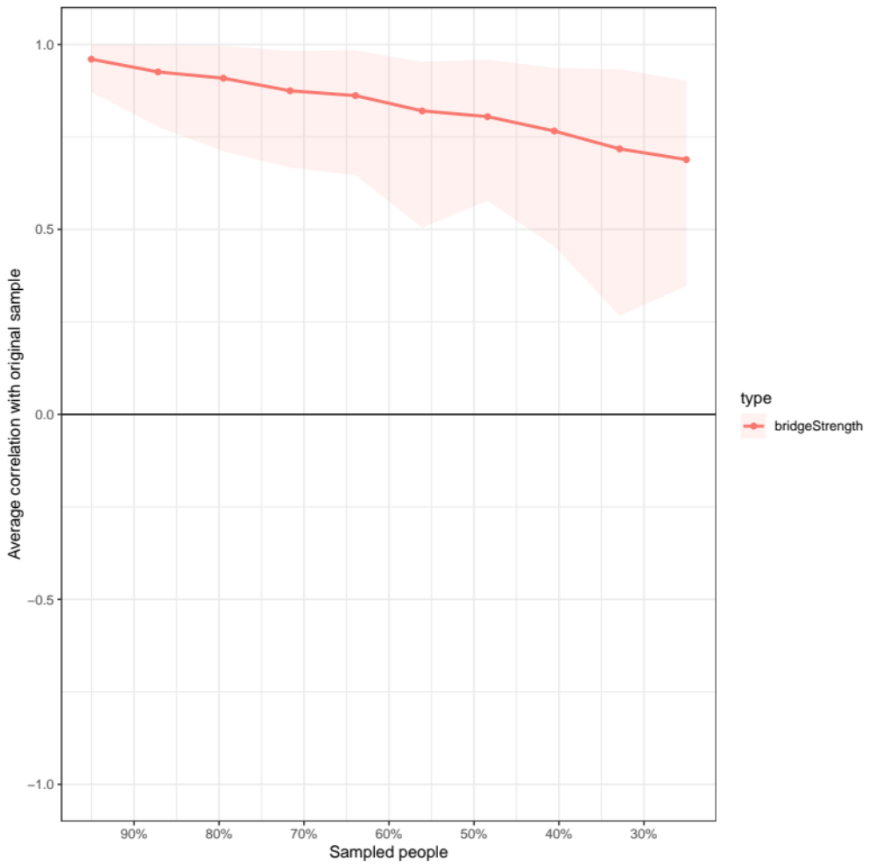
Figure S5. Stability of node bridge strengths
Note: The red bar represents the average correlation between node bridge strengths in the full sample and subsample with the red area depicting the 2.5th quantile to the 97.5th quantile.

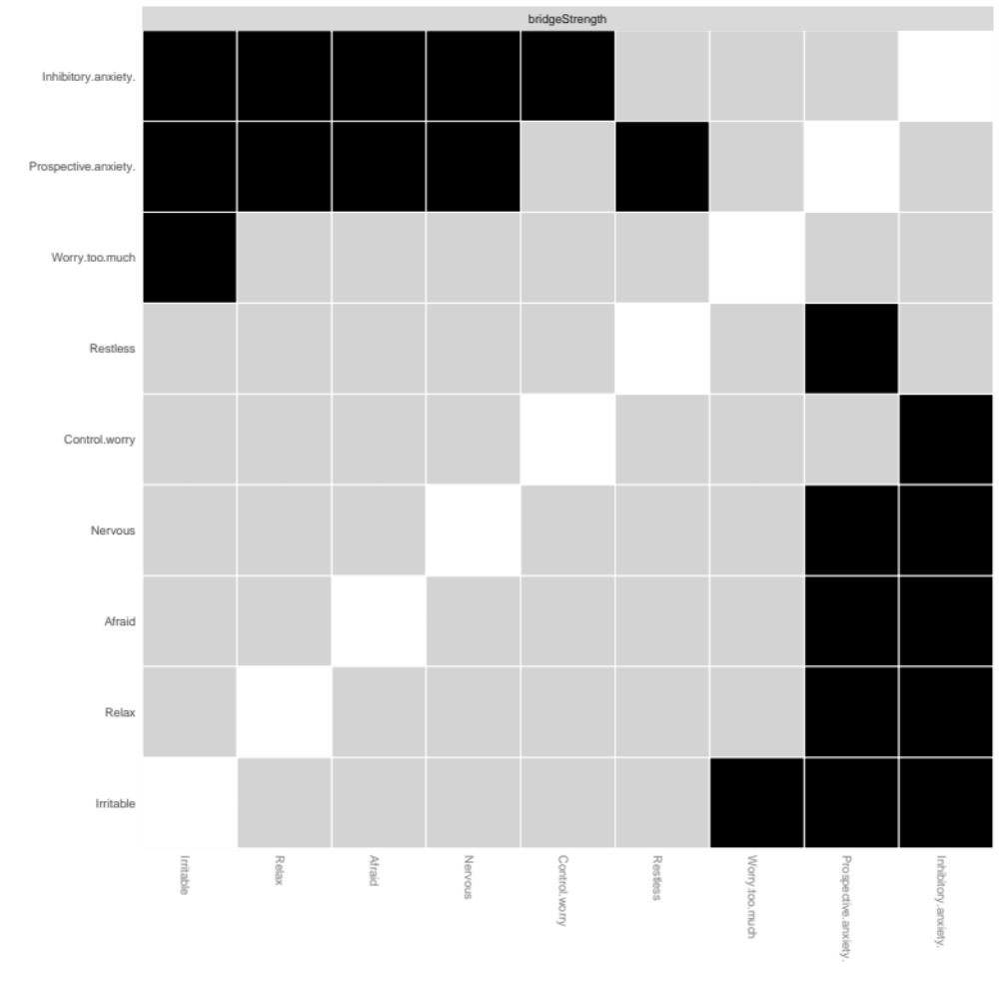
Figure S6. Bootstrapped difference test for node bridge strengths
Note: Gray boxes indicate node bridge strengths that do not differ significantly from one another, while black boxes indicate node bridge strengths that do differ significantly.

