Supplementary figures

Identification of proinflammatory pathways and promising bioactive polyphenols for the treatment of sickle cell anemia by in silico study and network pharmacology
Lila Rosa Maturana Pérez¹., Johana Márquez Lázaro²., Neyder Contreras Puentes²., Antístio Álvis Amador³., Albeiro Marrugo Padilla^{4*}.

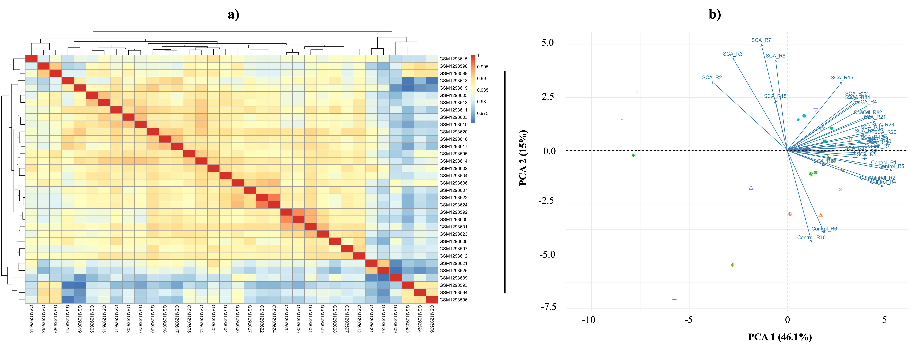

Fig. S1 Intra-group repeatability analysis (a) and principal component analysis of GSE53441 data set samples (b). Each point on the scatterplot represents a sample, with PC1 and PC2 serving as the X and Y axes, respectively. The larger the distance between the two samples in this PCA diagram, the greater the difference in gene expression patterns between the two samples.

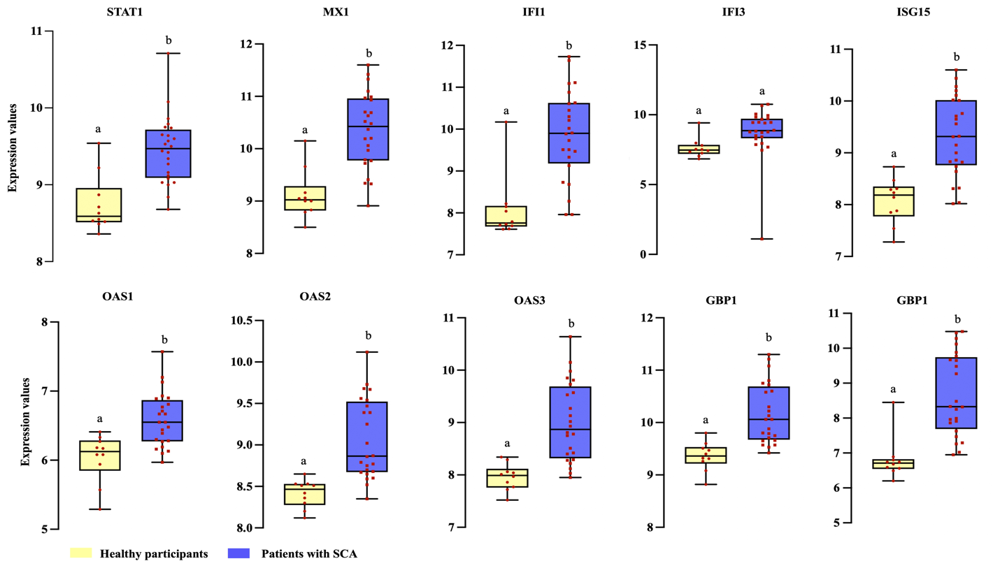

Fig. S2 Comparison of the central hub genes' levels of expression identified in the PPI-Net’s main cluster. The expression levels were derived from the GEO2R analysis; all genes, except for IFI3, were substantially overexpressed in SCA patients (different letters on the bar, P < 0.05).
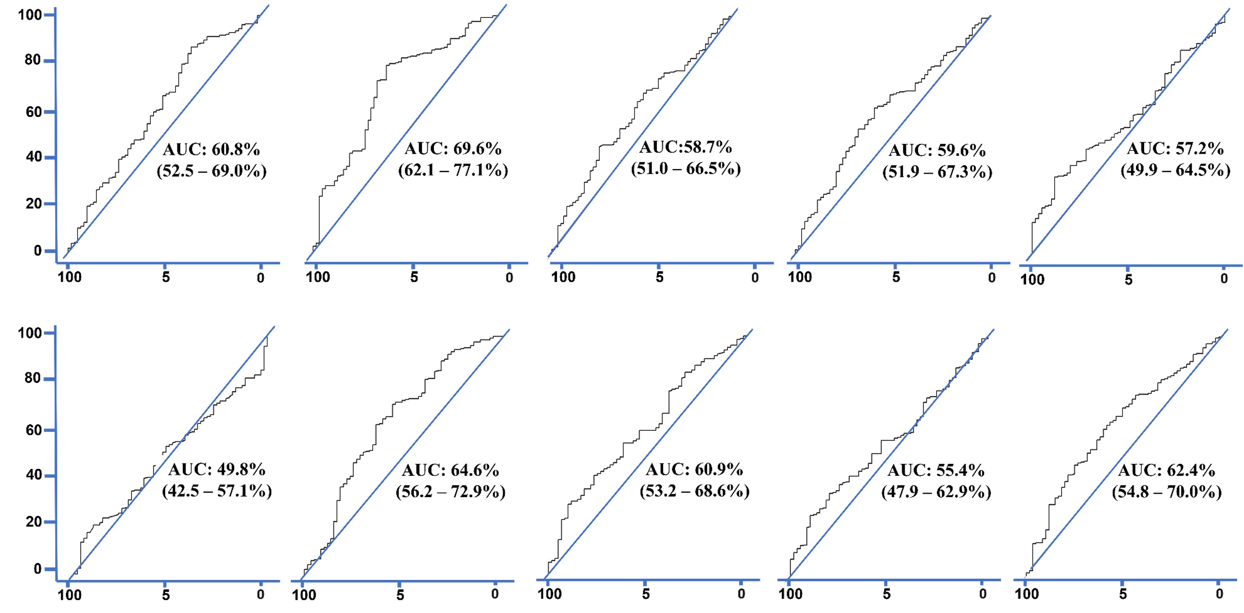

Fig. S3 Receiver operator characteristic curves of central hub genes.

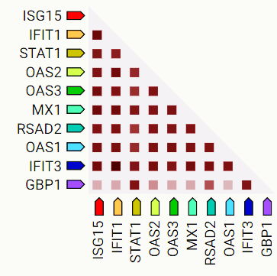

Fig. S4 I Co-expression of central hub genes in humans. Scores were based on RNA expression patterns and protein coregulation provided by the ProteomeHD database (https://www.proteomehd.net/proteomehd).

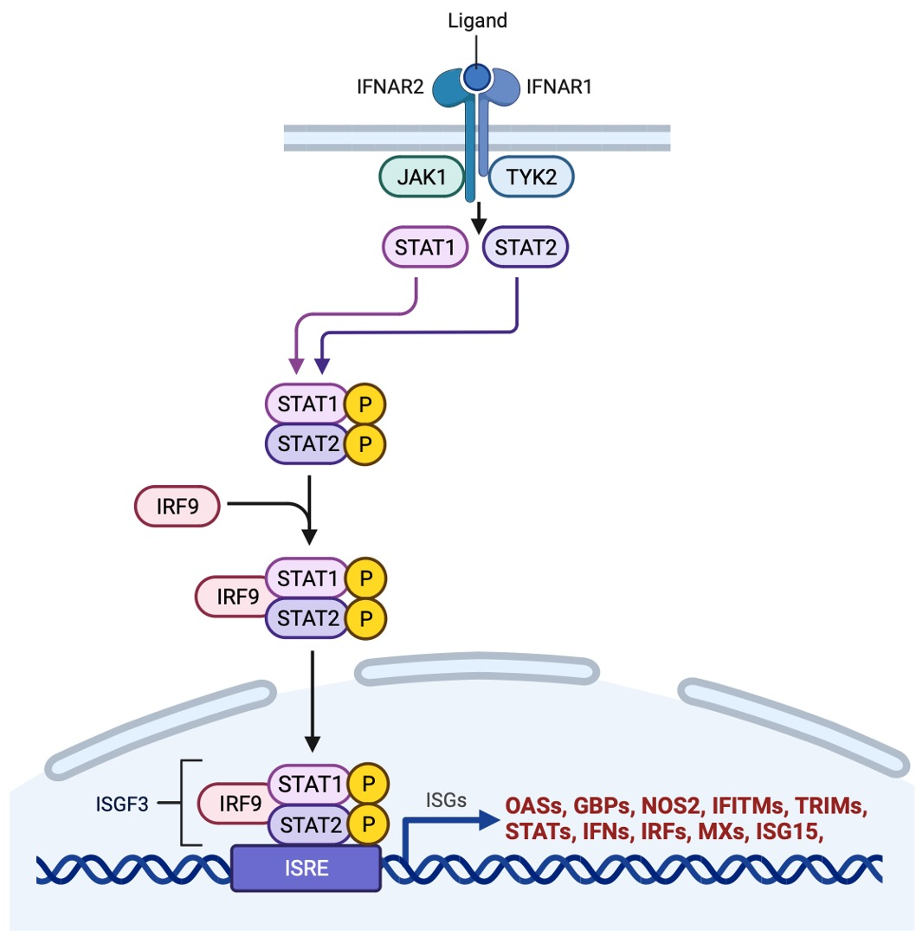

Fig. S5 Type I interferons (IFN-I) activate the classic JAK–STAT pathways via the interferon receptors. Tyrosine kinase 2 (TYK2) and JAK1, two Janus activated kinases (JAKs), are linked to the two subunits of the type I IFN receptor, IFNAR1 and IFNAR2.The two subunits of this receptor, IFNR1 and IFNR2, are also linked to JAK1 and JAK2, respectively. Tyrosine phosphorylation of STAT1 (signal transducer and activator of transcription 1) and STAT2 is caused by activation of the JAKs linked to the type I IFN receptor. This results in the formation of STAT1–STAT2–IRF9 (IFN-regulatory factor 9) complexes, also referred to as ISGF3 (IFN-stimulated gene (ISG) factor 3) complexes. To start the transcription of genes, these complexes go to the nucleus and attach to IFN-stimulated response elements (ISREs) in DNA. Figure designed in Biorender (https://app.biorender.com).

Table S1. Hub genes identified in the cluster 1 by each Cytohubba algorithm.

GEN | Algorithm*
GEN | MNC | MCC | EC | Degree | Closeness
OAS2 | 23 | 1.46x10¹⁹ | 1 | 23 | 23
GBP1
OAS1
OAS3
ISG15
RSAD2
STAT1
MX1
IFIT3
IFIT1

*Degree (Deg), Maximum Neighborhood Component (MNC), Maximal Clique Centrality (MCC), EcCentricity (EC) and Closeness

Table 3. Features of selected flavonoids and ligand of reference for STAT1 docking studies.
Flavonoid | 2D-Structure | Properties
Acacetin | 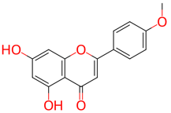 | Formula: C₁₆H₁₂O₅  Molecular Weight: 284.26 g/mol  IUPAC: 5,7-dihydroxy-2-(4-methoxyphenyl)chromen-4-one  ChEMBL ID: CHEMBL243664
Cyanidin | 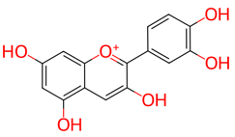 | Formula: C₁₅H₁₁O₆⁺  Molecular Weight: 287.24 g/mol  IUPAC: 2-(3,4-dihydroxyphenyl)chromenylium-3,5,7-triol  ChEMBL ID: CHEMBL404515
Chrysin | 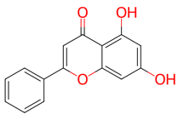 | Formula: C₁₅H₁₀O₄  Molecular Weight: 254.24 g/mol  IUPAC: 5,7-dihydroxy-2-phenylchromen-4-one  ChEMBL ID: CHEMBL117
Diosmetin | 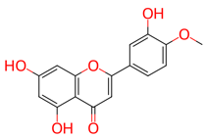 | Formula: C₁₆H₁₂O₆  Molecular Weight: 300.26 g/mol  IUPAC: 5,7-dihydroxy-2-(3-hydroxy-4-methoxyphenyl)chromen-4-one  ChEMBL ID: CHEMBL90568
Epicatechin | 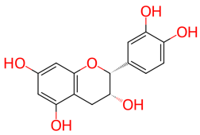 | Formula: C₁₅H₁₄O₆  Molecular Weight: 290.27 g/mol  IUPAC: (2R,3R)-2-(3,4-dihydroxyphenyl)-3,4-dihydro-2H-chromene-3,5,7-triol  ChEMBL ID: CHEMBL583912
Fisetin | 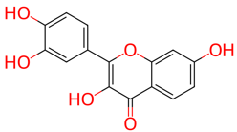 | Formula: C₁₅H₁₀O₆  Molecular Weight: 268.24 g/mol  IUPAC: 2-(3,4-dihydroxyphenyl)-3,7-dihydroxychromen-4-one  ChEMBL ID: CHEMBL31574
Formononetin | 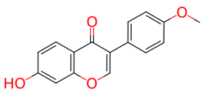 | Formula: C₁₆H₁₂O₄  Molecular Weight: 268.26 g/mol  IUPAC: 7-hydroxy-3-(4-methoxyphenyl)chromen-4-one  ChEMBL ID: CHEMBL242341
Gallocatechin | 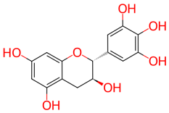 | Formula: C₁₅H₁₄O₇  Molecular Weight: 306.27 g/mol  IUPAC: (2R,3S)-2-(3,4,5-trihydroxyphenyl)-3,4-dihydro-2H-chromene-3,5,7-triol  ChEMBL ID: CHEMBL125743
Kaempferol | 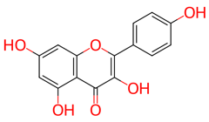 | Formula: C₁₅H₁₀O₆  Molecular Weight: 286.24 g/mol  IUPAC: 3,5,7-trihydroxy-2-(4-hydroxyphenyl)chromen-4-one  ChEMBL ID: CHEMBL150
Luteolin | 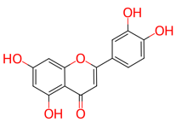 | Formula: C₁₅H₁₀O₆  Molecular Weight: 286.24 g/mol  IUPAC: 2-(3,4-dihydroxyphenyl)-5,7-dihydroxychromen-4-one  ChEMBL ID: CHEMBL151
Morin | 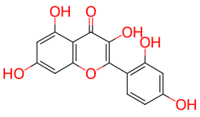 | Formula: C₁₅H₁₀O₇  Molecular Weight: 302.23 g/mol  IUPAC: 2-(2,4-dihydroxyphenyl)-3,5,7-trihydroxychromen-4-one  ChEMBL ID: CHEMBL9352

Naringenin | 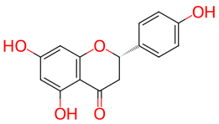 | Formula: C₁₅H₁₂O₅  Molecular Weight: 272.25 g/mol  IUPAC: (2S)-5,7-dihydroxy-2-(4-hydroxyphenyl)-2,3-dihydrochromen-4-one  ChEMBL ID: CHEMBL28626
Peonidin | 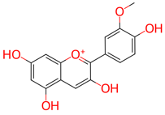 | Formula: C₁₆H₁₃O₆⁺  Molecular Weight: 301.27 g/mol  IUPAC: 2-(4-hydroxy-3-methoxyphenyl)chromenylium-3,5,7-triol  ChEMBL ID: CHEMBL1277324
Quercetin | 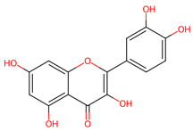 | Formula: C₁₅H₁₀O₇  Molecular Weight: 302.23 g/mol  IUPAC: 2-(3,4-dihydroxyphenyl)-3,5,7-trihydroxychromen-4-one  ChEMBL ID: CHEMBL50
Rhamnetin | 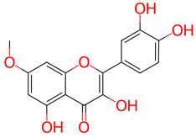 | Formula: C₁₆H₁₂O₇  Molecular Weight: 316.26 g/mol  IUPAC: 2-(3,4-dihydroxyphenyl)-3,5-dihydroxy-7-methoxychromen-4-one  ChEMBL ID: CHEMBL312163
Ligand of reference | 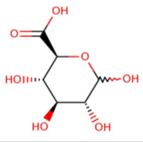 | Formula: C₆H₁₀O₇  Molecular Weight: 194.193 g/mol  IUPAC: ((2S,3S,4S,4S,5R)-3,4,5,6-tetrahydroxyoxane-2-carboxylic acid

